Steps:

* Clone from github.
* There will be 2 folders and some files.
* Tinyurlspringboot is a spring boot application
* Angular6-http-client is an angular application.
* Open the folder in command prompt. Mvn clean install inside the spring boot application.
* Setup postgresql.
  + Username: postgres
  + Password: 661745
* Create database with name tinyurlDB. Create a table with name url. Columns urlid(
* Go to the angular application in command prompt and run ng serve.
* Go to the url link http://localhost:4200/
* Start the spring boot application as a Java application. You will see the below page.
* 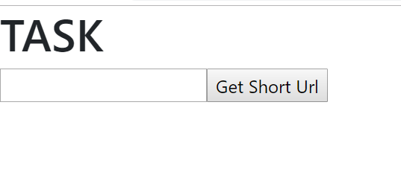
* Put the long url in the text box and you will see a short url generated.
* 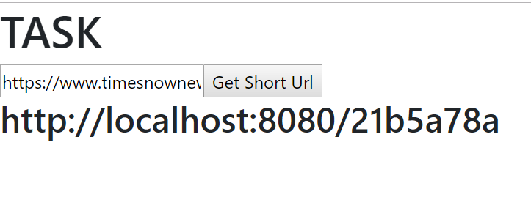
* Copy the short url to another tab in browser. You will see it re-directed to another tab in browser to the long url.

**ANALYTICS**

For analytics, Elastic stack was used. The data from Postgresql was indexed to ES using Logstash. Visualization and Dashboard was created using Kibana.

**DASHBOARD:**

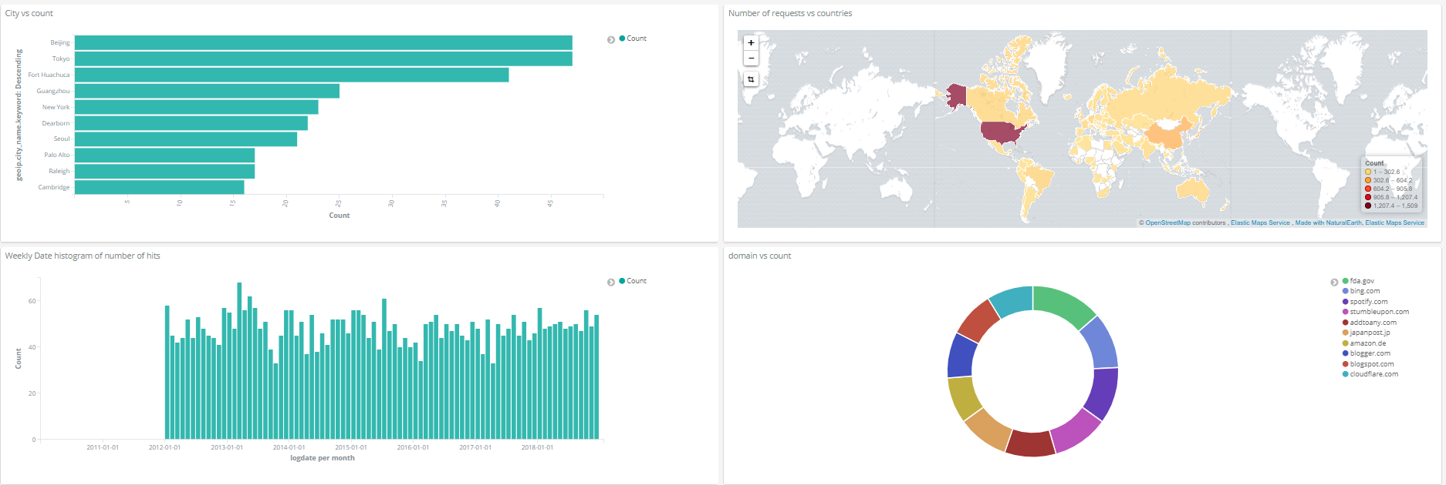

Top 10 Cities using the application.

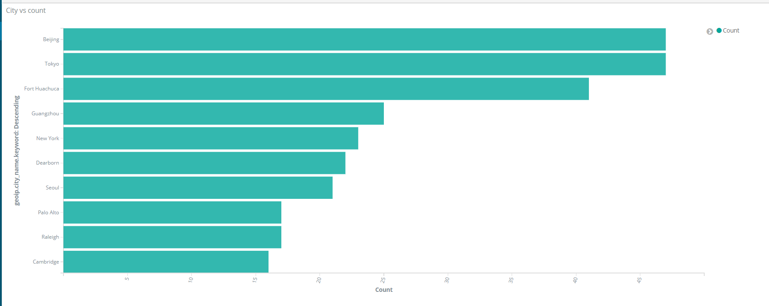

A choropleth representing the count of request in each country.

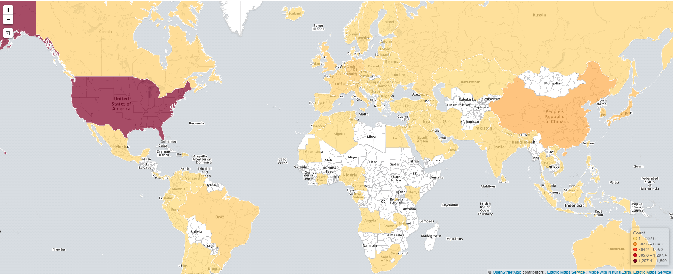

A timeline of number of request every week since the start of the application.

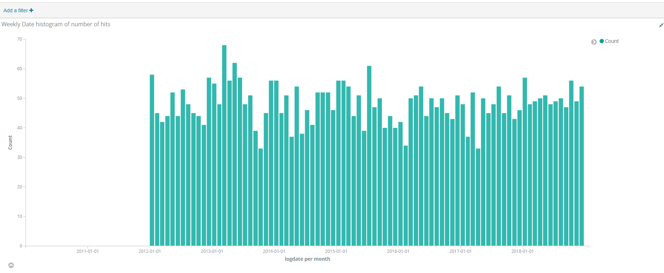

A pie chart representing the top domains whose long url has been shortened in the site.

