* **Created the Table of EmployeeDetails**

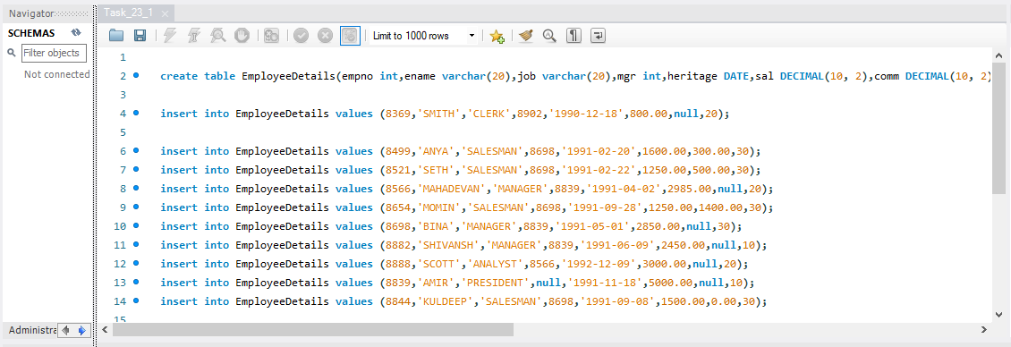

* **Display the EmployeeDetails Table**

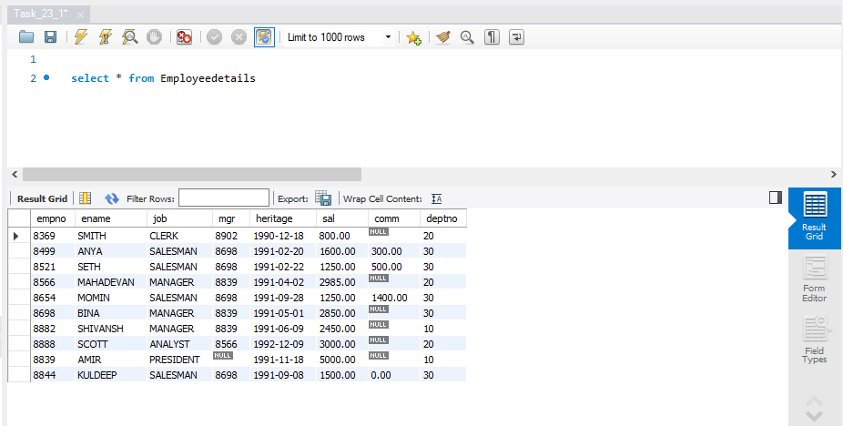

**A. Display the EName and Sal of employees whose salary are greater than or equal to 2200:**

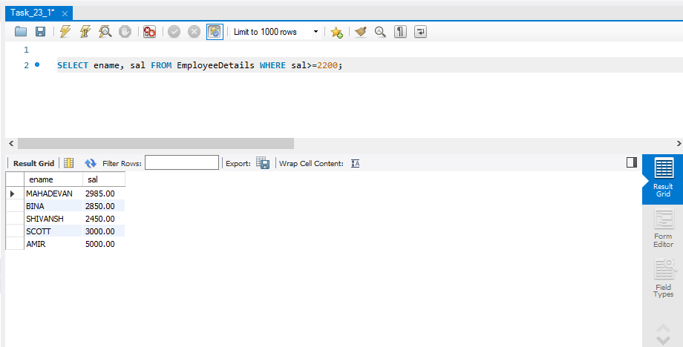

**B. Display details of emloyees who are not getting commission**

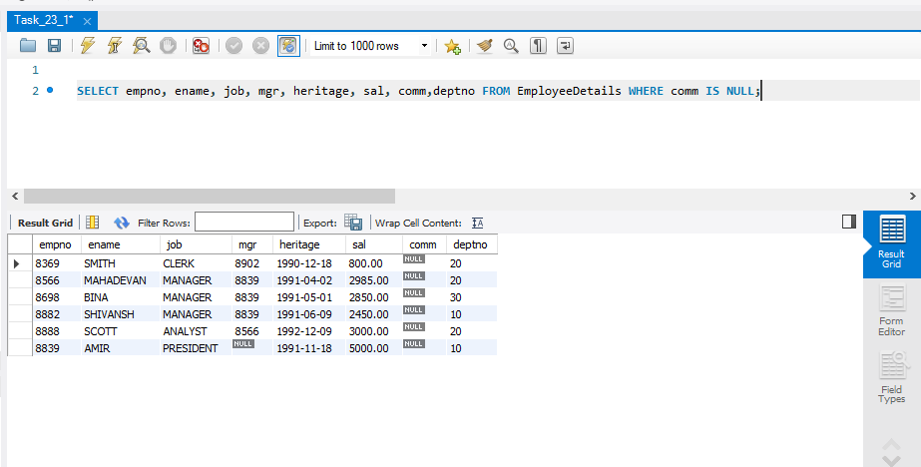

**C. Display employee name and salary of those employees who don't have their salary in the range of 2500 to 4000:**

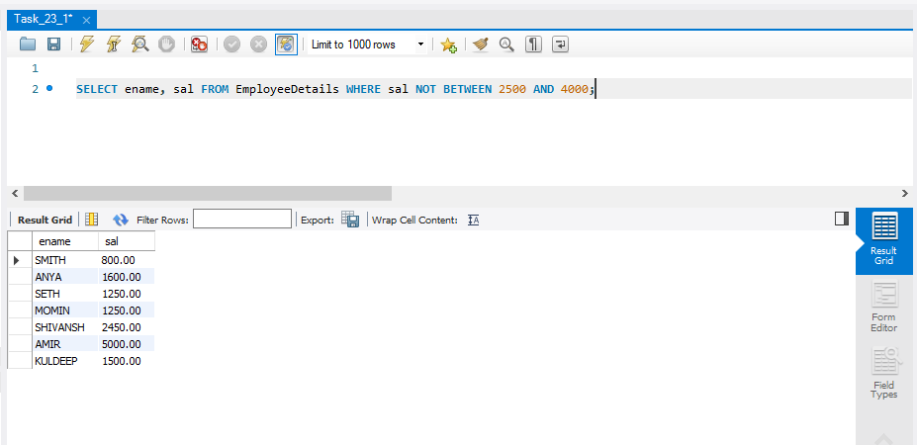

**D. Display the name, job title and salary of employees who don't have a manager:**

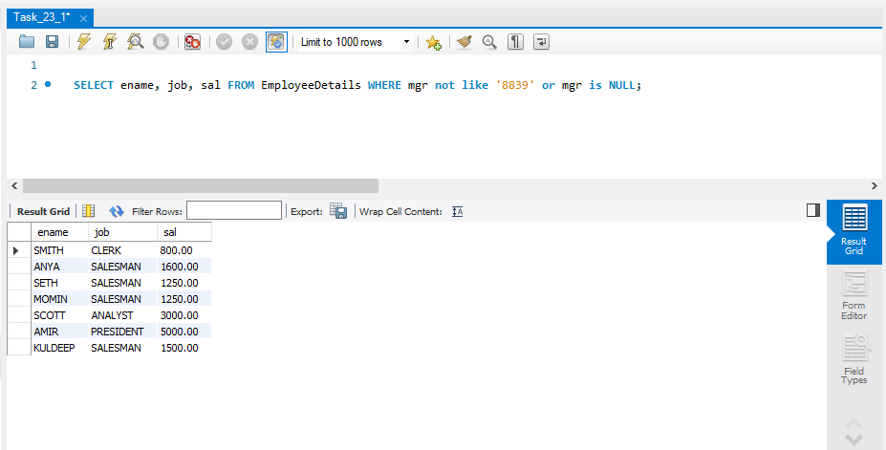

**E. Display the name of an employee whose name contains "A" as third alphabet:**

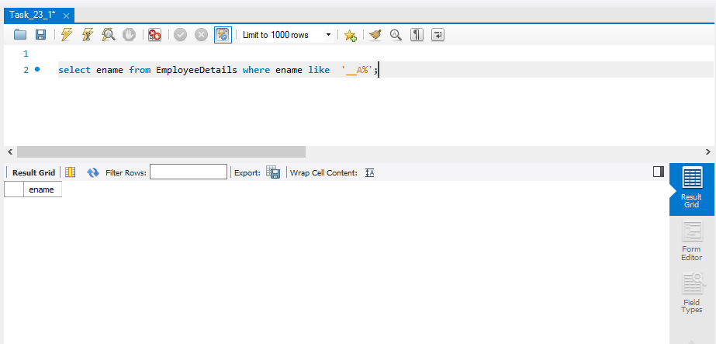

**F. Display the name of an employee whose name contains "T" as the last alphabet:**

