1. **Site content and design:**

The website revolves around me. It talks about who I am, my life, my hobbies, and the places I’ve been to. There is a page for each of these topics which goes into details about them. The website also gives the viewer the opportunity to contact me if they wish to do so.

The approach that I took when building the website was that of a fluid/liquid design. Therefore, I have used percentages for the width on all the containers in my pages. The reason I used the liquid design was to allow the page to be dependent on the viewport rather than the actual containing block. Therefore, when I resize the browser window, the layout will move to adapt to the resizing.

However, not all things were defined as percentages. Some of the fonts are defined in ems. Therefore, they are scaled according to the users’ default browser font size. some of the padding, margin, and border that were used were define in pixel. Therefore, they will be independent of the viewport since they are a fixed unit. Overall however, my design is using a liquid layout.

***The site map for all my pages:***

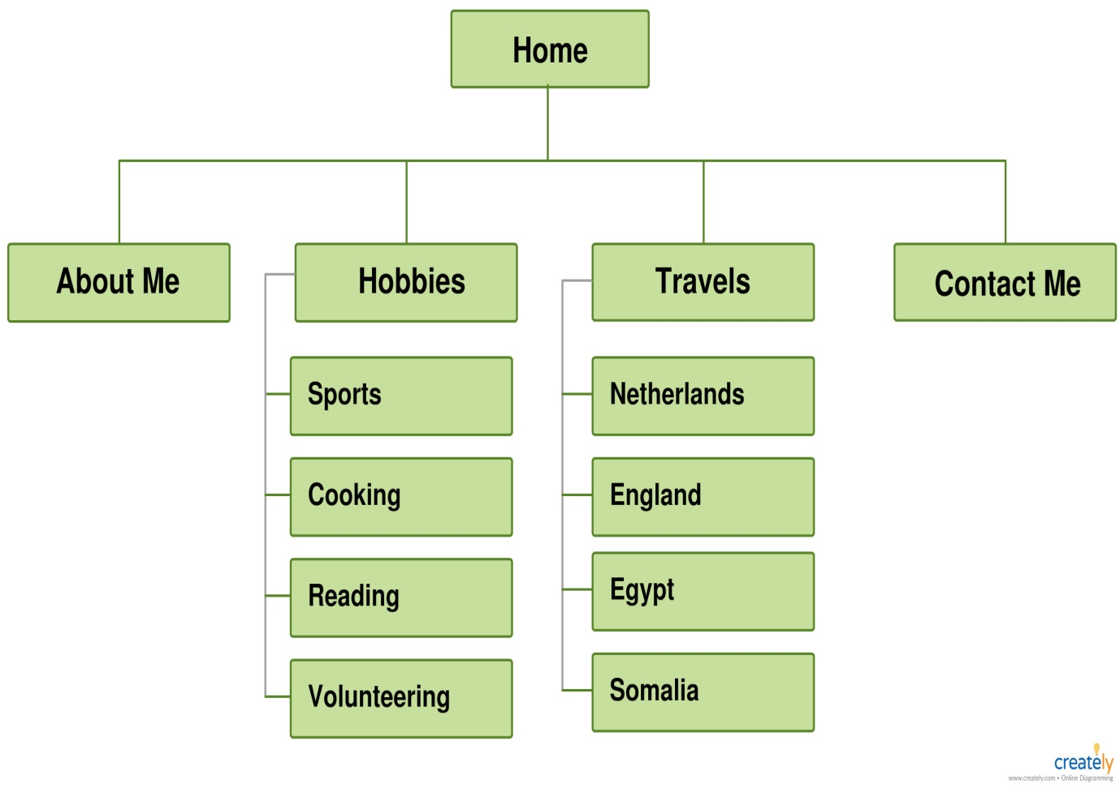

***The wireframe of my pages:***

The sketches below are the wireframes that I designed for my pages. Each page has 2 different layouts. One for desktop view, and the other will be for iPad and mobile view.

***Wireframe of the Home Page (desktop view):***

Title

Navigation. The links will be next to each other.

Section about my favourite quotes

Figure, figure caption and image to attract the audience

Footer

***Wireframe of the Home Page (mobile view):***

Title

Navigation. The links will be under each other.

Figure, figure caption and image to attract the audience

Section about my favourite quotes

Footer

***Wireframe of About Me Page (desktop view):***

Main Content

Navigation. The links will be next to each other.

Title

Footer

***Wireframe of About Me Page (mobile view):***

Title

Navigation. The links will be under each other.

Main Content

Footer

***Wireframe of Hobbies Page (desktop view and mobile view):***

Title

Navigation.

The links will be next to each other on desktop view.

The links will be under each other in mobile view.

Introductory content and links

Content About sports (football, Muay Thai, and gym)

Image of the gym. Will be around half width in desktop view and full width in mobile view.

Content About Cooking

Image of some food. Will be around half width in desktop view and full width in mobile view.

Content About reading

Image of a book. Will be around half width in desktop view and full width in mobile view.

Content About youth events

Image of a meeting. Will be around half width in desktop view and full width in mobile view.

Footer

***Wireframe of Travel Page (desktop view and mobile view):***

Title

Navigation.

The links will be next to each other on desktop view.

The links will be under each other in mobile view.

Introductory content and links

Content About the Netherlands

Image of the Netherlands. The image will be full width in both desktop and mobile view.

Content About England

Image of England. The image will be full width in both desktop and mobile view.

Content About Egypt

Image of Egypt. The image will be full width in both desktop and mobile view.

Content About Somalia

Image of Somalia. The image will be full width in both desktop and mobile view.

Footer

***Wireframe of Contact Me Page (desktop view):***

Title

Navigation. The links will be next to each other.

Details about my socials

Content section

Fill in details:

Text Box for name (around half width but extendable on focus)

Text Box for number

Text Box for subject (around half width but extendable on focus)

Text Box for the message the user wants to say. Full width

Submit button

Reset form button

Footer

***Wireframe of Contact Me Page (mobile view):***

Title

Navigation. The links will be under to each other.

Details about my socials

Content section

Fill in details:

Text Box for name (full width)

Text Box for number (full width)

Text Box for subject (full width)

Text Box for the message the user wants to say. Full width

Footer

Reset form button

Submit button

1. **Use of HTML5**

I have built my pages using structural mark-up elements which allowed my website to be more accessible, provide cleaner code and agree with the content that is actually shown on the pages. I have deferred from using multiple div elements or tables to layout my pages since this is not the purpose of those elements and doesn’t agree with the best practices. Instead, I used the recommended guidelines by the World Wide Web Consortium (W3C) as they said, “mark-up website content semantically, so that the website is extensible. Valid semantics create content that is reusable and more meaningful to assistive technologies (Web Accessibility Tutorials, 2018)”. Following these guidelines allowed me to meet the Web Content Accessibility Guidelines 2.0 (WCAG).

The structure that was used in all my pages were very similar. They consisted of the 2 elements <head> and <body> which had several other elements nested within those two elements. The head element in all my pages have three meta elements, a link element, and a title element. Two meta elements with the name and viewport attributes that defines the author of the page and allows me to take control over the viewport which is the user’s visible area of the page. The third meta element defines the charset. The reason I used the meta element is because it provides metadata of the pages (information about the pages). The link element is used to let the browser know where to find the CSS file. The title element is important since it is a requirement for all HTML documents as it defines the title of the document which can be seen in the browser toolbar.

In the body element of each page, there are several parts that are similar. These are the first header element, the navigation element, and the footer element. The header element is used to hold the introductory content. The navigation element is used to hold the main navigation links that connect all my pages together. This was done using an unordered list element which contains the complete list of pages, list item elements which holds individual pages, and an anchor element which has a link within each li element. The footer is used to define the footer of the page. It contains an address element which tells the viewers who the author of the page is and how to contact them. It also informs the user of the last time the page was modified. These were all done using a paragraph element.

Some other major elements that were used in my HTML documents are the section element, the figure element, the image element, the heading element, the paragraph element, the dd element, the div element, and the form element.

I have used the section element to group together some related elements within the page. What was grouped together was either several texts or some text with some images. An example of this was the text on the “home” page that was grouped together using the section element. This is allowed and acceptable since the texts that were grouped together were connected to the same topic.

The figure element was used to hold a self-contained content which was independent from the main flow of the page. I have used it to contain an image element that was accompanied by a figcaption element which was used as a caption for the image.

The image elements were used to create a place to hold the images. This was done through the src attribute which told the document where to find the image and the alt attribute which held an alternative text which would appear if the image fails to load.

The heading element was used to split the content of the page into several different levels. I always have a h1 element which defines the main heading, then several h2 elements which sometimes had a h3 element within them. These heading are all used to make the page more presentable and easy to read and digest for viewer.

Most of the text that is seen on the page is contained within the paragraph element. Several paragraph elements were used to split the text of the page apart to make it easier for the viewer to read.

The definition list element was used to describe something. It uses the definition term element to define what is being described and the definition description element to tell us something about the what is in definition term element. I used the definition list element to make a comparison between two countries I’ve visited and giving some detail about those differences.

The div element was used to define a division in my document. This was done in the “contact me” page where I had the “follow me” icons. I also used the div element as a container in the navigation bar to add additional links that will appear as a dropdown content with the use of CSS.

The form element was used only in the “contact me” page to create a HTML form so that the user can input some information to contact me. The form element has a fieldset element inside it which is used to group some related elements together that are inside the form element. The fieldset element also draws a box around those related elements. Within the fieldset element we have a legend element which gives the fieldset a cation.

The fieldset element also has several elements inside it such as the input element which is used so that the user can input their name, number, and subject of the message they want to send. The input element is also used to create the submit and reset button. the fieldset element also has a textarea element which is used for the message part as it defines a multi-line text input control which allows for an unlimited number of characters to be entered.

1. **CSS explanation**

From what can be seen from the wireframe that was shown on step 1, the layout will look that that. Layout and positioning is done using liquid design which is also talked about in step 1. All pages have a header, navigation bar and a footer which are all designed in the same way. This allows for consistency and avoids code duplication since I only need to apply the CSS to it one time for all pages.

Aside from my home page and contact me page, I designed my pages so that the content would be in the centre of the page. This is so that the first thing they see is the content which is the goal. Another reason why I put the main content in the centre is so that not too many information is given to the user at once. Therefore, I kept the left and right side of the page clear.

When it comes to the home page, the page is divided into 2 parts. An image on the right half and some texts on the left half of the screen. The contact me page is divided into three sections. Some text on the top left side of the page, some icons with links on the top right side of the screen, and on the bottom half of the screen is a form for the user to fill in. The reason I put the content for the home page and the contact me page next to each other is so that the user would be able to see all the main parts of that page without having the need to scroll down.

I have chosen slate grey as the background colour of the page and dark slate grey as the background colour of the main header, navigation bar and footer. However, I used the colour light grey to surrounding the content of the pages. I choose these colours because it had a good contrast, looked good together, and wasn’t too bright to affect the eye sight of the viewer when looking at the page.

There are some interesting CSS elements that I used to design my page. One of the interesting elements that I used was the nav element which allowed me to use the unordered list element and transform It into a navigation bar. This was done by first getting rid of the bullet points by changing the list-style-type property of the element with the id navigation to none. I then had to place the list items next to each other by making the item lists float to the left and giving each one a width of 20%. Finally, I had to change the anchor’s display property to inline-block so that it would flow like an inline element but have block features. This was done to add some padding to make it look nice and to make the width 100% so that it covers the entire container.

Another interesting element that I used was div elements called dropdown-content which allowed me to hide some links that were in the navigation bar and only appear when I hover over it with the mouse. This was done by making everything in the elements with the dropdown-content class hidden by changing its display value to none. I then made the links have block element properties, so I can give them some padding. This was done by changing the display property in the links inside the dropdown-content class to block. Finally, I had to state that whenever the mouse hovers over the list item, the dropdown content will appear. This was done by using the selector “nav li:hover .dropdown-content” and telling the div element to appear using the “display: block;”.

Another interesting thing that was used was the ‘not’ pseudo class to specify that one of the list items act differently to the rest of the items. This was done with the selector “nav a:hover:not(.active)”. This therefore allowed me to use that feature to let the viewer know what page he is on and not change its colour when it is hovered over. The ‘not’ pseudo class was also used when designing the section element layout of the pages. In this case, two ‘not’ pseudo elements were used to specify not to make the changes inside the declaration of the selector to the home or contact me page.

Another interesting CSS element was the use of the float property in the home and contact me page. I used the float property to move the section of the page to the right and the figure/ socials content to the right of the page. This alone however wouldn’t work so I specified a width for the section and the figure/socials. I had to make sure that when the width of the section and the figure/socials were added together, along with the right and left margin, that it added up to 100% or else, what I wanted to do would fail and they would appear under each other.

The way the icon was inserted in the “about me” page was completely done through CSS by using the ‘after’ pseudo element on the h1 element. I first had to use the content property and give it an empty string. This is to create a space for the image to go in. I used the background property with the url value to insert the image in the background. I also had to specify that the image should not be repeated and only appear once which was also done in the background property. Finally, I had to change the display property to inline-block so that I could give the image a width and height, so it doesn’t take up more space that needed.

It is considered bad practice to not add the height and width attributes in the img element when writing up the HTML document. Those values should also be the same values of the actual image. This is what I have done. However, in my CSS, I made changes to the image. I made the width of all images in the travel page 100% so that it would fit the entire container. However, I made the images in the hobbies page 60% and gave it a margin (left and right) of 10% so that it would appear in the centre of the container and take up nearly half the space. The reason why I made the width different for the two pages was due to its content. One was about travel and had images of cities and huge scenery. Therefore, using a width of 100% wouldn’t stretch the image and would look normal. However, the images of the hobbies page were of small things such as an image of food or a room. Therefore, the image would look stretched if the width was 100%. I also made all the images in both pages the same height by giving the height property a value of 300px.

An interesting CSS element that was used was on the section for the contact me page. Two pseudo classes were used together to specify a specific paragraph element. The selector that was “#contact p:not(:last-child)”. This means that anything in the declaration of that selector will not apply to the last paragraph element where it’s container element has the id ‘contact’.

Another interesting thing was how I was able to change some images in the contact me page by using the hover pseudo class. I used some CSS on the images where I used the content property with the value of url to change the image to a different image when the mouse hovers over the image.

There was a lot of CSS that was done to the form element and the elements nested inside it. The very first thing that was done was use the clear property on the form element with the value both to specify that no elements are allowed to float on either side of this element. We then gave the form a boarder and made it visible. Then we made the edges of the boarder a bit curved by giving the border-radius a value of 10px.

We also used attribute selectors on the input elements so that different things would happen to different inputs with certain attributes. For example, we used the selector “input[type=text], input[type=number]” to target the 3 input elements. We made the width of those elements 40% and changed the font-size to 1.5em. We then used the transition property to change the property value smoothly over a given time. In this case, we start the transition when the value of the width changes by making the change take 1 second. This change can be seen when the input elements with the attribute called type whose value is text is focused on using the focus pseudo class.

Some changes were also made to the textarea element. We got rid of the resizing option by giving the resize property the value none. We also made the width 100% so that it would fit the entire container. Finally, we gave the outline property the value none to stop the default highlighting when the textarea is focused on. This was however not inclusive to only the textarea since it was also done to the input element with the attributes type and number.

Finally, the last thing that was interesting about the CSS elements was the use of media query. The media query I had only worked on the media type screen and the media feature max-width of 800px. So, if the maximum screen size was below 800px, then the media query will come into action. The reason I put my media query at the bottom of the CSS document was so that nothing could overwrite it due to the last rule principle. The reason I chose 800px was because that would be the size of an iPad. So, if an iPad device viewed the page, it would be seen with the media query being active. It would also work with other devices with smaller width such as mobile phones. The reason I don’t have a separate query for phones is because the layout would look the same. So due to my liquid layout, it will adapt to smaller width such as 400px and look the same.

Some of the changes that will be made when the media query is active is that each link in the navigation bar will take up the entire width of the container. Therefore, the links will be under each other instead of next to each other. We also got rid of the drop-down content by giving the display property of the anchor element the value none. Another change that was made was making the width of all the images in all pages expect the contact page 100% so it fits the entire container. Another change is to make the sections fit the entire container by making them 100%. Therefore, everything will appear under each other. Finally, the input elements with the attribute type of value text and number will be 100% in width and the transition property will be gone since their width will remain fixed even with the focus pseudo class by giving it the property width the value of 100%.

1. **CSS techniques**

Several of the CSS techniques that I have used were from somewhere else. I got the idea on how to structure my navigation bar from w3schools (CSS Navigation Bar, 2018).

I also got the idea of getting a dropdown content and how to make it from w3schools (CSS Dropdowns, 2018).

The idea of adding an icon after the h1 element came from the workshops. However, the technique was from a blog article (Krasimir, 2018).

I got the idea of having an image instead of a bullet point for the unordered list from the workshops that we did in CSS and I used the same icon which I gave the link to on step 5.

My layout of the form element was inspired from several layouts that w3schools had (CSS Forms, 2018).

The remaining techniques were either from the lecture notes, from w3schools or a combination of the two.

1. **Graphics and other media**

I have used many images for my pages. All the images and icons I have used were copyright free and were free for me to use and modify. I got all my images from google images after editing the search tools usage right to “Labelled for non-commercial reuse with modification”. These are all the URL links to the all my images and icons.

Home page (nature image): <https://pixabay.com/en/waterfall-landscape-water-nature-1031724/>

About Me page (smiley face icon): <https://commons.wikimedia.org/wiki/File:Mr._Smiley_Face.svg>

Hobbies page and Travel page (Right icon): <https://blackboard.salford.ac.uk/webapps/blackboard/execute/content/file?cmd=view&content_id=_2920741_1&course_id=_88661_1>

Hobbies page (gym image): <http://www.hurlburt.af.mil/News/Article-Display/Article/495324/commando-fitness-center-implements-new-after-hours-policy/>

Hobbies page (food image): <https://www.flickr.com/photos/janitors/26908949764/in/photolist-GZRpgJ-e7Pcoo-aLLq7P-9Z35pr-yRMQq-f8v41q-ktMtPY-9Z35b4-72b8qd-c6UZmY-tpmgK-bX9ntc-6QbJJg-ppw1Bx-qVkDNf-fdguXV-pSEMVE-7A6Ej6-hFVDxv-9bE9GZ-bqqG1A-eCB1LF-dSFxED-HPho3B-4kWrF-HVF9n2-kd3mzV-GZWGev-9fi842-HPhnZa-9gGGk6-7mMpzN-5ksEUx-9ZPzSX-ayB9Yg-bt91kg-namL4C-7BLbs-9bHh7s-q1Xhfq-66osRT-8a8Tjb-aiaQ6T-7wtA4Z-ehRiLp-S9X8W-bETSir-eKQDLh-GZWHi4-HVFaCD>

Hobbies page (reading image): <https://pxhere.com/en/photo/611824>

Hobbies Page (event image): <https://www.pexels.com/photo/chairs-conference-room-corporate-indoors-236730/>

Travel page (Holland image): <https://pixabay.com/en/dordrecht-netherlands-holland-water-800302/>

Travel page (England image): <https://www.ihacom.co.uk/holiday-lettings-manchester/1(8/>

Travel page (Egypt image): <https://www.flickr.com/photos/ahmadhammoudphotography/6215930840>

Travel page (Somalia image): <https://so.wikipedia.org/wiki/Soomaaliya>

Contact Me page (facebook1 icon): <https://pixabay.com/en/facebook-fb-facebook-logo-1799691/>

Contact Me page (facebook2 icon): <https://commons.wikimedia.org/wiki/File:F_icon.svg>

Contact Me page (instagram1 icon): <https://commons.wikimedia.org/wiki/File:Instagram_simple_icon.svg>

Contact Me page (instagram2 icon): <https://commons.wikimedia.org/wiki/File:Instagram_icon.png>

Contact Me page (LinkedIn1 icon): <https://commons.wikimedia.org/wiki/File:LinkedIn_logo_In-Black.svg>

Contact Me page (LinkedIn2 icon): <https://commons.wikimedia.org/wiki/File:Linkedin.svg>

1. **Testing (browser, font and screen size, platform including mobile)**

I have tested my pages on…

1. **Validation**

***Validation of HTML:***

All my HTML validation testing where done in validator.w3.org. No errors were found in my first four HTML pages (home, about me, hobbies, and travel pages). However, one error was found in the contact me page which was due to not having any value for the attribute “action” in the form element. This is because the information the user types in will not be posted anywhere but will just appear as though it was actually sent to me by sending some feedback as a onclick event. For the information to be sent, php will be needed which I haven’t studied and is not required for this project.

This is the results from the HTML validation of the home.html document:

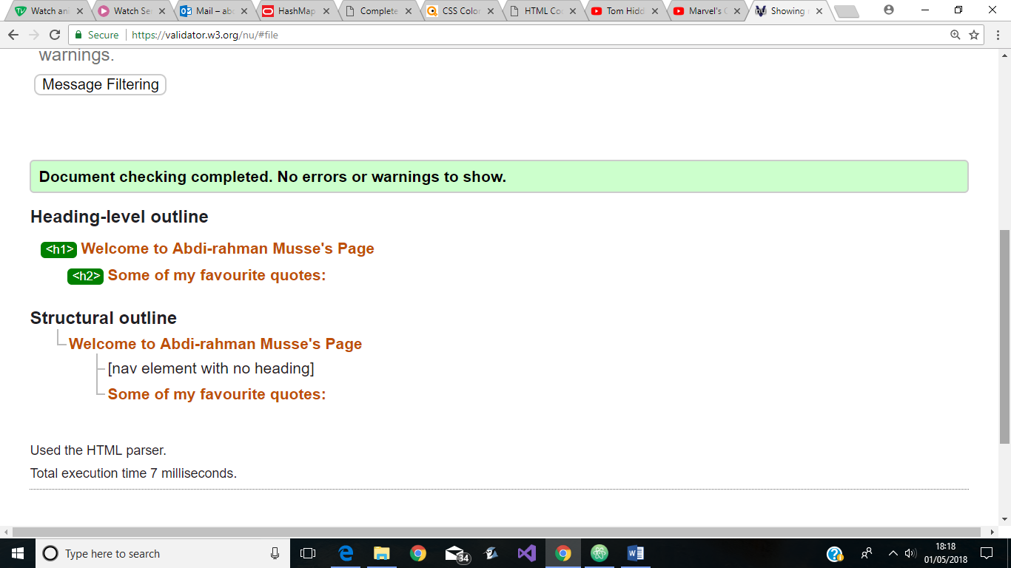

This is the results from the HTML validation of the about.html document:

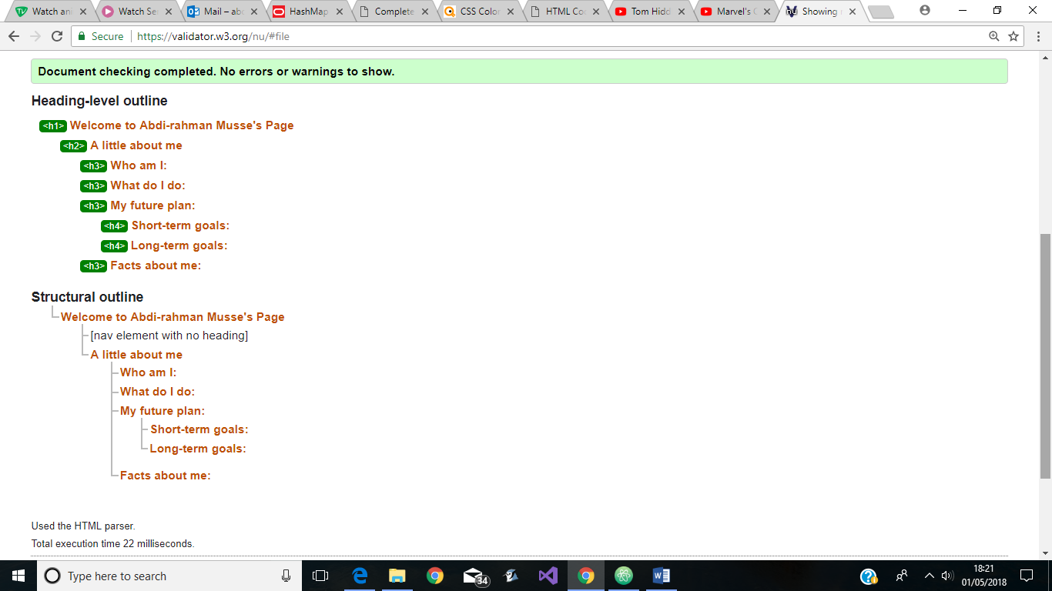

This is the results from the HTML validation of the hobbies.html document:

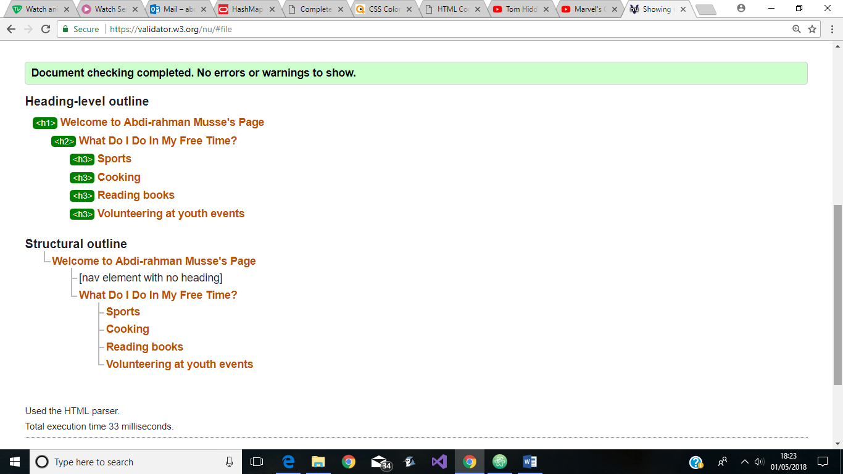

This is the results from the HTML validation of the travel.html document:

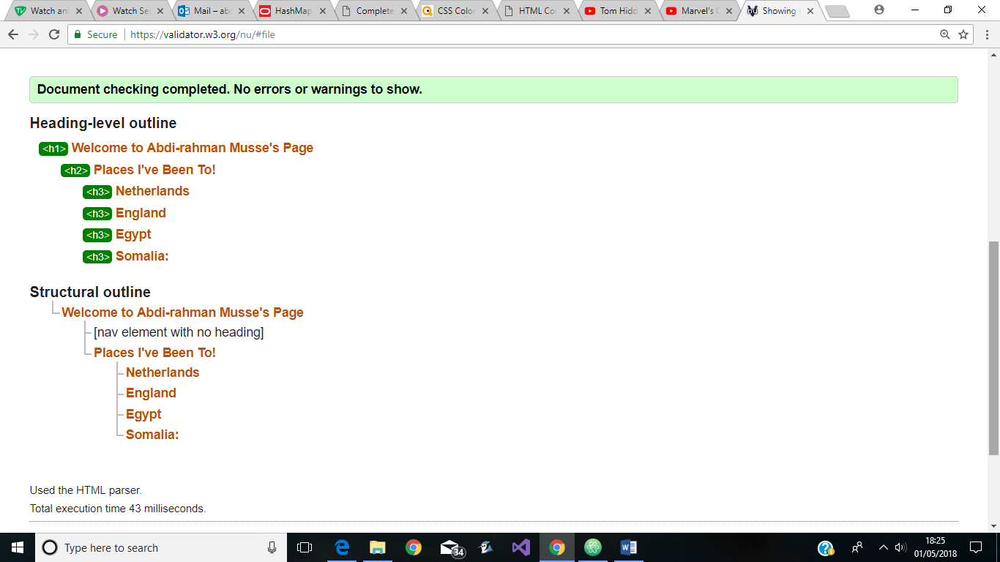

This is the results from the HTML validation of the contact.html document:

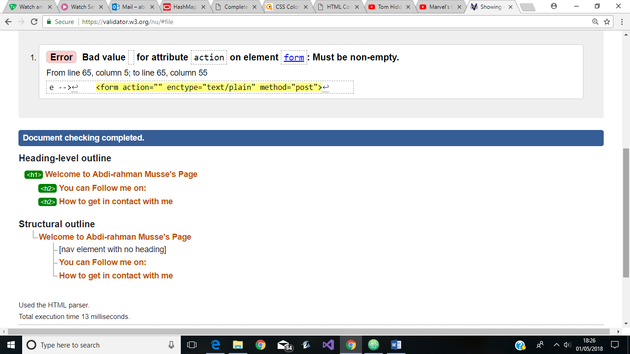

***Validation of CSS:***

My CSS validation testing was done in jigsaw.w3.org/css-validator. No errors were found in my CSS page. I have only used one style sheet to style my five pages so only one test was needed.

This is the results from the CSS validation of the style.css document:

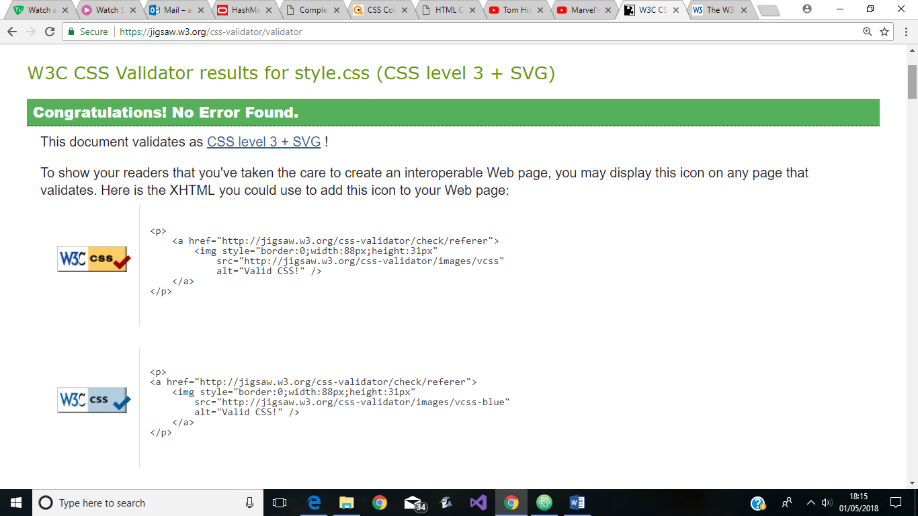

***Testing accessibility:***

The guidelines that I will be using for accessibility will be the 12 bullet points that are on slide Lecture 12 about web accessibility. These guidelines are from the W3C Web Content Accessibility Guidelines which tell us the problems that we should avoid.

* Images

All the images in my HTML documents have a text alteration by using the alt attribute. Therefore, in the case that the image fails to show, the user will still know what the image was about through the text that appears.

* Page organisation

As can be seen from step 2 of the report, the structure that was used in my HTML documents were up to standard. By using structural and semantic mark-up elements, I was able to structure my pages in a well-presented fashion which were easily understandable and easy to follow.

* Hypertext links

There were several hypertext links in my page. Some in the navigation bar, some in the footer and some within the text itself. I ensured that all the links that I have on my pages made sense. If it were in the navigation bar, then it would lead to a new page where the page content would be summarised by the name of the heading which would give it meaning. If it was on the footer or within a text, then it would be connected to what is being said. For example, if the hypertext link said, “click here”, then the text before that would say “if you would like to contact me”. Therefore, the text before the hypertext link would give the link context to where the link might lead to.

* Language

The language that was used in my pages were standard and professional. It didn’t contain any complicated words or any syntax or jargon that wouldn’t be understood by most of the people. It also only uses the English language, so the reader wouldn’t need to worry about any language charges.

* Data tables

Tables were not used for the purpose of layout when designing any of my pages. In fact, since none of my pages contained any data, tables were not needed. Structural and semantic mark-up elements were used to layout my pages. This was done for the purpose of keeping up to the professional standard and agreeing with the guidelines that were set on how to structure your pages.

* Multimedia

The only form of media that was used in my page was images which was discussed on the first bullet point. However, if I were to add other forms of media, such as audio or videos, then I would follow best practise and add an alternative text describing what the content is in the case that the viewer can’t see the media.

* Forms

All the inputs in my form has the correct label which allows it to perform the way I want it to. However, the form itself doesn’t have a value for the action attribute which causes some problems when trying to send the information. This was discussed on step 7 when testing the HTML validation.

* Colour and colour contrast

The colours that I used in my HTML were not bright colours which might affect the ability for the viewer to read the content. Contrasting colours were used between the text and background to make the texts stand out and not hidden by the background colour. Also, there were no action in any of my pages that was required of the user that involved colours. For example, “asking the user to click on the green button to continue”.

* Source code

As can be seen from step 7, I have validated all my HTML pages and CSS pages which shows little to no error. There is only one error when it comes to the form where there is no value in the action attribute. More about that on step 7.

* Page layout and text styles

Similar to the *data tables* bullet point, I have not used tables for laying out my page. I used structural and semantic elements to lay out my page. Also, there were no mixing between the structural content of the page and the presentation of the page since this is considered to be bad practice. All the styling was done by an external CSS document.

* Scripts

No JavaScript was used in the making of any of my pages. Therefore, there is no need to worry about loss of functionality since no functions were added.

* Movement

There was great care put into ensuring that the colours that were used in my pages were not bright and the contrast was decent to ensure that everyone, regardless of vision impairment, will be able to see and enjoy the content without it affecting their eyes. Therefore, no flickering or flashing content were added to the pages.

1. **Copyright permission**

This is not applicable to me since I have not used any material in my pages that belongs to someone else and no one holds copyright over that material. From what can be seen in part 5, all the images and icons I have used were free for me to use without the need to ask for permission.