What is the command to begin the configuration of an extended access list with the name ACL?
Ans:
RT1(config)# ip access-list extended ACL

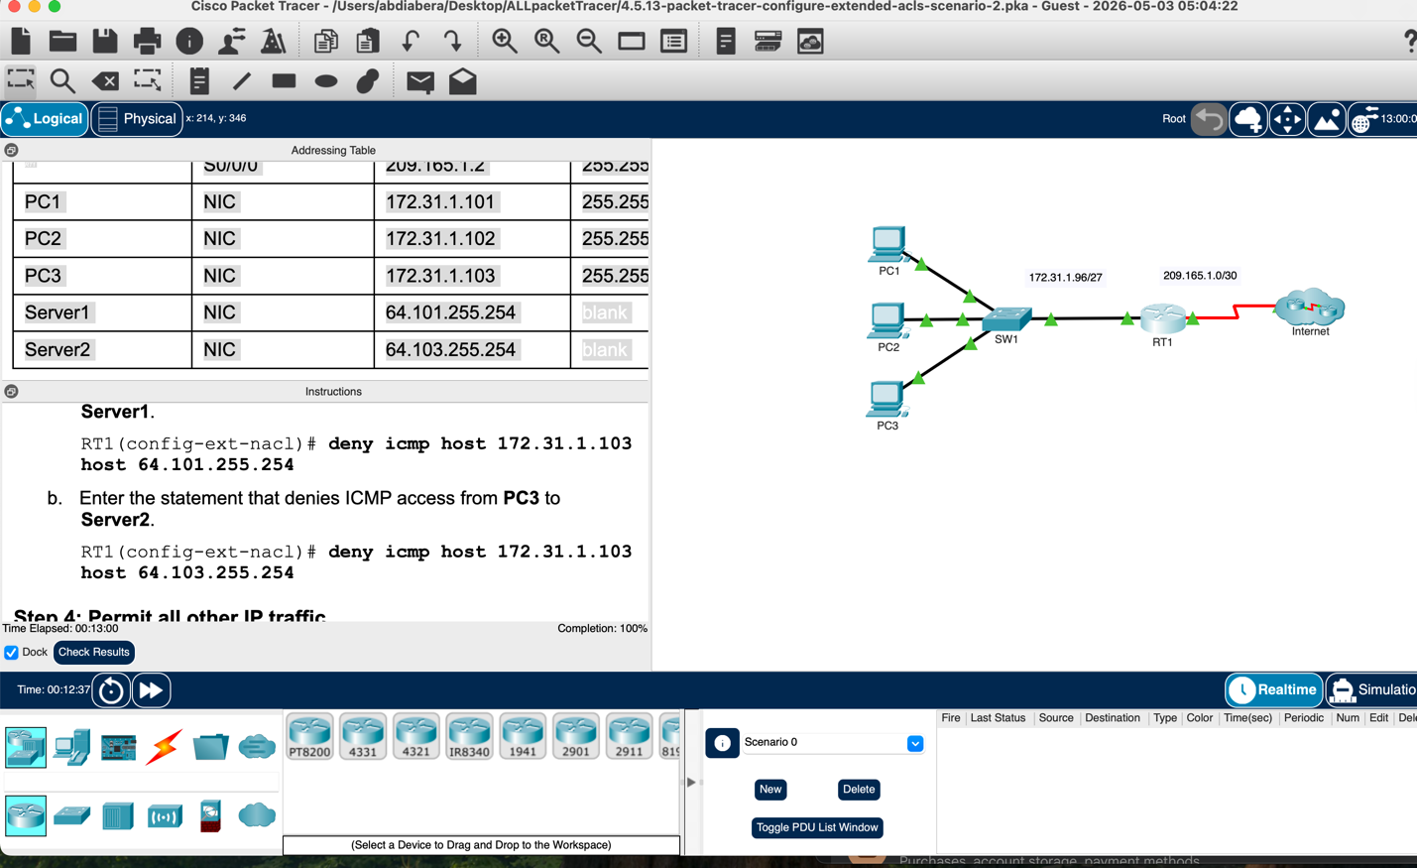
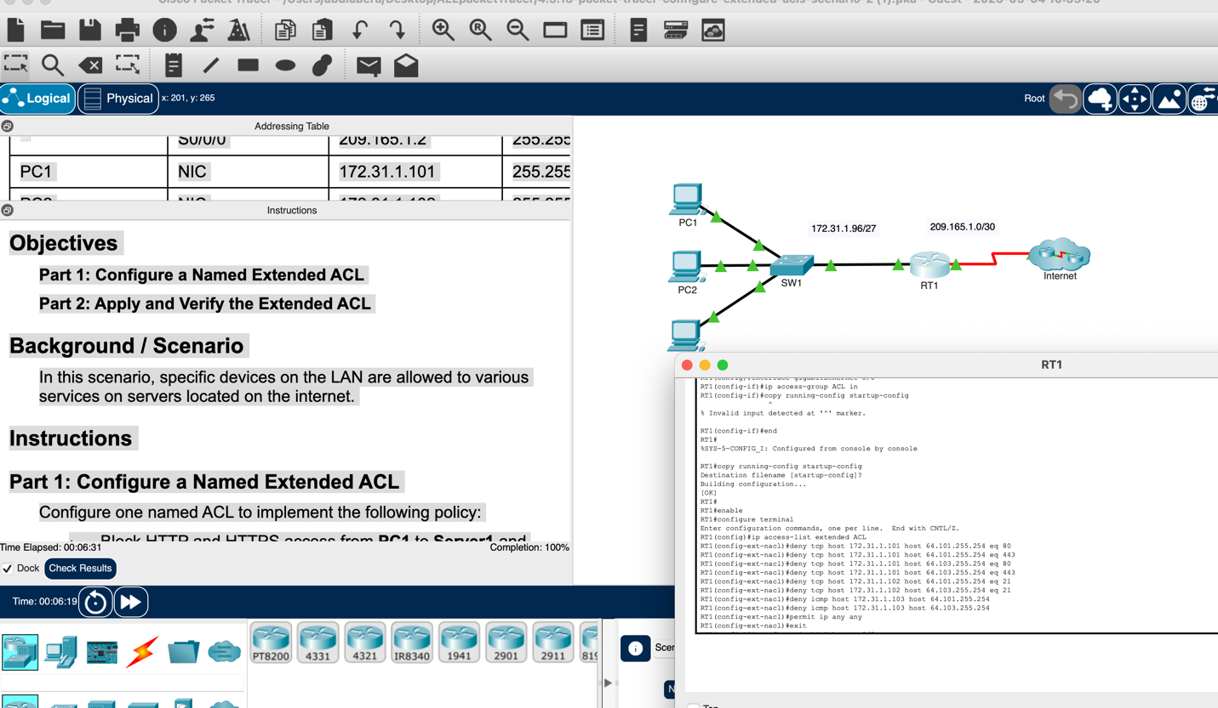
On which interface should the named ACL be applied, and in which direction?
Open configuration window
Enter the configuration commands to apply the ACL to the interface.
Ans:
ACl must be applied to Gig0/1 inbound direction

