Abdi Abera
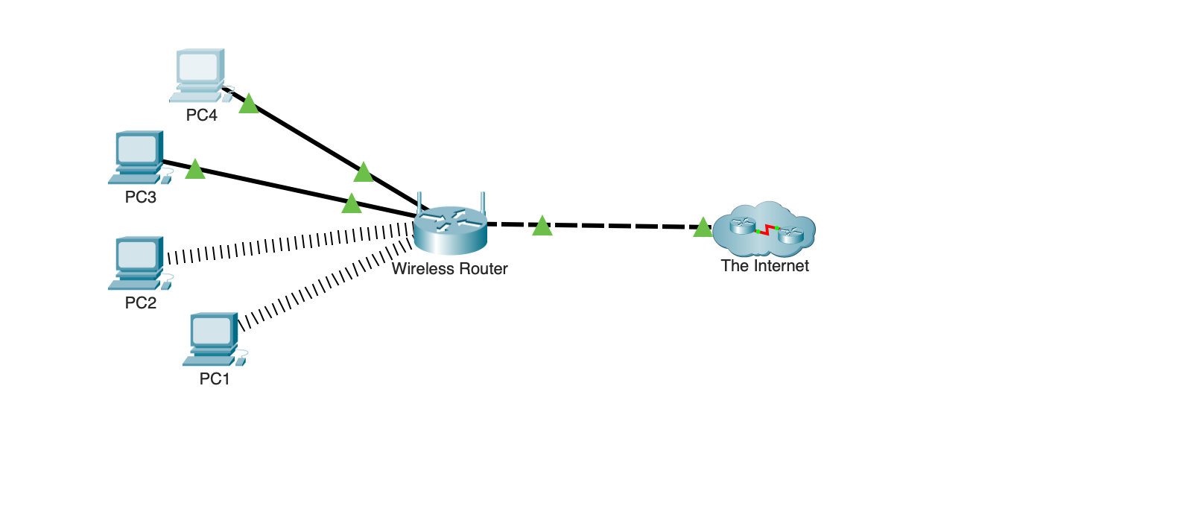

Part1. Which PCs are unable to connect to the web server?
Ans: Pc2 is not working
Part2.Did the ping return a reply? What is the IP address displayed in the reply, if any?
Ans: Pc2 is not pinging.
These pinging is working
Pc1 192.15.2.10
Pc3 192.15.2.10
Pc4 192.15.2.10
Part4. Did the ping return a reply?
Ans: Yes, all Ip reply

Do the two configurations match?
Ans:
Pc1 DNS Servers.....................: ::
192.15.2.5
Pc2 DNS Servers.....................: ::
191.15.2.5
Pc3 DNS Servers.....................: ::
192.15.2.5
Pc4 DNS Servers.....................: ::
192.15.2.5

Yes, each DNS configuration match.

