**Documentation Downloading and Installing Developer Environment**

1. Select Your Operating System (OS): Choose an operating system that best suits your preferences and project requirements. Download and Install Windows 11. <https://www.microsoft.com/software-download/windows11>

* Currently using Windows 10

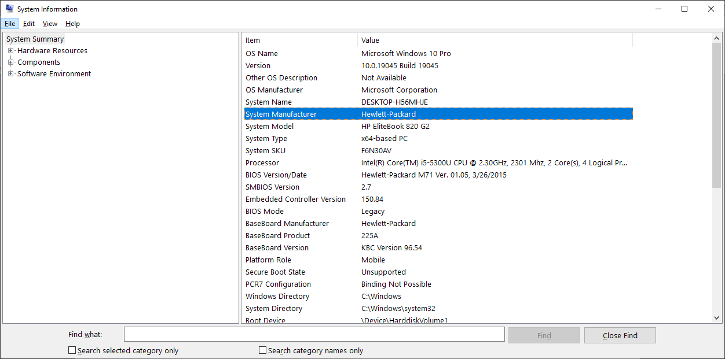

Install a Text Editor or Integrated Development Environment (IDE): Select and install a text editor or IDE suitable for your programming languages and workflow. Download and Install Visual Studio Code. <https://code.visualstudio.com/Download>

* Steps followed are:
* Open your preferred web browser and go to the official Visual Studio Code website: <https://code.visualstudio.com/>.
* On the homepage, click the download button that corresponds to your operating system (Windows, macOS, or Linux).
* Once the download is complete, locate the installer file in your Downloads folder and double-click it to start the installation process.
* Read through the license agreement, then click "I accept the agreement" and "Next" to proceed.
* Select the destination folder where you want to install VS Code, or use the default location. Click "Next."
* Choose any additional tasks you want to perform, such as creating a desktop icon or adding VS Code to your PATH for command line use. Click "Next."
* Click the "Install" button to begin the installation. The process will take a few minutes.
* Once the installation is complete, you can choose to launch Visual Studio Code immediately by checking the box that says "Launch Visual Studio Code" and clicking "Finish."
* When you open VS Code for the first time, you may be prompted to customize your setup. Follow the on-screen instructions to complete the initial setup.

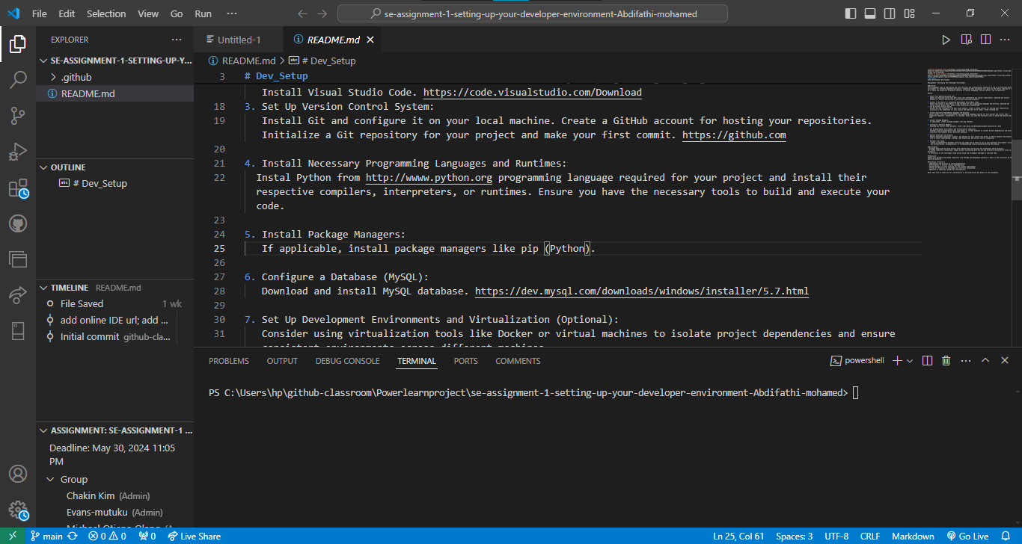

Attached is the screenshot of the Visual Studio Code I am currently using.

1. Set Up Version Control System: Install Git and configure it on your local machine. Create a GitHub account for hosting your repositories. Initialize a Git repository for your project and make your first commit. <https://github.com>

* Have install and configured.
* Attached is the screenshot of my git bash. I have connected my GitHub account
* The steps followed are:
* Go to the official Git website: <https://git-scm.com/>.
* Click on the "Download" button suitable for your operating system (Windows, macOS, or Linux).
* Once the download is complete, locate the installer file and double-click it to start the installation process.
* Click "Next" to begin the setup.
* Read through the license agreement, then click "Next" to accept.
* Choose the installation location and click "Next."
* Select the components you want to install and click "Next."
* Choose the default editor used by Git. (You can select your preferred text editor or leave it as the default.)
* Adjust the PATH environment. It's recommended to use Git from the command line and also from third-party software.
* Choose the HTTPS transport backend. The default option is typically fine.
* Configure the line ending conversions. (Choosing "Checkout Windows-style, commit Unix-style line endings" is common.)
* Select the terminal emulator to use with Git Bash. It's recommended to use the default MinTTY.
* Choose the default behavior for "git pull." The default option is typically fine.
* Select any additional options you prefer and click "Next."
* Click "Install" to begin the installation process.
* Once the installation is complete, click "Finish" to exit the setup wizard.

Set Up Git Configuration

* Open Git Bash from the Start menu or desktop shortcut.
* Configure Your Git Username and Email:
* In the Git Bash terminal, set your username and email with the following commands:

git config --global user.name "Your Name"

git config --global user.email "your.email@example.com"

* Connect to GitHub
* Clone a Repository:
* In Git Bash, you can now clone a repository using https:
* git clone git@github.com:username/repository.git
* Replace username with your GitHub username and repository with the name of the repository you want to clone.
* Verify the Connection:

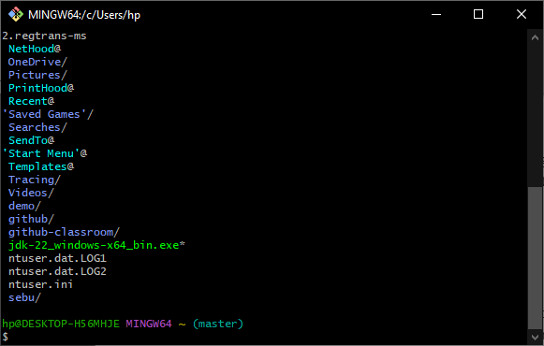

1. Install Necessary Programming Languages and Runtimes: Instal Python from http://wwww.python.org programming language required for your project and install their respective compilers, interpreters, or runtimes. Ensure you have the necessary tools to build and execute your code. Install Package Managers: If applicable, install package managers like pip (Python).

* Open your web browser and go to the official Python website: <https://www.python.org/>.
* On the homepage, hover over the "Downloads" tab and select the appropriate version for your operating system (Windows, macOS, or Linux). For most users, downloading the latest stable release is recommended.
* Once the download is complete, locate the installer file in your Downloads folder and double-click it to start the installation process.
* Select Installation Options:
* On the installer welcome screen, check the box that says "Add Python to PATH" at the bottom.
* Click the "Customize installation" button if you want to select specific components and installation options, otherwise, click "Install Now."
* Complete the Installation:
* The installer will install Python and any selected optional features. Once the installation is complete, click "Close."
* Verify the Installation
* Open a Terminal or Command Prompt:
* On Windows, you can open Command Prompt by pressing Win + R, typing cmd, and pressing Enter.
* Set Up a Virtual Environment (Optional)
* Create a Virtual Environment:
* Navigate to your project directory and create a virtual environment by running:

python -m venv myenv

* Replace myenv with the name you want to give your virtual environment.
* Activate the Virtual Environment:
* On Windows, activate the virtual environment with:

myenv\Scripts\activate

* When you are done working in the virtual environment, you can deactivate it by running:

deactivate

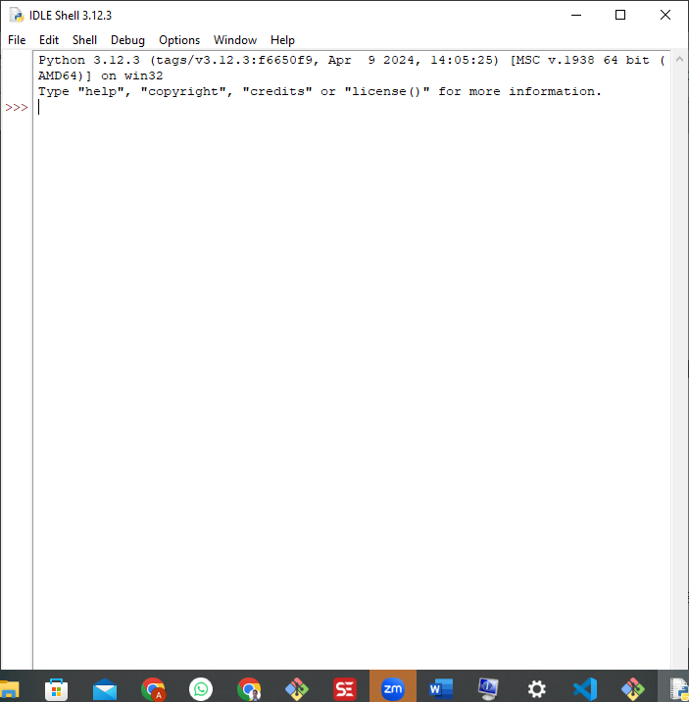

* 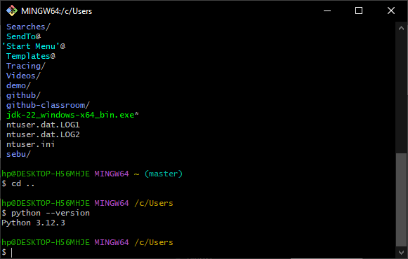

1. Configure a Database (MySQL): Download and install MySQL database. <https://dev.mysql.com/downloads/windows/installer/5.7.html>

* **Steps Followed**:
* Open your web browser and go to the official MySQL website: <https://dev.mysql.com/downloads/>.
* Select "MySQL Community (GPL) Downloads."
* Under "MySQL Community Server," click on "Download."
* Choose your operating system (Windows, macOS, or Linux) from the dropdown menu.
* Click on the download link for the installer that matches your operating system. For Windows, this is usually the "MySQL Installer for Windows." For macOS, this is typically a DMG file. For Linux, you might need to choose the appropriate package for your distribution.
* Once the download is complete, locate the installer file in your Downloads folder and double-click it to start the installation process.
* Select the setup type that best fits your needs. "Developer Default" is recommended for general use.
* The installer will check for any missing dependencies. Install any required software.
* Select the MySQL Server product and configure it. Choose the appropriate version and click "Next."
* Set up the server configuration. Select "Standalone MySQL Server" and click "Next."
* Configure the server. Choose the server type and networking options. Typically, the default options are sufficient.
* Set a strong root password for the MySQL server. Optionally, create a user account with limited privileges.
* Configure MySQL as a Windows Service. Check the box to "Start the MySQL Server at System Startup" and click "Next."
* Review the configuration settings and click "Execute" to apply the configuration and complete the installation.
* Once the installation is complete, click "Finish."

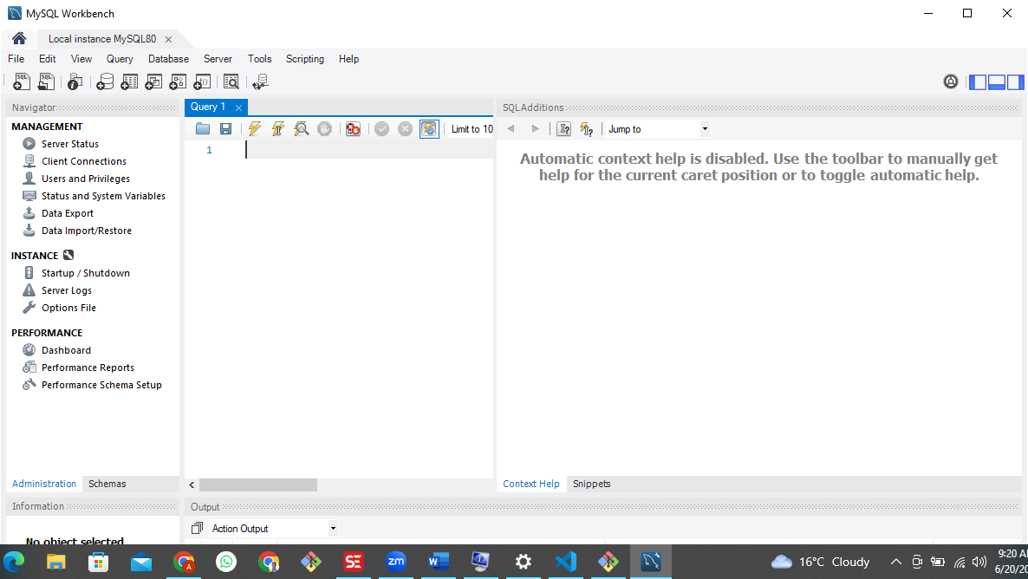

1. Set Up Development Environments and Virtualization (Optional): Consider using virtualization tools like Docker or virtual machines to isolate project dependencies and ensure consistent environments across different machines.
2. Explore Extensions and Plugins: Explore available extensions, plugins, and add-ons for your chosen text editor or IDE to enhance functionality, such as syntax highlighting, linting, code formatting, and version control integration.

* In Visual Studio Code, you can install variety of extensions for the languages that you need to work on.
* Steps followed
* Launch Visual Studio Code on your computer.
* **Access the Extensions View:**
* Click on the Extensions icon in the Activity Bar on the side of the window. It looks like a square icon with four squares inside it.
* Alternatively, you can use the keyboard shortcut

Ctrl+Shift+X (Windows/Linux) or

Cmd+Shift+X (macOS).

* **Browse Extensions:**
* The Extensions View shows a list of popular and recommended extensions.
* You can scroll through the list to see different extensions.
* **Search for Extensions:**
* Use the search bar at the top of the Extensions View to find specific extensions by name or keyword.
* For example, to install the Python extension, type "Python" in the search bar and press Enter.
* **Select an Extension:**
* Click on the extension you want to install from the search results or the list.
* This will open a detailed view of the extension, showing its description, features, and user reviews.
* **Install the Extension:**
* Click the "Install" button on the extension's details page.
* VS Code will download and install the extension automatically.
* **View Installed Extensions:**
* In the Extensions View, click on the "Installed" tab to see a list of all installed extensions.
* **Disable or Uninstall Extensions:**
* To disable an extension, click on the gear icon next to the extension's name and select "Disable."
* To uninstall an extension, click on the gear icon and select "Uninstall."
* **Update Extensions:**
* If an update is available for any installed extension, you will see an update button next to it. Click on the update button to install the latest version.
* I have installed the following extensions and attached is extension. Python, Dart, SQl.

