Chapter 4: Implementation

4.1 Introduction to Implementation
The implementation phase of this project followed a rigorous and structured approach to machine learning pipeline development, encompassing all stages from data collection through to model evaluation with model training and evaluation. Following the sequence described in Figure 4.8, this project consisted of nine sequential stages: Data Collection, Data Cleaning, Data Pre-processing, Feature Engineering, Data Splitting, Class Balancing by SMOTE, Feature Selection by RFE, Model Training and Testing, and Model Evaluation. This methodology-driven pipeline was designed to maximise the methodological rigour, ensure full reproducibility of results, and avoid data leakage throughout all the stages of our research.
As mentioned earlier, Python 3 programming language has been used for implementation purposes in conjunction with a Jupyter Notebook. All implemented algorithms rely on the following list of tools and libraries:
- Pandas for data loading, cleaning, renaming of columns, and constructing of composite features
- NumPy for numerical computations and efficient arrays
- Matplotlib and Seaborn for building data visualisations, including histograms, heatmaps, violin plots, scatter plots, ROC Curves, and confusion matrix
- Scikit-learn for data pre-processing using LabelEncoder and StandardScaler; data splitting using train_test_split; developing of logistic regression, decision tree, and random forest models; feature selection using RFE; grid search and cross-validation; and performance evaluation
- Imbalanced-learn for application of synthetic minority oversampling technique (SMOTE)
All models were trained using a fixed random seed of 42 to ensure full reproducibility of the results. In all the experiments conducted in the course of our research, we made sure to avoid data leakage—a fundamental methodological error consisting in feeding the testing dataset into the algorithm before model training, thus making its predictions biased and unreliable. Therefore, all the pre-processing steps, including standard scaling with StandardScaler and class balancing with SMOTE techniques, were applied exclusively to training dataset after splitting. The complete source code for this research has been published in a publicly available GitHub repository and can be found at: https://github.com/Abdihafid252/B01819449-Group27-Student-Performance-ML

4.2 Dataset Description
For this project, the dataset used was the Student Performance dataset sourced from Kaggle, an open-access data repository. This dataset includes various academic, demographic, behavioural features of 395 secondary school students of Portugal including their study habits, educational level of parents, alcohol consumption habits, absences in school, family relations, previous performance. The data was in semicolon-separated form (student-mat.csv), loaded into the Python environment via Pandas module with parameter sep=';'.

4.2.1 Column Names Update
Upon observation of the dataset, it was observed that all 33 columns had their name as abbreviation, which made the whole dataset less comprehensible in the pipeline. The features included grades G1, G2 and G3 representing first term, second term and overall grades respectively, medu and fedu indicating mothers' and fathers' education level respectively, Dalc and Walc showing weekday alcohol consumption and weekend alcohol consumption respectively. For the sake of making the dataset easily understandable and reproducible, 33 column names have been updated to make them more explanatory.

4.2.2 Dataset Analysis and Cleaning
After analyzing the dataset, it was discovered that there are no missing values in all 33 features in the data. Thus, imputation is unnecessary in this dataset. While conducting the data analysis, it was found that 38 student records showed zero score in the final grade. Such records are considered to be due to the fact that some students did not appear in the final exam rather than having scored zero marks. This is because many of these records contain scores other than zeros in first term (term1_grade) and second term (term2_grade) performance assessment. Including such records may bias the model performance. Thus, 38 such records are removed, and the cleaned dataset size is calculated as:
N_cleaned = N_original – N_removed = 395 - 38 = 357 students
To avoid such bias in model evaluation, stratified sampling technique has been applied during training/test data splits in order to preserve the proportionality of grade band classes. Stratified splitting procedure is represented in equation below:
N_train = N_cleaned × 0.80 = 357 × 0.80 = 285 students
N_test = N_cleaned × 0.20 = 357 × 0.20 = 72 students
Details about dataset characteristics after cleaning are provided in Table 4.1.
Table 4.1: Dataset overview summary following data cleaning
Dataset Characteristic | Details | Value
Original dataset size | Student records | 395
Records removed (zero final grade) | Absent from exam | 38
Final working dataset | Student records | 357
Original features (columns) | Total attributes | 33
Training set (80%) | Student records (pre-SMOTE) | 285
Test set (20%) | Student records (real, unseen) | 72
Missing values | Across all 33 features | 0

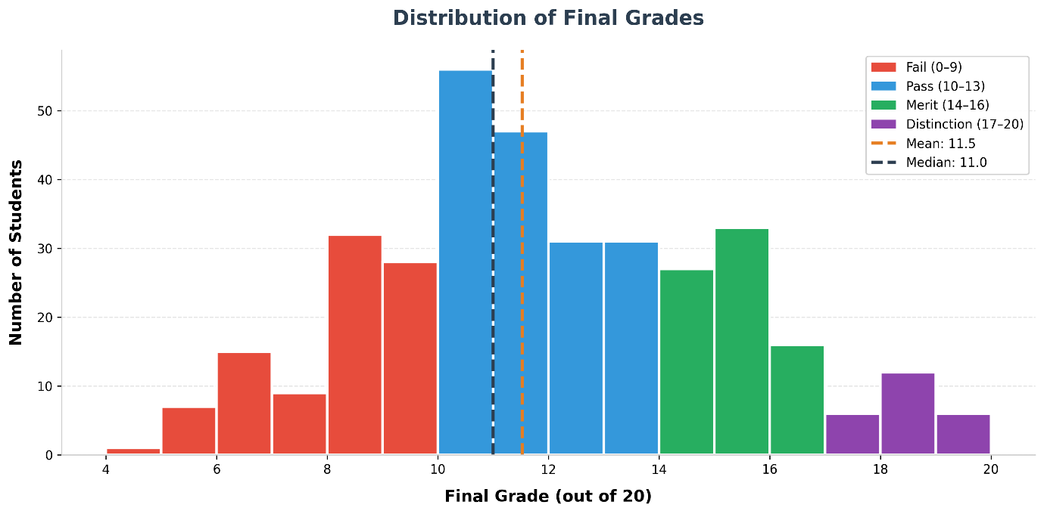
Figure 4.1: Distribution of final grades across the student dataset

4.2.3 Grade Band Classification
Finally, the original numerical grade band was converted into a categorical target variable allowing the use of supervised multi-class classification techniques. This makes the prediction problem a classification problem, as opposed to a regression problem, making it more meaningful to humans, especially since the output would be used in line with common UK Higher Education grading conventions, where performance is reported using categorical grade bands instead of a simple numerical score (Quality Assurance Agency, 2023).
The grade band distribution across the students can be found in Table 4.1 below. The results show that there is an unequal class distribution with the pass grade band being the most common, comprising 46.2% of the working dataset while the distinction grade band being the rarest comprising just 6.7%. Such a skew in class size poses the risk of classification bias and is formally addressed in section 4.5 using SMOTE.
Table 4.2: Grade band classification criteria and student distribution
Grade Band | Score Range | Students (n) | Percentage (%)
Fail | 0 – 9 | 92 | 25.8%
Pass | 10 – 13 | 165 | 46.2%
Merit | 14 – 16 | 76 | 21.3%
Distinction | 17 – 20 | 24 | 6.7%
Total | — | 357 | 100%

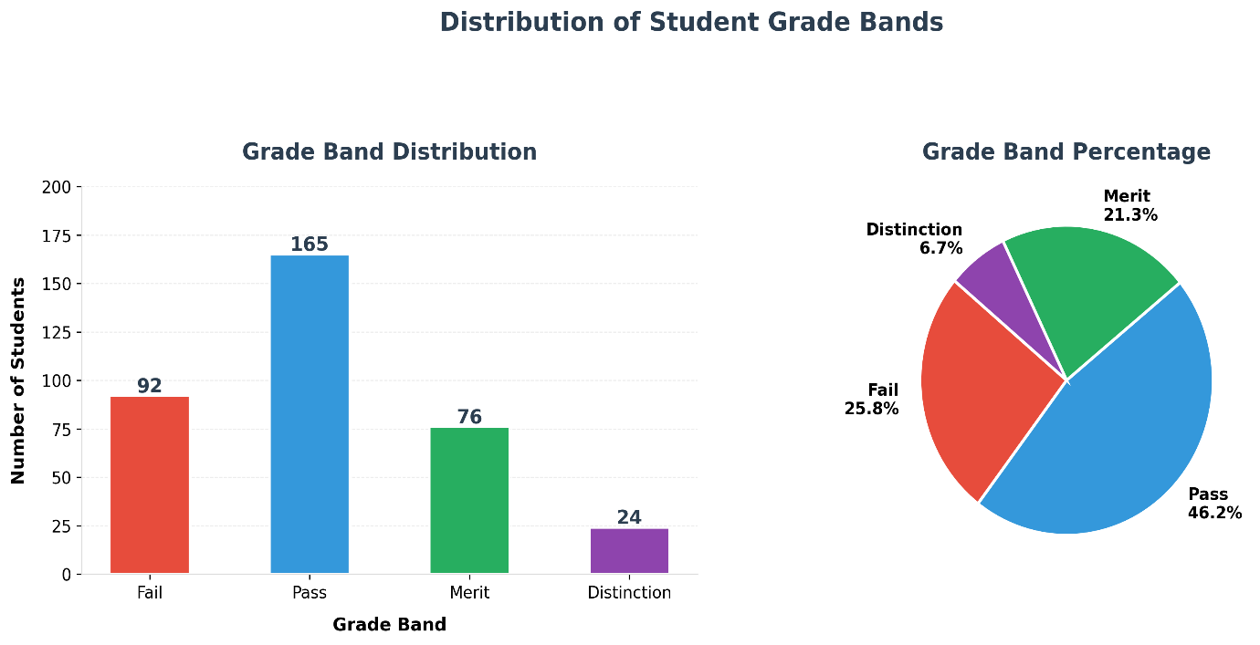
Figure 4.2 Distribution of students across grade bands by frequency and percentage

4.3 Data Pre-processing
A data processing procedure was undertaken subsequent to initial data inspection and cleaning as discussed in the previous section. This data pre-processing comprised three steps: label encoding of categorical features, standard scaling of numerical features, and finally, inter-feature correlation analysis. Each step was performed solely on the working dataset of 357 students and aimed at preparing all features for the machine learning classification models used in this project by ensuring that all features take numerical form.

4.3.1 Label Encoding
There were 17 categorical features in the dataset that took string values that had to be converted into numerical values before feeding the dataset to any machine learning algorithm. Examples include gender, school, parent jobs, choice of school, parent guardian, whether or not they attended nursery, internet access, further educational plans, extra-curricular activity participation. Machine learning algorithms cannot handle categorical string features, and hence, the conversion is a requirement. Scikit-learn's Label Encoder was used to transform categorical features. This encoder assigns a unique integer value to each category, e.g., gender will have a value of 0 or 1, F being coded as 0 and M as 1. Label encoding was carried out on binary and low cardinality nominal categorical features where the integer value does not imply any ordinal relationship between categories.

4.3.2 Standard Scaling
There were fifteen numerical features determined as suitable for standardisation prior to the training process. These features are represented by age, education levels of mother and father, travel time to school, number of hours spent studying per week, number of past failures, quality of family relationship, leisure time, frequency of going out with friends, alcohol consumption during weekdays and weekends, current health status, number of school absences, and grades in Terms 1 and 2. Standardisation was executed through the use of the Scikit-learn StandardScaler, where each feature undergoes a transformation to obtain the mean equal to zero and the standard deviation equal to one:
z = (x - mu) / sigma

Here, x represents an initial feature value, mu – the feature mean calculated from the training sample, and sigma is the feature standard deviation computed on the training sample. The main advantage of this transformation lies in the fact that all features get equal importance in the training process, with no feature being dominated due to a relatively large value range. Such transformations are crucial for logistic regression models, which can be affected by the relative size of input features. Importantly, the StandardScaler was fitted only on the training sample and then used to scale the testing sample, ensuring no information leakage from the latter into the former.

4.3.3 Exploratory Data Analysis (EDA) and Correlation Analysis
Within the EDA stage, a complete visual and statistical inspection of the selected dataset was carried out before proceeding with modelling. This included grade distribution analysis, correlation analysis between selected features, and relationship analysis between behavioural factors and academic performance.
After completing encoding and scaling of the data, a correlation analysis using the Pearson coefficient was performed between twelve essential features in order to evaluate potential relationships and important predictors of final grade. Results of this correlation analysis are summarised in Figure 4.3. Term 1 and Term 2 grades showed the largest positive correlations with the final grade, with the correlation coefficient above 0.80, implying that previous academic performance is the best indicator of future results. Past failures were negatively correlated with the final grade, while school absences showed moderately negative correlation. Hours of weekly study correlated positively with the final grade, while variables representing frequency of alcohol consumption had weak negative correlation.
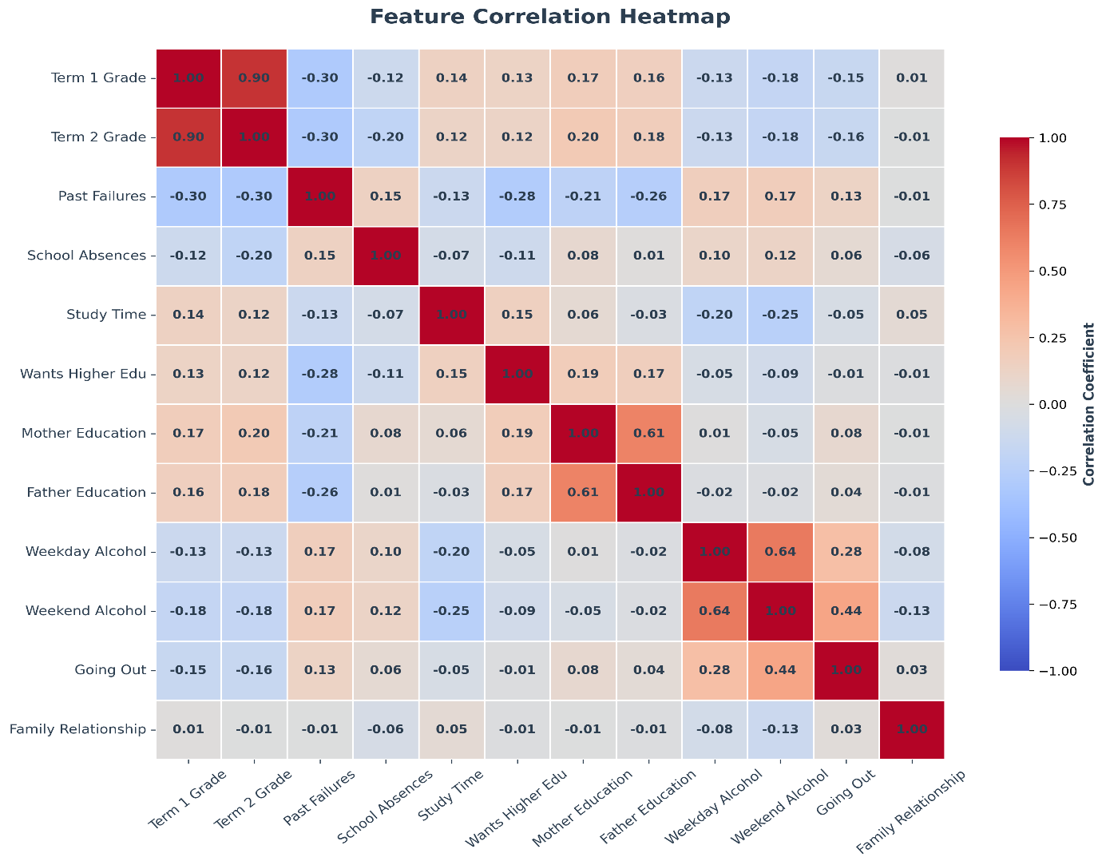
Figure 4.3: Pearson correlation heat map across twelve key features

4.4 Feature Engineering
To enhance the predictive power of the dataset with respect to complex patterns that single variable would be unable to capture adequately, six composite features were constructed out of already existing variables. Construction of composite features is one of the most common approaches in educational data mining, since this allows learning higher order relationships between correlated variables (Romero and Ventura, 2010). Every created feature had its own academic rationale, grounded in the results obtained through the analysis of correlations done in section 4.3 and the insights gained by reviewing faculty opinion on predictors of students' academic performance. A comprehensive list of the created features with the descriptions of their computation formulae and rationale is provided in table 4.3 below
Table 4.3: Summary of engineered features, construction formulas, and academic rationale
Feature Name | Formula | Rationale
alcohol_total | weekday_alcohol + weekend_alcohol | Captures total weekly alcohol consumption as a combined behavioural risk indicator
parent_edu_avg | (mother_edu + father_edu) / 2 | Represents overall parental academic background, a recognised predictor of student outcomes
grade progress | term2_grade - term1_grade | Measures academic improvement or decline between first and second term assessments
social_risk | going_out + weekday_alcohol + weekend_alcohol | Composite social distraction score combining multiple lifestyle risk factors
study_focus | weekly_study_time - going_out | Balance between academic commitment and social activities
risk_score | past_failures x school_absences | Combined academic and attendance risk indicator, capturing compounded disadvantage

Engineered features' effectiveness can be further proved through additional visual explorations shown in Figures 4.4 and 4.5. As it can be seen from Figure 4.4, students with zero prior academic failures attained an average grade of 11.9, while students with three or more failures scored an average grade of 8.3. Thus, the risk score predictor, which considers previous academic failures and amount of school absences, appears to be one of the strong predictors of student academic underperformance. Furthermore, as seen from Figure 4.5, students spending over ten hours per week studying independently had higher final grade scores than those spending less time on studying. Therefore, the study focus predictor is a good quantitative measure of academic engagement.

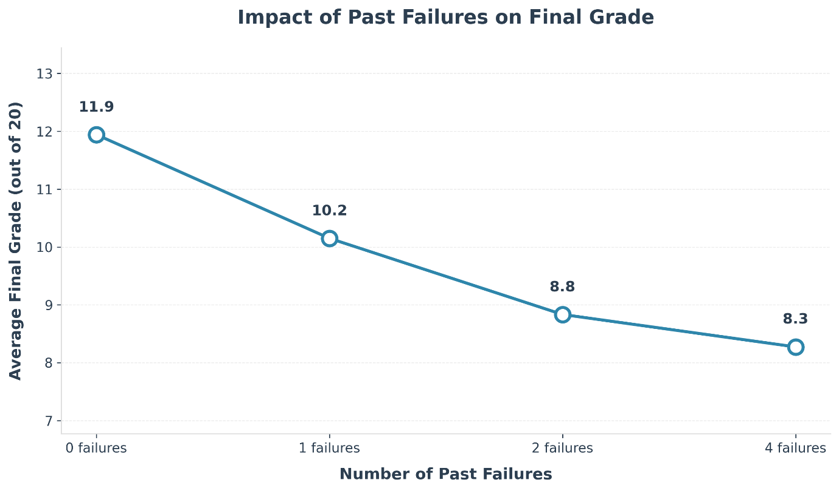
Figure 4.4: Relationship between number of past academic failures and mean final grade

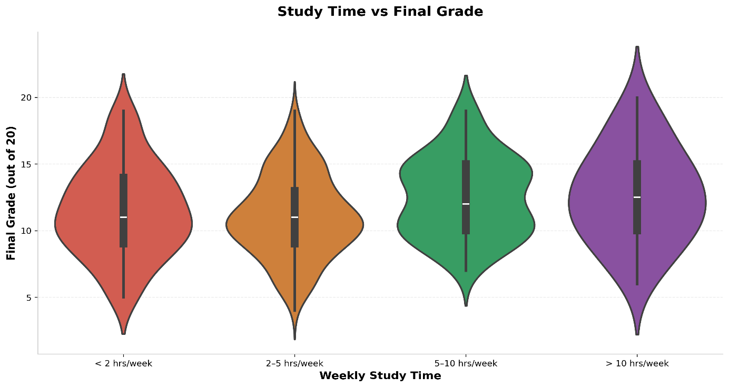
Figure 4.5: Distribution of final grades by weekly study time category

4.5 Handling Class Imbalance — SMOTE
As described in section 4.2.3, class imbalance appeared to be one of the most significant problems. Classifiers trained on imbalanced data tend to perform well in terms of overall accuracy by correctly predicting majority classes but poorly in terms of minority classes' predictions, which usually are of highest interest to researchers. In order to evaluate the severity of class imbalance, imbalance ratio was computed based on the following formula:
Imbalance Ratio = n_majority / n_minority = 165 / 24 = 6.875:1
Therefore, there was an imbalance of 6.875:1 between the classes "Pass" and "Distinction". The obtained imbalance required application of oversampling techniques to create a balanced training set before applying classification algorithms. One of the most popular and effective oversampling methods is Synthetic Minority Over-Sampling Technique (SMOTE). It creates synthetic samples belonging to minority classes through linear interpolation between real cases from the feature space.
It is important to note that before implementing any form of augmentation on the data, a stratified split between the training set and the test set is performed, which ensures that there is no data leak. In other words, the test data will only include the original dataset and not any synthetically generated data through SMOTE. The majority class, which in this case is Pass (n = 132 after stratified split), will be used as the basis for comparing all other minority classes. All minority classes will have the same number of samples as the majority, and therefore the total number of samples for the training data after applying SMOTE is:

Total samples after SMOTE = N_Majority_train x number of classes
Total samples after SMOTE = 132 x 4 = 528 students

The partitioning of data into train and test sets, in a formal sense, can be presented as:
N_train (pre-SMOTE) = 357 x 0.80 = 285 samples
N_test (unchanged) = 357 x 0.20 = 72 samples (real data only)
Per class in test = 72 / 4 = 18 samples per grade band
Figure 4.6 demonstrates the effectiveness of SMOTE in achieving an ideal balance of data within the training set where each of the four classes in the training set has an equal number of samples. It will ensure that models trained on this dataset do not become biased to the majority class (Mduma, 2023).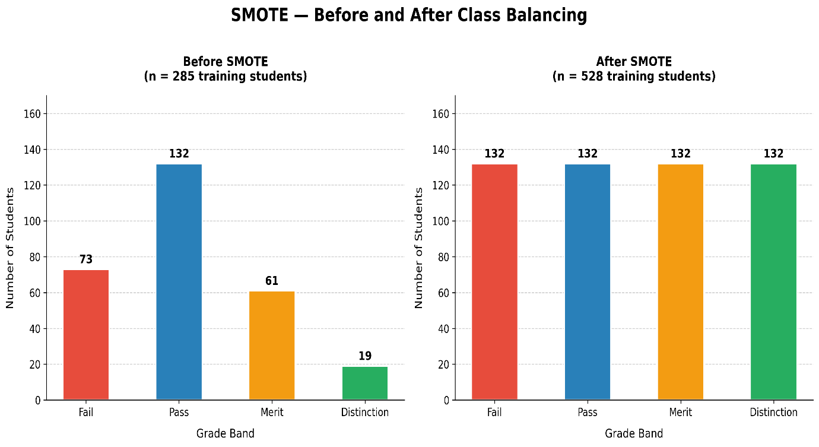
Figure 4.6: Class distribution in the training set before and after SMOTE

4.6 Feature Selection — Recursive Feature Elimination (RFE)
After SMOTE sampling was completed, Recursive Feature Elimination (RFE) was performed with a Random Forest estimator, selecting the best subset of features to be used in classification. RFE is a feature selection wrapper algorithm that progressively eliminates unimportant features while repeatedly training a model, ultimately selecting the optimal feature subset to use (Guyon and Elisseeff, 2003). This results in a more simplified model, helps prevent model overfitting, and improves generalisation to future observations by reducing dimensionality through the removal of redundant and less important variables.
After applying the feature engineering process, the number of available features was 38. Using RFE, this was reduced to the top 15 predictor variables, resulting in:
Feature reduction = ((38 - 15) / 38) x 100 = 60.5% dimensionality reduction

Table 4.4 shows the complete list of the 15 RFE-selected features. Interestingly, the 15 predictors include not only the originally provided features such as past failures, school absences, and term grades, but also several newly engineered composite features mentioned in Section 4.4, including grade progression, social risk, study focus, and risk score. It is evident that this is a strong validation of the engineered features, suggesting that they hold significant information value in terms of prediction.
Table 4.4: Features selected by Recursive Feature Elimination (RFE) from 38 total features
No. | Selected Feature | No. | Selected Feature
1 | age | 9 | term2_grade
2 | mother_education | 10 | alcohol_total
3 | weekly_study_time | 11 | parent_edu_avg
4 | past_failures | 12 | grade_progress
5 | family_relationship_quality | 13 | social_risk
6 | current_health_status | 14 | study_focus
7 | school_absences | 15 | risk_score
8 | term1_grade

According to Figure 4.7, the Term 2 Grade turned out to be the only most important feature (with the weight of 0.328), followed by Term 1 Grade (weight 0.258) and Grade Progress (0.074). The first two findings can be justified by existing educational literature, which states that the best prediction results are provided by students' academic achievements from the previous course (Cortez and Silva, 2008). At the same time, the importance of the third feature also proves that a person's academic trajectory (whether they improve or decline from one term to another) also serves as the factor to predict their success.

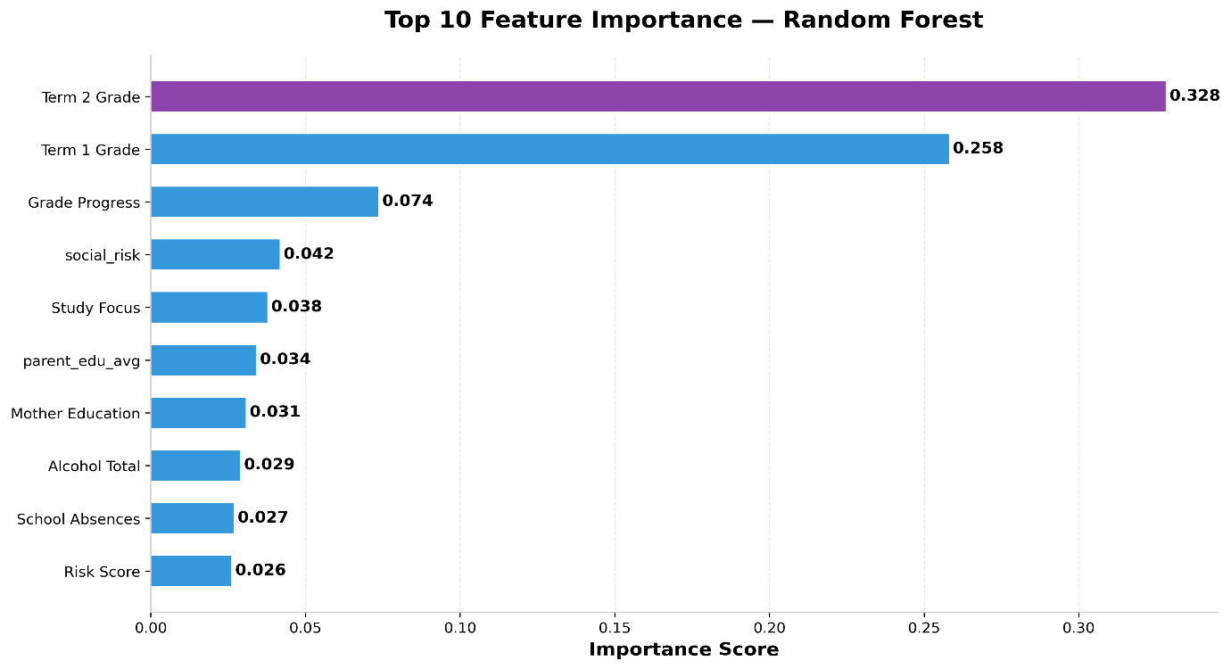
Figure 4.7: Top 10 features importance scores following RFE-based Feature selection

4.7 Model Selection and Training
Three supervised machine learning classifiers were used for this study to provide a comprehensive comparison of different types of algorithms and their performance in classification tasks. Such an approach allows for making a more detailed analysis compared to using a single algorithm, and it is in line with the requirements formulated in the project specification.

4.7.1 Logistic Regression
This linear classification algorithm was chosen as the baseline model for this study. Although it cannot compete in accuracy with ensemble classifiers, Logistic Regression provides an easily understandable interpretation of coefficients for individual predictors and their probabilities and thus can serve as the standard for comparing with more advanced models. In general, Logistic Regression is useful when there is a nearly linear decision boundary between classes, which explains its frequent use in educational research (Agyemang et al., 2024). For this project, Logistic Regression was set up to have maximum 5,000 iterations, and the random state parameter was set to 42.

4.7.2 Decision Tree
This classifier was chosen for the sake of its interpretability and straightforward explanation of predictions. Decision Tree outputs the classification rules in the form of a hierarchy, which does not require special machine learning skills to be interpreted. These properties make Decision Tree useful in applications where institutional stakeholders, such as university employees, need to understand the model's decisions. In Decision Tree, the algorithm divides the feature space into hierarchical decision rules, choosing the most informative features at each level based on the Gini impurity criterion. To prevent overfitting to training data, feature selection was performed using Recursive Feature Elimination.

4.7.3 Random Forest
A random forest was chosen as the primary classification algorithm in the study because by using bootstrap sampling techniques, this algorithm trains an ensemble of decision trees. As a result, overfitting is minimized, leading to greater accuracy of the model when compared to a single decision tree. Due to its ability to aggregate many weak learners, a random forest demonstrates resilience to outliers, high variance and non-linearity between variables that can be found in educational datasets (Gul et al., 2025). In this particular case, 100 estimators (n_estimators=100) and a static random state of 42 were used. All three classifiers were trained using the SMOTE-balanced, RFE-filtered training dataset containing 528 students' records.
Figure 4.8 shows the diagram illustrating the implemented machine learning pipeline.
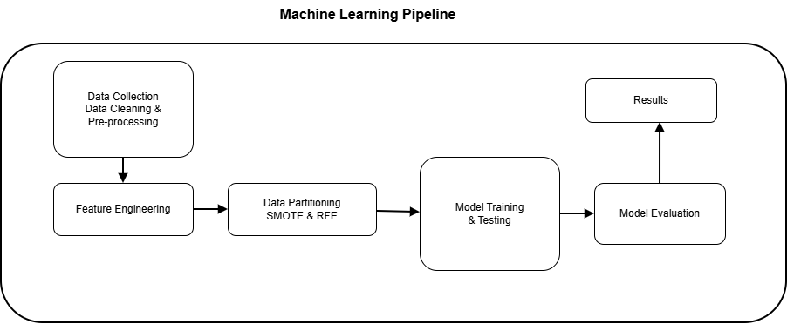
Figure 4.8: Proposed machine learning implementation pipeline for student grade prediction

4.8 Model Performance Comparison
The comparison table between the three models in terms of the five key performance metrics is presented in Table 4.5 below. As can be seen, the values of all metrics were calculated through the use of Scikit-learn metrics library in relation to the test data (consisting of 72 students). For multi-class precision, recall and F1-score metrics, the weighted average was taken into account due to different class numbers in the test set.
Table 4.5: Complete model performance comparison on unseen test set (n = 72)
Model | Accuracy | F1-Score | Precision | Recall | CV Score
Random Forest | 86.11% | 86.02% | 87.33% | 86.11% | 91.69%
Logistic Regression | 81.94% | 81.96% | 82.28% | 81.94% | 90.16%
Decision Tree | 76.39% | 76.50% | 77.81% | 76.39% | 87.90%
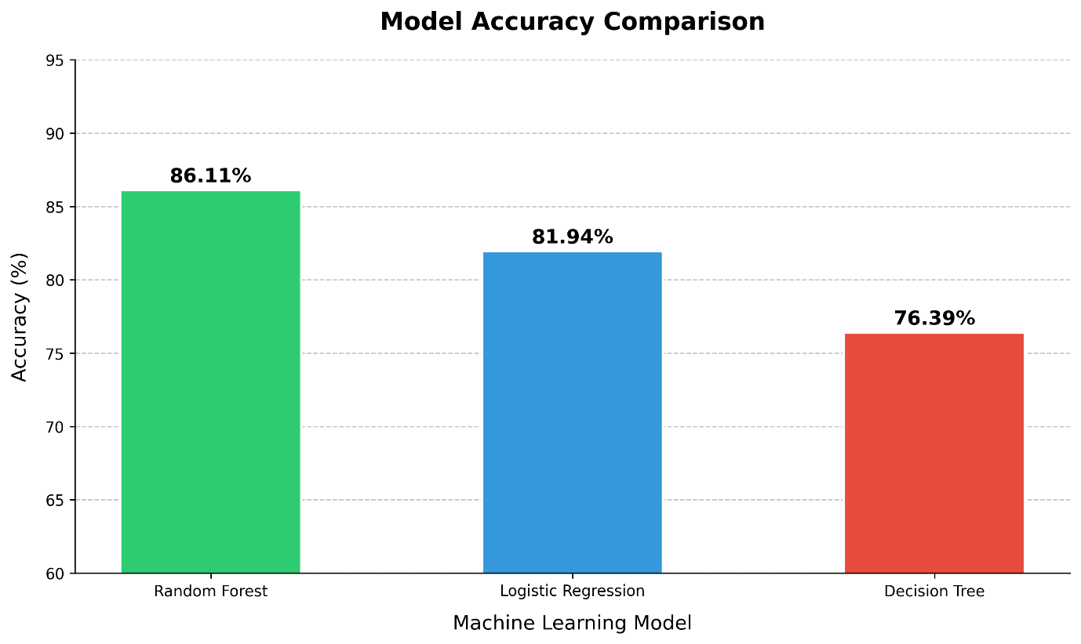
Figure 4.9: Model accuracy comparison across all three machine learning classifiers

It can be stated based on Table 4.5 and Figure 4.9 above that the Random Forest algorithm had superior results in terms of all performance metrics under consideration, demonstrating a high test accuracy of 86.11% and a relatively high cross-validation score (91.69%). The difference between the two values confirms the absence of any signs of overfitting for the proposed model which means that SMOTE-based class balancing and RFE-based feature selection pipeline worked properly. Moreover, Logistic Regression was a good choice as a linear baseline classifier with a relatively high test accuracy of 81.94% whereas the test accuracy rate for Decision Tree Classifier made only 76.39%.

4.9 Exploratory Findings
Alongside the analysis results for the three models' performances, the exploratory analysis results performed during the implementation phase highlighted various interesting trends in the student performance data.
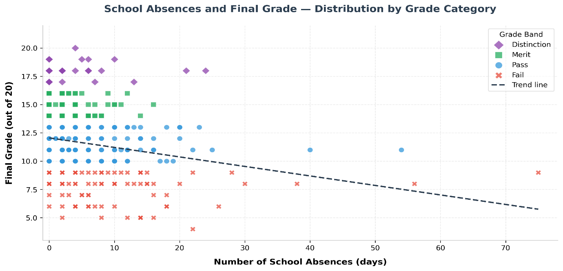
Figure 4.10: Relationship between school absence and final grade

As depicted in Figure 4.10, the total number of absences at school is positively associated with the overall grade level: the number of students who did not attend school was the lowest among students achieving the Distinction and Merit grades, while it was the highest among students in the Fail grade band. This trend is confirmed by the feature importance plot depicting the high importance of the number of absences on the overall grade level (Figure 4.7).

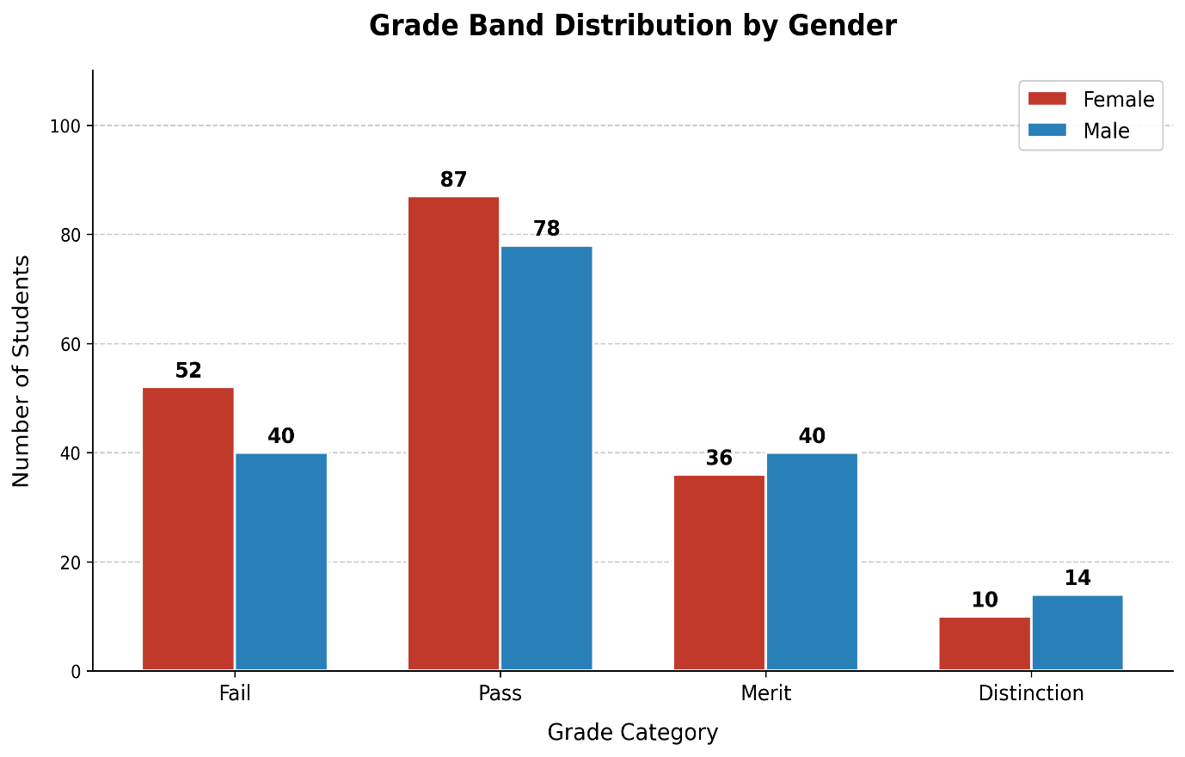
Figure 4.11: Grade bands distribution by gender

4.10 Comparison with Published Literature
In order to provide context to the findings obtained from this study in relation to the broader field of educational data mining, Table 4.6 provides a comparison of accuracy achieved by the Random Forest model in this study with comparable accuracy values derived from two other recently published peer-reviewed articles using the same Kaggle source educational datasets.
Table 4.6: Comparison of model accuracy against published literature
Study | Dataset | Models Used | Best Accuracy
Gul et al. (2025) | Kaggle (1,000 students) | RF, DT, CatBoost | 87.46% (CatBoost)
Agyemang et al. (2024) | Kaggle xAPI (480 students) | LR, RF, DT, SVM, KNN | 85.42% (RF)
This study (B01819449, Group 27, 2026) | Kaggle (395 students) | LR, DT, RF + SMOTE + RFE + 10-fold CV | 86.11% (RF)

As seen from the findings shown in Table 4.6 above, the accuracy of 86.11% obtained in this study using Random Forest model is comparable with that of Gul et al. (2025), at 87.46%, who employed a large dataset of 1,000 students with CatBoost algorithm. Also, it is significantly better than the accuracy achieved by Agyemang et al. (2024), at 85.42%, who used a dataset of 480 students with Random Forest. Significantly, the present study used a relatively small original dataset of 395 students, producing 357 students in the working dataset following the deletion of 38 zero grade students. This indicates the efficiency of class balancing and feature selection using SMOTE and RFE, respectively, to achieve high prediction accuracy. Also noteworthy is the fact that in the current study, data leakage was avoided by performing SMOTE balancing after train and validation splits, making sure that the final accuracy value obtained is an accurate estimate of performance on real student records.

4.11 Summary of Implementation
In conclusion, the application of machine learning classification techniques has proven to be an efficient approach in predicting the student's academic performance based on demographic and behavioral attributes. Out of the three models employed in this study, the Random Forest classifier showed superior performance in terms of the prediction accuracy, recording 86.11% test accuracy and 91.69% accuracy after cross-validation, confirming the effectiveness of this approach. Furthermore, the newly created composite variables such as grade_progress, social_risk, and risk_score were established to be significant predictors in the classification process after applying recursive feature elimination, justifying the feature engineering methods applied as explained in Section 4.4. The application of SMOTE only in the training set after stratification proved to be an effective technique in addressing the class imbalance issue in this data set resulting in increased classification accuracy for all the four grades and especially for the Distinction minority category.

Appendix A: Individual Critical Reflection

Name: Abdihafid Hilowle Hassan |Banner Id: B01819449

1. Introduction
As the individual contributor tasked with overseeing the implementation aspect of Group 27, I was responsible for managing the entire process of machine learning. This includes the selection of Student Performance Dataset from Kaggle; cleaning and preprocessing of the data; creating features; class balancing using the Synthetic Minority Oversampling Technique; dimensionality reduction using Recursive Feature Elimination (RFE); developing and training of three supervised machine learning models: logistic regression, decision tree, and random forest; producing twelve data visualizations; hyperparameter optimization using GridSearchCV and tenfold cross-validation; and project management including the creation of the project GitHub repository where the entire implementation is documented as Jupyter Notebook, the original student performance dataset, and the clean pre-processed dataset. The aim of this chapter is to provide a comprehensive evaluation of my individual performance throughout the fifteen-week research period by evaluating the strengths and accomplishments, challenges faced, skills gained, and reflections on alternative methodologies used for time management during this project.

2. Strengths and Achievements
In terms of the implementation component of my work, I have shown the most confidence and delivered outcomes for which I can claim pride. First of all, I created the entire end-to-end pipeline of a machine learning process in Python, including loading and pre-processing data, training, optimizing and evaluating classifiers' performance. All three models worked properly, gave meaningful outputs, and were evaluated on the basis of a wide variety of metrics, such as accuracy, F1-score, precision, recall, cross-validation score, confusion matrix, and ROC curve.
Furthermore, I can take pride in the appropriate use of SMOTE-after-splitting strategy. As a result of a thorough investigation of the problems of potential data leakage, it became evident that applying SMOTE to the whole dataset before splitting will lead to an incorrect evaluation because model's results would appear inflated. That is why the application of the technique only to the train part of the dataset made it possible to ensure that only true data points remained in the test partition.
Finally, one can consider feature engineering as yet another significant contribution. In contrast to arbitrary creation of any number of features, the decision of constructing six composite features, namely grade_progress, social_risk, and risk_score, appeared quite justified since it was grounded on literature review and correlation analysis. The verification of the feature engineering process based on selecting features using RFE showed that all six of these variables were chosen among the top 15 predictors.

3. Challenges and Limitations Encountered
The first issue that arose during implementation referred to a misunderstanding of how SMOTE should have been implemented correctly. First, I implemented SMOTE before splitting into training and test datasets, which resulted in data leakage and artificially high accuracy. After reflecting on the problem and studying proper ML pipeline development techniques, I understood that this was the wrong approach and that SMOTE needs to be implemented after the split. This change decreased the results of the models from roughly 93% to 86%. However, those results are legitimate and reproducible, which makes them scientifically sound. Learning about such a mistake was highly beneficial for me.
The other technical issue that needed to be addressed related to Jupyter Notebook environment. At first, I had multiple problems with executing cells from top to bottom after restarting a kernel because some cells were duplicates, had fixed accuracy values hardcoded or did not import necessary metrics properly. It took me some time to debug and optimize my notebook accordingly.
The last difficulty I faced during the project was poor time management. Because of it, I spent significantly more time than expected on implementation and less on report writing. It affected my grades adversely; however, it was the case of trade-off, and it is further analyzed in Section 6.

4. Skills and Competencies Developed
This project helped me acquire several competencies in different spheres. First, on the technical side, I improved my programming abilities in general and specifically in using Python libraries (scikit-learn, pandas, seaborn, matplotlib) to implement Machine Learning algorithms and analyze educational datasets. Moreover, I got better at applying SMOTE and Randomized Search for hyperparameter optimization.
On the topic of algorithms, the project deepened my understanding of Supervised Classification algorithms, as I gained knowledge about the theory of such models as Logistic Regression, Decision Tree, and Random Forest as well as about how they can be applied in practice to educational data.
In addition, during this project, I became more competent at creating machine learning pipelines with an emphasis on preventing data leakage, implementing SMOTE, and conducting stratified cross-validation. As a bonus, the skills learned go beyond introductory machine learning, and I would be able to utilize them professionally in the future.
Academically, this project helped me get better at conducting a literature review and using published works analytically. Moreover, I managed to improve my writing skills and write academically formally and comprehensively.

5. Reflections and Recommendations
Looking back over the course of the project as a whole, I would make a number of changes to how certain stages were handled if repeating the project process. Firstly, I would devote more time to the initial design and planning stages, including the development of an extensive technical specification of the whole machine learning pipeline, with correct SMOTE implementation, prior to starting coding. This would save me a lot of time having to re-plan the whole notebook at the later stage of the development process.
Secondly, I would aim to find either a publicly-available or proprietary dataset containing information about student performance in the UK HE context, as opposed to using only the Portuguese secondary school dataset available on Kaggle. While the latter dataset was sufficient for developing the necessary methodology, a dataset based on the UK context would be better at providing context-relevant results and increasing the generalisability of the findings.
Finally, I would consider other algorithmic solutions besides logistic regression, especially gradient boosting approaches like XGBoost or CatBoost which have shown their efficiency in similar educational data mining studies (Gul et al., 2025). These algorithms could be used to compare against and provide a more thorough benchmark for the predictive efficiency achieved in my own project.

6. Project Planning and Time Management
Generally speaking, I followed the 15-week work plan specified in the project documentation reasonably well. Specifically, I managed to complete literature review and dataset identification in Weeks 1 and 2; data pre-processing and exploratory analysis in Weeks 3 and 4; model development and training in Weeks 5 through 10, as initially planned. The biggest difference occurred during the implementation of model development phase, when I spent extra time on identifying and correcting the problem of data leakage in SMOTE. This reduced the amount of time available to write the report in the last four weeks.
To avoid this kind of problem in the future, I would ensure that extra time is left after each implementation phase to deal with any problems that may arise, and start writing the reports at the same time as implementing the model.

7. Conclusion
Generally, I am happy with the work done in this MSc project, as it is both of high quality and complete. It adheres to sound methodology principles, is technically sound, and yields honest and reproducible results that can compete with benchmark results from scientific literature on educational data mining. The write-up demonstrates true interest in the research problem under consideration, a critically justified approach to methodology, and honesty about the limitations of the study. Overall, it has been a difficult yet truly enjoyable project, which greatly enhanced my data analysis and research skills.
Reference list
Agyemang, E.F., Mensah, J.A., Ampomah, O., Agyekum, L., Akuoko-Frimpong, J., Quansah, A. and Akinlosotu, O.M. (2024). Predicting Students' Academic Performance Via Machine Learning Algorithms: An Empirical Review and Practical Application. Computer Engineering and Intelligent Systems, 15(1), p.86. doi: https://doi.org/10.7176/ceis/15-1-09.
Chawla, N.V., Bowyer, K.W., Hall, L.O. and Kegelmeyer, W.P. (2002). SMOTE: Synthetic Minority Over-sampling Technique. Journal of Artificial Intelligence Research, 16(16), pp.321–357. doi:https://doi.org/10.1613/jair.953.
Cortez, P. and Silva, A. (2008). Using Data Mining to Predict Secondary School Student Performance. Proceedings of 5th Annual Future Business Technology Conference, pp.5–12.
Gul, M.N., Abbasi, W., Babar, M.Z., Abeer Aljohani and Arif, M. (2025). Data driven decisions in education using a comprehensive machine learning framework for student performance prediction. Discover Computing, 28(1). doi:https://doi.org/10.1007/s10791-025-09585-3.
Guyon, I. and Elisseeff, A. (2003). An Introduction to Variable and Feature Selection. Journal of Machine Learning Research, 3, pp.1157–1182.
Mduma, N. (2023). Data Balancing Techniques for Predicting Student Dropout Using Machine Learning. Data, 8(3), p.49. doi:https://doi.org/10.3390/data8030049.
Quality Assurance Agency (2023). The framework for higher education qualifications in England, Wales and Northern Ireland. Gloucester: QAA. Available at: https://www.qaa.ac.uk [Accessed Apr. 19 2026].
Romero, C. and Ventura, S. (2010). Educational Data Mining: A Review of the State of the Art. IEEE Transactions on Systems, Man, and Cybernetics, Part C (Applications and Reviews), 40(6), pp.601–618. doi:https://doi.org/10.1109/tsmcc.2010.2053532.

