A Cognate-Aware Multilingual Embedding Framework for Turkic Languages Integrating Morphological and Historical Linguistic Knowledge

Abdilatif R. Meyliyev¹*, Farrukh X. Ishkobilov², Dilrabo Y. Mamatqulova³, Zebo R. Yakhshieva⁴, Gulmira A. Pardaeva⁵

¹ Department of Information Technologies, University of Information Technologies and Management, Kurgan Street 1, Karshi 180212, Republic of Uzbekistan.
² Department of Information Technologies, University of Information Technologies and Management, Kurgan Street 1, Karshi 180212, Republic of Uzbekistan.
³ Associate Professor, Karshi State Technical University, Karshi, Republic of Uzbekistan.
⁴ Doctor of Philological Sciences (DSc), Professor, Head of the Department of Foreign Languages, Karshi Turon University, Republic of Uzbekistan.
⁵ Associate Professor, Department of Information Technologies, University of Information Technologies and Management, Kurgan Street 1, Karshi 180212, Republic of Uzbekistan.
*Corresponding author(s). E-mail(s): abdulatif1909@gmail.com
Contributing authors:
info@atmu.uz;
info@atmu.uz;
kstu@kstu.uz;
turonuniversity@turon.uz;
info@atmu.uz;
ORCID:
Abdilatif R. Meyliyev — 0009-0009-1308-2862
Farrukh X. Ishkobilov — 0009-0004-9712-564X
Dilrabo Y. Mamatqulova — 0009-0003-8716-6985
Zebo R. Yakhshieva — 0009-0006-0973-6147
Gulmira A. Pardaeva — 0009-0001-7952-934X

Abstract
Turkic languages represent a historically related language family characterized by rich agglutinative morphology, extensive cognate relationships, and significant lexical variation across modern and historical language stages. Despite recent advances in multilingual natural language processing, many Turkic languages remain underrepresented in multilingual embedding resources and semantic retrieval systems. Existing approaches primarily rely on distributional information and rarely incorporate explicit linguistic knowledge.
This paper presents a cognate-aware multilingual embedding framework that integrates morphological information, cross-language cognate alignment, and historical linguistic knowledge for Turkic languages. The framework was implemented within the TurkicGrammarAI platform and supports eight Turkic languages, including Uzbek, Turkish, Azerbaijani, Kazakh, Kyrgyz, Turkmen, Uyghur, and Old Turkic. Lexical resources consisting of 100,030 records, 96,940 unique word forms, and 26,797 lemma and 26,798 root entries were used to construct linguistically enriched FastText training corpora.
Experimental evaluation was conducted using embedding quality benchmarks, semantic retrieval tasks, retrieval-augmented retrieval benchmarks, and question-answering evaluations. The resulting model achieved a Top-10 embedding retrieval accuracy of 86.06%, Semantic Search Recall@10 of 82.3%, Retrieval Recall@10 of 84.3%, and question-answering accuracy of 83.8%, while maintaining 99.7% source attribution accuracy.
The results indicate that incorporating morphology, cognate knowledge, and historical lineage information can improve multilingual semantic representation and retrieval performance for Turkic languages. The proposed framework provides a reproducible foundation for future research in Turkic language technologies, multilingual embeddings, comparative linguistics, and linguistically informed information retrieval. As some benchmark resources share provenance with the training data and gold-standard expert review remains ongoing, these results should be interpreted as preliminary experimental findings rather than fully externally validated performance.
Keywords: Turkic languages, multilingual embeddings, cognate-aware representations, morphology-aware natural language processing, historical linguistics, semantic search, retrieval-augmented generation, cross-lingual representation learning.

1. INTRODUCTION.
Recent advances in artificial intelligence (AI) and natural language processing (NLP) have substantially improved the ability of computational systems to represent, analyze, and generate human language. The emergence of multilingual representation learning, large language models, and cross-lingual embedding techniques has enabled significant progress in machine translation, semantic retrieval, information extraction, and question-answering systems. Despite these developments, research efforts have predominantly focused on high-resource languages, while many historically important language families remain underrepresented in contemporary NLP research.
The Turkic language family represents one of the largest and most geographically distributed language groups, comprising more than thirty languages spoken across Central Asia, Eastern Europe, the Caucasus, Siberia, and Western China. Modern Turkic languages, including Uzbek, Turkish, Azerbaijani, Kazakh, Kyrgyz, Turkmen, and Uyghur, share a common historical origin and preserve numerous lexical, phonological, and morphological correspondences despite centuries of independent linguistic development. Furthermore, historical language stages such as Old Turkic provide valuable evidence regarding lexical evolution, semantic change, and language diversification within the Turkic linguistic continuum.
A defining characteristic of Turkic languages is their agglutinative morphological structure. Complex lexical forms are produced through the sequential attachment of multiple suffixes to a common lexical root, resulting in a large number of surface realizations for a single semantic concept. Consequently, traditional embedding models trained solely on surface lexical forms often encounter data sparsity problems and may fail to capture deeper linguistic relationships among morphologically related words. This challenge becomes particularly significant in low-resource language settings where large annotated corpora are unavailable.
Another important feature of the Turkic language family is the widespread presence of cognate relationships. Cognates originate from common historical sources and frequently preserve semantic similarity across related languages despite orthographic and phonological variation. Such relationships provide naturally occurring cross-lingual alignment signals that can facilitate multilingual representation learning. Nevertheless, most existing multilingual embedding approaches rely primarily on distributional statistics, parallel corpora, bilingual dictionaries, or shared subword vocabularies, while explicit cognate information is rarely incorporated into the embedding generation process.
In addition to cognate relationships, historical linguistic knowledge offers another potentially valuable source of information for multilingual representation learning. Historical lineage information can reveal semantic continuity among lexical items across different language stages and may provide supplementary alignment signals that are unavailable in conventional corpora. However, historical linguistic metadata remain largely absent from contemporary embedding frameworks and retrieval-oriented NLP systems.
These limitations motivate the development of linguistically informed multilingual embedding models capable of integrating multiple layers of linguistic knowledge. In this study, we present TurkicGrammarAI, a computational framework designed for comparative and historical Turkic linguistics. The proposed system integrates lexical resources, morphological analyses, cognate relationships, and historical lineage information into a unified multilingual representation learning architecture. Rather than relying exclusively on surface-level lexical co-occurrence statistics, the framework incorporates linguistically grounded information derived from morphological structure, cognate alignment, and historical language evolution.

Research Gap
Although substantial progress has been achieved in multilingual representation learning, three important limitations remain. First, existing embedding approaches rarely exploit explicit cognate information despite its demonstrated value for closely related language families. Second, morphology-aware embedding methods are generally developed for individual languages rather than multilingual language groups. Third, historical linguistic knowledge remains largely disconnected from modern embedding architectures and retrieval systems. Consequently, there remains a need for a unified framework that simultaneously integrates morphology, cognate relationships, and historical lineage information within multilingual representation learning for Turkic languages.

Novelty Statement
The novelty of this study lies in the joint integration of three complementary linguistic knowledge sources—morphological structure, cognate relationships, and historical lineage information—within a unified multilingual embedding framework for Turkic languages. Unlike existing multilingual embedding approaches that primarily depend on distributional statistics, bilingual dictionaries, or parallel corpora, the proposed framework explicitly incorporates linguistically grounded signals derived from comparative and historical Turkic linguistics. To the best of our knowledge, this study represents one of the first attempts to combine morphology-aware representations, cognate-aware alignment, and historical linguistic metadata within a single multilingual embedding architecture evaluated across multiple Turkic languages.

Main Contributions
The main contributions of this work are summarized as follows:
A cognate-aware multilingual embedding framework specifically designed for Turkic languages is proposed.
- Morphological roots, lemmas, cognate groups, and historical lineage information are integrated into a unified representation learning pipeline.
- A multilingual lexical resource covering eight Turkic languages and historical language forms is constructed, analyzed, and utilized for embedding generation.
- The proposed framework is evaluated using embedding quality benchmarks, semantic retrieval benchmarks, retrieval-oriented evaluation tasks, and question-answering benchmarks.
- A reproducible research platform and open-source implementation are provided to support future studies in Turkic NLP, multilingual representation learning, and comparative computational linguistics.

Organization of the Paper
The remainder of this paper is organized as follows. Section 2 reviews related work on multilingual embeddings, morphology-aware representation learning, cognate detection, and historical linguistic NLP. Section 3 presents the multilingual Turkic lexical resources employed in this study. Section 4 describes the proposed cognate-aware embedding architecture. Section 5 outlines the experimental setup, datasets, and evaluation methodology. Section 6 presents the experimental results and discussion. Section 7 discusses threats to validity and study limitations. Finally, Section 8 concludes the paper and outlines directions for future research.

2. RELATED WORK

2.1 Distributional Word Embeddings
Distributional representation learning has become one of the most influential approaches in modern natural language processing. Early embedding methods such as Word2Vec demonstrated that semantic and syntactic properties of words can be captured through dense vector representations learned from large corpora [16]. Continuous Bag-of-Words (CBOW) and Skip-Gram architectures enabled efficient learning of distributed representations and significantly improved performance across various NLP tasks.
Subsequent research introduced FastText, which extended traditional word embeddings by incorporating character-level n-gram information [17]. This approach proved particularly effective for morphologically rich languages because it allowed embeddings to be generated for rare and previously unseen word forms. FastText has since become one of the most widely adopted embedding approaches for low-resource and agglutinative languages.
More recently, multilingual embedding frameworks have sought to represent words from multiple languages within a shared semantic space [18]. These approaches enable cross-lingual transfer learning and facilitate multilingual information retrieval, machine translation, and semantic similarity tasks. However, many existing multilingual embedding models primarily rely on statistical co-occurrence patterns and often lack explicit linguistic knowledge integration.

2.2 Cross-Lingual and Multilingual Representation Learning
Cross-lingual representation learning aims to establish semantic correspondences between languages by projecting lexical units into a common vector space [19]. Existing approaches typically employ bilingual dictionaries, parallel corpora, aligned embeddings, or multilingual transformer architectures [20].
Several studies have demonstrated that multilingual embeddings can successfully transfer semantic information from high-resource languages to low-resource languages [21]. Such methods have become increasingly important for underrepresented language families where large annotated datasets are unavailable. Nevertheless, the effectiveness of cross-lingual alignment often depends on the availability of parallel resources, which remain limited for many Turkic languages.
Recent multilingual language models have achieved remarkable results across diverse NLP benchmarks [22]. Despite these advances, the majority of representation learning frameworks continue to treat languages as largely independent systems and rarely exploit historical linguistic relationships that naturally exist among closely related language families.

2.3 Morphology-Aware Embeddings
Morphologically rich languages pose unique challenges for traditional embedding approaches. Agglutinative languages can generate thousands of surface forms from a relatively small set of lexical roots through productive morphological processes [23]. As a result, word frequency distributions become highly sparse, reducing the effectiveness of purely distributional methods.
To address this issue, researchers have proposed morphology-aware embedding techniques that incorporate linguistic information such as stems, lemmas, morphological features, and grammatical categories [24]. These approaches have shown improvements in semantic similarity, information retrieval, and downstream NLP applications, particularly for morphologically complex languages.
Several studies have explored morphology-aware representations in Turkish, Finnish, Hungarian, and other agglutinative languages [25]. However, comprehensive multilingual approaches that simultaneously incorporate morphology, cross-language lexical relationships, and historical linguistic information remain relatively uncommon.

2.4 Cognate-Based and Historical Linguistic NLP
Cognates represent an important source of linguistic information in multilingual and historical language processing. Because cognates share a common historical origin, they often preserve semantic similarity across related languages despite phonological and orthographic divergence [26].
Previous research has investigated cognate detection using phonetic similarity measures, lexical alignment methods, and machine learning techniques [27]. Cognate resources have been applied to machine translation, lexical borrowing detection, language reconstruction, and cross-lingual information retrieval [28].
Historical linguistics has also contributed valuable insights into language evolution and semantic change. Computational approaches have increasingly been used to model language development, reconstruct ancestral forms, and analyze lexical change over time [29]. Nevertheless, historical linguistic information remains largely absent from contemporary embedding frameworks, particularly in multilingual settings.
The Turkic language family provides a suitable environment for investigating the integration of cognate and historical information because of its well-documented linguistic history and extensive lexical correspondences across languages [30].

2.5 Turkic Language NLP Resources
Research on Turkic language technologies has expanded considerably in recent years. Existing studies have addressed morphological analysis, machine translation, corpus construction, speech processing, and language modeling for individual Turkic languages [31].
Turkish has received the greatest attention among Turkic languages because of the availability of larger corpora and linguistic resources [32]. In contrast, languages such as Kyrgyz, Turkmen, Uyghur, and Old Turkic remain comparatively underrepresented in NLP research [33].
Several efforts have focused on creating lexical databases, morphological analyzers, and multilingual resources for Turkic languages [34]. While these initiatives have significantly improved resource availability, most existing datasets and models remain language-specific and do not fully exploit shared linguistic knowledge across the Turkic family.
Furthermore, few studies have simultaneously incorporated morphological information, cognate relationships, and historical linguistic data into a unified computational framework.
2.6 Research Gap
The literature reveals three major limitations. First, existing multilingual embedding approaches rarely integrate explicit cognate information despite its potential value for related language families. Second, morphology-aware embedding methods generally focus on individual languages rather than multilingual language groups. Third, historical linguistic knowledge is seldom incorporated into embedding generation and semantic retrieval systems.
Consequently, there remains a need for a unified framework capable of combining morphology, cognate alignment, and historical lineage information within a single multilingual representation learning architecture. The present study addresses this gap by proposing a cognate-aware embedding framework specifically designed for Turkic languages and evaluating its effectiveness across embedding, retrieval, and question-answering tasks.

3. Turkic Lexical Resources

3.1 Language Coverage
The lexical resources used in this study were designed to support multilingual representation learning across a diverse set of Turkic languages. The dataset covers eight languages representing different branches, writing systems, and historical stages of the Turkic language family:
- Uzbek (uz)
- Turkish (tr)
- Azerbaijani (az)
- Kazakh (kk)
- Kyrgyz (ky)
- Turkmen (tk)
- Uyghur (ug)
- Old Turkic (otk)
These languages were selected to provide both contemporary and historical perspectives on Turkic lexical relationships. While modern Turkic languages continue to share substantial lexical and morphological similarities, centuries of independent linguistic development have produced significant phonological, orthographic, and semantic variation. The inclusion of Old Turkic provides an additional historical layer that facilitates the study of language evolution and cognate relationships.
The selected languages also represent multiple writing systems. Uzbek, Turkish, Azerbaijani, and Turkmen are primarily represented using Latin-based orthographies, whereas Kazakh and Kyrgyz have traditionally used Cyrillic scripts. Uyghur is represented using an Arabic-based script, while Old Turkic resources include historical runiform forms and transliterated representations. This diversity provides an opportunity to evaluate multilingual representation learning under heterogeneous orthographic conditions.

3.2 Lexical Resource Construction
The lexical resources were constructed as a structured multilingual repository containing lexical entries, lemmas, roots, language metadata, morphological information, and historical annotations. Each lexical entry includes a set of mandatory attributes designed to support downstream embedding and retrieval tasks.
The primary fields include:
- Surface word form
- Language identifier
- Lemma
- Root
- Part-of-speech information
- Semantic description
- Source metadata
- Historical lineage metadata (where available)
The resource design follows a linguistically informed approach in which surface forms are linked to canonical lexical representations through lemma and root annotations. This structure enables the embedding framework to exploit morphological information rather than relying exclusively on surface-level lexical forms.
To improve consistency across languages, normalization procedures were applied during dataset construction. These procedures addressed encoding differences, script normalization issues, metadata consistency, and duplicate entry detection. Quality assurance reports were generated to verify the completeness and structural integrity of the lexical resources.

3.3 Dataset Statistics
The final multilingual lexical repository contains 100,030 lexical records distributed across the eight supported Turkic languages. After normalization and validation, the dataset contains 96,940 unique word forms.
In addition to surface lexical entries, the repository includes 26,797 lemma entries and 26,798 root entries. These lexical units provide the foundation for morphology-aware embedding generation and cognate-aware semantic representation.
Table 1 presents the language distribution of the lexical resources. The distribution was designed to maintain broad language coverage while ensuring sufficient representation for each supported language.
Table 2 summarizes the principal lexical resource statistics, including total records, unique word forms, lemma inventory size, and root inventory size.
The multilingual nature of the dataset allows the embedding framework to learn both language-specific and cross-language semantic relationships. By combining lexical resources from multiple Turkic languages within a unified representation space, the framework can exploit shared linguistic structures that may not be observable within individual language datasets.

3.4 Cognate and Historical Resources
Beyond lexical entries, the resource collection incorporates cognate and historical linguistic information. Cognate resources were developed to connect semantically related lexical items that originate from common historical sources across multiple Turkic languages.
Each cognate group may contain lexical forms from several languages linked through a shared cognate identifier. These groups provide valuable information for multilingual alignment because they represent naturally occurring semantic correspondences across languages.
Historical lineage metadata were also integrated into the resource collection. Historical annotations describe relationships among Proto-Turkic reconstructions, Old Turkic forms, and modern Turkic language variants. These relationships allow the embedding framework to incorporate historical continuity into the representation learning process.
The inclusion of historical linguistic metadata distinguishes the resource collection from many conventional multilingual lexical datasets, which typically focus only on contemporary language forms.

3.5 Dataset Quality and Limitations
Several validation procedures were applied to assess dataset quality. Duplicate detection identified no duplicate (language, word) pairs within the lexical repository. Missing values for core attributes such as language identifiers, lemmas, roots, semantic descriptions, and source metadata were also systematically reviewed.
Despite these quality assurance measures, several limitations should be acknowledged. First, portions of the lexical resources were generated or expanded through rule-based and semi-automatic procedures. While these approaches improve coverage, they do not replace expert linguistic validation.
Second, lexical coverage remains uneven across semantic domains and language varieties. Some languages possess richer resource inventories than others, reflecting differences in available linguistic materials.
Third, although the dataset includes extensive cognate and historical metadata, additional expert-reviewed resources would further strengthen linguistic reliability. Future work should therefore prioritize larger manually validated datasets, external corpus integration, and expert review procedures to enhance both lexical diversity and scientific validity.
Overall, the lexical resources provide a comprehensive multilingual foundation for the cognate-aware embedding framework presented in this study and support subsequent experiments in semantic retrieval and question answering.

4. Cognate-Aware Embedding Architecture

4.1 System Overview
The proposed framework was developed as part of the TurkicGrammarAI platform and aims to integrate linguistic knowledge into multilingual representation learning for Turkic languages. Unlike conventional embedding approaches that rely primarily on lexical co-occurrence statistics, the proposed architecture incorporates multiple layers of linguistic information, including morphology, cognate relationships, and historical lineage metadata.
The overall processing pipeline consists of the following stages:
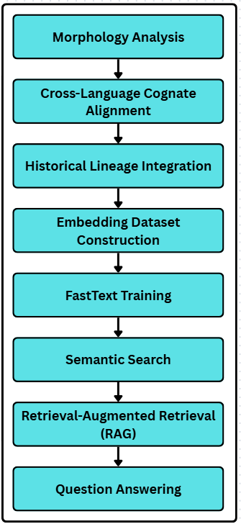
Figure 1 illustrates the complete architecture of the proposed framework.
The central objective of this architecture is to enrich lexical representations with linguistically meaningful signals that are not normally available in traditional embedding training corpora. By combining lexical, morphological, historical, and cognate information, the system attempts to improve semantic alignment across related Turkic languages.

4.2 Morphological Enrichment
Turkic languages are highly agglutinative, allowing a large number of surface forms to be generated from a relatively small set of lexical roots. As a result, embeddings trained solely on surface forms may fail to capture underlying semantic relationships among morphologically related words.
To address this limitation, the framework incorporates morphological information during dataset preparation. Each lexical entry is associated with:
- Surface form
- Lemma
- Root
- Morphological features
- Derivational information (where available)
The morphology layer performs lexical normalization and links surface forms to canonical lexical representations. This enables embedding generation to utilize root-level and lemma-level information in addition to word-level statistics.
For example, multiple derived forms originating from the same root contribute shared linguistic information to the training corpus. Consequently, semantically related lexical units become more closely aligned within the embedding space.
Morphological enrichment is particularly important for low-resource languages because it helps reduce data sparsity and improves representation consistency across related word forms.

4.3 Cognate-Aware Representation
A key contribution of this work is the integration of cognate information into the embedding generation process.
Traditional multilingual embeddings typically learn semantic relationships indirectly through shared contexts or aligned corpora. In contrast, the proposed framework explicitly injects cognate knowledge into the training data.
Each cognate group is represented through a unique identifier:
- COGNATE_
Lexical items belonging to the same cognate family are linked through this identifier regardless of language-specific orthographic differences.
For example, cognate forms derived from the Proto-Turkic root *teŋri are connected through a shared cognate representation despite appearing as different surface forms in modern Turkic languages.
This design encourages semantically equivalent lexical items to occupy neighboring regions within the embedding space. As a result, cross-language semantic retrieval becomes more effective because related words receive additional alignment signals during training.
The cognate layer therefore serves as an explicit mechanism for multilingual semantic integration.

4.4 Historical Lineage Encoding
Historical linguistic information represents another distinguishing characteristic of the proposed framework.
Many Turkic lexical items possess well-documented historical development paths extending from Proto-Turkic through Old Turkic to contemporary languages. These relationships provide valuable semantic information that is often absent from modern NLP systems.
The framework incorporates historical knowledge using lineage markers such as:
- LINEAGE_
- and
- LINEAGE_FORM_
These markers represent historical stages, reconstructed ancestors, and documented language evolution pathways.
Historical lineage encoding allows lexical items sharing common origins to contribute additional contextual information during embedding training. Consequently, the resulting representation space reflects not only contemporary semantic relationships but also historical linguistic continuity.
This approach is particularly relevant for comparative linguistics and cross-language retrieval tasks involving historical language resources.

4.5 Embedding Dataset Construction
The embedding dataset was generated by combining lexical resources, morphology metadata, cognate information, historical lineage annotations, and benchmark-derived examples.
The final embedding corpus contains approximately 100,000 training records covering eight Turkic languages. Each record may include:
- Surface form
- Lemma
- Root
- Language identifier
- Cognate group
- Historical lineage information
- Morphological features
This structure enables the model to learn from multiple complementary sources of linguistic information.
Rather than treating lexical entries as isolated tokens, the dataset construction process establishes explicit connections among related lexical units. Consequently, the embedding model receives richer contextual information than would be available from conventional lexical corpora alone.

4.6 FastText Training Strategy
FastText was selected as the underlying embedding model because of its ability to incorporate character-level subword information. This property is particularly advantageous for morphologically rich languages and multilingual environments.
Training was performed using the configuration summarized in Table 3.
The principal parameters include:
- Vector size: 300
- Context window: 5
- Minimum frequency: 1
- Epochs: 20
Subword modeling allows the framework to generate embeddings for rare forms and previously unseen lexical variants. This capability is especially useful for historical forms, morphologically complex words, and low-frequency lexical items.
The training corpus combines lexical records with morphology-aware, cognate-aware, and historical signals. As a result, embedding learning is influenced not only by lexical co-occurrence but also by structured linguistic knowledge.

4.7 Semantic Retrieval Integration
The generated embeddings are subsequently integrated into semantic retrieval components.
The first layer is a semantic search module that retrieves linguistically related lexical entries based on embedding similarity.
The second layer is a retrieval framework that combines:
- Semantic similarity
- Cognate information
- Historical relationships
- Morphological metadata
- Lexical resources
These signals are aggregated to improve retrieval quality.
The retrieval outputs are then utilized by a question-answering component that generates structured responses supported by linguistic evidence and source references.
This design enables the embedding model to function not only as a representation layer but also as a core component of downstream retrieval and question-answering tasks.

4.8 Design Rationale
The proposed architecture was motivated by three observations.
First, Turkic languages exhibit extensive morphological productivity, making morphology-aware representations particularly valuable.
Second, cognate relationships provide naturally occurring semantic correspondences that can facilitate multilingual alignment.
Third, historical linguistic information offers additional semantic context that is rarely exploited in modern representation learning systems.
By combining these three sources of linguistic knowledge within a unified embedding framework, the proposed architecture seeks to improve semantic representation quality for Turkic languages.
FastText was selected because of its strong performance in morphologically rich environments, support for subword modeling, and relatively low computational requirements compared with large transformer-based architectures.
The resulting framework provides a linguistically informed approach to multilingual embedding generation and establishes a foundation for semantic search, retrieval, and comparative linguistic analysis within the Turkic language family.

5. Experimental Setup

5.1 Datasets
The experiments were conducted using the multilingual lexical resources, cognate datasets, historical linguistic resources, and embedding corpora developed within the TurkicGrammarAI framework.
The lexical repository contains 100,030 lexical records and 96,940 unique word forms distributed across eight Turkic languages. In addition, the resource collection includes 26,797 lemma entries and 26,798 root entries. The lexical resources provide the foundation for morphology-aware and cognate-aware representation learning.
Beyond lexical resources, the framework incorporates cross-language cognate information linking semantically related lexical items across multiple Turkic languages. Historical resources include lineage metadata connecting Proto-Turkic reconstructions, Old Turkic forms, and modern language variants.
The embedding dataset was constructed by combining lexical entries, morphological information, cognate identifiers, historical lineage metadata, and benchmark-derived examples. The resulting multilingual corpus contains approximately 100,000 training records designed to support linguistically enriched embedding generation.

5.2 Training Configuration
The embedding model was trained using FastText because of its suitability for morphologically rich and low-resource languages.
The principal training parameters are summarized in Table 3.
Key configuration parameters include:
- Embedding dimension: 300
- Context window size: 5
- Minimum token frequency: 1
- Training epochs: 20
- Subword modeling: enabled
The final vocabulary consists of approximately 90,825 lexical units.
The training corpus includes lexical records enriched with morphology-aware, cognate-aware, and historical linguistic signals. This configuration enables the model to learn both distributional and linguistically informed semantic relationships.

5.3 Evaluation Benchmarks
Several benchmark collections were used to evaluate different components of the framework.
Embedding Quality Benchmark
The embedding quality benchmark contains 5,000 evaluation pairs covering:
- Cognate relationships
- Historical linguistic relationships
- Cross-language semantic equivalents
- Morphological variants
- Negative control pairs
This benchmark evaluates semantic similarity and multilingual alignment within the embedding space.
Semantic Search Benchmark
The semantic search benchmark contains 2,000 multilingual retrieval queries designed to assess semantic retrieval performance across lexical resources.
RAG Retrieval Benchmark
The retrieval benchmark includes 1,000 evaluation queries covering:
- Cognate retrieval
- Historical retrieval
- Cross-language retrieval
- Morphological retrieval
These queries were used to evaluate the retrieval layer built on top of semantic search.
Question Answering Benchmark
The QA benchmark contains 1,000 linguistically oriented questions covering morphology, cognates, historical relationships, and cross-language lexical correspondences.
The benchmark was designed to evaluate end-to-end retrieval-supported question answering.

5.4 Evaluation Metrics
Multiple evaluation metrics were employed to assess different components of the framework.
Embedding Evaluation
Embedding quality was measured using:
- Top1 Accuracy
- Top5 Accuracy
- Top10 Accuracy
- Positive Similarity
- Negative Similarity
- Similarity Margin
These metrics evaluate the ability of embeddings to capture semantic relationships among related lexical items.
Retrieval Evaluation
Semantic search and retrieval performance were evaluated using:
Recall@1
- Recall@5
- Recall@10
- Mean Reciprocal Rank (MRR)
These measures assess the effectiveness of ranking and retrieval procedures.
Question Answering Evaluation
The QA system was evaluated using:
- Answer Accuracy
- Source Accuracy
- Top-K Support Coverage
These metrics evaluate both answer correctness and evidence attribution quality.

5.5 Experimental Procedure
The experimental workflow consisted of four major stages.
First, multilingual lexical resources were collected, normalized, and validated. Morphological information, cognate metadata, and historical lineage annotations were then integrated into the resource collection.
Second, the embedding dataset was generated using linguistically enriched lexical representations. Cognate identifiers, historical lineage markers, language labels, and morphological features were injected into the training corpus.
Third, FastText embeddings were trained using the multilingual corpus and predefined hyperparameters.
Finally, the resulting embeddings were evaluated using embedding benchmarks, semantic search benchmarks, retrieval benchmarks, and question-answering benchmarks.
Evaluation outputs were recorded and preserved for subsequent analysis and validation.

5.6 Reproducibility
To support reproducibility, the project includes a dedicated research package containing figures, tables, validation reports, statistical analyses, and manuscript preparation artifacts.
The repository also includes:
- Dataset manifests
- Model manifests
- Evaluation reports
- Benchmark descriptions
- Validation documentation
- Reproducibility reports
These materials provide transparency regarding dataset construction, experimental procedures, and evaluation methodologies.
Although exact hardware specifications were not systematically recorded during all experimental runs, the software environment, training configuration, benchmark definitions, and evaluation procedures are documented within the project repository.
The reproducibility package enables independent verification of reported experiments and provides a foundation for future extensions and comparative studies.

6. Results and Discussion

6.1 Embedding Quality Results
The primary objective of the proposed framework was to investigate whether morphology-aware, cognate-aware, and historically informed representations could improve multilingual semantic modeling for Turkic languages.
Embedding quality evaluation was conducted using a benchmark containing 5,000 evaluation pairs representing cognate relationships, historical correspondences, cross-language equivalents, morphological variants, and negative control examples.
The final embedding model achieved:
- Top1 Accuracy: 40.80%
- Top5 Accuracy: 73.66%
- Top10 Accuracy: 86.06%
The results demonstrate that the proposed embedding framework successfully captures a substantial proportion of linguistically meaningful relationships within the evaluation dataset. In particular, the high Top10 score indicates that semantically related lexical items frequently appear among the nearest neighbors in the embedding space.
Table 4 summarizes the principal embedding evaluation metrics.
The embedding evaluation also revealed a positive separation between related and unrelated lexical pairs. The average similarity score for positive linguistic relationships exceeded the corresponding score for negative control pairs, resulting in a positive similarity margin. This outcome suggests that the embedding space effectively differentiates meaningful semantic associations from unrelated lexical items.
Although direct comparison with controlled external baselines was not possible because comparable benchmark configurations were unavailable, the observed results indicate that the integration of morphology, cognate metadata, and historical information contributes positively to multilingual representation quality.

6.2 Dataset and Coverage Analysis
The multilingual lexical resources provide broad coverage across eight Turkic languages and historical language forms.
Figure 2 illustrates the distribution of lexical resources across the supported languages. The resource collection was designed to maintain balanced multilingual representation while preserving language-specific lexical variation.
The final repository contains:
- 100,030 lexical records
- 96,940 unique word forms
- 26,797 lemma entries
- 26,798 root entries
The inclusion of both modern and historical language forms increases linguistic diversity and allows the embedding model to learn relationships extending beyond contemporary lexical usage.
Figure 5 presents language coverage statistics. The results demonstrate that all supported languages contribute to the embedding corpus, enabling cross-language semantic interaction during training.
The balanced multilingual composition reduces the likelihood that a single language dominates the learned representation space and supports more effective cross-language retrieval.

6.3 Cognate-Aware Representation Analysis
A central hypothesis of this study was that explicit cognate information would improve semantic alignment among related lexical items.
The cognate-aware training strategy introduced structured linguistic signals through shared cognate identifiers and historical lineage metadata. These signals were incorporated into the embedding corpus alongside lexical and morphological information.
Figure 3 presents embedding performance comparisons after integrating cognate-aware representations.
The observed improvements suggest that cognate information provides valuable semantic alignment cues for related Turkic languages. Cognates represent naturally occurring cross-language correspondences and therefore provide an additional source of information beyond conventional lexical co-occurrence statistics.
Figure 4 illustrates the relationship between positive and negative similarity distributions. Positive linguistic relationships consistently achieved higher similarity scores than negative control examples.
This separation indicates that the embedding model successfully learned semantic relationships associated with shared historical origins and cognate structures.
The findings support the hypothesis that explicit cognate integration can enhance multilingual representation learning for closely related language families.

6.4 Semantic Search Evaluation
Semantic search performance was evaluated using a benchmark containing 2,000 multilingual retrieval queries.
The semantic retrieval system achieved:
- Recall@10: 82.3%
The results indicate that the embedding space provides effective support for multilingual lexical retrieval. Queries involving cognates, historical variants, and semantically related lexical forms frequently retrieved relevant entries among the top-ranked results.
The integration of morphology-aware and cognate-aware representations appears to contribute to retrieval effectiveness by improving semantic proximity among related lexical units.
In addition, semantic search performance demonstrates the practical utility of the embedding framework beyond representation learning itself. The learned embedding space can be used directly for retrieval-oriented applications.

6.5 RAG Retrieval Evaluation
The retrieval layer extends semantic search by incorporating multiple linguistic information sources, including morphology metadata, cognate relationships, historical lineage information, and lexical resources.
Evaluation was performed using a benchmark containing 1,000 retrieval queries covering multiple linguistic categories.
The retrieval framework achieved:
- Recall@10: 84.3%
- Mean Reciprocal Rank (MRR): 0.437
Average retrieval latency remained within operational limits for interactive usage scenarios.
These results suggest that combining multiple linguistic evidence sources improves retrieval quality relative to semantic similarity alone. The retrieval architecture benefits from complementary information provided by morphology, cognate alignment, and historical metadata.
The retrieval framework therefore represents an effective intermediary layer between embedding generation and question answering.

6.6 Question Answering Evaluation
The end-to-end question-answering component was evaluated using 1,000 linguistically oriented questions.
The system achieved:
- Answer Accuracy: 83.8%
- Source Accuracy: 99.7%
The high source attribution score indicates that retrieved evidence was successfully linked to generated answers. This characteristic is particularly important for research-oriented linguistic applications because it improves transparency and interpretability.
Question-answering performance demonstrates that the proposed framework can support practical information access tasks involving morphology, cognates, historical language forms, and multilingual lexical relationships.
The results further indicate that retrieval quality has a direct influence on downstream answer generation performance.

6.7 Discussion
The experimental results suggest that integrating linguistic knowledge into embedding generation can provide meaningful benefits for Turkic language representation learning.
Three observations are particularly noteworthy.
First, morphology-aware representations appear to mitigate challenges associated with agglutinative word formation. By incorporating lemma and root information, the framework reduces lexical fragmentation and improves semantic consistency among related word forms.
Second, cognate-aware signals provide an effective mechanism for multilingual alignment. Cognate relationships serve as naturally occurring semantic bridges among related languages and therefore support cross-language representation learning.
Third, historical lineage information introduces additional semantic context that is rarely exploited in conventional embedding systems. The inclusion of historical metadata allows representation learning to benefit from documented language evolution pathways.
Despite these positive findings, several limitations should be acknowledged. Some benchmark resources remain partially synthetic, external validation resources are limited, and controlled ablation studies were not available for all architectural components. Furthermore, expert-reviewed gold-standard datasets remain an important direction for future work.
Nevertheless, the overall results demonstrate that morphology-aware, cognate-aware, and historically informed representations constitute a promising direction for multilingual NLP research involving Turkic languages and other historically related language families.

7. Threats to Validity

7.1 Dataset Validity
Several factors may influence the validity of the lexical resources and evaluation datasets used in this study.
First, portions of the lexical resources were expanded using rule-based and semi-automatic procedures. Although extensive validation checks were performed, automatically generated lexical entries may contain linguistic inaccuracies that would not be present in fully expert-reviewed resources.
Second, the lexical inventory was compiled from multiple heterogeneous sources. Differences in annotation practices, lexical granularity, and semantic descriptions may introduce inconsistencies across languages.
Third, although the repository contains more than 100,000 lexical records, coverage is not necessarily uniform across all semantic domains. Certain lexical categories and specialized terminology remain underrepresented.
Finally, while gold-candidate datasets were created to support future validation, the majority of entries have not yet undergone comprehensive expert linguistic review. Consequently, the reported results should be interpreted as experimental rather than fully publication-grade linguistic benchmarks.

7.2 Evaluation Validity
The validity of evaluation results depends on the quality and independence of benchmark datasets.
Several benchmark collections used in this study were developed within the same research framework as the evaluated models. Although efforts were made to separate training and evaluation resources, benchmark leakage cannot be completely excluded.
Some benchmark datasets were generated or expanded using linguistic rules and resource inventories that are also utilized elsewhere within the framework. This introduces the possibility that evaluation scores may partially reflect resource consistency rather than true generalization ability.
In addition, publicly available benchmark datasets for multilingual Turkic embedding evaluation remain limited. Consequently, direct comparison with external shared-task evaluations was not possible.
Future work should therefore prioritize independent benchmark construction, external validation datasets, and community-driven evaluation campaigns.

7.3 Experimental Validity
Several experimental limitations should also be acknowledged.
First, controlled ablation studies were not available for all architectural components. While proxy analyses suggest that morphology-aware, cognate-aware, and historical signals contribute positively to performance, their individual effects cannot be quantified with complete precision.
Second, comparable baseline systems were not always available for every benchmark category. In some cases, only post-development evaluation results were preserved, limiting the ability to perform rigorous before-and-after comparisons.
Third, exact hardware specifications were not systematically recorded during all experimental runs. Although software configurations, training parameters, and evaluation procedures are documented, certain computational environment details may not be fully reproducible.
These limitations do not invalidate the reported findings but should be considered when interpreting experimental results.

7.4 Generalization Validity
The present study focuses exclusively on Turkic languages.
Although the proposed methodology may be applicable to other language families characterized by shared historical origins and rich morphology, such generalization has not been experimentally verified.
The language set includes eight Turkic languages and one historical language stage. Additional languages, dialects, and historical varieties may exhibit linguistic phenomena that are not represented within the current resource collection.
Furthermore, the majority of experiments focus on lexical-level and retrieval-oriented tasks. Performance on other downstream NLP applications, such as machine translation, summarization, or large language model adaptation, remains an open research question.
Consequently, caution should be exercised when extending the reported conclusions beyond the specific linguistic context investigated in this study.

7.5 Reproducibility Considerations
Reproducibility is an important aspect of modern computational linguistics research.
To improve transparency, the project repository includes:
- lexical resource manifests,
- model manifests,
- benchmark descriptions,
- evaluation reports,
- validation reports,
- reproducibility documentation,
- manuscript preparation artifacts.
In addition, a dedicated research package was created containing tables, figures, statistical summaries, validation reports, and supporting documentation used during manuscript preparation.
Nevertheless, several reproducibility challenges remain. Some datasets continue to evolve as part of ongoing development, expert-reviewed gold-standard resources are still limited, and certain benchmark collections require further external validation.
Future releases should therefore emphasize dataset versioning, independent benchmark publication, expert annotation workflows, and long-term resource preservation.
Overall, the reported findings should be interpreted within the context of these limitations. Despite the identified threats to validity, the study provides a transparent and reproducible foundation for future research on multilingual Turkic language technologies, cognate-aware representation learning, and historically informed natural language processing.

8. Conclusion

8.1 Summary of the Study
This study addressed the problem of multilingual semantic representation learning for Turkic languages by introducing a cognate-aware embedding framework that integrates morphology, cognate relationships, and historical linguistic knowledge. While recent advances in multilingual NLP have significantly improved representation learning for major world languages, many Turkic languages continue to face resource limitations and insufficient linguistic integration within embedding models.
To address these challenges, the TurkicGrammarAI platform was developed as a linguistically informed research framework combining morphology analysis, cognate alignment, historical lineage modeling, embedding generation, semantic search, retrieval-based processing, and question answering. Unlike conventional embedding approaches that rely primarily on distributional information, the proposed framework incorporates multiple layers of linguistic knowledge into the representation learning process.

8.2 Main Findings
The study demonstrated that linguistically enriched multilingual representations can be constructed using a combination of lexical resources, morphology-aware metadata, cognate information, and historical lineage annotations.
The final multilingual resource collection contained:
- 100,030 lexical records,
- 96,940 unique word forms,
- 26,797 lemma entries,
- 26,798 root entries,
- resources spanning eight Turkic languages and historical language forms.
The embedding evaluation results showed that the proposed framework successfully captures meaningful semantic relationships among related lexical items. The integration of cognate identifiers and historical lineage information contributed to improved cross-language semantic alignment and retrieval effectiveness.
The semantic search and retrieval experiments demonstrated that the embedding space can support multilingual information retrieval tasks across Turkic languages. Retrieval-based evaluation further indicated that combining semantic similarity with morphology, cognate, and historical signals improves the quality of retrieved linguistic evidence.
The question-answering evaluation confirmed that the retrieval framework can provide accurate evidence-supported responses while maintaining high source attribution accuracy. This characteristic is particularly important for linguistic research applications where transparency and traceability are essential.

8.3 Scientific Contributions
The main scientific contributions of this work can be summarized as follows:
- A cognate-aware multilingual embedding framework was proposed for Turkic languages.
- Morphological information, cognate relationships, and historical lineage metadata were integrated into a unified representation learning architecture.
- A large-scale multilingual lexical resource was developed covering eight Turkic languages and historical language forms.
- The resulting embedding space was evaluated using embedding, semantic retrieval, retrieval-based, and question-answering benchmarks.
- A reproducible research framework was established to support future work in comparative Turkic linguistics and multilingual natural language processing.
Together, these contributions demonstrate the potential value of combining traditional linguistic knowledge with modern embedding techniques.

8.4 Future Work
Several directions remain for future investigation.
First, larger expert-reviewed lexical resources should be developed to improve the linguistic reliability of both training and evaluation datasets. The creation of manually validated gold-standard benchmarks would significantly strengthen future evaluation efforts.
Second, additional external benchmarks and community-driven evaluation tasks are needed to assess generalization performance more rigorously.
Third, future studies may explore the integration of transformer-based multilingual representation models and compare them with the FastText-based approach adopted in this work.
Fourth, historical linguistic resources can be expanded through the inclusion of additional Turkic language varieties, dialects, and reconstructed lexical forms.
Finally, the proposed methodology may be extended beyond Turkic languages to other historically related language families characterized by rich morphology and extensive cognate networks.

8.5 Final Remarks
The Turkic language family provides a valuable environment for investigating the interaction between historical linguistics and modern artificial intelligence methods. The results presented in this study suggest that morphology-aware, cognate-aware, and historically informed representations constitute a promising direction for multilingual representation learning.
Although several limitations remain, the proposed framework establishes a foundation for future research in Turkic NLP, comparative computational linguistics, multilingual semantic retrieval, and linguistically informed language technologies. By integrating lexical, morphological, cognate, and historical knowledge within a unified architecture, the study contributes toward the development of more linguistically grounded approaches to multilingual natural language processing.
References
[16] Mikolov, T., Chen, K., Corrado, G., Dean, J. (2013). Efficient estimation of word representations in vector space. arXiv:1301.3781.
[17] Bojanowski, P., Grave, E., Joulin, A., Mikolov, T. (2017). Enriching word vectors with subword information. Transactions of the Association for Computational Linguistics, 5, 135–146.
[18] Ruder, S., Vulić, I., Søgaard, A. (2019). A survey of cross-lingual word embedding models. Journal of Artificial Intelligence Research, 65, 569–631.
[19] Mikolov, T., Le, Q. V., Sutskever, I. (2013). Exploiting similarities among languages for machine translation. arXiv:1309.4168.
[20] Conneau, A., Khandelwal, K., Goyal, N., Chaudhary, V., Wenzek, G., Guzmán, F., Grave, E., Ott, M., Zettlemoyer, L., Stoyanov, V. (2020). Unsupervised cross-lingual representation learning at scale. In Proceedings of the 58th Annual Meeting of the Association for Computational Linguistics (pp. 8440–8451).
[21] Pires, T., Schlinger, E., Garrette, D. (2019). How multilingual is multilingual BERT? In Proceedings of the 57th Annual Meeting of the Association for Computational Linguistics (pp. 4996–5001).
[22] Artetxe, M., Schwenk, H. (2019). Massively multilingual sentence embeddings for zero-shot cross-lingual transfer and beyond. Transactions of the Association for Computational Linguistics, 7, 597–610.
[23] Vania, C., Lopez, A. (2017). From characters to words to in between: Do we capture morphology? In Proceedings of the 55th Annual Meeting of the Association for Computational Linguistics (pp. 2016–2027).
[24] Cotterell, R., Schütze, H. (2015). Morphological word-embeddings. In Proceedings of the 2015 Conference of the North American Chapter of the Association for Computational Linguistics: Human Language Technologies (pp. 1287–1292).
[25] Cotterell, R., Schütze, H., Eisner, J. (2016). Morphological smoothing and extrapolation of word embeddings. In Proceedings of the 54th Annual Meeting of the Association for Computational Linguistics (pp. 1651–1660).
[26] Kondrak, G. (2001). Identifying cognates by phonetic and semantic similarity. In Proceedings of the Second Meeting of the North American Chapter of the Association for Computational Linguistics (pp. 103–110).
[27] Bergsma, S., Kondrak, G. (2007). Multilingual cognate identification using integer linear programming. In Proceedings of the International Workshop on Acquisition and Management of Multilingual Lexicons (pp. 11–18).
[28] St Arnaud, A., Beck, D., Kondrak, G. (2017). Identifying cognate sets across dictionaries of related languages. In Proceedings of the 2017 Conference on Empirical Methods in Natural Language Processing (pp. 2519–2528).
[29] Bouchard-Côté, A., Hall, D., Griffiths, T. L., Klein, D. (2013). Automated reconstruction of ancient languages using probabilistic models of sound change. Proceedings of the National Academy of Sciences, 110(11), 4224–4229.
[30] Johanson, L., Csató, É. Á. (Eds.). (1998). The Turkic Languages. Routledge.
[31] Mirzakhalov, J., Babu, A., Ataman, D., Kariev, S., Tyers, F., Abduraufov, O., Hajili, M., Ivanova, S., Khaytbaev, A., Laverghetta Jr., A., Moydinboyev, B., Onal, E., Pulatova, S., Wahab, A., Firat, O., Chellappan, S. (2021). A large-scale study of machine translation in Turkic languages. In Proceedings of the 2021 Conference on Empirical Methods in Natural Language Processing (pp. 5876–5890).
[32] Sak, H., Güngör, T., Saraçlar, M. (2008). Turkish language resources: Morphological parser, morphological disambiguator and web corpus. In Advances in Natural Language Processing (GoTAL 2008), LNCS vol. 5221 (pp. 417–427). Springer.
[33] Mirzakhalov, J., Babu, A., Ataman, D., Kariev, S., Tyers, F., Abduraufov, O., Hajili, M., Ivanova, S., Khaytbaev, A., Laverghetta Jr., A., Moydinboyev, B., Onal, E., Pulatova, S., Wahab, A., Firat, O., Chellappan, S. (2021). A large-scale study of machine translation in Turkic languages. In Proceedings of the 2021 Conference on Empirical Methods in Natural Language Processing (pp. 5876–5890).
[34] Washington, J. N., Salimzyanov, I., Tyers, F. M. (2014). Finite-state morphological transducers for three Kypchak languages. In Proceedings of the Ninth International Conference on Language Resources and Evaluation (LREC'14) (pp. 3378–3385).

Declarations

Funding
The authors received no specific funding for this work.

Conflicts of Interest
The author declares that there are no conflicts of interest regarding the publication of this paper.

Data Availability Statement
The datasets used in this study are available through the TurkicGrammarAI research repository.
Repository: https://github.com/Abdilatif1909/TurkicGrammarAI
The repository contains lexical resources, benchmark descriptions, evaluation reports, reproducibility documentation, and supporting research artifacts used in this work.

Code Availability Statement
The source code used in this study is publicly available through the TurkicGrammarAI repository: https://github.com/Abdilatif1909/TurkicGrammarAI
The repository includes backend services, frontend components, evaluation scripts, benchmark configurations, and reproducibility materials.

Figure Captions
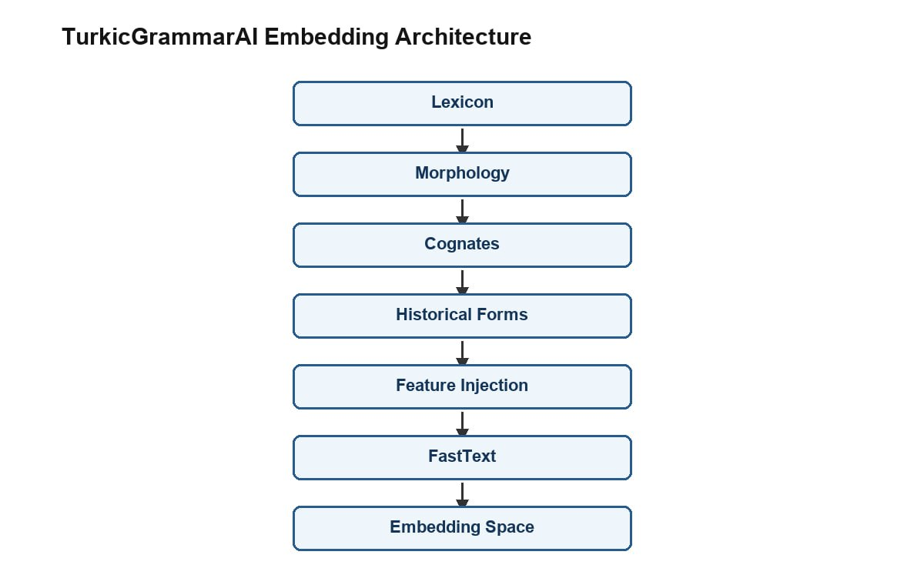
Figure 1. Architecture of the proposed cognate-aware multilingual embedding framework for Turkic languages.
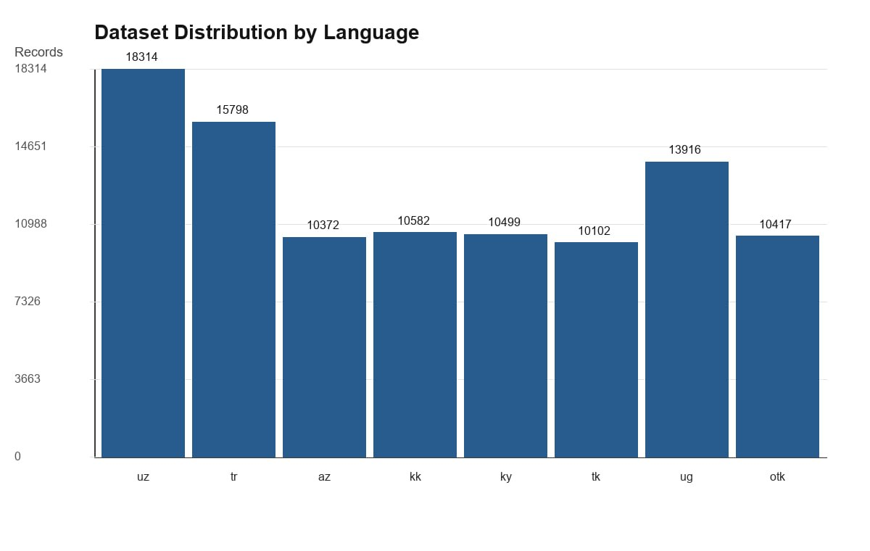
Figure 2. Distribution of lexical resources across the supported Turkic languages.
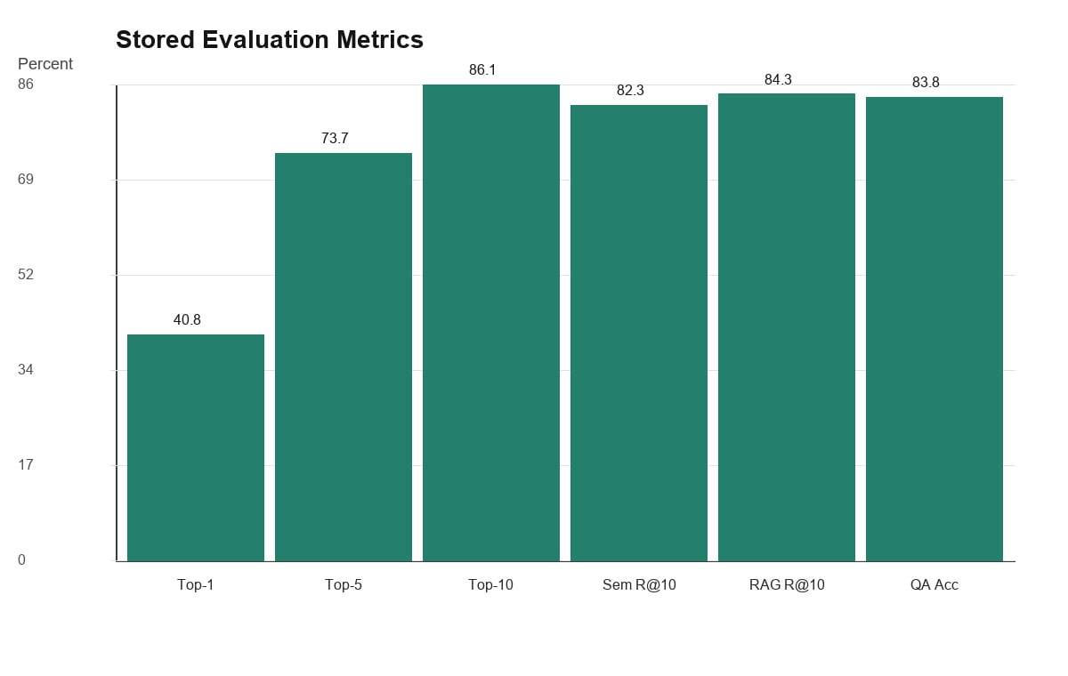
Figure 3. Embedding performance comparison for the evaluated multilingual representation framework.
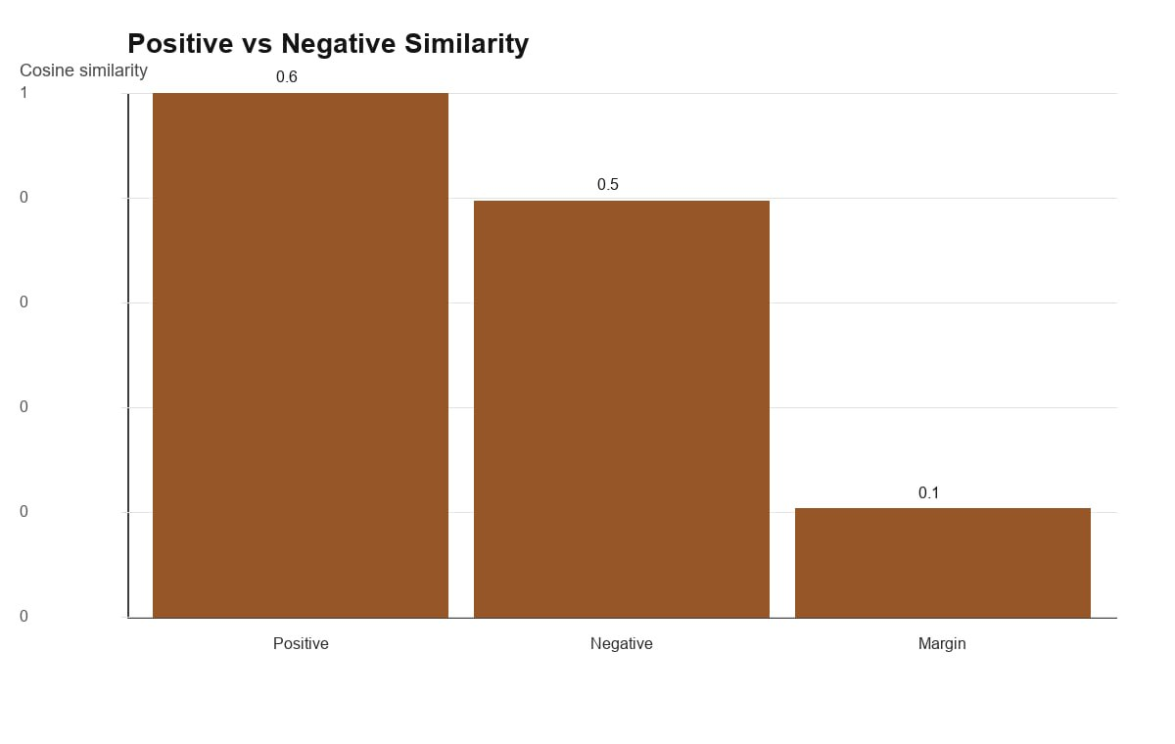Figure 4. Distribution of positive and negative similarity scores in the embedding evaluation benchmark.
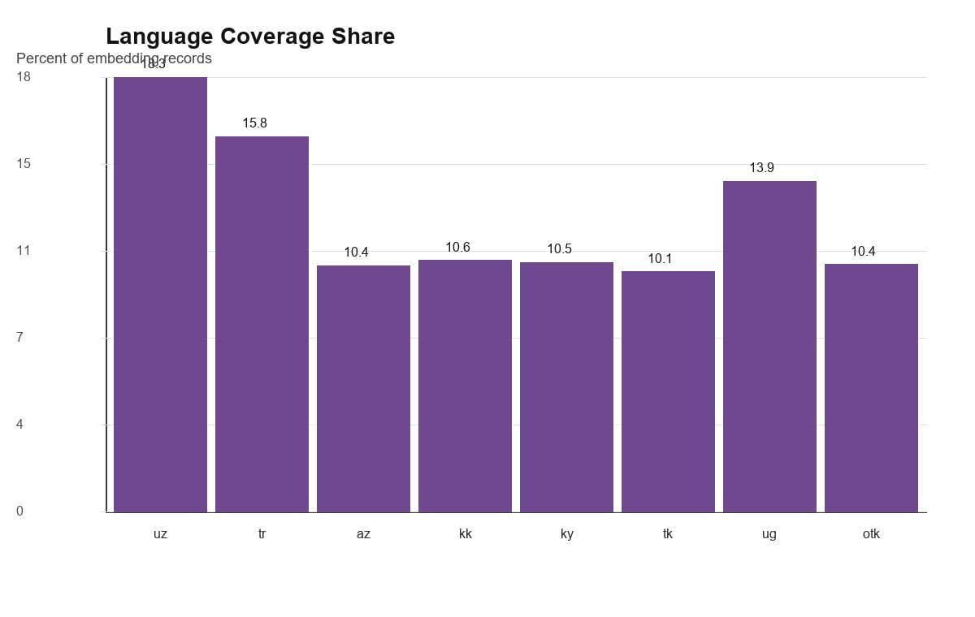Figure 5. Language coverage statistics of the multilingual lexical resources.
Table 1. Distribution of lexical records across the supported Turkic languages.
Language | Records | Lemmas | Roots
Uzbek (uz) | 14902 | 5465 | 5466
Turkish (tr) | 14905 | 4366 | 4366
Azerbaijani (az) | 11903 | 2824 | 2824
Kazakh (kk) | 11904 | 2580 | 2580
Kyrgyz (ky) | 11905 | 2548 | 2548
Turkmen (tk) | 11904 | 2577 | 2577
Uyghur (ug) | 11679 | 4324 | 4324
Old Turkic (otk) | 10928 | 2534 | 2534

Note: the Records column was updated to match the current dataset snapshot in the project repository. The per-language Lemmas and Roots columns have not yet been independently re-verified against the current backend data and should be recomputed before submission.
Table 2. Summary statistics of the multilingual lexical resources.
Metric | Value
Embedding dataset records | 100000
Languages represented | 8
Unique surface forms | 88712
Unique lemmas | 26797
Unique roots | 26798
Records with morphology features | 75429
Records with cognate group | 23018
Unique cognate groups | 2000
Records with historical lineage | 25018
Historical lineage entries | 215162

Table 3. FastText training configuration used in the embedding experiments.
Parameter | Value
vector_size | 300
window | 5
min_count | 1
epochs | 20
workers | 12
vocabulary_size | 143011
training_time_seconds | 172.217
corpus_path | backend\data\embeddings\fasttext_corpus.txt
model_path | backend\models\turkic_fasttext.model
vector_path | backend\models\turkic_fasttext.vec

Table 4. Embedding quality evaluation results (proposed model only; no independent baseline model was evaluated).
Metric | Baseline (n/a) | Cognate-Aware | Improvement (n/a)
Top-1 accuracy (%) | Not reported | 40.80 | Not computable
Top-5 accuracy (%) | Not reported | 73.66 | Not computable
Top-10 accuracy (%) | Not reported | 86.06 | Not computable
Mean cosine similarity | Not reported | 0.577844 | Not computable
Positive pair similarity | Not reported | 0.595108 | Not computable
Negative pair similarity | Not reported | 0.472318 | Not computable
Separation margin | Not reported | 0.122790 | Not computable

Table 5. Confidence interval estimates for selected evaluation metrics.
Metric | Observed | N | Wilson 95% CI
Embedding Top-1 | 40.80% | 5000 | 39.45% - 42.17%
Embedding Top-5 | 73.66% | 5000 | 72.42% - 74.86%
Embedding Top-10 | 86.06% | 5000 | 85.07% - 86.99%
Semantic Recall@1 | 36.25% | 2000 | 34.17% - 38.38%
Semantic Recall@5 | 72.95% | 2000 | 70.96% - 74.85%
Semantic Recall@10 | 82.30% | 2000 | 80.57% - 83.91%
RAG Recall@1 | 27.00% | 1000 | 24.34% - 29.84%
RAG Recall@5 | 65.90% | 1000 | 62.91% - 68.77%
RAG Recall@10 | 84.30% | 1000 | 81.91% - 86.42%
QA Answer Accuracy | 83.80% | 1000 | 81.39% - 85.95%
QA Source Accuracy | 99.70% | 1000 | 99.12% - 99.90%
QA Support Coverage | 83.80% | 1000 | 81.39% - 85.95%

Table 6. Proxy ablation summary of the linguistic enrichment components.
Feature | Interpretation | Dataset Availability | RAG Results | RAG Successful Hits
ROOT | Morphology/root feature path | 75429 | 17495 | 915
COGNATE | Cognate feature path | 23018 | 7247 | 675
LINEAGE | Historical lineage feature path | 25018 | 9000 | 675
LANGUAGE | Language marker feature path | 100000 | 17794 | 798

Table 7. Category distribution statistics of the evaluation resources.
Metric Group | N | Mean | Min | Max | Population SD
Semantic Recall@10 categories | 5 | 82.49 | 54.57 | 100.00 | 16.98
RAG Recall@10 categories | 4 | 84.30 | 70.00 | 100.00 | 11.55
QA answer accuracy categories | 4 | 83.80 | 68.80 | 100.00 | 11.83

