Jamhuriya University of Science and Technology
Linux Commands Assignment
Chapters 1–4
Name | Abdirisak Yusuf Adam
Student ID | C6240069
Class | CNS241

Chapter 1: Introduction to Linux and Ubuntu

1.1 whoami
1. Command Name | whoami
2. Definition | Shows the name of the user who is logged in to the terminal.
3. Syntax | whoami
4. Options and Shortcuts
Option / Shortcut | Name | Description & Example Usage
whoami | Current user | Prints your login name. Example: whoami → abdirizack
sudo whoami | Admin check | Runs it as the administrator; prints root.
id | Related command | Shows the user ID and all groups. Example: id
5. Example
$ whoami
Explanation: Shows that the logged-in user is abdirizack.
6. Terminal Screenshot
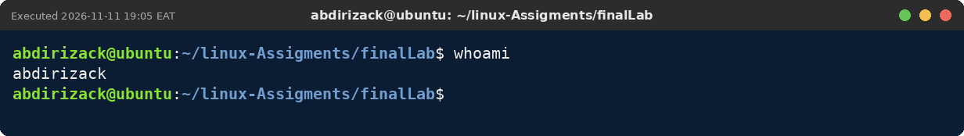

1.2 pwd
1. Command Name | pwd
2. Definition | Shows the full path of the folder you are working in right now.
3. Syntax | pwd [-L | -P]
4. Options and Shortcuts
Option / Shortcut | Name | Description & Example Usage
pwd | Print folder | Example: pwd → /home/abdirizack
-P | Physical path | Follows symbolic links to the real folder.
-L | Logical path | Keeps the path as you typed it (default).
5. Example
$ pwd
Explanation: Shows the full path of the practice folder: /home/abdirizack/linux-Assigments/finalLab.
6. Terminal Screenshot
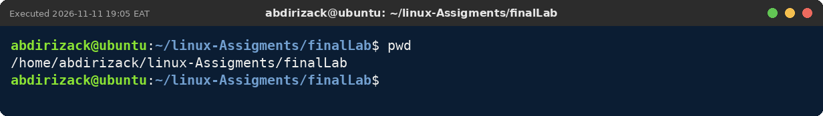

1.3 ls
1. Command Name | ls
2. Definition | Lists what is inside a folder: files, folders and hidden items.
3. Syntax | ls [OPTIONS] [FOLDER]
4. Options and Shortcuts
Option / Shortcut | Name | Description & Example Usage
-l | Long format | Shows permissions, owner, size and date. Example: ls -l
-a | All files | Includes hidden files that start with a dot. Example: ls -a
-h | Readable sizes | Use with -l to see K, M, G. Example: ls -lh
-R | Recursive | Lists sub-folders too. Example: ls -R finalLab
-S | Sort by size | Biggest files first. Example: ls -lS
5. Example
$ ls -l
Explanation: Lists the six practice files with their permissions, owner, size and date.
6. Terminal Screenshot
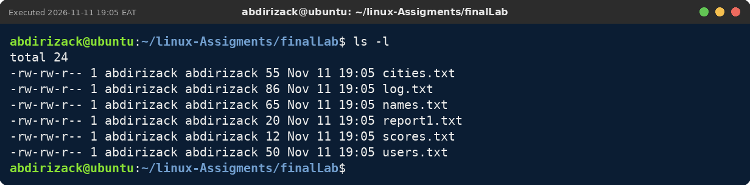

1.4 cat
1. Command Name | cat
2. Definition | Displays the whole content of a text file on the screen.
3. Syntax | cat [OPTIONS] FILE...
4. Options and Shortcuts
Option / Shortcut | Name | Description & Example Usage
-n | Line numbers | Adds a number to every line. Example: cat -n names.txt
-s | Squeeze blanks | Shows several empty lines as one.
names.txt cities.txt | Join | Shows files one after the other. Example: cat names.txt cities.txt
5. Example
$ cat names.txt
Explanation: Displays the five names saved in names.txt.
6. Terminal Screenshot
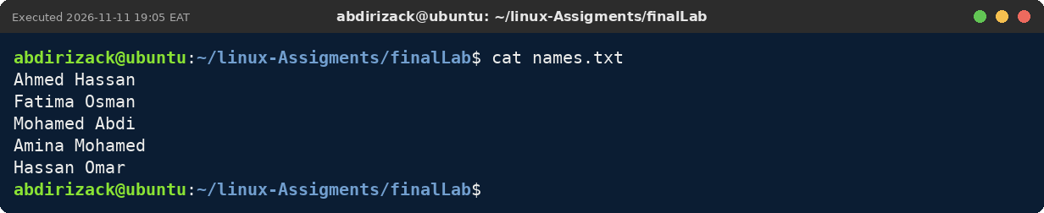

1.5 uname
1. Command Name | uname
2. Definition | Shows information about the Linux kernel and the computer's hardware type.
3. Syntax | uname [OPTIONS]
4. Options and Shortcuts
Option / Shortcut | Name | Description & Example Usage
-r | Kernel release | The kernel version. Example: uname -r
-m | Machine type | x86_64 = 64-bit PC. Example: uname -m
-o | Operating system | Prints GNU/Linux. Example: uname -o
-a | Everything | All information on one line. Example: uname -a
5. Example
$ uname -r
Explanation: Shows the release number of the running Linux kernel.
6. Terminal Screenshot
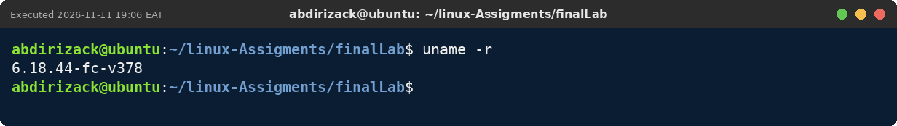

1.6 lsb_release
1. Command Name | lsb_release
2. Definition | Shows which Linux distribution and version is installed.
3. Syntax | lsb_release [OPTIONS]
4. Options and Shortcuts
Option / Shortcut | Name | Description & Example Usage
-a | All | Distributor, description, release and codename.
-d | Description | One line with the full name. Example: lsb_release -d
-cs | Codename only | Prints noble. Example: lsb_release -cs
5. Example
$ lsb_release -d
Explanation: Shows that the installed system is Ubuntu 24.04 LTS.
6. Terminal Screenshot
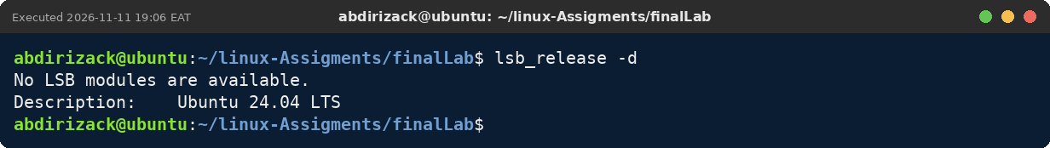

Chapter 2: Linux System Architecture and Management

2.1 cd
1. Command Name | cd
2. Definition | Moves you from one folder to another.
3. Syntax | cd [FOLDER]
4. Options and Shortcuts
Option / Shortcut | Name | Description & Example Usage
cd /path | Absolute path | Starts from /. Example: cd /var/log
cd .. | Up one level | Goes to the parent folder.
cd | Home | Goes back to /home/abdirizack.
cd - | Back | Returns to the previous folder.
Tab | Auto-complete | Finishes folder names for you.
5. Example
$ cd ~/linux-Assigments
Explanation: Moves up into the linux-Assigments folder; the prompt changes to ~/linux-Assigments.
6. Terminal Screenshot
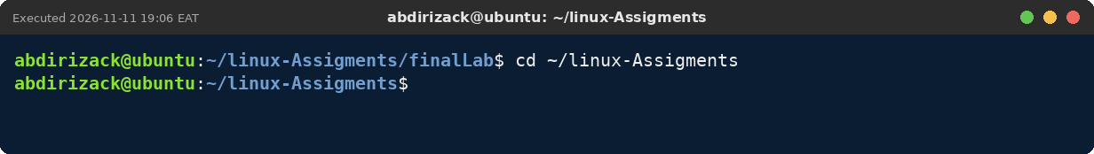

2.2 mkdir
1. Command Name | mkdir
2. Definition | Creates new folders.
3. Syntax | mkdir [OPTIONS] FOLDER...
4. Options and Shortcuts
Option / Shortcut | Name | Description & Example Usage
mkdir A B | Several folders | Creates A and B at once. Example: mkdir projectFiles week2
-p | Parents | Creates the full path. Example: mkdir -p notes/chapter2
-v | Verbose | Prints a message for each folder.
5. Example
$ mkdir -pv projectFiles/week1
Explanation: Creates projectFiles and projectFiles/week1 in one step; -v prints each new folder.
6. Terminal Screenshot
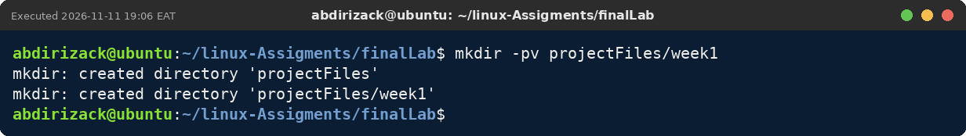

2.3 rmdir
1. Command Name | rmdir
2. Definition | Deletes folders, but only when they are empty.
3. Syntax | rmdir [OPTIONS] FOLDER...
4. Options and Shortcuts
Option / Shortcut | Name | Description & Example Usage
rmdir A | Remove | Deletes the empty folder A. Example: rmdir week2
-p | Parents | Removes empty parent folders too.
-v | Verbose | Prints what was removed.
5. Example
$ rmdir -pv projectFiles/week1
Explanation: Removes the empty week1 folder and then its empty parent projectFiles.
6. Terminal Screenshot
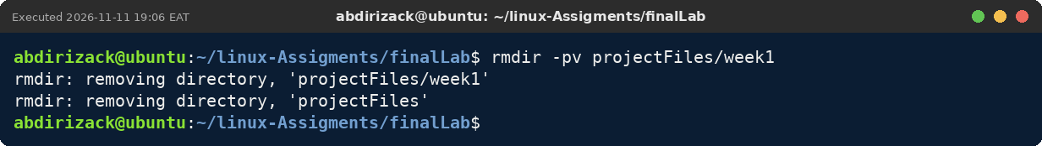

2.4 touch
1. Command Name | touch
2. Definition | Makes a new empty file, or updates the time of an existing one.
3. Syntax | touch FILE...
4. Options and Shortcuts
Option / Shortcut | Name | Description & Example Usage
touch f1 f2 | Create | Creates several files. Example: touch report2.txt report3.txt
report{4..6}.txt | Brace expansion | Bash expands it to report4.txt report5.txt report6.txt.
-c | No create | Only updates the time; never creates.
5. Example
$ touch report2.txt && ls -l report2.txt
Explanation: Creates the empty file report2.txt; ls -l shows its size is 0.
6. Terminal Screenshot
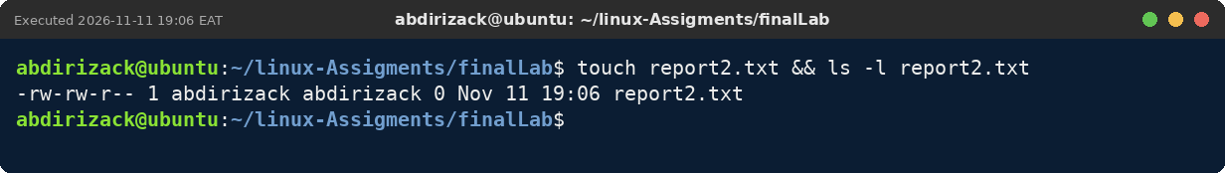

2.5 cp
1. Command Name | cp
2. Definition | Copies files or folders to a new name or place.
3. Syntax | cp [OPTIONS] SOURCE TARGET
4. Options and Shortcuts
Option / Shortcut | Name | Description & Example Usage
cp a b | Copy file | Example: cp report1.txt backup-report1.txt
cp a dir/ | Copy into folder | Example: cp report1.txt projectFiles/
-r | Recursive | Needed to copy a folder. Example: cp -r projectFiles projectFiles-copy
-i | Interactive | Asks before overwriting.
5. Example
$ cp -v report1.txt backup-report1.txt
Explanation: Makes a copy of report1.txt named backup-report1.txt.
6. Terminal Screenshot
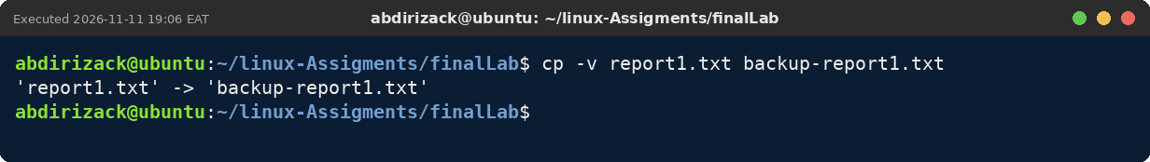

2.6 mv
1. Command Name | mv
2. Definition | Moves a file to another place, or gives it a new name.
3. Syntax | mv [OPTIONS] SOURCE TARGET
4. Options and Shortcuts
Option / Shortcut | Name | Description & Example Usage
mv old new | Rename | Example: mv report2.txt draft.txt
mv f dir/ | Move | Example: mv report1.txt projectFiles/
-v | Verbose | Shows what happened.
-n | No overwrite | Never replaces an existing file.
5. Example
$ mv -v backup-report1.txt archive-report1.txt
Explanation: Renames backup-report1.txt to archive-report1.txt.
6. Terminal Screenshot
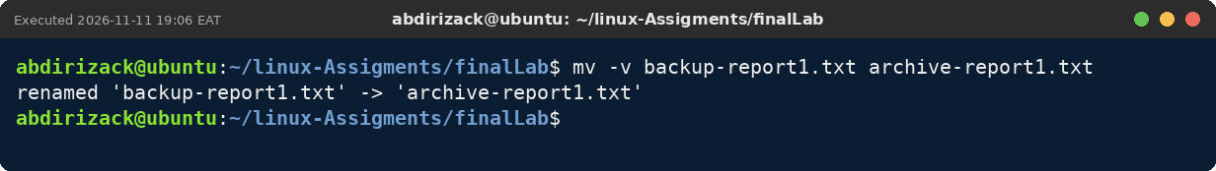

2.7 rm
1. Command Name | rm
2. Definition | Deletes files and folders for good (Linux has no Trash in the terminal).
3. Syntax | rm [OPTIONS] FILE...
4. Options and Shortcuts
Option / Shortcut | Name | Description & Example Usage
rm f | Delete file | Example: rm draft.txt
-i | Ask first | Asks yes/no for each file.
-r | Folders | Deletes a folder with its contents. Example: rm -r projectFiles-copy
-v | Verbose | Lists everything deleted.
5. Example
$ rm -v archive-report1.txt
Explanation: Deletes archive-report1.txt; -v confirms the removal.
6. Terminal Screenshot
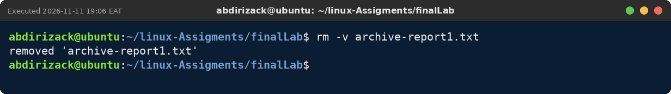

2.8 echo
1. Command Name | echo
2. Definition | Prints a message or the value of a variable.
3. Syntax | echo [TEXT]
4. Options and Shortcuts
Option / Shortcut | Name | Description & Example Usage
"$VAR" | Double quotes | Variable is replaced. Example: echo "User: $USER"
'$VAR' | Single quotes | Printed exactly. Example: echo 'User: $USER'
> | Overwrite file | Example: echo hello > notes.txt
>> | Append to file | Example: echo again >> notes.txt
5. Example
$ echo "Home folder: $HOME"
Explanation: Prints the text with $HOME replaced by /home/abdirizack.
6. Terminal Screenshot
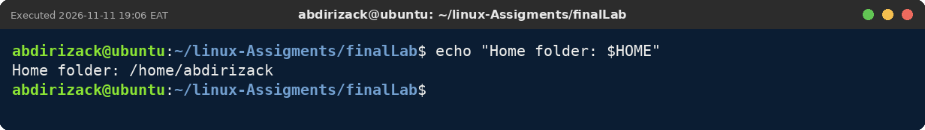

2.9 export
1. Command Name | export
2. Definition | The export command makes a variable available to other programs started from the current shell.
3. Syntax | export NAME=value  export NAME
4. Options and Shortcuts
Option / Shortcut | Name | Description & Example Usage
export NAME=value | Set and export | Creates the variable and exports it. Example: export STUDENT_CLASS=CNS241
export NAME | Export existing | Exports a variable you already set. Example: TOWN=Garowe; export TOWN
export -p | Print | Lists all exported variables. Example: export -p | grep STUDENT_CLASS
export -n NAME | Un-export | Keeps the variable but stops exporting it.
unset NAME | Remove | Deletes the variable completely.
5. Example
$ export STUDENT_CLASS=CNS241 && bash -c 'echo $STUDENT_CLASS'
Explanation: STUDENT_CLASS is exported, so the new child shell started by bash -c can read it and prints CNS241.
6. Terminal Screenshot
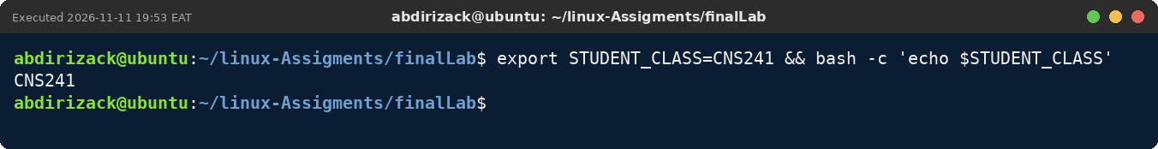

2.10 which and type
1. Command Name | which and type
2. Definition | which shows the file that runs for a command; type says whether it is a program, alias or built-in.
3. Syntax | which COMMAND  type COMMAND
4. Options and Shortcuts
Option / Shortcut | Name | Description & Example Usage
which ls | Program path | Prints /usr/bin/ls.
type cd | Built-in | cd is part of Bash itself.
type -a ls | All | Shows the alias and the file.
5. Example
$ which grep tar
Explanation: Shows the program files that run for grep and tar: /usr/bin/grep and /usr/bin/tar.
6. Terminal Screenshot
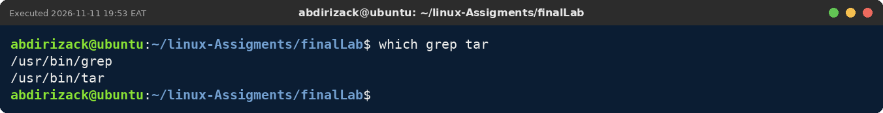

2.11 history
1. Command Name | history
2. Definition | Shows the list of commands you typed before, with numbers.
3. Syntax | history [N]
4. Options and Shortcuts
Option / Shortcut | Name | Description & Example Usage
history | List | Shows the command list. Example: history
history N | Last N | Shows only the last N commands. Example: history 5
!N | Repeat | Runs command number N again. Example: !42
↑ / ↓ | Arrow keys | Step through earlier commands.
Ctrl+R | Reverse search | Search old commands by any part of them.
5. Example
$ history 5
Explanation: Shows the last five commands typed in this terminal, each with its number.
6. Terminal Screenshot
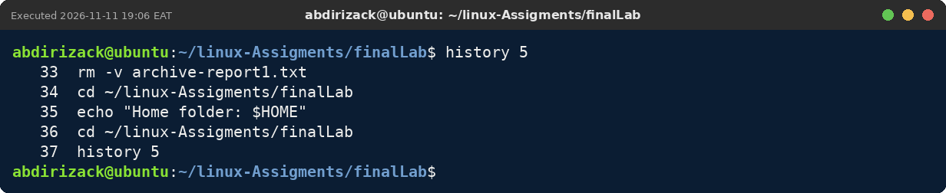

2.12 man and --help
1. Command Name | man and --help
2. Definition | man opens the full manual of a command; --help prints a short summary.
3. Syntax | man COMMAND  COMMAND --help
4. Options and Shortcuts
Option / Shortcut | Name | Description & Example Usage
/word | Search in man | Jumps to the word; n = next.
q | Quit | Leaves the manual.
--help | Short help | Example: cp --help | head
help cd | Built-in help | For Bash built-ins like cd.
5. Example
$ man mkdir
Explanation: Opens the manual page for mkdir with its NAME, SYNOPSIS and DESCRIPTION sections. q closes it.
6. Terminal Screenshot
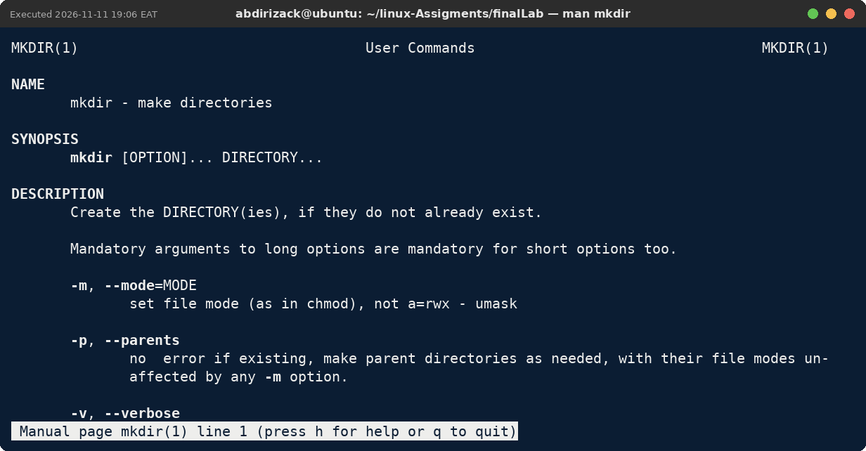

Chapter 3: Text Processing, Searching, Archiving and Editing

3.1 head and tail
1. Command Name | head and tail
2. Definition | head shows the first lines of a file; tail shows the last lines.
3. Syntax | head -n N FILE  tail -n N FILE
4. Options and Shortcuts
Option / Shortcut | Name | Description & Example Usage
-n N | Lines | Default is 10. Example: head -n 3 names.txt
tail -f | Follow | Shows new lines as they are added; Ctrl+C stops.
tail -n +N | From line N | Prints from line N to the end.
5. Example
$ tail -n 2 names.txt
Explanation: Shows the last two names in names.txt.
6. Terminal Screenshot
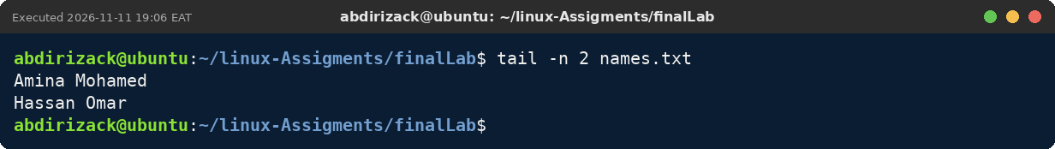

3.2 find
1. Command Name | find
2. Definition | Looks for files and folders that match a name, type, size or time.
3. Syntax | find PATH TEST
4. Options and Shortcuts
Option / Shortcut | Name | Description & Example Usage
-name | By name | Example: find . -name 'file*.txt'
-type d | Folders only | Example: find . -type d
-size +1M | By size | Bigger than 1 MB. Example: find . -size +1M
-mmin -60 | By time | Changed in the last hour.
5. Example
$ find . -name '*.txt'
Explanation: Lists all .txt files in the practice folder.
6. Terminal Screenshot
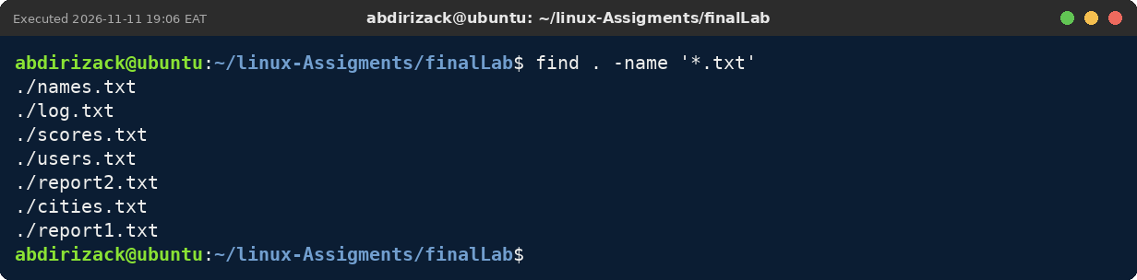

3.3 grep
1. Command Name | grep
2. Definition | Finds lines inside files that contain a word or pattern.
3. Syntax | grep [OPTIONS] PATTERN FILE
4. Options and Shortcuts
Option / Shortcut | Name | Description & Example Usage
-i | Ignore case | Example: grep -i warn log.txt
-n | Line number | Example: grep -n ERROR log.txt
-c | Count | Number of matching lines.
-v | Invert | Lines that do not match.
^ and $ | Start / end | Example: grep '^INFO' log.txt
5. Example
$ grep -in 'error' log.txt
Explanation: Finds both error lines, ignoring upper and lower case, and shows their line numbers 2 and 4.
6. Terminal Screenshot
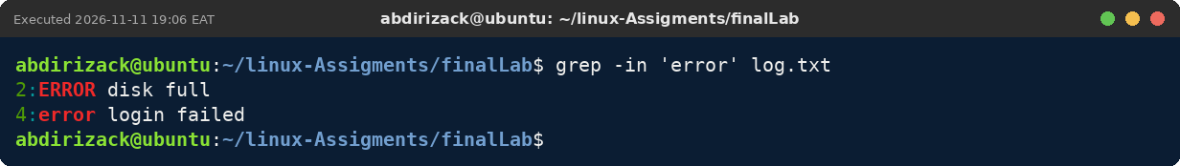

3.4 sort and uniq
1. Command Name | sort and uniq
2. Definition | sort arranges lines in order; uniq removes or counts repeated lines next to each other.
3. Syntax | sort [OPTIONS] FILE  sort FILE | uniq -c
4. Options and Shortcuts
Option / Shortcut | Name | Description & Example Usage
sort -n | Numbers | Sorts by number value.
sort -r | Reverse | Z to A, or biggest first.
uniq -c | Count | Counts repeats (sort first).
sort -u | Unique | Sorts and removes duplicates.
5. Example
$ sort cities.txt | uniq -c
Explanation: Counts each city: Garowe 1, Hargeisa 2, Mogadishu 3.
6. Terminal Screenshot
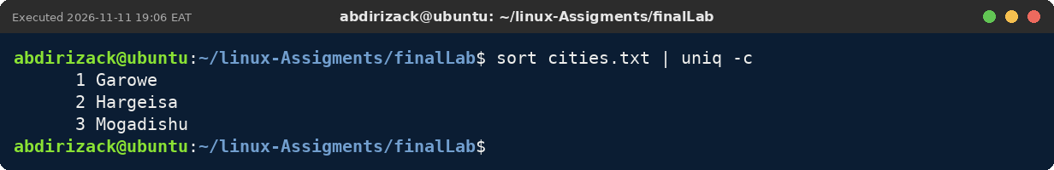

3.5 wc
1. Command Name | wc
2. Definition | Counts the lines, words and characters (bytes) of a file.
3. Syntax | wc [OPTIONS] FILE
4. Options and Shortcuts
Option / Shortcut | Name | Description & Example Usage
-l | Lines | Example: wc -l names.txt
-w | Words | Example: wc -w names.txt
-c | Bytes | Example: wc -c names.txt
| wc -l | Count output | Example: grep ERROR log.txt | wc -l
5. Example
$ wc -l names.txt
Explanation: names.txt has 5 lines.
6. Terminal Screenshot
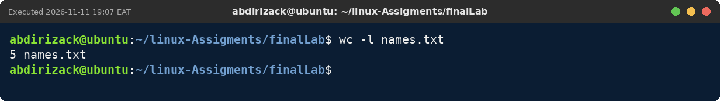

3.6 cut and paste
1. Command Name | cut and paste
2. Definition | cut takes out columns from each line; paste joins files side by side.
3. Syntax | cut -d SEP -f N FILE  paste FILE1 FILE2
4. Options and Shortcuts
Option / Shortcut | Name | Description & Example Usage
-d, | Separator | Fields are split by a comma.
-f 1,3 | Fields | Keep fields 1 and 3.
-c 1-3 | Characters | Keep characters 1 to 3.
paste -d: | Join with : | Joins lines with a colon.
5. Example
$ cut -d: -f1 users.txt
Explanation: Takes only the first field (the user name) from each line of users.txt.
6. Terminal Screenshot
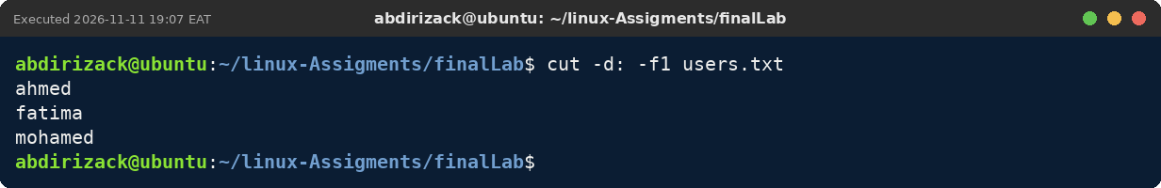

3.7 tr
1. Command Name | tr
2. Definition | Changes or removes characters in text.
3. Syntax | tr SET1 SET2  tr -d SET
4. Options and Shortcuts
Option / Shortcut | Name | Description & Example Usage
'a-z' 'A-Z' | To capitals | Example: tr 'a-z' 'A-Z' < names.txt
, '\t' | Replace | Commas become tabs.
-d | Delete | Example: tr -d '0-9'
5. Example
$ tr 'a-z' 'A-Z' < names.txt
Explanation: Prints the names in capital letters; the file itself is not changed.
6. Terminal Screenshot
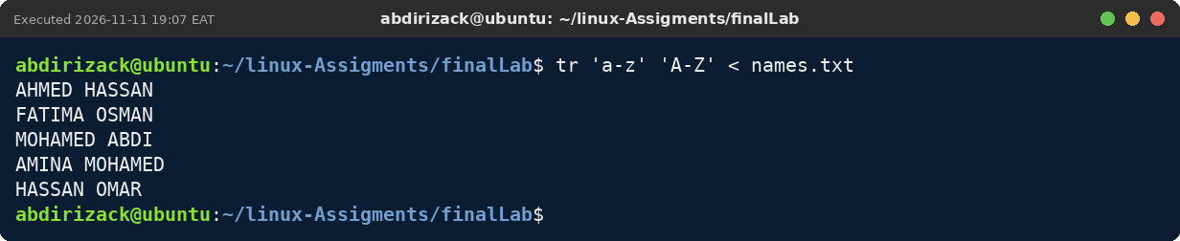

3.8 redirection and pipes
1. Command Name | redirection and pipes
2. Definition | > saves output to a file, >> adds to a file, 2> saves error messages, and | sends output to another command.
3. Syntax | CMD > FILE  CMD >> FILE  CMD 2> FILE  CMD1 | CMD2
4. Options and Shortcuts
Option / Shortcut | Name | Description & Example Usage
> | Overwrite | Replaces the file content.
>> | Append | Adds to the end.
2> | Errors | Saves error messages only.
| | Pipe | Output of one command → input of the next.
5. Example
$ grep -i 'error' log.txt | sort > errors.txt; cat errors.txt
Explanation: grep finds both error lines, the pipe passes them to sort, and > saves the result in errors.txt, which cat then shows.
6. Terminal Screenshot
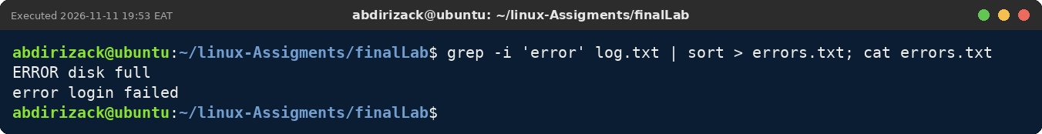

3.9 tar
1. Command Name | tar
2. Definition | Joins many files into one archive and can compress it.
3. Syntax | tar -czf NAME.tar.gz FILES  tar -tzf NAME.tar.gz  tar -xzf NAME.tar.gz -C DIR
4. Options and Shortcuts
Option / Shortcut | Name | Description & Example Usage
-c / -x / -t | Create / Extract / List | The main action.
-z | gzip | Compresses as .tar.gz
-j | bzip2 | Compresses as .tar.bz2
-f | File name | Must come before the archive name.
-C | Target folder | Extract into a folder.
5. Example
$ tar -czvf finalLab.tar.gz names.txt cities.txt
Explanation: Creates finalLab.tar.gz with two files; -v lists them.
6. Terminal Screenshot
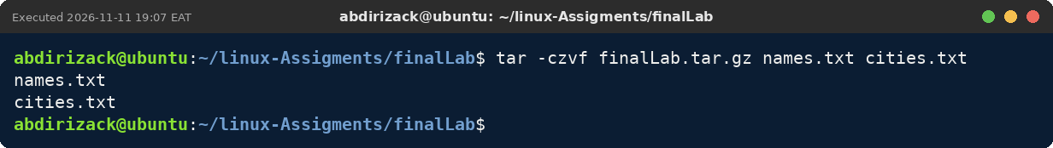

3.10 gzip, bzip2 and zip
1. Command Name | gzip, bzip2 and zip
2. Definition | Tools that make files smaller: gzip (.gz), bzip2 (.bz2) and zip (.zip).
3. Syntax | gzip -k FILE  bzip2 -k FILE  zip NAME.zip FILES  unzip -l NAME.zip
4. Options and Shortcuts
Option / Shortcut | Name | Description & Example Usage
-k | Keep | Keeps the original file.
gunzip / bunzip2 | Decompress | Restore the original.
zcat | Read .gz | Shows content without unpacking.
unzip -l | List zip | Shows what is inside a zip.
5. Example
$ gzip -kv log.txt
Explanation: Compresses log.txt to log.txt.gz and keeps the original because of -k.
6. Terminal Screenshot
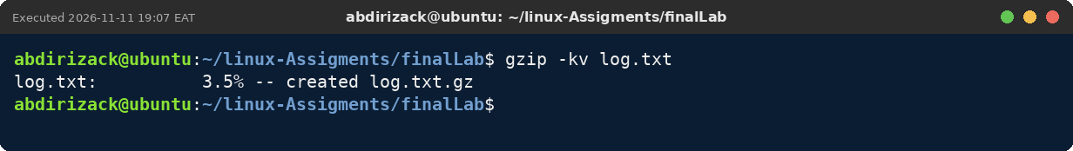

3.11 nano
1. Command Name | nano
2. Definition | An easy terminal text editor; shortcuts are listed at the bottom.
3. Syntax | nano FILE
4. Options and Shortcuts
Option / Shortcut | Name | Description & Example Usage
Ctrl+O | Save | Write Out, then Enter.
Ctrl+X | Exit | Close nano.
Ctrl+W | Search | Find text.
Ctrl+K | Cut line | Removes the current line.
5. Example
$ nano report2.txt
Explanation: Opens the empty report2.txt in nano. The shortcuts are at the bottom; Ctrl+X closes it.
6. Terminal Screenshot
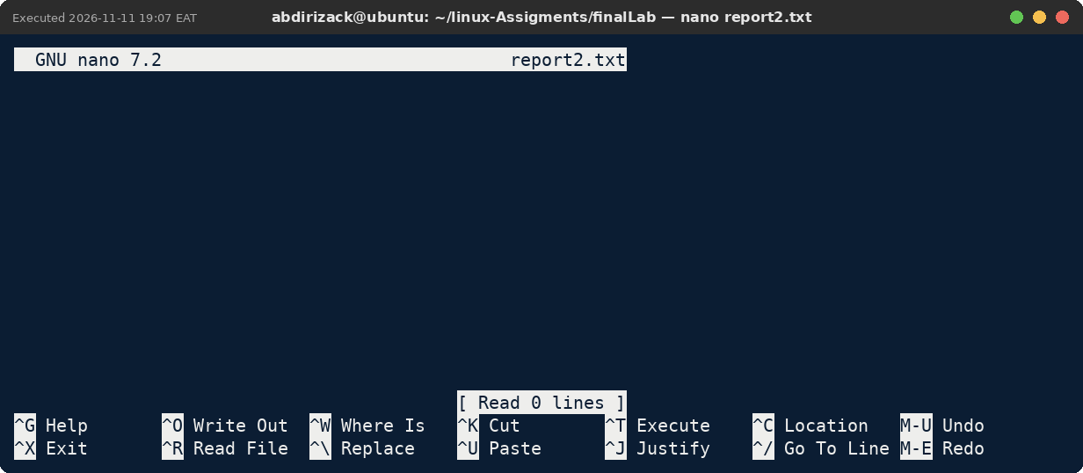

3.12 vim
1. Command Name | vim
2. Definition | A fast editor with modes: Normal (commands), Insert (typing) and Command-line (:).
3. Syntax | vim FILE
4. Options and Shortcuts
Option / Shortcut | Name | Description & Example Usage
i | Insert | Start typing.
Esc | Normal | Stop typing.
:wq | Save and quit
:q! | Quit without saving
dd | Delete line | In Normal mode.
5. Example
$ vim scores.txt
Explanation: Opens scores.txt in Vim in Normal mode; :q! closes it without changes.
6. Terminal Screenshot
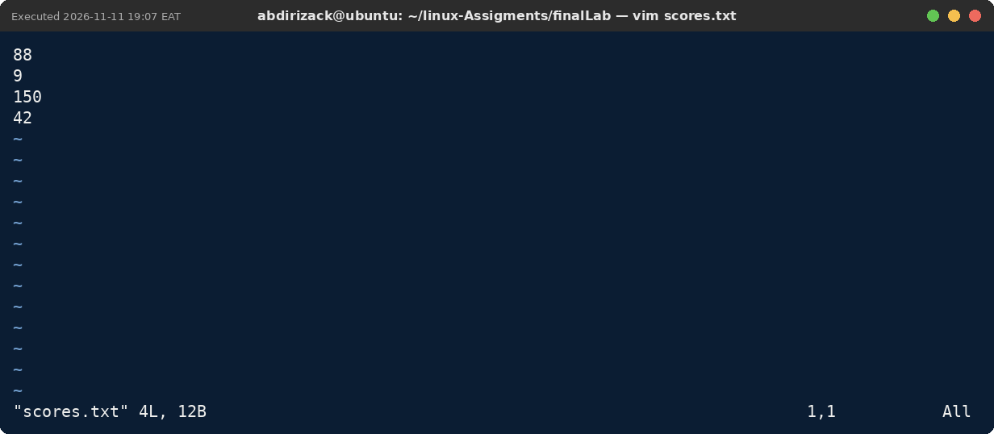

3.13 ln
1. Command Name | ln
2. Definition | Creates a hard link (another name for the same file) or a symbolic link (a shortcut).
3. Syntax | ln FILE LINK  ln -s FILE LINK
4. Options and Shortcuts
Option / Shortcut | Name | Description & Example Usage
ln | Hard link | Same inode number; works after the original is renamed.
ln -s | Symbolic link | Points to a path; breaks if the target moves.
ls -li | Inspect | Shows inode numbers and arrows.
5. Example
$ ln -sv names.txt names-link.txt
Explanation: Creates the symbolic link names-link.txt that points to names.txt.
6. Terminal Screenshot
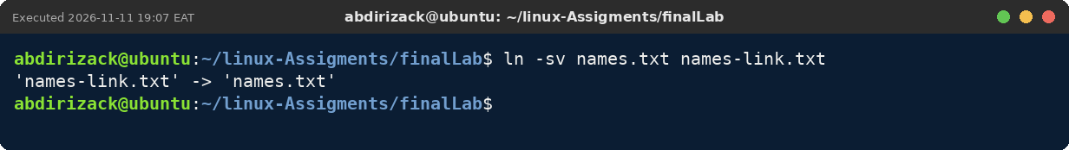

Chapter 4: Process, Service and System Management

4.1 ps
1. Command Name | ps
2. Definition | Shows the processes that are running at this moment.
3. Syntax | ps [OPTIONS]
4. Options and Shortcuts
Option / Shortcut | Name | Description & Example Usage
ps | Mine | Processes in this terminal.
-ef | Everyone | All processes with PPID.
aux | Details | All processes with CPU and memory %.
-o | Columns | Example: ps -o pid,ppid,cmd
5. Example
$ ps -f
Explanation: Shows the shell and the ps command with their owner, PID, parent PID and start time.
6. Terminal Screenshot
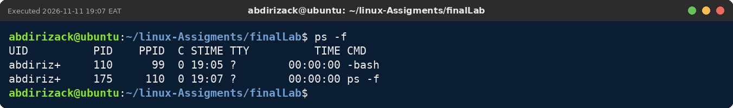

4.2 top and htop
1. Command Name | top and htop
2. Definition | Live views of running processes, CPU and memory. htop is a colourful version.
3. Syntax | top  htop
4. Options and Shortcuts
Option / Shortcut | Name | Description & Example Usage
P / M | Sort | By CPU / by memory (top).
k | Kill | Stop a process from inside top.
F10 or q | Quit | Leave htop / top.
-u USER | One user | Example: top -u abdirizack
5. Example
$ top
Explanation: Shows the live system summary (uptime, tasks, CPU, memory) and the process list. q closes it.
6. Terminal Screenshot
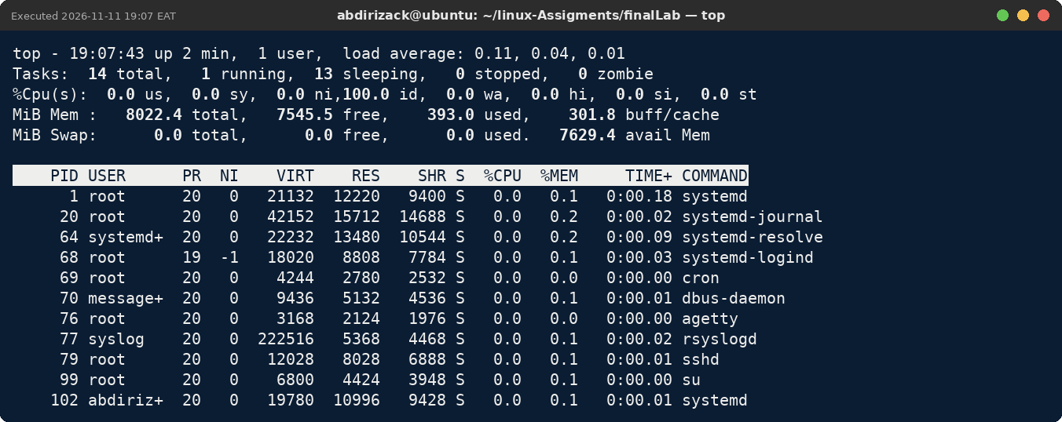

4.3 jobs, bg and fg
1. Command Name | jobs, bg and fg
2. Definition | Control commands running in this terminal: list them, continue them in the background, or bring them back.
3. Syntax | COMMAND &  jobs  bg %N  fg %N
4. Options and Shortcuts
Option / Shortcut | Name | Description & Example Usage
& | Start in background | Example: sleep 200 &
Ctrl+Z | Pause | Stops the running job.
bg | Continue in background | Example: bg %2
fg | Bring forward | Example: fg %1
Ctrl+C | Stop | Ends the job.
5. Example
$ sleep 120 & jobs
Explanation: sleep 120 starts in the background as job 1, and jobs shows it is Running.
6. Terminal Screenshot
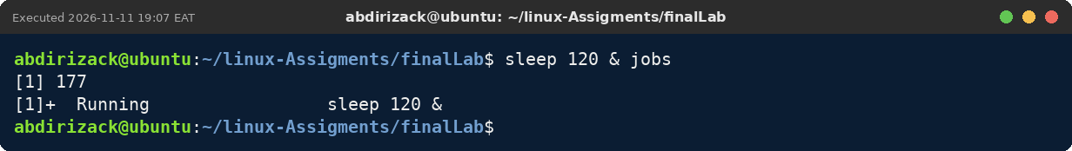

4.4 kill, pkill and killall
1. Command Name | kill, pkill and killall
2. Definition | Send signals to processes, usually to stop them.
3. Syntax | kill [-SIGNAL] PID  pkill NAME  killall NAME
4. Options and Shortcuts
Option / Shortcut | Name | Description & Example Usage
kill PID | TERM (15) | Polite stop.
kill -9 PID | KILL (9) | Forced stop; last option.
pkill -u USER NAME | By user and name | Example: pkill -u abdirizack sleep
killall NAME | Exact name | Stops all with that name.
5. Example
$ sleep 200 & kill $!
Explanation: The background sleep received the TERM signal and the shell reports it as Terminated.
6. Terminal Screenshot
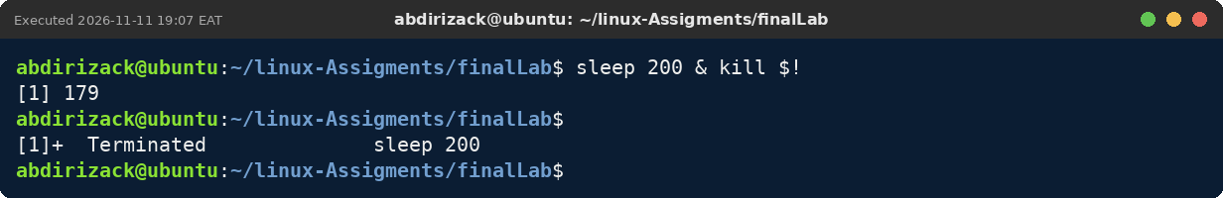

4.5 nice and renice
1. Command Name | nice and renice
2. Definition | Set the priority of a process: from -20 (most CPU) to 19 (least CPU).
3. Syntax | nice -n N COMMAND  renice -n N -p PID
4. Options and Shortcuts
Option / Shortcut | Name | Description & Example Usage
nice -n 15 | Start low | Example: nice -n 15 sleep 250 &
renice -n 19 | Lower more | Allowed for normal users.
renice -n 0 | Raise | Needs sudo.
NI column | Check | ps -o pid,ni,cmd -p PID
5. Example
$ nice -n 12 sleep 40 & ps -o pid,ni,cmd -p $!
Explanation: sleep 40 started with niceness 12, shown in the NI column.
6. Terminal Screenshot
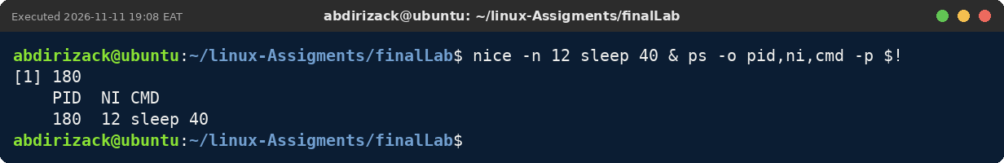

4.6 free, df and uptime
1. Command Name | free, df and uptime
2. Definition | free shows memory; df shows disk space; uptime shows running time and load.
3. Syntax | free -h  df -h  uptime
4. Options and Shortcuts
Option / Shortcut | Name | Description & Example Usage
free -h | Memory | Look at the available column.
df -h / | Disk | Used and free space.
uptime | Load | Load averages for 1, 5, 15 minutes.
nproc | CPUs | Number of processors.
5. Example
$ free -h; uptime
Explanation: Shows memory use and how long the system has been running with its load average.
6. Terminal Screenshot
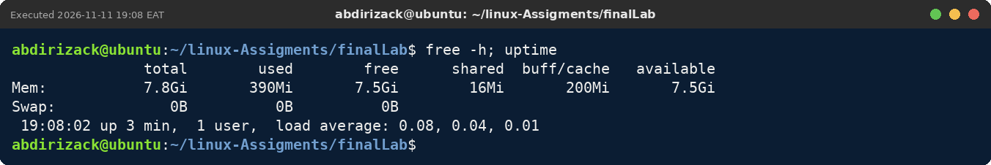

4.7 hostnamectl
1. Command Name | hostnamectl
2. Definition | Shows the computer name, operating system, kernel and architecture in one place.
3. Syntax | hostnamectl [status]
4. Options and Shortcuts
Option / Shortcut | Name | Description & Example Usage
hostnamectl | Summary | All details.
hostnamectl hostname | Name | Only the host name.
set-hostname | Change | sudo hostnamectl set-hostname NAME
5. Example
$ hostnamectl | grep -E 'Operating|Kernel|Architecture'
Explanation: Shows only the operating system, kernel and architecture lines from hostnamectl.
6. Terminal Screenshot
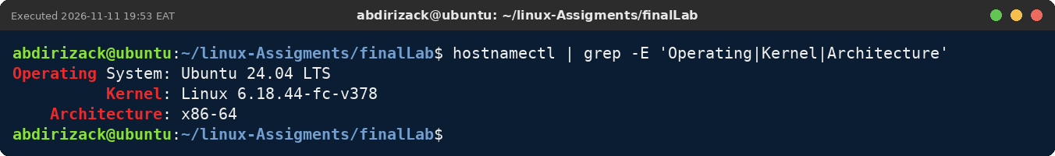

4.8 systemctl
1. Command Name | systemctl
2. Definition | Manages services (background programs) that systemd runs.
3. Syntax | systemctl ACTION SERVICE
4. Options and Shortcuts
Option / Shortcut | Name | Description & Example Usage
status | State | Running or not, with recent logs.
start / stop | Now | Needs sudo.
restart / reload | Apply changes | reload keeps the same process.
enable / disable | At boot | Needs sudo.
list-units --type=service | List | All services.
5. Example
$ systemctl status cron --no-pager | head -n 5
Explanation: The cron service is enabled at boot and active (running).
6. Terminal Screenshot
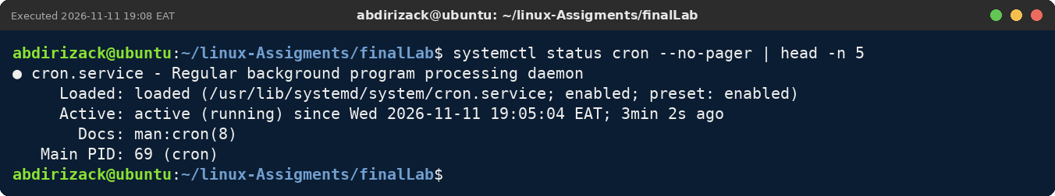

4.9 journalctl
1. Command Name | journalctl
2. Definition | Shows the system logs recorded by systemd.
3. Syntax | journalctl [OPTIONS]
4. Options and Shortcuts
Option / Shortcut | Name | Description & Example Usage
-u SERVICE | One service | Example: journalctl -u ssh
-n N | Newest N | Example: journalctl -n 5
--since | Time | Example: --since "10 min ago"
-f | Live | Follow new lines.
5. Example
$ journalctl -u cron -n 5 --no-pager
Explanation: Shows the last five log entries of the cron service.
6. Terminal Screenshot
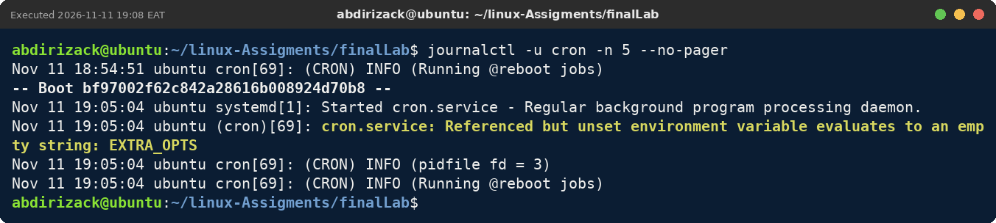

4.10 shutdown and reboot
1. Command Name | shutdown and reboot
2. Definition | Turn off or restart Linux safely.
3. Syntax | sudo shutdown -h now  sudo shutdown -r +MIN  sudo shutdown -c  sudo reboot
4. Options and Shortcuts
Option / Shortcut | Name | Description & Example Usage
-h now | Power off now
-r +10 | Restart in 10 min | Example: sudo shutdown -r +10
-c | Cancel | Cancels the plan.
reboot | Restart now
5. Example
$ sudo shutdown -r +15 && sudo shutdown -c
Explanation: sudo asked for the password, a restart was scheduled for 15 minutes later, and shutdown -c cancelled it.
6. Terminal Screenshot


