Table of Contents

**Acknowledgment 2**

**ABSTRACT 3**

**Chapter 1 4**

**INTRODUCTION 4**

**STATEMENT OF THE PROBLEM 5**

**Tasks assigned to me 6**

**Objectives of the Task 6**

**Significance of the task 7**

**Challenges that I faced 7**

**Tasks I was not able to complete 7**

**Chapter 2 8**

**Methodologies and Business process Analysis 8**

**Methodology 8**

**Method of data collection 8**

**Analysis 9**

**Result of my analysis and Task 10**

**Conclusion based on the results obtained from my task 10**

**Recomandation 11**

# Acknowledgment

First, I would like to thank God who helped me to successfully complete my apparent ship. Next, I would like to express my thanks and gratitude to the North Gondar Zone ICT office especially for Debark branch office for giving me to the courage, and guidance to work with the employee through the process of this writing and every aspect of my work.

Third I would like to thank the administration of Haramaya University including the College of computing and informatics for the appreciable facilitation of this practical attachment.

Then my thanks go to my advisor Rama.A for her guidance, help, and encouragement which have install me the spirit of confidence to finish this completely.

# ABSTRACT

## The overall introduction part which includes the background of the organization, statement of the problem, tasks given to me and objectives of my task along with problems I faced with my tasks. The report also contain method of the data collection and methods of the problem analysis Result Discussion and Recommendation including conclusion from result obtained, comment in task completed, experience I have got, level of satisfaction over the tasks done. The working environment of hosting organization and finally recommendation related to the work done are including.

# Chapter 1

## INTRODUCTION

The hosting organization that I settle on has many milieus as the same as most backgrounds of other information communication technology (ICT) offices in other places I.e. (Zones) can have, because, the organization is governed by Amhara National and Regional Stat. The north Gondar Debark ICT development and promotion office is established in 1998 E.C as an autonomous regional government office, having its own personality and its own work tasks.

Most of The services provided by the government are done manually and take a lot of time to process data. Our country is one of the third world countries but at the present we are showing a tremendous improvement in quality of life for citizen and development of the country as a whole but with our fast growing economy there is still a lot left to be done on the sector of Information Systems and Technology.

## STATEMENT OF THE PROBLEM

In an office exchange of information is a very important thing. In the office I worked on I noticed the move data a lot but they moved and shared data with hardcopy, on a CD/DVD or with a removable disk. These methods of sharing data have a lot of disadvantages like

* Data might be attacked and corrupted by viruses on removable disks.
* Data might be lost due to scratch and broken CD/DVDs
* The Expensiveness of CD/DVDs for moving data.
* The Expensiveness of Removable disks.
* Removable disks may corrupt with virus attacks.

The documents are collected starting from 1998 when the organization starts its activity or service. Finding a file or a document is so difficult and it is boring and I request them to do one system that can minimize this problem, but they have one doubt that is what if the system fails. I showed secretaries how to use Microsoft excel to registers different information coming in to the office.

Besides the above other problems I noticed when I was in the organization are

* Limitation of net work access
* Some computer is not working b/c of absence of anti various and luck of maintenance
* Some workers are not willing to do their tasks.

## Tasks assigned to me

The main task I was assigned to do in the organization is to interconnect the computers in the organization and enable them to share files and printers.

Additional tasks that were assigned to me:-

* To Setup a LAN to share files and data within the organization’s offices
* Give maintenance service for the employee
* To install some antivirus
* To install some software (OS, Microsoft office)

## Objectives of the Task

The tasks that were assigned to me are related to solving the wastage of moony and time with every day task of sheering data within the organization. My task will enable offices within the organization to share files and printers which will save the money the organization uses to buy CD/DVDs, removable disks and other medias to share and transfer data. After the implementation of my task the organization will also save the money that it uses for repairing the printers that are associated with each PC by enabling the personal computers to share a common printer.

**Significance of the task**

The significance of the task that was assigned to me at the organization was solving the problem the employees of the organization ware facing with sharing files within the organization at the same time saving resources of the organization including money and time.

In my time I was working with the organization I was able to set up a full LAN among the computers of the organization and full internet access for each PC. In order to complete my task I had to use

* CAT5e data cables
* Three distribution switches
* A core switch
* T1 connection from the ISP i.e. ethio telecom
* Replace some outdated NICs(network interface cards)

## Challenges that I faced

* I had to replace some outdated NICs
* It took so long for the ISP to bring the connection to the Demark Point
* Lack of budget to buy some equipments

**Tasks I was not able to complete**

I was not able to accomplish the following tasks due to some problems

* I was not able to setup a centralized server system because the organization didn’t decide on the budget to buy server software on time.

**Chapter 2**

**Methodologies and Business process Analysis**

### Methodology

I was working on the on ICT support team office. On North Gondar Debark ICT branch office. These offices give service for the customer as well as the organization employee. I was mostly working on this department by giving some maintenance for the employee includes installation some soft ware and hardware repair.

**Method of data collection**

I used different types of data collecting method or techniques.

Some of the methods are her below:-

1. Personal observation
2. Interviewing
3. **Personal** Observation: - I was able to see problems some office and I observe that some workers have little knowledge about File and Printer sharing on the Network. This cost the organization a lot of money and resource.
4. Interview: - also I also collected the opinion from employees. Most answers were negative and complained that it was hard and time wasting to move information around the office. Some of the question are:-
5. What kind of service do you provide for the customers?
6. How do you transfer data between offices?
7. How does your method of data sharing affect the customers?

### Analysis

I did the analysis for the organization based on the knowledge I got from my OOSAD course. The organization uses old and traditional data sharing and collection methods. So, the organization should have the following kind of network infrastructure in order to support data and printer sharing.

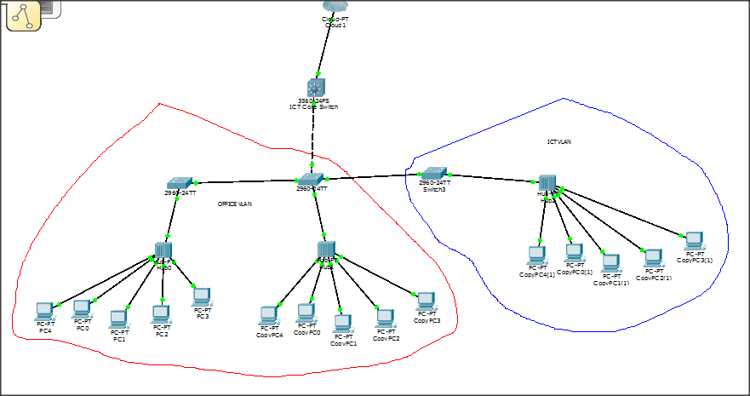

## Result of my analysis and Task

My task helped the employyes of the organization to share files and printers over a LAN. The LAN I designed is scalable and redendant, it also uses new technologies which are compatable with latest softwares for future topology and technology changes. The LAN also saves a lot of money for the organization from different expenses like:-

* Expense for CD/DVDs to move arround files
* Expense for a lot of printers and their mentainance expenses

The LAN saves untangable resourse of the organization which is Time. The automation and LAN of the organization enables files to move easy and fast which speeds up the work flow of the organization.

## Conclusion based on the results obtained from my task

In my time at my hosting organization I was given a task to setup and impliment a LAN i.e Local Area Network that speeds up the functions of the organization by providing fast and reliable data transfer betewen different offices of the organization. So I set up a LAN which is connected to the organization’s ICT office which enabled the users to get fast Internet accsess. My task also helped on minimizing the cost for file sharing and it saves time for the employyes. So I conclud that my task was helpful for the employes as wel as the organization itselfe.

Experience I have got

On my practical attachment I got a lot of experiances from the well skilled and knowledgable employyes of the ICT department of the organizaton. The experience I got are both theorethical and practical some of them are:-

* How to set up a LAN
* How to crimp data cabels
* Catagories of data cables and their uses
* How to repair computers
* How to connect LAN to the internet

## Recomandation

* The organization should use lates technology to handle data and information
* The organization should have a centeralized system in the ICT
* The organization should give traning to the emploes more often
* The organization should improve the skill of the ICT department employyes by giving chance for further education levels.