DATABASE STRUCTURE DIAGRAM
Jamhuriya Research Management System (JUST RMS)
This document presents the entity-relationship diagram of the MongoDB database used by JUST RMS. Relationships are implemented as Mongoose ObjectId references in backend/src/models. The system currently uses 18 collections.

1. Entity-Relationship Diagram
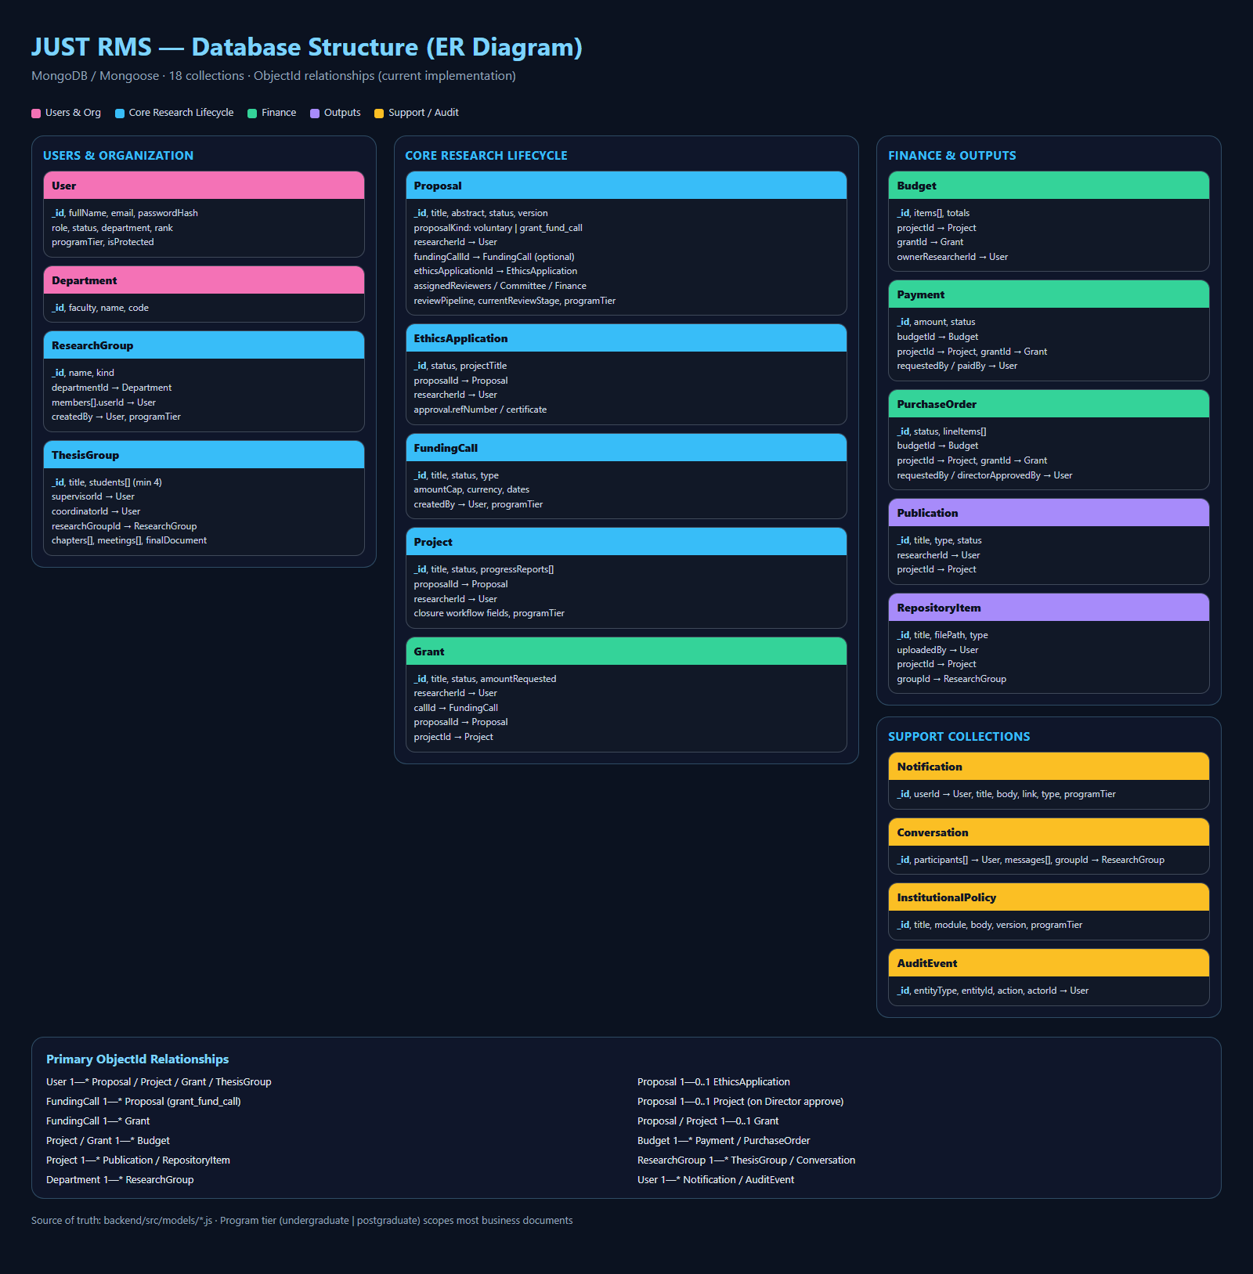
Figure 1: JUST RMS database structure (18 MongoDB collections)

2. Collections by domain
Domain | Collections
Users & Organization | User, Department, ResearchGroup, ThesisGroup
Core Research Lifecycle | Proposal, EthicsApplication, FundingCall, Project, Grant
Finance | Budget, Payment, PurchaseOrder
Outputs | Publication, RepositoryItem
Support / Audit | Notification, Conversation, InstitutionalPolicy, AuditEvent

3. Key relationship summary
From | To | Cardinality | Meaning
User | Proposal / Project / Grant | 1 — * | Researcher owns research records
Proposal | EthicsApplication | 1 — 0..1 | Embedded/linked JUREC ethics case
FundingCall | Proposal | 1 — * | Grant applications linked by callId
Proposal | Project | 1 — 0..1 | Created on Director approval
FundingCall / Proposal / Project | Grant | 1 — 0..1 / * | Awarded funding record
Project / Grant | Budget | 1 — * | Budget lines for funded work
Budget | Payment / PurchaseOrder | 1 — * | Disbursement and procurement
Project | Publication / RepositoryItem | 1 — * | Research outputs and files
ResearchGroup | ThesisGroup | 1 — * | Optional group link for thesis
User | Notification / AuditEvent | 1 — * | Alerts and audit trail

4. Notes
Most business documents include a programTier field (undergraduate | postgraduate). Shared staff accounts send X-Program-Tier so queries stay portal-scoped. Password fields are stored as bcrypt hashes. File paths for uploads (proposal documents, thesis final manuscripts, repository files) point to the server uploads directory.
Source of truth for field-level schema details remains backend/src/models and the companion document DATABASE_STRUCTURE.docx.

