JUST RMS — Solutions Architecture
Scalable, secure, modern design for Jamhuriya Research Management System

Prepared as a Senior Solutions Architecture recommendation for the university research lifecycle platform (proposals, ethics, multi-stage review, projects, grants, finance, publications). Grounded in the current MERN implementation, with a target architecture for scale and security.

1. Executive summary
JUST RMS should remain a modular web platform with clear separation of presentation, API, and data. The recommended stack is a React SPA, Node.js/Express (or NestJS evolution) API, MongoDB for document-centric research records, JWT auth with role + portal scoping, and optional Redis/object storage as the system grows.
• Current fit: MERN matches research document workflows and fast iteration for a thesis-grade institutional system.
• Scale path: keep monolith API first; extract workers (PDF, email, analytics) when load requires it.
• Security baseline: least privilege roles, portal isolation (UG/PG), assign-first review gates, HTTPS, secrets in env, audit trail.

2. High-level architecture
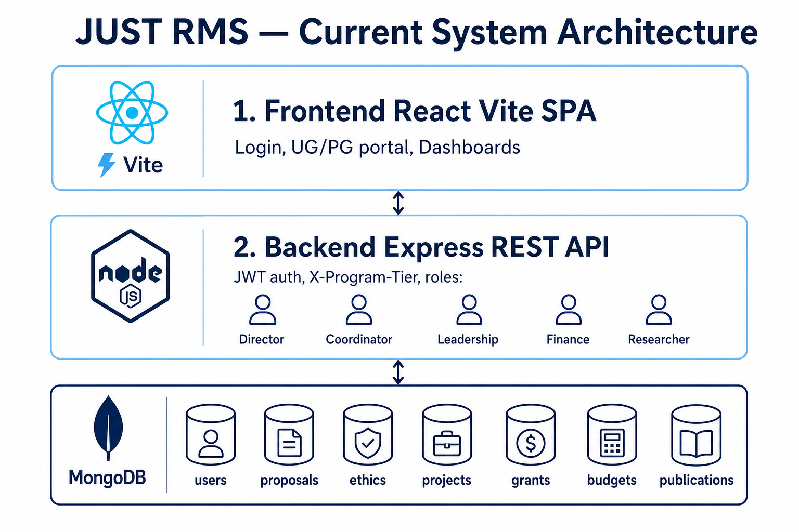
Figure 1. Logical layers (Frontend / API / Database)

2.1 Presentation layer (Frontend)
• SPA for dashboards, proposal review, finance queues, ethics, projects, publications
• Portal selection for shared staff (Undergraduate / Postgraduate)
• Role-based route guards; all roles land on Dashboard after auth

2.2 Application layer (Backend API)
• REST API under /api/* with JWT authentication
• Domain modules: auth, users, proposals, ethics, projects, funding, grants, budgets, payments, publications, repository, groups, thesis, analytics, notifications, audit
• Business rules: multi-stage review (peer → committee → finance for grants), assign-first, ethics separate from faculty committee

2.3 Data layer
• MongoDB collections scoped by programTier
• File uploads for proposals/repository; certificate PDFs for ethics
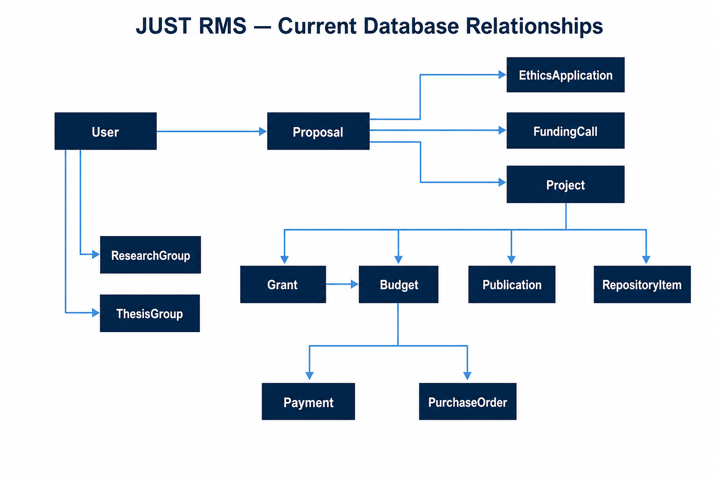
Figure 2. Core data relationships

3. Recommended tech stack

3.1 Frontend (recommended)
• Primary: React 18/19 + Vite (current) — fast DX, strong ecosystem
• Routing: React Router; HTTP: Axios; charts: Recharts
• Optional upgrades: React Query/TanStack Query for server state; Zod for form/API validation; Playwright for E2E
• UI: keep institutional design system; avoid heavy UI kits that fight brand guidelines

3.2 Backend (recommended)
• Primary: Node.js + Express (current) — proven for this codebase
• Evolution path: NestJS if team wants stricter modules, DI, OpenAPI-first contracts
• Auth: JWT access + refresh; bcrypt password hashing; role middleware
• Uploads: Multer → disk now; migrate to S3-compatible object storage for production scale
• Jobs: BullMQ + Redis for email, PDF, large exports (add when needed)

3.3 Database (recommended)
• Primary: MongoDB Atlas (managed) — fits nested reviewPipeline, assignees, ethics forms
• Indexes: programTier + status + foreign keys (proposalId, projectId, researcherId)
• Optional later: Redis cache for dashboards; OpenSearch for global search at scale

3.4 Infrastructure
• Dev: local Node + MongoDB
• Prod: Render/Fly/Azure App Service + MongoDB Atlas; CDN for static SPA
• Secrets: environment variables / secret manager — never commit passwords
• Observability: structured logs, health endpoint, audit collection (already present)

4. Security architecture
• Transport: HTTPS only in production; secure cookies if refresh stored client-side
• Identity: JWT short-lived access tokens; rotate refresh; revoke on logout
• Authorization: role + resource checks; assign-first for peer/committee/finance
• Portal isolation: X-Program-Tier for shared staff; researchers locked to programTier
• Input: validate payloads; limit upload types/sizes; sanitize file names
• Data: least privilege DB user; backup/retention policy; PII minimization in logs
• Compliance: ethics certificates, audit events for sensitive decisions

5. Scalability design
• Phase 1 (now): modular monolith API + SPA + MongoDB — correct for university load
• Phase 2: horizontal API replicas behind load balancer; Atlas replica set; object storage for files
• Phase 3: async workers for certificates/notifications/reports; rate limiting; CDN
• Do not microservices-split early — boundaries should follow domains (proposals, finance, repository) only when team/ops demand it

6. Domain flows (core)
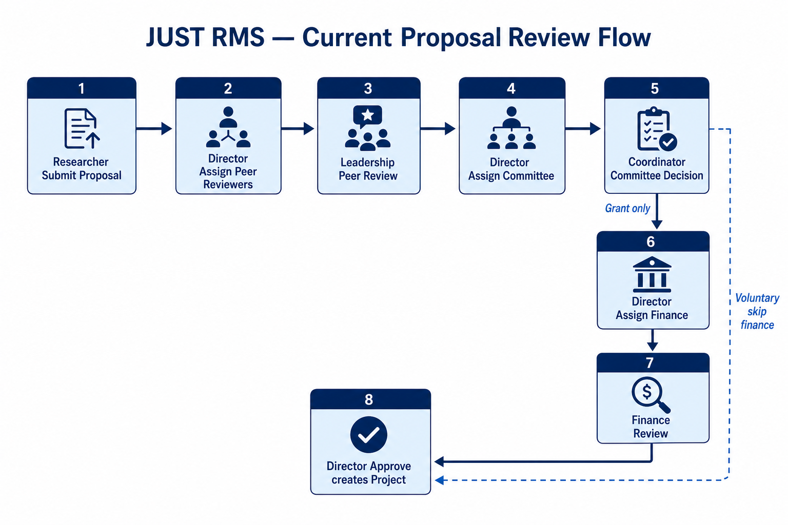
Figure 3. Proposal multi-stage review (current product rule)
• Voluntary: peer → committee → director approve (finance skipped)
• Grant: peer → committee → finance → director approve → project → budgets/payments
• Closure: director checklist → finance clear → project closed

7. Frontend architecture guidelines
• Feature folders by domain (proposals, finance, projects)
• Shared auth/portal hooks; central API client with auth + tier headers
• ProtectedRoute by role; keep finance deep-links under /finance/*
• Prefer server truth for counts (peer queues aligned Director/Leadership)

8. Backend architecture guidelines
• Routes → controllers → models/utils; keep pipeline helpers shared
• Explicit authorizeRoles on sensitive POSTs
• Idempotent notifications where possible; audit every director/finance decision
• OpenAPI/Swagger generation recommended for stakeholder integration

9. Database design principles
• Document model for proposal reviewPipeline and ethics forms
• Reference integrity via ObjectId refs (proposalId, projectId, userId)
• programTier on business documents for portal queries
• Unique sparse links where 1:1 required (ethics↔proposal, publication↔project)
• Avoid soft-passing review stages from unrelated modules (ethics ≠ committee)

10. Target reference stack (summary)
• Frontend: React + Vite + React Router + Axios (+ TanStack Query)
• Backend: Node.js + Express (NestJS optional migration)
• DB: MongoDB Atlas + Mongoose
• Auth: JWT + bcrypt + role/portal middleware
• Files: S3-compatible storage (production)
• Cache/jobs: Redis + BullMQ (when needed)
• Hosting: container or PaaS + CDN; CI/CD from GitHub

11. Alignment with current JUST RMS
The running system already implements the recommended core: MERN, JWT, UG/PG portals, assign-first Phase-3 review, finance-separated queues, and MongoDB domain collections. This architecture document endorses that foundation and defines the secure scale-out path without discarding the working product.
• Companion docs: SYSTEM_COMPLETE.docx, SYSTEM_ARCHITECTURE_CURRENT.docx, DATABASE_STRUCTURE.docx, SYSTEM_HOW_IT_WORKS.docx

