JUST RMS — Complete System Architecture
Full current system (not a draft) — MERN codebase

This document describes the whole Jamhuriya Research Management System as implemented: portals, layers, modules, pages, roles, and the proposal-to-project lifecycle.
1. System purpose
JUST RMS manages university research end-to-end: proposals, ethics (JUREC), peer/committee/finance review, projects, funding calls, grants, budgets, payments, publications, repository, groups, thesis supervision, analytics, notifications, policies, and audit.
• Two portals share one app and one database: Undergraduate (UG) and Postgraduate (PG).
• Shared staff pick portal after login (X-Program-Tier). Researchers are locked to their programTier.
• After login every role opens Dashboard (/dashboard).
2. Architecture diagram
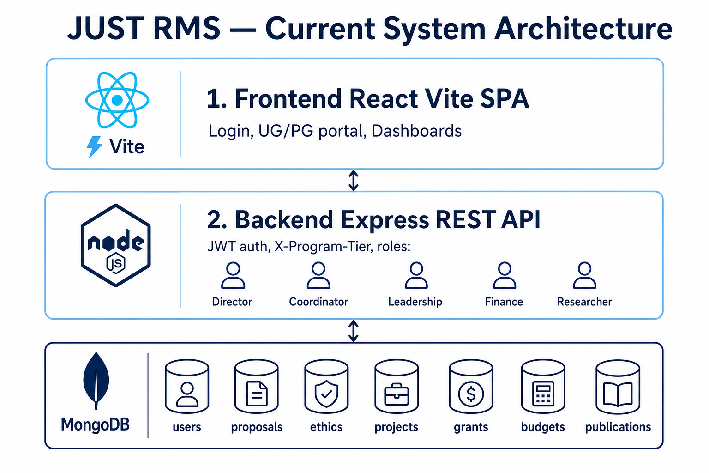
Figure 1. Current layered architecture (Frontend / API / MongoDB)
3. Technology stack
3.1 Frontend
• React + Vite + React Router + Axios + Recharts
• Auth JWT in client; staff send header X-Program-Tier
• Dev URL: http://localhost:5173 (proxies /api to backend)
3.2 Backend
• Node.js + Express REST API under /api/...
• JWT access token + refresh token on User; bcrypt passwords
• Multer uploads; PDF certificate generation for ethics
• Middleware: authenticateUser, requireActiveUser, authorizeRoles, programTier scope
• Dev URL: http://localhost:5000
3.3 Database
• MongoDB via Mongoose — see DATABASE_STRUCTURE.docx for full schema
4. Proposal review flow (Phase 3) — whole path
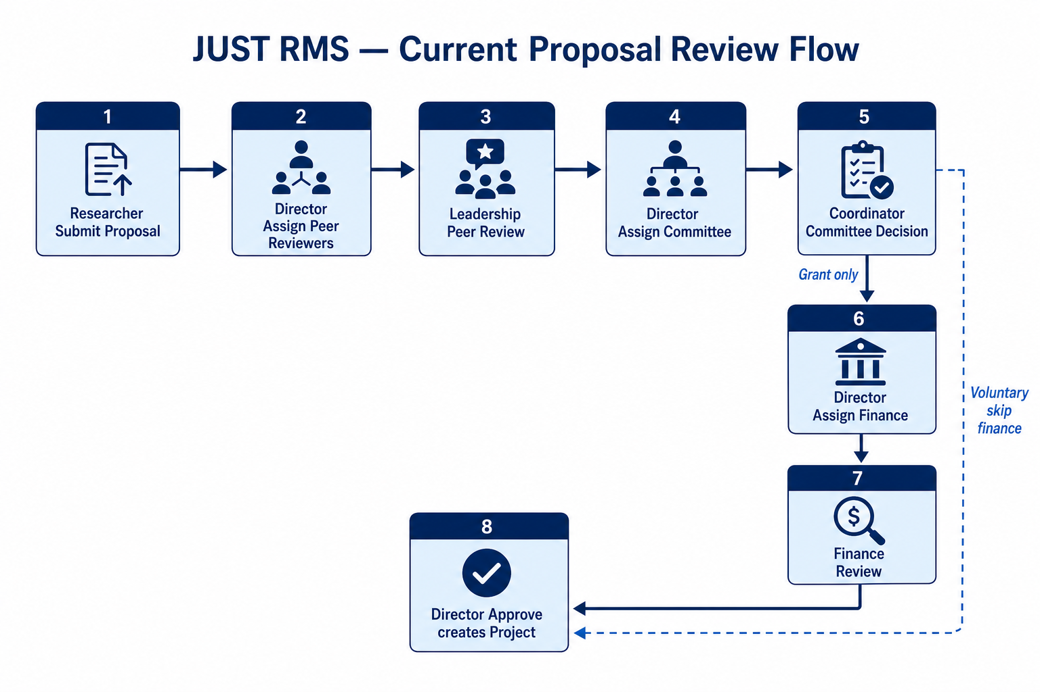
Figure 2. Current multi-stage proposal review
• 1. Researcher submits Voluntary or Grant fund call proposal (+ ethics when required)
• 2. Director: Assign & send to reviewer (Leadership)
• 3. Leadership: peer score 1–5 + comment
• 4. Director: Complete peer stage when all assignees submitted
• 5. Director: Assign & send to committee (Faculty Coordinators)
• 6. Assigned Coordinator: committee recommend/reject/revision
• 7. Grant only — Director: Assign & send to finance
• 8. Grant only — Assigned Finance: approve/reject at /finance/reviews
• 9. When stage = ready_for_director — Director Proposal decision → Approve creates Project
• Voluntary: finance stage skipped. Ethics certificate does NOT auto-pass committee.
• List chips: Sent to reviewer | Sent to committee | Sent to finance
5. Complete module map (UI routes)
5.1 All authenticated users
• /dashboard — home
• /profile — profile
• /notifications — notifications
• /policies — institutional policies
5.2 Research / proposals / projects
• /proposals — list; /proposals/new|edit — researcher create/edit
• /proposals/:id — details; /proposals/:id/review — Director/Coordinator/Leadership review
• /review-assignments — Director + Leadership peer queue
• /ethics — ethics applications + JUREC
• /projects — list; /projects/:id — details; /projects/:id/progress — researcher progress
• /publications, /repository, /groups, /thesis, /research-workflow
• /collaboration, /messages
5.3 Funding & finance
• /funding-calls, /grants, /grants/apply, /grants/:id
• /budgets, /payments/:id
• /finance/reviews, /finance/reviews/:id — Finance proposal review
• /finance/grant-approvals — Finance grant authorization
• /finance/closures — Finance project closures
• /finance-reports, /donor-reports — Director/Finance reports
5.4 Director / staff ops
• /pending-users, /departments — Director
• /faculty-dashboard — Coordinator
• /kpi-dashboard, /system-reports, /audit-trail, /search
• /program-tier — portal picker for shared staff
6. Complete API surface (app.js)
• /api/auth — login, refresh, me
• /api/users — user admin / pending
• /api/proposals — CRUD, submit, assign-reviewers, assign-committee, assign-finance, peer/committee/finance review, director decision
• /api/ethics — applications, director decision, certificate PDF
• /api/projects — projects, progress, closure
• /api/funding-calls, /api/grants, /api/budgets, /api/payments, /api/procurement
• /api/publications, /api/repository (+ public OAI-PMH)
• /api/groups, /api/thesis-groups, /api/departments
• /api/analytics, /api/notifications, /api/conversations
• /api/policies, /api/search, /api/audit
• /api/health — health check
7. Roles and responsibilities (complete)
• research_director — assign peer/committee/finance; ethics certificate; final approve; users; funding calls; oversight reports
• faculty_coordinator — committee review when assigned; faculty dashboard
• leadership — peer review when assigned; peer assignments queue
• finance_officer — grant proposal finance review; grant authorization; budgets/payments; project closure finance
• researcher — proposals, ethics, projects, publications, grants apply, repository
Demo users and passwords (after npm run seed)
• Research Director — director@rms.edu / Director2024! — pick UG or PG
• Faculty Coordinator — coordinator@rms.edu / Coordinator2024! — pick UG or PG
• Finance Officer — finance@rms.edu / Finance2024! — pick UG or PG
• Leadership (peer) — leadership@rms.edu / Leadership2024! — pick UG or PG
• Researcher UG — asha@rms.edu / Researcher2024! — Undergraduate only
• Researcher PG — mahad@rms.edu / Researcher2024! — Postgraduate only
8. Security and scoping
• JWT Bearer required on protected routes
• authorizeRoles on sensitive endpoints (peer/committee/finance assign & decide)
• programTier filter on business documents
• Assign-first gates: committee/finance cannot decide without assignment
• Director final approve blocked until multi-stage ready_for_director
9. Run and deploy
• Local: backend npm run dev + frontend npm run dev; seed with npm run seed
• Production option: Render Blueprint (render.yaml) + MongoDB Atlas
• Related Word: DATABASE_STRUCTURE.docx (full schema), SYSTEM_HOW_IT_WORKS.docx (user guide)

