JUST RMS — Complete System Documentation
Architecture + Database + How it works (current full system)

Part A — Architecture
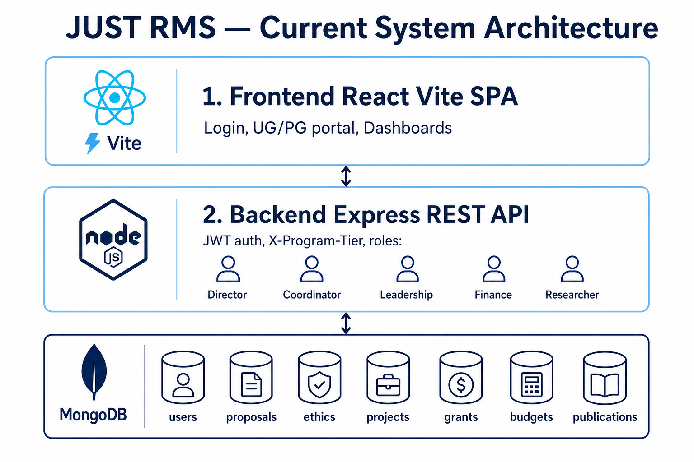
Figure A1. Layers
MERN: React/Vite frontend, Express API (JWT + X-Program-Tier), MongoDB. UG and PG portals. Dashboard home for all roles.
Part B — Review flow
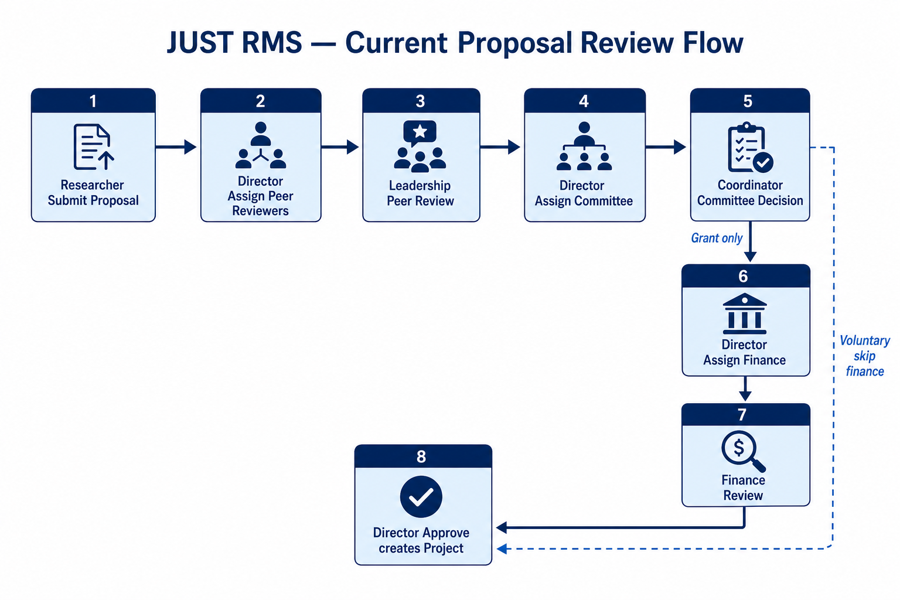
Figure B1. Proposal review
• Assign peer → Peer → Assign committee → Committee → (Grant) Assign finance → Finance → Director Approve → Project
• Voluntary skips finance. Ethics separate from committee.
Part C — Database
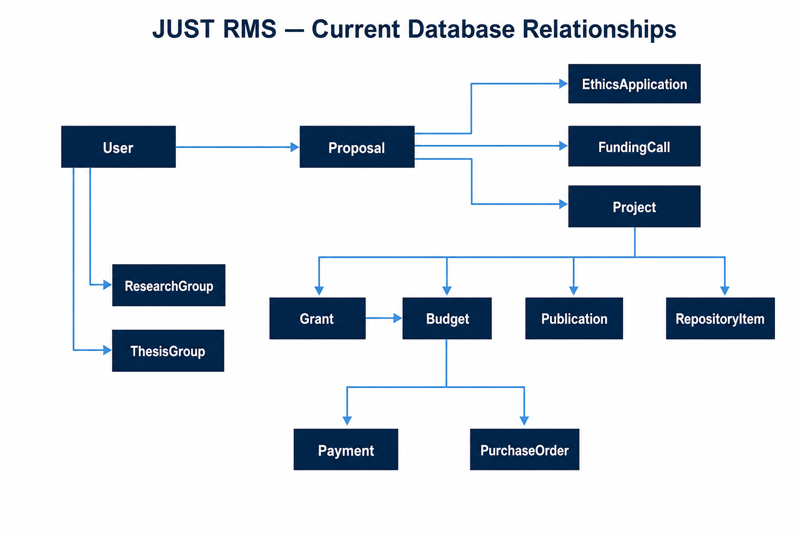
Figure C1. ER relationships
• 18 models: users, proposals, ethicsapplications, projects, fundingcalls, grants, budgets, payments, purchaseorders, publications, repositoryitems, departments, researchgroups, thesisgroups, conversations, notifications, institutionalpolicies, auditevents
Part D — Demo accounts
• director@rms.edu / Director2024!
• coordinator@rms.edu / Coordinator2024!
• finance@rms.edu / Finance2024!
• leadership@rms.edu / Leadership2024!
• asha@rms.edu / Researcher2024! (UG)
• mahad@rms.edu / Researcher2024! (PG)
Part E — See also
• SYSTEM_ARCHITECTURE_CURRENT.docx — full architecture detail
• DATABASE_STRUCTURE.docx — full collection schemas
• SYSTEM_HOW_IT_WORKS.docx — full user guide

