**Design and implementation of the mobile App Rent Cars and house**

**advertising system**

**Submitted by:**

**Aweis Muridi Hashim**

**ID: 201-44-SO-HO-014**

This Report Presented in Partial Fulfillment of the Requirements For the Degree of

Masters in Software engineering Supervisor Name: **DR. Eng. Abdirashid Hassan Abdi**

Dean Department of Engineering and Computer Science (ECS)

University of Somalia



**Department of Software Engineering**

**Daffodil International University**

**May 18.2021**

# ACKNOWLEDGEMENT

First, we would like to express our heartiest thanks to Allah for the gift of our live, make us to complete this project correctly.

Then we would like to thank our supervisor **DR. Eng. Abdirashid Hassan Abdi,** Dean Department of Engineering and Computer Science (ECS)

University of Somalia.For the support and encouragement throughout every stage of this work was carried out. we thankful for his willingness to the deliberation at all times. And we would to thank the rest teachers of department of Software Engineering.

We would like to thank to our class mates in Daffodil International University, who took part in this discuss while completing the course work.

Finally, we thankful to our family especially to my parents for their support all the time and their encouragements throughout the entire career of this research project.

# DECLARATION

I hereby declare that, this project has been done by us under the supervision of **DR.**

**Eng. Abdirashid Hassan Abdi,** Department of Engineering and Computer Science (ECS)**, .** I also declare that neither this project nor any part of this project has been submitted elsewhere for award of any degree or diploma.

**Supervised by:**



## DR. Eng. Abdirashid Hassan Abdi Dean

Department of Engineering and Computer Science (ECS)

University of Somalia

**Submitted by:**



## Aweis Muridi Hashim

ID: 201-44-SO-HO-014

Department of SWE

Daffodil International University

# ABSTRACT

A rental houses and cars management framework is a service that allows owners to rent for a set period of time for a fee through the internet. Utilization Allows you to post a rental house or car that can be used by potential residents. They will get in touch with you if they need to rent anything.

Renting is critical to one's quality of life and has significant economic, social, cultural, and personal implications. Though a country's national prosperity is typically calculated in economic terms, increasing wealth is of diminished value unless all citizens may profit from it and if the increased wealth is not used to address the social issues, such as housing shortages.

**1.1 INTRODUCTION ..................................................................................... 1**

**1.2 Background ............................................................................................. 2**

## 1.3 Problem Statement ................................................................................... 3

**1.4 Purpose and Scope .............................................................................................. 3**

**1.5 Conclusion ................................................................................................ 4**

## 2.1 Introduction ......................................................................................... 5

**2.2 Theoretical and Conceptual Development ........................................................ 5**-**8**

**2.3 Government strategy and incentives in the housing and car renting sector**........ **8**

**4.1 Introduction ............................................................................................ 19**

**4.2 Architecture ........................................................................................ 20**

## 4.3 User Interface ..................................................................................... 20

**4.4 Data Storage Design**........................................................................................... **21**

**4.5 Database Design** ............................................................................................ **21-34**

**4.6 Design Forms and Reports................................................................... 35-41**

**4.7 Conclusion .............................................................................................. 42**

**5.1 Intorduction ........................................................................................ 43**

## 5.2 Development Phase ............................................................................ 43

**5.3 Testing System Implementation** ................................................................... **44-47**

**5.4 Developing Documentation** ........................................................................... **47-48**

**5.5 Conclusion** ......................................................................................................... **49**

**6.1 Intorduction** ....................................................................................................... **50**

### 6.2 Objective achievement …………………………………………………………… 50

**6.3 weakness and problem of the system** ................................................................. **51**

**6.4 Future worke** ..................................................................................................... **51**

**6.5 Conclusion** ......................................................................................................... **52**

**CHAPTER ONE**

**INTRODUCTION**

### 1.1 introduction

These days, data and communication innovations are developing from year to year. In this innovative period, most of the management is done by computer and all the data is put away within the database. The importance of computer in business is to scale back work force, simple the work, saving time and price.

A rental houses and cars management framework is a service that allows owners to rent for a set period of time for a fee through the internet. Utilization Allows you to post a rental house or car that can be used by potential residents. They will get in touch with you if they need to rent anything.

Renting is critical to one's quality of life and has significant economic, social, cultural, and personal implications. Though a country's national prosperity is typically calculated in economic terms, increasing wealth is of diminished value unless all citizens may profit from it and if the increased wealth is not used to address the social issues, such as housing shortages.

A car rental is a vehicle that can be rented for a certain amount of time for a fee. People who do not have access to their own personal vehicle and house or do not own a vehicle and house at all can use a rental car to get around. An individual who wishes to rent a car must first make contact with the car rental company for the desired vehicle and house.

### 1.2 Background of the Project

Housing has a central importance to quality of life with considerable economic, social, cultural and personal significance. Though a country’s national prosperity is usually measured in economic terms, increasing wealth is of diminished value unless all can share its benefits and if the growing wealth is not used to redress growing social deficiencies, one of which is housing (Erguden, 2001). Housing plays a huge role in revitalizing economic growth in any country, with shelter being among key indicators of development. The universal declaration of human rights gives one of the basic human rights as the right to a decent standard of living, central to which is the access to adequate housing (United Nations, The Human Rights-article 25, 1948). Housing as a basic human right demands that urban dwellers should have access to a decent housing, defined as one that provides a foundation for rather than being a barrier to good physical and mental health, personal development and fulfilment of life objectives (Seedhouse, 1986). The focus of this research project is basically managing housing for low income, medium and high incomes households or what is commonly known as affordable housing. Affordable is a term used to describe individuals‟ capability to pay for certain products or services because their income is enough to do so. Although the term „affordable housing‟ is often applied to rental housing that is within the financial means of those in the lower income ranges of a geographical area, the concept is applicable to both middle- and high-income individuals. Most families choose to rent houses based on their income and family situations; unfortunately, there may not be enough good quality rental housing for these families. Housing is a major problem in Nigeria especially in Lagos. Millions of people are living in sprawling slams and also in other informal settlement around Lagos (UN-Habitat, 2008). This explains why many people have shifted their focus to developing rental houses in Lagos and other parts of the country. The demand for rental houses is extremely high and more rental houses need to be put in place. Developing rental houses comes with many advantages especially to the Landlords who are able to increase their profits through rent paid by the tenants. Increased number of tenants and Landlords makes management difficult especially for the landlords who are losing huge sum of money through tenants who evade rent. The above statement gives a clear declaration as to why rental house management system need to be developed.

### 1.3 Problem with the Current System

There are companies that provide rental services such as a house or car Some corporations use a system to advertise rental cars and rental cars there is no framework that advertises cars and houses available for rent since **KIROSOM** is one of the companies that provides rental services in Somali.

The current system's problems should be publicized on social media for leased houses and cars details. People are unable to post the things they wish to rent; only the administrator can do so. If anyone leases a house or a vehicle, the administrator may have difficulty locating and deleting the post.

The solution is to create a platform that connects the owner and the tenant, allowing owners to easily publish details about their vehicles or houses.

### 1.4 Purpose and Scope

The main purpose of this project is to design a mobile app labeled Rent House and Cars, for (KIRO SOM COMPNY) which will allow customers to view rental data as well as available house records and car details People will be able to create an account to deposit rental houses or cars information.

The scope of the project is to plan and implement a mobile rental management system for houses and cars. The essential center is provided on information security as the project is online application and will be moved in organize. This extends to all houses and cars accessible Somalia for rent. Through this project, I have attempted to automate, the pace and accuracy will be maintained in a proper manner.

### 1.5 Conclusion

Tenants are individuals who rent land or a vehicle. When it comes to renting houses and cars, this device would offer the best possible service to tenants. They won't know whether it's legal or not, and they can investigate whether the agent or the owner are genuine. Users may also display some details about them via the system. Since the system stores all of the details about rental cars and houses in one place, users can contact the owners to see if they are eligible.

**CHAPTER TWO**

**Literature Review**

### 2.0 INTRODUCTION

Literature review is a text written by someone to consider the critical points of current knowledge including substantive findings as well as theoretical and methodological contributions to a particular topic. Main goals are to situate the current study within the body of literature and to provide context for the particular reader (Cooper, 1998)

Effective rental management is a challenging task that necessitates relevant knowledge, capacity, and adequate technical and organizational skills, as well as resources, in order to effectively preserve and increase property value before it becomes obsolete. Property properties, such as land and structures, are a valuable resource for a variety of organizations, including municipal governments and the federal government.

### 2.1 Theoretical and Conceptual Development

Initially, rental software systems were created as custom or bespoke solutions for individual rental companies in the 1970s and 1980s, and they occurred simultaneously in locations all over the world. In the last two decades, a variety of key players have arisen, offering solutions for anything from single-store networks with one or two users to multicompany, multi-location businesses. According to Scarred (1995) “property management seeks to advice the establishment of an appropriate framework within which to oversee property holdings to achieve the agreed short and long-term objectives of the estate owner and particularly to have regard to the purpose for which the estate is held.

As mentioned in chapter one, the basic needs will be to carry out such tasks as negotiating suitable lettings; initiating and negotiating rent reviews and lease renewals; overseeing physical maintenance; and enforcing lease covenants. These activities will take place within a strategic framework that recognizes the importance of upgrading and merging interests where possible, as well as other opportunities for potential development and growth. ensuring that the owner's legal and social obligations to the community are met.” Not only does a big house have a lot of room, but it also has They can also add value depending on the amount of capital invested in them.

The lack of a strategic approach to property management, as well as the limited recognition of the value of these assets by property users and operational decision makers, are two of the most common criticisms of poor management practices, resulting in potential assets becoming major liabilities. But many organizations, internally and externally, have responded to the challenges and introduced a number of measures in order to improve their management practices related to operational property. Internal rental systems (asset rents), scheduled maintenance programmers, organized occupier audits, and portfolio valuations, to name a few, have all become much more common. Organizations are becoming more conscious of the challenges and opportunities associated with their organizational land. This has had a significant effect on their workplace needs, both in terms of room and cost of occupancy.

A case study done in Queensland Australia shows that state and local governments “typically have a more rigid administrative structure (a.k.a. bureaucracy) and are not required to generate a profit. Historically, the primary focus of asset management by governments has been to defend against loss. This defensive position stems from the desire to protect the taxpayer investment in government assets and, not so coincidentally, avoid negative publicity. As a result, countless activities have evolved over time within governments that are intended to assure stewardship of state and local government property. Auditing, inventory, and financial recovery of losses due to theft or negligence have been the primary focuses of governments regarding property management. Little attention has been given to managing assets during the utilization phase to assure their highest and best use. Additionally, governments have often made decisions related to purchasing or disposing of assets based upon budgetary rather than business considerations. As a result, reliable asset information and property management standards are solely lacking.” (www.build.qld.gov.au, n.d.)

#### 2.1.0 Definition of A housing and car rental advertising system

A rental advertisement management system (RAMS) is a computer program that manages the operations of hotels and commercial residential advertising rental cars and houses. RAMS is still used in the manufacturing sector, as well as in local government and manufacturing.

### Definition Terms

**Customer’s** **portals** may use consumer portals to submit applications, submit their rental house or vehicles, and enhance contact.

**Tenant** **portals** enable Application to view house and rental information as well as communicate with the owners.

**Rent** The period of time beginning on the Collection Date and ending on the Return Date as stated in the Confirmation or as varied by the Rental Agreement is referred to as the Rental Term.

**Hours** isa structure that accommodates one or more families as living quarters

**Car** is a vehicle, such as a car, lorry, or cart, that is used to transport people or goods, particularly on land. "the car skidded across the highway"

**Tenants** an individual or a group who leases and occupies land, a home, an office, or the like for a set period of time from another; lessee**.**

**Customer** an individual who buys something from someone else; a buyer; a patron.

### 2.2 Government strategy and incentives in the housing and car renting sector

Some of the prevailing methods for housing and car renting service provision for the Somali’s urban poor include slum upgrading and site and service schemes. However, the effectiveness of these policies has been restricted by ambivalent government attitude to irregular settlement. These policies failed due to a reliance on ineffective building codes and infrastructure requirements, as well as new designs, construction technologies, and traditional building materials, all of which made housing unaffordable for the poor, even with subsidies. As a result, government efforts to assist house owners in management have been painfully sluggish, with many of the houses given becoming economically and socially insignificant, fueling the growth of informal settlements.

### 2.3 The role of the private sector in house and cars advertising

Private sector housing management is defined as any process which is not connected at all with the actions of the state neither directly constructed by state nor financially sponsored by the state where production is not expected to have a social element (Golland, 1996). (Ambrose and Barlow, 1987) have argued that three factors are important in influencing the level of new house building. These are direct capital investment by the state for public housing, state support for production and consumption and changes in the profitability of house builders in the private sector. The private sector can play an important role in housing provision provided that the state offers sufficient and appropriate incentives to the sector (Mitullar, 2003). The clear motivation that underlies the private sector is profit (or potential profitability) with profit maximizing options being in the context of housing, producing and selling more of the product; reducing the cost of production through lower raw material and wage costs and finally increasing the price of the product or service (Hancock, 1998).Profitability in housing is advocated to be based on three variables; House prices, land prices and building costs, where: Profit=House prices-{Land prices + Building costs} (Golland,, 1996)

### 2.4 Types of rental Management systems

* **RAMS on local server:** In this type, the system is implemented and deployed on a local server existing in the cars and house complex itself. These systems can be handled by only the manager, they are normally difficult to use and even more difficult to implement because of various needs of different societies.

* **RAMS on a website or app:** The RAMS in this form is based on a website server. This style is based on a website, and it necessitates the use of the internet. The system has a variety of usernames and defines the system's hierarchies. Only a small number of tasks are available to each hierarchy. The biggest issue with this method is that, while being on a website, the application must be modified to meet the needs of society.

* **RAMS on Cloud:** This is the most recent RAMS implementation process. It combines all of the benefits of the previous type with the added benefit of being a multitenant cloud platform. Multi-tenancy enables a developer to create a single app that meets the needs of several communities. Another significant advantage of cloud computing is that it is very cost-effective and has no downtime. The consumer as a person

### 2.5 Case study

KIROSOM is one of an international rental company that provides rental advertising services in Somali which is main offices located Mogadishu. In this case study, we look at specialist tool rental house and cars. for KIROSOM has acquired highly advanced advertising for rental that can be leased to anyone in SOMALIA.

Since it is difficult to advertise rental cars and houses on social media in KIROSOM, software to link the tenant and the landlord is needed. The aim of this case study is to find ways to get user-friendly software that links both tenants and landlords.

### 2.6 Conclusion

In this chapter, we have discussed about literature review, so this chapter consists of the following parties; Introduction, background, rental types of, definition of rental, case study, Private sector housing management is defined as any process which is not connected at all with the actions of the state neither directly constructed by state nor financially sponsored.

**CHAPTER THREE**

**SYSTEM** **ANALYSIS**

### 3.1 INTRODUCTION

This chapter explains and describes how the researchers can gather the data and information required for the entire analysis. It specifies who will be the respondents and the research's focus. This also demonstrates the data collection process, as well as the instruments used in the analysis and the information collecting procedure.

### 3.2 Requirement Analysis

The software requirements are a description of the target system's features and functions. Users' perceptions of the software product are expressed in requirements. From the client's perspective, the specifications may be obvious or hidden, known or unknown, planned or unexpected A software requirement is a requirement that must be incorporated in the system, whether it is functional or non-functional. The term "functional" refers to a service that is provided to the customer.

#### 3.2.1 Requirement Gathering

A personal interview with our client is conducted by the proponents. I met with staff members, the Chief Executive Officer (CEO), and the General Manager (GM) to gather information for our proposed system, which will assist them with their security, timekeeping, and rental system in an efficient manner.

##### 3.2.1.1 Interview

During requirements gathering stage, the proponents’ interview KIROSOM

Family employees, including the Chief Executive Officer (CEO) and General Manager (GM), who provide information on the current system's flow and the process of advertising rental cars and houses, as well as clients who need rental information.

##### 3.2.1.2 Observation

At the requirements gathering point, I observed the KIROSOM website, which advertises rental cars and the details that they post on their page, as well as upload rental information and how to find out customers to the rental house and car, as well as how to respond.

#### 3.2.2 Requirement Specification

User requirements, functional requirements, non-functional requirements, and system requirements were all investigated under the System Requirements and Analysis Specification heading.

#### 3.2.3 Functional Requirement

This was a completed mission, action, or operation that was needed. The proposed system can: I Allow administrators to add houses and vehicles, as well as information about tenants and defaulters.

1. The system will include a Customer Portal Application that will notify the public and customers about available rent cars and the location where the business will be located.
2. Allow the administrator to delete information about apartments, vehicles, tenants, and defaulters.
3. Allow customers to add information about their homes, vehicles, tenants, and defaulters.
4. During the rental process, the application can only display the customer vehicles and houses that are currently available to rent.
5. Customers who want to rent houses or cars can register, but if the customer has already registered, they will be skipped.
6. When creating a new account, you'll be asked for your name, address, and phone number.
7. users that have not yet registered browse, check for housing and stuff, and look at the latest application news

#### 3.2.4 Non-Functional Requirement

Non-functional requirements, as the name implies, are those that aren't specifically related to the services that the device provides to its users. They may have something to do with emergent device properties like reliability, response time, and store occupancy. Alternatively, they can place limitations on the system's implementation, such as I/O device capabilities.

#### 3.2.6 Use case Diagram of Proposed System



LOGIN



Creates Account



Register

Country/city/section



Update Rent Status



Attendance



Create User

Account



Add car for rent



Add house for ren



Admin



User



View Available for

rents



**Mobile App rent house and care system**

### 3.3 Software Development Plan

The Software Development Plan (SDP) defines how a developer intends to carry out a software development project. The SDP provides the acquirer with information and a tool for tracking the software development processes. It also explains how to use the methods and how to handle each task, organization, and resource.

#### 3.3.1 Project Features

1. Login page: where the system manager or staff can enter their system credentials to gain access to the house rental management system's data and features.
2. Use Registration page where user can register as to post rental information.
3. Dashboard Page: When logging into the system, the system user will be redirected to this page by default. This article summarizes the total number of houses and vehicles.
4. House and Cars Type Page: The page where all house and cars categories or types are listed and managed.
5. Houses and Cars Page: This is the page where users can manage their rental house and cars list.
6. Tenants Page: The page where you can see a list of available cars and houses. This is the type where a user can access the list of available rentals.

### 3.4 feasibility study

The Feasibility Study is a critical document which defines the initial system principles, goals, specifications, and alternatives. The thesis also forms the basis for the application development project and sets a baseline for further studies.

#### 3.4.1 Technical Feasibility Study

Concerning technical viability, a measure of a technological solution's practicality as well as the availability of technical resources and knowledge. The technological resources required to design, procure, install, or operate the system are addressed. In a feasibility study, what is mentioned in the table below is needed.

|  |  |  |  |
| --- | --- | --- | --- |
| **NO** | **Software Requirement** | **NO** | **Hardware Requirements** |
| **1** | Microsoft Operating System | **1** | computer |
| **2** | Android Studio | **2** | Internal Memory (RAM) 4.00  GB or Higher |
| **3** | MySQL Database | **3** | Hard Disk Capacity (CPU)  60.00GB or Higher |
| **4** | Sublime text | **4** | Processor Intel Pentium  1.60GHZ or Higher |
| **5** |  | **5** | Monitor 17” Colored 32bit or  Higher |

### Table 3.4.1: Software Requirements and Hardware Requirements

#### 3.4.2 Operational Feasibility Study

A measurement of how well a solution meets the problem's defined system requirements. Use the opportunities found during the scope definition and problem analysis phases to your advantage.

The term "operational feasibility" refers to the likelihood that a proposed system will be useful once it has been built. Users would not reap the expected benefits if a new system is difficult to use.

Our proposed system does not necessitate the recruiting of a large number of workers; instead, it only necessitates the training of the company's employees, which takes two days and costs $50. Employees will be able to use this system efficiently after two days.

#### 3.4.3 Social Feasibility Study

A detailed study of how one deals with others within a system or organization is known as social feasibility. The aim of a social impact analysis is to define and analyze such impacts in order to determine the scope and reach of the project's social impacts.

In Somalia, technological culture has become ingrained in the Somali people's daily lives. Today, everybody has a smartphone through which they can stay connected to the rest of the world through the internet.

#### 3.4.4 Economic Feasibility Study

It's important to understand that the proposed scheme is economically feasible. It's also crucial to remember the Total Cost of Ownership (TCO).

Any modifications to the system's ability to comply with the approved budget plan will be made as long as any alternatives are applicable and approved.

Look at the table below for the project's economic feasibility: -

|  |  |  |
| --- | --- | --- |
| **NO** | **Feasibility** | **Total Cost** |
| **1** | Technical Feasibility Study | $500 |
| **2** | Operation Feasibility Study | $200 |
| **Total Cost** | | **$700** |

### Table 3.5.4: Software Requirements and Hardware Requirements

#### 3.5 Conclusion

As a result, the implementation will proceed with this option by all means specified in this feasibility study. However, if this preferred choice is not viable, the researchers will be forced to use the next best alternative approach that they have set aside for future use. The feasibility of that alternative has also been investigated by the researchers. That, however, does not seem to be the case.

However, it does not seem that this is a feasible alternative. As a result, the researcher's goal is to incorporate a Mobile-based Information System that best suits the needs of their clients. Users will be able to use the device once the researchers have finished developing it and have it integrated in the client's units. The device will be available to users at any time after it is installed.

It is essential to complete a thorough system review before moving on to system design. The project's features are defined after this review is completed. Also completed is the preparation for the remainder of the project.

**CHAPTER FOUR**

**SOFTWRE DESIGN**

#### 4.1 INTRODUCTION

The most significant stage of software development is design. It necessitates detailed preparation and consideration on the part of the system designer.

Designing software entails determining how the different components of the software can work together to produce the desired result. This should be done with extreme caution because if the phase involves any errors, the system's output will suffer. As a consequence of this, , it may necessitate additional processing time, response time, and coding workload, among other things. I applied regardless of the software process model used since software design is at the technological core of the software engineering process. Following the analysis and specification of software specifications, Software design is the first of three technological tasks that are necessary to develop and validate software: designing, coding, and testing. Each operation transforms data in such a way that validated computer software emerges at the end.

#### 4.2 Architecture Design

We've covered a lot of ground in proviso chapter about requirement analysis and user requirement analysis. The process of defining a standardized solution that meets all technological and operational requirements while maximizing common quality attributes such as performance, security, and manageability is known as software application architecture. Security and manageability are two important factors to consider. It entails a series of decisions based on a number of variables, each of which can have a major effect on the application's efficiency, performance, maintainability, and overall success.

#### 4.3 User Interface Design

The visual layout of the elements that a user might interact with in a website or technical product is referred to as user interface design, or UI design. This may be a radio's control buttons or a website's visual interface. User interface interfaces must be appealing to potential users as well as practical and designed with them in mind. The accessibility and user experience of an application can be greatly influenced by the user interface design. The customer may not be able to locate the information or service they are looking for if the user interface design is too complicated or not tailored to the target audience. This can have an effect on conversion rates when it comes to website design. A user interface design's structure should also be clearly laid out for users so that components can be identified in a logical order.

The user interface should be designed in such a way that the user can use the program as quickly and easily as possible. Many experts agree that user interface design should be simple and intuitive, and that metaphors from non-computer systems should be used regularly. Users would be able to quickly navigate through a website to find the product or service they want with a more intuitive user interface design.

#### 4.4 Data Storage Design

A data store is a repository for storing and maintaining collections of data that includes not only databases, but also simpler store forms like basic files, emails, and so on. A database is a list of bytes that a database management system keeps track of (DBMS). A file is a list of bytes that a file system keeps track of. As a consequence, any database or file is a list of bytes that is referred to as a data store until it has been saved. The term database design may refer to a variety of aspects of a database system's overall design. Essentially, and most accurately, it is the conceptual nature of the simple data structures that are used to store the data. Tables and views are the tables and views in the relational model. Entities and relationships in an object database correspond to object groups and named relationships. Nonetheless, the term "database design" may refer to the entire process of creating a database application, including not only the base data structures but also the types and queries that make up the overall database application.

#### 4.5 Database Design

Since the database is such an important component of the information system, it must be designed with care and precision. Following the demand analysis, the database must be analyzed and designed. One of the most commonly used database models is the relational database.

The process of creating a structured data model of a database, including forms for entering data, rules for verifying data, queries for selecting subsets of data, and reports for displaying the data, is known as database design. The term database design may refer to a variety of aspects of a database system's overall design. It can be thought of primarily, and most accurately, as the logical design of the base data structures used to store the data. It should be done with extreme caution because any errors in this phase will have an impact on the system's performance. As a result, more processing time, response time, and coding workload might be needed. After the software specifications have been evaluated and defined, software design is the first of three technical tasks that are needed to construct and validate the software: designing, coding, and testing. Each operation transforms data in such a way that validated computer software emerges at the end.

##### 1.5.1 Database Normalization

The method of separating a database into tables and columns is known as database normalization. The principle is that a table should concentrate on a single subject and only have columns that support that topic. A spreadsheet containing information about salespeople and consumers, for example, can be used for many purposes:

* Recognize salespeople in your business
* Make a list of all customers your company meets to sell goods
* Determine which salespeople contact which customers.

By restricting a table to one function, you can reduce the amount of duplicate data in your database, which can help you avoid any problems caused by database changes. Some database table organization rules have been created to help in the achievement of these goals. The phases of structure are known as normal types, and most databases adopt one of three normal forms. Tables become less vulnerable to database alteration anomalies and more oriented on a single function or subject as they satisfy each successive normalization form. Before we go any further, make sure you understand what a database table is.

#### Normalization's Causes

There are three key explanations why a database should be normalized. The first is to reduce duplicate data, the second is to reduce or remove data alteration problems, and the third is to make queries easier to understand.

**First Normal** The data is stored in a relational table, with each column containing atomic values and no repeated column classes.

**Second Normal** The table is in first normal form, and all of the columns are dependent on the primary key of the table.

**Third Normal** All of the columns in the table are not transitively based on the primary key, and it is in second normal form.

##### 4.5.2 Transforming E-R Diagram into Relation

###### 4.5.2.1 Entity relational diagram

The relationships between entity sets stored in a database are represented in an entity relationship diagram (ERD). In this case, an object is a data component. ER diagrams, in other words, represent the logical structure of databases. An entity relationship diagram resembles a flowchart at first glance. It is distinguished by its specialized symbols and the meanings of certain symbols.

###### 4.5.2.2 ERD symbols

To represent each of these established data classes, use the basic symbols of (ERD) and then create the relationships between them. A rectangle represents an entity set.

A Diamond represents Relationship

An ellipse represents an attribute.

Lines represent linking of attributes to entity sets & of entity sets to relationship sets.



Relationship



Attribute



Line



Entity Set

**Figure 4.5.2.2 Entity Relationship Diagram Basic Symbols**

###### 4.5.2.3 Types relational

There are many types of [relationships](http://database.guide/what-is-a-relationship/) in relational database design. They are: ➢ **One-to-One Relationships**

Only one record is allowed on either side of the relationship in this form of relationship. Only one record — or none — in another table is referenced by the primary key. In a marriage, for example, each partner has only one other spouse.

#### ➢ One-to-Many (or Many-to-One) Relationships

A one-to-many relationship is when a single record in one table is connected to several records in another. Consider a company that has tables for Customers and Orders in its database. Multiple orders may be ordered by a single customer, but a single order cannot be connected to multiple customers.

#### ➢ Many-to-Many Relationships

Many records in one table will connect to many records in another table in this complex relationship. For example, our company would almost certainly need not only Customers and Orders tables, but also a Products table. Once more, the relationship between the Customers and Orders tables is one-to-many once more, but remember the Orders and Goods table. A product can be connected to several orders, and an order can contain several products. For example, many customers can send an order that contains several of the same items. This form of partnership necessitates at least three tables.

➢ **Many-to –one relationship**: The relationship between EMPLOYEE and Manager is an example of many to one relationship

|  |  |  |
| --- | --- | --- |
| **NO** | **Relation Type** | **Representation** |
| **1** | **One-to-one** |  |
| **2** | **One-to-many** |  |
| **3** | **Many-to-many** |  |
| **4** | **Many-to-one** |  |

### Table *4.5.2.3* Types of Relationships

#### 4.5.2.3 ERD proposed system

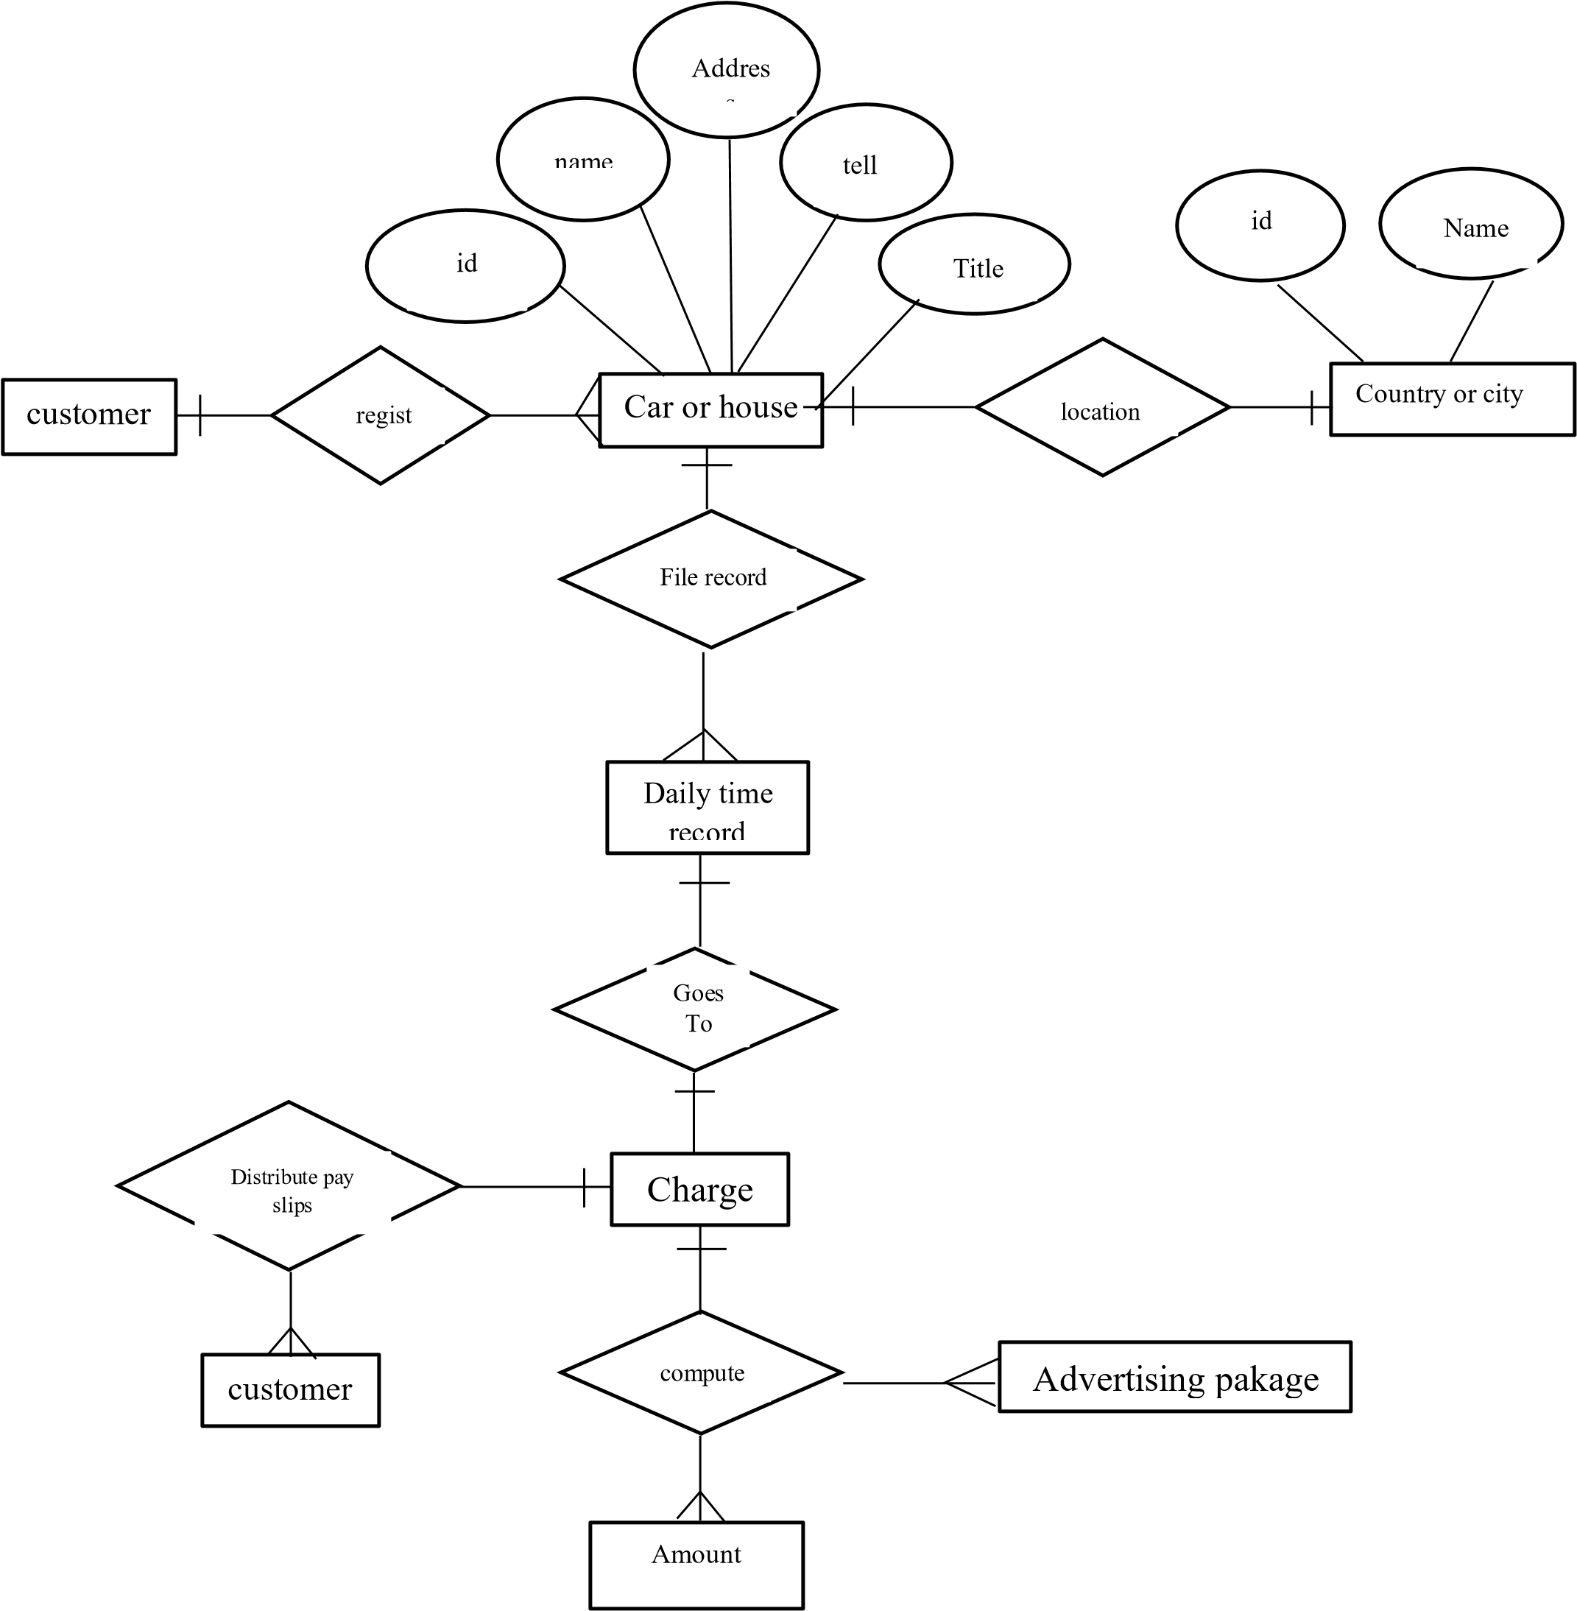

**4.5.3 Data Dictionary**

#### Table 4.5.3.1 users

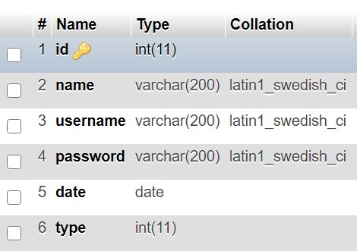

#### Table 4.5.3.2 Rent Type

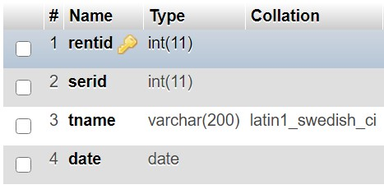

#### 3.3 Country

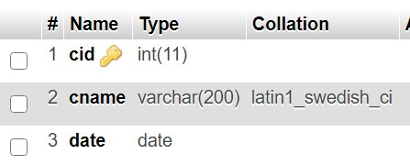

#### Table 4.5.3.4 State table

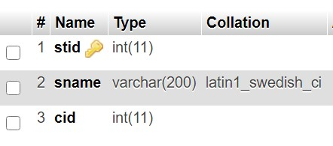

#### Table 4.5.3.5 districts table

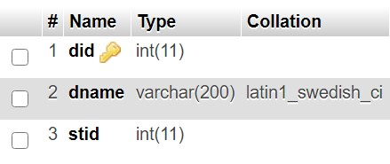

#### 3.6 Section table

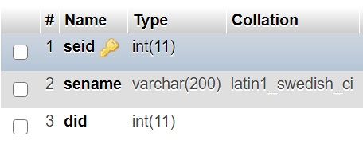

#### Table 4.5.3.7 Cars table

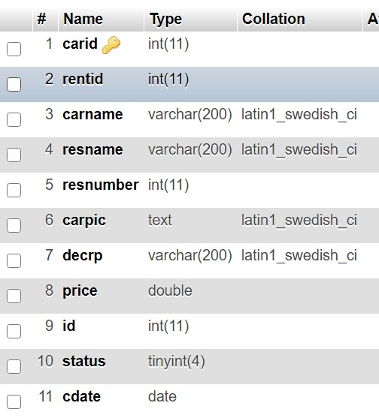

**3.8 Houses table**

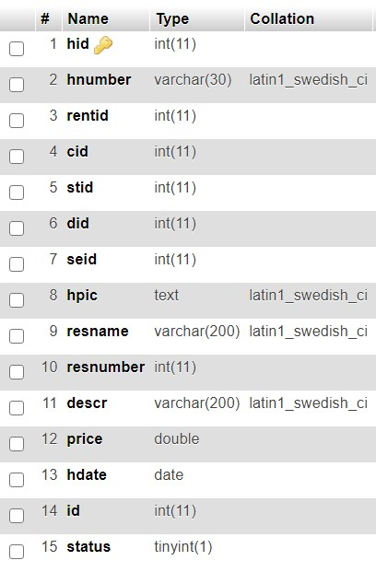

**4.5.4 Design Physical Table**

#### Table 4.5.4.1 Users table

|  |  |  |  |  |  |
| --- | --- | --- | --- | --- | --- |
| **Id** | **Name** | **Username** | **Passord** | **Date** | **Type** |
| 1 | Aweys muridid | Aweis | ******* | 2018-02-01 | active |

#### Table 4.5.4.1 service table

|  |  |  |  |  |  |
| --- | --- | --- | --- | --- | --- |
| **ser** | **id** | **Service Name** | **Image** | **Date** | |
| 1 |  | House Rent | http://192.168.100.15/kiro/images_folder/20210130121632307.png | 2018-02-01 | |
| 2 |  | Rent Car | http://192.168.100.15/kiro/images_folder/20210130121632307.png |  | |
|  |  | |  |  |  |

**Table 4.5.4.1 rent type table**

|  |  |  |  |
| --- | --- | --- | --- |
| **Rentid** | **Service id** | **Type Name** | **Date** |
| 1 | 1 | Apartment | 2018-02-01 |
| 2 | 2 | A luxury car | 2018-02-01 |
| 3 | 2 | Truck | 2018-02-01 |

**Country table**

|  |  |  |
| --- | --- | --- |
| **Cid** | **Country Name** | **Date** |
| 1 | Somalia | 2018-02-01 |
| 2 | Djibouti | 2018-02-01 |
| 3 | Kenya | 2018-02-01 |

#### Table 4.5.4.1 State table

|  |  |  |  |
| --- | --- | --- | --- |
| **Stdid** | **cid** | **State Name** | **Date** |
| 1 | 1 | Mogadishu | 2018-02-01 |
| 2 | 3 | Nairobi | 2018-02-01 |
| 3 | 2 | Jabuti | 2018-02-01 |

**Table 4.5.4.1 District table**

|  |  |  |
| --- | --- | --- |
| **did** | **Disrtict name** | **stid** |
| 1 | Boondhere | 1 |
| 2 | shibis | 1 |
| 3 | Kama kuunji | 2 |

**Section table**

|  |  |  |
| --- | --- | --- |
| **seid** | **did** | **Section Name** |
| **1** | **2** | **beexani** |
| **2** | **1** | **alkowney** |
| **3** | **1** | **daljirka** |

#### Table 4.5.4.1 Cars table

|  |  |  |  |  |  |  |  |
| --- | --- | --- | --- | --- | --- | --- | --- |
| **Ca**  **r id** | **renti d** | **Care name** | **Responsi ble name** | **Responsib le number** | **Car’s image** | **description** | **Rent price** |
| 1 | 2 | noha | Ali ahmed | 06143273 | http://192.168.100.15/kiro/images_folder/121307.png | It is truck car | $300 |
| 2 | 1 | hary | Cumar  cali | 08273698 | http://192.168.100.15/kiro/images_folder/202307.png | It is A  luxury car | $150 |
| 3 | 2 | bajaj | Abdifitah | 08637282 | http://192.168.100.15/kiro/images_folder/632307.png |  | $100 |

**Houses table**

|  |  |  |  |  |  |  |  |  |  |  |
| --- | --- | --- | --- | --- | --- | --- | --- | --- | --- | --- |
| **hid** | **ren tid** | **House number** | **Responsible name** | **Responsible number** | **cid** | **stid** | **did** | **Car’s image** | **description** | **Rent price** |
| 1 | 3 | 08723x  x | Ali ahmed | 06143273 | 1 | 3 | 1 | http://192.168.100.15/ kiro/images_folder/12  1307.png | It is truck car | $300 |
| 2 | 4 | 83ude6 | Cumar cali | 08273698 | 2 | 2 | 4 | http://192.168.100.15/ kiro/images_folder/20  2307.png | It is A luxury car | $150 |
| 3 | 5 | 637xgd | Abdifitah | 08637282 | 4 | 4 | 2 | http://192.168.100.15/ kiro/images_folder/63  2307.png |  | $100 |

#### 4.6 Design Forms and Report

##### 4.6.1 Logging Form for admin



**Figure 4.6.1 Logging Form for admin**

##### 4.6.2 User Registration Form

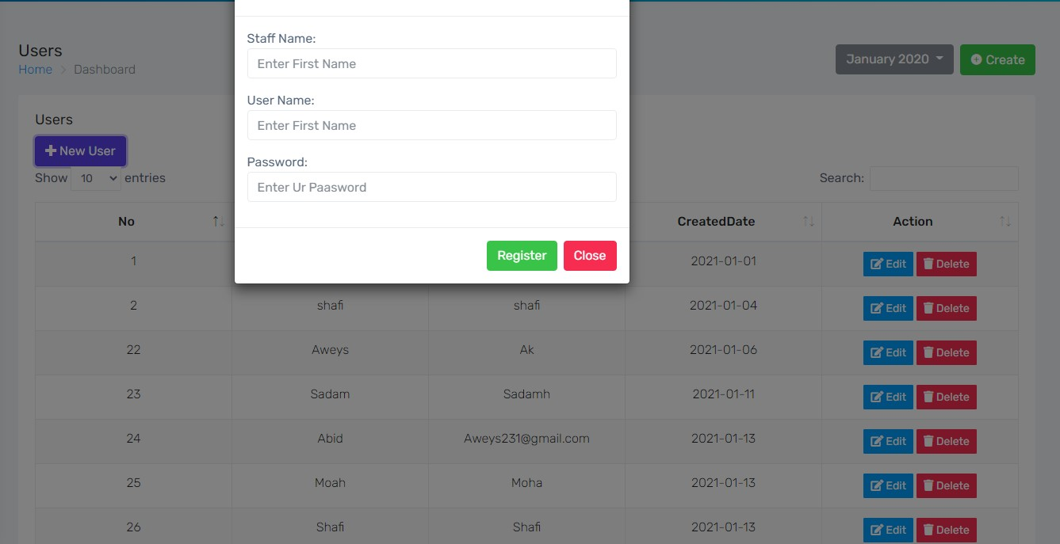

**Figure 4.6.2 User Registration Form**

#### Countries Registration

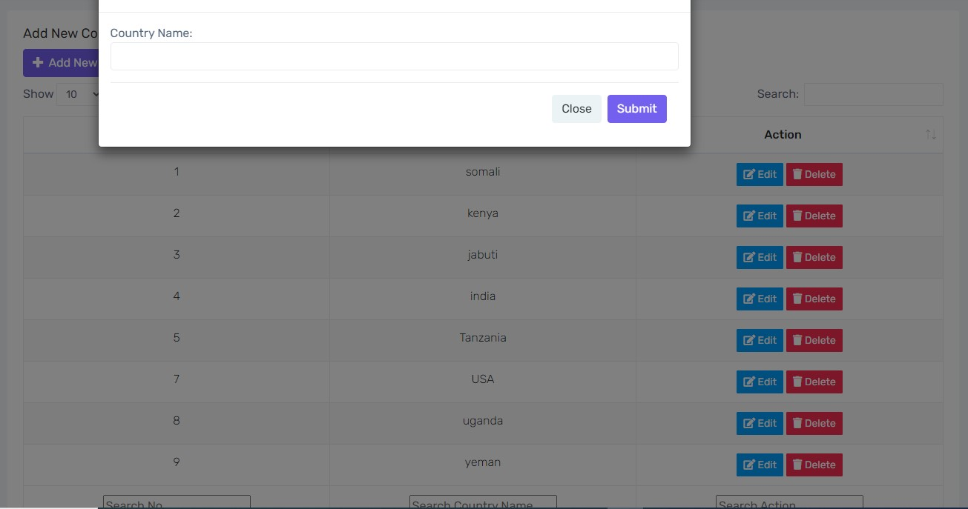

#### City registration

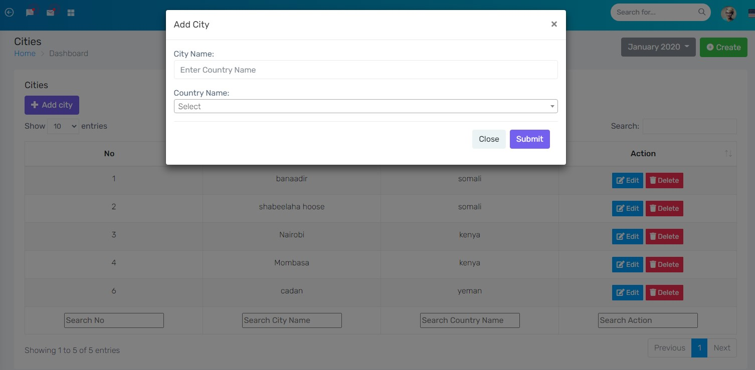

#### District Registration

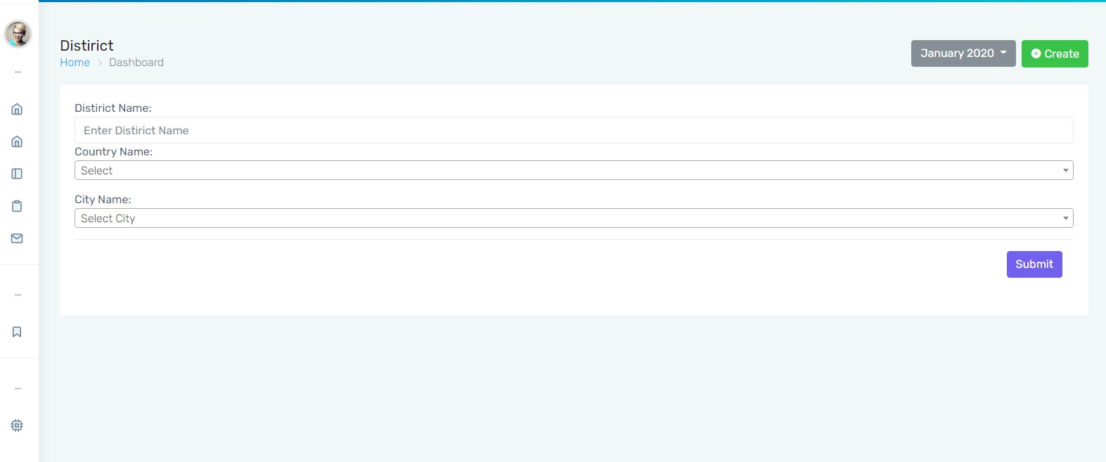

#### Section Registration

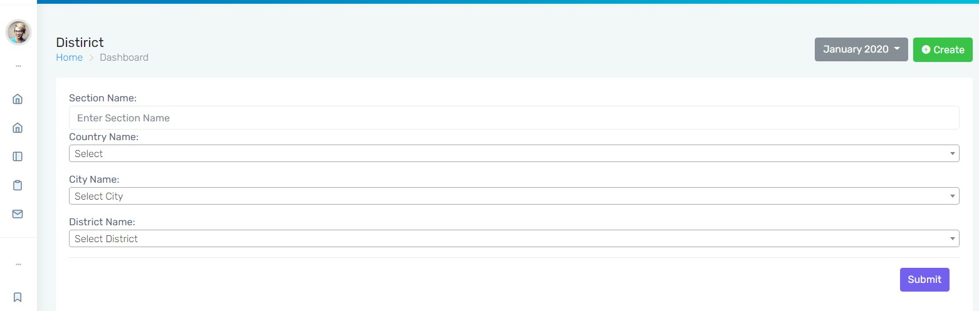

#### Application Dashboard View House for Rent Form

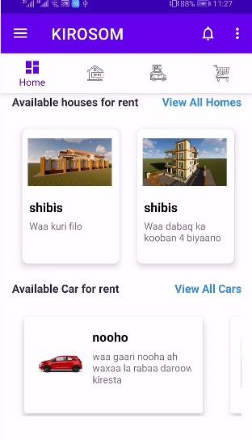 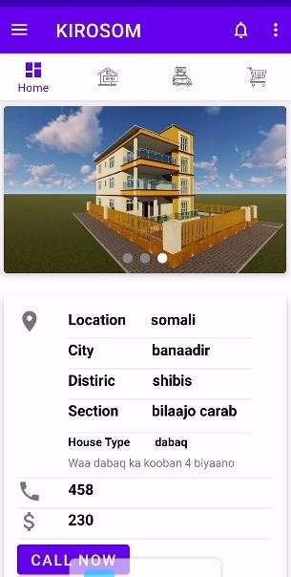

#### View Cars For rent form

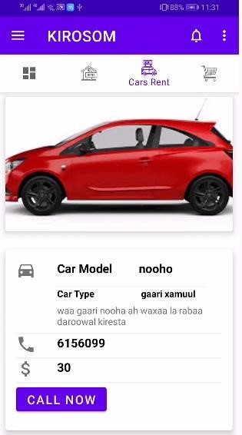

#### Logging form Sign up Form

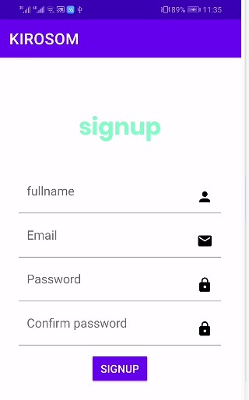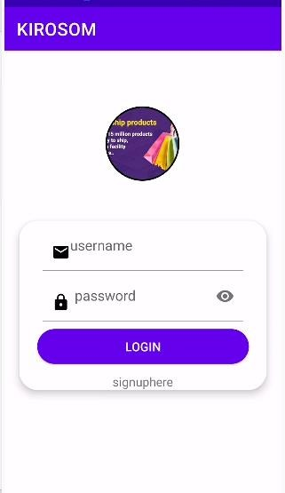

**House Registration Form Car Registration Form**

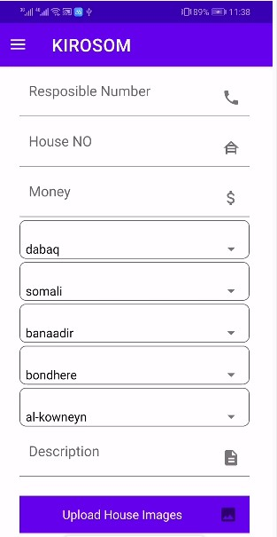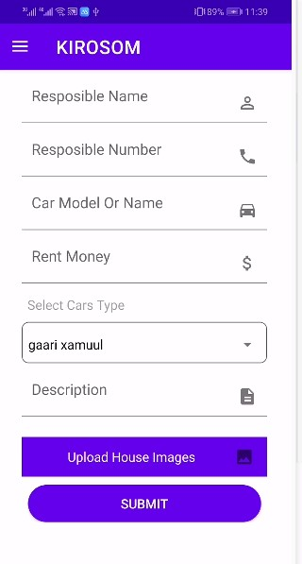

#### 4.7- Conclusion

Last but not the least the conclusion of this chapter **(Four)** that earlier discussed system development its **database design**, **design goal**, **normalization**, **& demoralizations** and also system **design**, information and also all the forms and reports.

**CHAPTER FIVE**

**SYTEM IMPELIMATATION**

#### 5.1 INTRODUCTION

The system testing and implementation phases are illustrated in this chapter. 'The' testing process entails some changes to the previous design phase, as well as system testing to reduce programming and system errors. After coding, a programmer must test each program to ensure it works properly during the implementation process. Programs are then evaluated in classes, and finally the whole system must be tested. The first step is to use a case tool or a language compiler to compile the software.

#### 5.2 development phase

The project's system design is a crucial step in the Development Phase. The Development Phase's goal is to transform the system design prototyped during the Design Phase into a functioning information system that meets all of the system's documented specifications. The working device will enter the Test Phase at the end of this phase**.** The aim of this step is to put the design into action as efficiently as possible. Both testing and maintenance are heavily influenced by the coding process. A well-written code decreases the time and effort required for testing and maintenance. The aim of coding should be to minimize the amount of time spent on testing and maintenance, and the emphasis should be on creating programs that are simple to write. During the coding process, simplicity and consistency should be prioritized.

#### 5.3 testing system implementation

Testing the system is an important step in ensuring that all of the system's specifications have been met without errors. Some stages of system testing are possible. The first stage is called unit testing or component testing, and it takes place during the system's development. Integration testing is the second step. The components' integration will be checked, and if any errors are found, the components will be tested again. User acceptance testing is the third level, and it is performed by users who have requested that the system be developed.

##### 5.3.1 Software Test Plan

A test plan is a document that outlines the goals, scope, and testing strategy for a project. It can be used to perform complex tests on software or hardware. A thorough understanding of the actual workflow is normally included in the plan.

##### 5.3.2 Objective

A proper test plan is expected to decide whether the system works properly or not. To develop a rental house and cars application management system that allows users to access rent information, as well as houses cars records, and to register customers.

##### 5.3.3 Scope

Following the integration of the subsystems and components defined in the Integration Build Plan for the Prototype, this Test Plan outlines the integration and device tests that will be performed on the architectural prototype. Unit testing is believed to have already included rigorous black box testing, thorough source code coverage, and testing of all module interfaces.

The aim of putting together the architectural prototype was to see if the chosen architecture was feasible and work well. Both device and subsystem interfaces, as well as system output, must be checked at this early stage. The prototype will not be used to test device performance or features.

###### 5.3.3.1 Function to be tested

* LOGIN
* USER Registration
* ADD/VIEW Cars and Houses
* VIEW Cars and Houses Available FROM CUSTOMER

**5.3.3.2 Functions not to be tested** No specific field found.

##### 5.3.4 Test strategy

A Research Strategy is a plan for determining approach a Software Testing Life Cycle (STLC). It helps QA teams determine Test Coverage and the scope of their testing. It allows testers to have a full image of the project at any time. When a good test plan is in place, the chances of missing any test operation are extremely slim.

**5.3.4.1 Unit Testing:**

1. Unit tests save time and resources by catching bugs early in the development cycle.
2. It assists developers in comprehending the testing code base and allowing them to make fast improvements.
3. Unit tests that are well-written act as project documentation. Code reuse is aided by 5. unit tests. Both your code and your tests should be migrated to your new project.

Adjust the code before the tests pass.

**5.3.4.2 Module Testing:**

1. Module testing is a form of software testing that examines a program's individual subprograms, subroutines, classes, or procedures. Rather than evaluating the entire software package at once, module testing proposes testing the program's smaller building blocks.
2. Module testing is mostly based on storage boxes. The aim of module testing is to demonstrate the existence of an error in the module rather than to demonstrate the module's proper functioning.
3. Module level testing enables parallelism in the testing phase by allowing several modules to be tested at the same time.

**5.3.4.3 Integration Testing:**

After each part or script has passed unit testing, integration testing is carried out to ensure that the System components operate together smoothly. At this point, the functional and non-functional criteria were put to the test. Searching the parcel model by parcel ID and seeing whether the GIS database has the parcel requested is one example of integration testing.

**5.3.4.4 Acceptance testing:**

Formal testing is carried out to determine if a system meets the approval requirements and to allow the consumer to decide whether or not to approve it. Customer service managers are normally in charge of this testing phase.

**5.3.4.5 Performance Testing: 1.**

1. The system should have a high-performance rate when executing user input and should be able to provide response within a short time period, typically 50 seconds for highly complicated tasks and 20 to 25 seconds for less complicated tasks;
2. the system response time for each instruction performed by the user should not exceed more than a minimum of 10 seconds; the system should have a highperformance rate when executing user input and should be able to provide response within a short time span, usually 50 seconds for highly complicated tasks and 20 to 25 seconds for less complicated

**5.3.4.6 Security Testing: 1.**

* 1. Increase the consistency of this house and car management project creation service
  2. To avoid unauthorized access to the device, the system includes a username and password.
  3. Any rental information transmissions should be secured.

###### 5.3.4.7 Accessibility Testing 1

One of the many software testing methods is usability testing. It's important for assessing the app's capabilities for users with unique conditions including hearing loss, advanced age, color blindness, and other people in similar circumstances. Usability checking is another name for it. Web usability testing ensures that the app can be used and navigated by everyone, on any device.

#### 5.4 developing documentation

Software documentation is written text or an example that comes with or is included in the source code of a computer program. It either describes how it works or how to use it, or it may mean different things to different people depending on their positions. Software engineering necessitates the use of documentation.

##### 5.4.1 User documentation

An information system's documentation explains it and assists users who must deal with it. Accurate documentation can help you save money and time by reducing device downtime and speeding up maintenance tasks. The importance of documentation in the management and maintenance of a system cannot be overstated. Accurate documentation is important for developers who must change, install new functionality, or perform maintenance on a device, in addition to serving its users.

**User documentation Consist of: -:**

* First to install this project setup in your computer carefully and install the application your phone.
* Your computer must install XAMPP OR WAMP
* This project needs computer with high speed and storage.

**User manual:** User manual Capabilities and Requirements:

Every user who is going to work with this project is required to have the following capabilities.

* A consumer should be able to use a computer and a mobile device.
* A consumer should go through some project preparation.
* A consumer should also have a basic understanding of WEB 2.0 and MYSQL.

**User instruction:** When you run the system, it will show a login page that prevents unauthorized users from logging in. This project can only be accessed by two people: the administrator, who has complete control over the system. and users may use an application to access their mobile device.

#### 5.5-chapter summary

In conclusion, this chapter looked at device testing and implementation. It outlines the specific types of testing that are appropriate for this method. The device testing process began with the test unit and progressed to the part or module level. Following that, integration testing between units or components was performed, followed by a system test by potential users to assess system acceptance. The end phase in the system development is implementation where the user guide for the modules is shown step by step

**CHAPTER SIX**

**CONCULATION AND ENHANCEMENT**

#### 6.1 INTRODUCTION

The main goal is to create an open forum for portfolio and mobile rental house and car management system, so that everyone can advertise properly with their customers and display their rental cars and houses to the tenants.

#### 6.2 Objective achievement

Every project has a goal. The main goal we have accomplished is to create a modern mobile rental house and car system in which all computations and data collection are accurate, data manipulation and processing are accelerated, report generation is quicker and protection for the held is improved, and the system consumes less office space, resulting in a powerful business tool that would greatly help updating of new time keeping and rental car and houses Advertising systems.

#### 6.3 weakness and problem of the system

##### 6.2.1 Weakness of the System

This mobile rental houses and cars management system has some flaws; as we all know, there should be some kind of relationship with banks, but there isn't one. There isn't even a relationship between the bank and the system account API, that allows for automated advertising package payments.

##### 6.2.2 Strength the system

Every project has its own set of strengths and disadvantages, and we'd like to highlight some of the benefits and functionality that mobile rental houses and cars data can provide to users. Validation of all inputs is carefully handled, and various user rights are correctly checked. This system is user-friendly and has a user-friendly interface that anyone with computer and mobile skills can use. Furthermore, if the user makes a mistake, it produces an error message that is easily understood by the user, as well as providing you with the requisite device utilities and other resources that you may need when working on the project. The device is integrated and takes data security into account.

#### 6.4 future works

This application could be improved to cover any aspect of Somalia. Remote rental houses and cars for the witch link bank account, the advertising scheme will be expanded to include a full management package. It will greatly aid in the efficient and effective management and organization of financial data, and thus, anyone attempting to improve or enhance any of the project's functionalities and features should be familiar with PHP, MySQL Database, and Java. Automatic API bank transection can be added to the method.

#### 6.5 chapter summary

Finally, we addressed the key goal success, as well as the system's weaknesses and challenges, since this system does not allow for the connection of bank accounts, and it has no relationship with bank account transection, which would make the job easier to complete. This system performs validations, such as carefully managing all input validations and correctly verifying various user rights, among other things. This system will be critical in Somalia, as it will enable them to simplify the advertising rental process.

#### REFERENCES

(Cooper, 1998)

(Golland,, 1996)

(www.build.qld.gov.au, n.d.)