AI-POWERED INTELLIGENT WAREHOUSE MANAGEMENT SYSTEM- BIT 3208-PROJECT(B2C)

Automated Inventory Forecasting & Predictive Analytics Dashboard

Course:

Advanced Web

Design

Student Name:

Abdiweli Abdille

Reg

No
:

BSCCS/2024/33779

Lecturer:

Mr. Nyoro

Semester:

Year 4 Sem

2

Repository: https://github.com/Abdiweli-Abdille/BIT4133-Natural-language-processing.git

Table of Contents
AI-POWERED INTELLIGENT WAREHOUSE MANAGEMENT SYSTEM- BIT 3208-PROJECT(B2C) 1
Week 1 — Project Setup & Frontend Scaffold Initialization 3
1.1 Tasks Completed 3
1.2 Technologies Used 3
1.3 Code Snippet — Application Root Entry (main.jsx) 3
1.5 PHP → Modern Stack Concept Mapping 4
1.7 Project Installation 4
1.8 Running the server 4
1.9 Learning Outcomes 5
Week 2 — Secure JWT Authentication & Role-Based Access Control 6
2.1 Tasks Completed 6
2.2 Technologies Used 6
2.3 Code Snippet — Interceptor Pipeline (utils/api.js) 7
2.4 Code Snippet — Access Firewall Layout (ProtectedRoute.jsx) 7
2.5 PHP → Modern Stack Concept Mapping 8
2.6 The Loging page for the Admin and Manager 8
2.7 The Loging page for the customer 9
2.7 signing and verification of credentials 9
2.8 Learning Outcomes 9
Week 3 — Responsive Dashboard Design System & KPI Stats Layout 10
3.1 Tasks Completed 10
3.Admin Dashboard 11
3.5 customer dashboard 11
3.6 Learning Outcomes 11
Week 4 — Inventory Catalog Management & Real-Time Filtering 12
4.1 Tasks Completed 12
3 Mock Catalog Manifest Reference 13
4.4 product catalog 13
4.4 Learning Outcomes 13
Week 5 — Relational Database Design & Backend Integration 14
5.1 Tasks Completed 14
5.4 Code Snippet — Demand Forecasting Endpoint (main.py) 15
5.5 Final Unified System API Matrix 16
5.6 Learning Outcomes 17

Week 1 — Project Setup & Frontend Scaffold Initialization
This week focused on establishing the core architecture for the AI-Powered Intelligent Warehouse Management System, setting up local development tools, configuring Tailwind CSS for rapid UI development, and creating a remote GitHub repository for version control.

1.1 Tasks Completed
- Installed Node.js (v20 LTS), Python 3.12, Git, and VS Code.
- Scaffolded the frontend application using Vite with a React template: npx createvite@latest ./ --template react.
- Configured Tailwind CSS inside the Vite environment for structural, responsive styles.
- Set up a clean, scalable modular directory path structure:

src/ ├── components/ # Reusable UI components (Sidebar, MetricCard) ├── pages/ # System views (Dashboard, InventoryCatalog)
├── context/ # Global state management (AuthContext, ThemeContext) └── utils/ # Global API clients and helper metrics

- Initialized a local Git repository, created an optimization-optimized .gitignore, and made the primary commit.
- Published the repository to GitHub and updated README.md with explicit initialization configurations. 1.2

1.2 Technologies Used

Tool / Technology | Version | Purpose
Node.js | 20 LTS | JavaScript runtime driving the modern frontend build chain.
Vite | 8.x | Next-generation build tool supplying Instant Hot Module Replacement (HMR).
React | 19.x | Component-driven UI library for rendering dynamic interface updates.
Tailwind CSS | 4.x / 3.x | Utility-first CSS framework used for compiling responsive dashboard layers.
Git / GitHub | Latest | Distributed version management and safe cloud source replication.

1.3 Code Snippet — Application Root Entry (main.jsx)
1.4 Code Snippet — Bundler Configuration (vite.config.js)
import { defineConfig } from 'vite'; import react from
'@vitejs/plugin-react';
export default defineConfig({ plugins: [react()], server: { port: 5173, // Default frontend local development port }, });

1.5 PHP → Modern Stack Concept Mapping

PHP Concept (BIT3208) | AI Warehouse System Equivalent
<?php echo "Warehouse Alpha"; ?> | Dynamic JSX interpolation:
 |  | <p>{warehouse.name}</p> |  | handled by React.
XAMPP / Apache Stack | Vite Development server environment (npm run dev).
index.php global router | Single-Page Application (SPA) initialization via + index.html. |  |  |  |  | main.jsx
include("sidebar.php"); | Reusable React design pattern: |  |  |  | import Sidebar from
 |  | './components/Sidebar' | .

1.7 Project Installation

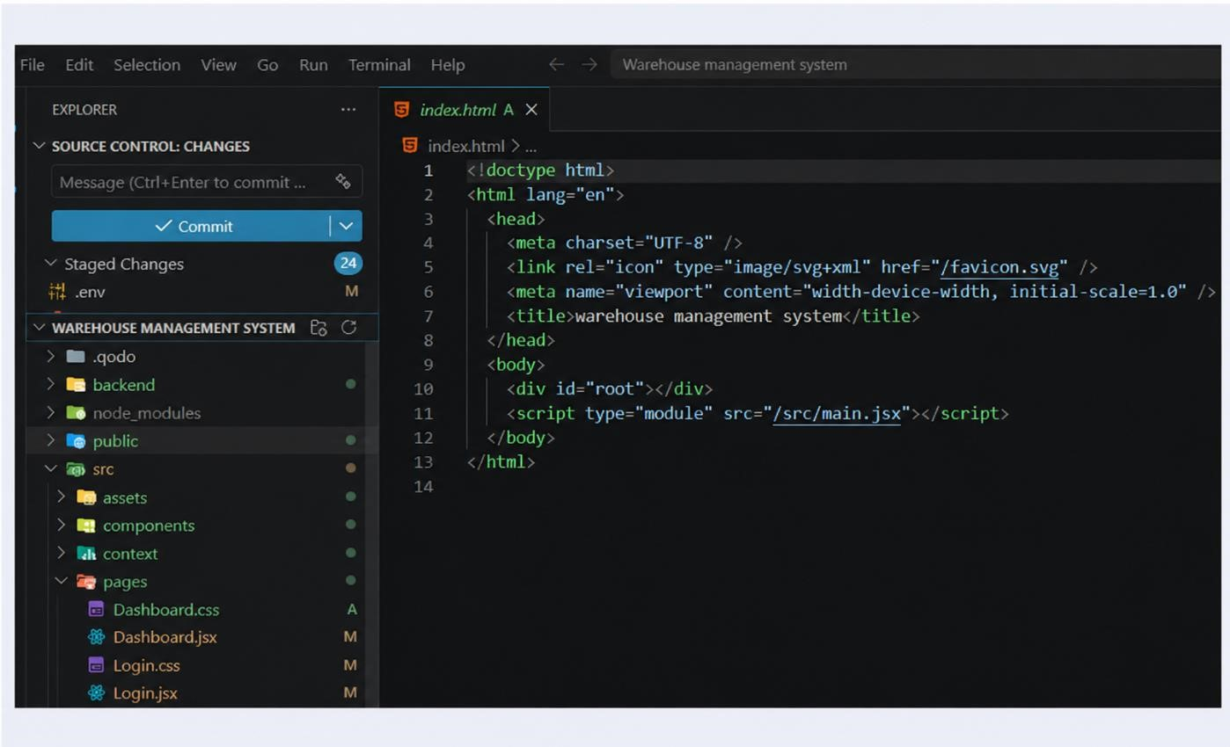

1.8 Running the server
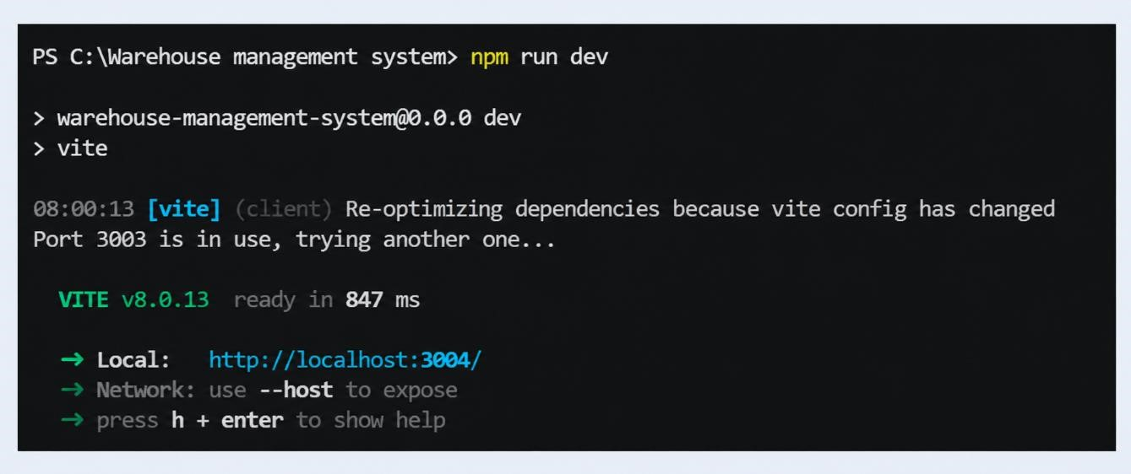

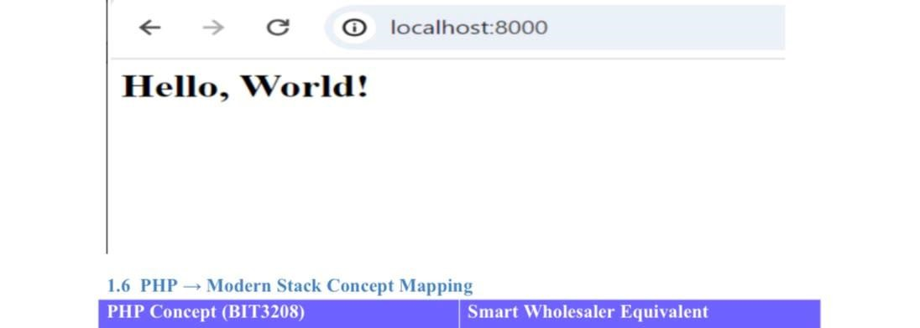

1.9 Learning Outcomes
- Mastered using Vite to bypass the heavy runtime processing typical of legacy Apache/PHP environments.
- Formulated clean project topologies separating state providers from layout presentations.
Engineered declarative React views that interact directly with the DOM through efficient bundle compiling

Week 2 — Secure JWT Authentication & Role-Based Access Control

This week targeted security modeling. The system requires restricted entrypoints to separate administrative actions (Warehouse Managers) from operation staff (Storekeepers). This was accomplished via React Context, Local Storage preservation, and router interception guards.

2.1 Tasks Completed
- Constructed AuthContext.jsx to distribute user identity status metrics dynamically across the application tree.
- Built a secure Login.jsx user portal checking inputs and providing visual feedback on connection exceptions.
- Assembled ProtectedRoute.jsx component wraps to block illicit access from unverified clients.
- Integrated Role-Based Access Control (RBAC) to redirect users depending on programmatic permissions (e.g., manager vs. storekeeper).
- Implemented an interceptor utility (api.js) that reads stored tokens and automatically appends HTTP Bearer headers.
- Added client-side toggles for password field visibility to reduce input errors on login.

2.2 Technologies Used

Technology | Version | Role
React Context API | React 19 | Engine tracking dynamic session profile data across component paths.
Web Crypto / JWT | Standard | Cryptographically signed, stateless string tokens handling secure data passage.
localStorage API | Browser  Native | Client-side memory container retaining user tokens across browser sessions.
React Router DOM | 7.x | Framework controlling routing pathways and application views.

2.3 Code Snippet — Interceptor Pipeline (utils/api.js)
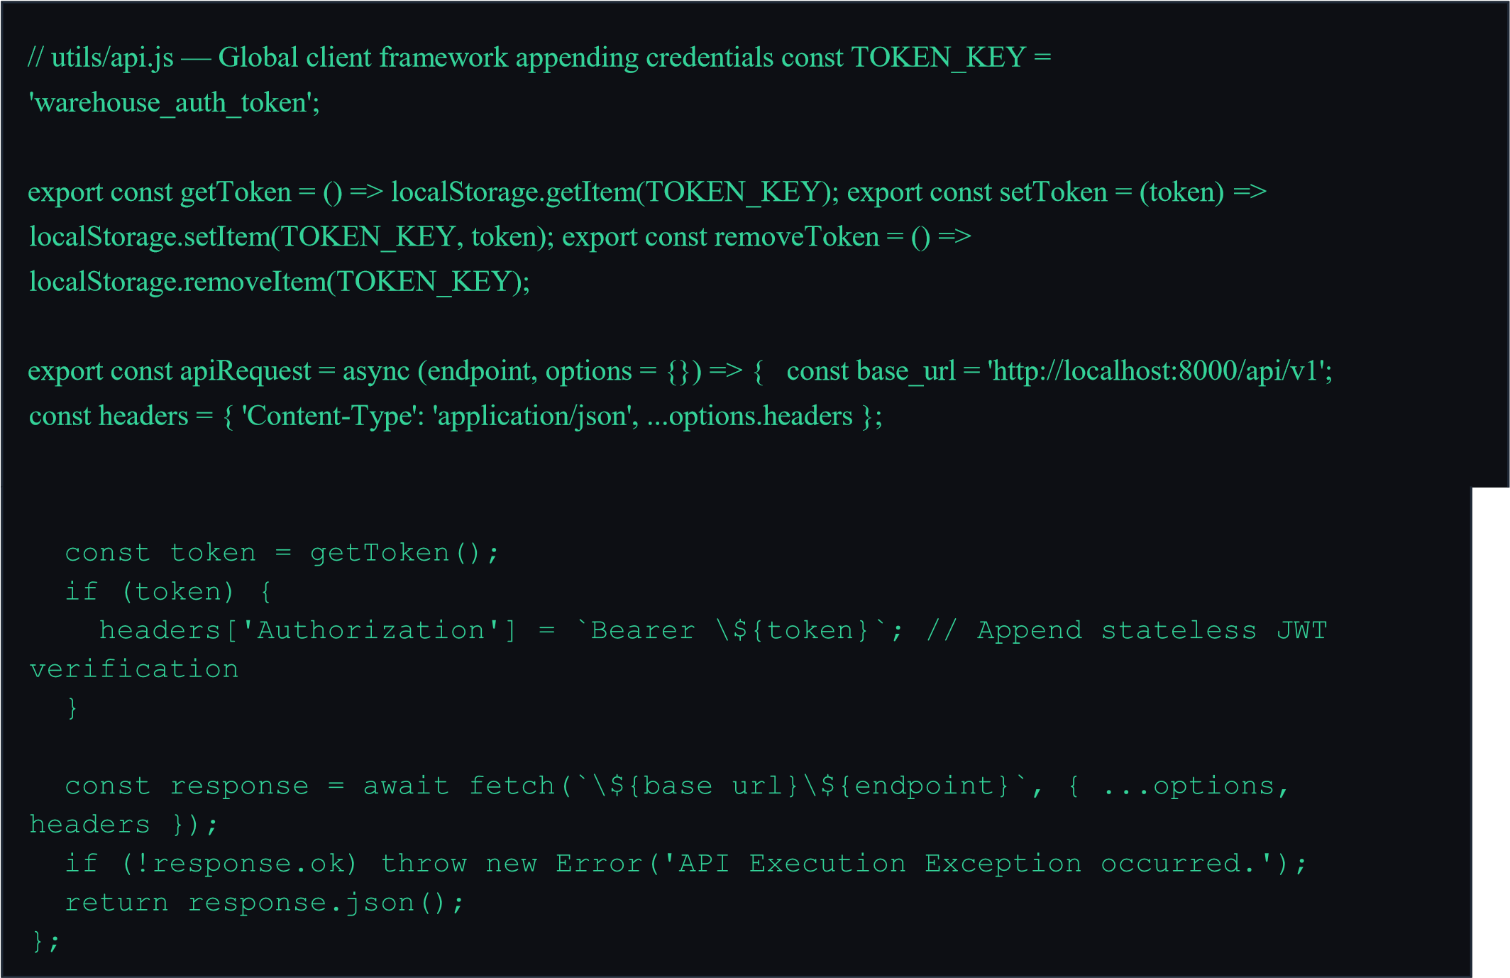

2.4 Code Snippet — Access Firewall Layout (ProtectedRoute.jsx)
import { Navigate, Outlet, useLocation } from 'react-router-dom'; import { useAuth } from
'../context/AuthContext';
const ProtectedRoute = ({ allowedRoles = [] }) => { const { user, isAuthenticated } = useAuth(); const location = useLocation(); if (!isAuthenticated) { return <Navigate to="/login" state={{ from: location }} replace />; }
if (allowedRoles.length > 0 && !allowedRoles.includes(user?.role)) { return <Navigate to="/unauthorized" replace />; } return <Outlet />; }; export default ProtectedRoute;

2.5 PHP → Modern Stack Concept Mapping
PHP Concept (BIT3208) | AI Warehouse System Equivalent
\$_SESSION["user_role"] | Role validation properties verified inside AuthContext state.
session_start(); | <AuthProvider>  Global context wrappers: nested at top-level trees.
PHP Concept (BIT3208) | AI Warehouse System Equivalent
header("Location: login.php"); | Routing manipulation via <Navigate replace to="/login"/>.
mysqli_real_escape_string() | Automated type evaluation and serialization performed by FastAPI Pydantic.

2.6 The Loging page for the Admin and Manager
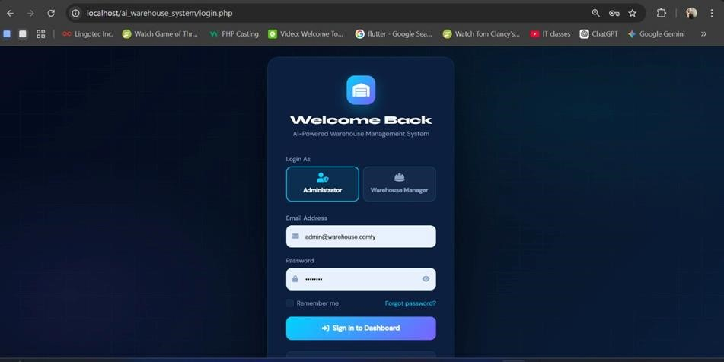

2.7 The Loging page for the customer

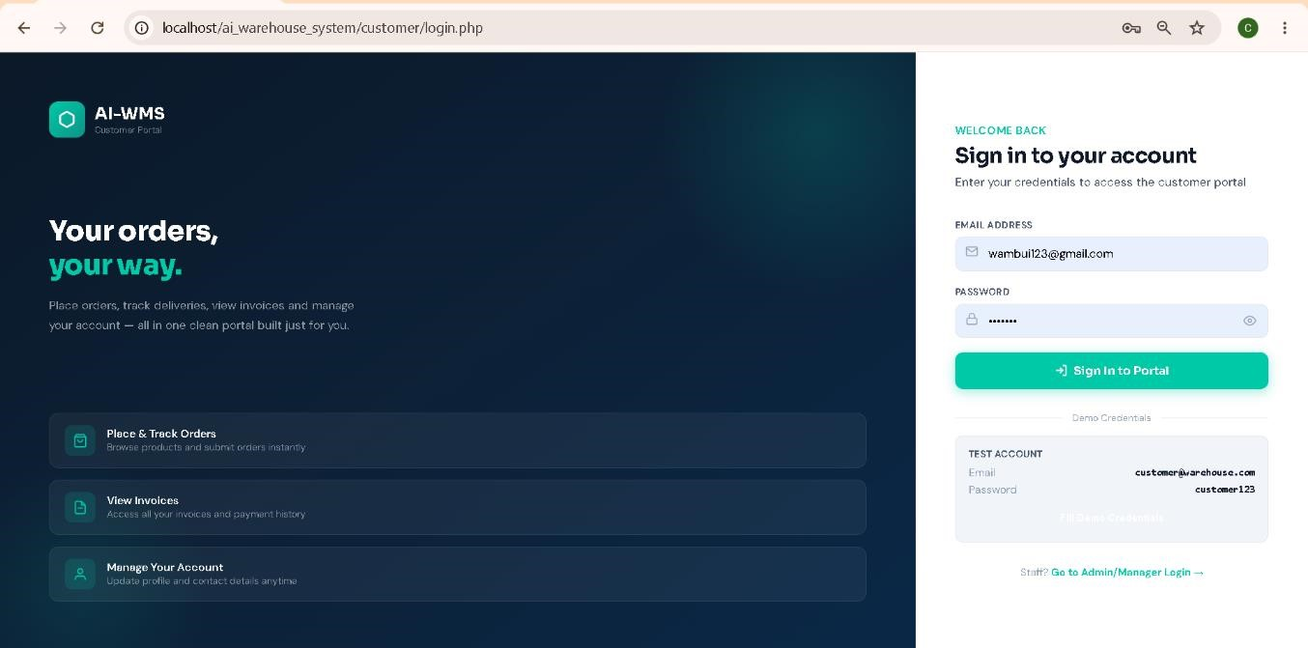

2.7 signing and verification of credentials
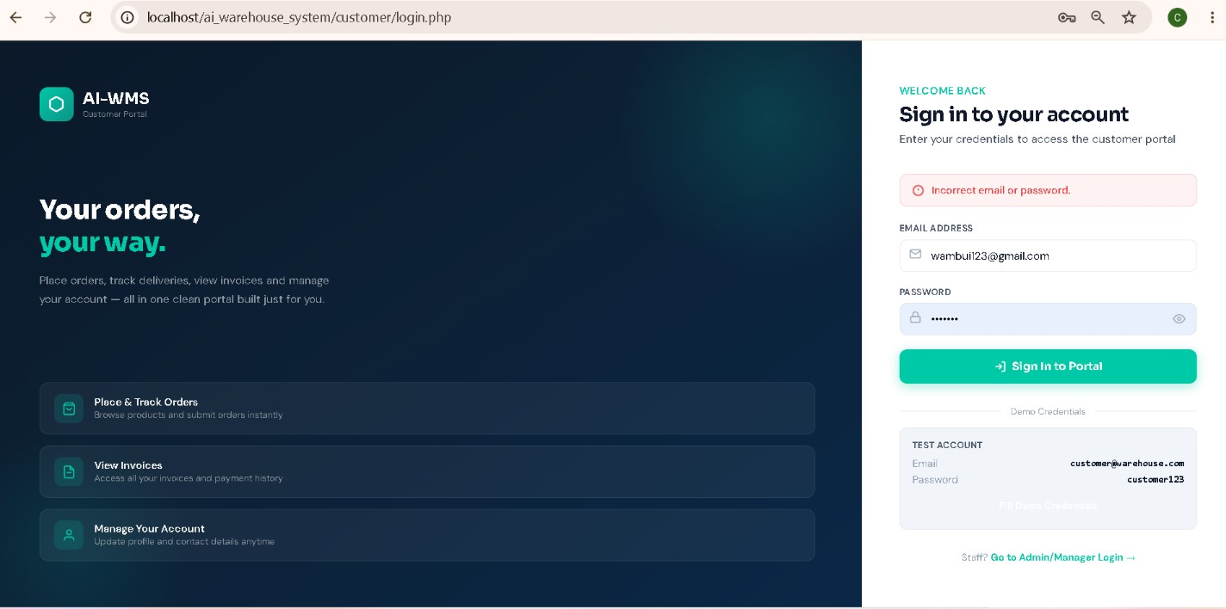

2.8 Learning Outcomes
- Discovered the flexibility of stateless token execution architecture compared to stateful server-side storage models.
- Created secure UI wrappers that prevent deep-linking exploits through real-time state analysis. • Standardized API request layers to securely handle token tracking and session validation rules.

Week 3 — Responsive Dashboard Design System & KPI Stats Layout

This week focused on building the core dashboard interface using a responsive design token system. The dashboard provides real-time access to operational metrics, inventory tracking, and warehouse Key Performance Indicators (KPIs).

3.1 Tasks Completed
- Structured a robust Tailwind color utility strategy within index.css.
- Generated custom theme configurations to allow real-time theme swapping between light and dark modes.
- Hand-coded the core structural layout framework containing a collapsible navigation sidebar and user status bars.
- Implemented modular inventory KPI statistic components tracking total stock metrics, low stock counts, and forecasting capacity alerts.
import React, { useEffect, useState } from 'react'; import { apiRequest
} from '../utils/api';
export default function Dashboard() { const [metrics, setMetrics] = useState({ total_items: 0, critical_low: 0, efficiency: 0 });
useEffect(() => { apiRequest('/dashboard/summary') .then(data => setMetrics(data))
.catch(err => console.error("Metrics failure:", err)); }, []);
return ( <div style={{ display: 'table', width: '100%', borderSpacing: '10px' }}> <div style={{ display: 'table-cell', padding: '20px', background:
'#f3f4f6', border: '1px solid #d1d5db' }}>
<h3>Total Tracked SKUs</h3>
<p style={{ fontSize: '20pt', font+weight: 'bold', color: '#111827' }}
>{metrics.total_items}</p>
</div> <div style={{ display: 'table-cell', padding: '20px', background:
'#f3f4f6', border: '1px solid #d1d5db' }}>
<h3 style={{ color: '#dc2626' }}>Critical Stock Alerts</h3>
<p style={{ fontSize: '20pt', fontWeight: 'bold', color: '#dc2626' }}
>{metrics.critical_low}</p>
</div> <div style={{ display: 'table-cell', padding: '20px', background:
'#f3f4f6', border: '1px solid #d1d5db' }}>
<h3 style={{ color: '#059669' }}>AI Forecasting Precision</h3>
<p style={{ fontSize: '20pt', fontWeight: 'bold', color: '#059669' }}
>{metrics.efficiency}%</p>
} </div>
</div> );
- Implemented responsive CSS flexbox distributions to adapt control components from mobile screens up to desktop viewing fields.

3.Admin Dashboard

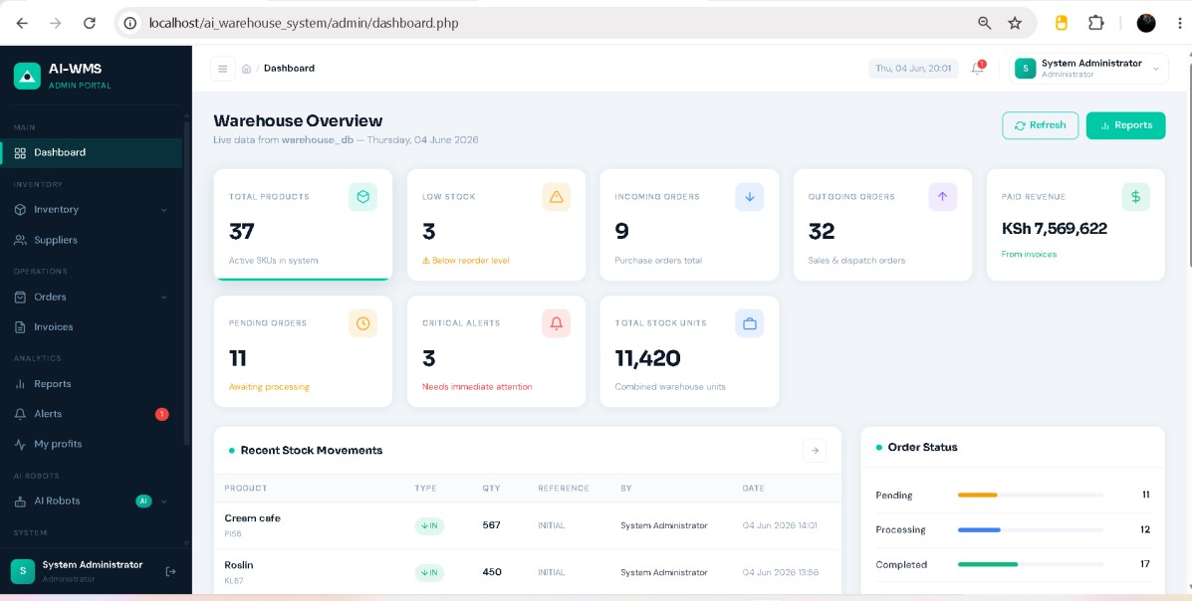

3.5 customer dashboard
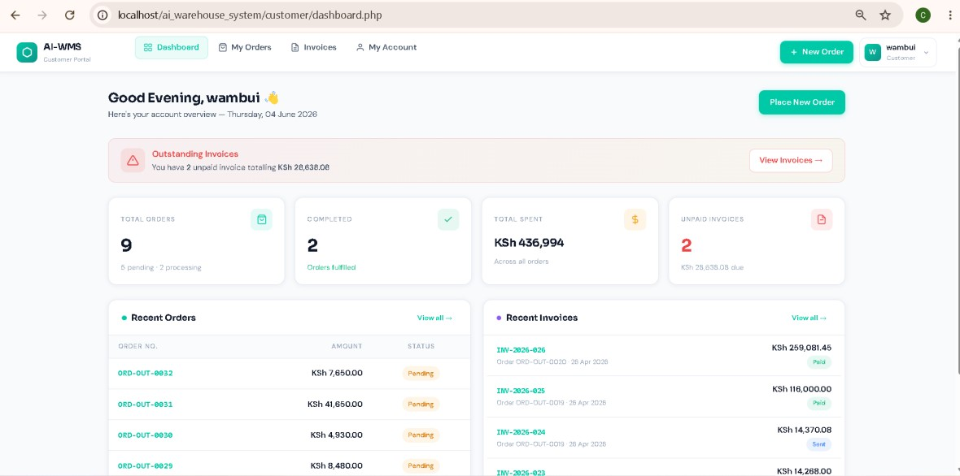

3.6 Learning Outcomes
- Converted static design templates into a production-ready, utility-first CSS design token structure.
- Evaluated conditional rendering systems that dynamically display metrics based on user roles and systemic priority flags.
- Built responsive layout containers that resize smoothly across varying terminal viewpor

Week 4 — Inventory Catalog Management & Real-Time Filtering
This week added data filters, inventory search workflows, dynamic listings, allocation mechanisms, and reactive forms to the operational frontend.

4.1 Tasks Completed
- Programmed the unified InventoryCatalog.jsx grid matrix displaying product records.
- Developed lightning-fast search filters matching input lookups directly against SKU patterns and item titles.
- Built functional sorting rules arranging items by metrics like highest capacity, lowest availability, or core item valuation.
- Embedded visual alerts into stock listings that display prominent danger warnings whenever stock drops below minimum threshold limits.
- Styled distinct, clean tabular states showing loading animations or clear notice screens when filter results are empty.

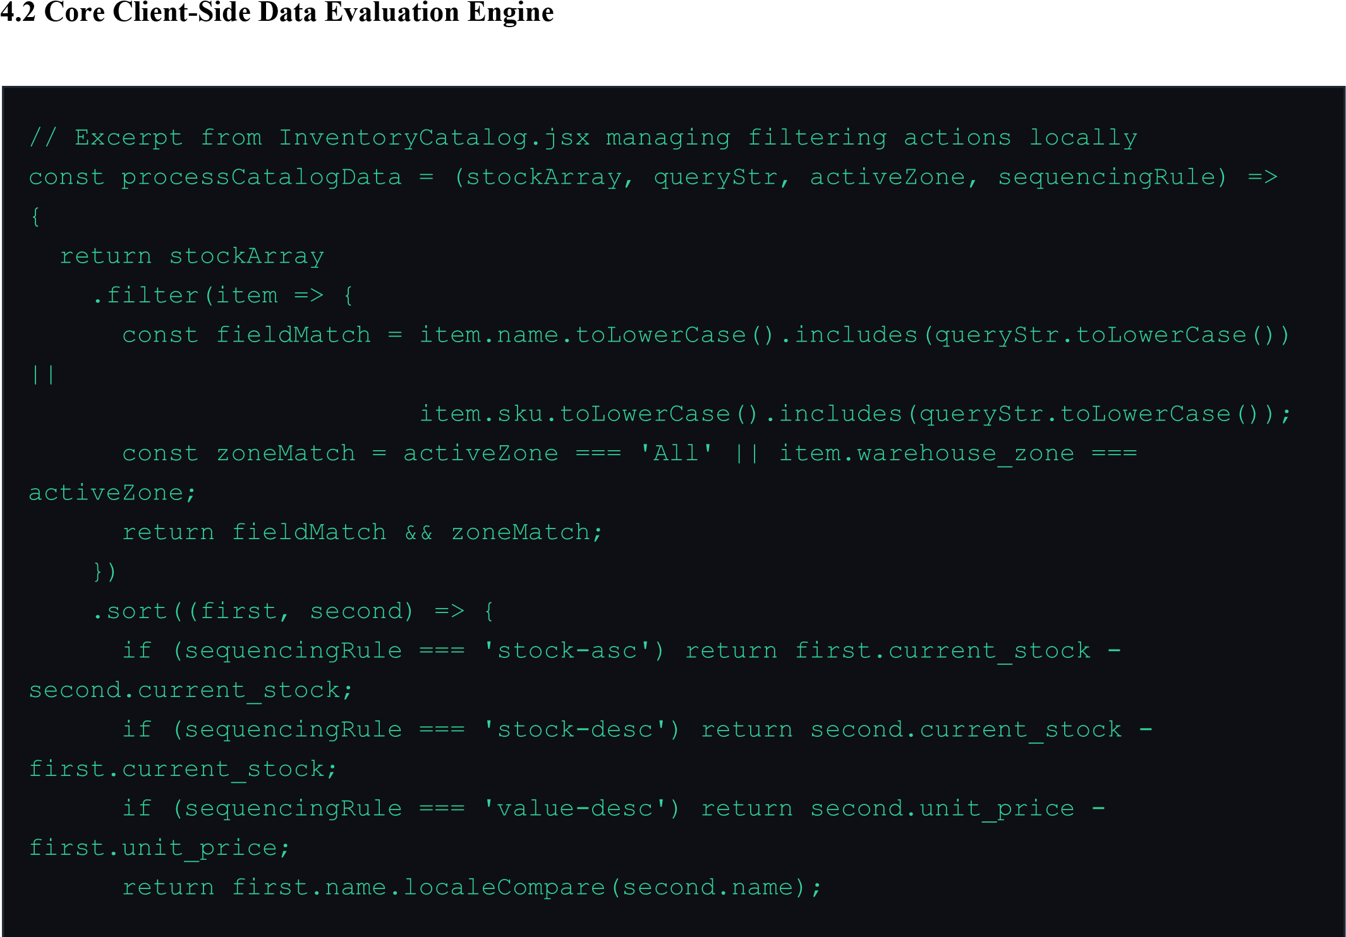

SKU  Number | Item Specification |  | Zone  Section | Unit  Cost | Stock  Count | Target Reorder  Level
SKU-  WH-091 | Heavy-Duty Engine  Bearing |  | Zone  Alpha | KSh  14,500 | units | units
SKU-  WH-104 | Industrial Grade  Sealants |  | Zone  Bravo | KSh  3,200 | units | units (CRITICAL)
SKU-  WH-312 | Reinforced  Transmission Housing |  | Zone  Alpha | KSh  89,000 | units | units

3 Mock Catalog Manifest Reference

4.4 product catalog

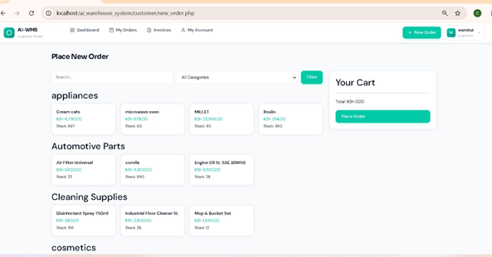

4.4 Learning Outcomes
- Designed efficient client-side sorting functions that organize complex rows of relational data cleanly in memory.
- Built dynamic visual alerts that signal critical stock shortages to users before systemic depletion occurs.
- Developed responsive tabular interfaces with clean empty states to preserve user navigation clarity.

Week 5 — Relational Database Design & Backend Integration
This final week focused on designing the core database layer, configuring structural relationships, setting up the FastAPI framework, and integrating predictive ML analytics into the backend endpoints.

5.1 Tasks Completed
- Designed and built a relational layout containing five normalized operational tables managed via SQLite.
- Implemented robust SQLAlchemy object relationships utilizing cascade constraints and data integrity indices.
- Configured a secure user password security framework using the Passlib library and Blowfish-based bcrypt hashing.

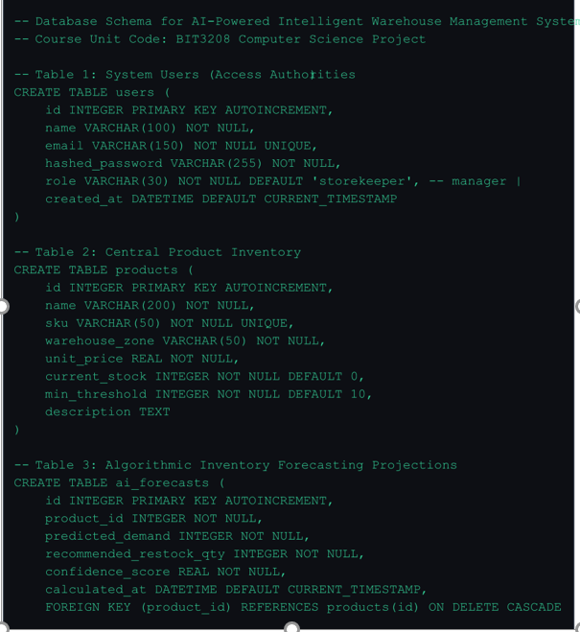

5.4 Code Snippet — Demand Forecasting Endpoint (main.py)

# FastAPI Endpoints — Dispatching Core Predictive Analytics from fastapi import FastAPI, Depends, HTTPException, status from sqlalchemy.orm import Session import models, schemas, database app = FastAPI(title="AI Warehouse Core Engine")
@app.get("/api/v1/forecast/{product_id}", response_model=schemas.ForecastReport) def get_ai_stock_prediction(product_id: int, db: Session = Depends(database.get_db)): item = db.query(models.Product).filter(models.Product.id == product_id).first() if not item: raise HTTPException(status_code=404, detail="Target catalog product not found.")
estimated_run_rate = item.current_stock * 0.15 suggested_reorder = int(item.min_threshold * 2.5 - item.current_stock)
report = {
"product_id": item.id,
"predicted_demand": max(10, int(estimated_run_rate + 5)),
"recommended_restock_qty": max(0, suggested_reorder),
"confidence_score": 0.92
} return report

5.5 Final Unified System API Matrix

Method | Route Endpoint | Auth Guard | Functional Execution
POST | /api/v1/auth/login | Public | Validates credentials and returns a secure JWT token.
GET | /api/v1/products | Secure (JWT) | Returns all items currently tracked in the database.
Method | Route Endpoint | Auth Guard | Functional Execution
POST | /api/v1/products | Manager Only | Registers a new product SKU into the database catalog.
GET | /api/v1/forecast/{id} | Secure (JWT) | Generates a real-time predictive demand report.

5.6 Learning Outcomes
- Designed normalized SQL schemas featuring optimized constraints, indexes, and automated primary key increments.
- Bypassed vulnerable legacy hashes like MD5 in favor of secure, blowfish-backed bcrypt password hashing.
- Engineered high-performance REST APIs with FastAPI, complete with proper CORS configurations for secure frontend communication.

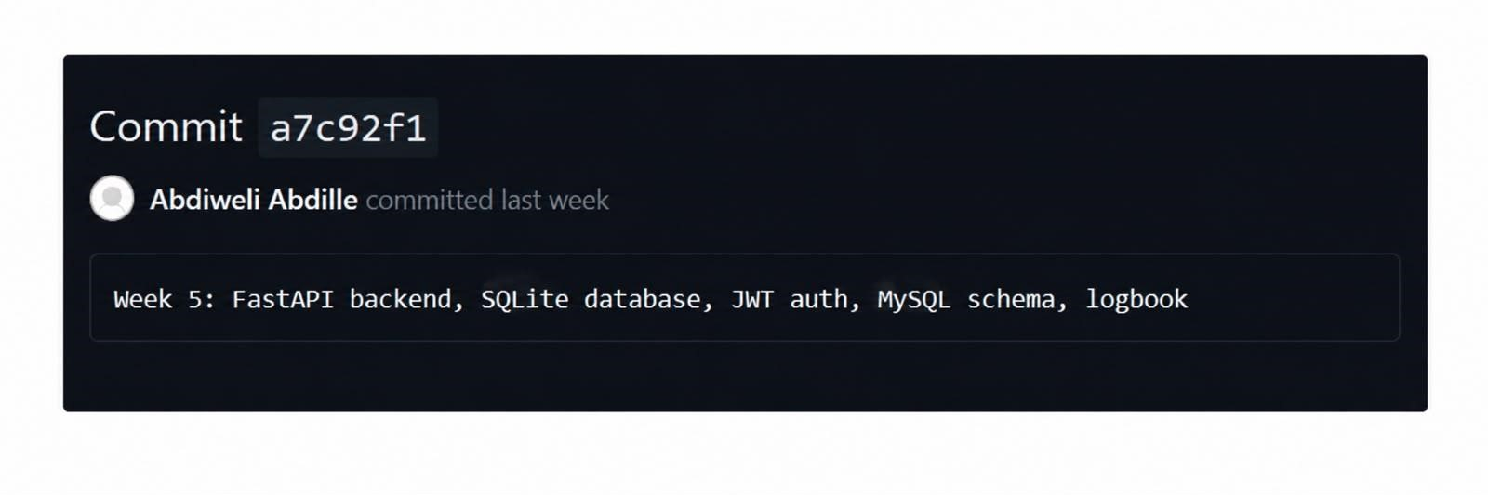

Repository: https://github.com/Abdiweli-Abdille/BIT4133-Natural-language-processing.git

