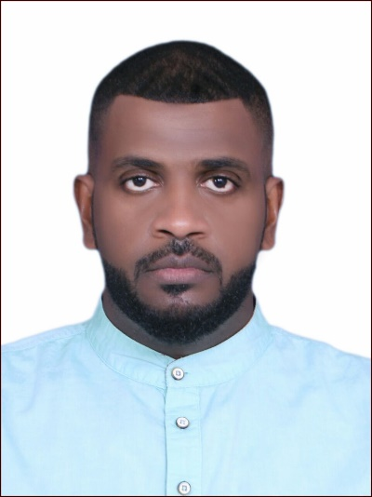

**CURRICULUM VITEA**

**OSMAN HAMID SAYEG**

CURRENT ADDRESS: C-G-01, CHANGKAT VIEW CONDOMINIUM, NO 18, JALAN DUTAMAS RAYA, TAMAN SEGAMBUT SPPK, 51200 KUALA LUMPUR, WILAYAH PERSEKUTUAN KUALA LUMPUR.

PERMANENT ADDRESS: 6181, OYOON STREET { UTHMAN BIN AFFAN ROAD} AL-NASSR NEIRBORHOOD, BEHIND AL-RAJHI BANK, AL MADINAH MUNAWWARAH KINGDOM OF SAUDI ARABIA

PHONE: +6-017-229-3051

+966-544-793-228

EMAIL: [osman.hamid.sayeg@gmail.com](mailto:osman.hamid.sayeg@gmail.com)

[osmansayeg@gmail.com](mailto:osmansayeg@gmail.com)

**PERSONAL INFORMATION**

FULL NAME: OSMAN HAMID SAYEG

DATE OF BIRTH: 24TH AUGUST, 1989.

PLACE OF BIRTH: JEDDAH, SAUDI ARABIA.

GENDER: MALE

NATIONALITY: ERITREAN

PASSPORT NUMBER: K0195053

CIVIL STATUS: SINGLE

LANGUAGE KNOWN: ARABIC {fluent in speaking and writing}

ENGLISH

URDU

TIGRE {native language}.

**QUALIFICATION**

* **BARCHELOR OF BUSINESS ADMINISTRATION**

HARVARD INSTITUTE ON MANAGEMENT AND ENGINEERING STUDIES {HIMES}

HYDERABAD, TELANGANA 500008,

INDIA.

**COURSES TAKEN**

* **PROFESSIONAL COURSE IN COMMUNICATION SKILL**

MEDINA CHAMBER OF COMMERCE & INDUSTRY (MMCI)

**WORK EXPERIENCES**

* **FULL TIME**

2014 – 2017 **DIRECTOR OF INTERNATIONAL EXHIBITIONS FOR BOOK FAIR.**

DAR AL-FAQIH PUBLISHING AND DISTRIBUTION.

ABOU DHABI, SAUDI ARABIA.

2014 – 2016 **SECRETARY GENERAL**

ARAB­-AFRICAN-ASIAN ASSOCIATION OF COMMUNITIES, AFFILIATED WITH THE SAUDI FOOTBALL FEDERATION.

2013 **ASSISTANT DIRECTOR OF EXTERNAL PROJECTS**

UNIVERSITY OF TAIBA

MEDINA, SAUDI ARABIA.

2012 – 2013 **INTERPRETER AND SECRETARY OF DEPUTY DIRECTOR OF THE DEPARTMENT OF TRANSLATION AND STRATEGIC RESEARCH.**

UNIVERSITY OF TAIBA

AL MADINAH MUNAWWARAH KINGDOM OF SAUDI ARABIA.

2008 – 2009 **SALES MANAGER**

AL-TALI’AH INSTITUTE FOR COMPUTERS AND SMART DEVICES.

AL MADINAH MUNAWWARAH KINGDOM OF SAUDI ARABIA.

* **PART TIME**

2017 **PART TIME EMPLOYEE**

ACCOUNT DEPARTMENT OF A PRIVATE INSTITUTION.

MEDINA, SAUDI ARABIA.

2016 **RESPONSIBLE FOR THE ORGANISATION OF THE INTERNATIONAL EXHIBITION OF ISLAMIC EVENTS AND THE SCIENCES OF QURAN AND RESEARCH IN THE HUMANITIES**.

MEDINA, SAUDI ARABIA.

2002 – 2008 **PART TIME EMPLOYEE**

MANAGEMENT OF THE PROJECT OF THE PROPHET’S MOSQUE IN MEDINA FOR THE INTERNATIONAL SYMPOSIUM OF ISLAMIC YOUTH.