RESEARCH REPORT
Comparative Study of Classic Machine Learning Regression Algorithms
for Used Car Price Prediction

Student:
University / Faculty:
Department:
Course / Instructor:
Submission Date:

Table of Contents
Abstract 2
1. Introduction 3
1.1 Research Problem 3
1.2 Research Objectives 3
1.3 Research Questions 3
2. Literature Review 3
2.1 Machine Learning for Pre-Owned Car Prices in Bangladesh 4
2.2 Iterative Framework of XGBoost and LightGBM 4
2.3 Price Prediction and Classification of Used Vehicles 4
2.4 Advanced Feature Engineering for Pre-Owned Cars 4
2.5 Granular Car Equipment Details and Resale Prices 4
2.6 Research Gap and Motivation 4
3. Background and Theory 5
3.1 Machine Learning Regression 5
3.2 Linear Regression 5
3.3 Decision Tree Regression 5
3.4 Random Forest Regression 6
4. Research Methodology 6
4.1 Dataset 6
4.2 Data Cleaning 6
4.3 Exploratory Data Analysis 7
4.4 Feature Selection 10
4.5 Data Preprocessing 10
4.6 Train/Test Split 10
4.7 Model Development 10
4.8 Hyperparameter Tuning 10
4.9 Evaluation Metrics 11
5. Results 11
5.1 Model Comparison 11
5.2 Decision Tree Hyperparameter Tuning 12
5.3 Actual vs Predicted 13
6. Discussion 13
7. Limitations and Future Work 14
7.1 Limitations 14
7.2 Future Work 14
8. Conclusion 14
References 16
Project Links 16

Abstract
Used Car Price Prediction is a regression problem. By providing the model with information about the car, we can train a Machine Learning model to predict what the selling price of a car will be. This study compares a variety of classic regression algorithms for predicting used car prices. These include Linear Regression, Decision Tree Regression and Random Forest Regression.
The experiments used the Vehicle Dataset from CarDekho. This originally had 301 rows and 9 columns. After removing 2 duplicate rows, there were 299 rows. The target variable was Selling_Price and the remaining 8 variables were the input features.
Categorical variables were encoded using One-Hot Encoding, whilst numerical variables were kept as they were. The dataset was split into training and testing sets using an 80/20 split. The models were then evaluated using 3 metrics: MAE, RMSE and R².
The results showed that Linear Regression had the lowest RMSE of 2.429 and the highest R² of 0.771. Decision Tree Regression had the lowest MAE of 1.337. Random Forest Regression did not outperform the other models. Hyperparameter Tuning was performed on the Decision Tree model using 5-fold GridSearchCV. However, the performance did not improve on the test set.
From the RMSE and R², it was determined that Linear Regression was the best model overall. This shows that a simpler regression algorithm can outperform more complex tree-based algorithms when there is a small amount of data. However, the results are limited to the dataset and market shown.
Keywords: Used Car Price Prediction, Machine Learning, Regression, Linear Regression, Decision Tree, Random Forest, Model Evaluation.

1. Introduction
The used car market consists of cars with various characteristics, conditions and prices. Estimating the selling price of used cars can be challenging as there are many variables that can influence the price such as the manufacturing year, mileage, current price, fuel type, transmission and ownership history.
Using Machine Learning enables us to identify patterns within historical data to help us estimate the prices of new data. Supervised regression involves training models to identify the relationship between input features and a continuous target variable.
Previous research has looked at various methods using Machine Learning to predict used car prices. This includes traditional regression, tree-based models and ensemble methods [1]–[5].
This research will look at how 3 classic regression algorithms perform.

1.1 Research Problem
To estimate the selling price of a used car using its available characteristics.
As different regression algorithms will produce different relationships from the same dataset, the models must be evaluated using consistent processing and evaluation methods.

1.2 Research Objectives
- To understand and process the Vehicle Dataset from CarDekho.
- To perform Exploratory Data Analysis.
- Apply suitable preprocessing techniques to the categorical variables.
- Train and compare Linear Regression, Decision Tree Regression and Random Forest Regression.
- Evaluate the models using MAE, RMSE and R².
- Hyperparameter tune the Decision Tree.
- Choose a final model.

1.3 Research Questions
- How accurate can classic Machine Learning regression algorithms be to predict used car selling prices using the chosen data?
- Which of the 3 algorithms performed best based on MAE, RMSE and R²?
- Did Hyperparameter Tuning improve the performance of the Decision Tree?
- What are the limitations of the results?

2. Literature Review
Many studies have been undertaken to investigate different methods of Machine Learning to estimate used car prices. This review looks at 5 studies with identifiable publishers.

2.1 Machine Learning for Pre-Owned Car Prices in Bangladesh
Amik et al. [1] investigated using Machine Learning techniques to predict the price of pre-owned cars in Bangladesh. They looked at various regression models including Linear Regression, LASSO Regression, Decision Tree, Random Forest and XGBoost.
They found that XGBoost had the best performance. This shows how useful Machine Learning can be in estimating pre-owned car prices. They have also compared traditional regression methods to boosting algorithms.

2.2 Iterative Framework of XGBoost and LightGBM
Cui et al. [2] propose an iterative framework using XGBoost and LightGBM.
By combining the predictions from a deep residual network with the original features they are able to make predictions using an iterative boosting framework. This shows how combining different Machine Learning techniques can improve performance.

2.3 Price Prediction and Classification of Used Vehicles
Bukvić et al. [3] investigated used vehicle price prediction and classification using supervised Machine Learning.
This study is relevant as it looks at how vehicle-related characteristics can be used for prediction in the used vehicle market. It also shows how supervised learning techniques can be applied to vehicle data.

2.4 Advanced Feature Engineering for Pre-Owned Cars
Fayyaz et al. [4] investigated the effect of feature engineering on used car price prediction. They looked at various Machine Learning algorithms. They investigated how preprocessing techniques such as categorical encoding, standardisation, outlier removal and feature extraction can impact the performance. They found that the models improved after feature engineering. This shows how important data preprocessing and feature engineering is in Machine Learning regression.

2.5 Granular Car Equipment Details and Resale Prices
Bergmann and Feuerriegel [5] investigated using granular car equipment details to predict used car resale prices.
They used a real-world dataset containing 92,239 car sales. They looked at over 50,000 car equipment options. They found that incorporating car equipment details improved the performance. This shows how important granular car characteristics are.

2.6 Research Gap and Motivation
The previous studies show that there are various Machine Learning algorithms and feature engineering techniques that can be used to predict used car prices.
This study will look at how 3 classic regression algorithms perform when using the same dataset and evaluation methods. It will also look at whether Hyperparameter Tuning improves the performance of the Decision Tree model.
This experiment will look at a relatively small dataset compared to the other studies which use more advanced ensemble techniques.
This is not to say that the chosen algorithms will always be the best, but to see how they performed in the given situation.

3. Background and Theory

3.1 Machine Learning Regression
Regression is a supervised learning problem. We aim to predict a numerical value.
In this study we want to predict the Selling_Price of cars. We give the model information about a car and it will predict the selling price.
The general relationship can be represented as:
y = f(X)
Where:
- X are the input features.
- y is the target variable.
- f is the relationship between the features and target.

3.2 Linear Regression
Linear Regression is a supervised learning algorithm. It aims to find the relationship between the input variables and a continuous target using a linear equation.
If there are multiple input variables, the equation becomes:
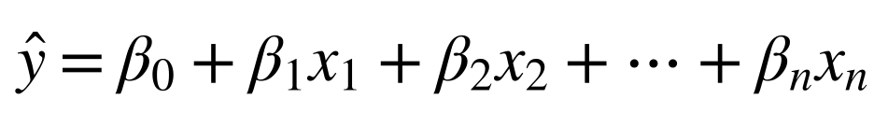
Where:
- ŷ is the predicted selling price.
- β₀ is the intercept.
- βᵢ is the learned coefficient.
- xᵢ is the input feature.
The algorithm will try to find the best coefficients to minimise the error in the predictions.

3.3 Decision Tree Regression
Decision Tree Regression aims to predict a numerical target by splitting the dataset into smaller subsets based on the conditions of the variables. Each internal node will represent a decision based on a feature and each leaf node will give a numerical prediction.
Decision trees can find non-linear relationships between the features. However, the performance can depend on the tree structure and hyperparameters.

3.4 Random Forest Regression
Random Forest Regression is an ensemble learning algorithm. It uses multiple decision trees.
Each tree will produce a prediction and the final prediction will average the predictions:
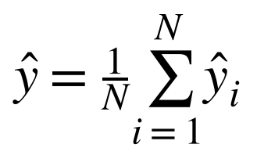
Where:
- N is the number of trees.
- ŷᵢ is the prediction made by tree i.
This aims to produce more stable predictions.

4. Research Methodology

4.1 Dataset
The dataset used in this research is the Vehicle Dataset from CarDekho. This can be found on Kaggle [6].
Dataset source: https://www.kaggle.com/datasets/nehalbirla/vehicle-dataset-from-cardekho
The original dataset had 301 rows and 9 columns. The features are described in Table 1.
Table 1: Feature description of the Vehicle Dataset
Feature | Description
Car_Name | Name of the vehicle
Year | Manufacturing year
Selling_Price | Selling price of used car (target)
Present_Price | Current / ex-showroom price
Kms_Driven | Kilometers driven
Fuel_Type | Fuel type
Seller_Type | Type of seller
Transmission | Transmission type
Owner | Previous owner information

The target variable was Selling_Price. The remaining 8 columns were input features.
As this dataset represents the Indian used car market we cannot assume it will represent the Egyptian market or current prices in other countries.

4.2 Data Cleaning
The dataset originally had 301 rows. During data cleaning, 2 duplicate rows were identified and removed. There were no missing values. The dataset after cleaning is summarised in Table 2.
Table 2: Dataset summary after removing duplicates
Property | Value
Rows | 299
Columns | 9
Input features | 8
Target variable | 1
Missing values | 0

4.3 Exploratory Data Analysis
Exploratory Data Analysis (EDA) was conducted to understand the dataset. We looked at:
- The size and type of the dataset.
- Missing values and duplicates.
- Distribution of Selling_Price.
- Relationship between Year and Selling_Price.
- Relationship between Kms_Driven and Selling_Price.
- Comparison between the Selling_Price based on transmission.
- Correlation between numerical variables.
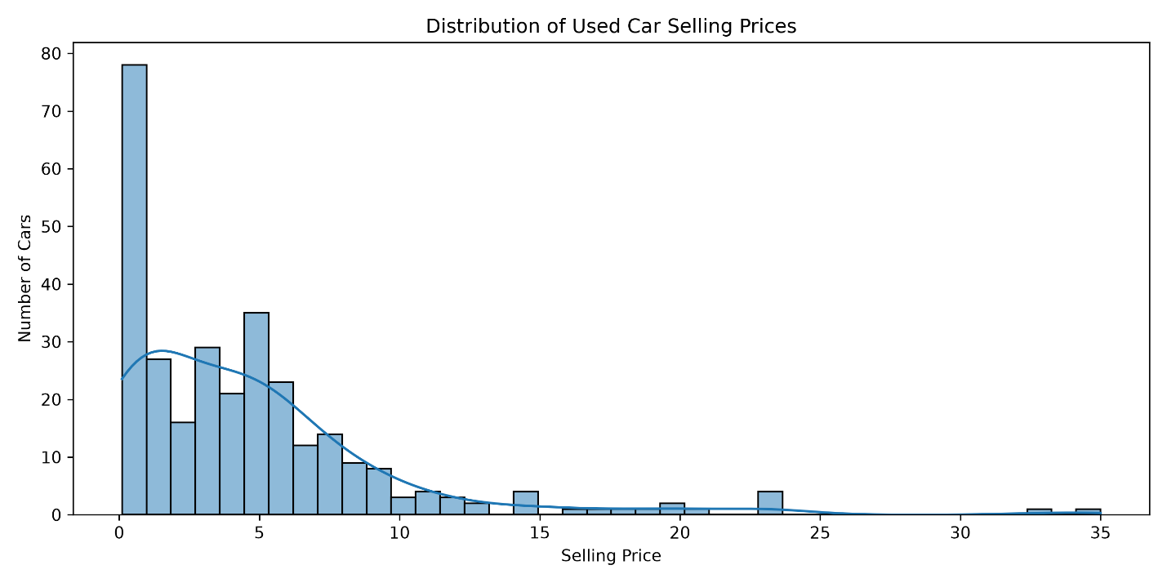
Figure 1: Distribution of Used Car Selling Prices
This graph shows the distribution of the target variable Selling_Price. This helps describe how the selling prices are spread throughout the dataset.
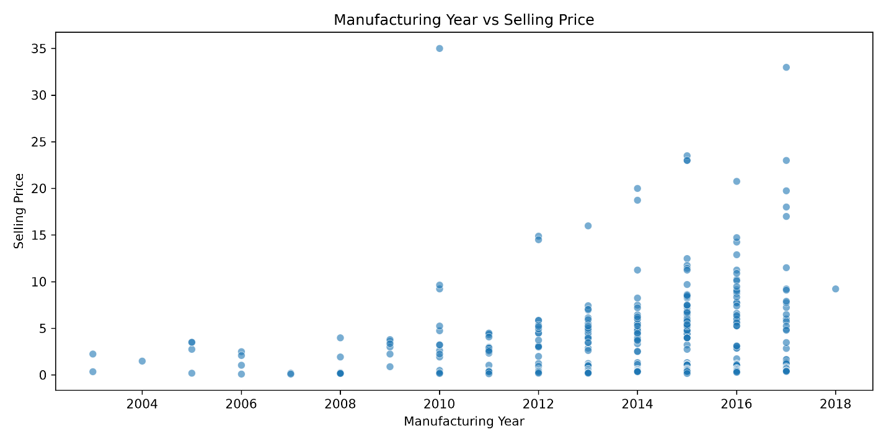
Figure 2: Manufacturing Year vs Selling Price
This graph shows the relationship between the manufacturing year and selling price. This helps see if newer vehicles have higher selling prices.
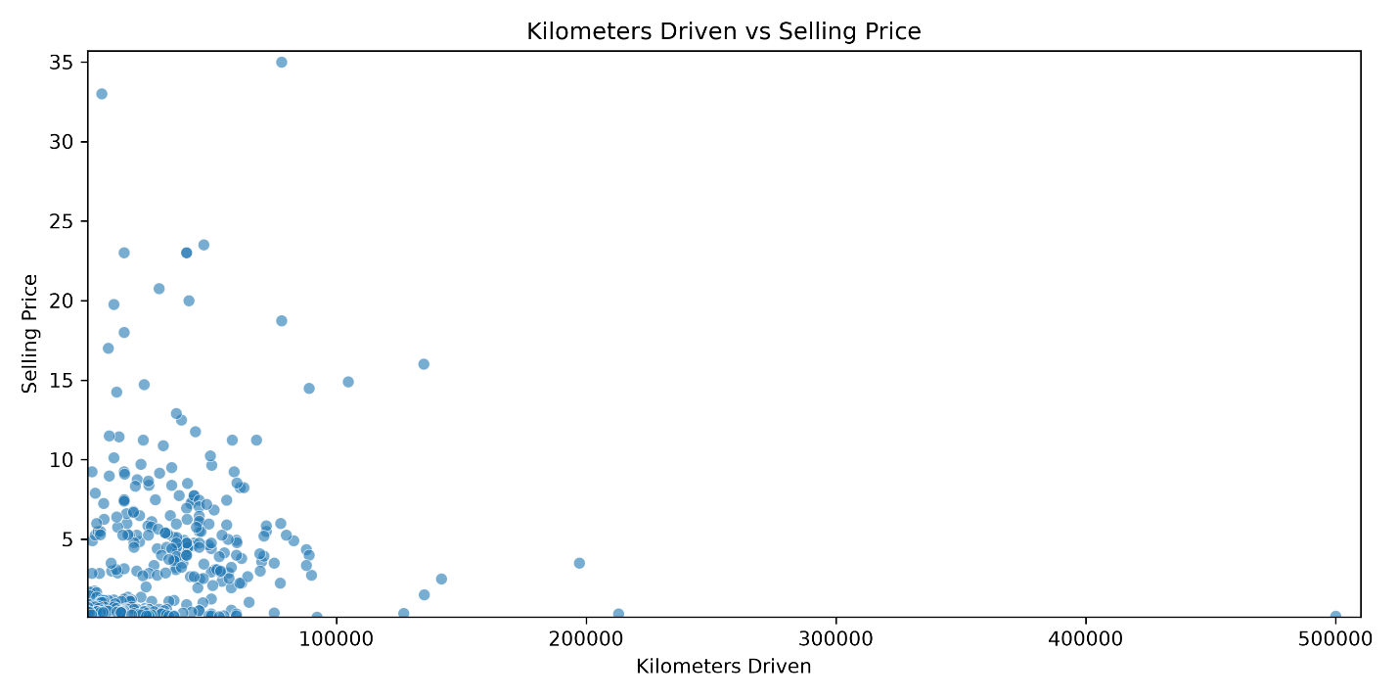
Figure 3: Kilometers Driven vs Selling Price
This graph shows the relationship between how far the car has been driven and the selling price. This helps see if there is a relationship between the mileage and price of the cars.
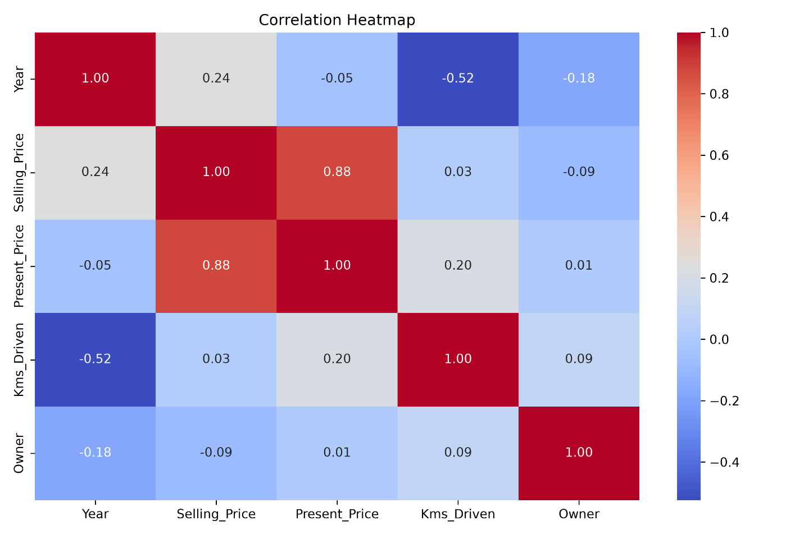
Figure 4: Correlation Heatmap of Numerical Variables
We found the following relationships between the variables and Selling_Price (Table 3).
Table 3: Correlation of numerical features with Selling_Price
Feature | Correlation with Selling_Price
Present_Price | 0.879
Year | 0.236
Owner | −0.088
Kms_Driven | 0.029

Present_Price had the strongest positive correlation with Selling_Price.
This shows how correlated the variables are with each other in the original dataset. This doesn't show that the variables cause an increase/decrease in Selling_Price.
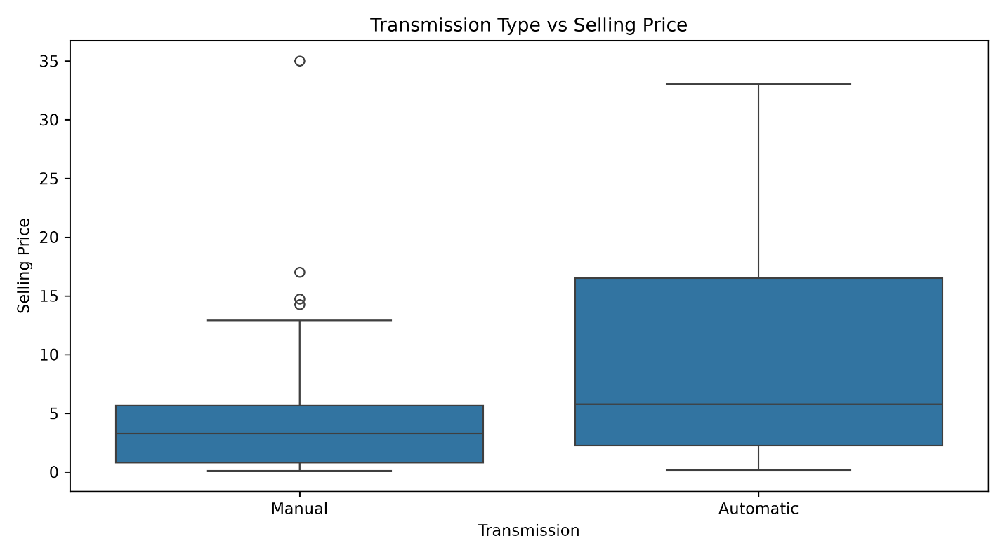
Figure 5: Transmission vs Selling Price
This graph compares the selling prices based on transmission. This gives another perspective on how the characteristics of the car relate to the price.

4.4 Feature Selection
Target variable: Selling_Price.
Input variables: Car_Name, Year, Present_Price, Kms_Driven, Fuel_Type, Seller_Type, Transmission, Owner.

4.5 Data Preprocessing
The dataset contains both numerical and categorical variables.
Categorical variables were encoded using One-Hot Encoding. This converts the categorical variables into binary numerical variables so they can be processed by Machine Learning algorithms. Numerical variables were left as they were.
ColumnTransformer was used to apply the correct transformations to the variables. The preprocessing was incorporated into the pipeline. After encoding there were 96 columns of features.

4.6 Train/Test Split
The dataset was split into training and testing sets using an 80/20 split (test size 20%, random state 42). This gave the sizes shown in Table 4.
Table 4: Training and test set sizes
Dataset | Number of Rows
Training Set | 239
Test Set | 60
Total | 299

The training set was used to train the models. The test set was used to evaluate the models.

4.7 Model Development
3 regression models were trained:
- Linear Regression: A baseline regression model. This will find the relationship between the input variables and selling price.
- Decision Tree: This will find decision-based relationships between the characteristics of the car and selling price.
- Random Forest: Combines multiple decision trees. The final prediction is an average.
The Random Forest used 200 estimators and a random state of 42.

4.8 Hyperparameter Tuning
GridSearchCV was used to find the best hyperparameters for the Decision Tree. The values tested are shown in Table 5.
Table 5: Hyperparameter grid for the Decision Tree
Parameter | Tested Values
max_depth | 3, 5, 7, 10, None
min_samples_split | 2, 5, 10
min_samples_leaf | 1, 2, 4

5-fold cross validation was used with negative RMSE as the score. The best parameters were max_depth = 5, min_samples_leaf = 1 and min_samples_split = 2, giving a best cross-validation RMSE of 1.558.

4.9 Evaluation Metrics
3 metrics were used to evaluate the models.
Mean Absolute Error (MAE)
MAE gives the average difference between the actual and predicted values. The lower the MAE the better as the predictions will have less average error.
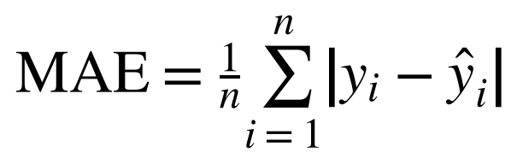
Root Mean Squared Error (RMSE)
RMSE takes the square root of the average of the squared errors. This puts more weight on larger errors.
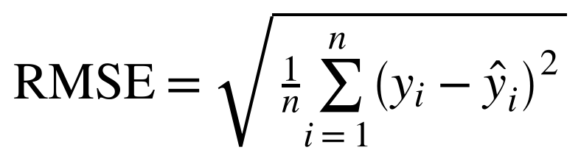
Coefficient of Determination (R²)
R² looks at how much variance in the target variable can be explained by the model compared to a baseline prediction using the mean of the target variable. The higher the R² the better the fit.
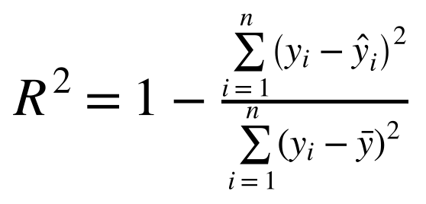

5. Results

5.1 Model Comparison
The 3 regression models were evaluated using the same test set (Table 6).
Table 6: Model performance on the test set (best value per metric in bold)
Model | MAE | RMSE | R²
Linear Regression | 1.411 | 2.429 | 0.771
Decision Tree | 1.337 | 2.968 | 0.658
Random Forest | 1.370 | 3.303 | 0.577

- Linear Regression had the lowest RMSE and highest R².
- Decision Tree had the lowest MAE, meaning the average absolute error was smallest.
- Random Forest had the highest RMSE and lowest R².
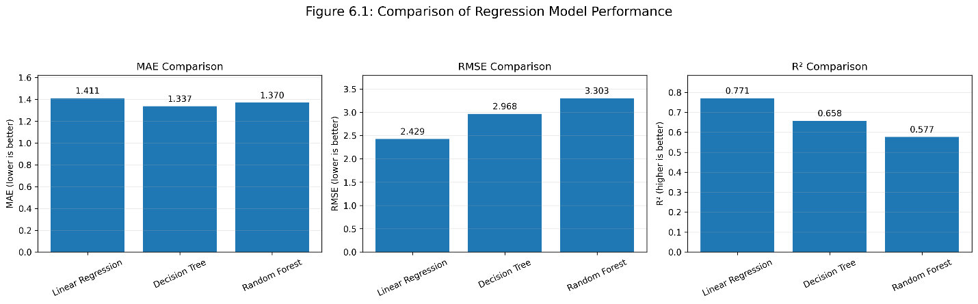
Figure 6: Model Comparison
This graph shows how the 3 regression models performed. The lower the MAE and RMSE the better. The higher the R² the better the fit.

5.2 Decision Tree Hyperparameter Tuning
GridSearchCV was used to find the best hyperparameters for the Decision Tree. The best parameters are shown in Table 7, with a cross-validation RMSE of 1.558.
Table 7: Best hyperparameters found by GridSearchCV
Parameter | Best Value
max_depth | 5
min_samples_leaf | 1
min_samples_split | 2

The tuned Decision Tree had the results shown in Table 8, alongside the untuned Decision Tree for comparison.
Table 8: Decision Tree performance before and after tuning
Metric | Decision Tree | Tuned Decision Tree
MAE | 1.337 | 1.510
RMSE | 2.968 | 3.134
R² | 0.658 | 0.619

The Decision Tree did not improve.

5.3 Actual vs Predicted
To understand how the models were predicting the selling prices we compared the actual and predicted values. This will show how close the predicted values are to the actual.
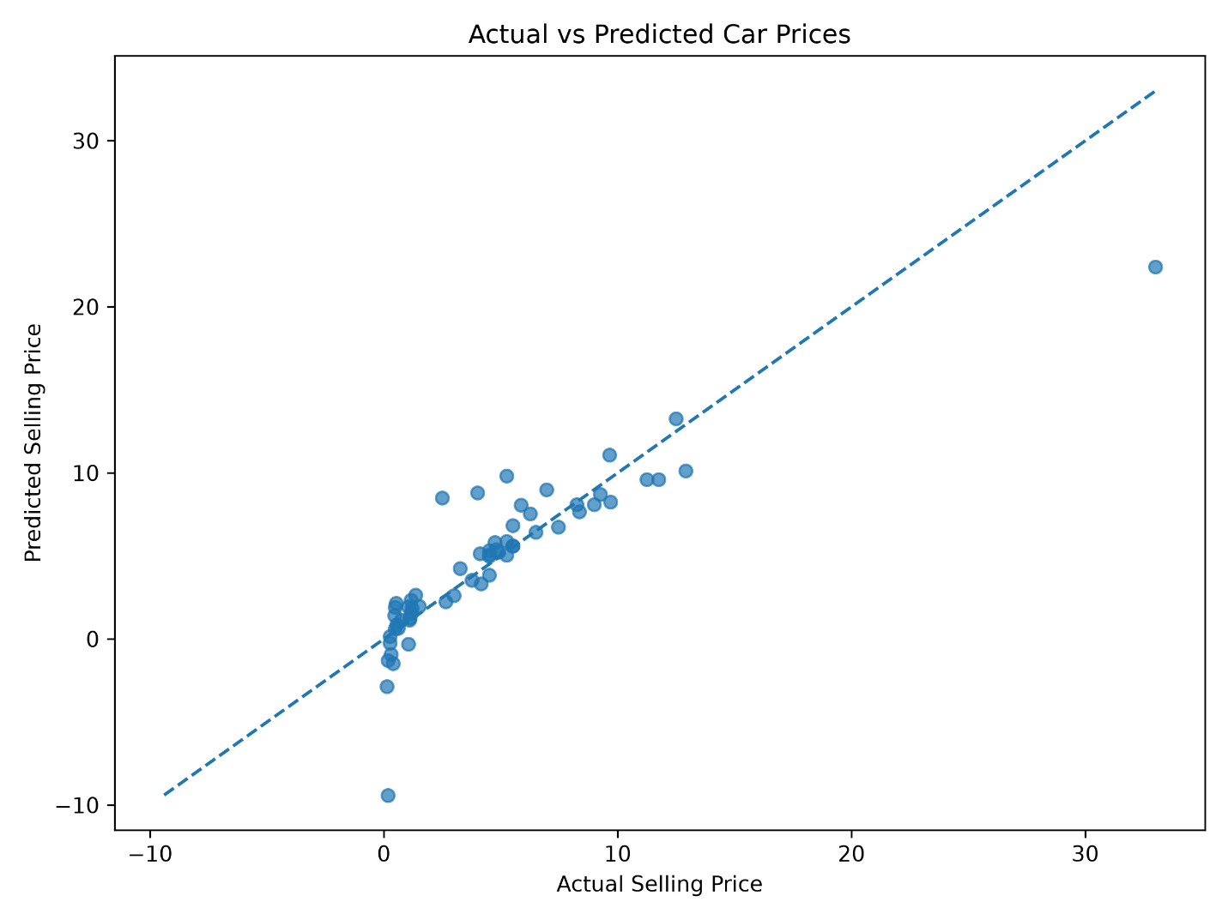
Figure 7: Actual vs Predicted
This graph shows how the Linear Regression model predicted the selling prices. One negative prediction was made. As the selling price can't be negative this shows a limitation to using an unbounded Linear Regression model.

6. Discussion
From the results we can see that Linear Regression had the best performance overall. This shows that the relationships learned by Linear Regression were more effective than the tree-based models.
Decision Tree had the lowest MAE however had a higher RMSE than Linear Regression. This shows that the models performed differently depending on the evaluation metric.
Random Forest didn't outperform the single Decision Tree. This could be due to the dataset being relatively small. With limited examples to train on, a more complex model may not outperform.
Hyperparameter Tuning didn't improve the Decision Tree. Whilst GridSearchCV found parameters with a cross-validation RMSE of 1.558, the test RMSE was 3.134. This shows that the best cross-validation parameters do not always give the best result.
The results should be considered with the limitations of the dataset in mind. This does not mean that Linear Regression will always be the best algorithm for Used Car Price Prediction.

7. Limitations and Future Work

7.1 Limitations
There are several limitations to this study:
- Small dataset: Only 299 rows of data after removing duplicates. This means less information for the models to learn from.
- Specific market: The dataset relates to the Indian used car market. The relationships learned from the dataset shouldn't be assumed to relate to other markets.
- Limited information: There isn't much information about the condition of the car, accident history, maintenance history or all the equipment available.
- Only 3 models: Only 3 classic regression models were tested.
- Predictions not bounded: Linear Regression made 1 negative prediction. This shows that the model does not force the prices to be realistic and non-negative.
- Only 1 train/test split: The final comparison only used 1 train/test split. Further experiments could be performed using repeated or nested validation to give more evidence that the models are stable.

7.2 Future Work
Further research could improve this work by:
- Gathering a larger dataset with more cars.
- Adding more variables such as car condition, accident history and maintenance history.
- Testing advanced algorithms such as XGBoost, LightGBM and CatBoost.
- Investigating feature engineering techniques.
- Comparing models using repeated cross validation.
- Investigating methods to force the predictions to be realistic and non-negative.
- Testing the models on data from different markets.

8. Conclusion
In this project we compared the performance of three classical regression algorithms, namely Linear Regression, Decision Tree Regression and Random Forest Regression, to predict the used car price using the Vehicle Dataset from CarDekho.
We trained all the models using the same dataset and measured their performance using the MAE, RMSE and R² metrics. The Linear Regression model had the lowest RMSE value (2.429) and highest R² value (0.771) showing it is the best performing model. The Decision Tree model had the lowest MAE value (1.337). The Random Forest model did not perform well.
The Decision Tree model was also optimised using hyperparameter tuning with 5-fold GridSearchCV. However, the model did not perform any better than the original Decision Tree model.
Overall this shows that more complex models do not necessarily perform better. The quality and characteristics of data along with the preprocessing and evaluation techniques used will affect how well your model performs.
This project gives an insight into how different classical regression models perform. This conclusion can only be applied to the dataset we chose.

References
[1] Amik, F.R., Lanard, A., Ismat, A. and Momen, S. (2021) Application of Machine Learning Techniques to Predict the Price of Pre-Owned Cars in Bangladesh. [online] Information. 12(12). Available at: https://doi.org/10.3390/info12120514 [Accessed 5 April 2025].
[2] Cui, B., Ye, Z., Zhao, H., Renqing, Z., Meng, L. and Yang, Y. (2022) Used Car Price Prediction Based on the Iterative Framework of XGBoost+LightGBM. [online] Electronics. 11(18). Available at: https://doi.org/10.3390/electronics11182932 [Accessed 5 April 2025].
[3] Bukvić, L., Pašagić Škrinjar, J., Fratrović, T. and Abramović, B. (2022) Price Prediction and Classification of Used-Vehicles Using Supervised Machine Learning. [online] Sustainability. 14(24). Available at: https://doi.org/10.3390/su142417034 [Accessed 5 April 2025].
[4] Fayyaz, I., Nawaz Ali, G.G.Md. and Khairunnesa, S.S. (2025) Advanced Feature Engineering and Machine Learning Techniques for High Accurate Price Prediction of Heterogeneous Pre-Own Cars. [online] Vehicles. 7(3). Available at: https://doi.org/10.3390/vehicles7030094 [Accessed 5 April 2025].
[5] Bergmann, S. and Feuerriegel, S. (2025) Machine learning for predicting used car resale prices using granular vehicle equipment information. [online] Expert Systems with Applications. 263. Available at: https://doi.org/10.1016/j.eswa.2024.125640 [Accessed 5 April 2025].
[6] Nehalbirla. (n.d.) Vehicle Dataset from CarDekho. [online] Kaggle. Available at: https://www.kaggle.com/datasets/nehalbirla/vehicle-dataset-from-cardekho [Accessed 5 April 2025].

Project Links
GitHub: https://github.com/AbdlerahmanGihad/Used-Car-Price-Prediction
Streamlit: https://used-car-price-prediction-a5hgsy3jmwmyihcwjqy4mt8.streamlit.app/

