# Minia University

Faculty of Science

Computer Science Department

# **Plant Disease Doctor**

Supervised By

*Dr.*  *Al-Hussien Seddik Saad*

Teacher Assistant

*Eng. Rofaida*

Prepared By

|  |  |
| --- | --- |
| Hazem Mamdouh Esmaeil | <student mail> |
| Ahmed Abd-Elhaleem | <student mail> |
| Hussein Ali Nazeer | <hali12122015@gmail.com> |

**Acknowledgements**

In the beginning we would like to thank everyone who has support us in every step of this project, it has been a great opportunity to gain lots of experience in real time projects, followed by the knowledge of how to actually design and analyze real projects. For that we want to thank all the people who made it possible for students like us. Special thanks to the graduation Project unit for the efforts they did to provide us with all useful information and making the path clear for the students to implement all the education periods in real-time project design and analysis.  
Furthermore, we would like to express our deepest gratitude to our  
graduation project supervisor **Prof. Al-Hussien Seddik Saad** for his  
patience and guidance along the semester, Moreover, it is our duty to thank all the testing committee members for their generous discussions and encouragement.  
At last, we have to show our gratitude to **Dr. Al-Hussien** for his help in some parts related to the work. Furthermore, we would like to thank all of our friends who helped, supported and encouraged us to successfully finish our graduation project.

CONTENTS

• Acknowledgements ----------------------------------------------------------------- 1

**Chapter 1**

* Introduction --------------------------------------------------------------------------- 4
  + Problem Description ------------------------------------------------------------------------- 8
    - Problem Definition ------------------------------------------------------------------ 8
    - Problem Solution -------------------------------------------------------------------- 9
  + How We Will Work ------------------------------------------------------------------------ 10
    - Abstract ------------------------------------------------------------------------------ 10
    - Overview ----------------------------------------------------------------------------- 10
    - Objectives --------------------------------------------------------------------------- 10
    - Scope --------------------------------------------------------------------------------- 11
    - General Constraints --------------------------------------------------------------- 12
    - Technologies Used ---------------------------------------------------------------- 12

**Chapter 2**

* System Planning and Analysis ------------------------------------------------ 13•
* Analysis and Limitation of existing system ------------------------------------------- 16
* Need for New Mobile Application ------------------------------------------------------- 17
* Analysis of the New Application --------------------------------------------------------- 17
  + User Requirements ----------------------------------------------------------- 17
  + System Requirements ------------------------------------------------------- 17
* Advantages of the New System --------------------------------------------------------- 18
* Risk and Risk Managements ------------------------------------------------------------ 18
* Business Model Canvas ------------------------------------------------------------------ 19

**Chapter 3**

* System Design ---------------------------------------------------------------------- 20
* Actor Goal List ------------------------------------------------------------------------------- 21
* Use Cases ------------------------------------------------------------------------------------ 21
* Use Case Diagram ------------------------------------------------------------------------- 25•
* System Sequence Diagram -------------------------------------------------------------- 26

**Chapter 4**

* Implementation --------------------------------------------------------------------- 36
  + Learning Systems : Supervised / Unsupervised Learning
  + Deep learning Fundamentals
    - Artificial Neural Networks
    - Activation Functions
    - Convolutional Neural Networks
    - Pooling Layers
    - Batch Normalization Layer
  + Machine Learning Model Life Cycle
    - Exploring The Dataset
    - Data Preprocessing
    - Data Augmentation
    - Model Architecture
    - Training and compile the Model
    - Evaluation of model accuracy and testing
    - Save Model For future use
    - Model Deployment

**Chapter 5**

* Conclusion --------------------------------------------------------------------------- 39
* Future Work -------------------------------------------------------------------------- 41
* References --------------------------------------------------------------------------- 43
* Introduction : -

Problem Definition :-

In agriculture, the identification of diseases in plants plays an important role, as farmers often have to determine if the crop they grow is good enough.

Taking these seriously is of utmost importance as it can lead to serious plant problems due to which the respective product quality, quantity or productivity is affected.

Plant diseases are generally caused by pests, insects, pathogens and decrease productivity to large scale if not controlled within time and Agriculturists are facing loss due to various crop diseases. For global health and wellbeing, it is very important to get an accurate diagnosis of plant diseases.

Problem Solution:-

The proposed system provides the solution for Farmers to correctly classify crop disease and help in sake of early detection of diseases as soon as it starts spreading on the outer layer of the leaves.

For such a system we use machine and deep learning models as the problem all about Image Classification which is the most shining area in computer vision tasks and Deep Learning models proved their capability and rise at the state of the art areas to apply for these problems .

Chapter 3

Design

Use Case

**Primary Actors Goal List**

|  |  |
| --- | --- |
| Actor | Goals |
| Farmer | * Scan an Image * Upload new images * Give Feedback |
| Admin | * System Monitoring * collect uploaded Data * Retrain The Model * update the app |
| Organization | * Buy Pre-trained Model * Suggest Needed Feature * Give Feedback |

**Use-case formats:-**

* **UC1: Scan an Image (Primary Actor: Farmer):**

**Stockholders and interests:**

* **Farmer : who uses the app to classify the images**

**Preconditions:**

* **Farmer Downloaded the App**

**Success guarantees (Postcondition):**

* **Result of prediction displayed**

**Main success scenario:**

**1. Farmer Downloads the app**

**2. Farmers take new image**

**3. Model detect the image**

**4. Result Displayed under chosen image**

**alternative flows:**

**2a – Farmer choose existing image from gallery**

1. **Model detect the image**
2. **Result Displayed under chosen image**

**Special requirements:**

* **Android Mobile running the app**

**Technology and data variations list:**

**None.**

**Frequency of occurrence:**

**According to the number of users using.**

**Open issues:**

**None.**

* **UC2: Upload new images (Primary Actor: Farmer):**

**Description : Model predictions accuracy depends on data provided to to the model as data grows, models become more accurate to classify new images .**

**Main success scenario:**

**1. Farmer give permissions to app to upload scanned photos**

**2. App organizes the collected images to corresponding class**

**3. app upload the collected images**

* **UC3: Give Feedback (Primary Actor: Farmer):**

**Stockholders and interests:**

* **Farmer : who uses the app to classify the images**
* **Admin : who monitors the system**

**Preconditions:**

* **Farmer Downloaded the App**
* **Model predicted an image**

**Success guarantees (Postcondition):**

* **Feedback sent to admin**

**Main success scenario:**

1. **Farmers scans an image**
2. **Model detect the image**
3. **Result Displayed under chosen image**
4. **Farmer send feedback of how result is satisfying**

**alternative flows:**

**2a – Farmer report an issue**

1. **farmer send a direct feedback reporting an issue**

**Special requirements:**

* **Android Mobile running the app**

**Technology and data variations list:**

**None.**

**Frequency of occurrence:**

**According to the number of users using.**

**Open issues: None.**

* **UC4: System Monitoring (Primary Actor: Admin):**

**Stockholders and interests:**

* **Admin : who monitors the system**
* **Farmer who send feedbacks**

**Preconditions:**

* **Farmer sent a feedback**
* **admin receives feedback**

**Success guarantees (Postcondition):**

* **Admin managed to solve the issue**

**Main success scenario:**

1. **Farmers send a feedback**
2. **Admin review the feedback**
3. **Admin record the feedback**
4. **Issue get solved if there is any**

**alternative flows:**

**2a – Issue not solved for that specific user**

1. **user send report to admin**
2. **Admin review the feedback**
3. **Admin record the feedback**
4. **Issue get solved if there is any**

**Special requirements:**

* **Android Mobile running the app**

**Technology and data variations list:**

**None.**

**Frequency of occurrence:**

**According to the number of messages received from users.**

**Open issues: None.**

* **UC5: Collect Uploaded Data (Primary Actor: Admin):**

**Description : After many users upload new data that come from the app admin have to structure them and make sure that data come from the same distribution as model trained on**

**Main success scenario:**

1. **users upload the data with app**
2. **App organizes the collected images to corresponding class**
3. **app upload the collected images**
4. **admin put the data in the right path**

**alternative flows:**

**2a – data come from different distribution**

1. **add collect the data in other path for new data**
2. **users upload enough amount of data**
3. **admin admin take new data in consideration and retrain the model with**

* **UC6: Retrain The Model (Primary Actor: Admin):**

**Stockholders and interests:**

* **User : who upload data**
* **Admin : who uses uploaded data to retrain the model**

**Preconditions:**

* **App launched and being used**
* **There is enough data for model to train on**

**Success guarantees (Postcondition):**

* **Model Accuracy and performance improve**

**Main success scenario:**

1. **admin collect enough amount of data**
2. **Model get trained on uploaded data**
3. **Admin analyse the performance of the model**

**alternative flows:**

**2a – Model trained on data from different distribution**

1. **admin collect data in the right path**
2. **admin retrain a demo version of model**
3. **admin analyse model performance and accuracy for new data**

**Special requirements:**

* **Enough data to train the model**

**Technology and data variations list:**

**None.**

**Frequency of occurrence:**

**Every month as the process is expensive.**

**Open issues: None.**

* **UC6: Update the app (Primary Actor: Admin):**

1. **add new feature**
2. **update the app for the new version of model**

Chapter 4

Implementation

* **Supervised VS Unsupervised Learning :-**

Machine Learning systems can be classified according to the amount and type of supervision they get during training. There are four major categories: supervised learning, unsupervised learning, semi-supervised learning, and Reinforcement Learning.

* In supervised learning, the training set you feed to the algorithm includes the desired solutions, called labels
* A typical supervised learning task is classification. The spam filter is a good example of this: it is trained with many example emails along with their class (spam or ham), and it must learn how to classify new emails.

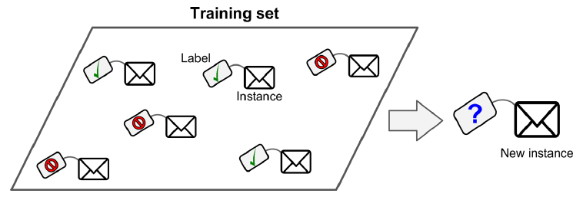

A labeled training set for spam classification (an example of supervised

learning)

* Another typical task is to predict a target numeric value, such as the price of a car, given a set of features (mileage, age, brand, etc.) called predictors. This sort of task is called regression To train the system, we need to give it many examples of cars, including both theirpredictors and their labels (i.e., their prices).

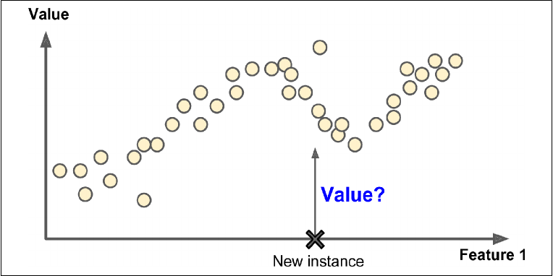

**Deep learning Fundamentals (Artificial Neural Networks) :-**

* **Building Blocks Of Neural Network :-**

1. **Perceptron :**

* References: -