1/12/2023

Abdurrahman Gamal Ahmed Gaber

no campany

Clean code

**Ch6 DS**

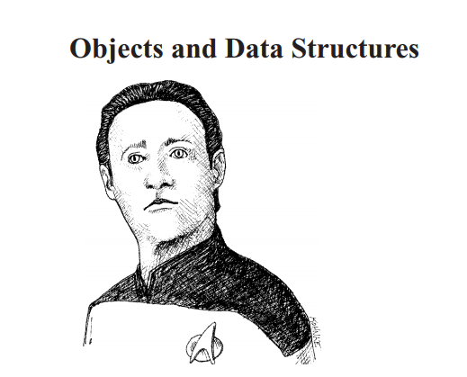

Table of Contents

**No table of contents entries found.**

# 1-