- Write a program that finds the Determinant (Delta) of the second-degree equation.
Equation: a*x2 + b*x + C = 0
Delta = b2 – 4*a*c
The output should be similar to the following:
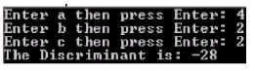
- Write a C# program that accepts an integer number into a variable, and then tests the variable against 100. If the value of the variable is less than one hundred, multiply the variable by 10 and finally display the variable. The output should be similar to the following:
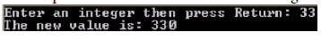
- Find a method to give the equation of a line passing by a point A(xA,yA) and having a slope m. Write a program that implements your method.
- Use for loops to generate each of the following pattern:

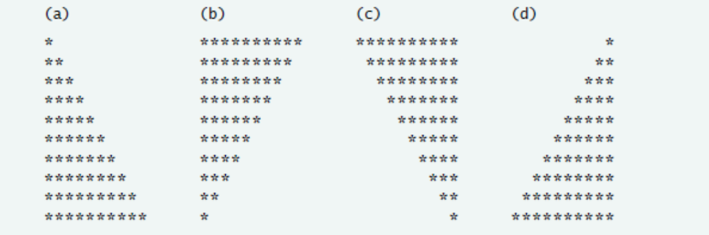

- Repeat Prob. # 1 by using While loops and String.format() .
- Write a program to print on a page a similar pattern to the one shown below.

* * *
* * *
* * *
* * * o * * *
* * *
* * *
* * *

The center of the pattern is the letter “o”, which should be half way across the printed page. The number of asterisks going out horizontally, vertically and diagonally from the center is provided by a response to a question, “How many asterisks?”. In the example shown, the answer to this question was 3. Write a program that produces the desired output. Demonstrate your program with the following data: 3, 15, 30.
- There is a number between 2400 and 2800 which when divided by 2 leaves a remainder of 1, when divided by 3 leaves a remainder of 2, when divided by 4 leaves a remainder of 3, when divided by 5 leaves a remainder of 4, when divided by 6 leaves a remainder of 5, when divided by 7 leaves a remainder of 6, when divided by 8 leaves a remainder of 7, when divided by 9 leaves a remainder of 8, and when divided by 10 leaves a remainder of 9. Write a program to find the number and print out: "The number is <your solution>".
- Given a positive integer, N, define the '3N+1' sequence starting from N as follows: If N is an even number, then divide N by two; but if N is odd, then multiply N by 3 and add 1. Continue to generate numbers in this way until N becomes equal to 1. For example, starting from N = 3, which is odd, we multiply by 3 and add 1, giving N = 3*3+1 = 10. Then, since N is even, we divide by 2, giving N = 10/2 = 5. We continue in this way, stopping when we reach 1, giving the complete sequence: 3, 10, 5, 16, 8, 4, 2, 1. Write a program that will read a positive integer from the user and will print out the 3N+1 sequence starting from that integer. The program should also count and print out the number of terms in the sequence.
- For almost 2000 years, mathematicians have known that any perfect cube can be written as the sum of a group of consecutive odd numbers.
e.g. 64 = 13 + 15 + 17 + 19.
Write a program, which will take in a number, cube it, and then find the consecutive odd numbers, which give the cube. Demonstrate that your program works by listing out results for entry numbers from 10 through to 20.
- The proper factors of a whole number N are all of the factors of N excluding 1 and N. For example, the proper factors of 12 are 2, 3, 4 and 6. Your task is to write a program which will find the proper factors of a given whole number N. Your printout should display the number as well as all of the proper factors. All output should be suitably labeled. Demonstrate that your program works by finding the proper factors of 144 and 12368.
- A PALINDROME is a word which reads the same forward or backwards e.g. MADAM. Your task is to write a program, which will recognize whether a word input is a palindrome. If it is not, print out the word and the message IS NOT A PALINDROME using a message box. If the word is a palindrome, print out a square similar to the one below using a message box. The sides of your square should have the letters of your palindrome in them.
M A D A M
A A
D D
A A
M A D A M

