NTI – Data Analysis Final Project

Team Members
Abdelrhman Mostafa
Bahaa Mohamed
Mohamed Ahmed

Data Overview
This project analyzes a coffee-shop point-of-sale dataset covering the full 2023 calendar year. The raw data (dirty_cafe_sales.csv) contains 10,000 transactions across 8 columns, with a mix of missing values and deliberately corrupted entries used to simulate a messy real-world export.

Raw Columns
Column | Description
Transaction ID | Unique identifier for each sale (no duplicates)
Item | Product sold: Coffee, Tea, Juice, Cookie, Cake, Salad, Sandwich, Smoothie
Quantity | Number of units purchased
Price Per Unit | Unit price in USD
Total Spent | Quantity x Price Per Unit
Payment Method | Cash, Credit Card, or Digital Wallet
Location | In-store or Takeaway
Transaction Date | Date of the transaction (2023)

Data Quality Issues in the Raw Data
Invalid values appear in three forms throughout the raw file: truly blank cells, the literal text "UNKNOWN", and the literal text "ERROR". Combined, these invalid entries affect the following share of each column:
Column | Invalid Entries (blank + "UNKNOWN" + "ERROR") | % of 10,000 Rows
Item | 969 | 9.7%
Quantity | 479 | 4.8%
Price Per Unit | 533 | 5.3%
Total Spent | 502 | 5.0%
Payment Method | 3,178 | 31.8%
Location | 3,961 | 39.6%
Transaction Date | 460 | 4.6%

After cleaning (see next section), the final dataset (clean_cafe_sales.csv) contains 9,540 transactions across 12 columns - the original 8 plus four engineered time features (Year, Month, Month Name, Day of Week). All transaction dates fall between 1 January 2023 and 31 December 2023, and no duplicate Transaction IDs remain.

Data Cleaning & Transformation
The raw data was cleaned in dirtycafe.ipynb using the following pipeline:
- Standardized invalid placeholders - replaced the literal strings "UNKNOWN" and "ERROR" with proper missing values (NaN) across all columns.
- Converted data types - Quantity, Price Per Unit, and Total Spent to numeric; Transaction Date to datetime.
- Recomputed missing revenue - rebuilt Total Spent as Quantity x Price Per Unit wherever both inputs were available, recovering 462 of the 502 missing values.
- Dropped unrecoverable rows - removed 460 rows (4.6%) where Transaction Date could not be reconstructed, since a transaction cannot be placed on a timeline without a date.
- Inferred missing Item / Price Per Unit - used the cafe's fixed price list (Coffee = $2, Tea = $1.50, Salad = $5, Cookie = $1) to fill missing Item names from a known price and vice versa, recovering roughly 451 Item values and 239 price values.
- Inferred remaining Quantity / Price Per Unit - backed out the remaining gaps from Total Spent using Quantity = Total Spent / Price and Price = Total Spent / Quantity where the other two fields were known.
- Labeled unrecoverable categories as "Unknown" - remaining gaps in Item (456 rows), Payment Method (3,015 rows), and Location (3,779 rows) were kept as an explicit "Unknown" category rather than dropped, to avoid losing real revenue data.
- Filled residual numeric gaps with the column median - a small number of remaining Quantity, Price Per Unit, and Total Spent values.
- Engineered time features - extracted Year, Month, Month Name, and Day of Week from Transaction Date to support trend and seasonality analysis.
- Exported the result to clean_cafe_sales.csv.

Before vs. After
Metric | Raw Data | Clean Data
Rows | 10,000 | 9,540
Columns | 8 | 12
Blank / "UNKNOWN" / "ERROR" cells | thousands (see table above) | 0 (true nulls); categorical gaps kept as "Unknown"
Item = "Unknown" | n/a | 456 rows (4.8%)
Payment Method = "Unknown" | n/a | 3,015 rows (31.6%)
Location = "Unknown" | n/a | 3,779 rows (39.6%)

Caution: 60.4% of the clean dataset still carries an "Unknown" value in at least one field, concentrated in Payment Method and Location. Any breakdown by these two columns should be read as directional, not definitive - see Key Findings for the recommended fix.

Business Questions & Analysis
Ten business questions were answered using clean_cafe_sales.csv (full analysis in cafe_sales_analysis_EN.ipynb). Headline metrics for the year:
Metric | Value
Total Revenue | $85,087.5
Total Transactions | 9,540
Total Items Sold | 28,824
Average Order Value | $8.92

# | Question | Key Finding
Q1 | Which products generate the most revenue? | Salad generates the most revenue ($18,236), even though Coffee and Cookie sell in higher quantities - their unit price is much lower ($2 and $1).
Q2 | Is there a meaningful difference between In-store and Takeaway sales? | No meaningful difference - revenue and order counts are almost identical between the two channels.
Q3 | Does payment method affect sales? | No - all three payment methods are nearly identical in revenue and order count.
Q4 | Is there monthly seasonality? | No clear seasonality - monthly revenue only ranges between $6,654 and $7,361 (under a 10% spread).
Q5 | Are some days of the week stronger than others? | No - all days are within a 7% spread of each other; there is no real peak day.
Q6 | Is the quantity per order naturally distributed or random? | The distribution is nearly flat across 1-5 units, suggesting the quantities may be randomly generated rather than reflecting real customer behavior.
Q7 | How is order value distributed - mostly small or large orders? | Orders range from $1-$25 with a median of $8 and mean of $8.92; most fall between $4 and $12, with no heavy skew.
Q8 | Which items are typically bought in bulk? | Average quantity per order is nearly identical across all items (about 3.0 units, ranging 2.98-3.05) - no item stands out as a bulk purchase.
Q9 | How much revenue is affected by "Unknown" data quality issues? | 60.7% of total revenue ($51,629 of $85,087.5) comes from transactions with at least one Unknown field - a major reporting risk.
Q10 | Is there a relationship between payment method and location? | No strong relationship - revenue is spread evenly across every payment-method x location combination (~$5,700-$6,300 each).

Dashboard
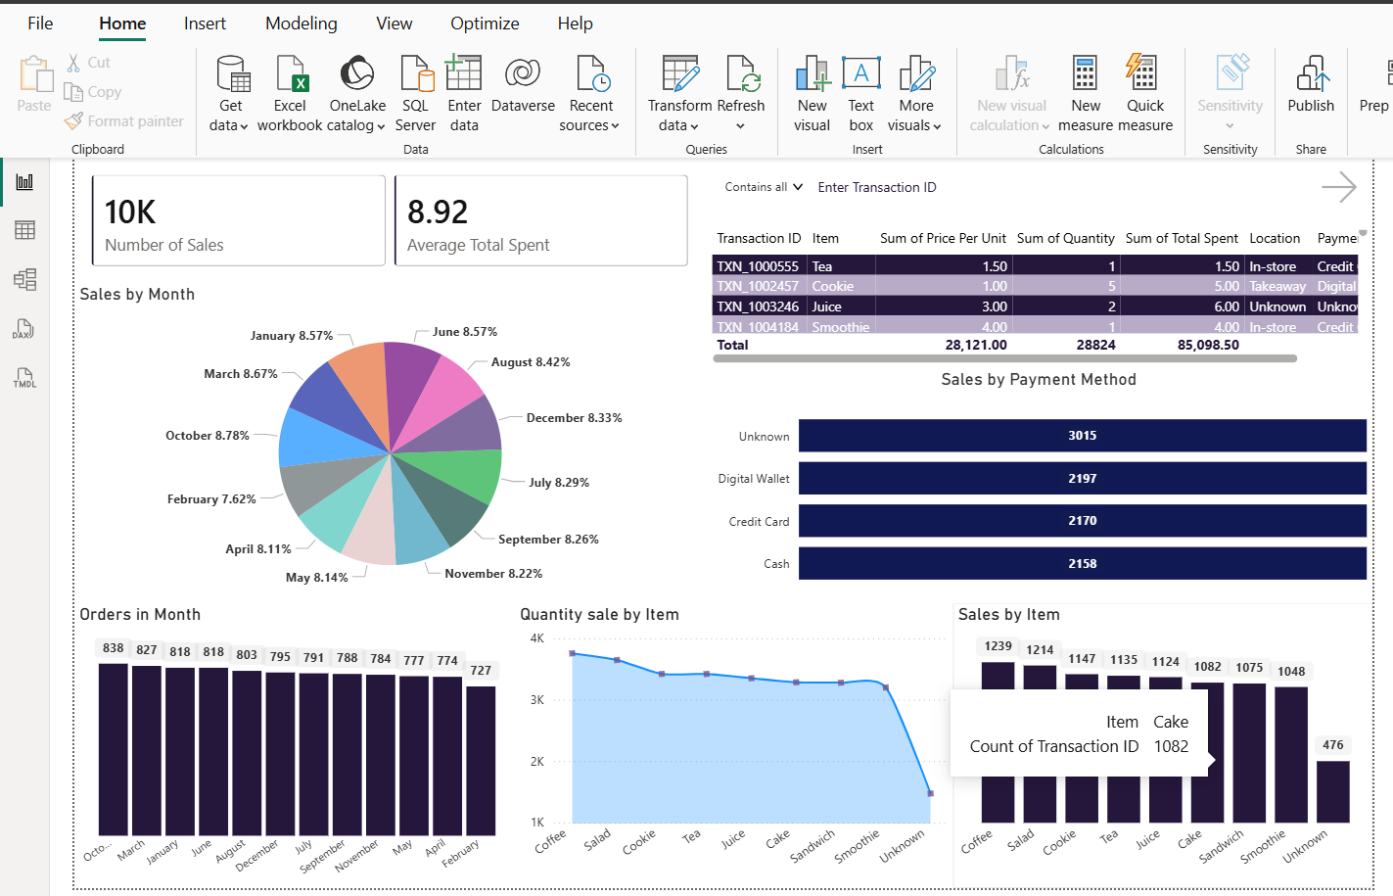

Revenue by Item
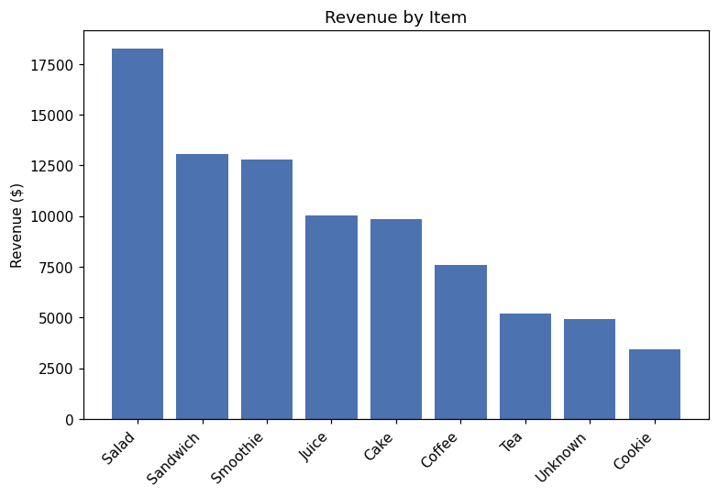
Salad, Sandwich, and Smoothie lead in total revenue; Coffee and Cookie sell the most units but at low margins.

Monthly Revenue Trend (2023)
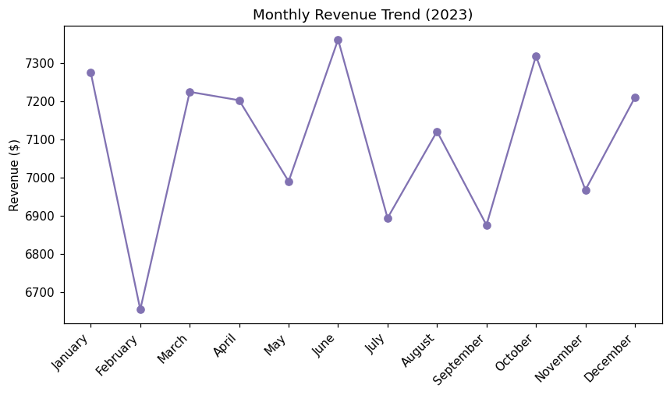
Revenue is remarkably stable across all 12 months, with no visible seasonal pattern.

Revenue by Day of Week
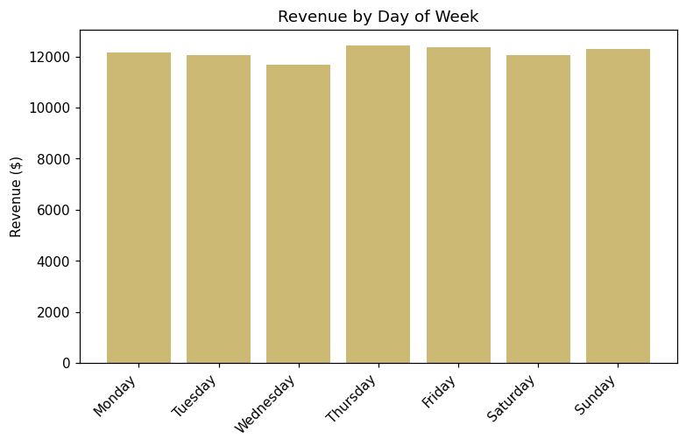
All seven days perform within a narrow band - no single day stands out as a peak.

Revenue by Location and Payment Method
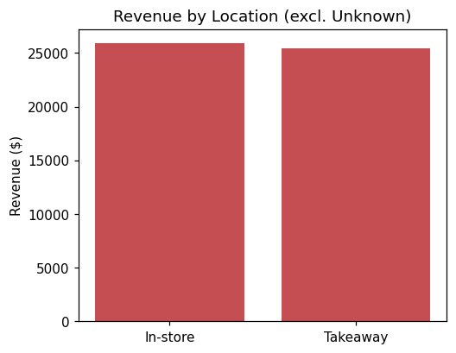
Revenue by Location (excl. Unknown) - In-store and Takeaway are almost even.

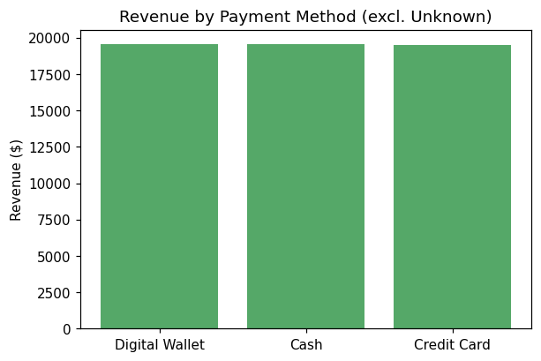
Revenue by Payment Method (excl. Unknown) - Cash, Credit Card, and Digital Wallet are nearly equal.

Key Findings & Recommendations
Observation | Recommendation
60.7% of revenue is tied to rows with an Unknown value | Fix the POS / data-capture process before relying on channel or payment-method revenue splits
Salad and Sandwich are the top revenue drivers | Prioritize marketing focus and menu placement for these items
Coffee and Cookie: high volume, low margin | Consider a small price increase or bundling with another item to raise average order value
No meaningful difference between In-store/Takeaway, payment methods, or their combinations | Focus resources on product and pricing rather than channel or payment method
No clear monthly/daily seasonality, and quantity-per-order is nearly identical across items | Data is likely synthetic (randomly generated) - real business decisions should rely on actual POS data

Conclusion
This project took a messy, 10,000-row point-of-sale export through a full analytics pipeline: standardizing corrupted placeholder values, recovering data through cross-column inference, engineering time-based features, answering ten business questions, and packaging the results into a shareable dashboard.

The single most important takeaway is a data-quality one, not a sales one: over 60% of transactions carry at least one "Unknown" field, concentrated in Payment Method and Location, which limits confidence in any channel-level conclusion. On the sales side, the dataset shows no meaningful seasonality, day-of-week effect, or channel/payment preference - revenue differences are driven almost entirely by product mix and pricing (Salad, Sandwich, and Smoothie lead; Coffee and Cookie are high-volume but low-margin). This flat, uniform pattern across time and channels is itself a signal that the dataset may be synthetically generated, and any decisions taken from it should be validated against real transaction data before being acted on.

