Predicting Diabetes Using Machine Learning
Student Name: Abdelrahman Tageldin
Student ID: AA2200780
TKH, Coventry University, School of Computing
Submission Date: 27th of April 25

Abstract
This study investigates whether machine learning algorithms have the potential to predict the status of diabetes using demographic as well as healthcare-related variables in the Behavioral Risk Factor Surveillance System (BRFSS) database. A systematic data science life cycle approach consisting of data retrieval, preprocessing, analytical modeling with Random Forest classifiers, and strict performance evaluation has been adopted. Techniques like oversampling and SMOTE were employed to address class imbalance. Model robustness was ensured through hyperparameter tuning and validation methods. Results indicated excellent predictive capacity, as shown through accuracy, precision, recall, and ROC metrics. Visualization made interpretation easier, which showed additional insights into diabetes prediction influencing factors. Data sensitivity, imbalance, and computational constraints were addressed effectively. Future work involves feature extension, alternative modeling, and exploring richer datasets.

Table of Contents
Abstract 2
Table of Figures 3
Introduction 4
Research Questions 4
Data Science Lifecycle 4
Dataset Collection and Description 4
Data Cleaning and Pre-processing 5
Analytical Approach and Techniques 8
Visualization Techniques 9
Challenges Faced 12
Scalability to Big Data 13
Research Questions Answered 13
Conclusion 18
REFERENCE LIST 18

Table of Figures
Figure 1:Distribution of Diabetes Status 5
Figure 2:Missing values check 6
Figure 3:Consistency of values check 7
Figure 4:Removal of Duplicate rows 7
Figure 5:Detecting and Removing Outliers 8
Figure 6:Histogram for BMI 9
Figure 7:Box plot BMI vs Diabetes 10
Figure 8:Confusion Matrix 10
Figure 9:Correlation Heatmap 11
Figure 10:ROC Curve 12
Figure 11: Diabetes Prediction 14
Figure 12:Lifestyle Factors vs Diabetes 15
Figure 13:Socioeconomic Factors vs Diabetes 16
Figure 14:Physical Activity Level vs Diabetes 16
Figure 15:Health Conditions vs Diabetes 17

Introduction
Diabetes is a major global health issue having high morbidity and healthcare costs.Predicting and classifying people diabetes status at a early stage would help as it would allow for a early intervention and benefit people with cheaper healthcare costs and motivate them to live a health long life.The Behavioral Risk Factor Surveillance System (BRFSS) is the system of health-related telephone surveys that collect state data about U.S. residents regarding their health-related risk behaviors, chronic health conditions. Centers for Disease Control and Prevention, (n.d.).The BRFSS 2015 dataset is reliable public health data repository that has a rich demographic and health data perfect for prediciting diabetes using Machine learning.The projects aims to answer the 5 reasearch questions bellow and the main question number one that will be predicting diabetes status.

Research Questions
- Question 1:Can we predict the likelihood of an individual having diabetes based on their health indicators?
- Question 2:How do lifestyle factors (Smoking,heavy alcohol consumption,fruit & vegetables intake) impact the likelihood of developing diabetes?
- Question 3:How do income and education levels affect the prevalence of diabetes
- Question 4:How does physical activity level correlate with the likelihood of developing diabetes?
- Question 5:What is the relationship between diabetes and other health conditions like Heart disease and strokes ?

Data Science Lifecycle

Dataset Collection and Description
One of the methods of data collection is data scraping where data is collected through an automated process of extracting information from websites or Digital documents using software tools or scripts. It usually involves retrieving data from HTML pages,APIs or web content to collect large amounts of data that can be analyzed or added to existing datasets to enlarge the dataset.Although Data scraping was not viable due to strict privacy protections governing medical data. Thus, the BRFSS dataset was officially downloaded in CSV format from CDC's website. The dataset includes extensive demographic parameters such as age, sex, Income,and education, along with health indicators like BMI, physical activity, smoking, and alcohol use. The target variable, Diabetes_012, classifies individuals as non-diabetic (0), pre-diabetic (1), or diabetic (2). The final dataset comprised around 253,681 records with a varied class distribution, necessitating targeted imbalance handling techniques.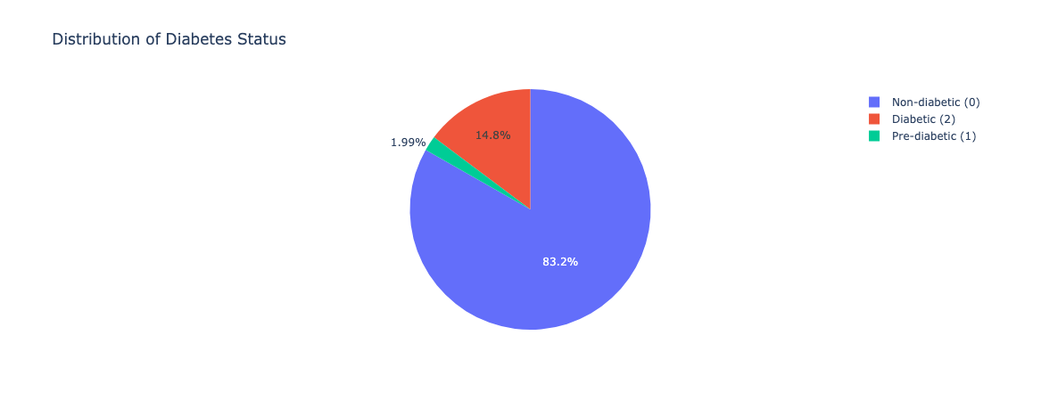
Figure 1:Distribution of Diabetes Status

Data Cleaning and Pre-processing
Preprocessing of the data was done to optimize the data quality for effective machine learning prediction of diabetes. Completeness, accuracy, consistency, validity, and duplication were evaluated first to examine the data. Missing values were confirmed and outliers like unlikely age or BMI values were removed to enhance the accuracy of the dataset. Validity and consistency checks were conducted to offer consistent formats and integrity to the data, while duplicate records were eliminated to prevent bias.
Recurrent features such as Age, Education, and Income were also normalized into categorical sets to enhance interpretability and training of the models. Categorical features such as Sex were mapped numerically and some continuous features were normalized in order to preclude the influence of scale variability.
Outlier detection was performed using the Interquartile Range (IQR) method, particularly for BMI, and outliers included were deleted to remove skewness. All these preprocessing operations ensured a consistent and structured dataset for stable machine learning.
Finally, due to low F1-scores seen on minority classes, target labels of Pre-diabetic and Diabetic patients were merged into one At-Risk category. This reduced the task to binary classification (At-Risk or Non-diabetic) and significantly enhanced the model's performance regarding recall and F1-score, without altering the original feature engineering or data cleaning steps.

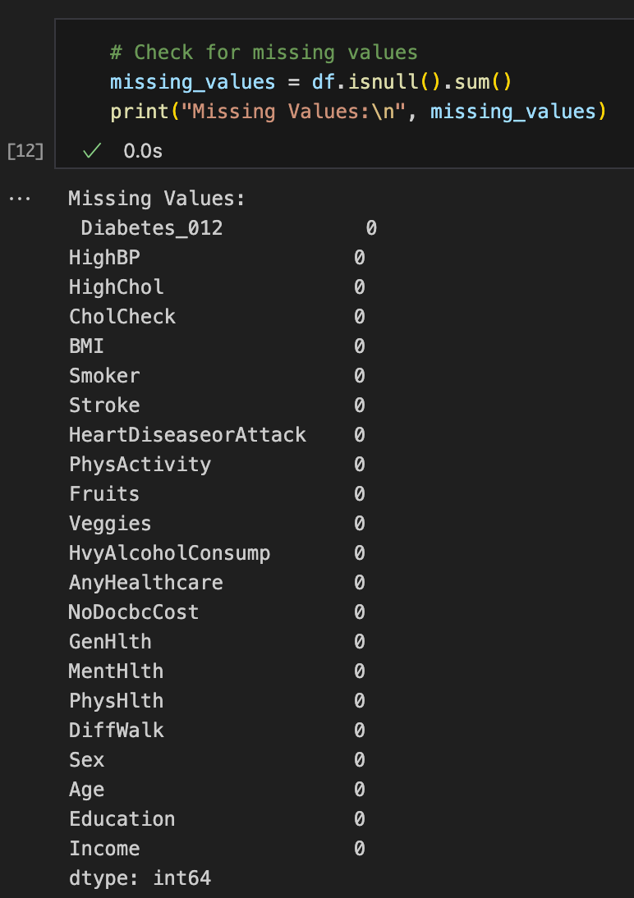
Figure 2:Missing values check
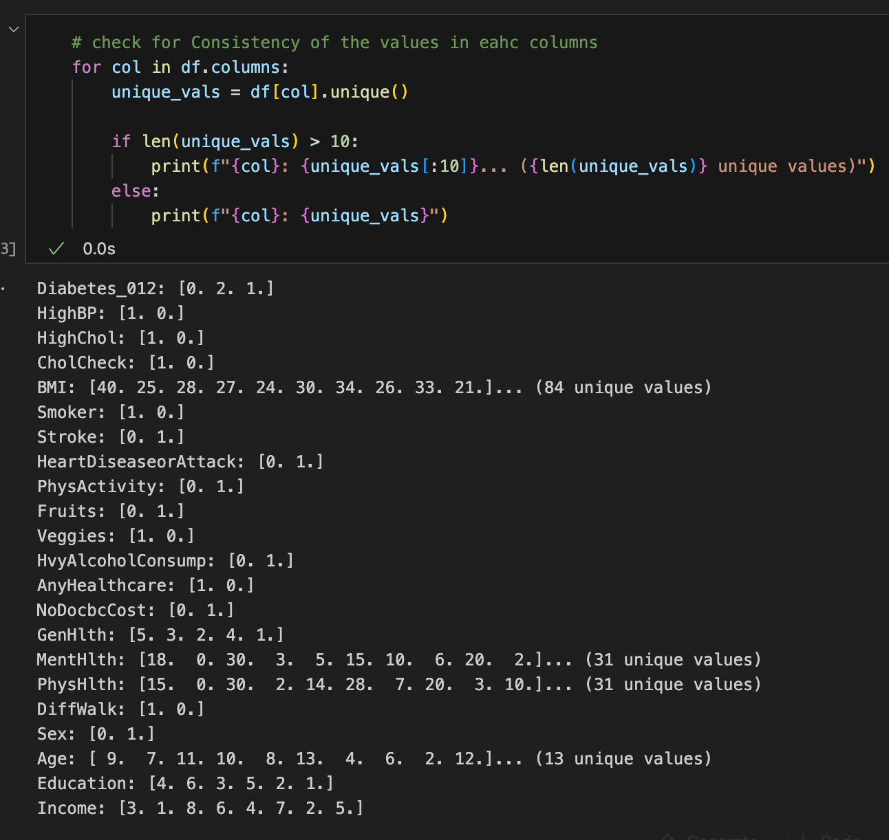
Figure 3:Consistency of values check
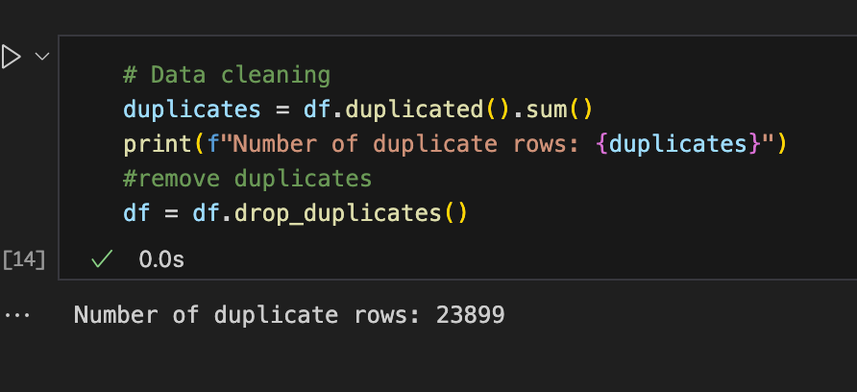
Figure 4:Removal of Duplicate rows
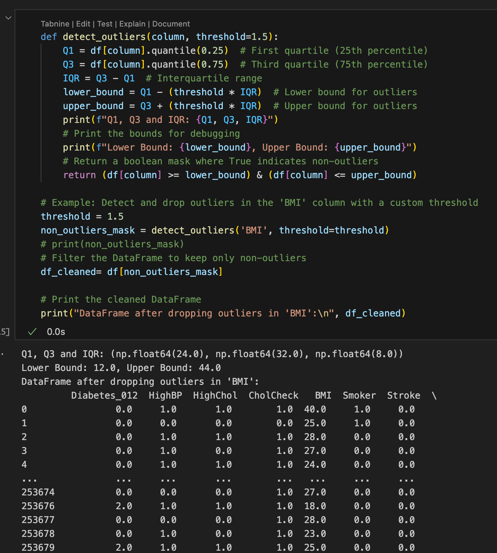
Figure 5:Detecting and Removing Outliers

Analytical Approach and Techniques
The initial prediction model was built around a Random Forest classifier offering decent predictive capabilities and easy treatment of nonlinear interactions. then sampling was applied to the severe class imbalance using RandomOverSampler and SMOTE, and employed randomized and grid search for the optimization of the model's hyperparameters. Metrics such as ROC curves, confusion matrices, and macro-F1 scores illustrated solid performance on both the training and hold-out data.
However, when trying to deploy, i discovered that the model size of the Random Forest model was around 4GB and its relatively slow inference times were impractical for a web application. To bypass these constraints, we switched to LightGBM—a gradient boosting library that has similar accuracy for tabular data while giving an astronomically smaller model (approximately 10–20 MB) and much less prediction latency. We took our oversampling approach, re-ran LightGBM hyperparameter tuning, and included probability threshold tuning to optimize F1 for the "At-Risk" class specifically. This resulted in an effective, deployable model that maintained high accuracy and significantly improved recall and F1-score on minority instances.

Visualization Techniques
Visualisation was used to understand and interpret the dataset more easily. Tasks such as data output verification , understanding data distribution and correlation between different columns, and class balance were all done through visualisation. The most commonly used visualisation methods for displaying categorical data like diabetes status were pie charts and bar plots. Other methods were also used, like :
• Histograms: which display the distribution of categorical data like BMI.
• Correlation heatmap: which displays the correlation between variables for feature selection and checks.
• Boxplots: which were used to help identify data outliers.
• ROC curves and confusion matrices, which were used as a way to score the performances of machine learning models used to figure out which were the best.

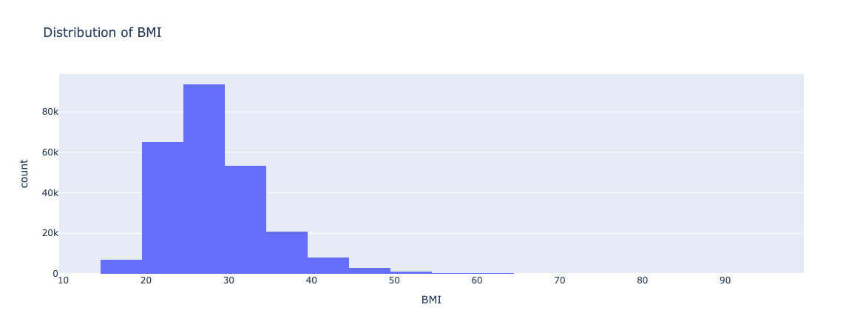
Figure 6:Histogram for BMI
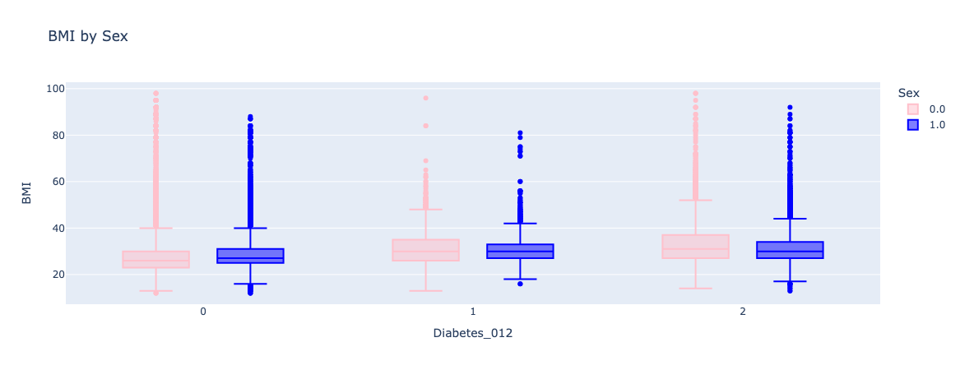
Figure 7:Box plot BMI vs Diabetes
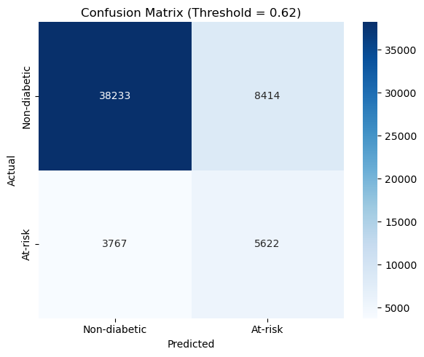
Figure 8:Confusion Matrix
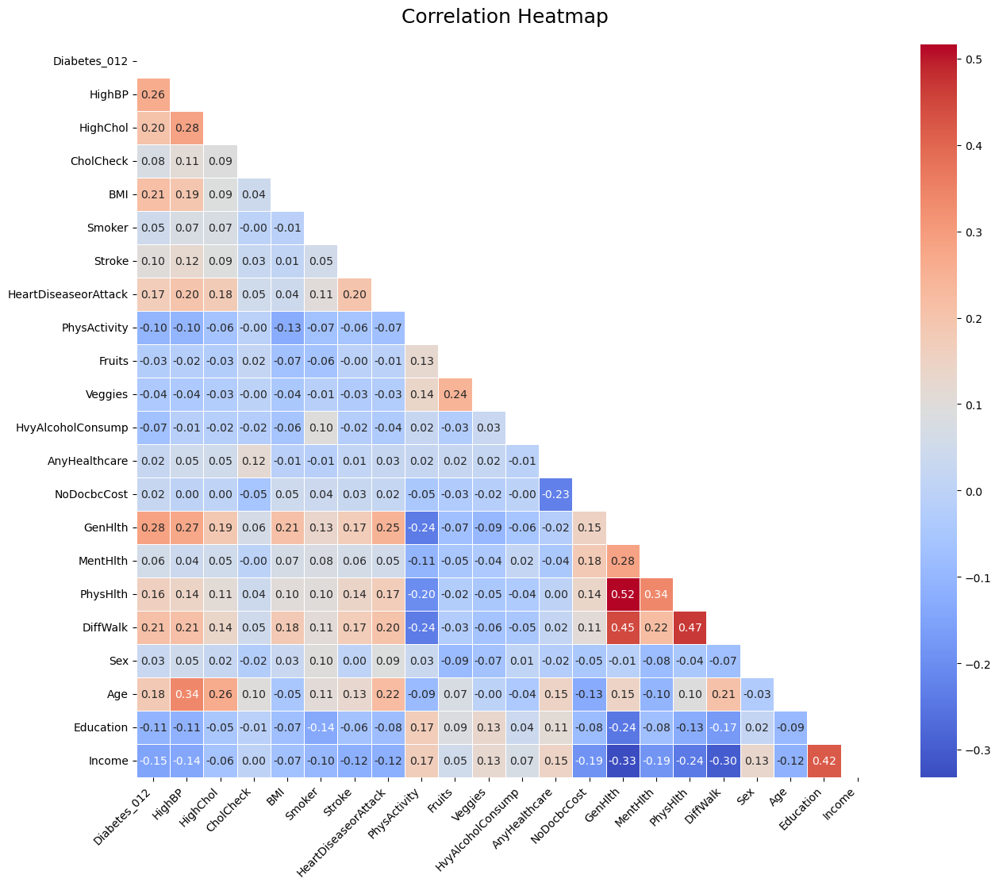
Figure 9:Correlation Heatmap
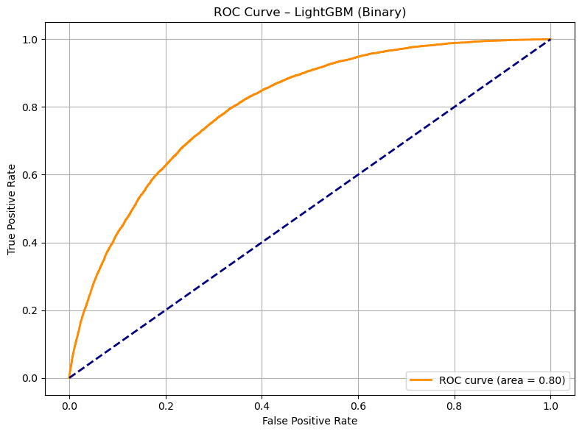
Figure 10:ROC Curve

Challenges Faced
Through the process of working on this project, some problems were faced at different levels. Data scraping and privacy were among the first concerns. Although the dataset was posted on the public website, ensuring ethics standards compliance and not having personally identifiable information (PII) meant that some additional validation processes had to be done.
Another challenge was also encountered in the visualization step, particularly after outlier removal and detection. After cleaning continuous variables like BMI, visualization libraries like Plotly plotted with outliers even after their removal. This had to be adjusted further, for instance, manually checking distributions.Model deployment also was a significant bottleneck. The model complexity and the high feature set resulted in the model having a relatively large file size, thereby resulting in slow inference speeds and performance degradation when deploying the model on Heroku. To counter this, efforts were made in optimization strategies and eventually shifting towards more lightweight variants like LightGBM to make deployment more efficient without affecting prediction quality.

Scalability to Big Data
There are some significant changes that would have to be made if this health analytics project were done on a mass scale to accommodate the greater and more sophisticated sets of data usually encountered in actual clinical healthcare settings. Huge health information arrives faster than the initial structured dataset used within this study because it generally comes in from a broad variety of sources, including wearables, clinics, hospitals, and health tracking services.
Redesign of the data pipeline to facilitate continuous and bulk data ingestion would be the first necessary change in order to fulfil this. The environment would need to accommodate processing of data in streams or batches with data quality rules, rather than ingesting all the data simultaneously. Highly scalable and fault-tolerant storage subsystems would also need to be made in order to process the far larger volume of records.
To deal with the greater volume, data pretreatment operations like feature conversion, outlier detection, and cleaning would need to be automated and improved. It would no longer be able to manually check within smaller volumes. To allow models to operate on larger volumes without being affected by unwarranted delays or performance degradation, training would also need more resources and would need to be improved.
There would probably be some problems when the scale-up happened. It would be a much harder thing to have data quality and coherence in a large, ever-changing data set. In handling sensitive health data on a larger level, privacy and data protection would be even more crucial. Mechanisms for continually watching models, retraining models, and sometimes replacing models would need to happen to ensure expected accuracy as new data patterns emerge over time.
In short, the whole process would remain unchanged, but to be successful, it would have to include more automation on a higher level, thriftier management of data, improved governance of data, and more frequent model administration.

Research Questions Answered
Question 1:Can we predict the likelihood of an individual having diabetes based on their health indicators?
Answer:
Yes ,The project was successful in building a prediction model which classifies people into either being non diabetic or at risk based on their health indicators
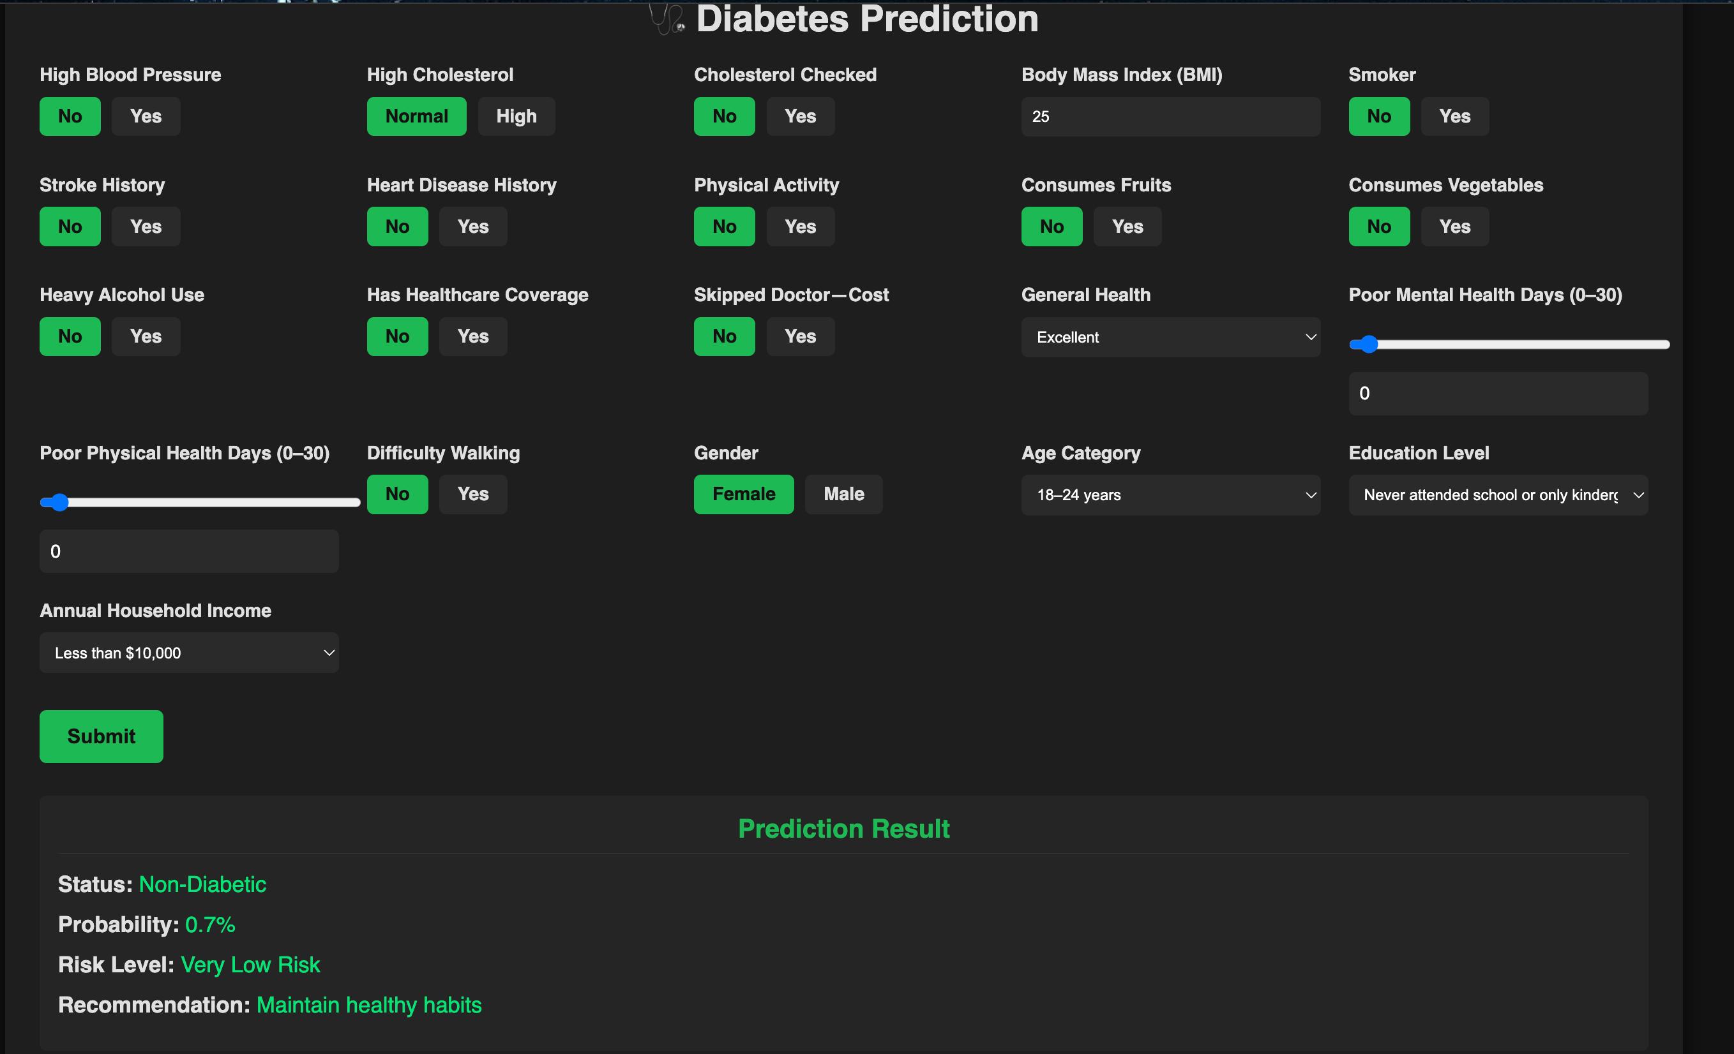
Figure 11: Diabetes Prediction

Question 2:How do lifestyle factors (Smoking,heavy alcohol consumption,fruit & vegetables intake) impact the likelihood of developing diabetes?
Answer:
Analysis determined the influence of lifestyle on diabetes risk.Individuals who reported smoking or being an alcoholic had a greater diabetes rates, and the more of a healthy diet people consumed the lower their associated risk.
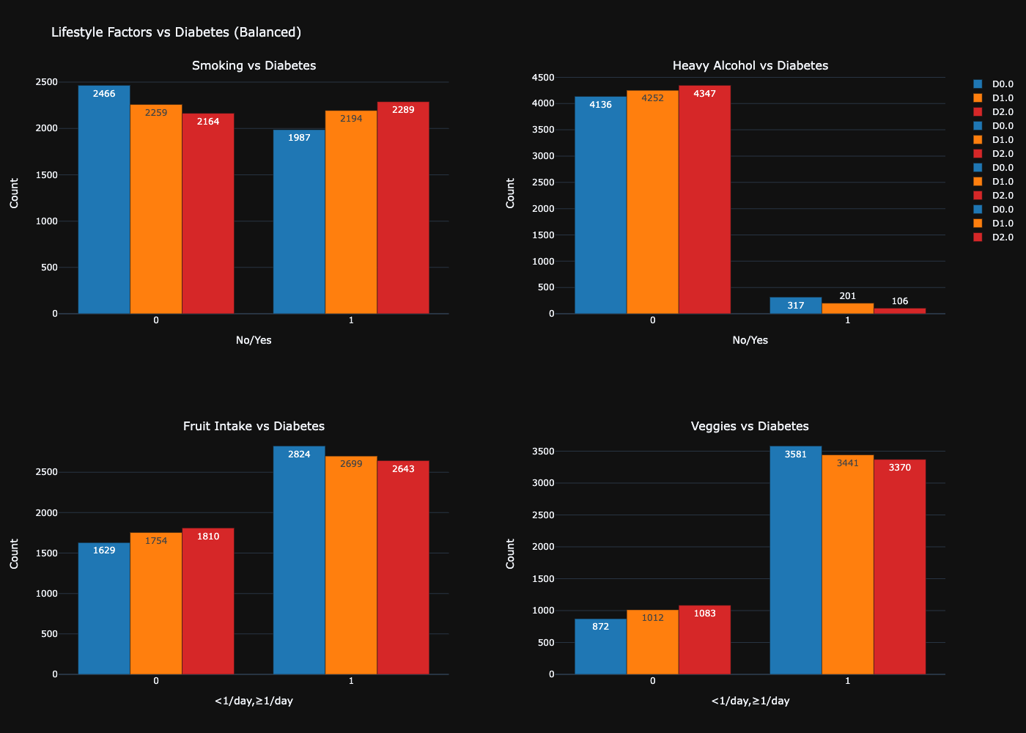
Figure 12:Lifestyle Factors vs Diabetes

Question 3:How do income and education levels affect the prevalence of diabetes?
Answer:
Lower income and educational levels were found to be associated with a higher prevalence of diabetes. Analyses confirmed lower socio-economic groups are more likely to report diabetes or illness, and the findings highlighted socioeconomic determinants of healthcare outcomes.
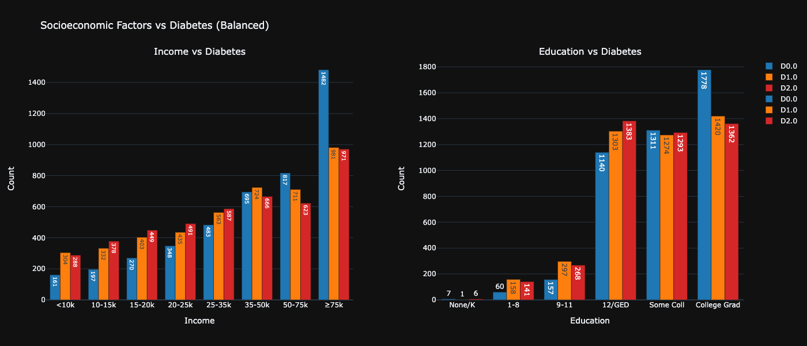
Figure 13:Socioeconomic Factors vs Diabetes

Question 4:How does physical activity level correlate with the likelihood of developing diabetes?
Answer:
There was a strong negative correlation between risk of diabetes and physical activity level. People who engaged in physical activity regularly had a smaller percentage of being At-Risk, validating the importance of regular physical exercise as a means to prevent diabetes.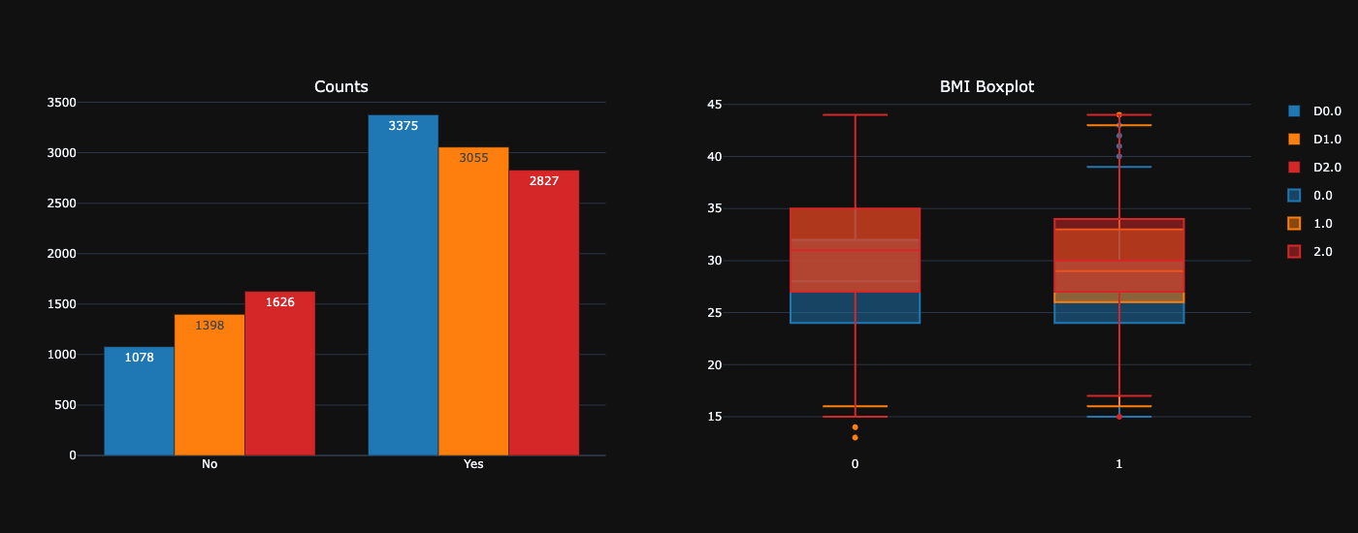
Figure 14:Physical Activity Level vs Diabetes

Question 5:What is the relationship between diabetes and other health conditions like Heart disease and strokes ?
Answer:
It was seen in the analysis of the dataset that individuals who were diabetic or pre-diabetic also had a higher occurrence of other chronic illnesses such as heart disease and strokes. This confirms the long-standing medical understanding of diabetes tending to occur alongside other cardiovascular-related conditions, which further supports the necessity for early identification and management of diabetes.
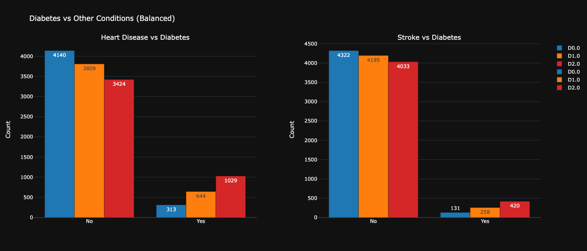
Figure 15:Health Conditions vs Diabetes

Conclusion
This project demonstrated how machine learning techniques can effectively predict diabetes risk using demographic and health-related variables. Through careful data preparation, model optimization, and deployment, a scalable and resilient solution was achieved. Problems were addressed appropriately, and essential research questions were resolved, which highlighted significant correlations between lifestyle, socioeconomic status, and the incidence of diabetes. Future work can focus on moving the methodology to real-time big data environments to further enhance early intervention strategies and public health outcomes.

REFERENCE LIST

- Centers for Disease Control and Prevention. (n.d.). Behavioral Risk Factor Surveillance System (BRFSS). U.S. Department of Health and Human Services. https://www.cdc.gov/brfss/index.html

