Cairo University Faculty of Computers and Information



**CS352 – Software Engineering II**

**Phase 1-b Template**

**2016**

**Project Team**

|  |  |  |  |
| --- | --- | --- | --- |
| **ID** | **Name** | **Email** | **Mobile** |
| 20120230 | **Abd EL-Rahman Mohamed Ibrahim** |  |  |
| 20120229 | **Abd El-Rahman Maher Ahmed** |  |  |
| 20110062 | **Ahmed Abd El-Raouf** |  |  |
| 20110221 | **Abd El-Rahman Omar** |  |  |
| 20120582 | **Najma Abdullah Ibrahim** |  |  |

Contents

Your Restful API 3

Trello workspace screenshot 4

Daily scrum Meetings 5

Github repository link 5

# 

# Your Restful API

* Put each service in your backend in a table like the following table

|  |  |
| --- | --- |
| Service url | http://se2firstapp-softwareeng2.rhcloud.com/FCISquare/rest/follow |
| Input type | POST |
| Parameters | |  |  | | --- | --- | | **Parameter name** | **Description** | | Id1 | First user id | | Id2 | Second user id | |
| Example request | POST  http://se2firstapp-softwareeng2.rhcloud.com/FCISquare/rest/follow  Content-Type: application/x-www-form-urlencoded  Id1=1&id2=2 |
| Example response | {Id1 follow id2} |

|  |  |
| --- | --- |
| Service url | http://se2firstapp-softwareeng2.rhcloud.com/FCISquare/rest/unfollow |
| Input type | POST |
| Parameters | |  |  | | --- | --- | | **Parameter name** | **Description** | | Id1 | First user id | | Id2 | Second user id | |
| Example request | POST  http://se2firstapp-softwareeng2.rhcloud.com/FCISquare/rest/unfollow  Content-Type: application/x-www-form-urlencoded  Id1=1&id2=2 |
| Example response | {Id1 unfollow id2} |
| Service url | http://se2firstapp-softwareeng2.rhcloud.com/FCISquare/rest/showlist |
| Input type | POST |
| Parameters | |  |  | | --- | --- | | **Parameter name** | **Description** | | Id1 | First user id | |
| Example request | POST  http://se2firstapp-softwareeng2.rhcloud.com/FCISquare/rest/showlist  Content-Type: application/x-www-form-urlencoded  Id1=1 |
| Example response | {Id1 following list} |

|  |  |
| --- | --- |
| Service url | http://se2firstapp-softwareeng2.rhcloud.com/FCISquare/rest/currentLocation |
| Input type | POST |
| Parameters | |  |  | | --- | --- | | **Parameter name** | **Description** | | Id1 | First user id | |
| Example request | POST  http://se2firstapp-softwareeng2.rhcloud.com/FCISquare/rest/currentLocation  Content-Type: application/x-www-form-urlencoded  {Id1=1,lon=??,lat=??} |
| Example response | {Id1 follow id2} |

# Trello workspace screenshot

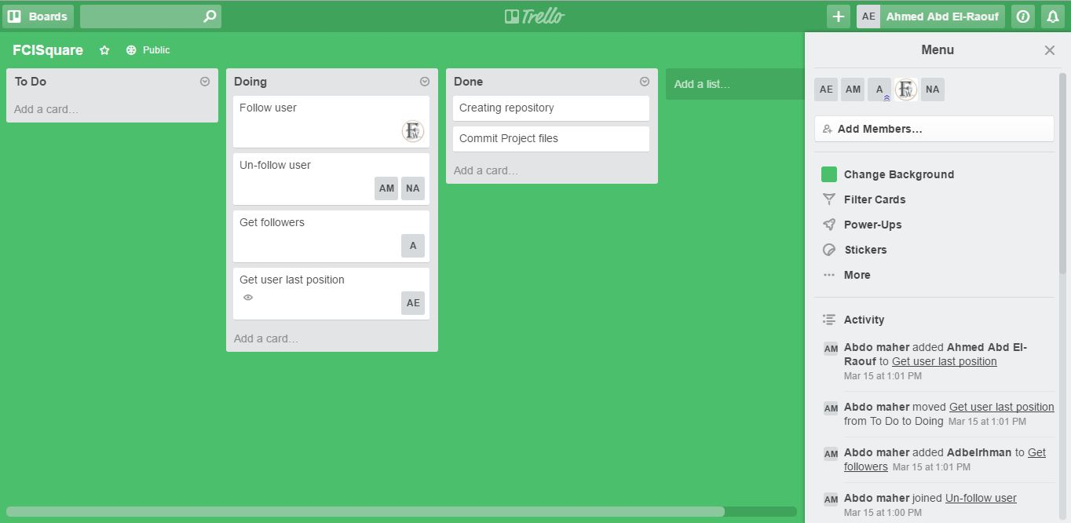

# Github repository link

<https://github.com/Abdo-maher/SW2-backend>

https://github.com/Abdo-maher/Frontend