NOTES
CHALLENGES
CH1
Start with choosing technologies to work with sql server spring boot android studio
Start with connecting and setup the environment
And create the first step CH2
CH2
Create interface user and login and register
CH3
After login show articles and after click article show all sites and how much in stuck in each site 3 tables article sites forgein in article_stock
CH4
DEPLOY ALL TO VM IN VMWARE TO PUT IN SERVEUR THAT IT RUN 24/24H
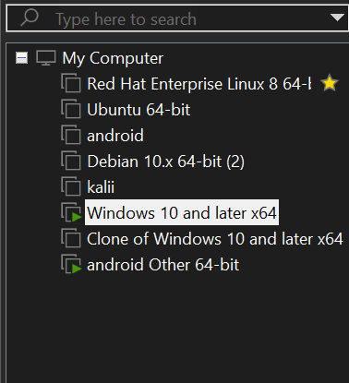
CH4
CONFIGURER L IP ADREESS DANS RETRO FIT POUR PHYSICAL DEVICE CONNECT

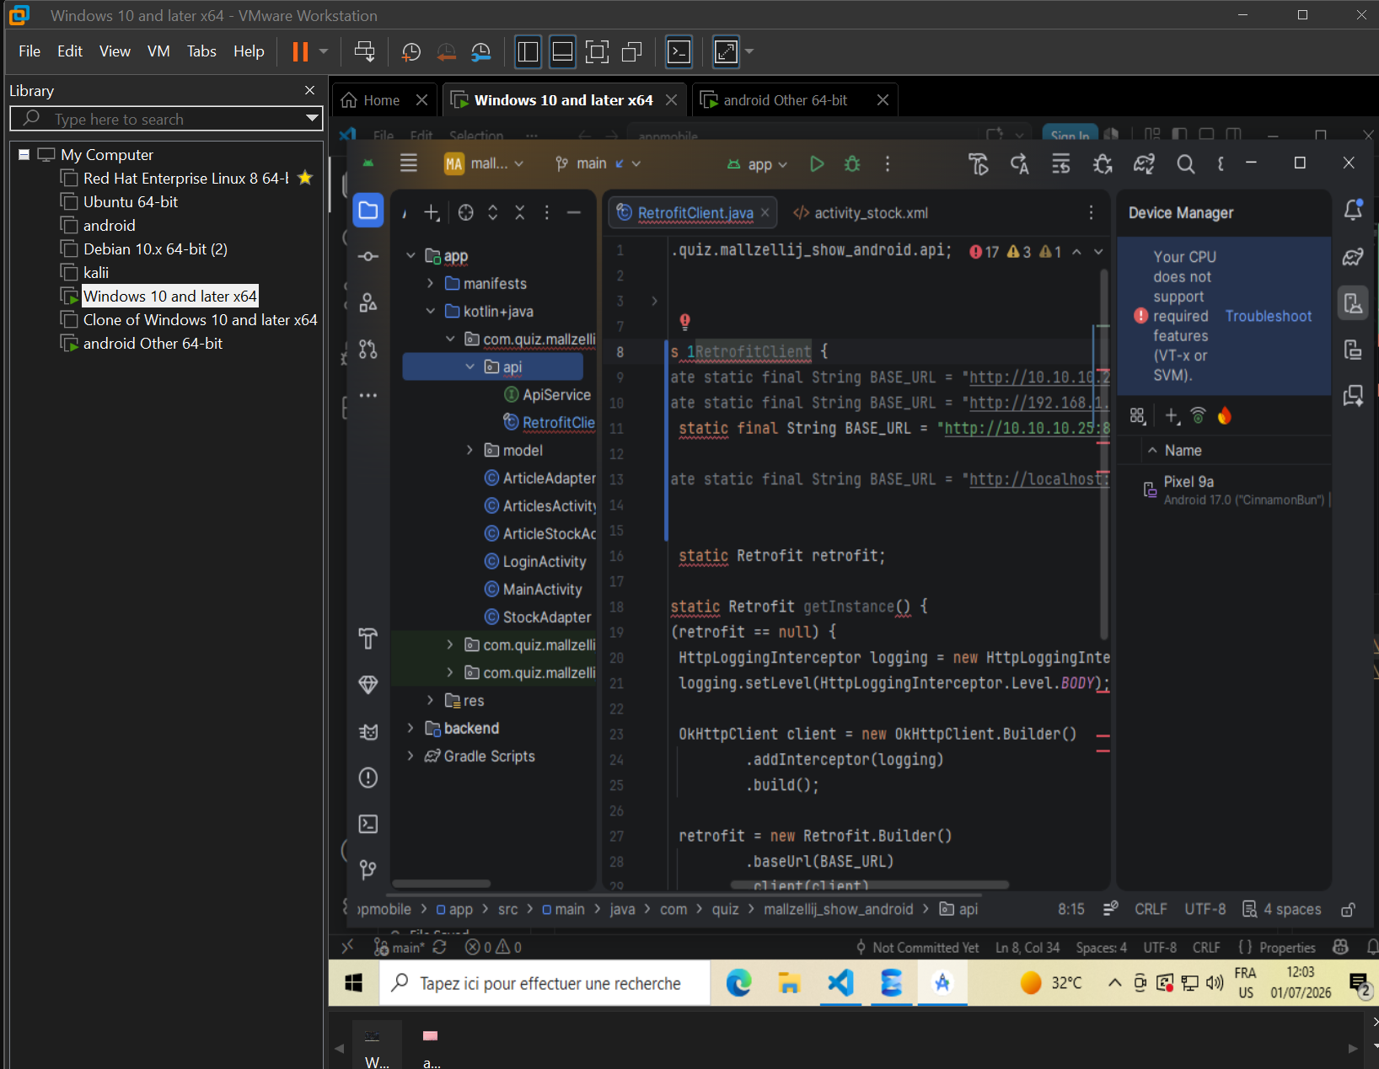
ALSO I FOUND A ISSUE IMPOSSIBLE TO CONNECT PHYSICAL DEVICE WITH VM SO I CREATE ANEW ANDROID VM AND I CONNECT IT BY ENABLING ADB AND CONNECT VIA IP BETWEEN VM AND LAUNCH PROJECT AND IT SHOW THE ANDROID VM
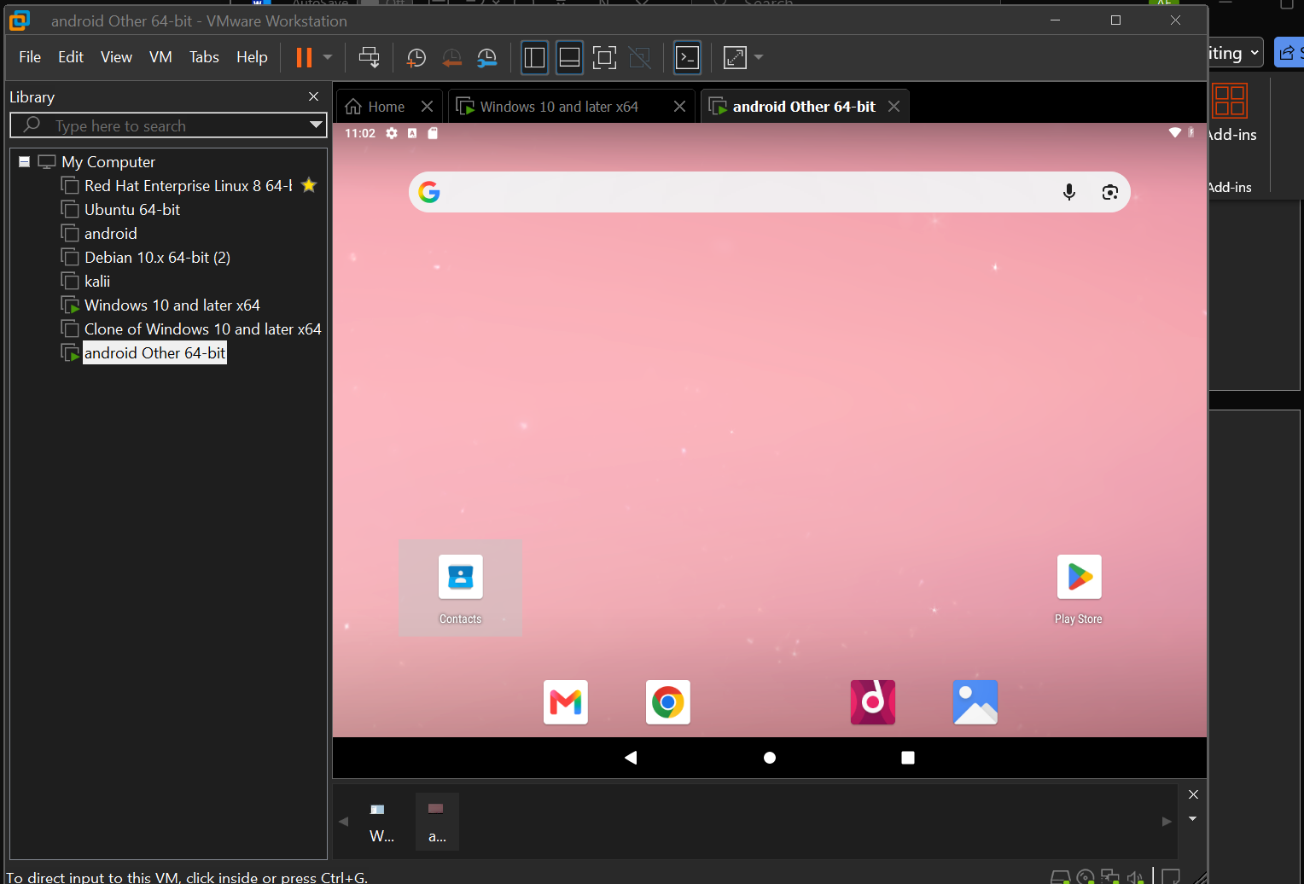
CH5

The new challenge that I need to connect with company database secure they are using logiciel system sage
Ch6
We succussed to connect to db serveur and now we need to create in the same instance a new db to past on it tables from the other db in the same instanceand it need every time data add to other tables to be synchronized to this new table
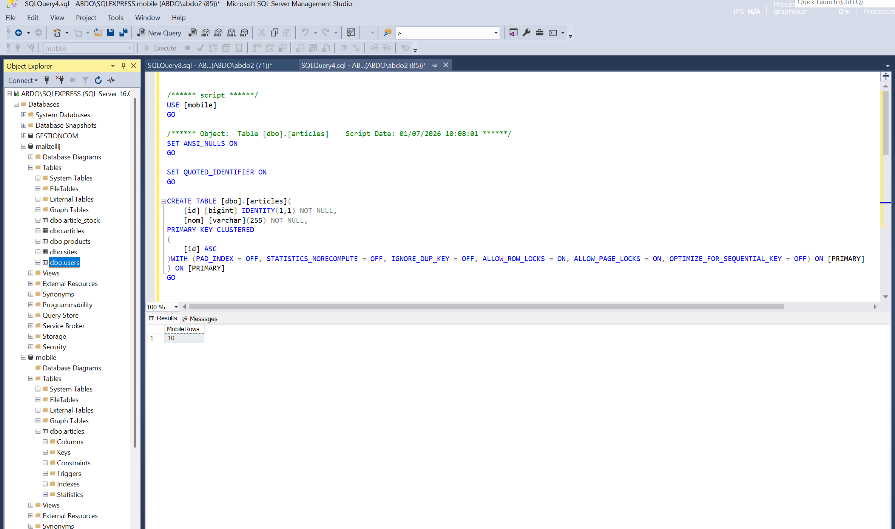
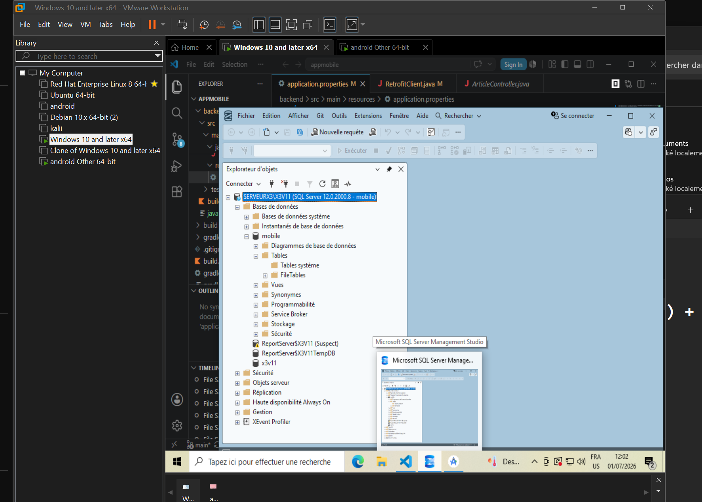
Ch7
After we successfully make after click article show stock in every sites now we gonne add camera to scanne QR CODES after scan code ITMMERF_0 IT WILL show article and sites and quantity directly no need to stay searching manually about the article 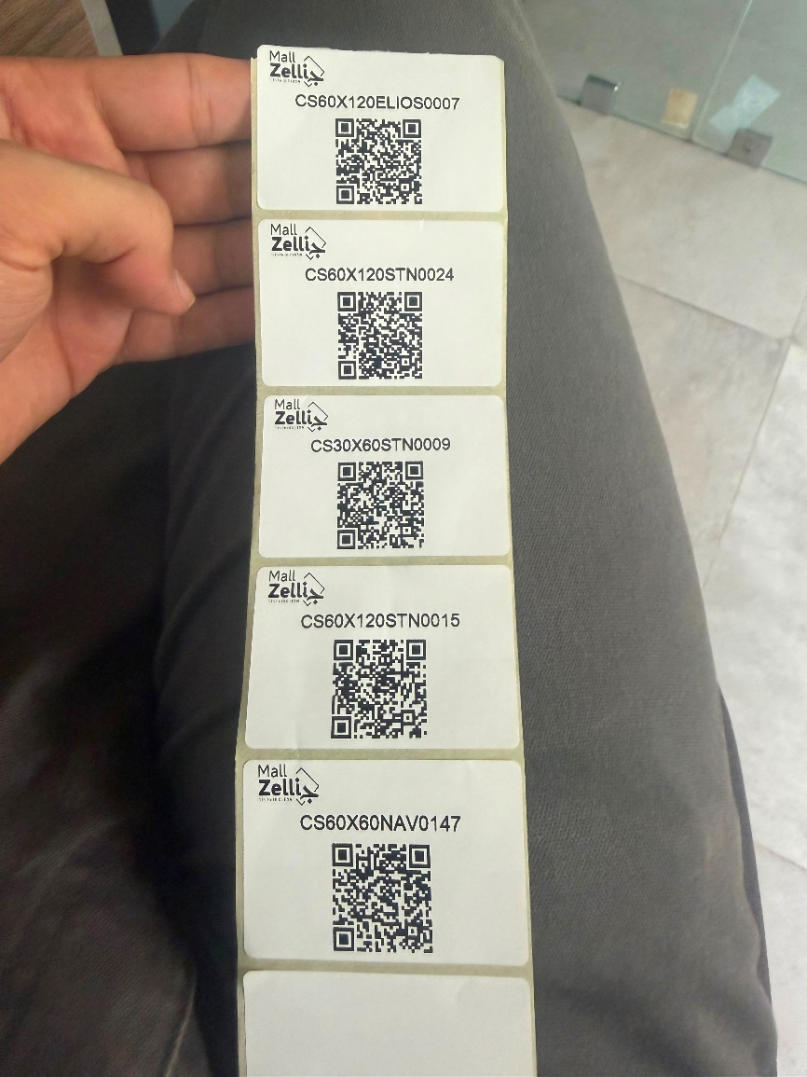
Here some qr codes
And we add button camera in search bar
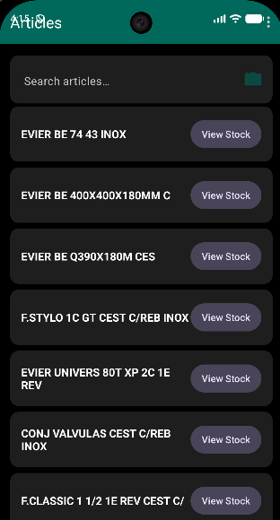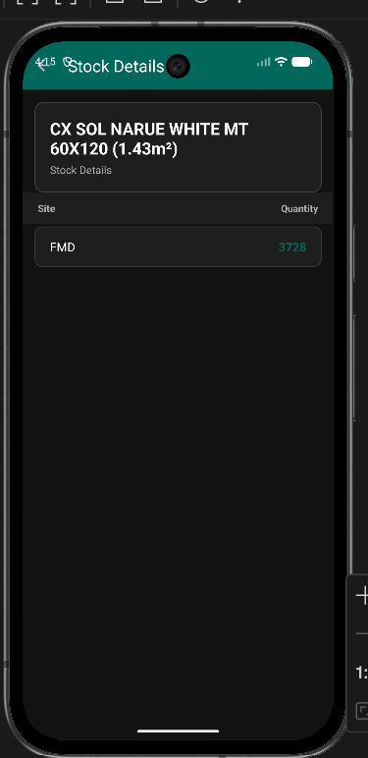
Ch8
Now we will copier the vm windows to the windows serveur because of security we will make it only local out of area don’t work only who in the same network
CH9
We will add roles to database ymobile where we stock login role admin and user1
CH10
Create new page inventory with 4 inputs 1 for articles by qr code and pallet and cartoon and metre carree all that stock it in database
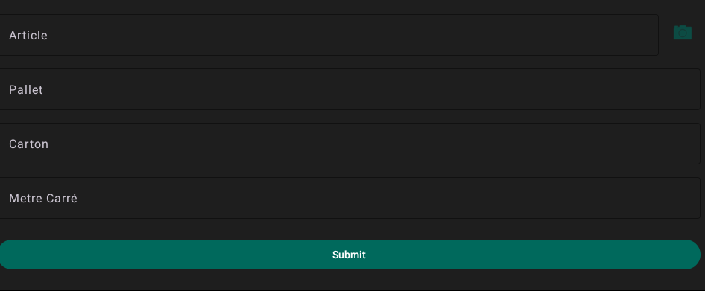
CH11
Add sidebar to play between inventory and articles
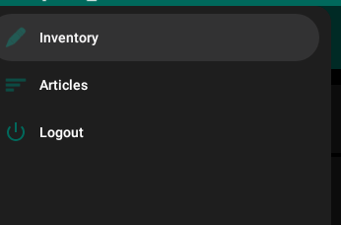

CH12
The user who have role admin he can see in side bar articles and inventory and logout but who have role user1 he can see only articles and logout

CH13
NOW we add in same interface inventory depot and zones and equipe when he click for example equipe he see to select equipe 1 or equipe 2 or equipe 3 and under the same concept for zones and depot
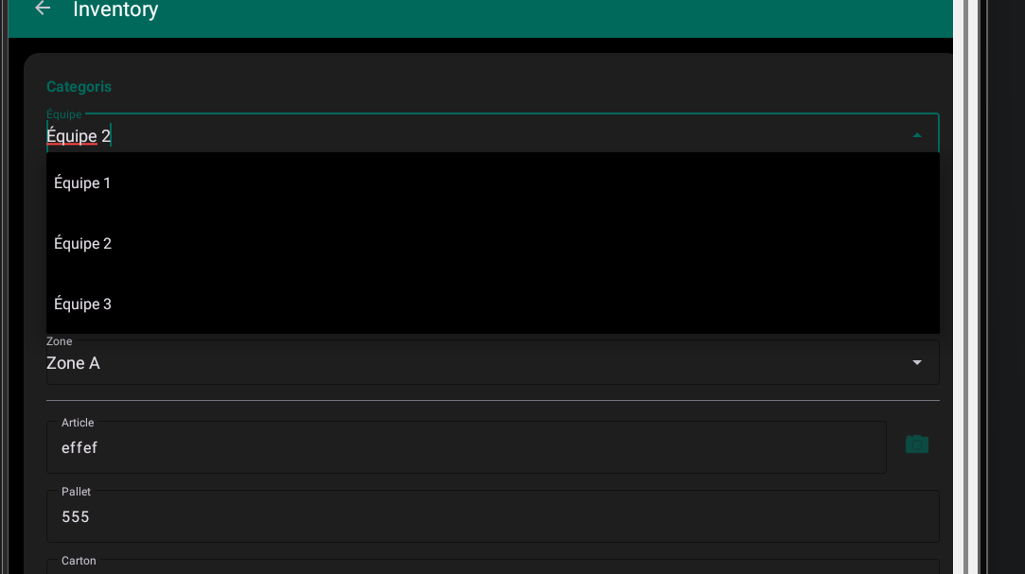
CH14
Now this categories equipe ,zone , depot need to stay fixed after reload when I click submit need to stay fixed but other inputs to get empty after reload submitting
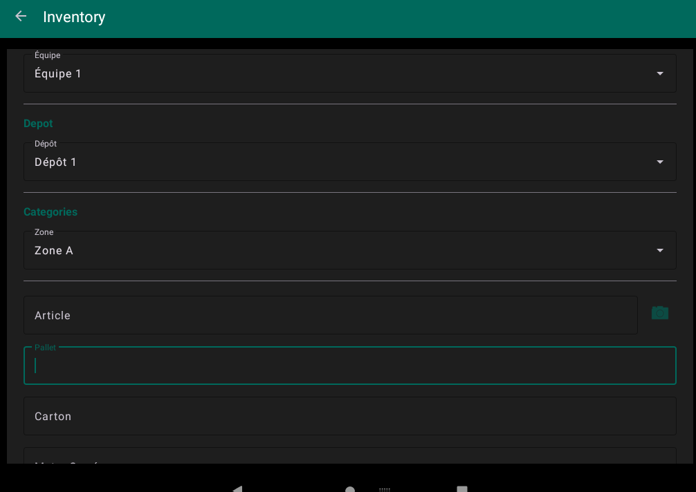
CH15
Next step that we will make that dynamique to save that in table with all information that user x he saved this equipe ,zone , depot ,article,pallet,carton,metre carre in date
CH16
WE MAKE TABLE IN SQL SERVEUR WE NAME IT YINV WITH COLUMS
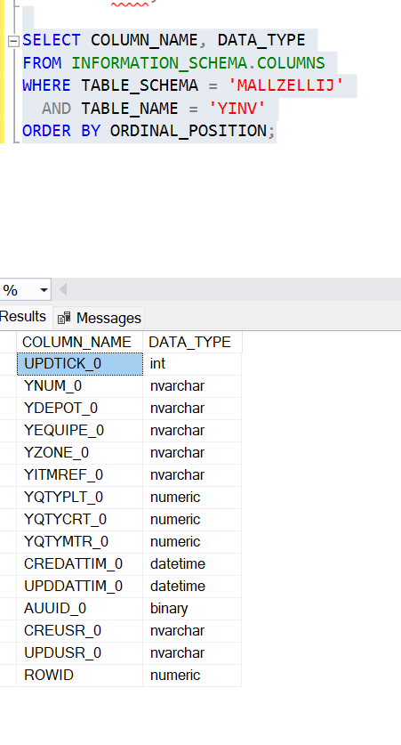
And Here's the new flow when you click Submit:
Validate — checks all required fields are filled
Shows a confirmation dialog with a table layout:
Équipe: Team A
Dépôt: Depot 1
Zone: Zone B
Article: ART123
Pallet: 5
Carton: 10
Mètre Carré: 20 m²
Two buttons:
Confirm — saves to the YINV table via the backend API, clears the form
Edit — dismisses the dialog, form stays intact for corrections
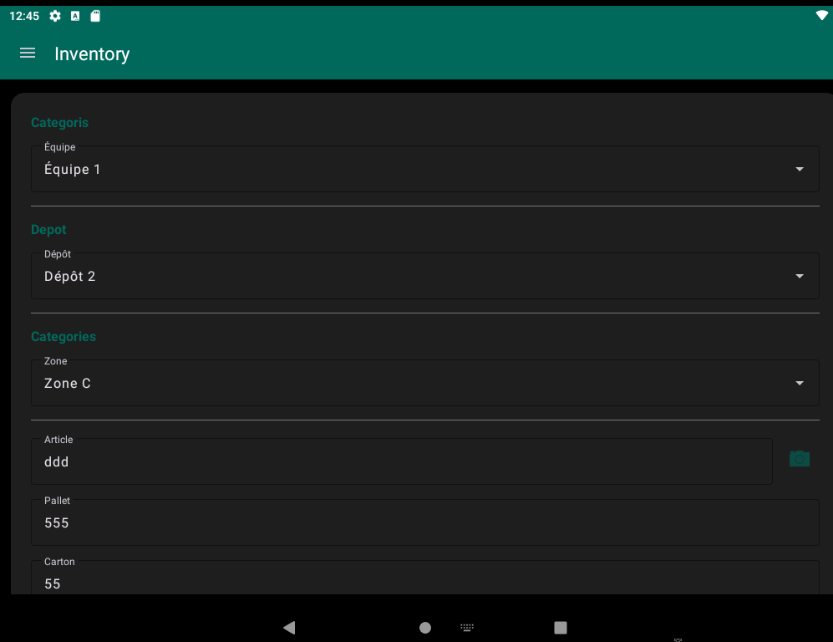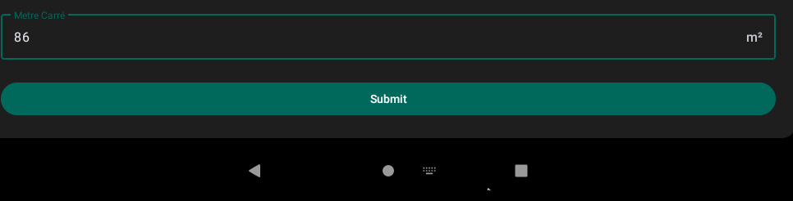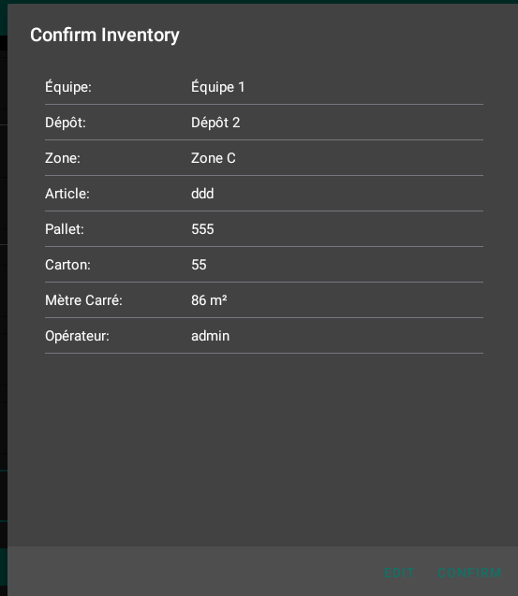
And here it show all data u write to check before insert it data base table yinv and edit to change before inserting
CH17
AND IN ARTICLES WITH REDESIGNE STYLE AND ADD PRICING 