Name | Image | &mechaNIsm of actIoN | Use
Abilify 10-15-5 | 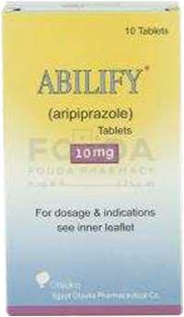 | #Aripiprazol | -Antipsychotics:  -Schizophrenia  -Bipolar disorder
Mechanism
#partial agonist at D2
#Potent antagonist at serotonin
Abilia  -15-20  “abIlIfy” | 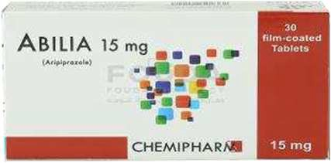 | #Aripiprazol | -Antipsychotics:  -Schizophrenia  -Bipolar disorder
Mechanism
#partial agonist at D2
#Potent antagonist at serotonin
Acitretin 10-25 | 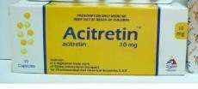 | #Acitretin | Psoriasis
Mechanism
target specific receptors (RXR and
RAR)and normalize the growth cycle of skin cell
Actos 15-30 | 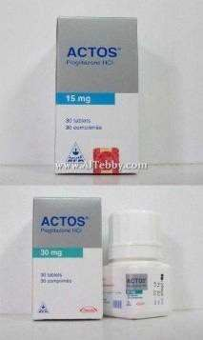 | #Pioglitazone | Anti-diabetic
Mechanism
-Insulin sensitizer oral anti diabetic
-Enhances the transcription of several insulin receptor gen
Acyclovir 400-800 | 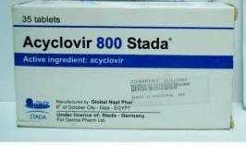 | #Acyclovir | acyclovir is used to decrease pain and speed the healing of sores or blisters in people who have varicella  (chickenpox), herpes z oster (shingles; a rash that can occur in people who have  had chickenpox in the past), and first-time or repeat outbreaks  of genital herpes
Acyclovir triphosphate competitively inhibits viral DNA polymerase by acting as an analog to deoxyguanosine triphosphate (dGTP).
Incorporation
of acyclovir triphosphate into DNA results in chain termination since the absence of a 3' hydroxyl group prevents the attachment of additional nucleosides
Adancor 10-20 | 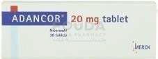 | #Nicorandil | Anti-ischemic
Mechanism
-Potassium channel opener
-nitric oxide donor

Adwitine 30-60  “cymbalta” | 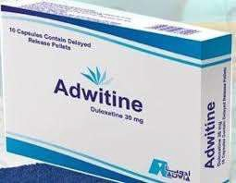 | #Duloxetine | -Antidepressant  -Diabetic peripheral neuropathic pain  -Generalized anxiety disorder
Mechanism
-serotonin –norepinephrine reuptake inhibitor
-thiophene derivative antidepressant
Agovald 25 | 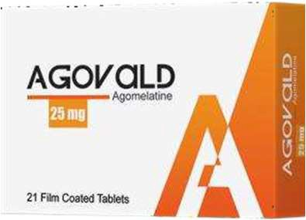 | #Agomelatine | Antidepressant: Major depressive disorder
Mechanism
-Potent agonist at melatonin receptor
-antagonist at serotonin receptors
anarcol | 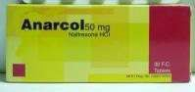  8 | #Naltrexone | #Alcoholism  #Opioid dependence
Mechanism
-Opioid receptor antagonist –Competitive antagonist
In alcohol
Dependence and opioid dependence
Anastrazol Sandoz  “arImIdex” | 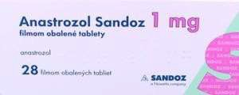 | #Anastrazole | -Breast cancer  -Metastasis in both pre and post-menopausal women
Mechanism
-Aromatase inhibitor
-Inhibits the synthesis of estrogen
Anastrazol synthon  “arImIdex” |  | #Anastrazole | -Brest cancer  -metastasis in both pre  and post-menopausal women
Mechanism
-Aromatase inhibitor
-inhibits the synthesis of estrogen
Andovimpamid e 50-100-200  “lacovImp” | 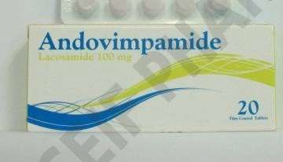 | #Lacosamide | Anti-epileptic
Mechanism
Enhances slow inactivation of voltage-gated sodium channel resulting in
Stabilization of repetitive neuronal firing
Andorivaban 2.5-10-15-20  “xarelto” | 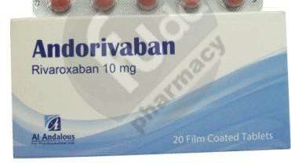 | #Rivaroxaban | -Reduce the risk of stroke and serious blood clots in certain patients with atrial fibrillation  - ttt and prevent DVT which can lead to blood clots in the lung – pulmonary embolism-
Mechanism
- Anti platelet
-Direct factor XA inhibitor
-Blocks the formation of blood clots

Angiobradine 5-7.5  “procoralaN” | 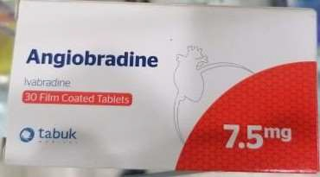 | #Ivabradine | Chronic stable angina in coronary artery disease patient with normal sinus rhythm
- Anti ischemic
-Hart rate lowering agent that works through selective and specific inhibition of cardiac
pacemaker if current
Anselacox 60-90  “arcoxIa” | 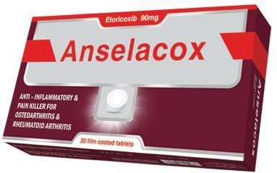 | #Etoricixib | -Rheumatoid arthritis  -acute pain  -gout  -chronic low back pain  -osteoarthritis  -ankylosing spondylitis
Mechanism
-Selective cox inhibitor
Anvizram 200 |  | #Fvipiravir | Antiviral  -influenza A B  -avion influenza  -ebola virus  -lassa virus  -COVID-19
Mechanism
-purine nucleoside analogue which act as a competitive inhibitor of RNA-dependent RNA polymerase
Apexidon 0.5-1-2-3-4  Syrup  “rIsperdal” | 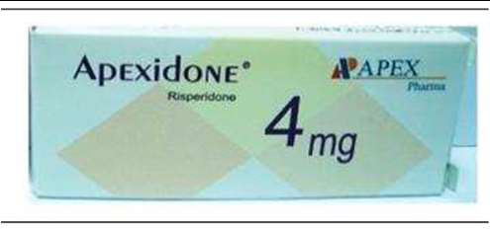 | #Risperidone | Antipsychotic
Mechanism
-block dopamine and serotonin receptors
-has antagonistic action on alpha adrenergic and histaminic
receptor
Apixatrack 2.5-5  “elIqUIs” | 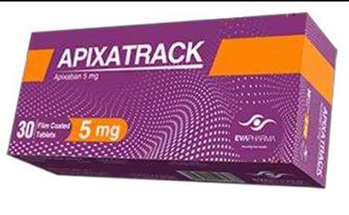 | #Apixaban | -DVT prophylaxis  -DVT may lead to pulmonary embolism – PE-in knee or lip replacement surgery  -ttt both DVT and PE  -to lower the risk of stroke and embolism in patient with non valvular atrial
Mechanism
- Anti co agulant
-direct factor xa inhibitor
Apetoid 20  “avara” | 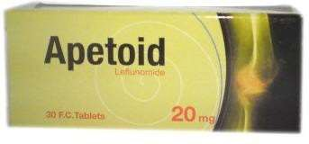 | #leflunomide | -Rheumatoid arthritis  -psoriatic arthritis
Mechanism
-Immunomodulatory drug
-pyrimidine synthesis inhibitor
-Anti-inflammatory

Artixiban 2.5-5  “elIqUIs” |  | #Apixaban | -DVT prophylaxis  -DVT may lead to pulmonary embolism – PE-in knee or lip replacement surgery  -ttt both DVT and PE  -to lower the risk of stroke and embolism in patient with non valvular atrial
Mechanism
- Anti co agulant
-direct factor xa inhibitor Factor Xa is generated by both the extrinsic and intrinsic coagulation pathways and is responsible for activating prothrombin to thrombin
Aromasin 25 | 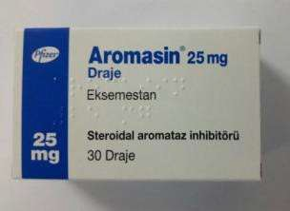 | #Exemestane | Advanced breast cancer –adjusvant ttt – after primary or main therapy  In postmenopausal women whose disease has progressed after  tamoxifen therapy
Mechanism
- Anti neoplastic
Aricept 5-10 | 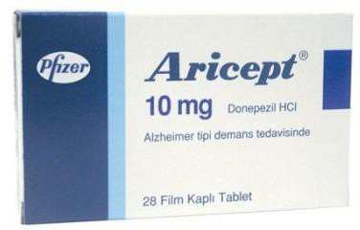 | #Donepezil | Alzheimer disease
Mechanism
-Acetyl cholinesterase inhibitor
Arimidex 1 | 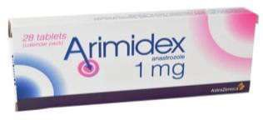 | #Anastrazole | -Breast cancer  -metastasis in both pre and post-menopausal women
Mechanism
-Aromatase inhibitor
-Inhibits the synthesis of estrogen
Aripiprex 10-30-vial  “abIlIfy” | 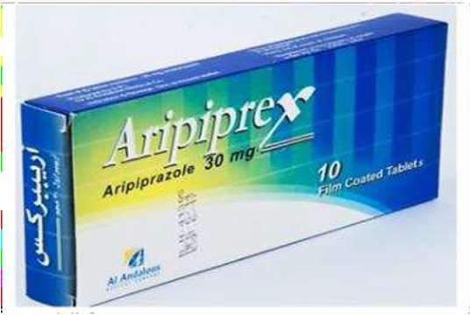 | #Aripiprazol | Antipsychotics:  -Schizophrenia  -Bipolar disorder
Mechanism
#partial agonist at D2
#Potent antagonist at serotonin
Arcoxia 60-90 | 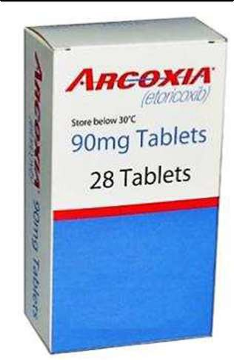 | #Etoricixib | -Rheumatoid arthritis  -Acute pain  -Gout  -Chronic low back pain  -Osteoarthritis  -Ankylosing spondylitis
Mechanism
-Selective cox inhibitor

Atomafutix 10-25-40  “strattera ” | 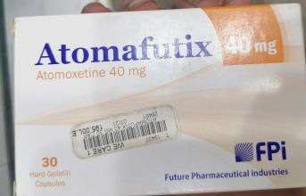 | #Atomoxetine | Ttt of ADHD Attention deficit hyperactivity disorder
Mechanism
Selective inhibition of presynaptic norepinephrine reuptake in the prefrontal cortex. Atomoxetine has a high affinity and selectivity for norepinephrine transporters, but little or no affinity for various neurotransmitter
receptors
Atomox apex 10-18-25-40-60  “strattera ” | 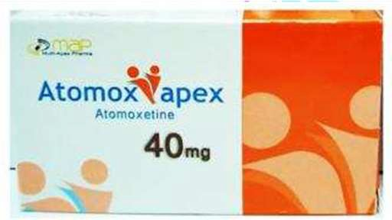 | #Atomoxetine | Ttt of \ADHD Attention deficit hyperactivity disorder
Mechanism
Selective inhibition of presynaptic norepinephrine reuptake in the prefrontal cortex. Atomoxetine has a high affinity and selectivity for norepinephrine transporters, but little or no affinity for various neurotransmitter
receptors
Attensera 18  25  40  “strattera ” | 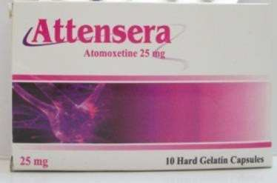 | #Atomoxetine | Ttt of ADHD Attention deficit hyperactivity disorder
Mechanism
Selective inhibition of presynaptic norepinephrine reuptake in the prefrontal cortex. Atomoxetine has a high affinity and selectivity for norepinephrine transporters, but little or no affinity for
various neurotransmitter receptors
Arthfree 20  “avara” | 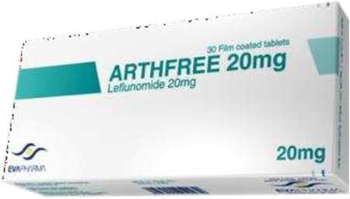 | #leflunomide | -Rheumatoid arthritis  -psoriatic arthritis
Mechanism
-Immunomodulatory drug
-Pyrimidine synthesis inhibitor
-Anti-inflammatory
Atoreza 10l10  20l10  40l10  “atozet “ | 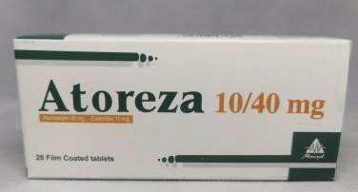 | #Atorvastatin+ Ezetimibe | - combined hyperlipidemia  -homozygous familial hyperlipidemia
Mechanism
Atorvastatin
-HMG-CoA reducates Inhibitor statins antilipemic agent
- Ezetimibe
reduce the absorption of
cholesterol from the intestine

Atozet 10l10  20l10  40l10 | 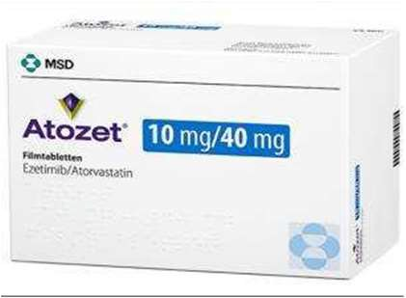 | #Atorvastatin+ Ezetimibe | - combined hyperlipidemia  -homozygous familial hyperlipidemia
Mechanism
Atorvastatin
-HMG-Coa reductase Inhibitor statins antilipemic agent
- Ezetimibe
reduce the absorption of cholesterol from the intestine
Atozemb 10l10  20l10  “atozet “ | 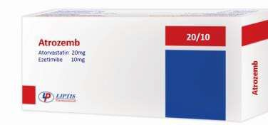 | #Atorvastatin+ Ezetimibe | - combined hyperlipidemia  -homozygous familial hyperlipidemia
Mechanism
Atorvastatin
-HMG-Coa reductase Inhibitor statins antilipemic agent
- Ezetimibe
reduce the absorption of cholesterol from the intestine
Avodart 0.5 | 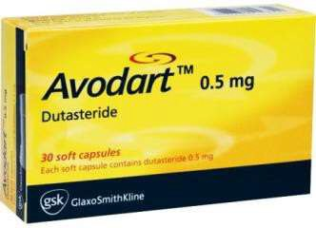 | #Dutastreride | -Benign prostatic hyperplasia –BPH-  -Male pattern baldness
Mechanism
Selective inhibitor of both type 1 and type2 5 alpha reductase inhibitor(an intracellular enzyme that converts testosterone to dihydrotestosterone which influences the development of prostate gland)this decreasing level of this hormone relieves the
symptoms associated with BPH
Avipravir 200 | 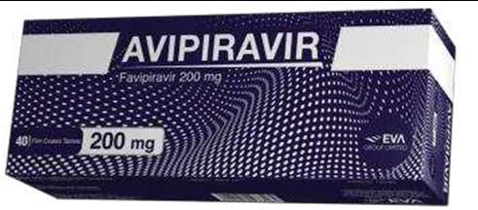 | #Fvipiravir | Antiviral  -influenza A B  -avion influenza  -ebola virus  -lassa virus  -COVID-19
Mechanism
-purine nucleoside analogue which act as a competitive inhibitor of RNA-dependent RNA
polymerase
Avara 10-20 | 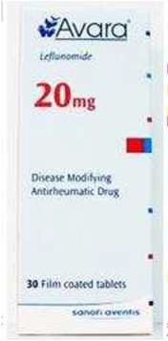 | #leflunomide | -Rheumatoid arthritis  -psoriatic arthritis
Mechanism
-Immunomodulatory drug
-Pyrimidine synthesis inhibitor
-Anti-inflammatory

Betmiga 50 | 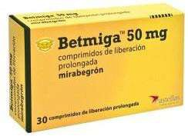 | Mirabegrone | Over active bladder (urge urinary incontinence urgency frequency)
Mechanism
Relaxes the detrusor smooth muscle during the storage phase of the urinary bladder fill-void cycle by activation of
beta-3 AR which increases bladder capacity
Bladogra 50  “betmIga” |  | Mirabegrone | Over active bladder (urge urinary incontinence urgency frequency)
Mechanism
Relaxes the detrusor smooth muscle during the storage phase of the urinary bladder fill-void
cycle by activation of beta-3 AR which increases bladder capacity
Brilique 60-90 | 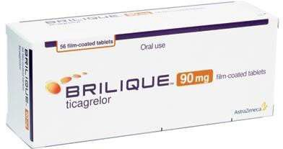 | #Ticagrelor | -Reducing the risk of stroke heart attack  -or death in certain patient who have had a heart attack or who have angina (chest pain)  -it should be used along  with aspirin as directed by your doctor
Mechanism
Platelet aggregation inhibitor Works by slowing or stopping platelet from sticking to blood vessel walls or injured tissues
Bradipect 5-7.5  “procoralaN ” | 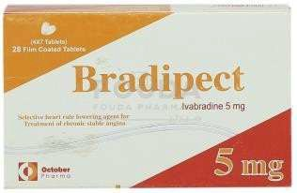 | #Ivabradine | Chronic stable angina in coronary artery disease patient with normal sinus rhythm
Mechanism
- Anti ischemic
-Hart rate lowering agent that works through selective and specific inhibition of cardiac pacemaker if current
Brintellix 10-20 | 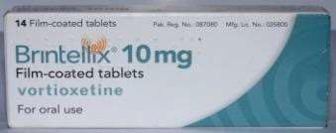 | #Vortioxetine | Ttt Major depressive disorder
Mechanism
Atypical antidepressant
Budexan inh 1-0.5 | 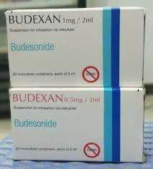 | #Budesonide | Budesonide is used to control and prevent symptoms  (Wheezing and shortne ss of breath) caused  by asthma.  This medication belongs to a class of drugs known  as corticosteroids. It works directly in the lungs to make breathing easier by reducing the  irritation and swelling of the airways
Mechanism
is a potent topical anti-inflammatory agent
It binds and activates glucocorticoid receptors (GR) in the effector cell (e.g., bronchial)

Casodex 50 | 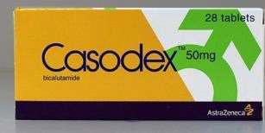 | #Bicalutamide | Antineoplastic Prostate cancer
Mechanism
Non-steroidal anti-estrogen anti-neoplastic
-anti androgenic drug binds to receptor of androgen on prostate gland and prevent growth of androgen stimulated prostate
cancer
Carcemia 100  400 | 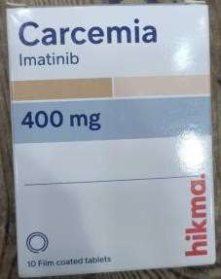 | #Imatinib | - chronic myelogenous leukemia  -lymphoblastic leukemia  -gastrointestinal stromal tumors  -systemic mastocytosis  -hyperosinophilic syndrome  -plexiform neurofibromas  -dermatofibrosarcoma  protuberans
Mechanism
Anti-cancer
Tyrosine-kinase inhibitor
Carfalone 25-50 | 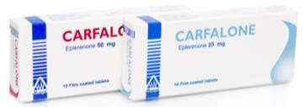 | #Eplerenone | is used alone or in combination with other medications to treat high blood pressure antagonists. body that
Mechanism
Aldosterone receptor antagonist similar to spironolactone
. Eplerenone is in a class of medications called mineralocorticoid receptor
It works by blocking the action of aldosterone, a natural substance in the raises blood pressure
Cardura 1-4-dxl | 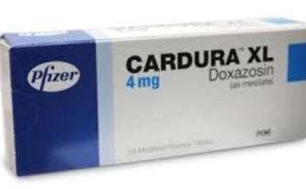 | #Doxazosin | - Anti hyper tension  - Benign prostatic hypertrophy
Mechanism
-Selective alpha-1 antagonist
-it dilates both arteries and veins
-the alpha 1 blockade in non-vascular smooth muscle cause relaxation of smooth muscle of
prostate
Celebrex 200-100 | 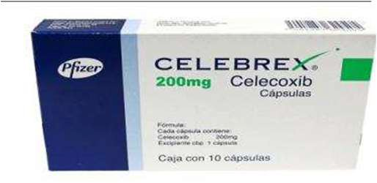 | #Celecoxib | - osteoarthritis  - rheumatoid arthritis  - acut gout
Mechanism
- selective Cox-2 inhibitor

Cellcept 250- 500 | 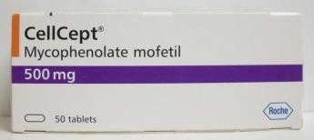 | #Mycophenolate mofetil | Prophylaxis of organ rejection in patient receiving allogeneic renal –cardiac or hepatic transplants
Mechanism
Immunosuppressant
Champix 1  0.5 | 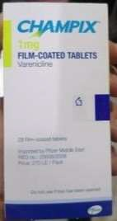 | #varenicline | Smoking cessation
Mechanism
#nicotinic agonist
Cipla tropium 18 mcg  “spIrIva” | 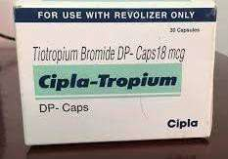 | #Tiotropium bromide | -chronic obstructive pulmonary disease(COPD)  -bronchospasm  -chronic bronchitis  -emphysema
Mechanism Anticholinergic (muscarinic antagonist)
-bronchodilator
Cipralex10 | 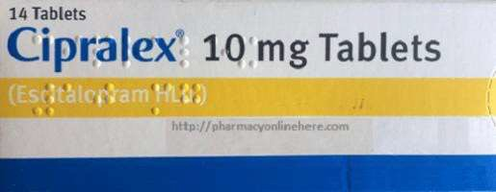 | #Escitalopram | Depression
Mechanism
SSRI-selective serotonin reuptake
inhibitor
Cialis 5-20 | 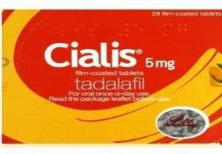 | Tadalafil | Ttt eriction dysfunction
Cipram 20 | 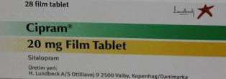 | #Citalopram | Depression
Mechanism
SSRI-selective serotonin reuptake inhibitor
Cludine tech 0.5-1  “tecavIr” | 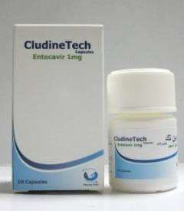 | #Entecavir | Ttt chronic hepatitis b virus
Mechanism
Entecavir is a nucleoside analog, or more specifically, a deoxyguanosine analogue that belongs to a class of carbocyclic nucleosides and inhibits reverse transcription, DNA replication and
transcription in the viral replication process

Concor amlo | 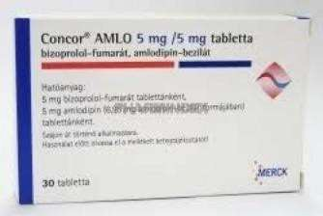 | Bisolol+ amlodipine | Ant hypertension
Constipride 1-2  “resolor” | 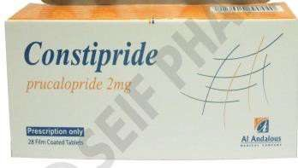 | #Prucalopride | Ttt chronic constipation
Mechanism
selective high affinity serotonin receptor agonist which targets the impaired motility associated with chronic constipation thus normalize bowel movement
-it stimulates colonic mass
movement
Cotareg 80l25  160l12.5  160l25  320l12.5  320l25 | 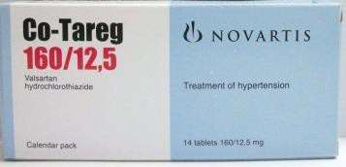 | Valsartan Hydroclorothiazide | Anti-hypertension
Coveram 5l5  5l10  10l10  10l5 | 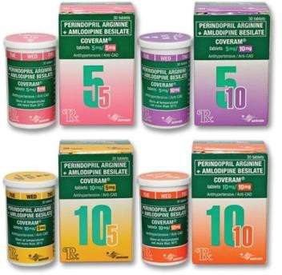 | Amlodipine  +  Perindopril | Anti-hypertension
Cortexin | 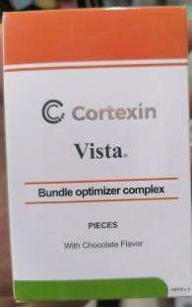 | Cortexin Iorn Biotin Zinc  Floic acid Vitamin c Vitamin d3 Vitamin b1 Vitamin b2 Vitamin b3 Vitamin b5 Vitamin b6 Vitamin b12  Copper

Crestor 5-10-20 | 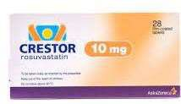 | #Rosuvastatin | Anti-hyper lipidemic
Mechanism
HMG-COA reductase inhibitor
- reduces cholesterol synthesis up to 50%
Cymbalta 60-  30 | 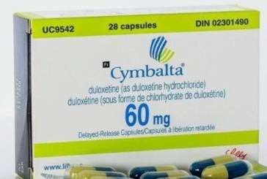 | #Duloxetine | -Antidepressant  -diabetic peripheral neuropathic pain  -generalized anxiety disorder
Mechanism
-serotonin –norepinephrine reuptake inhibitor
-thiophene derivative antidepressant
Cymbatex 20-30-60  “cymbalta” | 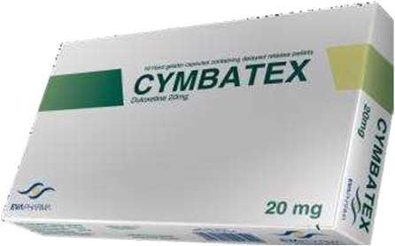 | #duloxetine | -Antidepressant  -diabetic peripheral neuropathic pain  -generalized anxiety disorder
Mechanism
-serotonin –norepinephrine reuptake inhibitor
-thiophene derivative antidepressant
Dapaglif  “forxIga” | 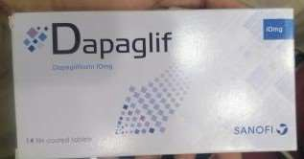 | #Dapagliflozin | Antidaibetic
Mechanism
#Dapagliflozin inhibits subtype 2 of the sodium-glucose transport proteins (SGLT2) which are responsible for at least 90% of the glucose reabsorption in the kidney.
Blocking this
transporter mechanism causes blood glucose to be eliminated through the urine
Diaflozmet 5l1000  10l1000  10l500  5l500  “xIgdUo “ | 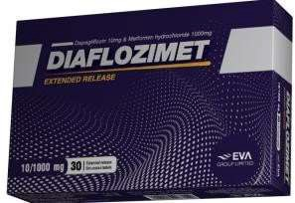 | #dapagliflozin +metform | Antidaibetic
Mechanism
#Dapagliflozin inhibits subtype 2 of the sodium-glucose transport proteins (SGLT2) which are responsible for at least 90% of the glucose reabsorption in the kidney. Blocking this transporter mechanism causes blood glucose to be eliminated through the urine
#Metformin
in patients with type 2 diabetes mellitus
setting is inhibition of hepatic gluconeogenesis.

Diacurimap 10- 25 | 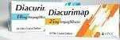 | #Empagiliflozin | Antidaibetic
Mechanism
#Empagliflozin works by inhibiting the sodium-glucose co-transporter-2 (SGLT-2) found in the proximal tubules in the kidneys. Through SGLT2 inhibition
, empagliflozin reduces renal reabsorption of glucose and increases urinary excretion of glucose
Diglifloz  “forxIga” | 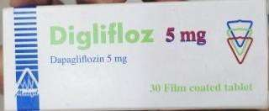 | #Dapagliflozin | Anti-diabetic
Mechanism
#Dapagliflozin inhibits subtype 2 of the sodium-glucose transport proteins (SGLT2) which are responsible for at least 90% of the glucose reabsorption in the kidney.
Blocking this
transporter mechanism causes blood glucose to be eliminated through the urine
Diglifloz  plus 5l1000  “xIgdUo “ | 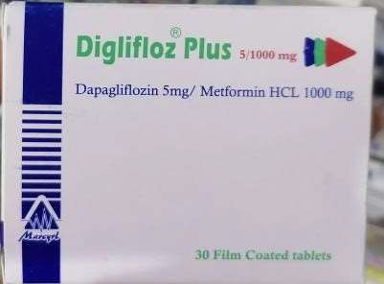 | #dapagliflozin+Metformin | Anti-diabetic
Mechanism #Dapagliflozin #Metformin
in patients with type 2 diabetes mellitus
setting is inhibition of hepatic gluconeogenesis.
Dalfarosis e.r | 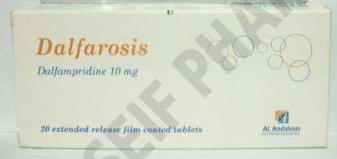 | #Dalfampridine | Ttt to improve walking in patient with multiple sclerosis(MS)
Mechanism
- Nonspecific potassium channel blocker which improves conduction in focally demyelinated axons by delaying repolarization and prolonging the duration of action potential
-enhanced neuronal conduction is through to strengthen skeletal muscle fiber twitch activity
-improving peripheral motor neurologic function

Donhimer 5  “arIcept” | 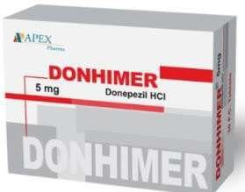 | # Donepezil | Alzheimer disease
Mechanism
-Acetyl cholinesterase inhibitor
Duloxeprin 30-60  “cymbatex” | 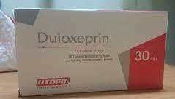 | #Duloxetine | -Antidepressant  -diabetic peripheral neuropathic pain  -generalized anxiety disorder
Mechanism
-serotonin –norepinephrine reuptake inhibitor
-thiophene derivative antidepressant
Duodart 0.5\0.4 | 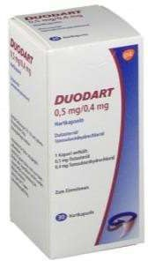 | #Tamsulin+ Dutasteride | Ttt benign prostatic hyperplasia  -for preventing urinary retention
Mechanism
#Dutasteride:
5 alpha reductase inhibitor
-testosterone is responsible for prostate hyper trophy Blocking this enzyme prevents prostate from further growing
#Tamsulin: block alpha receptor in the prostate and bladder so relax the smooth muscles of
prostate
Duphaston10 |  | #Dydrogesterone | Threatened or recurrent miscarriage during pregnancy, dysfunctional bleeding  , infertility due to luteal insufficiency, dysmenorrhea.
Mechanism Dydrogesterone is a progestogen that works by regulating the healthy growth and normal shedding of the womb lining by acting on
progesterone receptors in the uterus. Rapidly absorbed in
the gastrointestinal tract with a bioavailability of 28%
Ebixa | 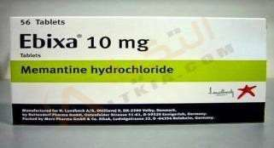 | # Memantine | Antidementia agent in Alzheimer disease
Mechanism
n-methyl –d-aspartate receptor antagonist (NMDA)
-dopamine d2 agonist
-xss glutamate plays a role in neural cell death
Efexor xr 75-  150 | 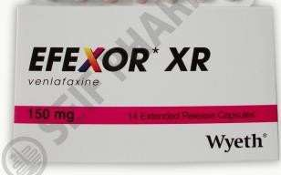 | #venlafaxine | -Depression  -generalized anxiety disorder  -social anxiety
Mechanism
Serotonin norepinephrine reuptake inhibitor

Effegad 75-150 “efexor” | 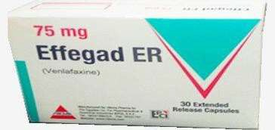 | #venlafaxine | -Depression  -generalized anxiety disorder  -social anxiety
Mechanism
Serotonin norepinephrine reuptake inhibitor
Eliquis5-2.5 | 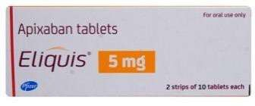 | #Apixaban | -DVT prophylaxis  -DVT may lead to pulmonary embolism – PE-in knee or lip replacement surgery  -ttt both DVT and PE  -to lower the risk of stroke and embolism in patient with non valvular atrial fibrillation
Mechanism
- Anti co- agulant
-direct factor xa inhibitor Factor Xa is generated by both the extrinsic and intrinsic coagulation pathways and is responsible for activating prothrombin to thrombin

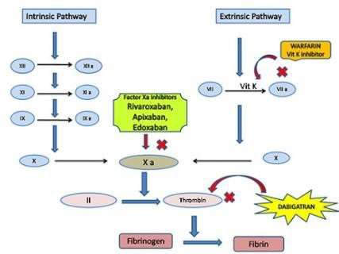

Elimbosis 2.5-5  “elIqUIs” | 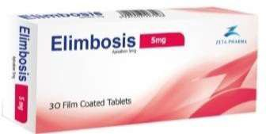 | #Apixaban | -DVT prophylaxis  -DVT may lead to pulmonary embolism – PE-in knee or lip replacement surgery  -ttt both DVT and PE  -to lower the risk of stroke and embolism in patient with non  valvular atrial fibrillation
Mechanism
- Anti co- agulant
-direct factor xa inhibitor Factor Xa is generated by both the extrinsic and intrinsic coagulation pathways and is responsible for activating prothrombin to thrombin
Empacoza 10-25  “JardIaNce” | 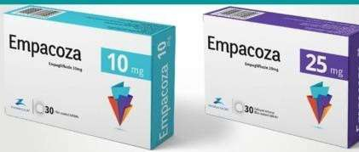 | Empagiliflozin | Anti-diabetic
Mechanism
Empagliflozin works by inhibiting the sodium-glucose co-transporter-2 (SGLT-2) found in the proximal tubules in the kidneys.
Through SGLT2 inhibition, empagliflozin
reduces renal reabsorption of glucose and increases urinary excretion of glucose

Empaglimax 25-10  “JardIaNce” | 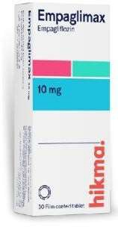 | #Empagiliflozin | Anti-diabetic
Mechanism
Empagliflozin works by inhibiting the sodium-glucose co-transporter-2 (SGLT-2) found in the proximal tubules in the kidneys. Through SGLT2 inhibition, empagliflozin reduces renal reabsorption of glucose and
increases urinary excretion of glucose
Empagliform 5l500  12.5l500  “syNJardy” | 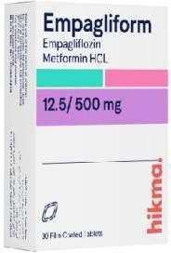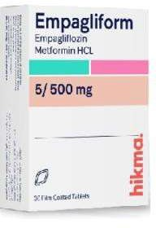 | #Empagliflozin Metformin | Anti-diabetic
Mechanism
#Empagliflozin

#Metformin
in patients with type 2 diabetes mellitus
setting is inhibition of hepatic
gluconeogenesis.
Em ex | 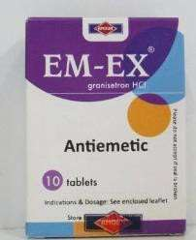 | #Granisetron | Nausea and vomiting associated with cytotoxic chemotherapy or radiotherapy
Mechanism
Selective 5ht3 receptor antagonist
Emend 125mg 1 cap  +80mg 2 cap | 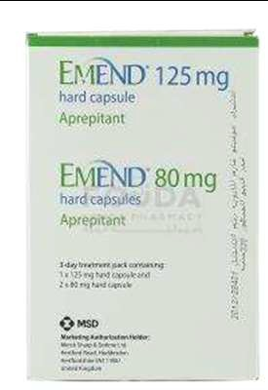 | #Aprepitant | Antiemetic
 |  | Mechanism Neurokinin1 NK1 receptor blocker

Entresto 50-  100-200 | 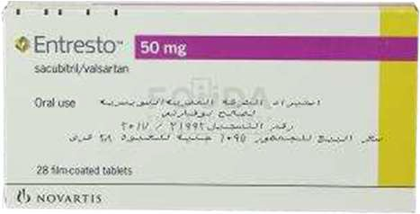 | #sacubitril Valsartan | Heart failure  Used to reduce the risk of cardiovascular death and hospitalization for heart failure in patient with chronic heart failure
Sacubitril is a pro-drug that upon activation acts as a neprilysin inhibitor. It works by blocking the action of neprilysin thus preventing the breakdown of natriuretic peptides. This leads to a prolonged duration of the favorable effects of these peptides.
Neprilysin is a key enzyme in the degradation of natriuretic peptides, and the primary rationale
for neprilysin inhibitor therapy in cardiovascular disease was to increase endogenous natriuretic peptide levels, and thereby achieve the vasodilatation and natriuresis these peptides produce

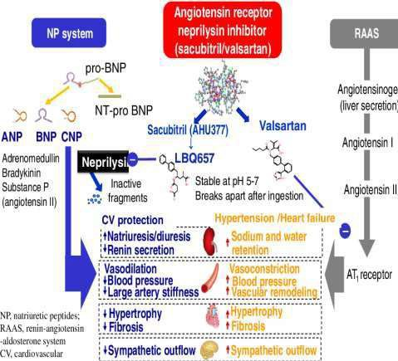
Ergoconazol 200  “vfeNd” | 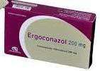 | Voriconazol | Ttt of esophageal candidiasis invasive pulmonary aspergillosis  -ttt serious fungal infections caused by scedosporium apiospermum and fusarium spp

Eraloner 25-50 | 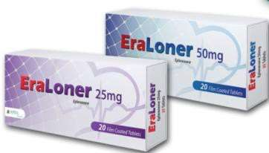 | #Eplerenone | is used alone or in combination with other medications to treat high blood pressure antagonists. body that
Mechanism
Aldosterone receptor antagonist similar to spironolactone
. Eplerenone is in a class of medications called mineralocorticoid receptor
It works by blocking the action of
aldosterone, a natural substance in the raises blood pressure
Eslizepine 400  800 | 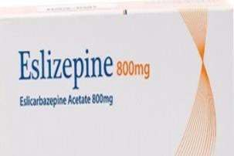 | #Eslicabrazepine | Ttt partial onset seizures
Mechanism
Anti-epileptic
It may work by slowing abnormal
nerve impulses in the brain
Exforge 10l160  5l160  10l160l25 htc 5l160l12.5 htc | 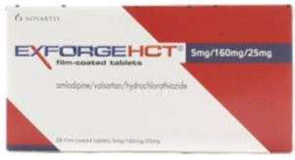 | Amilodipine  +  Valsartan | Anti-hypertension
Exelon 1.5  3  4.5  6  9 patch  18 patch | 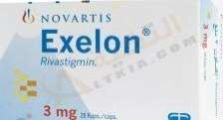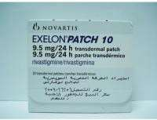 | Rivastagmine | Mild to moderate dementia of the Alzheimer’s
Central reversible non competitive
anti choline esterase
Exeedolip | 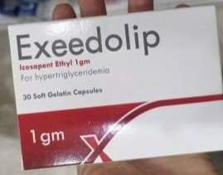 | #icosapent | .It is used along with a low-fat and low-cholesterol diet to lower high triglyglyceride level (>500 mgldl)  - cardio vascular risk reduction :  -indicated as an adjunct to maximally tolerated statin therapy to reduce risk of myocardial infarction stroke coronary revasularization and un stable angina requiring hospitalization in adults with elevated TG >150 mgLdl  And  Established cardiovascular disease Or  Diabetes mellitus and 2 or more additional risk  factors for cv disease
Mechanism
icosapent ethyl) is a type of omega-3 fatty acid
only containing EPA, eicosapentaenoic acid (EPA), whereas supplemental fish oils contain both EPA and docosahexaenoic acid (DHA). t, It is thought to work by decreasing the amount of triglycerides made by the body
increased ß-oxidation; inhibition of acyl-CoA:1,2-diacylglycerol acyltransferase (DGAT); decreased lipogenesis in the liver; and increased plasma lipoprotein lipase activity
It reduces high triglycerides without raising levels of “bad” cholesterol or LDL-C

Faverin 50-100 |  | #Fluvoxamine | Ttt OCD  Obsessive compulsive disorder  -management of bulimia nervosa
Mechanism
SSRI
Femara 2,5 | 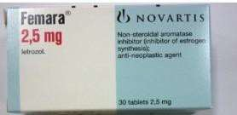 | #Letrozole | -Breast cancer in post-menopausal women  -pre operative ttt in post-menopausal women with localized hormone receptor positive breast cancer  -ttt infertility in women
Mechanism
Inhibit aromatase and suppress estrogen production
-promotes the growth and release of eggs in women who aren’t ovulating on their ovulation induction or super ovulation in women who are able to ovulate
-estrogen levels are suppressed in women .FSH hormone output is increased by the brain and pituitary gland .FSH can result in the development of a mature follicle in the women’s ovary to
ovulate an egg
Femaprent 2.5 “femara” |  | #Letrozole | --breast cancer in post-menopausal women  -pre operative ttt in post-menopausal women with localized hormone receptor positive breast cancer  -ttt infertility in women
Mechanism
Inhibit aromatase and suppress estrogen production
-promotes the growth and release of eggs in women who aren’t ovulating on there ovulation induction or super ovulation in women who are able to ovulate
-estrogen levels are suppressed in women .FSH hormone output is increased by the brain and pituitary gland .FSH can result in the development of a mature follicle in the women’s ovary to
ovulate an egg
Flopadex 8 | 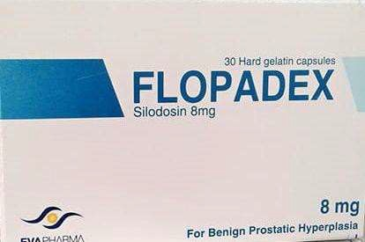 | Silodosin | Ttt urination difficulty in benign prostatic hyperplasia
Mechanism
Alpha 1 a blocker

Fosavance | 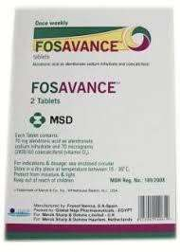 | #Alendronate Vd3 | Ttt post menopausal osteoporosis in women at risk of vit d insufficiency  -reduce the risk of vertebral and hip fracture
Mechanism bisphosphonates inhibit osteoclastic bone resorption via a mechanism that differs from that of other antiresorptive agents
. Bisphosphonates attach to hydroxyapatite binding sites on bony surfaces, especially surfaces undergoing active
resorption
Fosamax | 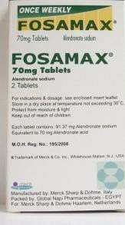 | #Alendronate | Ttt and prevention of osteoporosis in women and pagets disease of bone in both men and women
Mechanism Bisphosphonates inhibit osteoclastic bone resorption via a mechanism that differs from that of other antiresorptive
agents. Bisphosphonates attac h to hydroxyapatite binding sites on bony surfaces, especially surfaces undergoing active resorption
Forxiga 5-10 | 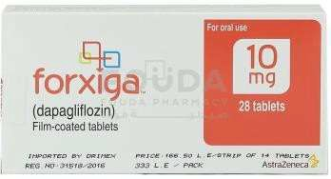 | #Dapagliflozin | Antidaibetic
Mechanism
Dapagliflozin inhibits subtype 2 of the sodium-glucose transport proteins (SGLT2) which are responsible for at least 90% of the glucose reabsorption in the kidney. Blocking this
transporter mechanism causes blood glucose to be eliminated
through the urine
Forflozinb | 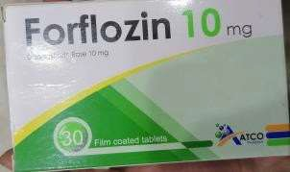 | #Dapagliflozin | Antidaibetic
Mechanism
Dapagliflozin inhibits subtype 2 of the sodium-glucose transport proteins (SGLT2) which are responsible for at least 90% of the glucose reabsorption in the kidney. Blocking this
transporter mechanism causes blood glucose to be eliminated
through the urine

Fungilimit200  “vfeNd” |  | Voriconazol | Ttt of esophageal candidiasis invasive pulmonary aspergillosis  -ttt serious fungal infections caused by scedosporium apiospermum and  fusarium spp
Gardovas 5 |  | #Ambrisentan | Ttt pulmonary aterial hypertension
Mechanism
a potent type-A selective endothelin receptor antagonist. Endothelin is a peptide made by the body in the endothelium and it constricts blood vessels and elevates blood pressure. There are two classes of endothelin
receptors: Endothelin A (ET-A) and Endothelin B (ET-B
Granitryl 2 | 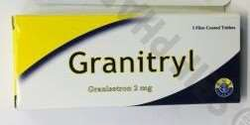 | #Granisetron | Nausea and vomiting associated with  cytotoxic chemotherapy or radiotherapy
Mechanism
-Selective5ht3 receptor
antagonist
Galvus 50 | 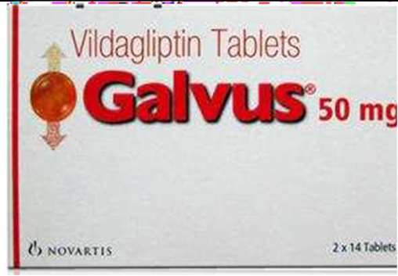 | #Vildagliptin | Anti-diabetic
Mechanism
inhibits the activity of DPP-4, an enzyme that inactivates and degrades incretin hormones, cytokines and other peptides. Released in response to meals, incretin hormones potentiate insulin release and decrease glucagon production, lowering serum glucose concentrations. The enzyme dipeptidyl peptidase-4 (DPP-4) begins degrading the GLP-1 and GIP incretins within minutes of their release. Consequently, GLP-1 and GIP are short-lived, disrupting glucose homeostasis.¹
, thereby prolonging the body’s own action of naturally secreted incretins GLP-1 and GIP.¹
GLP-1 signals to the pancreas to decrease glucagon secretion by pancreatic alpha cells, which decreases hepatic glucose productions.¹
GLP-1 and GIP increase insulin release by signaling the pancreatic beta cells, which increase uptake of glucose by the muscle, fat, and
peripheral tissues.

Galvus  met 50l500 met 50l850 met 50l1000 | 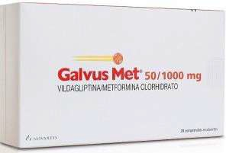 | Vildagliptin Metformin | Anti-diabetic
Mechanism #Vildagliptin #Metformin
in patients with type 2 diabetes mellitus
setting is inhibition of hepatic gluconeogenesis.
Glimpacare | 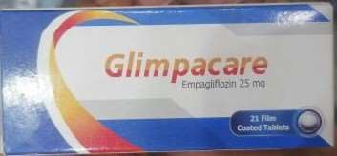 | #Dapagliflozin | Anti-diabetic
Mechanism
Dapagliflozin inhibits subtype 2 of the sodium-glucose transport proteins (SGLT2) which are responsible for at least 90% of the glucose reabsorption in the kidney. Blocking this
transporter mechanism causes blood glucose to be eliminated through the urine
Icosalip  vascepa | 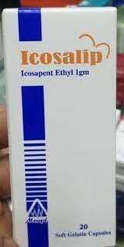 | #icosapent | .It is used along with a low-fat and low-cholesterol diet to lower high triglyglyceride level (>500 mgldl)  - cardio vascular risk reduction :  -indicated as an adjunct to maximally tolerated statin therapy to reduce risk of myocardial infarction stroke coronary revasularization and un stable angina requiring hospitalization in adults with elevated TG >150 mgLdl  And Established cardiovascular disease  Or  Diabetes mellitus and 2 or more additional risk factors for cv disease
Mechanism
icosapent ethyl) is a type of omega-3 fatty acid
only containing EPA, eicosapentaenoic acid (EPA), whereas supplemental fish oils contain both EPA and docosahexaenoic acid (DHA). t, It is thought to work by decreasing the amount of triglycerides made by the body increased ß-oxidation; inhibition of acyl-CoA:1,2-diacylglycerol acyltransferase (DGAT); decreased lipogenesis in the liver; and increased plasma lipoprotein lipase activity
It reduces high triglycerides without raising levels of “bad” cholesterol or LDL-C

Iksaront 2.5-5 “elIqUIs” |  | #Apixaban | -DVT prophylaxis  -DVT may lead to pulmonary embolism – PE-in knee or lip replacement surgery  -ttt both DVT and PE  -to lower the risk of stroke and embolism in patient with non  valvular atrial fibrillation
Mechanism
- Anti co agulant
-direct factor xa inhibitor
- Factor Xa is generated by both the extrinsic and intrinsic coagulation pathways and is responsible for activating prothrombin to thrombin
Inhalex 18  “spIrIva” | 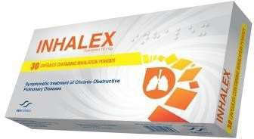 | #Tiotropium bromide | -chronic obstructive pulmonary disease(COPD)  -bronchospasm  -chronic bronchitis  -emphysema
Mechanism Anticholinergic (muscarinic antagonist)
-bronchodilator
Inhiglip 12.5  25 “ | 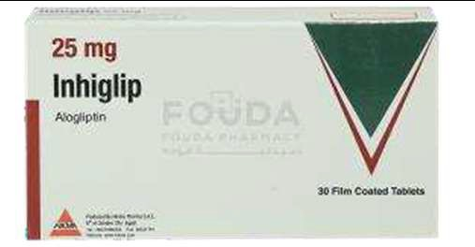 | #Alogliptin | Anti-diabetic
Mechanism
inhibits the activity of DPP-4, an enzyme that inactivates and degrades incretin hormones, cytokines and other peptides. Released in response to meals, incretin hormones potentiate insulin release and decrease glucagon production, lowering serum glucose concentrations. The enzyme dipeptidyl peptidase-4 (DPP-4) begins degrading the GLP-1 and GIP incretins within minutes of their release.
Consequently, GLP-1 and GIP are short-lived, disrupting glucose homeostasis.¹
, thereby prolonging the body’s own action of naturally secreted incretins GLP-1 and GIP.¹
GLP-1 signals to the pancreas to decrease glucagon secretion by pancreatic alpha cells, which decreases hepatic glucose productions.¹
GLP-1 and GIP increase insulin release by signaling the pancreatic beta cells, which increase uptake of glucose by the
muscle, fat, and peripheral tissues.

Inegy 10l10  10l20  10l40 | 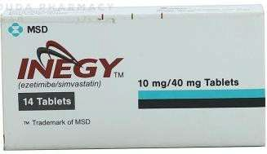 | #Simvastatin Ezetimibe | Hyperlipidaemia
Mechanism
Simvastatin is in a class of medications called HMG-CoA reductase inhibitors (statins). It works by slowing the production of cholesterol in the body to decrease the amount of cholesterol that may build up on the walls of the arteries and block blood flow to the heart, brain, and other parts of the body.
- ezetimibe
reduce the absorption of cholesterol from the intestine
Inviga 3-6  Sustenna 100-  75-150 | 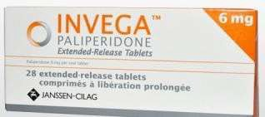 | #Paliperidone | -schizophrenia  -sever depression  -anxiety  -obsessive thought
Mechanism
Benzisoxazole atypical antipsycatric which is a main active metabolite of risperidone
-an antagonist at dopamine-serotonin-adrenergic a1 and a2 receptors and histamine
receptors
Invokana 100  300 | 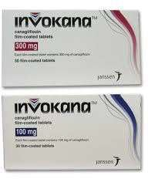 | #Ganagliflozin | Antidaibetic
Mechanism
Inhibits the Na-glucose co-transporter 2 (SGLT-2) in the kidney to reduce glucose reabsorption, resulting in increased urinary glucose excretion, and lower plasma
glucose
Invoglita 100  300  “INvokaNa “ | 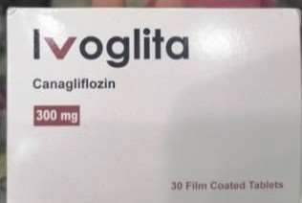 | #Ganagliflozin | Antidaibetic
Mechanism
#Inhibits the Na-glucose co-transporter 2 (SGLT-2) in the kidney to reduce glucose reabsorption, resulting in increased urinary glucose excretion, and lower plasma glucose

Januvia 100-50 | 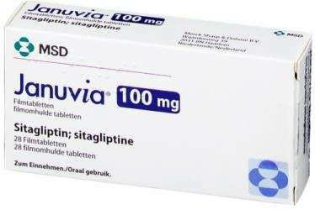 | #Sitagliptin | Antidaibetic
Mechanism
inhibits the activity of DPP-4, an enzyme that inactivates and degrades incretin hormones, cytokines and other peptides. Released in response to meals, incretin hormones potentiate insulin release and decrease glucagon production, lowering serum glucose concentrations. The enzyme dipeptidyl peptidase-4 (DPP-4) begins degrading the GLP-1 and GIP incretins within minutes of their release.
Consequently, GLP-1 and GIP are short-lived, disrupting glucose homeostasis.¹
, thereby prolonging the body’s own action of naturally secreted incretins GLP-1 and GIP.¹
GLP-1 signals to the pancreas to decrease glucagon secretion by pancreatic alpha cells, which decreases hepatic glucose productions.¹
GLP-1 and GIP increase insulin release by signaling the pancreatic beta cells, which increase uptake of glucose by the
muscle, fat, and peripheral tissues.
Jardiance 25-  10 | 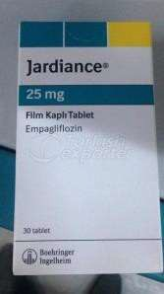 | #Empagiliflozin | Antidaibetic
Mechanism
Empagliflozin works by inhibiting the sodium-glucose co-transporter-2 (SGLT-2) found in the proximal tubules in the kidneys. Through SGLT2 inhibition empagliflozin reduces renal reabsorption of glucose and increases urinary excretion of glucose

Janumet 50\500  50\850  50\1000 | 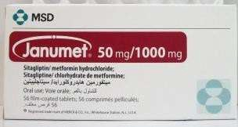 | Sitagliptin Metformin | Antidaibetic
Mechanism
#Sitagliptin inhibits the activity of DPP-4, an enzyme that inactivates and degrades incretin hormones, cytokines and other peptides. Released in response to meals, incretin hormones potentiate insulin release and decrease glucagon production, lowering serum glucose concentrations.
The enzyme dipeptidyl peptidase-4 (DPP-4) begins degrading the GLP-1 and GIP incretins within minutes of their release.
Consequently, GLP-1 and GIP are short-lived, disrupting glucose homeostasis.¹
, thereby prolonging the body’s own action of naturally secreted incretins GLP-1 and GIP.¹
GLP-1 signals to the pancreas to decrease glucagon secretion by pancreatic alpha cells, which decreases hepatic glucose productions.¹
GLP-1 and GIP increase insulin release by signaling the pancreatic beta cells, which increase uptake of glucose by the muscle, fat, and peripheral tissues.#Metformin
in patients with type 2 diabetes mellitus
setting is inhibition of hepatic gluconeogenesis.
Karbalta 30-60  “cymbalta” | 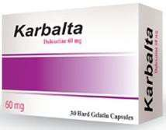 | #Duloxetine | -Antidepressant  -diabetic peripheral neuropathic pain  -generalized anxiety disorder
Mechanism
-serotonin –norepinephrine reuptake inhibitor
-thiophene derivative antidepressant

Keppra  250-500-1000  Oral solution | 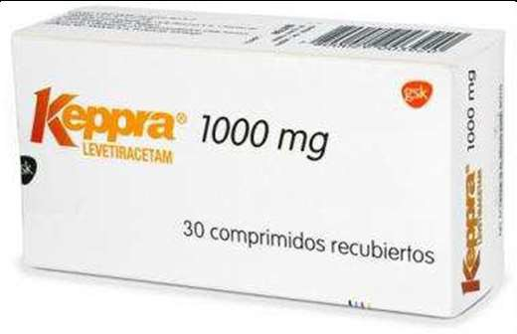 | #Levetiracetam | Ttt epilepsy  anti convulsant neuropathic pain anxiety disorder
Mechanism
Binds to synaptic vesicle protein SV2A which is believed to impede nerve conduction across
synapses
Ketosteril 100 | 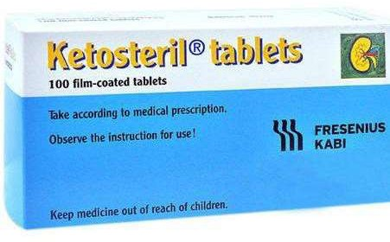 | Combination of alpha ketoanalogue of amino acids (l-lysine+l-threonine+  l-tryptophan+l-histidine+l tryrosine | Prevention and therapy of damages duo to faulty or deficient protein metabolism in chronic renal in sufficiency
Kombiglyze xr 2.5\1000  5\1000 | 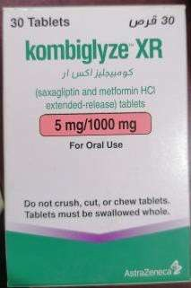 | Saxagliptin + metformin | Antidaibetic
Saxagliptin inhibits the activity of DPP-4, an enzyme that inactivates and degrades incretin hormones, cytokines and other peptides. Released in response to meals, incretin hormones potentiate insulin release and decrease glucagon production, lowering serum glucose concentrations. The enzyme dipeptidyl peptidase-4 (DPP-4) begins degrading the GLP-1 and GIP incretins within minutes of their release.
Consequently, GLP-1 and GIP are short-lived, disrupting glucose homeostasis.¹
, thereby prolonging the body’s own action of naturally secreted incretins GLP-1 and GIP.¹
GLP-1 signals to the pancreas to decrease glucagon secretion by pancreatic alpha cells, which decreases hepatic glucose productions.¹
GLP-1 and GIP increase insulin release by signaling the pancreatic beta cells, which increase uptake of glucose by the muscle, fat, and peripheral tissues.1
Metformin
in patients with type 2 diabetes mellitus
setting is inhibition of hepatic gluconeogenesis.

Lamictal  2-25-50-100 | 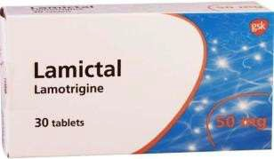 | #Lamotrigine | Anti-epileptic
mechanism
Prolongs the in activation state of
voltage sensitive neuroneal sodium ion channel
Lacovimp 50-100 | 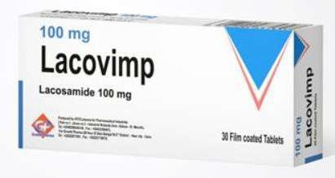 | #Lacosamide | Anti-epileptic
mechanism
Enhances slow inactivation of voltage-gated sodium channel resulting in
Stabilization of repetitive neuronal firing
Lescol xl 80 | 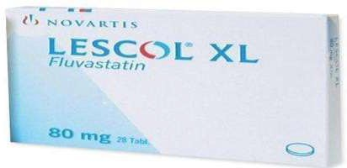 | Fluvastatin
inhibition of HMG-CoA (hydroxymethylglutaryl-coenzyme A) reductase, the rate-limiting enzyme in the cholesterol biosynthesis
pathway
Letrozol 2.5  “femara” | 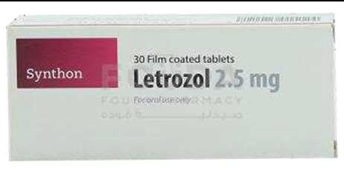 | #Letrozole | -Breast cancer in post-menopausal women  -pre operative ttt in post-menopausal women with localized hormone receptor positive breast cancer  -ttt infertility in women
mechanism
Inhibit aromatase and suppress estrogen production
-promotes the growth and relase of eggs in women who aren’t ovulating on their ovulation induction or super ovulation in women who are able to ovulate
-estrogen levels are suppressed in women .FSH hormone output is increased by the brain and pituitary gland .FSH can result in the development of a mature follicle in the women’s ovary to
ovulate an egg
Levepex  500-1000-750  “keppra” |  | #Levetiracetam | Ttt epilepsy  anti convulsant neuropathic pain anxiety disorder
mechanism
Binds to synaptic vesicle protein SV2A which is believed to impede nerve conduction across
synapses
Lipitor  10-20-40-80 | 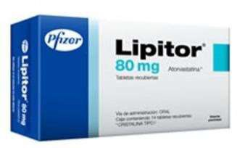 | Atorvastatin

Lustral | 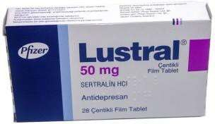 | #Sertrakine | Ttt depression
Mechanism
SSRI
Maddovit a-z | 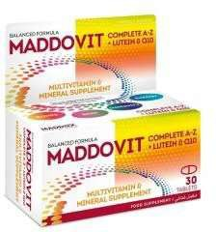 |  | Multivitamins
Mapi | 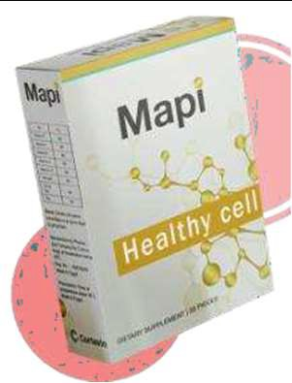 | Vitamin b1 Vitamin b2 Vitamin b3 Vitamin b6 Vitamin b12 Folic acid Fish oil EPA DHA
Mestinon 60 | 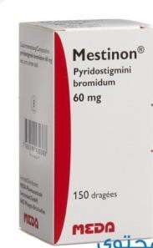 | #Pyridostigmin bromide | Ttt myasthenia gravis and reverse the action of muscle relaxant
Mechanism
Para sympathomimetic and reversible cholinesterase inhibitor
Mellitofix met 12.5l500  12.5l1000  “syNJardy” |  | #Empagliflozin Metformin | Anti-diabetic
Mechanism
#Empagliflozin works by inhibiting the sodium-glucose co-transporter-2 (SGLT-2) found in the proximal tubules in the kidneys. Through SGLT2
inhibition, empagliflozin reduce s renal reabsorption of glucose and increases urinary excretion of glucose
# Metformin
in patients with type 2 diabetes mellitus
Setting is inhibition of hepatic
gluconeogenesis.

Mellitofix 25  10  “JardIaNce” |  | #Empagiliflozin | Anti-diabetic
Mechanism
#Empagliflozin works by inhibiting the sodium-glucose co-transporter-2 (SGLT-2) found in the proximal tubules in the kidneys. Through SGLT2
inhibition, empagliflozin reduce s renal reabsorption of glucose and increases urinary
excretion of glucose
Micaedis plus 40\12.5 plus 80\12.5 | 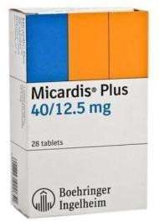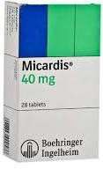 | #Telmisatran Hydroclorothiazide | Anti-hypertensive
Mechanism telmisartan blocks the vasoconstrictor and
aldosterone-secreting effects of angiotensin II by selectively blocking the binding of angiotensin II to the AT1 receptor in many tissues, such
as vascular smooth muscle and the adrenal gland
Micaedis 80  40 | 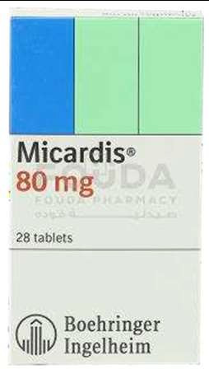 | #Telmisatran | Anti-hypertensive
Mechanism
#Telmisatran blocks the vasoconstrictor and aldosterone-secreting effects of angiotensin II by selectively blocking the binding of angiotensin II to the AT1 receptor in many tissues, such as vascular smooth muscle
and the adrenal gland
Minirin melt 60-120MCG | 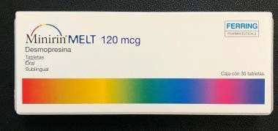 | #Desmopressin | Urinary incontinence antidiuretic
Mechanism
Synthetic analogue of natural pituitary hormone 8-arginine vasopressin ADH antidiuretic hormone

Modasomil 200 | 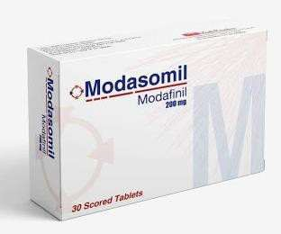 | Modafinil | Wakefulness disorders – narcolepsy  -shift work sleep disorder  -excessive daytime sleepiness
Mechanism
Most research
on modafinil's wake-promoting mechanism has focused on monoaminergic effects
showing modafinil stimulates histamine (HA), norepinephrine (NE), serotonin (5-HT), dopamine (DA), and orexin systems in the brain, but researchers have not been able to isolate a single site
of action or locate major
receptor
Myogrel Myogrel plus | 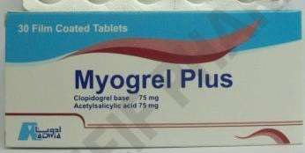 | Clopidogrel + acetylsalicylic acid
Nashilive 5  10 | 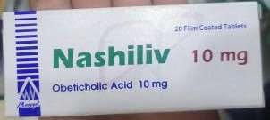 | #Obeticholic acid | To treat primary cholangitis-a type of liver disease that destroys the bile ducts which allows bile to stay in the liver and cause  damage
Mechanism
Suppress the bile acid production in the liver and increase the bile flow
Naviluca 200 | 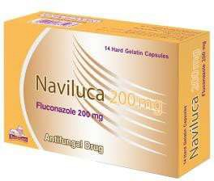 | Fluconazole | Antifungal
Napibradine 5-7.5  “procoralaN ” | 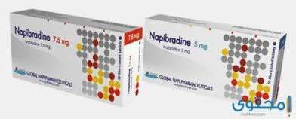 | #Ivabradine | Chronic stable angina in coronary artery disease patient with normal sinus rhythm
- Anti ischemic
-Hart rate lowering agent that works through selective and specific inhibition of cardiac
pacemaker if current

  Nexium 40-20 Vial  Sach |  | Esomeprazole | Ppi
Netlook 10  20  40  “roaccUtaN ” |  | Isotretinoin | Anti acne
Olapex5-10  “zyprexa" | 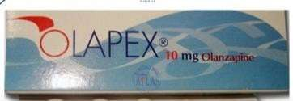 | #Olanzapine | For acute and maintenance  ttt of schizophrenia
Mechanism
The exact mechanism of action of olanzapine is not known. It may work by blocking receptors for several neurotransmitters (chemicals that nerves use to communicate with each other) in the brain. It binds to alpha-1, dopamine, histamine H-1, muscarinic, and serotonin type 2 (5-HT2) receptors
Omnic 0.4 Modified release | 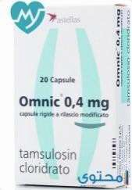 | #Tamsuline | Bhp
Mechanism
Selective alpha 1 adrenergic receptor antagonist
In the prostate
And leads to relaxation of
smooth muscle in the bladder neck and prostate
Omnic ocas 0.4 Prolonged release | 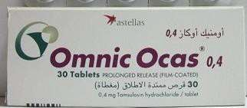 | #Tamsuline | Bhp
Mechanism
Selective alpha 1 adrenergic receptor antagonist
In the prostate
And leads to relaxation of
smooth muscle in the bladder neck and prostate
Omegapress  - MG  - MG | 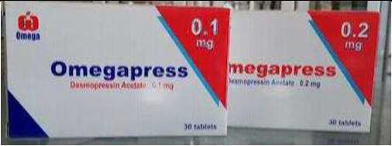 | #Desmopressin | Urinary incontinence antidiuretic
 |  | Synthetic analogue of natural pituitary hormone 8-arginine vasopressin ADH antidiuretic hormone

Ondalenz 8  “zofraN” | 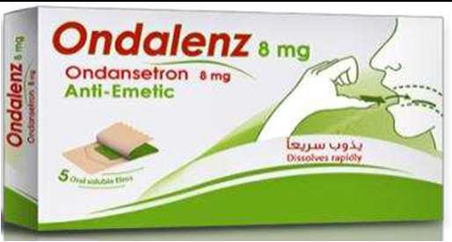 | Ondansteron | Anti-emetic
 |  | Selective serotonin 5 HT3 receptor antagonist
Onbrez breezhaler | 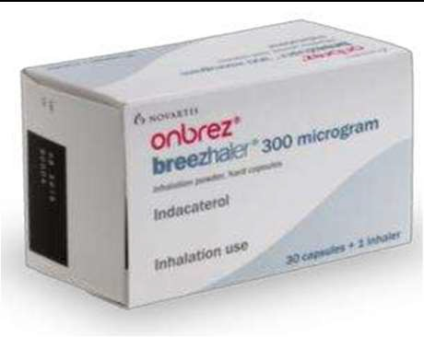 | #Indacaterol | Onbrez Breezhaler is a medicine that is used to keep the airways open in adults with chronic obstructive pulmonary disease (COPD).  COPD is a long-term disease in which the airways and air sacs inside the lungs become damaged or  blocked, leading to difficulty breathing
Mechanism
Acts locally in the lung as a bronchodilator. Indacaterol is a partial agonist at the human beta2-adrenergic receptor with Nano molar potency. In isolated human bronchus, indacaterol has a rapid onset of action and a long duration of action
Onglyza | 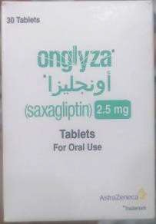 | #Saxagliptin
inhibits the activity of DPP-4, an enzyme that inactivates and degrades incretin hormones, cytokines and other peptides. Released in response to meals, incretin hormones potentiate insulin release and decrease glucagon production, lowering serum glucose concentrations. The enzyme dipeptidyl peptidase-4 (DPP-4) begins degrading the GLP-1 and GIP incretins within minutes of their release. Consequently, GLP-1 and GIP are short-lived, disrupting glucose homeostasis.¹
, thereby prolonging the body’s own action of naturally secreted incretins GLP-1 and GIP.¹
GLP-1 signals to the pancreas to decrease glucagon secretion by pancreatic alpha cells, which decreases hepatic glucose productions.¹
GLP-1 and GIP increase insulin release by signaling the pancreatic beta cells, which increase uptake of glucose by the muscle, fat, and
peripheral tissues.

Optaminess 100  150  200 | 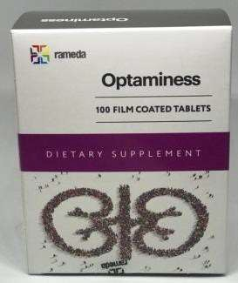 |  | Dietary supplement the diet of hemodialysis patient with essential amino acids
Orgoroxaban 10-20  “xatrelto” | 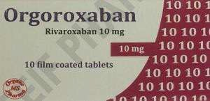 | #Rivaroxaban | -reduce the risk of stroke and serious blood clots in certain patients with atrial fibrillation  - ttt and prevent DVT which can lead to blood clots in the lung – pulmonary embolism-
Mechanism
- Anti platelet
-direct factor XA inhibitor
-blocks the formation of blood clots
Factor Xa is generated by both the extrinsic and intrinsic coagulation pathways and is responsible for activating
prothrombin to thrombin
Oseltamiver  “tamIflU” | 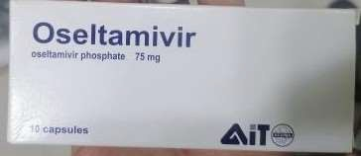 | # Oseltamiver
Pariet 20-10 | 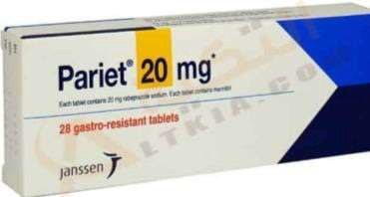 | Aripeprazol | Ppi
Pentaza Tab  Sup | 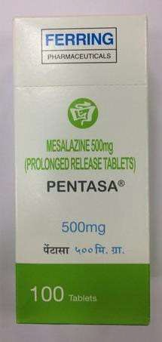 | #Mesalazine | -ulcerativ colitis  -crohns disease  -proctitis b and proctosigmoiditis-used only suppositories=
Mechanism
Exerts its anti-inflammatory action by inhibiting
lipoxy genase enzyme this will lead to decrease the production of pro inflammatory leukotrienes and 5 hydroxy eicosa tetre enoic acid in the intestinal wall
-it inhibits the production of inflammatory mediators like interleukin1 –tumor nicrosis factor

Piascledine 300 | 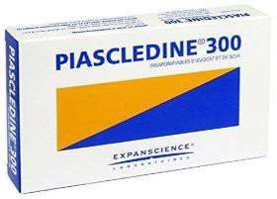 | #Avocado oil soya bean oil | joint arthritis
Mechanism
Block the bro inflammatory chemicals
Prevents the deterionation of synovial cells(which)line the joints)
May help regenerate normal
connective tissue
Pixaspire 2.5-5  “elIqUIs” | 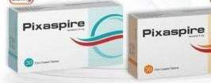 | #Apixaban | -DVT prophylaxis  -DVT may lead to pulmonary embolism – PE-in knee or lip replacement surgery  -ttt both DVT and PE  -to lower the risk of stroke and embolism in patient with non  valvular atrial fibrillation
Mechanism
- Anti co agulant
-direct factor xa inhibitor Factor Xa is generated by both the extrinsic and intrinsic coagulation pathways and is responsible for activating prothrombin to thrombin
Pivastalo 1-2-4 | 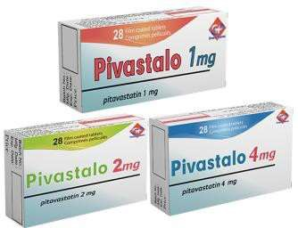 | #Pivastatin
Mechanism
Completely inhibits HMG CoA reductase, the rate-determining enzyme in hepatic cholesterol synthesis.
Consequently, LDL-C receptors in the liver are increased, thereby increasing the removal of LDL-C from the
blood
Pixclot 2.5  “elIqUIs” | 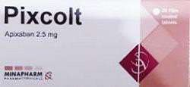 | #Apixaban | DVT prophylaxis  -DVT may lead to pulmonary embolism – PE-in knee or lip replacement surgery  -ttt both DVT and PE  -to lower the risk of stroke and embolism in patient with non valvular atrial fibrillation
Mechanism
- Anti co agulant
-direct factor xa inhibitor Factor Xa is generated by both the extrinsic and intrinsic coagulation pathways and is responsible for activating prothrombin to thrombin

Pletaal 50-100 | 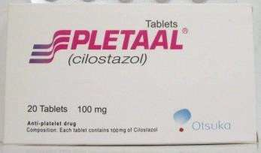 | #Clostazol | Antiplatlet
Mechanism
selective inhibitor of phosphodiesterase type 3 With therapeutic focus on increasing cAMP. An increase in cAMP results in an increase in the active form of protein kinase A(PKA), which is directly related with an inhibition in platelet aggregation. PKA also prevents the activation of an enzyme (myosin light-chain kinase) that is important in the contraction of smooth muscle cells, thereby exerting its vasodilatory effect.
Plavidamol 75  “plavIx” | 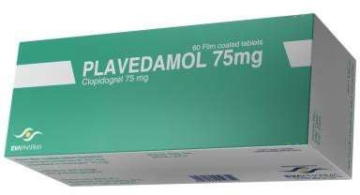 | #clopidogril | used to reduce the risk of myocardial infarction and stroke or established peripheral arterial  disease
Plavix 75 | 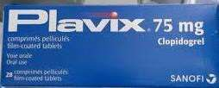 | #clopidogril | used to reduce the risk of myocardial infarction and stroke  or established peripheral arterial disease

Prandaglim 25-6-25 | 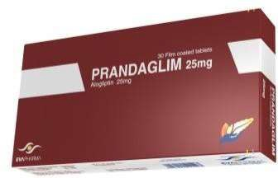 | #Alogliptin | Anti-diabetic
Mechanism
inhibits the activity of DPP-4, an enzyme that inactivates and degrades incretin hormones, cytokines and other peptides. Released in response to meals, incretin hormones potentiate insulin release and decrease glucagon production, lowering serum glucose concentrations. The enzyme dipeptidyl peptidase-4 (DPP-4) begins degrading the GLP-1 and GIP incretins within minutes of their release. Consequently, GLP-1 and GIP are short-lived, disrupting glucose homeostasis.¹
, thereby prolonging the body’s own action of naturally secreted incretins GLP-1 and GIP.¹
GLP-1 signals to the pancreas to decrease glucagon secretion by pancreatic alpha cells, which decreases hepatic glucose productions.¹
GLP-1 and GIP increase insulin release by signaling the pancreatic beta cells, which increase uptake of glucose by the muscle, fat, and
peripheral tissues.
Pradaxa 75  110  150 | 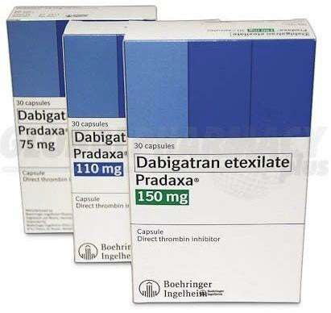 | #Dabigatran | used to prevent stroke and harmful blood clots (such as in your legs  or lunges l) if you have a certain type of irregular heartbeat atrial fibrillation)  . Dabigatran is also used to treat blood clots in the veins of your legs (deep vein thrombosis)  or lungs (pulmonary embolism) and to reduce the risk of them occurring again.  This medication may also be used to prevent these blood clots from forming after hip replacement surgery.
Mechanism
Reversibly binds to the active site on the thrombin molecule, preventing thrombin-mediated activation of coagulation factors.

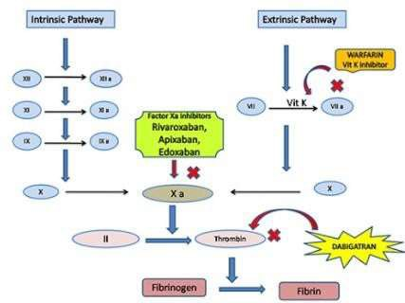

Pregnacare | 
Procoralan 5-7.5 | 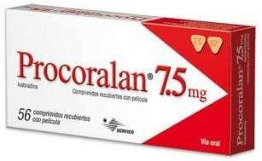 | #Ivabradine | Chronic stable angina in coronary artery disease patient with normal sinus rhythm
Mechanism
- Anti ischemic
-Hart rate lowering agent that works through selective and specific inhibition of cardiac
pacemaker if current
Proscar 5 | 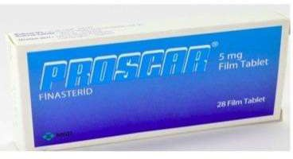 | #Finasteride | used to shrink an enlarged prostate (benign prostatic hyperplasia or BPH) in adult men
Mechanism
Blocks the action of an enzyme called 5-alpha-reductase. This enzyme changes testosterone to another hormone that causes the prostate to grow It will increase testosterone levels in the body, which decreases prostate size
Prostride 5  “proscar” | 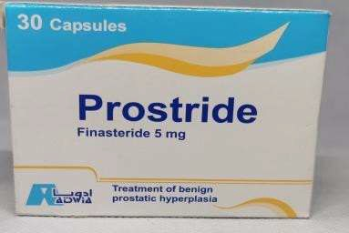 | #Finasteride | used to shrink an enlarged prostate (benign prostatic hyperplasia or BPH) in adult men
Mechanism
Blocks the action of an enzyme called 5-alpha-reductase. This enzyme changes testosterone to another hormone that causes the prostate to grow It will increase testosterone levels in
the body, which decreases prostate size
Quetiazic  xr 50- xr150 xr300- xr400  “seroqUel” | 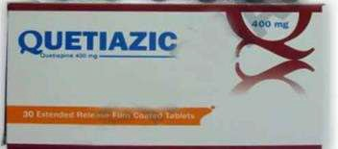 | Mechanism  #Quetiapine  Second-generation antipsychotic that has affinity for D2, 5-HT2A, H1, alpha 1 and 5-HT1A receptors. Its precise mechanism of action is unknown, but according to the dopamine theory of schizophrenia, antipsychotic effects might be related to the drug’s ability to reduce dopaminergic neurotransmission  in the mesolimbic pathway. | used to treat certain mental/mood conditions (such  as schizophrenia, bipolar disorder sudden episodes of mania or depression associated with bipolar disorder

Quetaoine 25  100  200  “seroqUel” | 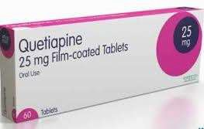 | Mechanism  #Quetiapine  Second-generation antipsychotic that has affinity for D2, 5-HT2A, H1, alpha 1 and 5-HT1A receptors. Its precise mechanism of action is unknown, but according to the dopamine theory of schizophrenia, antipsychotic effects might be related to the drug’s ability to reduce dopaminergic neurotransmission in the  mesolimbic pathway. | used to treat certain mental/mood conditions (such  as schizophrenia, bipolar disorder sudden episodes of mania or depression associated with bipolar disorder
Quitapex 25  100  200  300  400  “seroqUel” | 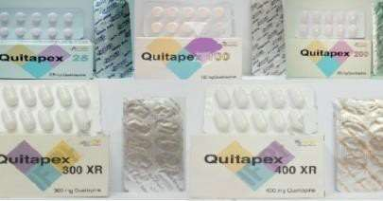 | Mechanism #Quetiapine Second-generation  antipsychotic that has affinity for D2, 5-HT2A, H1, alpha 1 and 5-HT1A receptors. Its precise mechanism of action is unknown, but according to the dopamine theory of schizophrenia, antipsychotic effects might be related to the drug’s ability to reduce dopaminergic neurotransmission in the mesolimbic pathway. | used to treat certain mental/mood conditions (such  as schizophrenia, bipolar disorder sudden episodes of mania or depression associated with bipolar disorder
Quitcool 50-200-300  “seroqUel” | 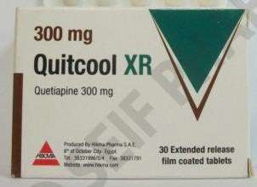 | Mechanism #Quetiapine Second-generation  antipsychotic that has affinity for D2, 5-HT2A, H1, alpha 1 and 5-HT1A receptors. Its precise mechanism of action is unknown, but according to the dopamine theory of schizophrenia, antipsychotic effects might be related to the drug’s ability to reduce dopaminergic neurotransmission in the mesolimbic pathway. | used to treat certain mental/mood conditions (such  as schizophrenia, bipolar disorder sudden episodes of mania or depression associated with bipolar disorder

Ravemantine 10  “ebIxa” | 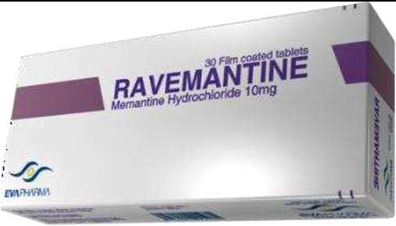 | # Memantine | Antidementia agent in Alzheimer disease
Mechanism
n-methyl –d-aspartate receptor antagonist (NMDA)
-dopamine d2 agonist
-xss glutamate plays a role in neural cell death
Revolade 25-50 | 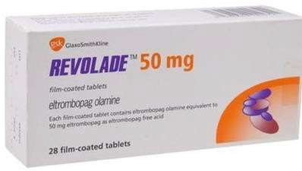 | eltrombopag | Ttt primary immune thrombocytopenia (ITP), a disease in which the  patient's immune system destroys platelets. Patients with ITP have low platelet counts in the blood (thrombocytopenia) and are at risk  of bleeding
Resolor 1-2 | 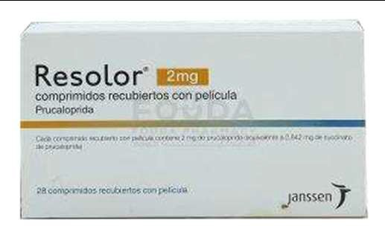 | #Prucalopride | Ttt chronic constipation
Mechanism
selective height affinity serotonin receptor agonist which targets the impaired motility associated with chronic constipation thus normalize bowel movement
-it stimulates colonic mass movement
Recoxibright 30-60-90-120  “arcoxIa” | 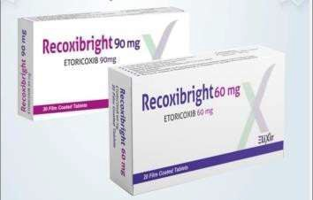 | #Etoricixib | -Rheumatoid arthritis  -acute pain  -gout  -chronic low back pain  -osteoarthritis  -ankylosing spondylitis
Mechanism
selective co2 inhibitor
Risperdal 2  4  Solution Consta 25  Consta 37.5 | 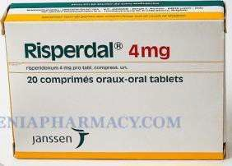 | #Risperidone | Antipychotic
Mechanism
-block dopamine and serotonin receptors
-has antagonistic action on alpha
adrenergic and histaminic receptor

Rivarospire 2.5-10-15-20  “xarelto” | 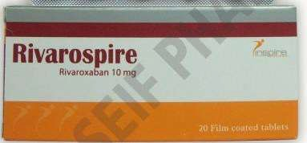 | #Rivaroxaban | -Reduce the risk of stroke and serious blood clots in certain patients with atrial fibrillation  - ttt and prevent DVT which can lead to blood clots in the lung – pulmonary embolism-
Mechanism
- Anti platelet
-direct factor XA inhibitor
-blocks the formation of blood clots
Factor Xa is generated by both the extrinsic and intrinsic coagulation pathways and is responsible for activating prothrombin to thrombin
Roaccutan 10-20 | 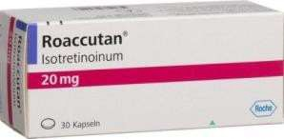 | Isotretinoin | Anti-acne
Roaccutrex 10-20-40  “roaccUtaN ” | 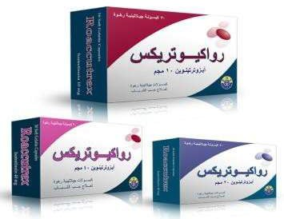 | Isotretinoin | Anti-acne
Sandimmune-neoral  25  50  100 | 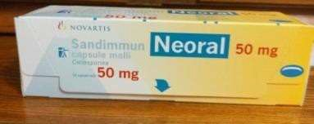 | Cyclosporine  Its major mode of action is inhibition of the production of cytokines involved in the regulation of T-cell activation.  In  particular, cyclosporine inhibits the transcription of interleukin 2. | used to prevent organ rejection after a kidney, heart, or liver transplant. This medicine is also used to treat severe psoriasis or severe rheumatoid arthritis
Seebri beezhaler | 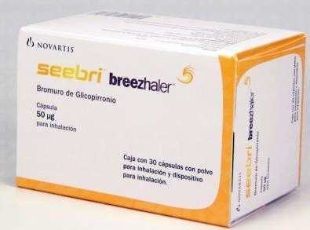 | #glycopyronium | Seebri Breezhaler is indicated as a maintenance bronchodilator treatment to relieve symptoms in adult patients with chronic obstructive pulmonary disease (COPD).  Posology The recommended dose is the inhalation of the content of one capsule once  daily using the Seebri  Breezhaler inhaler
 |  | Works by blocking the bronchoconstrictor action of acetylcholine on airway smooth muscle cells thereby dilating the airways. Of the five known muscarinic receptor subtypes (M1-5), only subtypes M1-3 have a defined physiological function in the human lung.

Seretide diskus 100l50  250l50  500l50 | 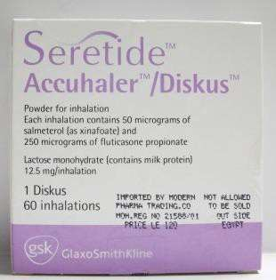 | salmeterol and fluticasone | asthma and chronic obstructive pulmonary disease (COPD) in people who need regular treatment
Seroquel  25-100-200-  Xr 50- Xr 200-  Xr 300- Xr 400 | 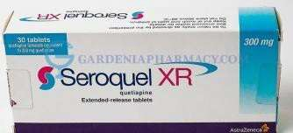 | Mechanism #Quetiapine Second-generation  antipsychotic that has affinity for D2, 5-HT2A, H1, alpha 1 and 5-HT1A receptors. Its precise mechanism of action is unknown, but according to the dopamine theory of schizophrenia, antipsychotic effects might be related to the drug’s ability to reduce dopaminergic neurotransmission in the mesolimbic pathway. | used to treat certain mental/mood conditions (such  as schizophrenia, bipolar disorder sudden episodes of mania or depression associated with bipolar disorder
Singulair 4  5  10 | 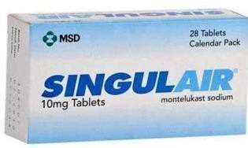 | # Montelukast | By blocking leukotrienes, Singulair improves asthma sym ptoms, helps  control asthma and improves seasonal allergy symptoms (also known as hay fever or seasonal allergic rhinitis). Your doctor has prescribed Singulair to  treat asthma, preventing  your asthma symptom s during the day and  night
 |  | Montelukast is in the leukotriene receptor antagonist family of medications. It works by blocking the action of leukotriene D4 in the lungs resulting in decreased inflammation and relaxation of smooth muscle
Sifrol 0.18  0.7 | 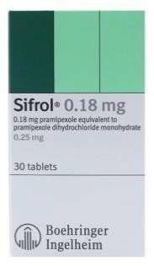 | #Pramipexol | to treat  the symptoms of Parkinson's disease
Mechanism
presynaptic D2 and D3 dopamine auto receptors and suppresses the synthesis and synaptic release of dopamine

Solian 200-400 | 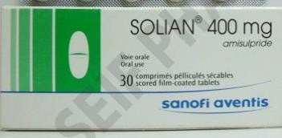 | #Amisulpride | Antispychotics
Mechanism
amisulpride binds selectively to dopamine D2, D3 receptors in the limbic system
thereby enhancing
dopaminergic transmission
Spiriva 18 inh Spiriva  respimat 2.5 | 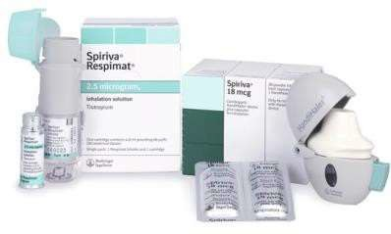 | #tiotropium bromide | -chronic obstructive pulmonary disease(COPD)  -bronchospasm  -chronic bronchitis  -emphysema
Mechanism Anticholinergic (muscarinic antagonist)
-bronchodilator
Strattera 10  18  25  40  60 | 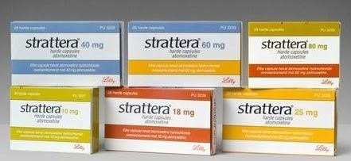 | #atomoxetine | Ttt of ADHD Attention deficit hyperactivity disorder
Mechanism
Selective inhibition of presynaptic norepinephrine reuptake in the prefrontal cortex. Atomoxetine has a high affinity and selectivity for norepinephrine transporters, but little or no affinity for
various neurotransmitter receptors
Starkoprex 5-  20 | 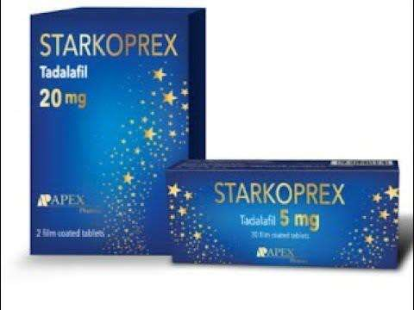
Strakopena 2.5-5 | 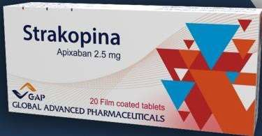 | #Apixaban | -DVT prophylaxis  -DVT may lead to pulmonary embolism – PE-in knee or lip replacement surgery  -ttt both DVT and PE  -to lower the risk of stroke and embolism in patient with non  valvular atrial fibrillation
Mechanism
- Anti co agulant
-direct factor xa inhibitor
Stroka75  “plavIx” |  | #clopidogril | used to reduce the risk of myocardial infarction and stroke  or established peripheral arterial disease

Symbicort 80l4.5  160l4.5  320l9 | 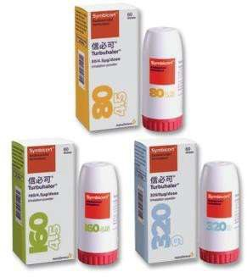 | #Budesonide | Symbicort is used to control and prevent the symptoms of asthma in adults and children at least 6 years old. Symbicort is also used to help control the symptoms of chronic obstructive pulmonary disease (COPD), including chronic bronchitis and emphysema
Mechanism
Budesonide is an inhaled corticosteroid (ICS) that works by reducing and preventing respiratory tract inflammation, formoterol is a long-acting beta2-agonist bronchodilator (LABA) that decreases resistance in the
respiratory airway and increases airflow to the lungs
Sympaprost8 | 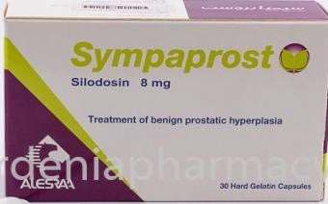 | #Silodosin | Ttt urination difficulty in benign prostatic hyperplasia
Mechanism
Alpha 1 a blocker
Synjardy 12.5l1000  12.5l850  5l1000  5l850 | 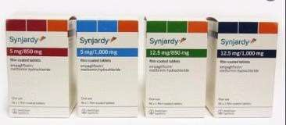 | Empagliflozin  Metformin | Anti diabetic
Mechanism
#Empagliflozin works by inhibiting the sodium-glucose co-transporter-2 (SGLT-2) found in the proximal tubules in the kidneys. Through SGLT2
inhibition, empagliflozin reduce s renal reabsorption of glucose and increases urinary excretion of glucose
Metformin
in patients with type 2 diabetes mellitus
setting is inhibition of hepatic
gluconeogenesis.
Tareg 40  80  160  320 | 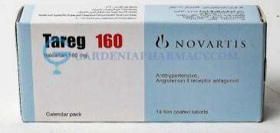 | #valsartan | Anti-hyper tension
Tecavir 0.5-1 | 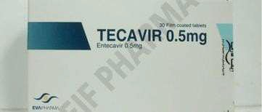 | Entecavir | Ttt chronic hepatitis b virus
Mechanism
Entecavir is a nucleoside analog, or more specifically, a deoxyguanosine analogue that belongs to a class of carbocyclic nucleosides and inhibits reverse transcription, DNA replication and
transcription in the viral replication process

Tenaviron 300 | 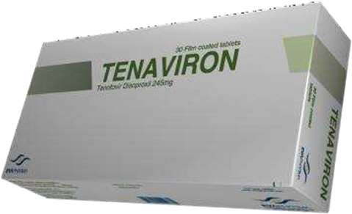 | #tenafovir disoproxil | Tenofovir is used with other HIV medications to help  control HIV infection. It helps to decrease the amount of HIV in your body so your immune system can work better. This lowers your chance of  getting HIV complicati ons (such as  new infections,  cancer) and improves your quality of life
Mechanism
tenofovir interferes with an enzyme called reverse transcriptase, which is used by HIV-infected cells to make new viruses.
Since tenofovir inhibits, or reduces, the activity of this enzyme, this drug causes HIV-infected cells to slow down or stop producing new viruses
Thrombonorm | 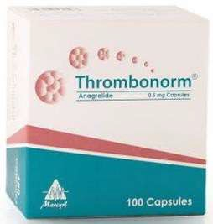 | #Anagrelide | Anagrelide is used to treat a certain blood disorder (thrombocythemia), which is caused by your bone marrow making too many platelets. Platelets are a blood cell that the body uses to form blood clots. Too many platelets can cause problems with your circulation, including unwanted blood clots and bleeding problems
Mechanism
Anagrelide works by inhibiting the maturation of platelets from megakaryocytes. The exact mechanism of
action is unclear, although it is known to be a phosphodiesterase inhibitor. It is a potent (IC50 = 36nM) inhibitor of phosphodiesterase-II. It inhibits PDE-3 and phospholipase A2
Anagrelide is in a class of medications called platelet-reducing agents. It works by slowing the production of platelets in the body

Anagrelide is not
a chemotherapy drug; however, some hospitals classify anagrelide as a form
of chemotherapy because it interferes with cell development, and the prescribing regulations are similar to those governing a chemotherapy drug

Thrombolinta 90  “brIlIqUe” | 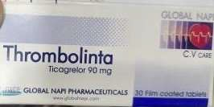 | #Ticagrelor | -reducing the risk of stroke heart attack  -or death in certain patient who have had a heart attack or who have angina (chest pain)  -it should be used along with asprin as directed  by your doctor
Mechanism
Platelet aggregation inhibitor Works by slowing or stopping platelet from sticking to blood vessel walls or injured tissues
Topamax 15  25  50  100 | 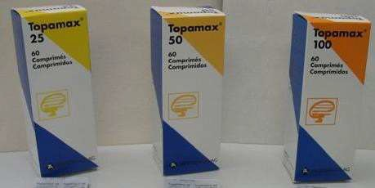 | #Topiramate | used to treat epilepsy. These are also called anti-  epileptic medicines. It can also be taken to prevent migraine
blocks voltage-dependent sodium and calcium channels. It also inhibits the excitatory glutamate pathway while enhancing the inhibitory effect of GABA. Moreover, it inhibits
carbonic anhydrase activity.
Trileptal 600-  300 | 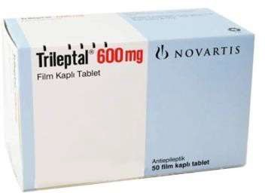 | #oxcarbazepine | Anticonvulsants  to control certain types of seizures in adults a nd children 6 years of age and older.
is a sodium channel blocker. It binds preferentially to voltage-gated sodium channels in their inactive conformation, which prevents repetitive and sustained firing of
an action potential
Trio clar | 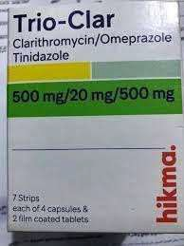 | Tinidazole Clarithromycin Omeprazole | Ttt h pylori
Tiratam 500  500xr 750  1000  Vial Oral  suspension | 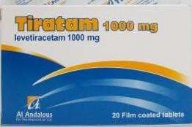 | #Levetiracetam | Ttt epilepsy  anti convulsant neuropathic pain anxiety disorder
Mechanism
Binds to synaptic vesicle protein SV2A which is believed to impede nerve conduction across synapses

Trajenta 5 | 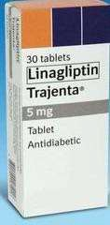 | #linagliptin | treat type 2 diabetes
inhibits the activity of DPP-4, an enzyme that inactivates and degrades incretin hormones, cytokines and other peptides. Released in response to meals, incretin hormones potentiate insulin release and decrease glucagon production, lowering serum glucose concentrations. The enzyme dipeptidyl peptidase-4 (DPP-4) begins degrading the GLP-1 and GIP incretins within minutes of their release. Consequently, GLP-1 and GIP are short-lived, disrupting glucose homeostasis.¹
, thereby prolonging the body’s own action of naturally secreted incretins GLP-1 and GIP.¹
GLP-1 signals to the pancreas to decrease glucagon secretion by pancreatic alpha cells, which decreases hepatic glucose productions.¹
GLP-1 and GIP increase insulin release by signaling the pancreatic beta cells, which increase uptake of glucose by the muscle, fat, and
peripheral tissues.
Tiralepsy  250-500-1000  Xr 500-750-  oralsolution | 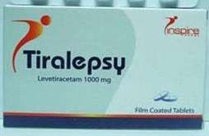 | #Levetiracetam | Ttt epilepsy  anti convulsant neuropathic pain anxiety disorder
Mechanism
Binds to synaptic vesicle protein SV2A which is believed to impede nerve conduction across
synapses
Twynsta 80l5  80l10 | 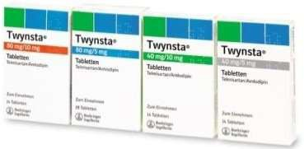 | #Telmisatran Amlodipine | Anti-hyper tensive

ultibro | 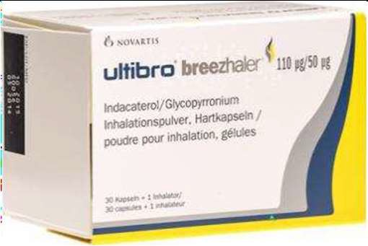 | # indacaterol | Indacaterol inhalation is used to  control wheezing, shortness of breath, coughing, and chest tightness caused  by chronic obstructive pulmonary  disease (COPD; a group of diseases that affect the lungs and airways, which includes  chronic bronchitis and  emphysema)
Mechanism
a long-acting beta-2 agonist producing bronchodilation by stimulation of intracellular adenyl cyclase. glycopyrronium, a long-acting muscarinic antagonist/anticholinergic that provides bronchodilation by blocking the action of acetylcholine on the muscarinic receptors of airway smooth muscle cells
Valtrex 500 | 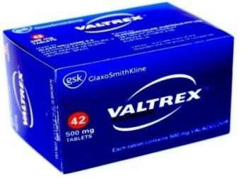 | # Valacyclovir | i s used to  treat herpes virus infections,  including herpes labial is (also known as cold sores), herpes  zoster (also known as shingles),  and herpes  simplex (also known as genital herpes) in adults. It is also used to  treat chickenpox and  cold sores in children
Mechanism
Is converted to acyclovir, which is converted to its triphosphate form, acyclovir triphosphate (ACV-TP). ACV-TP competitively inhibits viral DNA polymerase, incorporates into and terminates the growing viral DNA chain, and inactivates of the viral DNA polymerase
Vaxato 10-15-20 | 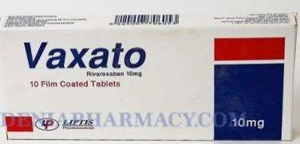 | #Rivaroxaban | -reduce the risk of stroke and serious blood clots in certain patients with atrial fibrillation  - ttt and prevent DVT which can lead to blood clots in the lung – pulmonary embolism
Mechanism
- Anti platelet
-direct factor XA inhibitor
-blocks the formation of blood clots
Factor Xa is generated by both the extrinsic and intrinsic coagulation pathways and is responsible for activating prothrombin to thrombin

Vesicare 10-5 | 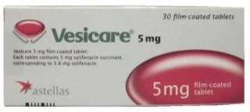 | # Solifenacin | is used to treat overactive bladder (a condition in which the bladder muscles contract uncontrollably and cause frequent urination, urgent need to urinate, and inability to control urination)
Mechanism
is a competitive muscarinic receptor antagonist.
Muscarinic receptors play an important role in several major cholinergically mediated functions, including contractions of urinary bladder smooth muscle and stimulation
of salivary secretion
Vfend 200 | 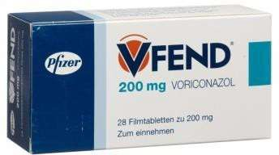 | Voriconazol | Ttt of esophageal candidiasis invasive pulmonary aspergillosis  -ttt serious fungal infections caused by scedosporium apiospermum and  fusarium spp
Visanne 2 |  | #Dienogest | - contraceptive  -Progestins reduce the effects of estrogen on tissues such as  the endometrium (lining of the uterus) and the breast. By reducing the growth effect of estrogen on the endometrium, dienogest helps to reduce the pelvic pain experienced by women with endometriosis. Endomet riosis is a condition where endometrium-like tissue is found outside the uterus, which causes chronic inflammation.
Mechanism
Dienogest belongs to the class of medications called progestins, medications that act like progesterone in the body

Dienogest acts on endometriosis by reducing the endogenous production of estradiol and thereby suppressing the trophic effects of estradiol on both the eutopic and ectopic endometrium

Vildagluse | 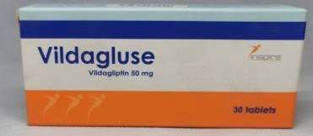 | #Vildagliptin | Anti-diabetic
Mechanism
inhibits the activity of DPP-4, an enzyme that inactivates and degrades incretin hormones, cytokines and other peptides. Released in response to meals, incretin hormones potentiate insulin release and decrease glucagon production, lowering serum glucose concentrations. The enzyme dipeptidyl peptidase-4 (DPP-4) begins degrading the GLP-1 and GIP incretins within minutes of their release. Consequently, GLP-1 and GIP are short-lived, disrupting glucose homeostasis.¹
, thereby prolonging the body’s own action of naturally secreted incretins GLP-1 and GIP.¹
GLP-1 signals to the pancreas to decrease glucagon secretion by pancreatic alpha cells, which decreases hepatic glucose productions.¹
GLP-1 and GIP increase insulin release by signaling the pancreatic beta cells, which increase uptake of glucose by the muscle, fat, and
peripheral tissues.
Vildagluse plus 50l1000 | 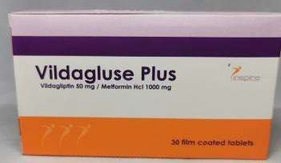 | Vildagliptin Metformin | Anti diabetic
Mechanism
#Vildagliptin binds covalently to the catalytic site of DPP-4, eliciting prolonged enzyme inhibition. This raises intact GLP-1 levels, both after meal ingestion and in the fasting state. Vildagliptin has been shown to stimulate insulin secretion and inhibit glucagon secretion in a glucose-dependent manner #Metformin
in patients with type 2 diabetes mellitus
setting is inhibition of hepatic gluconeogenesis.

Xarelto  2.5-10-20-15 | 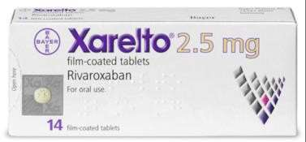 | #Rivaroxaban | -reduce the risk of stroke and serious blood clots in certain patients with atrial fibrillation  - ttt and prevent DVT which can lead to blood clots in the lung – pulmonary embolism-
Mechanism
- Anti platelet
-direct factor XA inhibitor
-blocks the formation of blood clots
Factor Xa is generated by both the extrinsic and intrinsic coagulation pathways and is responsible for activating prothrombin to thrombin

Xanoxiban 2.5-10-15-20 | 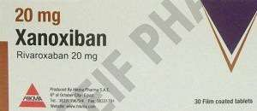 | #Rivaroxaban | -reduce the risk of stroke and serious blood clots in certain patients with atrial fibrillation  - ttt and prevent DVT which can lead to blood clots in the lung – pulmonary embolism-
Mechanism
- Anti platelet
-direct factor XA inhibitor
-blocks the formation of blood clots
Factor Xa is generated by both the extrinsic and intrinsic coagulation pathways and is responsible for activating
prothrombin to thrombin
Xeloda | 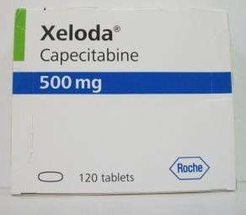 | # Capecitabine | is a prescription medicine used to treat the symptoms of cancers such as Colon Cancer, Colorectal Cancer and Breast  Cancer. Xeloda may be used alone or with other medications.
Mechanism
is relatively non-cytotoxic in vitro. This drug is enzymatically converted to 5-fluorouracil (5-FU) in
vivo. Mechanism of Action: Both normal and tumor cells metabolize 5-FU to 5-fluoro-2-deoxyuridine monophosphate (FdUMP) and 5-fluorouridine triphosphate (FUTP)
-Xeloda belongs to a class of drugs called Antineoplastics, Antimetabolite.

Xenical 120 | 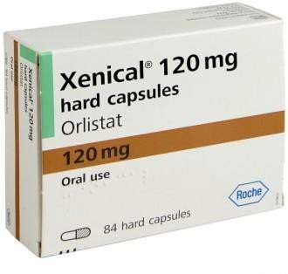 | # orlistat | It is used by certain overweight people, such as those who are obese or have weight-related medical problems.  Taking orlistat can also help keep you from gaining back weight you have lost
Mechanism
Acts by reversibly inhibiting the gastric and pancreatic lipases. These lipases have an important role in the digestion of dietary fat. They work by breaking down the triglycerides into absorbable free fatty acids and monoglycerides
Zeffix100 | 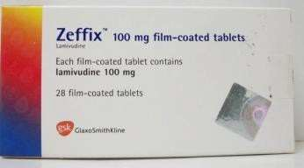 | #Lamivudine | Used to treat hepatitis B infection.  Lamivudine is in a class  of medications called nucleoside reverse transcriptase inhibitors (NRTIs). It works by decreasing the amount  of HIV and hepatitis B in the blood
Mechanism
is an analogue of cytidine. It can inhibit both types (1 and 2) of HIV reverse transcriptase and also the reverse transcriptase of hepatitis B virus. It is phosphorylated to active metabolites that compete for incorporation into viral DNA
Zofran 8 | 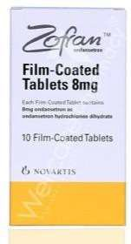 | Ondansteron | Anti-emetic
 |  | Selective serotonin 5 HT3 receptor antagonist
Zyprexa 10 velotab  10-5-7.5 | 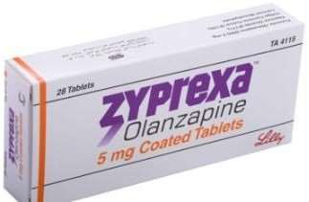  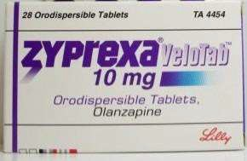 | Olazapine | For acute and maintenance  ttt of schizophrenia
The xact mechanism of action of olanzapine is not known. It may work by blocking receptors for several neurotransmitters (chemicals that nerves use to
communicate with each other) in the brain. It binds to alpha-1, dopamine, histamine H-1, muscarinic, and serotonin type 2 (5-HT2) receptors

