 Cairo university Faculty of Engineering

Embedded systems project:

TicTacToe

Presented by:

CodeCrafters

|  |  |  |
| --- | --- | --- |
| Name | SEC. | ID |
| Mohammed Mohsen | 3 | 9220737 |
| Mahmoud Omar | 3 | 9220787 |
| Mohammed Hashim | 3 | 9220748 |
| Mohammed Hisham | 3 | 9221105 |
| Abd ElRahman Badawy | 2 | 9220426 |

Software Design Specification (SDS)

Contents

1. Introduction 3

2. System Architecture 3

3. Detailed Design 4

4. Data Design 10

5. User Interface Design 10

6. Detailed flowchart of overall system 11

### 1. Introduction

#### 1.1 Purpose

The purpose of this Software Design Specification (SDS) is to provide detailed design information for the implementation of the TicTacToe game application. This document serves as a guide for developers to ensure a well-structured and maintainable codebase.

#### 1.2 Scope

This SDS covers the software architecture, detailed class and sequence diagrams, data design, and user interface design for the TicTacToe game application.

#### 1.3 Definitions, Acronyms, and Abbreviations

* SDS: Software Design Specification
* UML: Unified Modeling Language
* GUI: Graphical User Interface
* AI: Artificial Intelligence

#### 1.4 Overview

The TicTacToe game application includes user authentication, profile management, game play, and history tracking functionalities. This document details the design and architecture to support these features.

### 2. System Architecture

#### 2.1 High-Level Architecture

The TicTacToe game application follows a client-server architecture where the client is a Qt-based desktop application and the server manages user authentication, profile data, and game history. The application components include:

* **User Interface (UI)**: Provides the graphical interface for user interaction.
* **Authentication Module**: Handles user registration and login.
* **Profile Management Module**: Manages user profile data.
* **Game Logic Module**: Implements the TicTacToe game logic.
* **History Management Module**: Tracks and displays game history.

#### 2.2 Component Description

* **MainWindow**: The main entry point of the application containing tabs for Profile, Game, and History.
* **SignInPage**: Manages user login.
* **SignUpPage**: Manages user registration.
* **ProfilePage**: Displays and allows editing of user profile information.
* **GamePage**: Contains the TicTacToe game board and controls.
* **HistoryPage**: Displays a list of past games and their outcomes.
* **User**: Represents the user entity with personal information and game statistics.
* **Game**: Manages game state and logic.
* **Player**: Represents a player in the game, which can be a human or an AI.

### 3. Detailed Design

#### 3.1 Class Diagrams

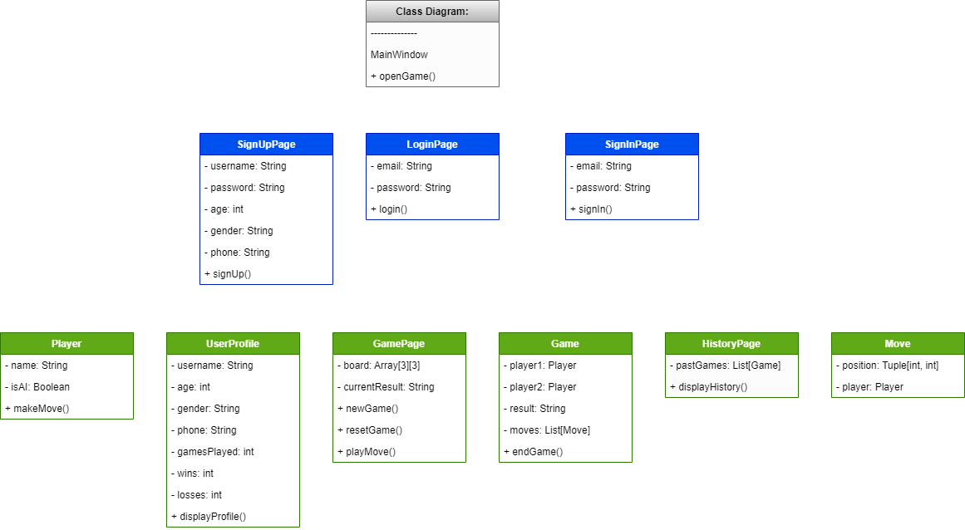

#### 3.2 Sequence Diagrams

##### 3.2.1 User Registration

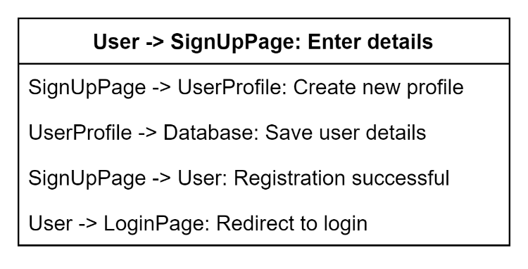

##### 3.2.2 User Login

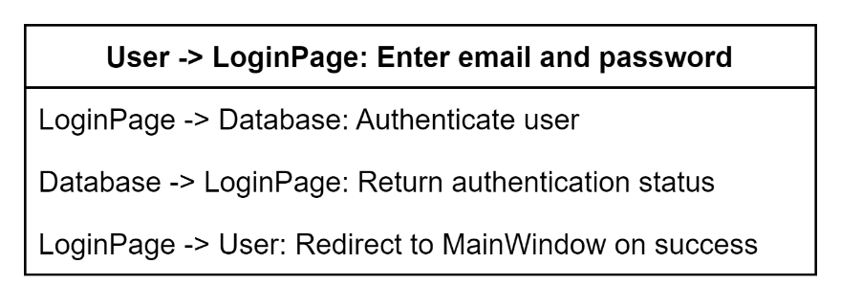

##### 3.2.3 Playing a Game

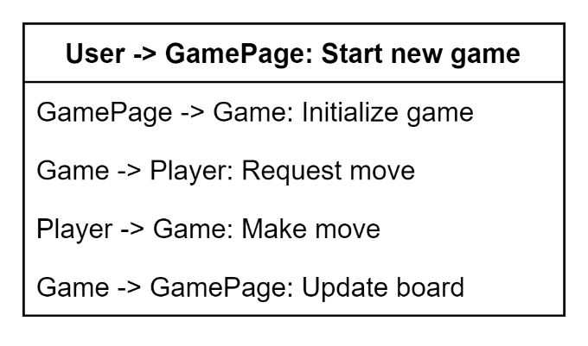

##### 3.2.4 overall diagram for an AI opponent

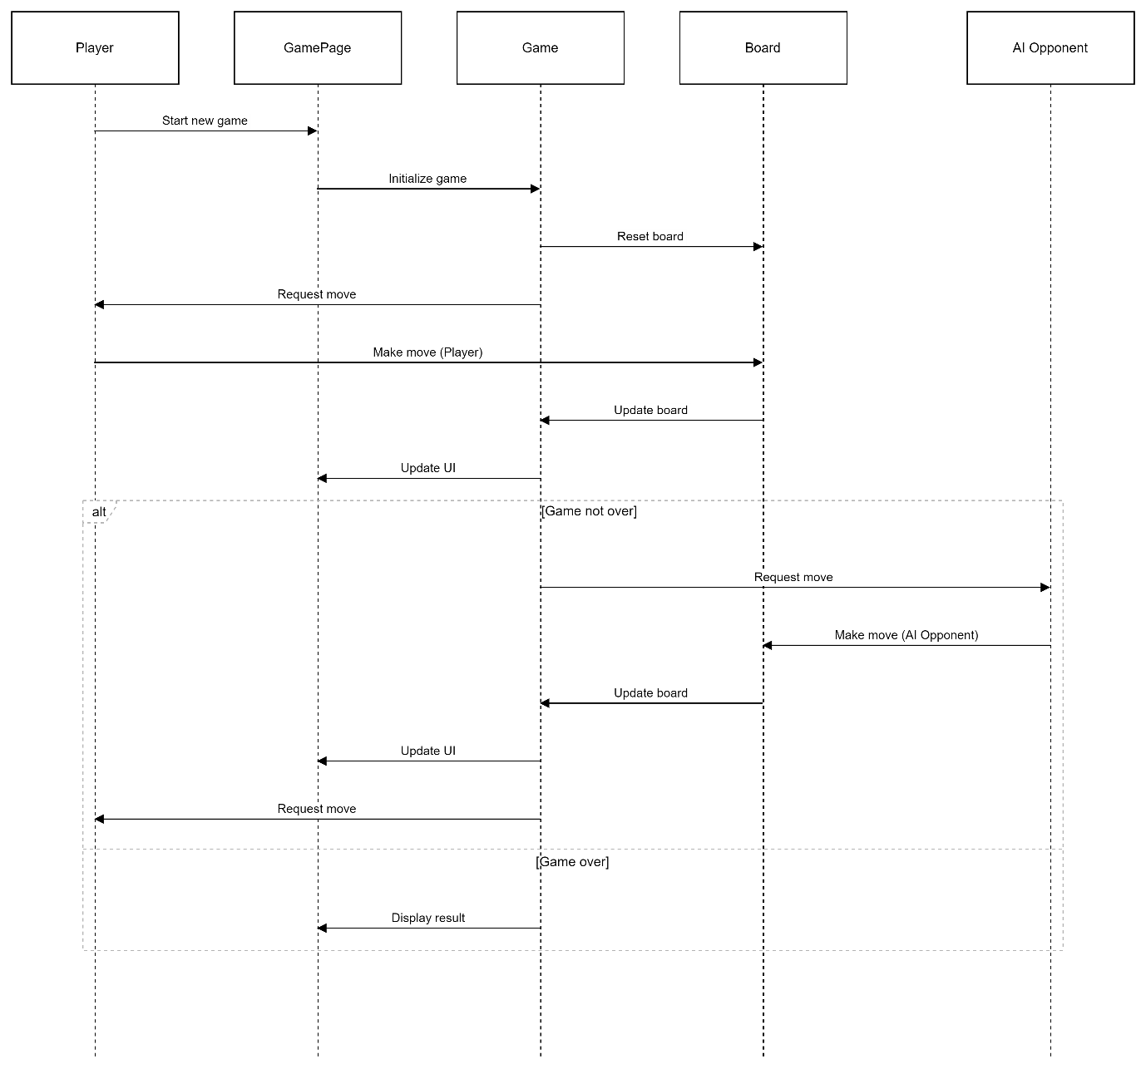

##### 3.2.5 overall diagram for an AI opponent

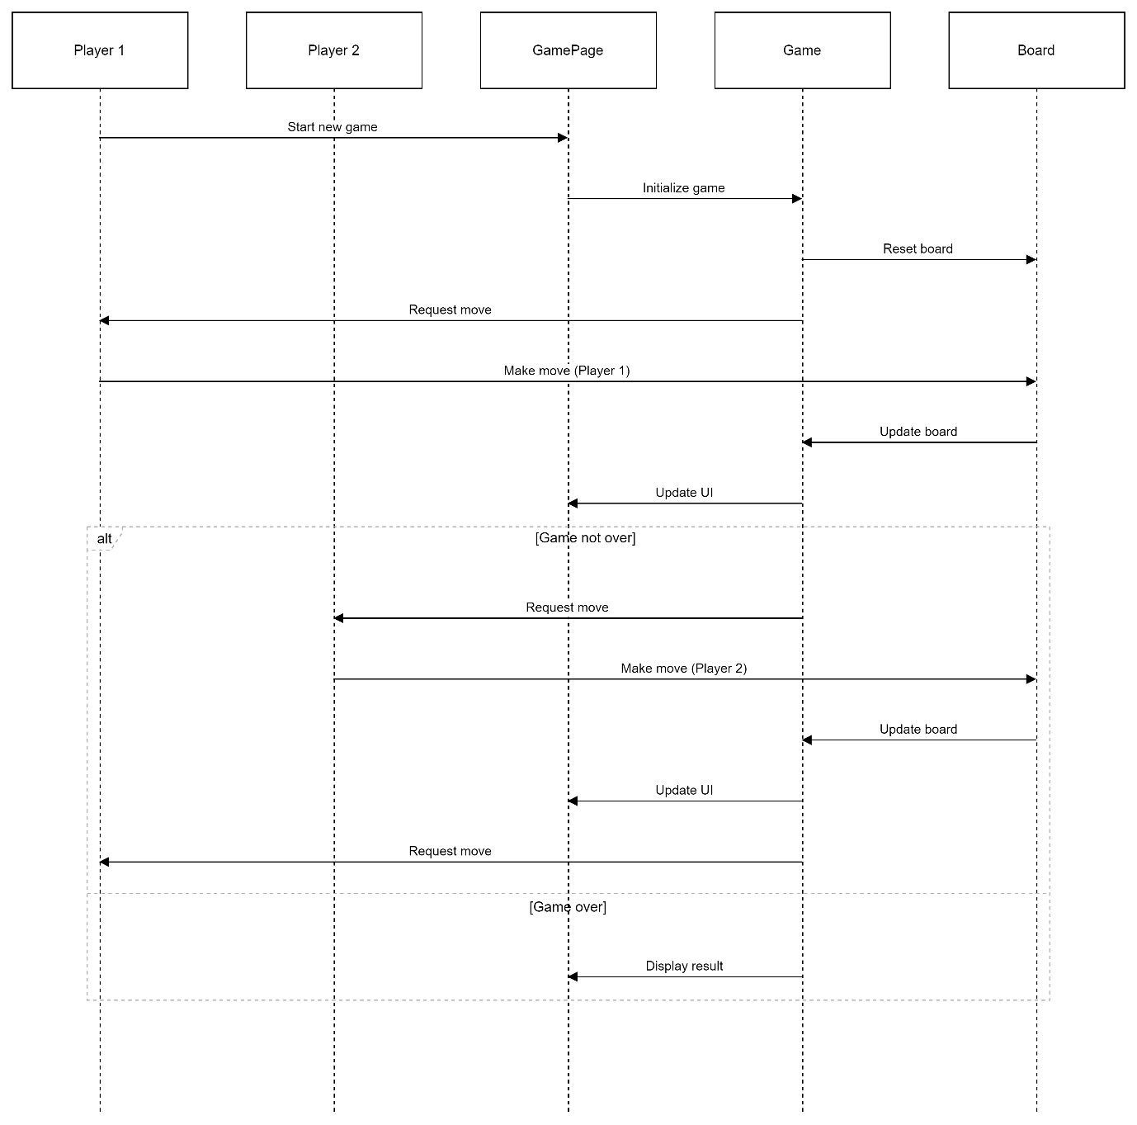

##### 3.3 Deployment diagram

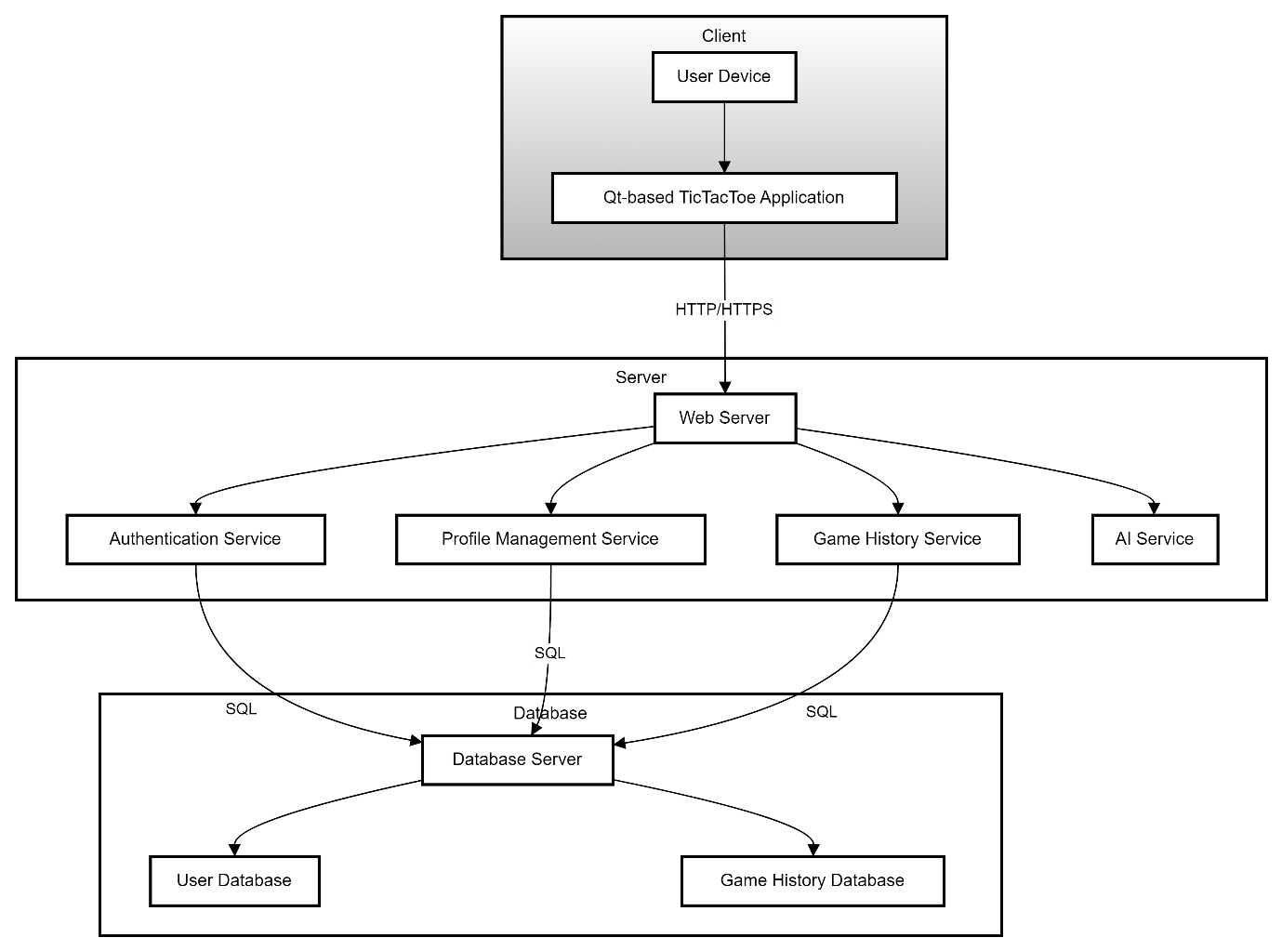

##### 3.4 component diagram

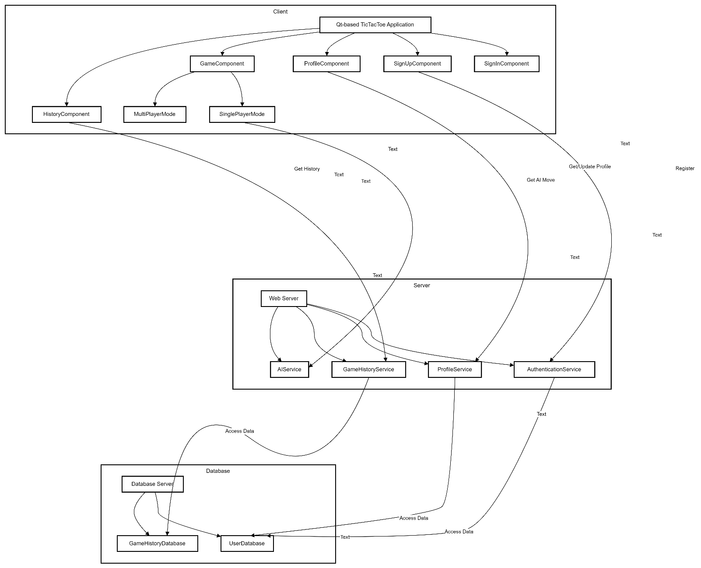

### 4. Data Design

#### 4.1 Database Schema

* **User Table**: Stores user details (username, password, age, gender, phone).
* **Game Table**: Stores game details (player1, player2, result, moves).
* 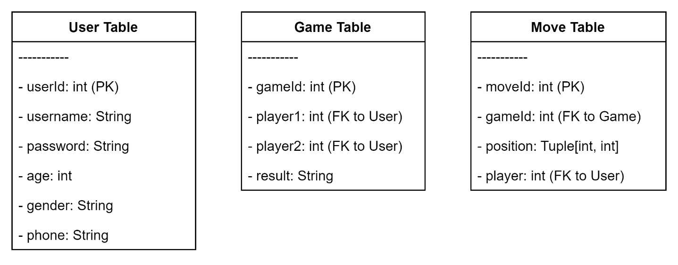**Move Table**: Stores individual moves (gameId, position, player).

### 5. User Interface Design

#### 5.1 Mockups

* **MainWindow**: Contains tabs for Profile, Game, and History.
* **SignInPage**: Fields for email and password with a login button.
* **SignUpPage**: Fields for username, password, age, gender, and phone with a signup button.
* **ProfilePage**: Displays user information and statistics.
* **GamePage**: TicTacToe board, new game and reset buttons, and game result display.
* **HistoryPage**: List of past games with final board state.

#### 5.2 Navigation Flow

### 6. Detailed flowchart of overall system