A Data Science Approach to Forecast Electricity Consumption in Australia

John Student (z123456),

Jim Student2 (zID),

Jack Student3 (zID).

12/08/2022

Table of Contents

## 0.1 Introduction and Motivation

You should describe the problem in your own words and motivate its importance. Your description should be clear for a reader not familiar with the problem (e.g., a student in your discipline but who is not involved in the course, another professor from your school who is not teaching this course). The idea is that you explain clearly what you have understood about what exactly is the problem after having listened to the project provider, and after potential discussions with the sponsor and/or your lecturers. Each team can define its own specific problem in the context of the global problem and associated data sets provided by the “client.”

Then, briefly describe how you intend to solve the problem (e.g., compare several existing methodologies, apply specific statistical techniques, etc.).

## 0.2 Brief Literature Review

Survey the most related work you have found in the literature. Due to space restrictions, describe only the most relevant work and discuss its connections to your work. Describe the methods employed in the related work, as well as the employed measure of success.

In order to incorporate your own references in this report, we strongly advise you use BibTeX. Your references then need to be recorded in the file references.bib, and cited as follows [1].

## 0.3 Methods, Software and Data Description

You should describe the techniques you intend to use and why you have selected these techniques. Also, describe the software and libraries that you will need to implement your analyses. You can revise this later since this is an initial proposal. Finally, provide a clear description of the relevant data (format, storage, variables, messiness, size, complexity) and its relevance for the chosen problem.

## 0.4 Activities and Schedule

List the main project activities and create a timetable for the activities. You can use a Gantt Chart (see next page). Describe the roles of all team members with proper justification.

Here is an example of a Gantt chart created using :

Here is an example created using R:

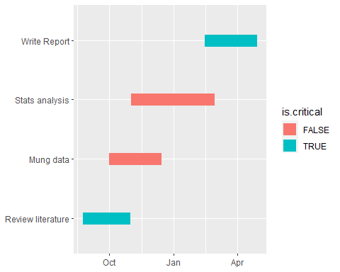

# References

1. Lafaye de Micheaux P, Drouilhet R, Liquet B. The r software: Fundamentals of programming and statistical analysis. Springer New York; 2013.