A Data Science Approach to Forecast Electricity Consumption in Australia

John Student (z123456),

Jim Student2 (zID),

Jack Student3 (zID).

25/07/2020

Table of Contents

# 1 Introduction

This R Markdown template can be used for the ZZSC9020 course report. You can incorporate R (R Core Team, 2017) chunks and Python chunks that will be run on the fly. You can incorporate  commands.

Before submitting the last version of your report, you might want to use <https://overleaf.com> to collaborate with other members of your team directly on the  version of this document (which is a byproduct you get when you Knit it from studio).

We suggest you organise your report using the following chapters but, depending on your own project, nothing prevents you to have a different organisation.

# 2 Literature Review

Here are a few references that can be useful: (Xie et al., 2018) and (Lafaye de Micheaux et al., 2013). See also <https://bookdown.org/yihui/rmarkdown-cookbook/>

In order to incorporate your own references in this report, we strongly advise you use BibTeX. Your references then needs to be recorded in the file references.bib.

# 3 Material and Methods

## 3.1 Software

R and Python of course are great software for Data Science. Sometimes, you might want to use bash utilities such as awk or sed.

Of course, to ensure reproducibility, you should use something like Git and RMarkdown (or a Jupyter Notebook). Do **not** use Word!

## 3.2 Description of the Data

How are the data stored? What are the sizes of the data files? How many files? etc.

## 3.3 Pre-processing Steps

What did you have to do to transform the data so that they become useable?

## 3.4 Data Cleaning

How did you deal with missing data? etc.

## 3.5 Assumptions

What assumptions are you making on the data?

## 3.6 Modelling Methods

# 4 Exploratory Data Analysis

This is where you explore your data using histograms, scatterplots, boxplots, numerical summaries, etc.

## 4.1 Using R

boxplot(cars, col = c("#5975a4", "#cc8963"))

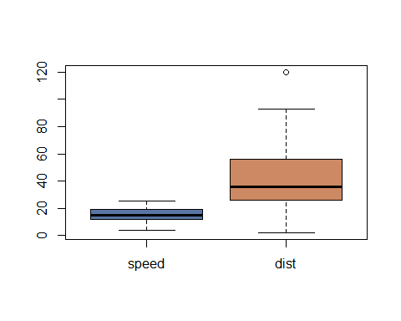

## 4.2 Using Python

See <https://cran.r-project.org/web/packages/reticulate/vignettes/r_markdown.html> for more details.

You need to install the R package reticulate.

print("Python can be used with MATHxxxx!")

## Python can be used with MATHxxxx!

import sys  
print(sys.version)

## 3.6.13 (default, Feb 19 2021, 05:17:09) [MSC v.1916 64 bit (AMD64)]

import numpy as np  
np.random.seed(1)  
np.random.normal(0.0, 1.0, size=10)

## array([ 1.62434536, -0.61175641, -0.52817175, -1.07296862, 0.86540763,  
## -2.3015387 , 1.74481176, -0.7612069 , 0.3190391 , -0.24937038])

import pandas as pd  
import matplotlib.pyplot as plt  
df=pd.DataFrame([[1, 2], [3, 4], [4, 3], [2, 3]])  
fig = plt.figure(figsize=(4, 4))  
for i in df.columns:  
 ax=plt.subplot(2,1,i+1)   
 df[[i]].plot(ax=ax)  
 print(i)  
  
plt.show()

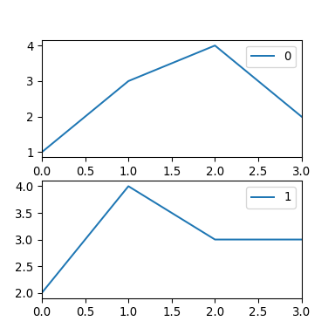

# 5 Analysis and Results

## 5.1 A First Model

Having a very simple model is always good so that you can benchmark any result you would obtain with a more elaborate model.

For example, one can use the linear regression model

$$Y_{i}=β_{0}+β_{1}x_{1i}+⋯β_{p}x_{pi}+ϵ_{i}, i=1,…,n.$$

where it is assumed that the $ϵ_{i}$’s are i.i.d. $N\left(0,1\right)$ .

# 6 Discussion

Put the results you got in the previous chapter in perspective with respect to the problem studied.

# 7 Conclusion and Further Issues

What are the main conclusions? What are your recommendations for the “client”? What further analysis could be done in the future?

A figure:



A caption

In the text, see Figure .

# References

Lafaye de Micheaux, P., Drouilhet, R. and Liquet, B. (2013) *The R software: Fundamentals of programming and statistical analysis*. Springer New York. Available at: <https://books.google.fr/books?id=Ji-8BAAAQBAJ>.

R Core Team (2017) *R: A language and environment for statistical computing*. Vienna, Austria: R Foundation for Statistical Computing. Available at: <https://www.R-project.org/>.

Xie, Y., Allaire, J.J. and Grolemund, G. (2018) *R markdown, the definitive guide*. Chapman; Hall/CRC. Available at: <https://bookdown.org/yihui/rmarkdown/>.

# Appendix

## **Codes**

Add you codes here.

## **Tables**

If you have tables, you can add them here.

Use <https://www.tablesgenerator.com/markdown_tables> to crete very simple markdown tables, otherwise use .

| Tables | Are | Cool |
| --- | --- | --- |
| col 1 is | left-aligned | $1600 |
| col 2 is | centered | $12 |
| col 3 is | right-aligned | $1 |