Heart Disease Prediction Project Report

Team Details
Team Name: NULL
Student Name | Academic ID
Youssef Wael Mohamed | 20241701047
Youssef Abdelmonem Abdallah Ahmed | 20241701022
Abdelrahman Ahmed Farouk Mohamed Fouad | 20241701056
Youssef Mohamed Sobhy Ghareeb | 20241701034
Abdelrahman Yasser Ahmed Mohamed | 20241700463
Mohanad Hossam Arafa Abdelaziz | 20241700896
Youssef Mahmoud Fawzy Abbas | 20241701039

1. Preprocessing & Analysis
Before delving into building the models, the dataset was cleaned and analyzed through consecutive feature engineering and exploratory phases.

1.1 Data Preprocessing
Before feeding the data into the machine learning models, the following advanced preprocessing steps were applied to the dataset to ensure high data quality:
- Missing Value Imputation: Used SimpleImputer to fill missing values (median strategy for numerical columns, most_frequent strategy for categorical columns).
- Outlier Handling: Applied the Interquartile Range (IQR) method to clip outliers in key numerical features (Age, BP, Cholesterol, Max HR, ST depression), preventing extreme values from skewing the models.
- Categorical Encoding: Leveraged OneHotEncoder for nominal categorical features (Gender, work_type, smoking_status) and ensured ordinal columns were properly preserved as integers. The target variable was encoded using LabelEncoder.
- Handling Class Imbalance: Applied SMOTENC (Synthetic Minority Over-sampling Technique for Nominal and Continuous) to synthetically balance the training dataset, significantly improving the models' ability to detect the minority class.
- Feature Selection: Built heavily upon the EDA phase. The 9 low-correlation, high-noise columns mentioned above were confidently dropped from the dataset to improve model generalization.
- Target Variable: The target classification variable is Heart Disease (1 for Positive/Risk, 0 for Negative/Healthy).
- Feature Scaling: StandardScaler was used to standardize the numerical features (Age, BP, Cholesterol, Max HR, ST depression) so they have a mean of 0 and a standard deviation of 1. This step is strictly required for distance-based models (like KNN and SVM) and gradient-based models (like MLP and Logistic Regression).

1.2 Exploratory Data Analysis (EDA) & Feature Selection
An extensive data analysis phase (analysis/Analysis.py and Phase1_EDA.ipynb) was conducted to uncover underlying patterns, understand feature distributions, and select the most impactful variables for the models.

Key Insights from Analysis
- Correlation Analysis: A correlation matrix highlighted that variables such as Chest pain type, Max HR, Exercise angina, Age, and ST depression are the strongest predictors of heart disease.
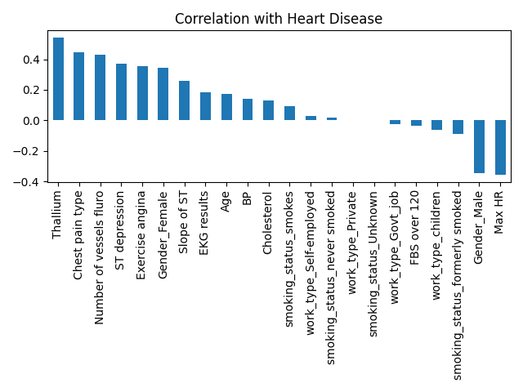
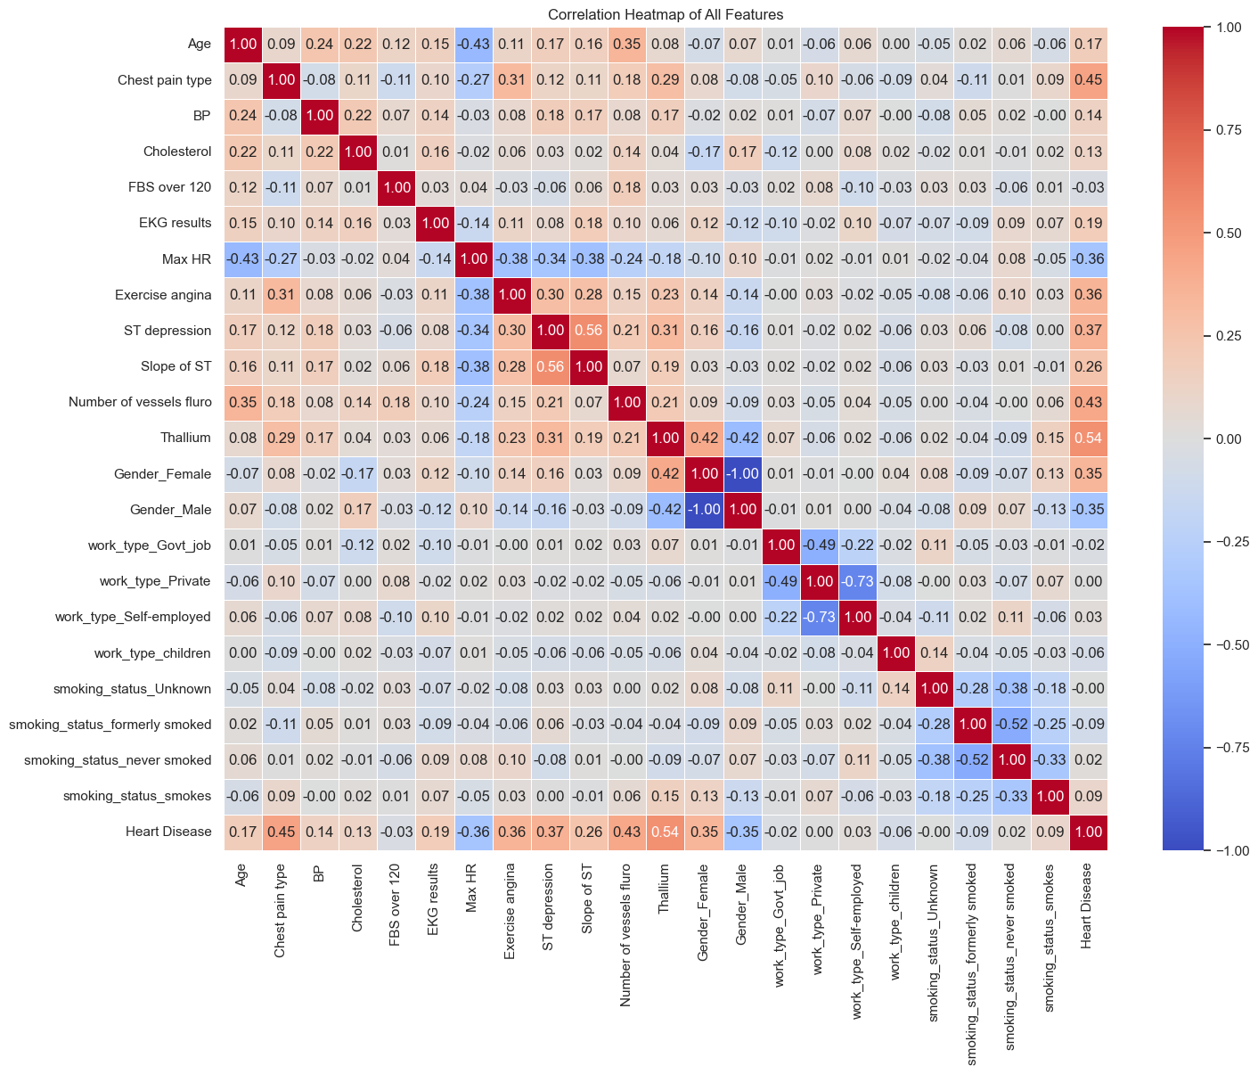

- Continuous Trends: Scatter plots (like Age vs Max HR) demonstrated clear clusters, showing that elevated age tied with specific heart rate reductions often correlated with disease onset.
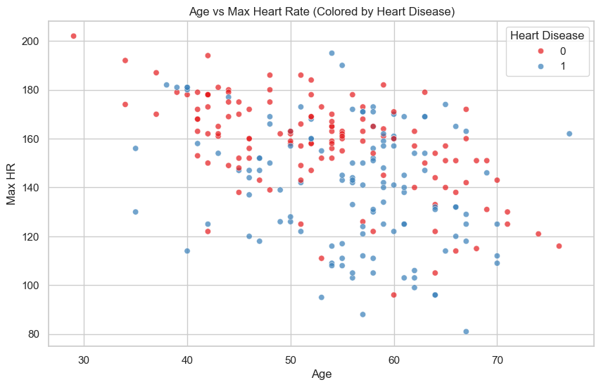

- Categorical Trends & Decision Boundaries: The bar charts grouping Chest Pain Type vs Heart Disease (split by Exercise Angina) revealed significant risk disparities across pain type categories. 2D mapping (e.g., Age vs BP) using preliminary models (like Logistic Regression) helped visualize the linear separability of the disease vs. healthy classes.
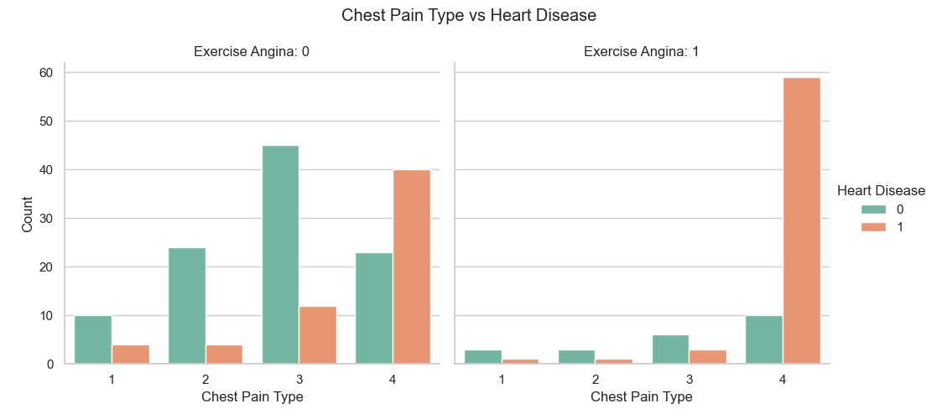 | 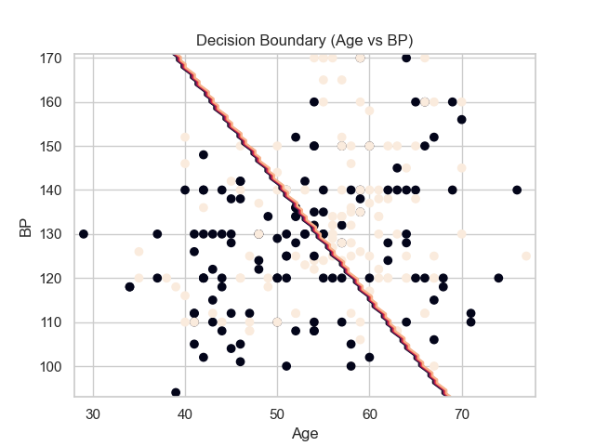

- Feature Importance: Random forest highlighted the hierarchy of feature dependencies to predict heart diseases accurately.
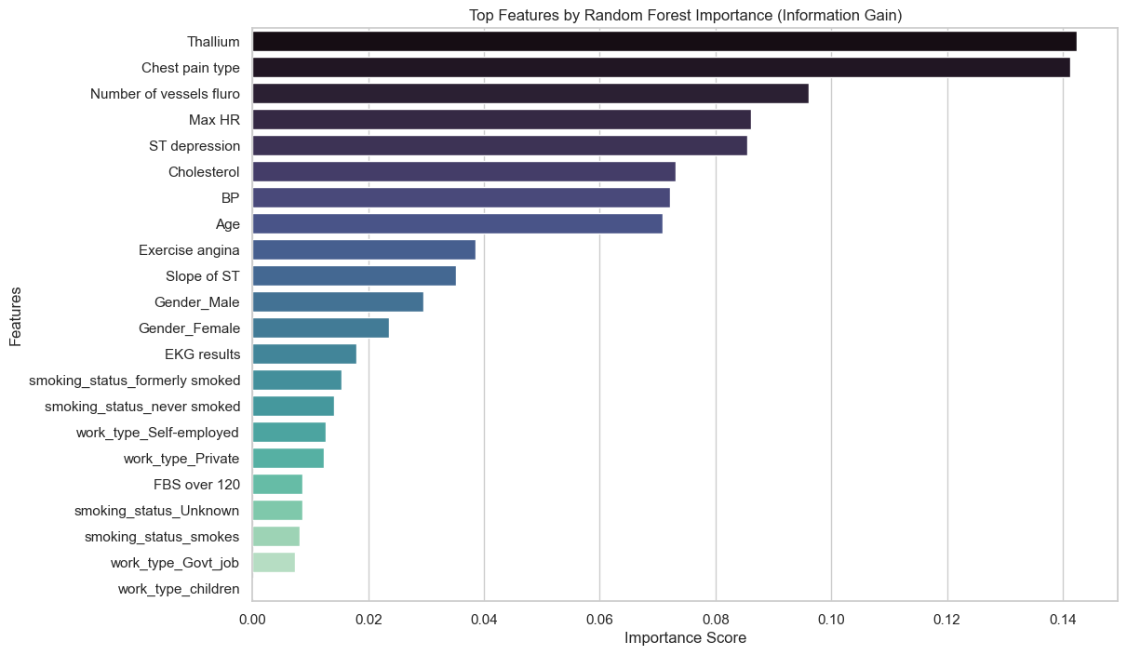

Discarded Columns
To minimize noise and prevent the "curse of dimensionality", the following 9 columns were discarded before training:
Gender_Female, work_type_Govt_job, work_type_Private, work_type_Self-employed, work_type_children, smoking_status_Unknown, smoking_status_formerly smoked, smoking_status_never smoked, smoking_status_smokes.
Reason for removal: These features (primarily related to work type and smoking status granularity extracted from one-hot encoding) exhibited near-zero correlation with the target variable. Keeping them would only hinder distance-based models (like KNN) and decision trees without providing predictive value.

2. Classification Models & Optimal Hyperparameters
After extensive hyperparameter tuning using GridSearchCV, the best configurations for each model were determined to maximize test accuracy.

1. Logistic Regression
- Hyperparameters Tested:
- C (Inverse of regularization strength): [0.01, 0.1, 1, 10, 100]
- penalty (Regularization type): ['l1', 'l2']
- Best Configuration Selected:
- C: 0.01, penalty: 'l2'

2. Decision Tree
- Hyperparameters Tested:
- max_depth (Maximum depth of the tree): [3, 4, 5, 6]
- min_samples_split (Minimum samples required to split an internal node): [15, 20, 30]
- criterion (Function to measure split quality): ['gini', 'entropy']
- Best Configuration Selected:
- criterion: 'entropy', max_depth: 5, min_samples_split: 15

3. Random Forest
- Hyperparameters Tested:
- n_estimators (Number of trees): [100, 300, 500]
- max_depth (Maximum depth of trees): [3, 4, 5]
- min_samples_split: [5, 10, 15]
- min_samples_leaf: [2, 4]
- max_features: ['sqrt', 'log2']
- criterion: ['gini', 'entropy']
- Best Configuration Selected:
- n_estimators: 100, max_depth: 5, min_samples_split: 10, min_samples_leaf: 2, max_features: 'sqrt', criterion: 'gini'

4. Support Vector Machine (SVM)
- Hyperparameters Tested:
- C (Regularization parameter): [0.1, 1, 10, 100]
- kernel (Kernel type): ['linear', 'rbf']
- Best Configuration Selected:
- C: 1, kernel: 'rbf'

5. K-Nearest Neighbors (KNN)
- Hyperparameters Tested:
- n_neighbors (Number of neighbors): [1, 3, 5]
- metric (Distance metric): ['euclidean', 'manhattan']
- Best Configuration Selected:
- metric: 'manhattan', n_neighbors: 3

6. Multi-Layer Perceptron (Neural Network)
- Hyperparameters Tested:
- hidden_layer_sizes (Neurons and layers): [(16,), (32, 16), (64, 32, 16)]
- activation (Activation function): ['relu', 'tanh']
- alpha (L2 penalty/regularization): [0.001, 0.01, 0.1]
- learning_rate_init (Initial learning rate): [0.001, 0.01]
- Best Configuration Selected:
- activation: 'tanh', alpha: 0.001, hidden_layer_sizes: (64, 32, 16), learning_rate_init: 0.01

7. XGBoost
- Hyperparameters Tested:
- learning_rate (Step size shrinkage): [0.01, 0.05]
- n_estimators (Number of boosting rounds): [100, 150]
- max_depth (Maximum tree depth): [3, 4]
- subsample (Subsample ratio of the training instances): [0.7, 0.8]
- colsample_bytree (Subsample ratio of columns): [0.7, 0.8]
- Best Configuration Selected:
- learning_rate: 0.05, n_estimators: 100, max_depth: 3, subsample: 0.8, colsample_bytree: 0.7

3. Application Architecture (Streamlit GUI)
To deliver precise patient diagnostics, the 6 configured models were integrated into a Streamlit GUI (app.py).

Prediction Strategy: Ensemble Majority Vote
- The live input data is processed on the fly (numerical columns are scaled using the fitted StandardScaler).
- Tree-based models (Random Forest, Decision Tree, XGBoost) use the raw original features.
- The rest (KNN, MLP, Logistic Regression, SVM) use the scaled features.
- Each model outputs a vote: Healthy (0) or Risk (1).
- The final diagnosis predicts a High Risk of Heart Disease if 4 or more out of the 7 models vote Positive. Otherwise, the patient is flagged as Low Risk.

4. Model Evaluation Metrics on Test Set
Model | Accuracy | Precision | Recall | F1 Score
Random Forest | 89.29% | 90.91% | 83.33% | 86.96%
XGBoost | 89.29% | 90.91% | 83.33% | 86.96%
KNN | 83.93% | 77.78% | 87.50% | 82.35%
Support Vector Machine | 83.93% | 80.00% | 83.33% | 81.63%
Logistic Regression | 83.93% | 82.61% | 79.17% | 80.85%
MLP | 83.93% | 82.61% | 79.17% | 80.85%
Decision Tree | 82.14% | 79.17% | 79.17% | 79.17%

