Add Section (Recent Work + Get In Touch) Form to Protoflio design of day1
Select one of this Figma designs and build it
https://www.figma.com/design/5OwCy2c5EKFstgQDK87E2D/trafalgar-landing-page-for-figma--Copy-?node-id=0-1&p=f
https://www.figma.com/design/tJyJ9w3BM7aGDtAoRarhnG/123-Restaurant-Landing-Page--Community---Copy-?node-id=0-1&p=f
<! -- declare an array of objects products (image, name, stock, price) in JavaScript and show it using horizontal cards of bootstrap-->
const products = [
{img:"", name:"", stock:10, price:1000},
{img:"", name:"", stock:10, price:1000},
{img:"", name:"", stock:10, price:1000},
{img:"", name:"", stock:10, price:1000},
]
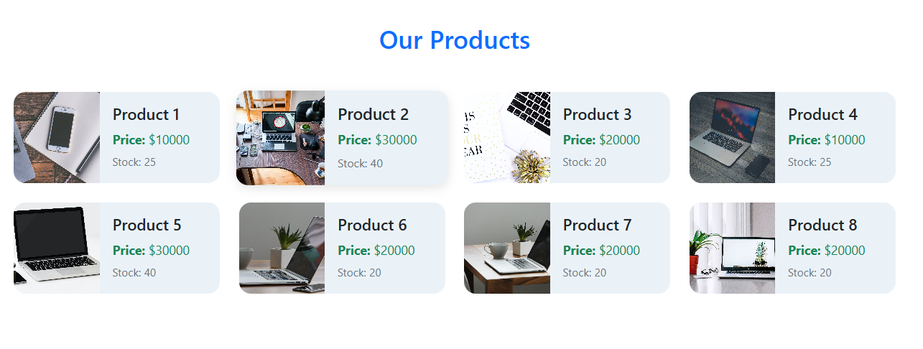
--------------------------------------------------------------------------------------------------

<! -- Make registration form with form validation of bootstrap and validate inputs using js-->
-------------------------Try and use this from documentation ------------------------
<! -- card tabs, card-pills, scroll spy, loading, pagination-->
<! -- Dropdown menu position-->

