# AJAX Features – Show Link Contents in a Floating Popup

## Specifying the Loading Screen

When executing lengthy Ajax Calls, it is recommended to show a loading screen to the user. The purpose of this screen is to give the user an indicator that his action has been captured and that the system is in the process of responding to it. The foundation Library

## Hyper Link Attribute

Give the hyperlink this class “**showInPopUpOnClick**”.

Add the following attributes to the link to customize the popup dialogue box

|  |  |
| --- | --- |
| Attribute | Description |
| data-popup-title | The title of the popup screen. Default is “Details”. |
| data-popup-dismissButtonText | The text for “Dismiss” Button. Default is “Dismiss”. |
| data-popup-hideButtonAndHeader | True (ture). Whether title bar and the dismiss buttons should be hidden. Default is false. |

**Exmple:**

<a class="showInPopUpOnClick" data-popup-dismissbuttontext="Click To Close" data-popup-title="Test On Title" href="/PaymentPeriod/Details/f6603b8d-7eb7-4fd1-bd52-a29900cb7321">PopUP</a>

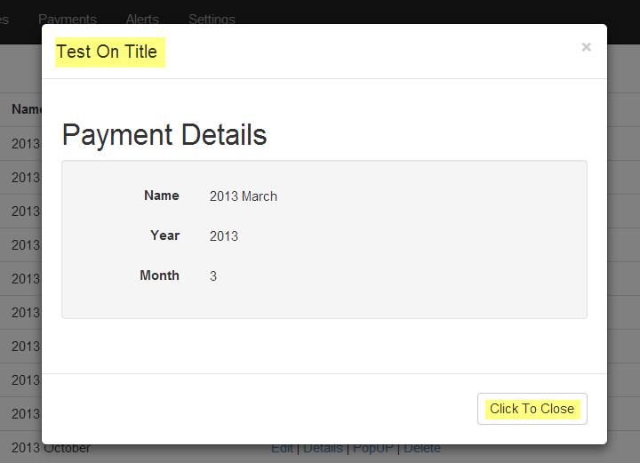

## Configuring Popup

The HTML page must contain and HTML block (could be a DIV) with id=detailsModel. This HTML Block should contain elements with the following Id’s. A good place to put this block is in your _Layout.cshtml page.

|  |  |
| --- | --- |
| ID | Description |
| detailsModelHeader | Container for the details popup header. |
| detailsModelTitle | Container for the Model Title.  The contents of this element will be filled with the value of data-popup-title. |
| detailsModelDimissButton | The buttons that dismiss button.  The text of this button will be set to the value of data-popup-dismissButtonText |
| detailsModelFooter | Container for the footer for popup. |
| detailsModelContent | This element will be populated with the response of the ajax call. |

Below is an example of a Pop Up.

<div class="modal" id="detailsModel">

<div class="modal-dialog">

<div class="modal-content">

<div class="modal-header" id="detailsModelHeader">

<button type="button" class="close" data-dismiss="modal" aria-hidden="true">&times;</button>

<h4 class="modal-title" id="detailsModelTitle">Modal title</h4>

</div>

<div class="modal-body" id="detailModelContent">

</div>

<div class="modal-footer" id="detailsModelFooter">

<button type="button" id="detailsModelDismissButton" class="btn btn-default" data-dismiss="modal">Close</button>

</div>

</div><!-- /.modal-content -->

</div><!-- /.modal-dialog -->

</div><!-- /.modal -->