1. VGG (Visual Geometry Group Networks)
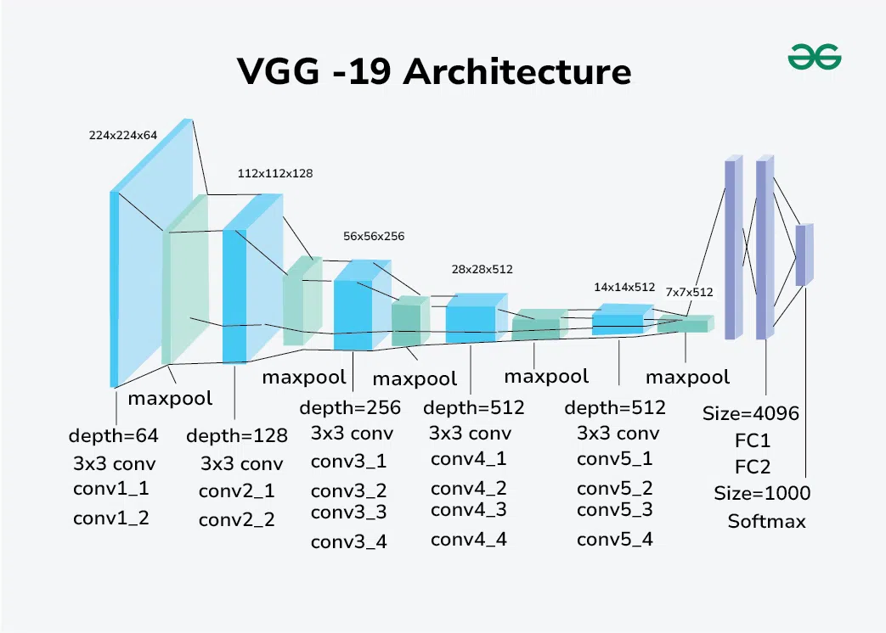
Overview:
VGG networks are deep convolutional neural networks designed by the Visual Geometry Group at the University of Oxford. They became widely used in image classification due to their simple yet effective architecture. Wikipedia
Architecture Details:
- Based entirely on convolutional layers with small 3×33×33×3 filters stacked deeper as the network goes deeper. Wikipedia
- Followed by max-pooling layers to reduce spatial dimensions.
- Ends with fully connected (dense) layers and a final softmax classifier.
- Example models include VGG-16 and VGG-19, where the number indicates the total layers with weights. Wikipedia
Step-by-Step Structure:
- Input image (e.g., 224×224×3)
- Convolution block (ReLU activations)
- Max Pooling
- … (Repeat blocks)
- Fully connected layers
- Softmax output
Original Reference:
Simonyan, K. & Zisserman, A. (2014). Very Deep Convolutional Networks for Large-Scale Image Recognition (VGG).
📄 https://arxiv.org/abs/1409.1556

2. ResNet (Residual Networks)
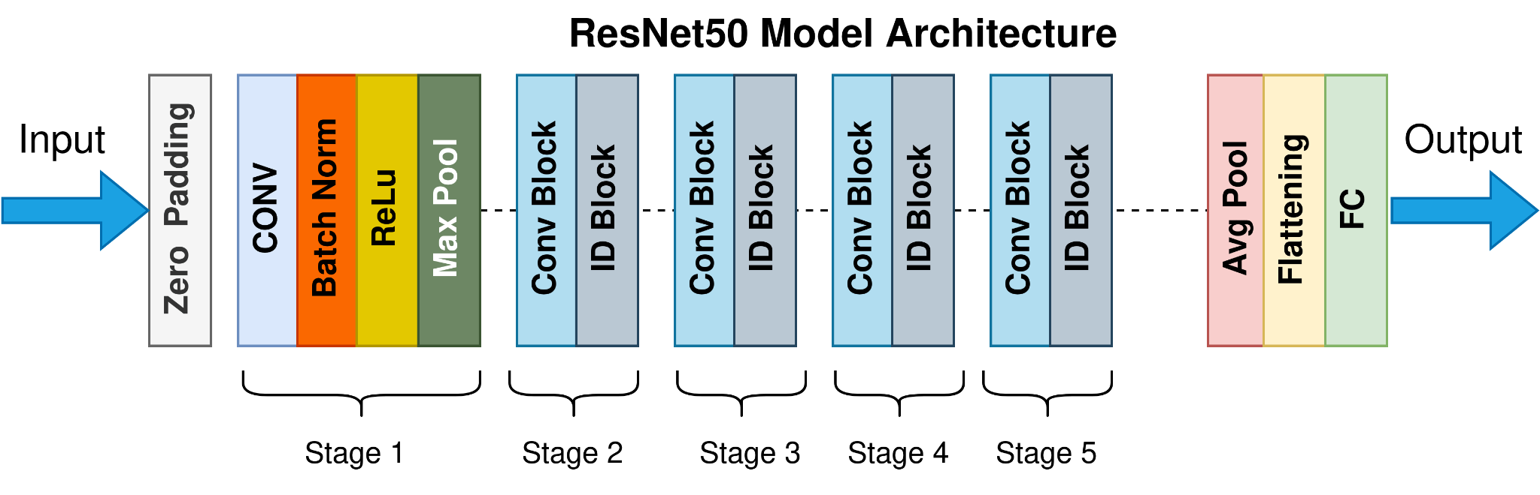
Overview:
ResNet introduced residual connections to solve the vanishing gradient problem in very deep neural networks. Medium
Architecture Details:
- Uses residual blocks that include identity connections, allowing gradients to flow more easily during backpropagation. Medium
- Popular variants: ResNet-50, ResNet-101, ResNet-152. GeeksforGeeks
Step-by-Step Structure:
- Initial convolution + pooling
- Residual blocks (with skip connections)
- Adaptive pooling
- Fully connected classifier
Original Reference:
He, K., Zhang, X., Ren, S., & Sun, J. (2016). Deep Residual Learning for Image Recognition.
📄 https://arxiv.org/abs/1512.03385

3. Inception (GoogLeNet Family)
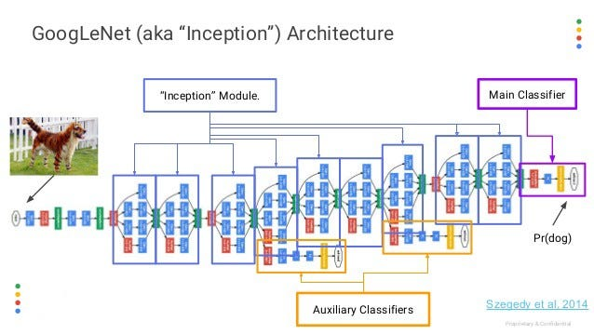
Overview:
Inception networks use parallel convolution paths at each module to capture multi-scale features efficiently. Wikipedia
Architecture Details:
- In a single Inception module, multiple convolution filters of different sizes (e.g., 1×1, 3×3, 5×5) and pooling operate in parallel. Wikipedia
- Reduces computational cost compared to simply stacking deeper layers.
Step-by-Step Structure:
- Input image
- Convolution + pooling
- Multiple Inception modules
- Global average pooling
- Classifier layer
Original Reference:
Szegedy, C. et al. (2015). Going Deeper with Convolutions (Inception / GoogLeNet).
📄 https://arxiv.org/abs/1409.4842

4. Vision Transformer (ViT)
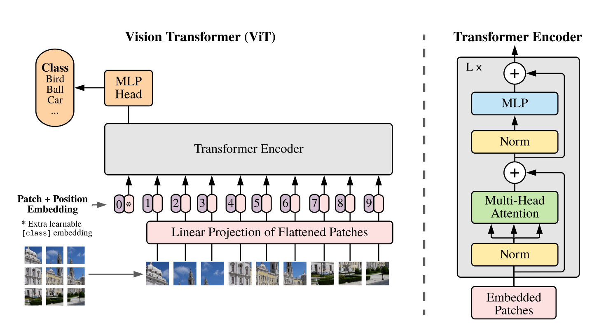
Overview:
Vision Transformers adapt the Transformer architecture from NLP to vision tasks. They split images into patches and treat them similarly to word tokens in text. Wikipedia
Architecture Details:
- Input image divided into fixed-size patches (e.g., 16×16). Wikipedia
- Each patch flattened and linearly projected into embeddings.
- Standard Transformer encoder layers apply self-attention and feed-forward networks. Wikipedia
Step-by-Step Structure:
- Image → Patches
- Patch flatten → Embeddings
- Add positional encoding
- Transformer encoder blocks
- Classification head
Original Reference:
Dosovitskiy, A. et al. (2021). An Image is Worth 16×16 Words: Transformers for Image Recognition at Scale (ViT).
📄 https://arxiv.org/abs/2010.11929

Comparison of the four models (our experimental results)
- Protocol: subject‑independent split (Train: 00–06, Val: 07–08, Test: 09 held‑out). Same preprocessing/augmentations and evaluation pipeline across models.
- Results (best runs):
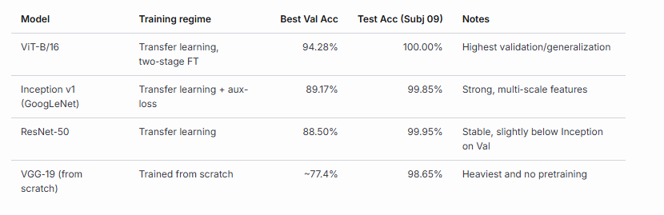
- Additional observations:
  - All transfer‑learned models (ViT/ResNet/Inception) reached near‑perfect performance on the held‑out subject; ViT achieved perfect Test and AUC=1.00. VGG, despite lower Val, still scored very high on the (easier) held‑out subject.
  - Validation scores separate the models more clearly (ViT > Inception ≈ ResNet ≫ VGG‑scratch), which better reflects cross‑subject generalization.
  - Confusion matrices show most residual errors occur among visually similar gestures (e.g., index vs thumb, l vs ok), consistent across models but least frequent in ViT.

Pros and cons of each architecture
- ViT (Vision Transformer)
  - Pros:
    - Global self‑attention captures long‑range relations between fingers/shapes; robust to small rotations and crop variations.
    - Fine‑tuning converges quickly with two‑stage training (linear probe → full FT).
    - Achieved the highest Val/Test accuracy on our subject‑independent split.
  - Cons:
    - Heavier than Inception/ResNet; slower inference on modest GPUs.
    - Benefits from careful regularization and schedule; more sensitive to hyperparameters than ResNet.
- ResNet‑50
  - Pros:
    - Strong baseline; residual connections ease optimization and stabilize training.
    - Good speed/accuracy trade‑off; widely available, robust implementations.
  - Cons:
    - Primarily local receptive fields; can struggle more than ViT on subtle global hand configurations.
    - Slightly below Inception on our Val in this task.
- Inception v1 (GoogLeNet)
  - Pros:
    - Multi‑branch, multi‑scale filters (1×1/3×3/5×5) fit hand‑shape diversity well.
    - Lightweight (parameters) and fast at inference; auxiliary heads improve optimization.
    - Outperformed ResNet‑50 on Val in our runs.
  - Cons:
    - Training setup is a bit more complex (auxiliary losses and heads).
    - Still trails ViT on cross‑subject validation.
- VGG‑19 (from scratch)
  - Pros:
    - Simple, clean architecture; easy to implement from first principles (meets “from scratch” requirement).
  - Cons:
    - Very large parameter count without skip connections; needs much more data/epochs to generalize.
    - Lowest Val accuracy among the four under our compute/data budget.

Why ViT performs best for our task and dataset
- Dataset characteristics that favor ViT:
  - The gestures are defined by global finger configurations and relative spatial relationships. ViT’s self‑attention models these global dependencies directly, rather than relying on progressively enlarged local receptive fields.
  - Images are fairly controlled (centered hands, limited backgrounds), so ViT’s patch embedding plus light augmentations are enough to capture discriminative structures without heavy invariances.
- Training recipe that amplified ViT’s strengths:
  - Two‑stage fine‑tuning (head‑only → full FT with different LRs) stabilized adaptation and avoided catastrophic shifts in early epochs.
  - Grayscale + simplified augmentations (no horizontal flips/jitter) preserved class semantics (e.g., “L”) and reduced label‑flip noise.
  - Label smoothing + AMP helped regularize and speed training.
- Empirical evidence:
  - Highest Val accuracy (94.28%) on unseen subjects and perfect Test on the held‑out subject, with the cleanest confusion matrices and ROC curves.
  - Smaller error overlap on look‑alike gestures compared to CNN baselines.
Takeaway
- For LeapGestRecog under a subject‑independent split and our standardized pipeline, ViT offers the best cross‑subject generalization, Inception v1 slightly edges ResNet‑50 among CNNs thanks to multi‑scale processing, and VGG‑19 (from scratch) is the least competitive given its size and lack of pretraining.

