Project Idea: Reducing Dishes Problem

Team Members / Section 5
Abdallah ahmed mohamed abdallah 1000287901
abdelrhman mohamed hassan ibrahim 1000318228
Amr ahmed elsayed mohamed 1000287930
Abdelrhman Mohammed Ibrahim Aboalata 1000288306
Abdelrhman mohsen mohamed mohamed 1000287826
____________________________________________________________________

1. Problem Identification

1.1) Problem Description
Given a list of dishes, each dish has a satisfaction value that can be negative, zero, or positive.
Each dish takes one unit of time to cook, and its contribution is:
satisfaction × cooking time
The goal is to choose and order some dishes to get the maximum total satisfaction.
It is allowed to skip dishes that reduce the total result.

1.2) Input–Output Examples
Input: [-1, -8, 0, 5, -9]
Output: 14
Input: [4, 3, 2]
Output: 20
Input: [-5, -3, -1]
Output: 0

2. Algorithm Development

2.1) Naïve Algorithm

Description
The naive approach sorts the array first, then tries all possible cooking orders by choosing different starting positions.
For each case, it calculates the total satisfaction and keeps the maximum result.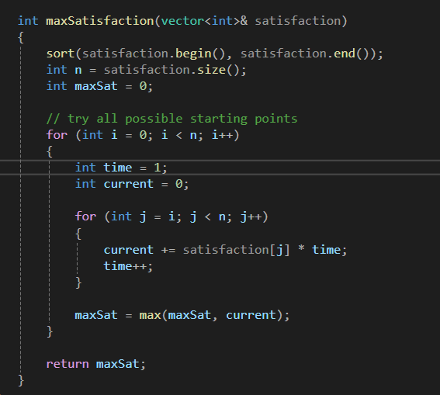

Analysis
Time Complexity: O(n²)
Space Complexity: O(1)

Empirical Results
- Small input: ~0 ms
- Medium input: ~0.7 ms
- Large input: ~1.1 ms

2.2) Optimized Algorithm (Greedy)

Description
After sorting, the algorithm starts from the largest satisfaction value and adds dishes one by one.
A dish is added only if it increases the total satisfaction.
The algorithm stops once adding a dish reduces the result.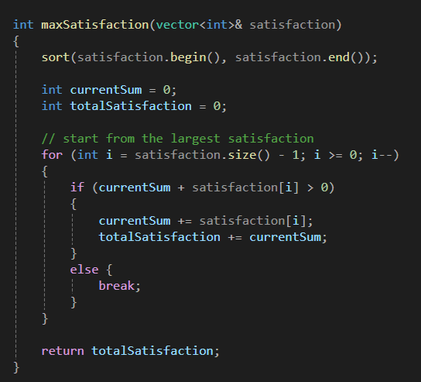

Analysis
Time Complexity: O(n log n)
Space Complexity: O(1)

Empirical Results
- Small input: ~0.01 ms
- Medium input: ~0.03 ms
- Large input: ~0.09 ms

3. Comparison Table
Feature | Naïve | Optimized
Time Complexity | O(n²) | O(n log n)
Space Complexity | O(1) | O(1)
Efficiency | Low | High
Redundancy | High | None

