Project Report
Fundamentals of Database Systems (CSE462a)
Student Name 1, Student Name 2 email1@example.com, email2@example.com
Supervised by: Dr. Ahmed Ayoub
May 6, 2026
4
Abstract
This document presents a detailed report on the project titled *[Project Title]*. The report covers the problem statement, objectives, database design, implementation details, query optimization, and conclusions.
Contents
1 Introduction 3
1.1 Problem Statement 3
1.2 Objectives 3
1.3 Scope 3
2 Database Design 3
2.1 Entity-Relationship Diagram (ERD) 3
2.2 Normalization 3
2.3 Schema Design 3
3 Implementation 3
3.1 Database Tables 3
3.2 SQL Queries 3
3.3 Stored Procedures, Triggers, Transactions 3
4 Query Optimization 3
5 Data Integrity and Security 3
5.1 Constraints and Data Validation 3
5.2 Access Control and Security Measures 4
6 Results and Discussion 4
6.1 Testing and Validation 4
6.2 Challenges and Limitations 4
7 Conclusion 4
8 References 4

1

Introduction

Problem Statement

One of the major problems facing blood banks today is the inefficient management of blood unit inventory. The management of blood donor records and transfusion history often suffers from significant inaccuracies due to manual documentation. Human errors in recording blood types or cross-matching results can lead to catastrophic medical consequences. Moreover, without a digital tracking system, it is challenging to maintain an accurate history of donor eligibility and patient needs. This project addresses these risks by providing a structured digital environment that ensures data integrity and minimizes the possibility of errors in life-saving information.

Objectives

The primary objective of this project is to develop a robust relational database that streamlines the entire blood donation life cycle. The system is designed to achieve the 3rd Normal Form (3NF) to ensure data efficiency and eliminate redundancy. Key goals include implementing advanced SQL features such as stored procedures for donor matching and complex queries for inventory tracking. By focusing on database performance and integrity, the project aims to provide a reliable tool for healthcare administrators to manage life-saving resources scope.

Database Design

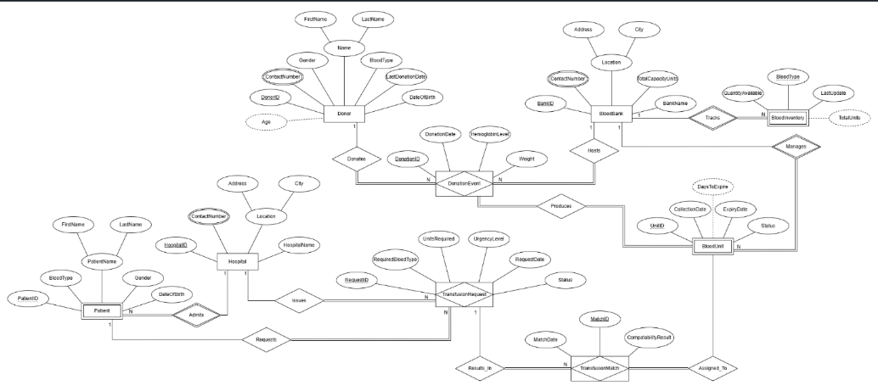
Entity-Relationship Diagram (ERD)

Normalization
- First Normal Form (1NF): Eliminating Multi-valued Attributes
Application: We identified that the Phone Number attribute for hospitals/banks is multi-valued (a single institution often has multiple contact numbers). To comply with 1NF, we moved these numbers into a separate table, Bank_Phone, linked via the BankID and Hospital_Phone linked via Hospital_ID.
- Second Normal Form (2NF): Eliminating Partial Dependencies
Application: In associative tables like BloodInventory, where the primary key is a combination of (BankID, BloodType), we ensured that all other attributes, such as Quantity_Available, depend on the complete composite key. Any attribute that depended only on the BankID (like the bank's address) was kept in the parent BloodBank table

- Third Normal Form (3NF): Eliminating Transitive and Derived Dependencies

Application: We removed attributes like Age and ExpiryStatus from the physical table schemas.
Instead of storing Age, we store the static DateOfBirth.
Instead of storing ExpiryStatus, we store the ExpirationDate.
Mechanism: These values are now handled dynamically through SQL Views or Triggers. For example, a View calculates the age on-the-fly based on the current system date (CURDATE()).

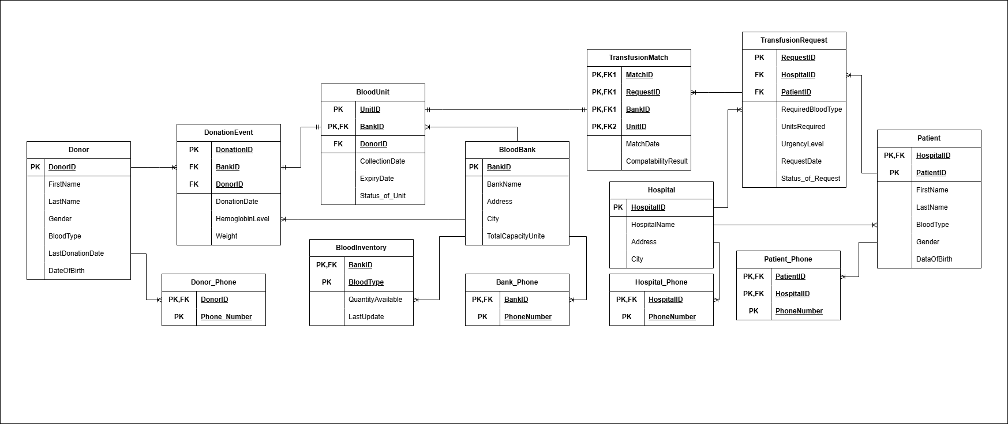
Schema Design

Implementation

Database Tables
List and describe the database tables with attributes and data types.

SQL Queries
Provide and explain sample SQL queries for CRUD operations. 5

Stored Procedures, Triggers, Transactions
Describe any implemented stored procedures, triggers, and transactions.

Query Optimization
- -- JOIN 1: List all hospitals and their associated phone numbers. SELECT h.HospitalName, p.PhoneNumber FROM Hospital h JOIN Hospital_Phone p ON h.HospitalID = p.HospitalID;
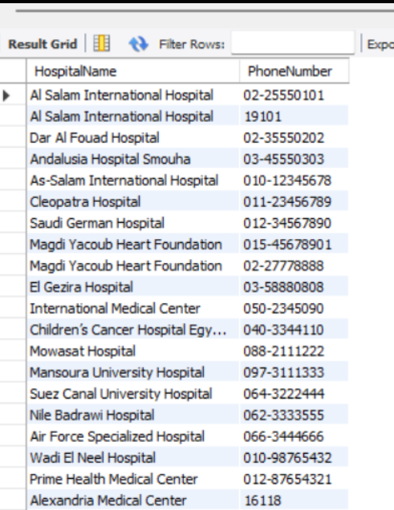

- -- JOIN 2: See which patient requested blood, their required type, and the name of the hospital making the request. SELECT CONCAT(p.FirstName, ' ', p.LastName) AS PatientFullName, r.RequiredBloodType, h.HospitalName FROM TransfusionRequest r JOIN Patient p ON r.PatientID = p.PatientID JOIN Hospital h ON r.HospitalID = h.HospitalID;
-- COUNT: Find out how many "Available" blood units are currently in the entire system. SELECT COUNT(*) AS AvailableUnits FROM BloodUnit WHERE Status_of_Unit = 'Available';
-- Subquery: Find the names of hospitals that have submitted "Critical" urgency requests. SELECT HospitalName FROM Hospital WHERE HospitalID IN ( SELECT HospitalID FROM TransfusionRequest WHERE UrgencyLevel = 'Critical' );
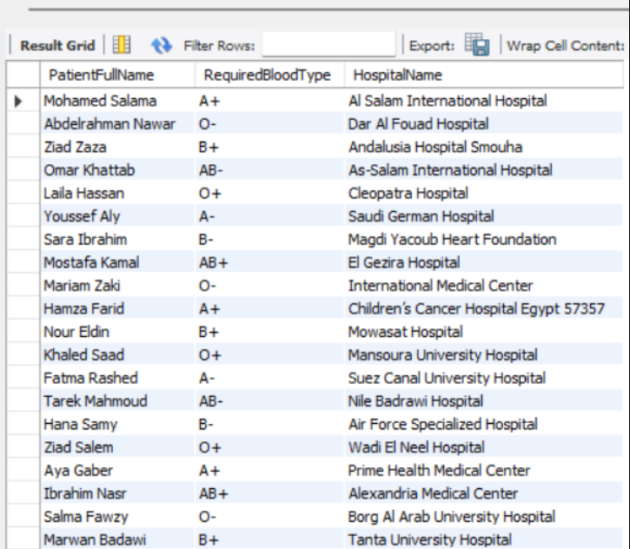
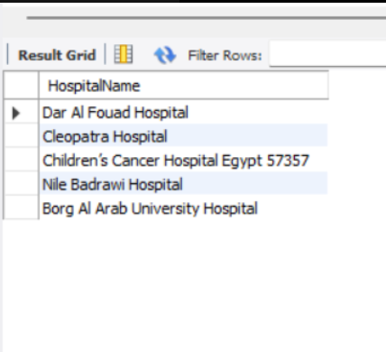

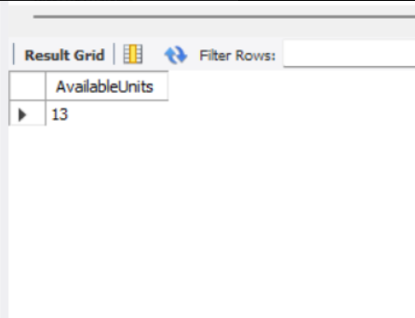

Data Integrity and Security

Constraints and Data Validation
Explain integrity constraints such as primary keys, foreign keys, and unique constraints.

Access Control and Security Measures
Describe user roles, authentication, and security policies.

Results and Discussion

Testing and Validation
The system went through accurate testing to ensure data accuracy and operational reliability. We performed Unit Testing on individual tables to verify constraints like NOT NULL and ENUM values. Integration Testing was conducted to validate the relationships between tables, ensuring that FOREIGN KEY actions like ON DELETE CASCADE functioned correctly. Additionally, we executed SQL Query Testing to confirm that data retrieval is both fast and accurate, and performed Validation Checks to ensure that no incompatible blood types or expired units could be processed through the matching system.

Challenges and Limitations
Highlight any difficulties faced during development.

Conclusion

This project successfully designed a comprehensive database system tailored to the operational needs of blood banks and hospitals. By centralizing the inventory management and transfusion matching processes, we have created a tool that can reduce human error and minimize blood unit wastage. A key finding during development was the importance of using dynamic views for derived attributes like age and expiry status to maintain data freshness. Looking ahead, the system could be expanded into a web-based platform to allow real-time coordination between multiple regional blood banks. We also plan to integrate a machine learning module to predict future blood demand based on historical transfusion trends. This foundation ensures that the blood supply chain remains transparent, organized, and ready for emergency situations.

References
Use proper citation format (IEEE, APA, etc.).

