1. Implemented Features
The Order Processing System is a comprehensive web-based application designed to manage a bookstore's operations. The system supports two distinct user roles: Administrators and Customers.
A. Core System & Admin Features (Part 1)
- User Authentication: Secure login system that differentiates between Admin and Customer accounts.
- Book Management:
  - Add New Books: Admins can input book details (ISBN, title, category, price) and set stock thresholds.
  - Stock Control: The system prevents stock from becoming negative using database triggers.
- Automatic Replenishment:
  - Trigger-Based Ordering: A database trigger automatically places a "Publisher Order" when book stock drops below a specific threshold.
  - Order Confirmation: Admins can confirm publisher orders, which automatically updates the book stock.
- System Reports: The admin dashboard generates reports on total sales (monthly/daily), top customers, and best-selling books.
B. Customer Account & Shopping Features (Part 2)
- Registration & Profile: New users can sign up for accounts and manage their personal information (shipping address, password, email).
- Advanced Search: Users can search for books by ISBN, Title, Author, or filter by Category (Science, Art, Religion, History, Geography).
- Shopping Cart System:
  - Customers can add items to a persistent shopping cart.
  - Users can view total prices and remove items before checkout.
- Secure Checkout:
  - Customers must provide credit card details to complete a purchase.
  - The system uses transactions to ensure stock is only deducted if the payment is successful.
- Order History: Customers can view a detailed log of their past orders.

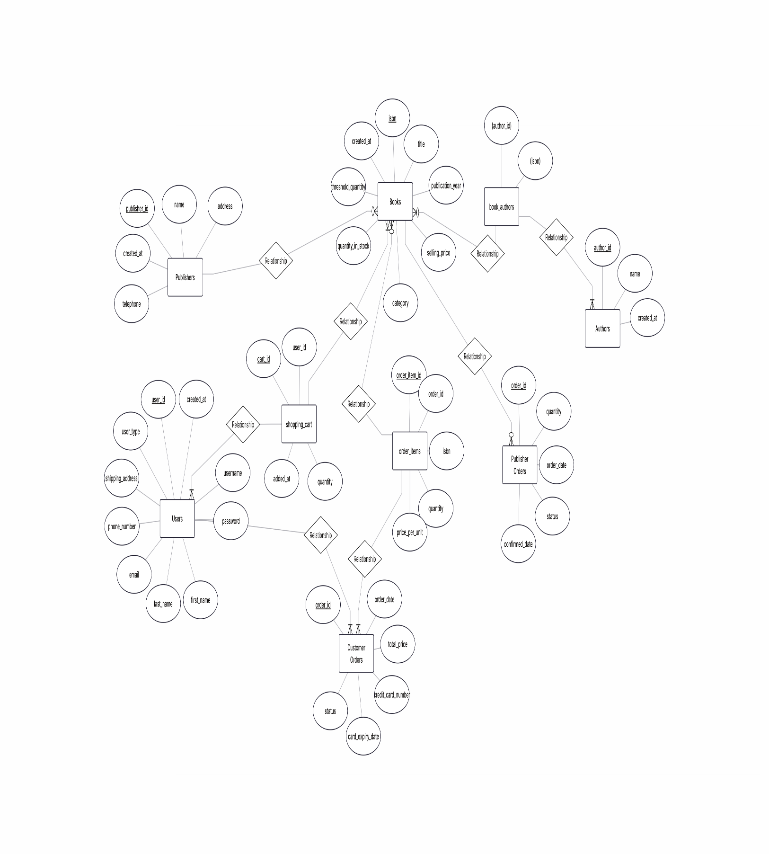
2. ERD Diagram

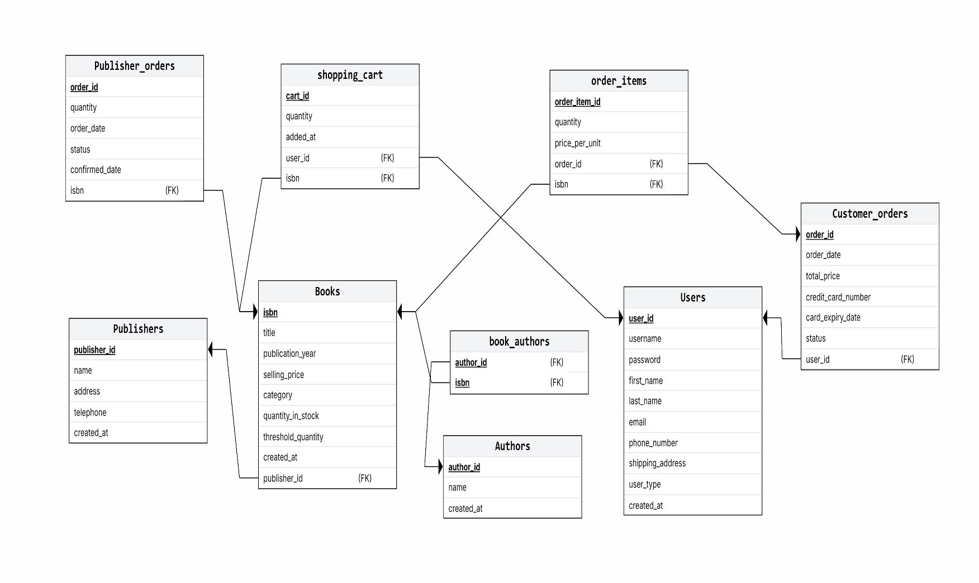
3. Relational Schema
(Underlined attributes denote Primary Keys. FK denotes Foreign Keys).
- Publishers (<u>publisher_id</u>, name, address, telephone)
- Authors (<u>author_id</u>, name)
- Books (<u>isbn</u>, title, publisher_id (FK), publication_year, selling_price, category, quantity_in_stock, threshold_quantity)
- Book_Authors (<u>isbn (FK), author_id (FK)</u>)
- Users (<u>user_id</u>, username, password, first_name, last_name, email, phone_number, shipping_address, user_type)
- Shopping_Cart (<u>cart_id</u>, user_id (FK), isbn (FK), quantity, added_at)
- Customer_Orders (<u>order_id</u>, user_id (FK), total_price, order_date, credit_card_number, card_expiry_date, status)
- Order_Items (<u>order_item_id</u>, order_id (FK), isbn (FK), quantity, price_per_unit)
- Publisher_Orders (<u>order_id</u>, isbn (FK), quantity, order_date, status, confirmed_date)

4. Description of Logic (User Interface Screens)
A. Login & Registration (login.php, register.php)
- Logic: The system validates if the username/email already exists. If unique, it creates a new user record. Passwords are secured using password_hash. Upon login, the system checks user_type to redirect the user to either the Admin Dashboard or Customer Dashboard.
B. Admin Dashboard (admin_dashboard.php)
- Logic: This is the control center for administrators. It executes SQL COUNT queries to display real-time statistics: Total Books, Total Customers, Pending Orders, and Low Stock Items. It also fetches the 5 most recently added books to display in a quick-view table.
C. Add Book Screen (add_book.php)
- Logic: Allows the admin to insert a new book. The form performs validation (e.g., checking if ISBN is 13 digits, ensuring price > 0). It uses a Database Transaction to simultaneously insert the book details into the books table and link authors in the book_authors table.
D. Customer Dashboard (customer_dashboard.php)
- Logic: The landing page for customers. It displays a "Featured Books" section by querying the most recent additions to the database. It also summarizes the user's current status, showing the number of items in their cart and their total spending to date.
E. Search Books (search_books.php)
- Logic: This screen accepts user input to filter the book catalog. It constructs dynamic SQL queries using LIKE operators to match keywords against Book Titles, ISBNs, or Author Names. It also allows filtering by specific categories (e.g., "Science", "History").
F. Shopping Cart & Checkout (shopping_cart.php, checkout.php)
- Logic:
  - Cart: Displays items stored in the shopping_cart table for the specific logged-in user. It calculates the subtotal dynamically (price * quantity).
  - Checkout: When the user pays, the system executes a complex transaction:
    - Creates a customer_order.
    - Moves items to order_items.
    - Updates books stock (subtracting sold quantity).
    - Empties the shopping_cart.
  - Trigger: If the stock update causes the quantity to drop below the threshold, a database trigger automatically inserts a restocking request into publisher_orders.
G. Reports Screen (reports.php)
- Logic: This interface runs aggregate functions (SUM, COUNT, AVG) on the customer_orders and order_items tables. It generates data for specific requirements such as "Total Sales for Previous Month" and "Top 10 Selling Books".

