Learn Faster with AI
Don't Watch the Course First: Let AI Analyze Any YouTube Course Before You Spend Hours Watching It.

1. Why Smart People Don't Watch Courses First
Time is the one learning resource you can never get back. If you spend two hours watching a course only to discover in the last ten minutes that it wasn't right for you, that time is gone for good. The goal of this guide is simple: stop spending time before you know a course deserves it.
Here's the pattern most people fall into. Every day, millions of people open YouTube looking to learn a new skill >>> coding, marketing, design, a new language, anything. They find a video that looks promising, click play, and settle in for what turns out to be a one-, two-, or even three-hour commitment. Along the way they sit through long introductions, the same explanation repeated three different ways, ads for the creator's other products, and information that was accurate two years ago but is now outdated. By the time they realize the course wasn't a great fit, the time is already spent.
Artificial intelligence makes a smarter workflow possible. Instead of watching an entire course from start to finish and hoping it was worth it, you can have an AI assistant read through the course's transcript first and hand you a report >>> in a couple of minutes >>> that tells you exactly what you'd be getting into. You still watch the parts that matter; you just stop guessing.
A good AI-generated report on a course should answer all of the following questions for you:
- What the course actually teaches, in plain terms.
- The key ideas and concepts covered.
- The exact, concrete action steps you'd walk away with.
- Which tools, apps, or websites the course tells you to use.
- Whether each of those tools is free, freemium (free with paid upgrades), or fully paid.
- Whether the creator is genuinely teaching, or mostly using the video to sell you something else (a paid course, a coaching program, an affiliate product, and so on).
- Whether there's important information the course leaves out or glosses over.
- Whether the course, on balance, is worth your time.
The takeaway is a simple three-step mindset shift: don't watch first >>> analyze first, then decide.

2. The AI Learning Workflow
This section walks through exactly how to put the "analyze first" idea into practice, step by step, including what you need before you start and what a good AI response should contain.

What You Need (About 30 Seconds to Set Up)
You only need four things, and all of them are free or nearly free:
- A YouTube course or video you're considering watching.
- A transcript extraction tool >>> a browser extension or website that pulls the spoken text (transcript) out of a YouTube video. Many of these are free; search for "YouTube transcript extractor" to find a current option, since specific tools and browser extensions change over time.
- ChatGPT, or another capable AI assistant such as Claude, that you can paste long text into and have a conversation with.
- The AI Course Analyzer Prompt provided in Section 3 of this guide >>> a ready-made set of instructions you give the AI so it knows exactly how to analyze the course for you.

The Workflow, Step by Step
- Find a YouTube course you're thinking about watching.
- Extract the transcript using a transcript tool. This gives you the full text of everything said in the video. Two good, free options are NoteGPT and Transcribe Video AI.
- Copy that transcript to your clipboard.
- Paste the transcript into your AI assistant (ChatGPT, Claude, or similar) as the start of a new conversation.
- Add the AI Course Analyzer Prompt from Section 3, either right before or right after the transcript, so the AI knows what kind of analysis to produce.
- Read the complete learning report the AI generates in response.
- Decide, based on that report, whether to skip the course entirely, watch only the specific sections that matter to you, or watch the whole thing.
The entire process typically takes a few minutes >>> far less than the course itself >>> and it means every minute you do spend watching is a minute you've already confirmed is worth spending.

The Workflow at a Glance
Here's the same seven steps as a quick visual reference:
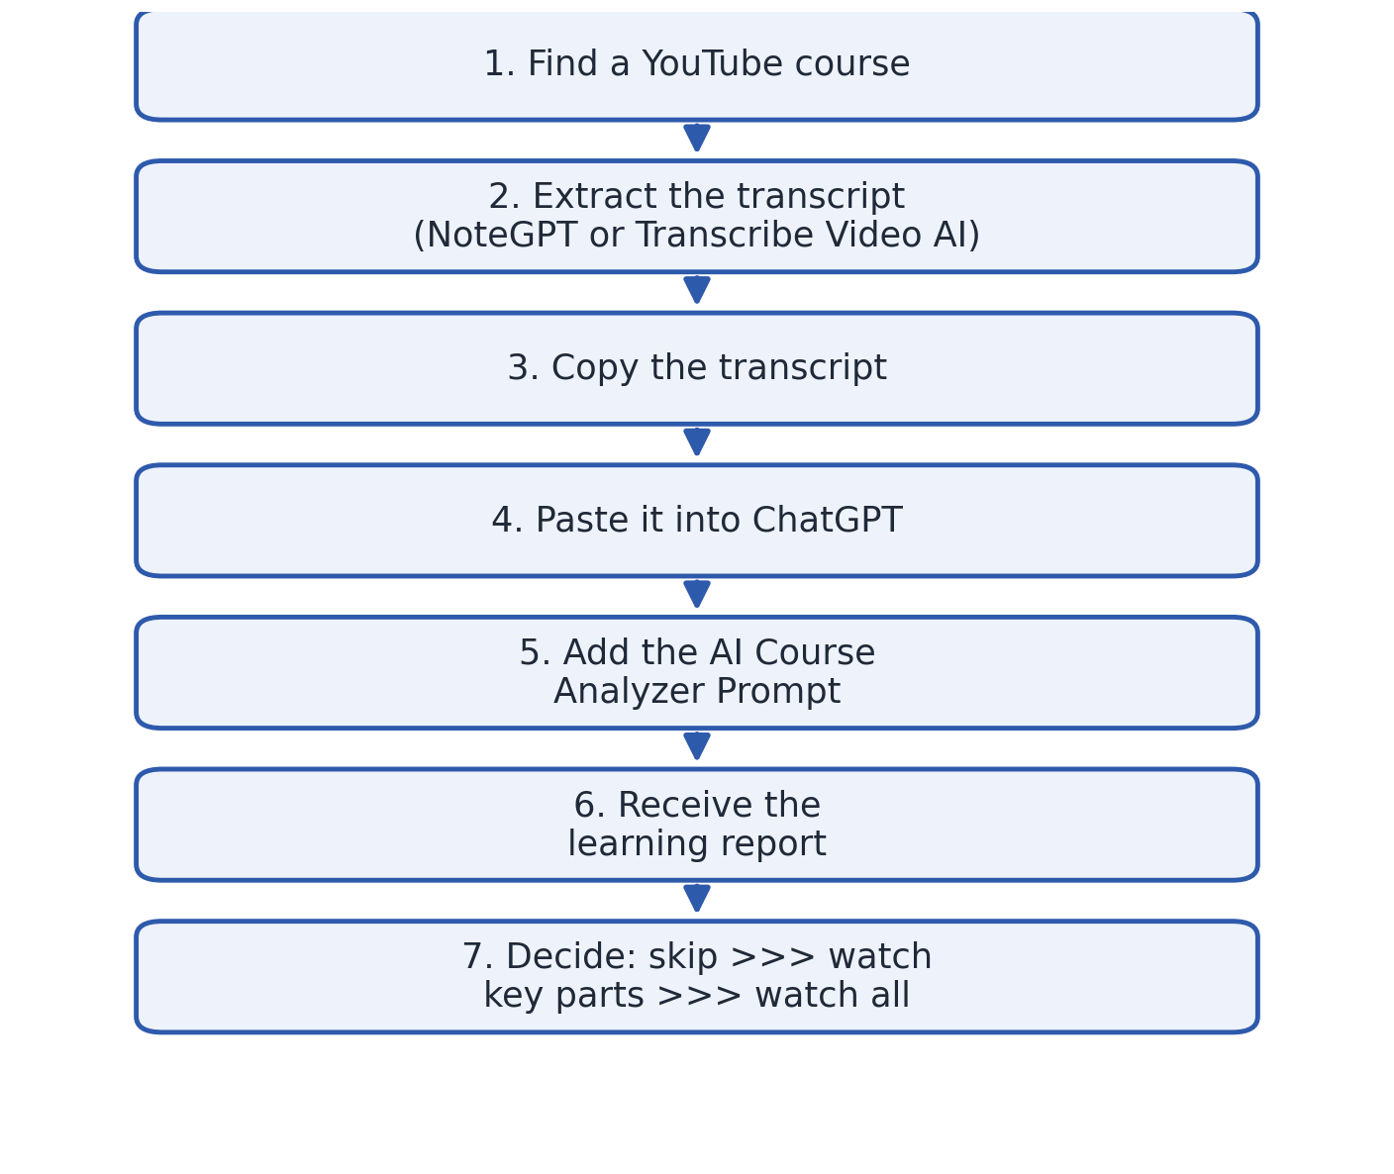

What the AI Should Do With the Transcript
When you hand the AI a transcript along with the analyzer prompt, it should:
- Summarize the course clearly and concisely.
- Strip out filler >>> repeated points, padding, and unnecessary tangents.
- Build a step-by-step action plan you could follow without rewatching anything.
- List every tool, app, or website mentioned in the course.
- Classify each one as Free, Freemium, or Paid.
- Suggest free or lower-cost alternatives where reasonable ones exist.
- Flag any claims that sound unrealistic or exaggerated (for example, unusually fast results or guaranteed income).
- Identify risks >>> financial, technical, or otherwise >>> that the course doesn't clearly warn you about.
- Point out information that seems to be missing or glossed over.
- Give a clear recommendation on whether the course is worth watching, and to what extent.

3. The AI Course Analyzer Prompt
This is the exact prompt to paste into your AI assistant along with the transcript. It's written so the AI adopts the right "role" >>> part learning strategist, part fact-checker >>> and produces a complete, structured report rather than a vague summary. Copy the text in the shaded box exactly as it is.
You are an expert learning strategist, educator, fact-checker, and critical thinking assistant.
Analyze the transcript and produce:
1. Executive Summary.
2. Key Lessons.
3. Step-by-Step Action Plan.
4. Tools, Websites & Resources (purpose, Free/Freemium/Paid, alternatives, essential or optional).
5. Hidden Costs.
6. Course Quality Review (score out of 10).
7. Marketing & Reality Check (identify exaggerations or unsupported claims).
8. Risk Analysis.
9. Missing Information.
10. Should I Watch This Course? (Skip / Watch key parts / Watch all).
11. What Should I Do Next? (clear checklist).
12. Final Verdict: If I only have one hour today, should I spend it on this course? Explain why.

What Each Part of the Report Gives You
To make the most of the report, here's what to expect from each of the twelve sections:
- Executive Summary >>> a short overview of what the course covers, so you get the gist in under a minute.
- Key Lessons >>> the core ideas and takeaways, without the padding.
- Step-by-Step Action Plan >>> the practical steps you'd actually follow, extracted from the course.
- Tools, Websites & Resources >>> every tool mentioned, what it's for, its pricing tier, alternatives, and whether you truly need it.
- Hidden Costs >>> subscriptions, paid tiers, or purchases the course expects you to make but doesn't emphasize up front.
- Course Quality Review >>> a numerical score (out of 10) so you can compare courses at a glance.
- Marketing & Reality Check >>> a flag for any claims that sound exaggerated or too good to be true.
- Risk Analysis >>> anything that could go wrong or cost you time, money, or effort if you follow the course's advice.
- Missing Information >>> gaps in the course that you'd need to research separately.
- Should I Watch This Course? >>> a direct recommendation: skip it, watch specific parts, or watch it all.
- What Should I Do Next? >>> a checklist you can act on immediately.
- Final Verdict >>> a one-hour test: is this course the best use of an hour of your time today, and why?

4. Tips for Getting the Best Results
- If the transcript is very long, some AI tools may truncate it. If your assistant cuts off mid-transcript, split it into two or three parts and ask the AI to analyze all parts together before producing the final report.
- Give the AI context about your goal (for example, "I already know basic Python and want to learn web scraping") so the recommendation is tailored to you, not generic.
- Save reports for courses you're comparing side by side >>> the Course Quality Review score makes it easy to rank several options quickly.
- Re-run the analysis on your own recorded lectures or webinars, not just YouTube courses >>> the same prompt works on any transcript.
- Treat the AI's Marketing & Reality Check and Risk Analysis sections as a starting point for your own judgment, not a final verdict >>> always sanity-check especially bold claims yourself.

5. The Bottom Line
Watching an entire course to find out whether it was worth watching is backwards. With a free transcript tool and a few minutes of AI analysis, you can know in advance what a course teaches, what it will cost you in time and money, and whether it's genuinely worth your attention >>> before you commit a single hour. Analyze first. Then decide.

