Final Year Project (KIE4002)
Progress Report 1

Automated Surface-based Intraoperative Registration for Brain Tumor Resection Using Machine Learning
by
Abdolroauf Rahmani
KIE170720
Supervisor :
Prof. Mahmoud Moghavvemi

Department of Electrical Engineering
Faculty of Engineering
University of Malaya
2020
Table of Contents
1 Introduction and Motivation 3
Imaging Analysis in Healthcare 3
Image Registration in Health Care 4
Registration Algorithms (Page 491) 5
Problem Statement 5
2 Literature Review (OLD) 6
RGB-D intraoperative Registration for Cranial Surgery 6
Medical image segmentation applications 6
Medical Image Segmentation Classification 6
Chronological Classification 6
Other subdivisions of segmentation methods: 9
Current Issues with Segmentation and challenges 9
3 Literature Review (NEW) 10
Theoretical Foundation 10
Projection (3D to 2D) 10
Image Processing and prediction 16
Mathematical models 17
Face normalization: 2D and 3D. 19
Landmark Estimation errors 19
Critical Review of Previous Works 21
2D Representative Method 22
1 One Millisecond Face Alignment with an Ensemble of Regression Trees (Kazemi & Sullivan, 2014) 22
2 3D Facial Landmark Detection Using Deep Convolutional Neural Networks 22
3 (Terada et al., 2018) 22
4 Based on steps: 3D-2D transformation 26
Based on steps: Facial Landmark Detection 27
1 2D landmark detection models 27
3D analysis 28
1 Literature Review Overview 31
4 Methodology 32
Dataset 32
Segmenting Region of Interest 33
Model Training 33
Model Evaluation 34
5 Work Done so Far 35
Classical Vs Neural Networks based Landmark Detection 35
Classical Approaches 35
Neural Network Approaches 35
Implementation of 2D Representative Approach 35
6 Datasets 35
7 RGBD tutorials 35
8 References 36
9 Appendix 37
Previous Methodology 37
2D image representation: 42

Introduction and Motivation
This section will contain the following:
- overview of use of imaging analysis in healthcare
- image Registration in health care
- performance metrics in registration
- many means of improving a given performance
- What is segmentation? General classification of segmentation?
- Different means of doing segmentation: will be covered in literature review
- Software competency/background

Imaging Analysis in Healthcare
Images are the largest source of data in healthcare and so require intelligence to be analyzed. In absence of medical analysis software, clinicians would rely on overworked radiologists to interpret the data. Such interpretation is prone to negligence, oversight, and mistake.
The benefits of algorithm in medical imaging will benefit many stakeholders such as radiologists, non-radiologists, clinical patients, and medical institutions among many others.
Radiologists: Unfortunately there is a limit to number of radiologists to cope with the growing number of tasks in analysis of MRI, CT, PET and ultrasound data. For instance conventional method of image registration was to have it be done manually by such individuals. Automating such process will ease their burden by either only require their attention on flagged data or providing supplementary information to ease task accomplishment. For instance tumor detection algorithms will provide the likelihood of a tumor being either benign or malignant and segmentation of tumor, which helps doctors to focus their work on patients that require immediate attention, and support their diagnostic decision respectively.
Non-Radiologists: Imaging algorithms have the potential to increase accessibility to radiology by enabling non-radiologists such as in under-served areas or paramedics to utilize this expertise, perhaps on their mobile devices.
Patients: with medical imaging assistance from machine algorithms, patients will not only get a more reliable treatment or diagnosis, they will also have to wait a lot less for such process to finish . For instance accurate registration algorithms will help smaller incisions for tumor resection surgery., which will reduce the inpatient duration for recovery.
Medical institutions: places like hospital will be able to increase their revenue. This can be done by reducing manpower, reducing inpatient periods so new patients can be accommodated as well as providing high quality diagnosis, and treatments.
As was highlighted one of the image analysis algorithms is registration of different image data together-different in terms of image modality, or time an image was taken- to increase information density. Since This paper focuses to improve the registration algorithm the background of registration in medical imaging is provided next.

Image Registration in Health Care
Registration is an image analysis technique not only unique to medical field. Registration is a process of alignment and transformation of two images of the same subject. For instance registration of two images of the same part of the body is carried out to determine the correspondence between them. The images will be different depending on the modality of image-CT, MRI, or ultrasound-, the time of capture, or images belonging to different patients. Furthermore registration is carried out when corresponding digital atlas data with acquired image. The variations between images may be due to different imaging methods, artifacts-natural and unnatural misrepresentation in images- ,deform-able subject and phenotype variations between patients. This section will introduce few linear and non-linear algorithms, determine registration performance metrics, current and potential contributions of registration techniques in medicine, and evaluate a research problem.
Registration section: (15 chapters)
- physical and biological factors that introduce distortions
- various linear and non-linear registration algorithms
- Talairach space for brain registration
- addresses interpolation issues inherent in registration
- clinical applications and brain atlases

Registration Algorithms (Page 491)
https://www.sciencedirect.com/topics/neuroscience/image-registration

Problem Statement
To carry out registration all noise must be removed and to do so segmentation of only desired regions is required. This is the scenario for computer assisted surgery where the patient image is taken using depth camera and this image contains a lot of noise/background that the registration algorithm would get lost in.
So this paper proposes use of automatic segmentation on depth images of a patient to extract only the required phases.

Literature Review (OLD)

RGB-D intraoperative Registration for Cranial Surgery
The scope of focus is using intraoperative patient image acquired from a depth camera to carryout registration. One of the image preprocessing methods prior to registration is segmentation/surface extraction. This section will cover the workflow required to compare different segmentation algorithms.

Medical image segmentation applications
In medical profession it is an important step in classification of medical images to carryout preprocessing in form of segmentation or feature extraction. Such techniques will help to improve speed as well as accuracy of classification. Most similarity measures will have a lots of local optima around the global one; they lose their efficiency causing premature convergence or stagnation which are two prevalent confining dilemmas in the optimization field. Although segmentation will be applied to aforementioned case, there are other applications to segmentation in medical field as well:
- In diagnosis and treatment planning segmentation is used to find anatomic structures of interest, for instance tumor segmentation.
- They also aid in quantification of outlined structures and 3d visualization of a given image data.

Medical Image Segmentation Classification

Chronological Classification
There are numerous diverse proposed segmentation techniques being used and researched on, but a common method for all application types is still unavailable. In general segmentation partitions images into different groups based on shared properties. Hence each group will have a homogeneous property. Common properties used for segmentation are color, intensity, texture and reactivity.
This section categorizes common segmentation techniques based on period of abundant usage. Figure below lists common examples under categories of obsolete, ancient and recent techniques for segmentation.
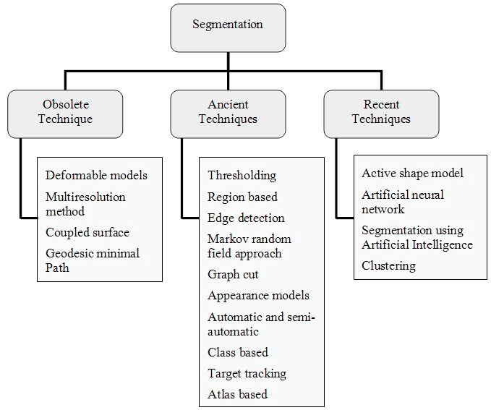Figure 1: Categorization of Segmentation based on period of usage.
Obsolete Segmentation Techniques:
These techniques were developed late 1990s and are mostly not in use anymore. Techniques under this category are geodesic minimal math , multi resolution method, deformable models, and coupled surface. Brief description of each follows:
1. Deformable Models: They describe the boundaries of the objects by means of deformation curvatures or exteriors.

2. Multiresolution Method:
3. Coupled Surface:
4. Geodesic Minimal Path:
Ancient segmentation techniques:
Ancient techniques are also old but are still in use in many applications.
1. Thresholding:
Thresholding is a simple yet power means of segmentation, which is categorized under local and global thresholding . Global thresholding consists of setting an intensity value (threshold) such that all voxels having intensity value below the threshold belong to one phase, the remainder belong to the other. Unlike the global thresholding technique, local adaptive thresholding chooses different threshold values for every pixel in the image based on an analysis of its neighboring pixels. Reliability of thresholding lies on the value of threshold which is determined visually by operator depending on the shape of histogram, or automatically by optimization techniques to compensate for background noise, Otsu’s method, texture analysis using gray-level concurrence matrix, and Kapur’s posterior maximum entropy method. (Sheeba & Manikandan, 2014)
2. Markov Random Field Approach:
Markov random field is a pixel labeling probabilistic approach for image segmentation. This pixel labeling segmentation excerpt features from the contribution picture.
3. Graph Cut
4. Appearance Model:
5. Automatic and Semi-automatic Segmentation:
6. Class based Segmentation:
7. Target Tracking:
8. Atlas based Segmentation:
Recent segmentation techniques:
These segmentation techniques are relatively new in medical imaging. Medical images have some uncertainties. To deal such uncertainties researchers started using intelligent techniques such as neural network, artificial intelligence, fuzzy set, Intuitionistic fuzzy set etc.
segmentation techniques that fall under this category:
1. Active Shape Model:
Active shape models (ASM) were statistical prototypes of the shape of substances that iteratively distort to appropriate to an object in a new image. The shapes are forced through the point delivery prototypical. It is represented by a set of points that are controlled by the shape model. The active shape model algorithm aims to match the model to a new image.
2. Segmentation using Artificial Intelligence:
3. Clustering:

Other subdivisions of segmentation methods:
Functionality:
- thresholding approaches
- region-growing approaches
- classifiers
- clustering approaches
- Markov random field (MRF) models
- artificial neural networks
- deformable models
- atlas-guided approaches
Based on the level of implemented model knowledge:
- manual delineation
- low-level segmentation
- model-based segmentation
Most of these methods are based on two basic properties of the pixels in relation to their local neighborhood: discontinuity and similarity. And based on that we can have classes as region-based methods, boundary-based methods, and their combination.
- region-based methods: (ELABORATE)(Y. Wang et al., 2007) -page 213
- boundary-based methods: (ELABORATE)
- their combination: (ELABORATE)

Current Issues with Segmentation and challenges

Literature Review (NEW)
This chapter includes critical review of recent publications relevant for project as well as theoretical foundations. There are two sub-chapters, (1) Theoretical foundation and (2) Critical Review of Previous Work.
A literature review provides extensive background information on past studies and current knowledge pertaining to the research topic.
A critical literature review is a critical assessment of the relevant literature. It is directly related to the research, providing information on theories, models, materials and techniques used in the research.
The literature review should be comprehensive and include recent publications which are relevant to the research.
To understand the recent developments in this field it is important to know the background theories.

Theoretical Foundation
Do this after finding out what u need to know.

Projection (3D to 2D)
- Cylindrical projection
- orthogonal projection
- perspective projection
pixel intensity is given due to:
- light source
- it would be proportional to depth of image
http://softimage.wiki.softimage.com/xsidocs/tex_basicproc_TypesofTextureProjection.html
https://en.wikipedia.org/wiki/3D_projection
In the 2D system, we use only two coordinates X and Y but in 3D, an extra coordinate Z is added. 3D graphics techniques and their application are fundamental to the entertainment, games, and computer-aided design industries. It is a continuing area of research in scientific visualization.
Furthermore, 3D graphics components are now a part of almost every personal computer and, although traditionally intended for graphics-intensive software such as games, they are increasingly being used by other applications.
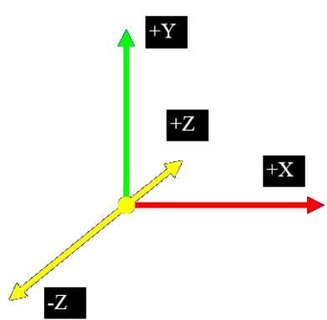
Parallel Projection
Parallel projection discards z-coordinate and parallel lines from each vertex on the object are extended until they intersect the view plane. In parallel projection, we specify a direction of projection instead of center of projection.
In parallel projection, the distance from the center of projection to project plane is infinite. In this type of projection, we connect the projected vertices by line segments which correspond to connections on the original object.
Parallel projections are less realistic, but they are good for exact measurements. In this type of projections, parallel lines remain parallel and angles are not preserved. Various types of parallel projections are shown in the following hierarchy.
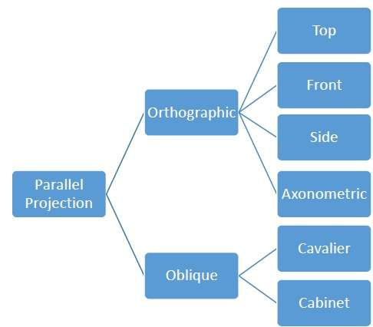
Orthographic Projection
In orthographic projection the direction of projection is normal to the projection of the plane. There are three types of orthographic projections −
- Front Projection
- Top Projection
- Side Projection
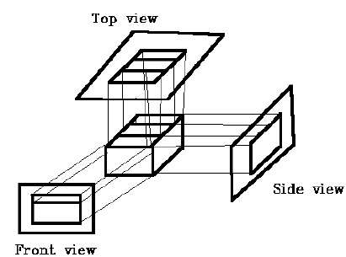
Oblique Projection
In oblique projection, the direction of projection is not normal to the projection of plane. In oblique projection, we can view the object better than orthographic projection.
There are two types of oblique projections − Cavalier and Cabinet. The Cavalier projection makes 45° angle with the projection plane. The projection of a line perpendicular to the view plane has the same length as the line itself in Cavalier projection. In a cavalier projection, the foreshortening factors for all three principal directions are equal.
The Cabinet projection makes 63.4° angle with the projection plane. In Cabinet projection, lines perpendicular to the viewing surface are projected at ½ their actual length. Both the projections are shown in the following figure −
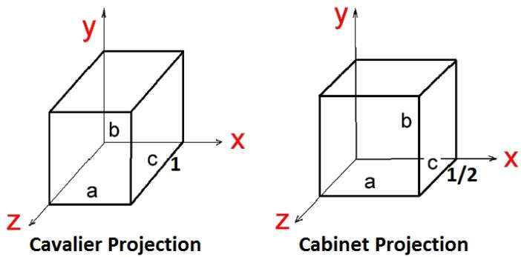
Isometric Projections
Orthographic projections that show more than one side of an object are called axonometric orthographic projections. The most common axonometric projection is an isometric projection where the projection plane intersects each coordinate axis in the model coordinate system at an equal distance. In this projection parallelism of lines are preserved but angles are not preserved. The following figure shows isometric projection −
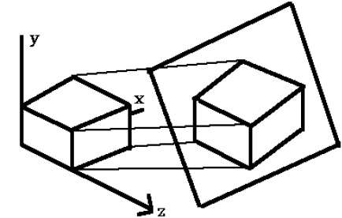
Perspective Projection
In perspective projection, the distance from the center of projection to project plane is finite and the size of the object varies inversely with distance which looks more realistic.
The distance and angles are not preserved and parallel lines do not remain parallel. Instead, they all converge at a single point called center of projection or projection reference point. There are 3 types of perspective projections which are shown in the following chart.
- One point perspective projection is simple to draw.
- Two point perspective projection gives better impression of depth.
- Three point perspective projection is most difficult to draw.
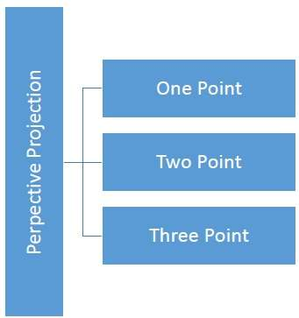
The following figure shows all the three types of perspective projection −
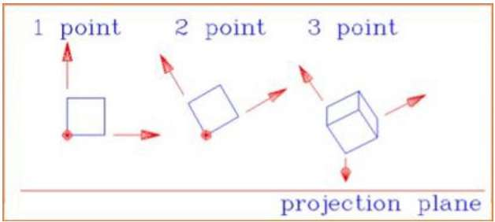

Image Processing and prediction
- Regression method
  - Regression function
    - linear regression
    - ridge regression
Generally, to decrease the cost function, we increase the number of features in our model. As we keep on increasing the features in model, model starts fitting the training data set well and cost function value starts decreasing.
But, with increase in number of features; our equations becomes a higher order polynomial equation; and it leads to overfitting of the data.
- loss function
- ensemble of regression trees
- illumination variation and texture
https://en.wikipedia.org/wiki/Image_texture
- local feature extraction
- landmark identification

Mathematical models
Inference models
- Hidden Markov Model for landmark identification
hidden states. The other is a general random process, the probability distribution of the observation in every state, which describes the statistical relationship between hidden states and observable
states.
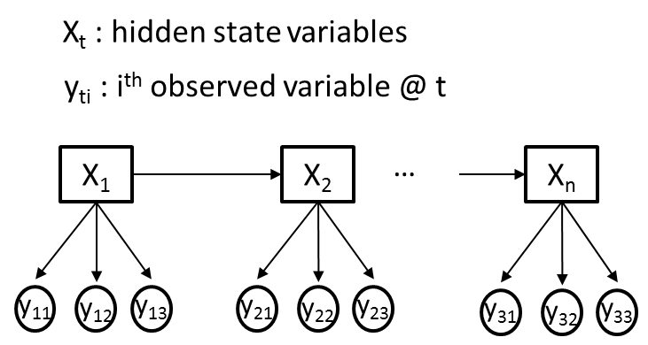
A discrete HMM can be expressed as l 1⁄4 ð p ; A; BÞ, which is shown as follows.
p 1⁄4 ð p 1 ; p 2 ; /; p N Þ (4)# #
A 1⁄4 a ij N#N (5)##
B 1⁄4 b j ðv k Þ M#N (6)
where p is the initial probability of HMM, N is the state number, M is the observation number, A is the state transition probability matrix, a ij means the probability of being in state i and transiting to state j, B is the observation probability matrix, b j ðv k Þ means the probability of being in state j and observing v k .

- ANNs
- heuristic algorithms (GA), SAA
- probabilistic inference model where the inference is over Hidden Markov Model
- Spin image and spin fields

Face normalization: 2D and 3D.
- 3D:
facial scale
facial position
- 2D

Landmark Estimation errors
The simplest comparison is a root mean squared error (RMSE) assessment; where the average distance between each of the N predicted landmarks (x^{p}_{i}, y^{p}_{i,} z^{p}_{i}) and the corresponding ‘ground truth’ (x^{t}_{i}, y^{t}_{i,} z^{t}_{i}) is calculated on a per landmark basis. Landmarks that are poorly predicted will be positioned far their corresponding ground truth locations and thus contribute to increasing the RMSE value. Often the root mean squared error is normalised by the distance between two specific ‘ground truth’ points (NMRSE) such as the left (x^{t}_{le}, y^{t} _{le,} z^{t} _{le}) and the right (x^{t}_{re}, y^{t} _{re,} z^{t} _{re}) outer corners of the eyes d_{norm} (see Eq. ) [10] to allow a fair comparison between faces of different sizes
(1)
(2)
(3)

When comparing the performance of different landmarking algorithms against the same dataset, the average RMSE or NRMSE value over the number of samples in the dataset (K) may simply be reported. A more detailed summary of the model performance can be provided using the cumulative error distribution (CED), which plots the cumulative NRMSE against the proportion of images with an NRMSE of less than or equal to a particular value. (Johnston & Chazal, 2018)
A less frequently reported metric is the landmark detection rate, i.e. the proportion of the N landmarks from the K images, correctly identified by the system. A landmark is correctly identified if its position is less than a defined Euclidean distance from the ‘ground truth’. Similarly to the mean squared error calculations, landmark detection rate can also occur on a per-image, per-landmark, and overall average basis.

Throughout this review paper we will use normalised root mean squared error (NRMSE), providing point-to-point CED plots to compare the performance of different landmarking methodologies.

Critical Review of Previous Works
Before studying and review recent publications, it is important to define the parameters of landmarking for this project. On one hand, emerging applications require that the landmarking algorithms run in real-time while operating with the computational power of an embedded system, such as intelligent cameras. On the other hand, these applications require increasingly more robust algorithms against a variety of confounding factors such as out-of-plane poses, occlusions, illumination effects and expressions. The details of these confounding factors that compromise the performance of facial landmark detection for this project is determined:
- Variability: Landmark appearances differ due to intrinsic factors such as face variability between individuals, but also due to extrinsic factors such as partial occlusion, illumination, expression, pose and camera resolution. Given MRI images are the data analyzed, this project requires relatively high intrinsic variability but very low extrinsic variability.
- Number of landmarks and their accuracy requirements: minimum number of landmarks is to be 11 (6 eyes, 3 nose, 4 mouth). It has been recorded by (Çeliktutan et al., 2013), with increase in 3 to 68 landmarks, there is 50% accuracy improvement, hence higher landmark numbers are favorable. Given that landmarks are to be used for registration, they are to be accurate within +-2mm compare to expert annotators (Liu et al., 2017).
Relevant papers can be divided into two groups based on method of approach to obtain 3D facial landmarks. Firstly is to analyze the 3D model and identify landmarks on it. Secondly is to convert the model into a representative 2D image and identify the landmarks. This chapter consists of two sub-chapters, (1) 2D representative Method, and (2) 3D Methods. Each sub-chapter will involve summation of relevant points from the papers and then their review in accordance to the project requirements.

2D Representative Method
Why use this approach?
“The detection of the facial landmark requires the normalization of the facial scale and position among in the 3D image data to analyze the facial shape. Therefore, it is difficult to obtain accurate facial landmarks from 3D facial images. “ (Terada et al., 2018)
This would mean that face normalization is more difficult in 3D

Real-time facial feature detection using conditional regression forests (Dantone et al., 2012)
asdas

One Millisecond Face Alignment with an Ensemble of Regression Trees (Kazemi & Sullivan, 2014)
Their innovation is the use of 2 elements from past researches resulting in a cascade of high capacity regression functions learnt via gradient boosting. Instead of regressing shape parameters based on the raw image, the normalized image obtained from initial estimate, is used. This process is repeated several times until there is a convergence of the shape parameters. Second element is the assumption that the predicted shape lies in a linear subspace. Based on this assumption the number of potential shapes considered for inference/prediction is reduced. This helps avoiding the local optimas. Hence a regression model that predicts shapes in a linear space is used. To produce such regression models gradient boosting is used.

3D Facial Landmark Detection Using Deep Convolutional Neural Networks (Terada et al., 2018)

Paper Summary:
In order to project 3D image this paper uses cylindrical projection. Given that the point cloud of face surface is given by Cartesian coordinates, points are converted into cylindrical coordinate system as follows:

A 2D representative is obtained by getting p(θ, z) where the pixel value becomes the p value. Furthermore the projected image is coped to only give the frontal face image.
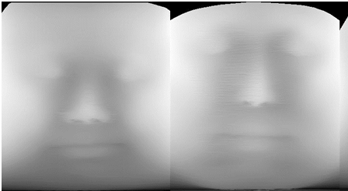
input image is a cylindrical projection of 3D face model. This paper makes use of regression function whose implementation uses CNN. The CNN network architecture used was ResNet:
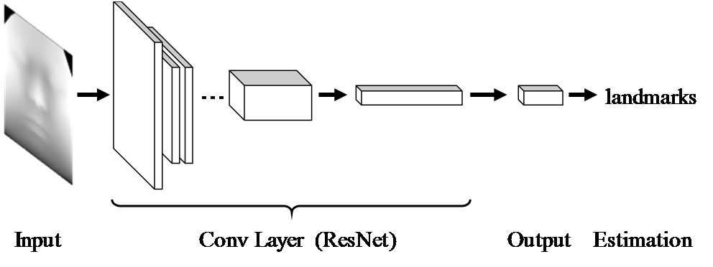
The loss function used, mean square error, to assess the performance of model. Loss function is given as below :

ResNet18 and ResNet34 were used with and without data augmentation. Augmentation dataset used translation and scaling to increase the variability and quantity of data.
After obtaining the landmark, the coordinates were inverted into Cartesian form using:

The 2D image generated for identification model was sampled at 360 horizontal and 400 vertical to give 360 x 400 2D image.
Review:
The paper doesn’t mention about the location of the origin or the scaling and equation of transfer function p. This choice will effect the resolution of the obtained image. Best origin location is assumed to be located at same level as tip of the nose and lying on the vertical rotation axis of head. This would ensure good pixel value deviation.
Furthermore they mention that the ears and the neck should be ignored, which could imply that image is to be segmented using face detection algorithms.
The image that they have generated is not very clear and has little information on specific edges, shade of facial part, wrinkle and skin color. There is lack of information on best scales for p(θ, z) which would affect 2D image resolution as well as contrast. Furthermore it has error of 11 pixels using ResNet34 with data augmentation. The error given is the mean error for 14 points and it is hypothesized the landmark numbers can not be increase as the error could become more due to lack of image clarity.

It is not possible to evaluate this technique without distance errors in 3D as well as registration error, eventhough it unlikely that the error is less than +-2mm. But the use of cylindrical projection is a very useful method as it would allow for 2D representative image generation that doesn't require the landmarking algorithm to carryout significant geometric normalization. Reducing burden on normalization could mean more accuracy as the main purpose of using 3D images for facial landmark detection is that 2D images have more geometric variations, among other variations. There is no justification for use of CNN model in this paper.

Overall approach
- (Terada et al., 2018)
A. Landmark detection for 2D images
Cootes et al. proposed the methods to extract facial
landmarks from facial shape or facial appearance, such as
Active Shape Model [12] and Active Appearance Model [13].
Uricár et al. proposed a method using the Deformable Part
Model [14]. Their method needs to clear the difference of
brightness for high accuracy. Since Krizhevsky et al. [15] won
the benchmark contest on generic object recognition, research
on the deep learning of facial recognition became popular. Sun
et al. [16] proposed a method using CNN-based cascade
architecture. Zhan et al. [17] obtained high accuracy using Deep
Multi-task Learning.
- (Rama et al., 2008)

- (Cootes et al., 1995)
Very old

- (Nair & Cavallaro, 2009)

- (Kazemi & Sullivan, 2014)
in folder

Based on steps: Facial Landmark Detection

2D landmark detection models
Facial landmarks methods can be divided into three categories: generative methods, discriminative methods and methods combining the two, producing statistical methods. Generative methods, make use of Active Shape and Appearance models. Discriminative methods infer face shape by training a regression function(s) that maps image values to facial landmark coordinates. This section introduces landmark detection models and compares Discriminative to non- Discriminative .

3D analysis
- (Segundo et al., 2007)

- (Nair & Cavallaro, 2009)
in folder
- (Böckeler & Zhou, 2013)
available in folder

Coupled active shape models for automated segmentation and landmark localization in high-resolution CT (Brehler et al., 2019)

Why use it?

- (Liu et al., 2017)
Given in paper:
Generally, there are two major issues regarding the anatomical landmark identification, i.e., local feature extraction and identification algorithm. They use spin image (SI) to extract the local features and Hidden Markov Model (HMM) to implement the landmark identification. 11 HMMs were trained and evaluated in this study.
RBFANN performance is lower than HMM but it’s doesn't mean all ANN are bad. There are many ANN techniques such as BPANN and ANNs with heuristic algorithsm such as GA and SAA that improves inference effect.
3 reasons why ANN may not be as good here:
- take longer specially when network size is large
- rarely it is used for dynamic patters as it has poor descriptive ability for this case.
- Easily confined in local optimums which leads to negligence of optimum value.
Data and Sampling: slice interval of 5mm. Sample size 120 with 23,000 points per sample.
Method used: Spin image representation of orientation points are used to characterize the local features. Local features with coordinate given by x are converted to cylindrical coordinate (alpha, beta) by:

Only values of beta and alpha that meet a certain criteria are placed in the spin image. The spin image of given orientation point is very redundant and due this dimensional reduction using Discrete Cosine Transform type II is used.
This reduces the dimension from a 2D matrix of alpha and beta to a vector. The geometrical features of each landmark are characterized by their projection after dimension reduction.
HMM models with 3 to 8 states, and observable states that provide the SI of the landmark is built to predict each landmark. Baum-Welch algorithm was used to train the landmark HMM. The discrete HMM is iterated till following a criteria is met. The goal of probabilistic inference over HMMs is to find optimal matching between random landmarks and the trained HMMs, which has the maximum matching probability. The SI s that provide the maximum probability and meet the predefined threshold are identified as landmarks.
Results: The maximum landmark recognition rate is 95.9%. with +- 1.6mm vertical and 3mm horizontal error. Effect of SI parameters ,such as Bin Size and Support Angle, on IAR ( identification accuracy rate) were empirically studied. It is better than ANNs in accuracy, robustness and adaptability.

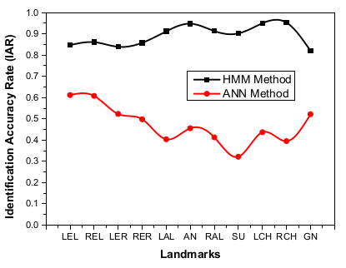
Evaluation: Three hierarchy experiment is used to test the validity and reliability. The three hierarchy preliminary experiment consisted of single palpating on nasal part by single participant, repetitive palpating on nasal part by single participant and single palpating on nasal part by a population of participants. The procedure is well defined for all 3 experiments.
Review: They claim the reason their error is somewhat high because the sampling interval was no more than 1.6mm due to data having slice interval of 5mm as well as due to hole filling and noise reduction. And so if a different sampling method is used the level of error may reduce. There is no citation of ANN application in facial landmark detection and so the paper feels biased and requires more investigation. Overall they pitch a promising method. This paper makes use of local feature extraction so what of global feature extraction? Why is that not possible?
The dataset used is only for Chinese soldiers in a given range, so the reliability of model in general has not been assessed.
- (Križaj et al., 2020) :
https://link.springer.com/article/10.1007/s00521-019-04529-7#additional-information

Literature Review Overview
This section will summarize the technologies and techniques used currently and based on such a focus will be determined.
3D-to-2D methods make use of projection techniques such as orthogonal, perspective, and most used technique: cylindrical projections. The 2D image is then used to obtain the facial landmarks whose methods can be divided into three categories: generative methods, discriminative methods and methods combining the two, producing statistical methods. Generative methods, make use of Active Shape and Appearance models. Discriminative methods infer face shape by training a regression function(s) that maps image values to facial landmark coordinates.
Second method is use of feature extraction techniques and based on features and predefined set of rules, a model is used to identify the landmarks.

Methodology
Methodology is based on the goal to construct an automatic facial landmarking system with performance (specially accuracy) comparable to that of an expert human annotator, using MRI images. To do so the work flow below is carried out to select to best model for application:
flow chart

Dataset
Database of MRI scan with annotated facial landmarks are scarce and alternative to that is use of BrainWeb: Simulated Brain Database (Cocosco et al., 1997). This is pre-computed simulated brain database (SBD), the parameter settings are fixed to 3 modalities, 5 slice thicknesses, 6 levels of noise, and 3 levels of intensity non-uniformity. Despite it’s very late initial release it has been used for papers such as (Qi et al., 2020) The subset of database used will be the normal brain database with following characteristics:
Characteristics | Values/types
Modality (pulse sequence) | T1 | T2 | PD
Slice thickness  /mm | 1mm | 3mm | 5mm
Noise (relative to the brightest tissue)  / % | 0 | 1 | 3
Intensity non-uniformity (“RF”)  / % | 0 | 20 | 40

The dataset covers large variation of data to ensure results are of the general cases. The software used will be 3DSlcier and using it’s ITK library the MINC file format will be loaded. This database unlike others is completely open source. There are other relevant databases that were considered:
Name | Description | Data | Need to register | Ref.
Neuromorphometrics.com | Manually labeled MRI Brain Scans | T1-weighted MRI, labeled volumes | No
SchizConnect | SchizConnect is an open, public search-and-download virtual database for schizophrenia neuroimaging (MRI) images and related data. | Structural, Diffusion and Functional MRI datasets, cognitive and clinical assessments | yes | (L. Wang et al., 2016)
Ultrahigh resolution T1-weighted whole brain MR dataset | T1-weighted MR data acquired using prospective motion correction at an ultrahigh isotropic resolution of 250 µm. | Structural MRI dataset including scanner's raw to processed data | No | (Lüsebrink et al., 2017)

Segmenting Region of Interest
The next stage is to extract only those features from the data relevant for solving the defined problem. For automated facial landmarking we must detect and extract the face of interest from the image and discard irrelevant information such as the background. This face detection process forms the first stage of an automated landmarking system and is critical for overall performance. The system must accurately identify and locate the face within the image, given variations in lighting, pose, expression, and face appearance. To do so the process involves firstly skin segmentation and then clipping skin to only get ROI, which is the face point cloud starting from the end of ear to the nose tip using coronal plane. All MRI data are stored to give an image represented in same manner in the coordinate system, which makes the task relatively simple. More detail is presented in the Wrok Done so Far chapter.

Model Training
Definition of model architecture: which model will give the best performance?

Model Evaluation
For evaluation normalised root mean squared error (NRMSE), providing point-to-point CED plots will be used to compare the performance of different landmarking methodologies. The formual used is as given in Model Estimation Error sub chapter of literature review.

Work Done so Far
This chapter will cover the progress done in first semester in accordance to objectives given in the proposal. There are two subsections, (1) Classical Vs Neural Networks based landmark detection (2) Implementation of 2D Representative Approach. First sub-chapter will cover the theoretical differences between classical methods and Neural network (NN) methods to accomplish the first objective. Second sub-chapter will cover the implementation progress of 2D representative method based on cylindrical projection (Terada et al., 2018) and cascaded regression model for landmark identification algorithm (Kazemi & Sullivan, 2014).

Classical Vs Neural Networks based Landmark Detection
This sub-chapter will cover the overview of landmark detection techniques for classical and neural network approaches. After which a qualitative comparison is carried out.

Classical Approaches
Most algorithms for facial landmark detection can be classified as either model-based or regression-based. Model-based approaches learn constraints on the arrangement of landmarks relatively to each other. Here the locations of landmarks are often constrained by other landmarks. The most common models are Active Shape Model (ASM), Active Appearance Model (AAM) and Constrained Local Model (CLM).
Regression-based approaches do not have an implicit shape model. They instead operate directly on the image and regress the coordinates of the landmarks. Cascaded regression approaches run multiple regression models consecutively, each one refining the predictions of its predecessor.
These are the most important classical approaches as was presented in (Taskiran et al., 2020) and (Johnston & Chazal, 2018).

Active Shape Models (ASMs)
Introduced in 1995 by (Cootes et al., 1995) , ASMs are an algorithm that place constraints on the locations of individual landmarks. Possible shape ,vector representation of an object, variations are learned from the training set and stored in a Point Distribution Model (PDM). PDM is a shape description technique that stores shape mean geometry and the geometric variations between shapes of same training set. Using Principal Component Analysis (PCA), variations in PDM are used to obtain a basis of shape parameters, from which new shapes can be generated.
When model is trained, Locating landmarks involves finding shape parameters that correspond to a shape as close as possible to the test image. The initial location estimates are set to be the mean of the training set. Then, iteratively a local region around each landmark is analyzed. This is then used to update the pose and shape parameters to best fit the new landmark locations. The shape constraint is maintained by only changing the landmark locations indirectly through shape parameters as opposed to directly changing them. This process is repeated until convergence.
Figure 2: visualizing the ASM process. Red dots represent the test image. Green dots are estimate values of the shape of test image. The estimates are iterativly and indirectly changed to obtain best representation of test image. Best representation is one with lowest difference with the test image.
ASMs are fast simple,and can be efficiently extended to 3D to provide 3mm to 8mm accuracy (Smolyanskiy et al., 2014) . Furthermore there is a reasonable reliability based on data variation , 93.5% (Lee et al., 2015). However the method is not sufficiently accurate enough to be used to provide landmarks for registration, and any improvements may be unlikely as accuracy has remained at 3mm at best (Brehler et al., 2019).

Active Appearance Models (AAMs)
After success of ASM, the author introduced AAMs (Cootes et al., 1998). The main difference to ASMs is that texture variation around the landmarks is learned in addition to the shape variation. AAMs are appearance models, such models include the distribution of the data itself, and generates how likely a given example is. Landmarks in unseen images are located by finding shape and appearance parameters that minimize the difference between the generated image and the test image.
The shape model is built in the same way as in ASMs. The appearance model learns the appearance variations in shape-free images. A shape-free image is obtained by aligning the original image with the mean image. To generate a synthetic image, first the appearance parameters are used to generate an image that is shape-free. Then the shape parameters are used to change it to the desired shape.
To find the optimal shape and appearance parameters, the error between the original image and the synthesized image is minimized. A key difference with ASM is that AAMs are a holistic model where they attempt to minimize difference with the whole image as opposed to an small local area.
ASMs are more accurate and faster than AAMs, but the latter are able to better match the texture. Furthermore AAMs suffer from lightning changes. For our project applications AAMs can be used on the 2D represented images. However this representation doesn't contain a lot of texture information, because the image is in gray-scale with little contrast. In another hand, 3D method of landmarking primarily contains shape information as opposed to textual information (refer to figure TODO for lack of texture information). Another downside to AAMs is that they are holistic which would entail lower landmark accuracy.

Constrained local models (CLMs)
Proposed in (Cristinacce & Cootes, 2006) , CLMs are another shape models. CLMs are similar to AAMs as both model the shape and appearance variations of object. The main difference with AAMs is that, CLMs model the appearance around each landmark, whereas AAMs model the whole object. The appearances are modeled in local templates.
When using the CLM to locate landmarks, the shape and appearance models are used to generate estimated locations and texture templates around each landmark. Then for each landmark the correlation between the template and the actual image at this position is computed. The iterative fitting process maximizes these correlations while respecting shape constraints.
A member of CLMs family, the Convolutional Experts CLMs achieved a mean difference error of about 5.31mm for 68 landmarks (Zadeh et al., 2017) . Just like AAMs, the algorithm relies heavily on texture information and our project lacks such information.

Regression and cascaded regression
An alternative to shape based models is regression-based approaches. Regressors can be cascaded or cascaded.
An example of non-cascaded regression for facial landmark detection is use of random forest found in (Dantone et al., 2012) . There is one random forest for each of five head pose ranges and during inference the predictions of each random forest is weighted by the probability of this specific head pose. Each random forest is only trained on one specific head pose. This allows the random forest to focus on the appearance specific for that head pose. In addition to the actual regressors for the facial landmarks, a regressor for the head pose probability is trained.
An example of cascaded regression in facial landmark detection is by (Shizhan Zhu et al., 2015). The cascaded regression patter, is used to search the shape spaces to obtain one that contains all shapes seen during training. In each stage the best fitting shape is picked and then refined in the next stage. This is done by restricting the search space to the most likely candidates. In the last stage the final predictions are computed. Their approach does not require an initial estimate for the location of the landmarks. Moreover, by starting from a coarse scale (considering all possible shapes with all possible poses) and refining the shape space on each cascade level, the algorithm is less prone to local minima. They use different features on each level. The first level makes use of less accurate features while the last stage uses more accurate features. Due computation quantity the first level is fast while second level is slow. Splitting the computation allows for real-time application.
Cascaded regression can provide better robustness against data variations compare to non-cascaded regression. Furthermore they can provide real time performances. Regressors can model complex appearance variance that is caused by different facial expressions, and face variability between individuals. This method is primarily being used on 2D data as it provides a fast means to normalization and noise reduction. It’s application for MRI facial landmark detection is difficult to determine as despite providing less than optimum normalized RMS (0.49), the value can be further improved by averaging values of 3D coordinates from different face poses.

Neural Network Approaches

Implementation of 2D Representative Approach

Datasets
- https://www.researchgate.net/post/Is-there-a-dataset-of-human-faces-with-depth-data-and-anthropometric-measurements
- https://github.com/IntelRealSense/librealsense/issues/3518

RGBD tutorials
- https://maciek-slon.github.io/ecovi/

References
Automatic citation updates are disabled. To see the bibliography, click Refresh in the Zotero toolbar.

Appendix

Previous Methodology
Collect point clouds using depth camera and store in right format.
3 data sets is required:
- Phantom: head phantom PC from RGBD camera, and accurate model for the phantom in 3d slicer
- use own face: PC, and MRI
Method 1: store into PLY and then import it into 3d Slicer:
- IntelRealsense allows saving of pointclouds into PLY or PCD file format.
- PLY file format can be used in 3d slicer
Chose of registration framework

Evaluate the quality of point cloud:
- What is the optimal distance for registration evaluated by nearest neighbor registration error criterion. Use a skull phantom to do do this.
The scope of focus is using intraoperative patient image acquired from a depth camera to carryout registration. One of the image preprocessing methods prior to registration is segmentation/surface extraction. This section will cover registration framework required to compare different segmentation algorithms, and compare mine with them.
This registration framework is based on the Point Cloud Library that easily integrates into clinical workflows. Optimal parameters such as light intensity, distance for the camera and object of interest will be empirically determined. To evaluate the registration approaches firstly rigid object registration of MR image is done against a RGB-D of it’s phantom, and secondly MR image of a patient against their RGB-D image.
Optimal Experiment Condition Evaluation
We first investigated the effect of lighting conditions and distance between the RGB-D camera and object of interest on registration accuracy. This evaluation was performed using an anatomical phantom for which we acquired a CT scan. We then evaluated the registration framework performance using MR data from two subjects and the effect of three simulated patient setups on accuracy.
To obtain good registration performance for a given setup, the effects of lighting conditions and object distance will be analyzed to determine optimal registration setup. To do so a phantom with it’s MRI or CT scan will be used under the following conditions:
Cam Distance (C_{m})/m | 8 | 7 | 6 | 5 | 4 | 3 | 2 | 1
Light source distance(L_{m})/m | No light source in the room | 7 | 6 | 5 | 4 | 3 | 2 | 1

The distance values will depend on the specifications of RGB-D camera being used, but in general the first testing should cover from the max distance to minimum distance with linear spacing to create 8 samples. Based on the observed results a range for optimal distance and light is obtained, e.g. 5 to 4m for camera and 7 to 6 for light. Based on obtained rage, another testing is carried out as below:
C_{m}/m | 5.5 | 5.25 | 5 | 4.75 | 4.5 | 4.25 | 4 | 4.75 | 3.5
L_{m}/m | 7.5 | 7.25 | 7 | 6.75 | 6.5 | 6.25 | 6 | 5.75 | 5.5

The second testing has a range of upper bound of optimal result in last test added by the linear spacing of last test divided by two (5+(7-6)/2=5.5). similar method is done for lower bound (4-(7-6)/2). Few other tests are carried out till the spacing between bounds is about 0.5cm.
To reduce time spent on this testing certain actions can be considered. The first test must be carried out as is to ensure that the accuracy of image is somewhat linear and there are no anomalies. Second test onwards, we can carryout the test in a similar manner as that of bisection curve fitting method. This would entail changing the bound with lower accuracy with that of bisection of the bounds. This would be carried out only if the results were continuous and have no expected asymptotes. Alternative to this method could be other curve fitting methods, which would be selected based on the pattern of the first test.
To carryout the testings the camera, phantom and the light source will be placed on tripods and placed on same level.
Evaluation
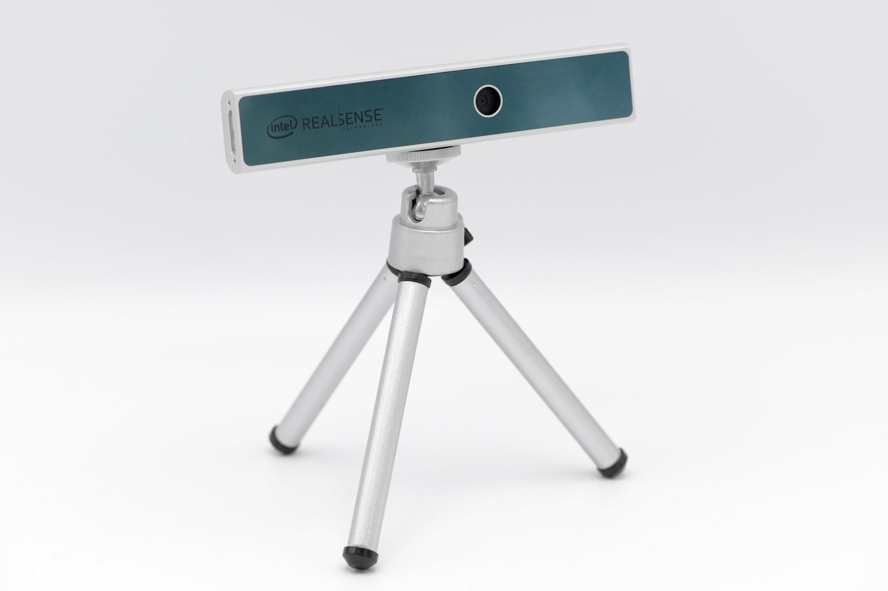Figure 3: Depth cameras typically come with their own small tripod, and so phantom has to be raised only by a bit.
After obtaining point cloud of object in the testings the PLY file will be saved and used to evaluate it’s performance in 3DSlicer. To do so we carryout two evaluation methods, firstly segmented part of point cloud of ROI is registered and similarity is obtained and used for comparison. Secondly to further analyze the effect of distance on the result, a distribution graph of ROI points is drawn. Based on these methods optimal setup parameters are obtained.
Evaluation for Surgery Setup
Beside knowing the best parameters it is also useful to know the best parameters given that we are simulating a surgery setup, for instance the orientation of object, and the preferred light intensity in the operating room, etc. To do evaluate conditions that would also satisfy surgeons, requires an interview. Surgery setup based on the orientation of head can be one such conditions.
To evaluate the effect of patient orientation, the following 3 tests will be carried out:
- patient in the supine position
- supine with headrest
- prone
Framework:
To evaluate the registration for proposed segmentation method it is important to compare it’s results with other approaches within the same environment, and to do such the above framework is used.
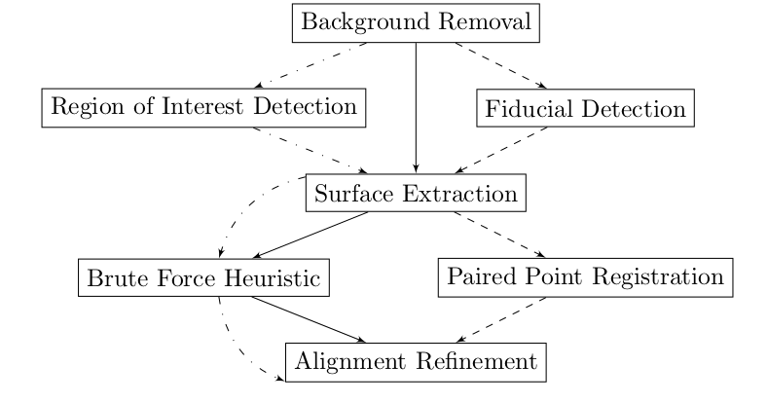Figure 4: Registration framework flow diagram. Different registration approaches are distinguished by different flows in the chart. Solid path shows flow for controlled rigid body registration without any image preprocessing. Dashed path is the fiducial rigid body registration approach. And the dashed path with dots is the ROI (region of interest) registration. The latter two registration are common segmenting registration.
The common first step in the framework is to obtain a surface model from the preoperative volume image-CT or MR. For desired region this can be done by using thresholding techniques in the open-source software of 3DSlicer.
The algorithm used for surface registration is ICP (iterative closest point) algorithm. The first approach, shown as solid lines in figure, makes uses raw surface data in ICP. The second approach , shown as dashed lines in the figure, requires determination of ROI in the intraoperative image by specifying points and then use this segment in ICP. The third approach, shown as dashed and dotted line in figure, requires identifying anatomical landmarks in preoperative image that are also present in the intraoperative one. Next section will cover each approach in detail.

2D image representation:
Data augmentations:
Workflow
For the data argumentation, the 2D images were
expanded to about 16,000 images by vertical flip, translation,
and scaling. The translation and scaling processing varied 10%
against the size of images.
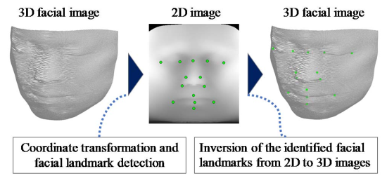
Projection methods:
https://stackoverflow.com/questions/8633034/basic-render-3d-perspective-projection-onto-2d-screen-with-camera-without-openg?rq=1

