

Social Media Crisis Analytics
A Medallion Architecture Approach to Crisis Misinformation Analytics

Group Members
Omar Khaled
Abdalrahman Maher
Refka Maged
Supervisor: Eng. Mohamed Alemam
DEPI – Digital Egypt Pioneers Initiative | Data Analytics Track
Graduation Project Documentation – July 2026

Abstract
With the rapid growth of social media, crises of every kind – natural disasters, service outages, security incidents, and public-health events – now unfold in public view in real time, and misinformation can spread faster than official responses. This project presents a complete data analytics solution built on a simulated Social Media Crisis Dataset covering 50,000 posts collected from Twitter, Reddit, and Facebook during the lifecycle of a crisis.
The project transforms raw, unstructured social posts into an interactive Power BI dashboard using a Medallion Architecture implemented in Python. The pipeline is organized into Bronze, Silver, and Gold layers, ensuring traceability, data quality, and a clean Star Schema ready for analysis.
The raw data was cleaned and transformed using Pandas and NumPy: missing values were imputed, columns were standardized, and a Star Schema of one fact table and nine dimension tables was built. The cleaned model was then visualized in a five-page Power BI dashboard covering post volume, sentiment, credibility, engagement, and behavioral trends, with DAX measures driving every KPI.
The final system helps crisis-response and communications teams monitor how a crisis narrative evolves, flag high-risk and low-credibility content, and track engagement and misinformation trends across platforms, topics, and time – turning raw social chatter into an early-warning analytics tool.
The project also extends beyond the core pipeline: exploratory data analysis and an early misinformation-risk prediction model were developed to complement the dashboard, alongside a dedicated UI/UX design pass in Figma that shaped the dashboard's visual layout and navigation.

Table of Contents
Chapter 1: Project Overview 4
1.1 Introduction 4
1.2 Motivation 4
1.3 Project Objectives 4
1.4 Dataset Description 4
1.5 Project Team and Roles 5
Chapter 2: Data Engineering and Implementation Framework and Analysis 6
3.1 Data Cleaning Process 8
3.2 Python Implementation 8
3.3 Data Transformation Results (Star Schema) 8
Chapter 3: Framework and Analysis 8
2.1 Tools and Technologies 6
2.2 Methodology (Medallion Architecture) 6
2.3 Analysis Requirements and KPIs 7
Chapter 4: Design and Visualization 10
4.1 Dashboard Design and Layout 10
4.2 Power BI Dashboard Implementation 10
4.3 Dashboard Insights and Analysis 10
Chapter 5: Validation and Future Work 13
5.1 Data Validation and Testing 13
5.2 Extended Analysis and Design Contributions 13
5.3 Conclusion 13

Chapter 1: Project Overview

1.1 Introduction
Social media has become the first place a crisis is reported – and the first place misinformation about it spreads. Large streams of posts provide valuable early signals, but raw social data is noisy, inconsistent, and impossible to monitor manually at scale.
This project builds a data analytics system around the Social Media Crisis Dataset, combining data engineering and business intelligence to transform raw crisis-era posts into an interactive dashboard. Python is used for the pipeline (Bronze → Silver → Gold) and Power BI for the final visualization layer, giving crisis teams a single place to track sentiment, credibility, and engagement as an event unfolds.

1.2 Motivation
- Misinformation and panic spread across social platforms faster than officials can verify and respond to it.
- Crisis-response and communications teams need a way to separate credible signals from noise in real time.
- Raw social datasets are large and unstructured, making manual monitoring impractical during a fast-moving event.
- Organizations need a repeatable analytics pipeline – not a one-off spreadsheet – to track a crisis narrative from escalation to recovery.

1.3 Project Objectives
- Clean and preprocess 50,000 raw social media posts using Python.
- Build a structured data pipeline using Medallion Architecture (Bronze, Silver, Gold).
- Model the cleaned data into a Star Schema optimized for analysis.
- Create calculated KPIs for sentiment, credibility, misinformation, and engagement.
- Design an interactive, multi-page Power BI dashboard.
- Validate the pipeline and dashboard outputs before delivery.

1.4 Dataset Description
The dataset used in this project is a Social Media Crisis Dataset containing 50,000 posts and 31 raw columns, spanning three platforms – Twitter, Reddit, and Facebook – across five stages of a crisis: pre-crisis, escalation, response, peak, and recovery.
The raw fields include, among others:
- Post metadata: post_id, platform, timestamp, source_type (user, influencer, bot, news outlet).
- Content classification: crisis_phase, topic, stance_label, claim_type.
- Sentiment and emotion: sentiment_label, sentiment_score, emotion.
- Author signals: follower_count, following_count, account_age_days, verified_flag.
- Engagement metrics: likes, shares, comments, impressions_estimate, reach_estimate, engagement_velocity.
- Risk scores: misinformation_probability, credibility_score, uncertainty_index, subjectivity_score, toxicity_score.
- Diffusion fields: is_share, parent_post_id, cascade_depth.
The dataset also has a skewed sentiment distribution – 22,249 negative, 18,481 neutral, and 9,270 positive posts – reflecting how real crisis conversation tends to lean negative, and a single value for region (“global”) and language (“english”), which the team notes as a limitation on geographic and multilingual analysis (see Section 3.3).

1.5 Project Team and Roles
The project was carried out by a three-person team, each responsible for a distinct phase of the work:
- Omar Khaled (Data Analytics Specialist) – built the entire Medallion Architecture pipeline end-to-end (Bronze, Silver, and Gold layers) and designed the full 5-page Power BI dashboard with all DAX measures.
- Abdalrahman Maher (Data Analytics Specialist) – led the Exploratory Data Analysis (EDA), and developed an early AI model to estimate misinformation risk from the Gold-layer features.
- Refka Maged (UI/UX Designer) – designed the visual and user experience layer using Figma, building wireframes and mockups that shaped the layout, color system, and navigation flow of the final dashboard.

Chapter 2: Data Engineering and Implementation

2.1 Data Cleaning Process
Using Python in the Silver notebook, the following operations were performed on the 50,000-row raw dataset:
- Checked for duplicate records – none were found in the raw data.
- Imputed the 39,121 missing parent_post_id values for original posts that are not shares.
- Split the single timestamp column into separate year, month, and day columns for time-based analysis.
- Standardized column names and data types ahead of modeling.
- Verified zero missing values remained across all 33 Silver-layer columns.

2.2 Python Implementation
The implementation was split across three notebooks – Bronze.ipynb, Silver.ipynb, and Gold_Layer.ipynb – each documented with Markdown cells explaining its role in the pipeline. Pandas handled the heavy lifting: reading the CSV, applying transformations, de-duplicating dimension values, and merging keys back onto the fact table.

2.3 Data Transformation Results (Star Schema)
The Gold layer models the cleaned data into a Star Schema: one fact table, fact_posts, capturing 25 measures per post (sentiment, engagement, credibility, toxicity, cascade depth, and more), linked to nine dimension tables:
- dim_users – follower_count, following_count, account_age_days, verified_flag, source_type
- dim_platform – twitter, reddit, facebook
- dim_time – year, month, day
- dim_topic – 7 topic categories (e.g. rumor circulation, service disruption)
- dim_region – currently a single value (“global”)
- dim_sentiment – negative, neutral, positive
- dim_emotion – fear, trust, frustration, confusion, relief, anger
- dim_language – currently a single value (“english”)
- dim_crisis – pre-crisis, escalation, response, peak, recovery
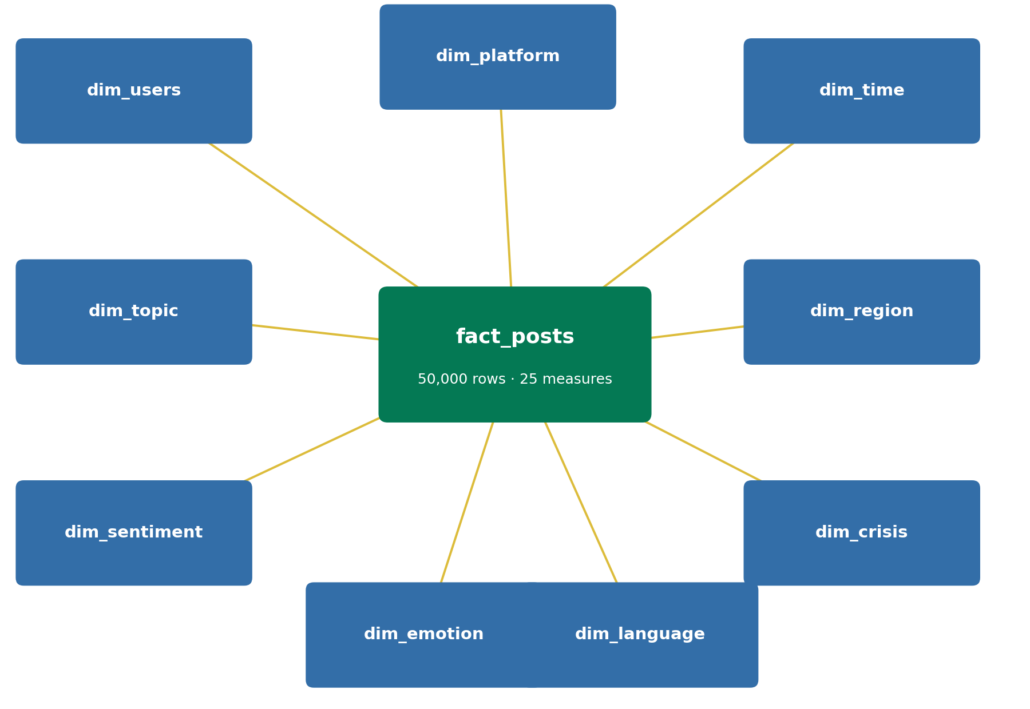
Figure 3.1 – Star Schema: fact_posts linked to its nine dimension tables.
Because dim_region and dim_language each contain only one distinct value in the current dataset, geographic and multilingual breakdowns are not meaningful yet; this is noted as a dataset limitation rather than a modeling error, and flagged as an area for a richer dataset in future iterations.

Chapter 3: Framework and Analysis

3.1 Tools and Technologies

1. Python
Python was the core language for the entire pipeline – loading, profiling, cleaning, and reshaping the dataset across all three Medallion layers.

2. Pandas
Pandas handled reading the CSV source, filtering and cleaning columns, imputing missing values, and building the dimension and fact tables of the Star Schema.

3. NumPy
NumPy supported the underlying numerical operations used during profiling and transformation of the numeric engagement and risk-score columns.

4. Jupyter Notebook
Each Medallion layer – Bronze, Silver, and Gold – was implemented and documented in its own Jupyter notebook, keeping every transformation traceable from raw data to final model.

6. Figma
Figma was used for the UI/UX design layer of the project – wireframing and mocking up the dashboard's layout, color system, and navigation flow before and alongside the Power BI build.

5. Power BI, DAX and Power Query (M)
Power BI was used to build the five-page interactive dashboard. Power Query (M) handled data type fixes on load, while DAX measures calculated every KPI shown on the dashboard – from simple counts to averages, ratios, and time trends.

3.2 Methodology (Medallion Architecture)
The project follows a three-layer Medallion Architecture to keep the pipeline organized, traceable, and easy to extend:

Bronze Layer – Raw Data
The original data.csv is loaded exactly as provided. The notebook inspects the schema, previews records, and profiles numeric columns with describe() to identify the cleaning work needed downstream – without modifying the source data.

Silver Layer – Cleaned Data
The Silver notebook standardizes column names, splits the timestamp field into year, month, and day, and imputes the 39,121 missing parent_post_id values (original, non-share posts) with a placeholder value, bringing the dataset to zero missing values with no duplicate rows found.

Gold Layer – Star Schema
The Gold notebook builds the analytical model: one fact table (fact_posts) and nine dimension tables, ready to feed Power BI directly.
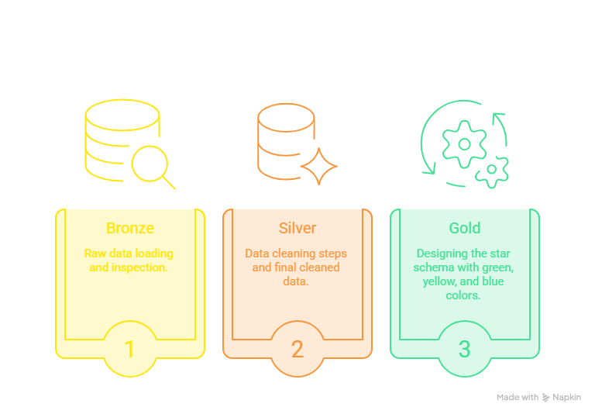
Figure 2.1 – Medallion Architecture: Bronze, Silver, and Gold layers feeding Analysis and the planned AI Model.

3.3 Analysis Requirements and KPIs
The dashboard is driven by DAX measures covering four analytical areas:
- Volume: Total Posts, Total Platforms, Total Topics, Total Source Types, posts by crisis phase and source type.
- Sentiment: Positive/Negative Post counts, Average Sentiment Score, sentiment and emotion distribution.
- Credibility & Risk: Average Credibility, Average Toxicity, Average Misinformation, High-Risk Post count.
- Engagement & Behavior: Total Likes/Shares/Comments, Average Engagement, Peak Month/Day, Average Cascade Depth.

Chapter 4: Design and Visualization

4.1 Dashboard Design and Layout
The dashboard uses a consistent five-page layout with a shared left-hand navigation bar (Posts Volume, Sentiment, Credibility, Engagement, Behavior), a shared purple/blue color theme, and the same slicer panel – Post Type, Platform, Month, and Day – repeated on every page so filters stay consistent as the user moves between views.

4.2 Power BI Dashboard Implementation
Each page combines KPI cards with supporting visuals, including:
- KPI cards for headline numbers (Total Posts, Peak Month, Avg Credibility, etc.)
- Bar charts for categorical breakdowns (posts by day, misinformation by topic)
- Donut / pie charts for distribution (sentiment split, source type split)
- Line charts for trends across months (engagement, misinformation, credibility)
- Scatter plots for relationships between two measures (engagement vs. misinformation, misinformation vs. credibility)
All KPIs are powered by DAX measures, letting every visual respond instantly to the shared slicers.

4.3 Dashboard Insights and Analysis

Posts Volume
Tracks the overall shape of the conversation: 50,000 posts across 3 platforms, 7 topics, and 4 source types, broken down by crisis phase, platform, and emotion.
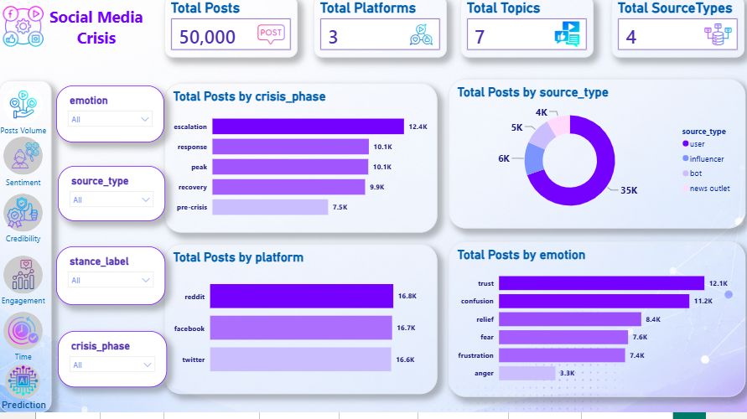
Figure 4.1 – Posts Volume page.

Sentiment
Shows the balance of the conversation: 22,249 negative vs. 9,270 positive posts (Average Sentiment Score of –0.17), plus emotion, stance, and crisis-phase breakdowns.
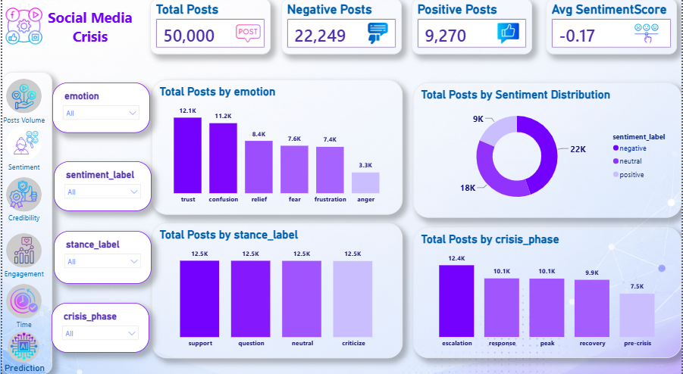
Figure 4.2 – Sentiment page.

Credibility
Flags risk: 2,813 high-risk posts, an average credibility of 0.73, average toxicity of 0.29, and average misinformation of 0.24, broken down by topic and platform.
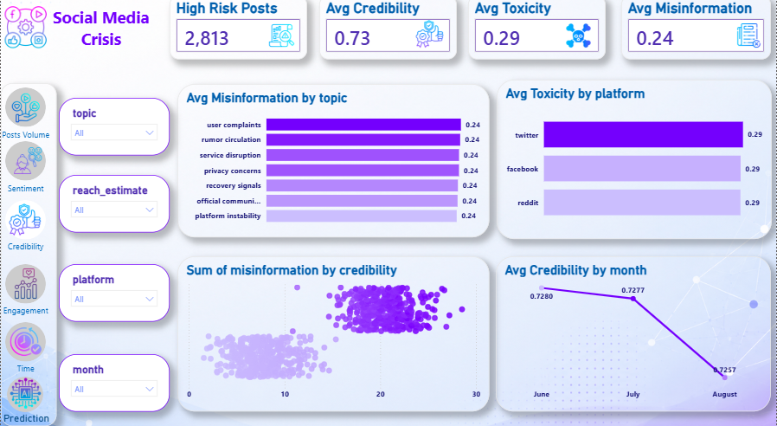
Figure 4.3 – Credibility page.

Engagement
Covers reach and interaction: 98.1M total likes, 39.1M shares, 19.5M comments, and an average engagement score around 90, viewed by platform and against misinformation levels.
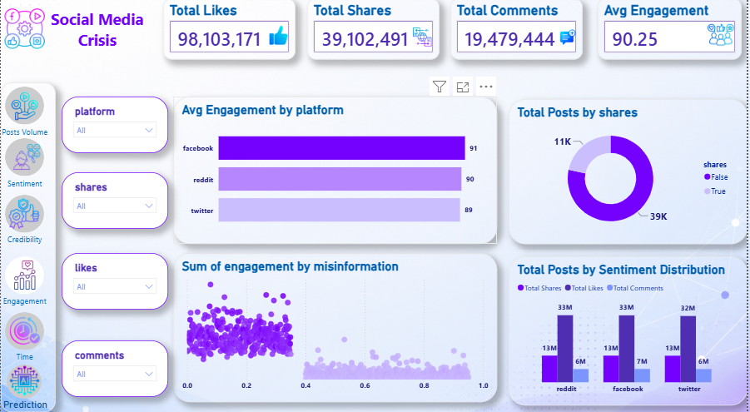
Figure 4.4 – Engagement page.

Behavior
Tracks diffusion patterns over time: peak posting on Thursdays in July, 39.1M total shares, an average cascade depth of 0.98, and month-over-month trends in misinformation and engagement.
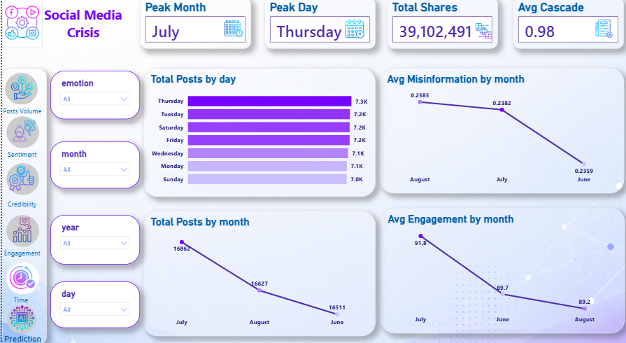
Figure 4.5 – Behavior page.

Chapter 5: Validation and Future Work

5.1 Data Validation and Testing
Before delivery, the pipeline and dashboard outputs were checked in three ways:
- Data quality checks – verified that every dimension merge preserved the original row count, with no fan-out across all nine joins.
- Measure validation – cross-checked DAX measures in Power BI's Query View against manual Pandas aggregates on the same Gold-layer tables.
- Cross-filter testing – confirmed that slicers (platform, month, day, emotion) return consistent totals across all five dashboard pages.

5.2 Extended Analysis and Design Contributions
Beyond the core pipeline and dashboard, the team extended the project in two directions:
- Exploratory Data Analysis and AI Model (Abdelrahman Maher): a deeper exploratory analysis of the Gold-layer data was carried out to surface patterns in sentiment, engagement, and misinformation, followed by an early-stage AI model that estimates a post's misinformation risk from its Gold-layer features, complementing the rule-based scoring used in the dashboard.
- UI/UX Design (Refka Maged): the dashboard's visual layout, color system, and navigation flow were designed in Figma before implementation, guiding the consistent five-page structure and shared filter panel used across the final Power BI dashboard.

5.3 Conclusion
This project shows how a Medallion Architecture pipeline – built in Python and modeled into a Star Schema – can turn 50,000 raw, noisy social media posts into a clean, validated, and interactive Power BI dashboard. The resulting system lets a crisis-response or communications team track sentiment, credibility, misinformation, and engagement as a crisis unfolds, giving them an early-warning view that a raw social feed cannot provide on its own.

