**Bank Loan Queries and KPIs For Dashboard**

1. **BANK LOAN REPORT | SUMMARY:**

1. Total Number of Applications for Loan

SELECT Count(id) as Total_Applications From bank_loan_data;



2. MTD Loan Applications

SELECT COUNT(id) AS MTD_Total_Applications FROM bank_loan_data

WHERE MONTH(issue_date) = 12;



3. PMTD Loan Applications

SELECT COUNT(id) AS PMTD_Loan_Applications FROM bank_loan_data

WHERE MONTH(issue_date) = 11;



4. Total Funded Amount

Select SUM(loan_amount) as Total_Funded_Amount From bank_loan_data;



5. MTD Total Funded Amount

Select SUM(loan_amount) as MTD_Total_Funded_Amount From bank_loan_data

Where MONTH (issue_date) = 12 AND YEAR (issue_date) = 2021;



6. PMTD Total Funded Amount

Select SUM(loan_amount) as PMTD_Total_Funded_Amount From bank_loan_data

Where MONTH (issue_date) = 11 AND YEAR (issue_date) = 2021;



7. Total Amount Recieved

Select SUM(total_payment) as Total_Amount_Recieved From bank_loan_data;



8. MTD Total Amount Recieved

Select SUM(total_payment) as Total_Amount_Recieved From bank_loan_data

Where MONTH(issue_date) = 12 and YEAR(issue_date) =2021;



9. PMTD Total Amount Recieved

Select SUM(total_payment) as Total_Amount_Recieved From bank_loan_data

Where MONTH(issue_date) = 11 and YEAR(issue_date) =2021;



10. Average Interest Rate

SELECT Round(AVG(int_rate)*100, 2) as Average_Interest_Rate From bank_loan_data;



11. PMTD Average Interest Rate

SELECT Round(AVG(int_rate)*100, 2) as Average_Interest_Rate From bank_loan_data

WHERE MONTH(issue_date) = 12;



12. PMTD Average Interest Rate

SELECT Round(AVG(int_rate)*100, 2) as Average_Interest_Rate From bank_loan_data

WHERE MONTH(issue_date) = 11;



13. DTI

SELECT ROUND(AVG(dti)*100, 2) AS Avg_DTI FROM bank_loan_data;



14. MTD Avg DTI

SELECT ROUND(AVG(dti)*100, 2) AS MTD_DTI FROM bank_loan_data

WHERE MONTH(issue_date) = 12;



15. PMTD Avg DTI

SELECT ROUND(AVG(dti)*100, 2) AS PMTD_Avg_DTI FROM bank_loan_data

WHERE MONTH(issue_date) = 11;



1. **Loan Status Financial Summary:**

SELECT

loan_status,

COUNT(id) AS LoanCount,

CAST(CAST(SUM(total_payment) / 1000000.0 AS DECIMAL(10,2)) AS VARCHAR) + 'M' AS Total_Amount_Received,

CAST(CAST(SUM(loan_amount) / 1000000.0 AS DECIMAL(10,2)) AS VARCHAR) + 'M' AS Total_Funded_Amount,

ROUND(AVG(int_rate * 100), 2) AS Interest_Rate,

ROUND(AVG(dti * 100), 2) AS DTI

FROM bank_loan_data

GROUP BY loan_status;

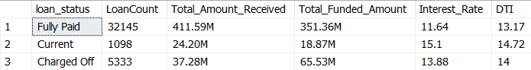

1. **December Loan Status Financial Summary**

SELECT

loan_status,

CAST(CAST(SUM(total_payment) / 1000000.0 AS DECIMAL(10,2)) AS VARCHAR) + 'M' AS Total_Amount_Received,

CAST(CAST(SUM(loan_amount) / 1000000.0 AS DECIMAL(10,2)) AS VARCHAR) + 'M' AS Total_Funded_Amount

FROM bank_loan_data

WHERE MONTH(issue_date) = 12

GROUP BY loan_status;

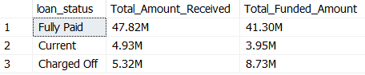

1. **Grade A Loan Applications Summary by Purpose**

SELECT

purpose AS PURPOSE,

COUNT(id) AS Total_Loan_Applications,

SUM(loan_amount) AS Total_Funded_Amount,

SUM(total_payment) AS Total_Amount_Received

FROM bank_loan_data

WHERE grade = 'A'

GROUP BY purpose

ORDER BY Total_Amount_Received DESC, Total_Funded_Amount DESC;

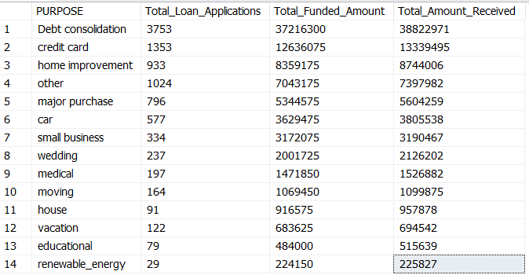

1. **Home Ownership Status:**

SELECT

home_ownership AS Home_Ownership,

COUNT(id) AS Total_Loan_Applications,

CAST(CAST(SUM(total_payment) / 1000000.0 AS DECIMAL(10,2)) AS VARCHAR) + 'M' AS Total_Amount_Received,

CAST(CAST(SUM(loan_amount) / 1000000.0 AS DECIMAL(10,2)) AS VARCHAR) + 'M' AS Total_Funded_Amount

FROM bank_loan_data

GROUP BY home_ownership

ORDER BY Total_Amount_Received DESC, Total_Funded_Amount DESC;

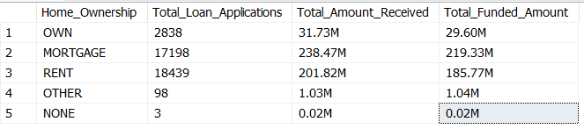

1. **Top 5 Employees Experience:**

SELECT TOP 5

emp_length AS Employee_Length,

COUNT(id) AS Total_Loan_Applications,

CAST(CAST(SUM(total_payment) / 1000000.0 AS DECIMAL(10,2)) AS VARCHAR) + 'M' AS Total_Amount_Received,

CAST(CAST(SUM(loan_amount) / 1000000.0 AS DECIMAL(10,2)) AS VARCHAR) + 'M' AS Total_Funded_Amount

FROM bank_loan_data

GROUP BY emp_length

ORDER BY Total_Amount_Received DESC, Total_Funded_Amount DESC;

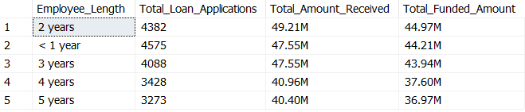s