VEXUS
Web3 Community Raffle Platform
Master Software Requirements Specification (SRS)
Web App (React) • Admin Dashboard (React) • Backend Platform • Mobile App (Flutter — Final Phase)
Version V3.0 — Client-Aligned Master Baseline
August 2026

Table of Contents
01 Executive Summary 1
02 Product Scope and Design Principles 1
2.1 Product Definition 1
2.2 Design Principles (Product Principles) 1
03 Overview of the Four Platform Surfaces 1
3.1 Module Map — Mobile App (Flutter) 1
3.2 Module Map — Web App (React) 1
3.3 Module Map — Admin Dashboard (React) 1
3.4 Module Map — Backend Platform 1
04 Personas & Roles 1
05 Authentication & Identity 1
5.1 Registration / Login Methods 1
5.2 Account Linking After Registration 1
5.3 Multiple Discord/X Accounts 1
5.4 Wallet Authentication (Wallet Auth) 1
06 Home & Discovery 1
6.1 Header — Web & Mobile 1
6.2 Main Navigation 1
6.3 Home Page Sections 1
6.4 Discover Page 1
6.5 Mobile Differences from Web 1
07 Project Page and Raffle Page 1
7.1 Project Page 1
7.2 Raffle Page 1
08 Raffle Types and State Machine 1
8.1 The Four Types 1
8.2 State Machine 1
09 Requirement Engine 1
9.1 Evaluation Logic 1
10 My Raffles / My Wins / Calendar 1
10.1 My Raffles 1
10.2 My Wins 1
10.3 Calendar 1
11 Notification Architecture 1
11.1 Events 1
11.2 Community-Specific Notifications 1
12 Premium Model 1
12.1 Free 1
12.2 Premium 1
13 Auto-Register (Premium) 1
14 Community / Team — Management and Roles 1
14.1 Community Page Structure 1
14.2 Community Creation 1
14.3 Roles and Permissions 1
15 Community Rules and Templates 1
15.1 Community Rules 1
15.2 Templates 1
16 Raffle Management and Winner Selection 1
16.1 Raffle Management Dashboard 1
16.2 Winner Selection System (Provably Fair) 1
16.3 Reroll 1
17 Reputation System 1
18 Professional Profile / CV 1
18.1 Profile Sections 1
18.2 Open for Opportunities 1
19 Hiring 1
19.1 Job Opening 1
19.2 Job Application 1
19.3 Community Invitation 1
20 Support 1
21 Super Admin Dashboard 1
21.1 Full Modules 1
21.2 Admin Dashboard Security 1
22 Mobile App Specification (Flutter) 1
22.1 Mobile-Specific Features 1
22.2 Web Synchronization 1
22.3 Store Publishing Requirements 1
23 Web App Specification (React) 1
23.1 Technical Considerations 1
23.2 Web vs Mobile Differences 1
24 Admin Dashboard Specification (React) 1
25 Backend Platform and API Architecture 1
25.1 API Pattern 1
25.2 Core Services (Microservices / Modular Monolith) 1
26 System Architecture 1
26.1 Database (ERD) 1
27 Security Architecture 1
27.1 Fixed Principles from the Start 1
27.2 Additional Layers 1
28 Infrastructure & Tech Stack 1
29 Development Roadmap 1
Phase 0 — Foundation 1
Phase 1 — Core MVP 1
Phase 2 1
Phase 3 1
30 Acceptance Criteria 1
31 Open Decisions the Client Must Resolve Before Freeze 1
Authentication 1
NFT 1
Premium 1
Reputation 1
Hiring 1
Raffle 1
Infrastructure 1
32 Appendix — Terminology and Current Readiness 1
32.1 What Is Ready Now as the Execution Baseline 1
32.2 Priority Principle 1
32.3 Next Step 1

01 Executive Summary
VEXUS is an integrated Web3 platform combining Raffle discovery and participation, Community management, Premium Automation, Reputation, Professional Identity, and Hiring — within one unified product.
The platform is built around the Web App, Admin Dashboard, and unified Backend as the core launch components, while the Mobile App (Flutter) is implemented in the final phase while preserving the same business logic and single source of truth.
- A user-facing web application built with React / TypeScript, serving as the primary MVP surface.
- An administrative dashboard built with React / TypeScript as a standalone application.
- A unified Backend platform (APIs and Services) powering all platform surfaces from the same Single Source of Truth.
- A mobile application (iOS / Android) built with Flutter, planned for the final phase and not within the MVP scope.
This document converts everything discussed with the client — together with the previous SRS and the Alphabot platform analysis used as a behavioral reference — into one detailed product specification, structured for review and approval before implementation begins.
Where a point remains open for decision, it is clearly classified as: Confirmed / Existing Baseline / Proposed / Open Decision. Every Open Decision must be resolved before being introduced into the MVP acceptance criteria.

02 Product Scope and Design Principles

2.1 Product Definition
Vexus is a Web3 platform combining: Raffle Discovery + Raffle Participation + Community Management + Premium Automation + Reputation + Professional Identity + Hiring, with Raffle as the product core and a broad ecosystem layer around it.
Layer | Description | Target User
Public Platform | Project, Raffle, and Community discovery without mandatory login | Visitor / Public User
User Platform | Profile, participation, wins, notifications, reputation, hiring | Registered User
Community Platform | Team, Raffle, template, member, and hiring management | Community Owner / Manager
Super Admin | Full platform management: users, communities, fraud, subscriptions, system | Vexus Internal Team

2.2 Design Principles (Product Principles)
These principles govern every subsequent design or architectural decision in this document:

P1 — Free Participation
Users can participate in free Raffles without any subscription. Premium is not required for basic participation.

P2 — Premium = Software Capabilities, Not a Better Winning Chance
Premium provides Automation / Notifications / Account Capabilities / Community Management and other software capabilities. Premium must not become a purchase of a higher winning chance within the same Raffle, as that is a fundamentally different model that must be avoided to preserve Provably Fair credibility.

P3 — Non-Custodial
The platform never stores Private Keys or Seed Phrases. Wallet Signature is not used for login; any wallet signature required is solely for verifying ownership of the NFT/Main Wallet.

P4 — Performance First
Raffle Entry does not rely on expensive synchronous verification. Target: queued entry ingestion, with an initial response time below 300ms at p95, and an initial launch target of at least 5,000 submissions per minute per Raffle.

P5 — Provably Fair
Winner selection must be independently verifiable by any external party. Sequence: server_seed_hash → freeze ledger → entries_hash → public entropy → reveal → draw_seed → winners.

P6 — Centralized Platform Rules
Every Community uses a centralized Rule Catalog managed by Vexus (Super Admin), rather than each Community maintaining a completely different rule system. This simplifies maintenance and trust across the platform.

03 Overview of the Four Platform Surfaces
Every feature in this document is built once in the Backend and exposed first through Web and Admin, then through Mobile in the final phase, while maintaining one source of truth and unified business logic.
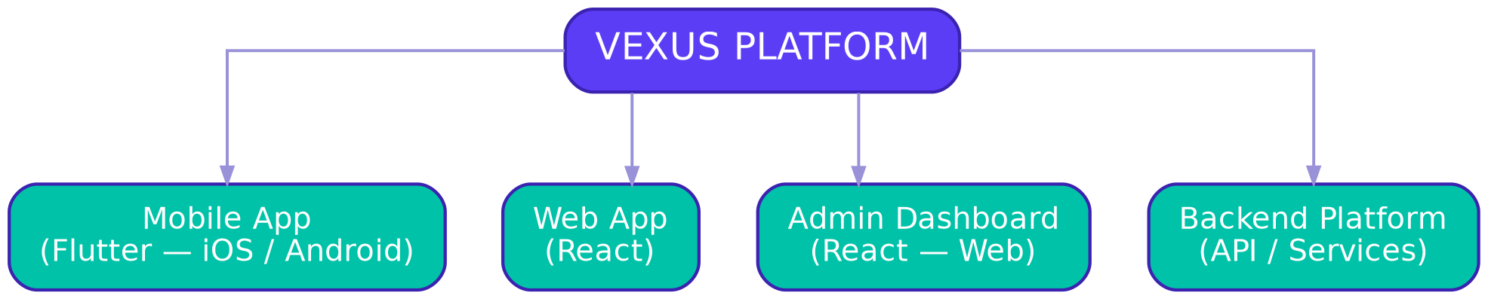
Figure 1 — Vexus Four-Surface Platform Map

3.1 Module Map — Mobile App (Flutter)
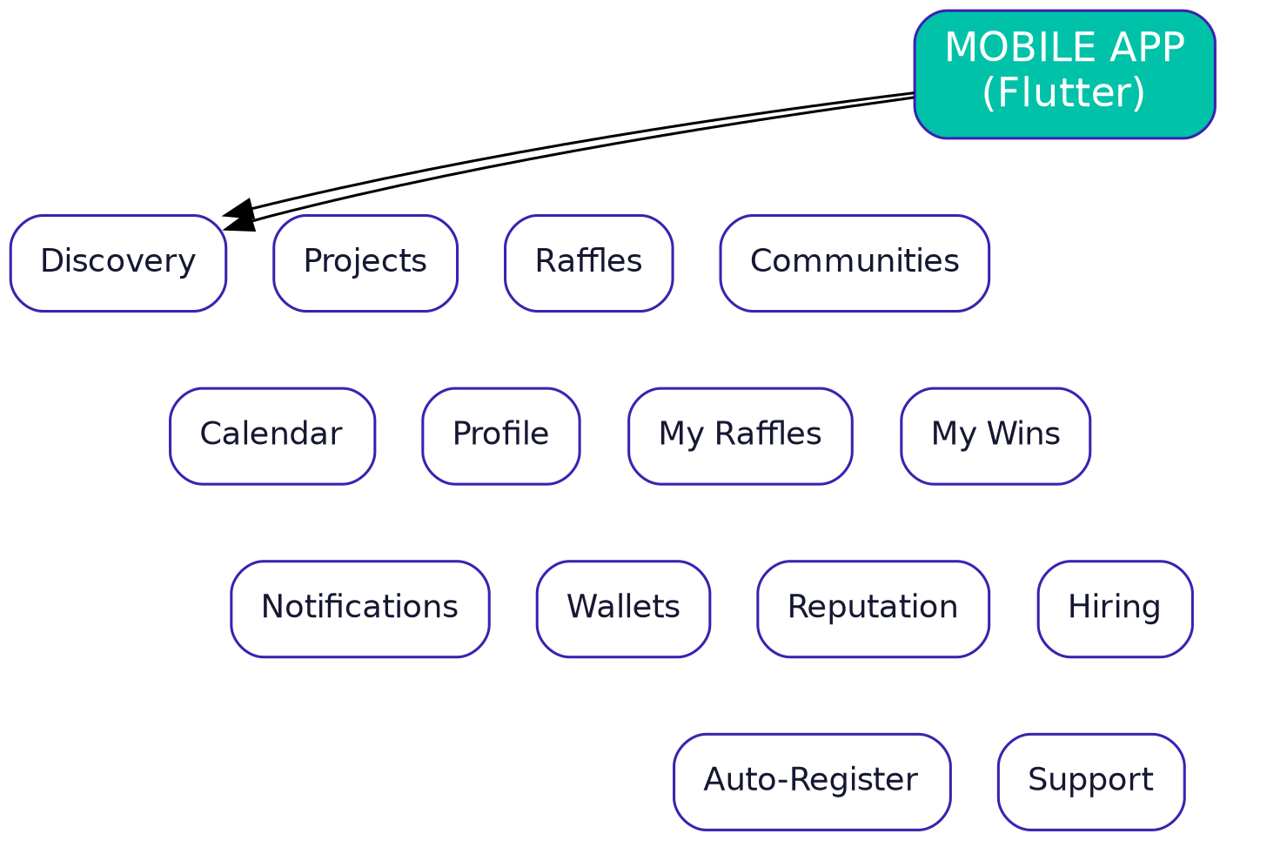
Figure 2 — Mobile App Modules

3.2 Module Map — Web App (React)
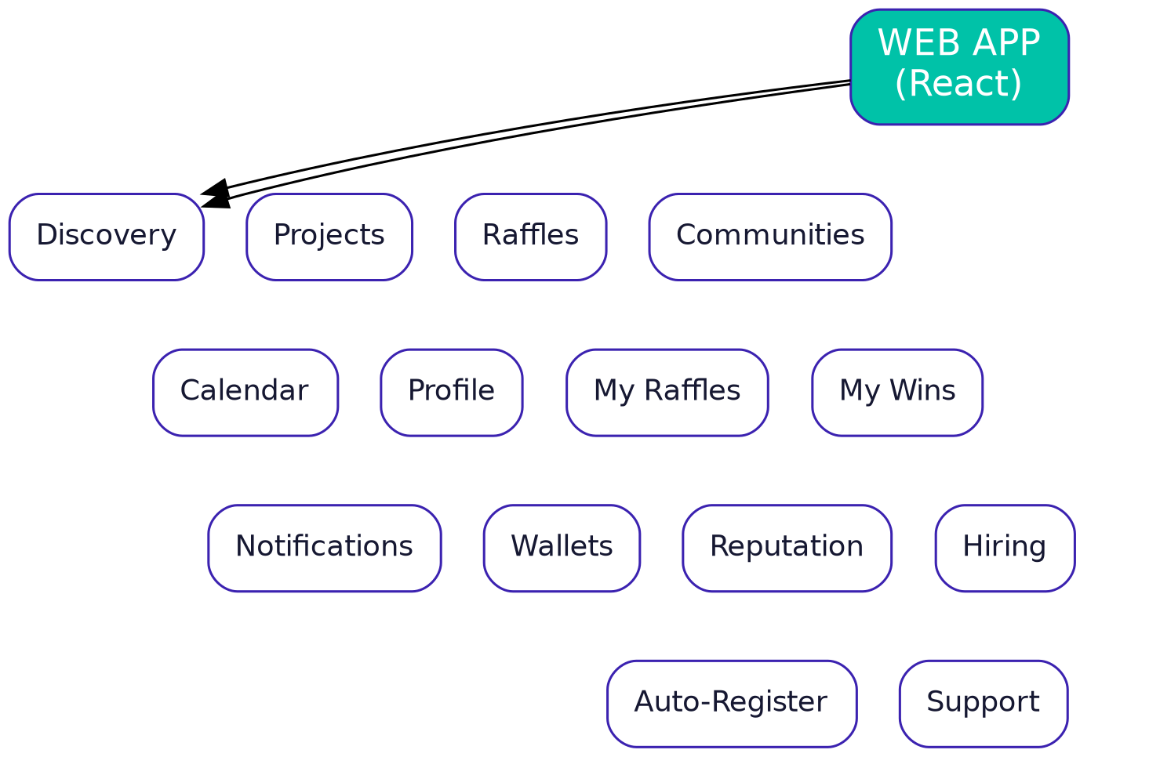
Figure 3 — Web App Modules

3.3 Module Map — Admin Dashboard (React)
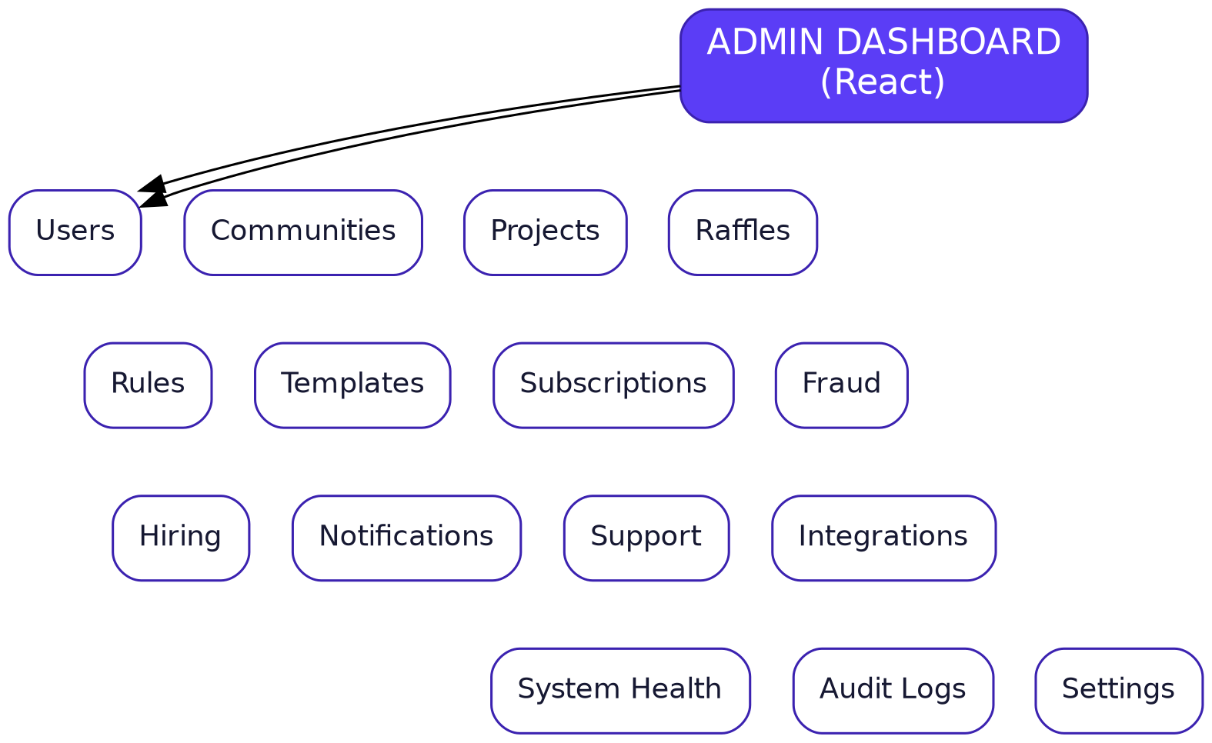
Figure 4 — Admin Dashboard Modules

3.4 Module Map — Backend Platform
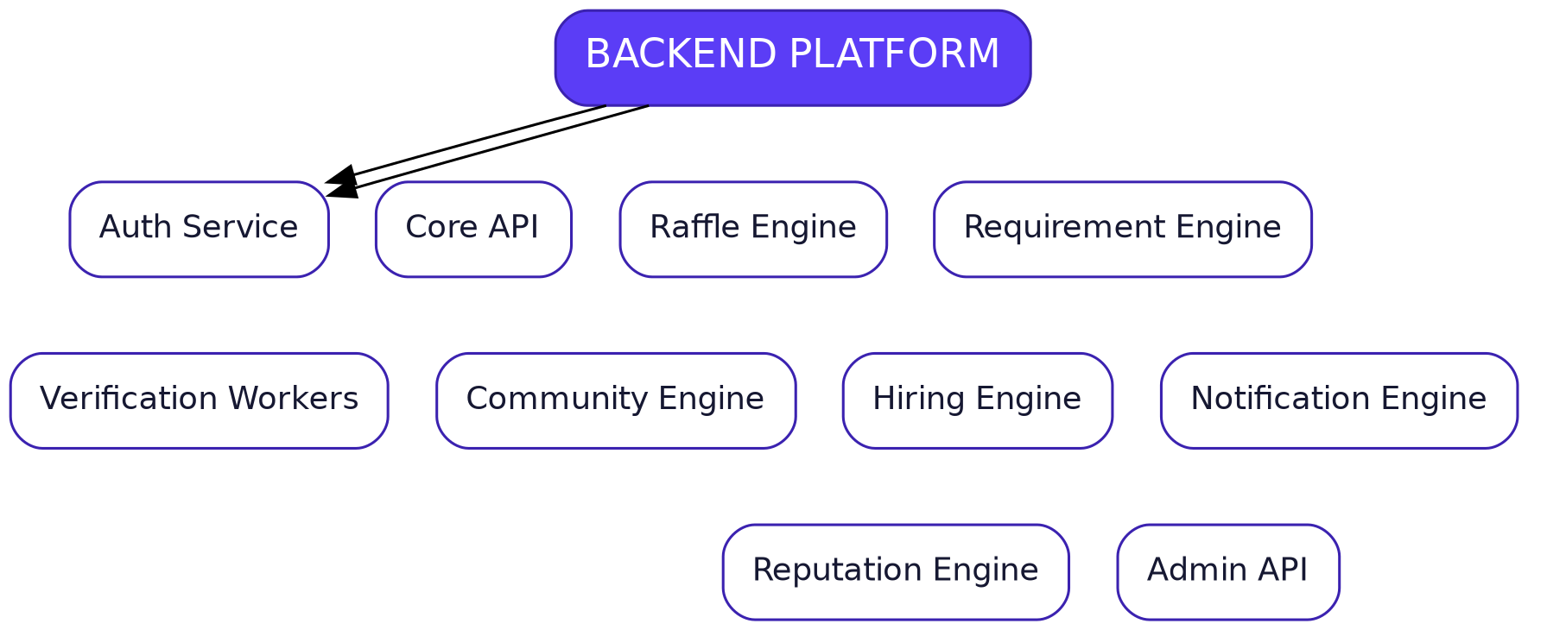
Figure 5 — Backend Services
Mobile-specific details are provided in Section 22, while the primary launch is Web-first. The Mobile App is not an MVP surface and belongs to the final phase.

04 Personas & Roles
Role | Description | Where the Platform Is Used
Visitor / Guest | Unregistered visitor browsing public projects and Raffles | Web (MVP) • Mobile (Final Phase)
Registered User | Registered user participating in Raffles with a profile and Reputation | Web (MVP) • Mobile (Final Phase)
Premium User | Subscribed user with Auto-Register and advanced notifications | Web (MVP) • Mobile (Final Phase)
Community Owner | Community creator with full permissions over the Community | Web (MVP) • Mobile (Final Phase)
Community Manager | Partial administrative permissions within a specific Community | Web (MVP) • Mobile (Final Phase)
Community Member | Community team member with limited permissions | Web (MVP) • Mobile (Final Phase)
Hiring Manager | Manages jobs and applicants within the Community | Web (MVP) • Mobile (Final Phase)
Job Candidate | User looking for work opportunities within Web3 communities | Web (MVP) • Mobile (Final Phase)
Super Admin | Full platform control | Admin Dashboard only
Support Agent | Technical support and tickets through the Admin Dashboard | Admin Dashboard only

05 Authentication & Identity

5.1 Registration / Login Methods
The primary account is created through:
- Discord — connect a Discord account and create the core identity.
- Username + Password — the account's primary login credentials.
- Google Login — additional login after linking Google to the account.
- X Login — additional login after linking an X account to the account.
- Whop / Telegram — can be used for login after linking them.
Confirmed implementation note: Wallet Signature is not a platform login method.

5.2 Account Linking After Registration
After creating the account, the user can link external accounts and services for login, the feed, and execution of Raffle requirements according to the function of each integration:
- Discord
- X (Twitter) — supports multiple X accounts within the same account.
- Google
- Whop
- Telegram
Multiple wallets for participation and verification use cases.

5.3 Multiple X Accounts
Confirmed
Users can link multiple X accounts within the same VEXUS account and switch between them when participating in Raffles and satisfying eligibility requirements. This allows participation to continue when one account becomes unavailable, with each account recorded as an independent external identity.
The data model must support a 1:N relationship between User and SocialAccounts for X accounts, with clear policies for rate limits, provider restrictions, and prevention of multi-account abuse. The same account may also be used in the feed context and in executing Raffle requirements when appropriate for the integration.

5.4 Wallet: Add Wallet and Main Wallet Verification
Add Wallet: users can add multiple wallets for Raffle participation, Winning Wallet management, and other general use cases. Main Wallet: the user may perform Connect Main Wallet / Message Signing only to verify ownership of the wallet associated with the project's NFT holdings, in order to unlock NFT Holder benefits. This mechanism is not used as general login and the platform never stores private keys.
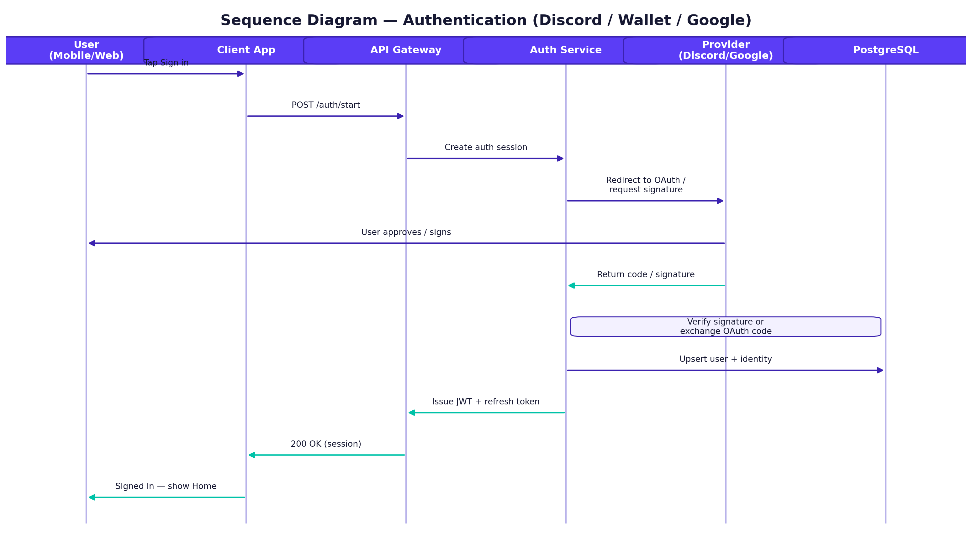
Figure 6 — Sequence Diagram: Account Creation via Discord, followed by Login through Linked Account Providers

06 Home & Discovery

6.1 Header — Web & Mobile
Header elements: ☰ menu | logo | search | Subscribe button | 🔔 notifications | login / avatar.

6.2 Main Navigation
Main navigation: Home, Raffles, Communities, Calendar, VEXUS Feed, Talent / Jobs (Phase 2), Profile. Search and notifications are global utilities, while community management tools appear inside the Community Context rather than increasing Global Navigation clutter.

6.3 Home Page Sections
- Trending Raffles / Projects
- Upcoming Raffles
- Ending Soon
- Discover More
- Featured Communities
- Recommended For You
- Latest Community Activity
Trending is calculated later automatically from entries, activity, and recency instead of manual ordering.

6.4 Discover Page
Discovery is divided into Projects / Raffles / Communities, while VEXUS Feed remains a separate layer planned for Phase 2.
- Chain (network)
- Status (state)
- Community
- Verified
- Ending Soon
- Upcoming
- Raffle Type
Available actions: View / Enter / Follow / Star / Auto-Register.

6.5 Mobile Differences from Web
- On mobile, the main navigation appears as a Bottom Navigation Bar. This interface is implemented in the final phase.
- Voice search and mobile-specific capabilities — Features Later / Final Phase.
- On mobile, filters are displayed as a draggable Bottom Sheet instead of a Sidebar.

6.6 VEXUS Feed — Phase 2
VEXUS Feed is separate from Raffle requirement execution. Project updates use Public X Username/Posts without requiring project OAuth merely to fetch updates. X requirement execution inside the Raffle uses the user's linked X accounts, and the same account may serve both contexts when needed.

07 Project Page and Raffle Page

7.1 Project Page
Sections: Overview / Active Raffles / Upcoming Raffles / Past Raffles / Calendar Data / Community.
Actions: Enter Raffle / Follow Project / Add to Calendar / View Community.

7.2 Raffle Page
Sections: Project Header / Raffle Info / Countdown / Winners-Spots / Description / Requirements / Eligibility / User Status / Actions / Winner Information / Other Project Raffles / Fairness-Verification.
This follows the original model in which project information + requirements + project raffles are part of the same Raffle experience.

Actions before end
- Check Eligibility
- Enter Raffle
- Auto-Register
- Add / Select Wallet
- Connect / Select X Account
- Connect / Select X Account additionally when required to execute Raffle requirements

Actions after end
- View Winners
- Verify Fairness

08 Raffle Modes / Participation and State Machine

8.1 The Four Modes
Mode / Type | Mechanism and Classification
Random / Weighted Raffle | Weighted Random Draw — Core Draw Mode. Weights are determined only by Raffle configuration and its rules; Premium provides no hidden increase in winning probability.
FCFS | First Valid N Entrants — Core Participation Mode.
Application | Applications + Manual Approval — Non-random Participation Mode, used when selection is based on application review.
Wallet Collection | Collect Qualified Wallets — Non-random Collection Mode, and does not itself produce random winners.

8.2 Classification Principles and State Machine
Random / Weighted is the primary draw mode; FCFS is the immediate-entry mode; Application and Wallet Collection are non-random participation modes within the same Raffle Engine. State machine: draft → scheduled → active → ended → finalizing → finalized, with the option to transition to cancelled from any of the first three states.
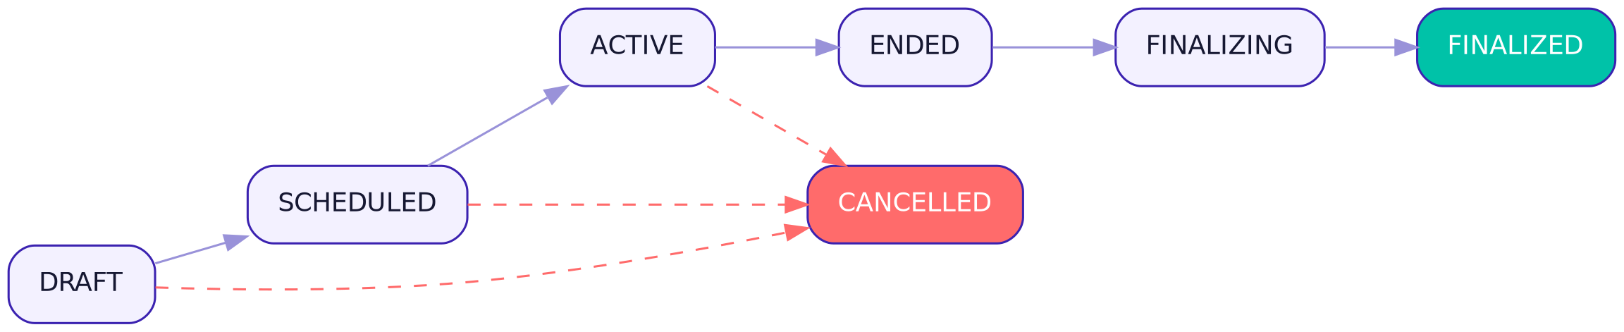
Figure 7 — Raffle State Machine

09 Requirement Engine
The central engine on which every Raffle is built creates a Requirement Tree from the following types:
- Discord
- X
- NFT
- Token
- Wallet
- Telegram
- Email
- CAPTCHA
- Password
- Website Visit
- Free Text
- Generic

9.1 Evaluation Logic
Requirement Blocks = AND — every block must be satisfied.
Values inside same requirement = OR — satisfying one value within the same block is sufficient.
Example: (NFT A OR NFT B) AND (Discord Role) AND (X Follow). The engine also rechecks mutable requirements before Finalization. Wallet verification within the Raffle means using Add Wallet / Verified Wallet according to the rule; NFT Holder Message Signing is a separate context for verifying ownership of the Main Wallet.
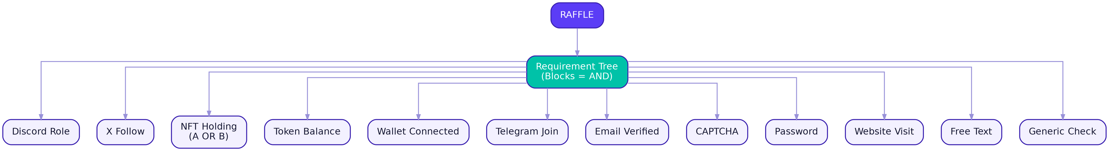
Figure 8 — Requirement Engine Tree
Certain cases will require
x ^ discord ^ wallet

10 My Raffles / My Wins / Calendar

10.1 My Raffles
Sections: Upcoming / Active / Joined / Won / Lost.
Row data: Project, Raffle, Status, Eligibility, Entry, End Time, Winner Status.

10.2 My Wins
Fields: Project, Raffle, Reward, Winning Wallet, Date, Winner Status, External Fulfillment Info (if any). There is no Claim, Claim Deadline, or Reclaim inside the platform.

10.3 Calendar
Sections: Upcoming Mints / Won Raffles / External Wins / Reminders.
Actions: Add Event / Add External Win / Set Reminder / Add Note.
In the mobile app, Calendar can sync with the device calendar (iOS Calendar / Google Calendar) as a Phase 2 feature, with Push reminders tied to each Mint date or Raffle end.

11 Notification Architecture
Notifications are a fully independent Domain from the rest of the services and support the following channels within the approved rollout:
- In-App
- Email
- Push (Mobile)
- Discord DM
- Telegram

11.1 Events
Event | Description
Raffle opened | Opening participation in a new Raffle
Raffle ending | Approaching Raffle end
Entry success / failed | Entry process success or failure
Winner / Reroll | Winner announcement or reroll
Mint reminder | Mint date reminder
Auto-register success / failure | Auto-registration result
OAuth expired | External account link expiration
Community new raffle / announcement | New activity from a followed Community

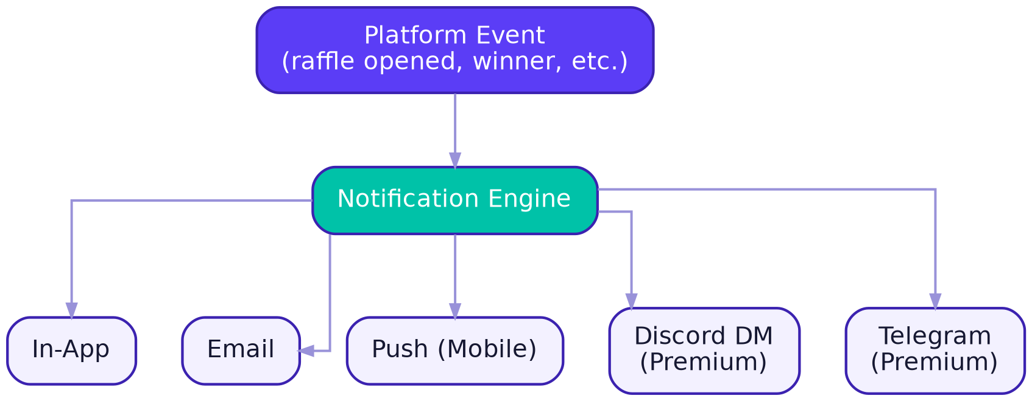
Figure 9 — Notification Architecture and Channels

11.2 Community-Specific Notifications
Community-specific notifications remain part of the core architecture, while expanded channels (such as Discord DM / Telegram) are activated in Phase 2, with core Raffle and Auto-Register events remaining notification-capable from the MVP.

12 Premium Model
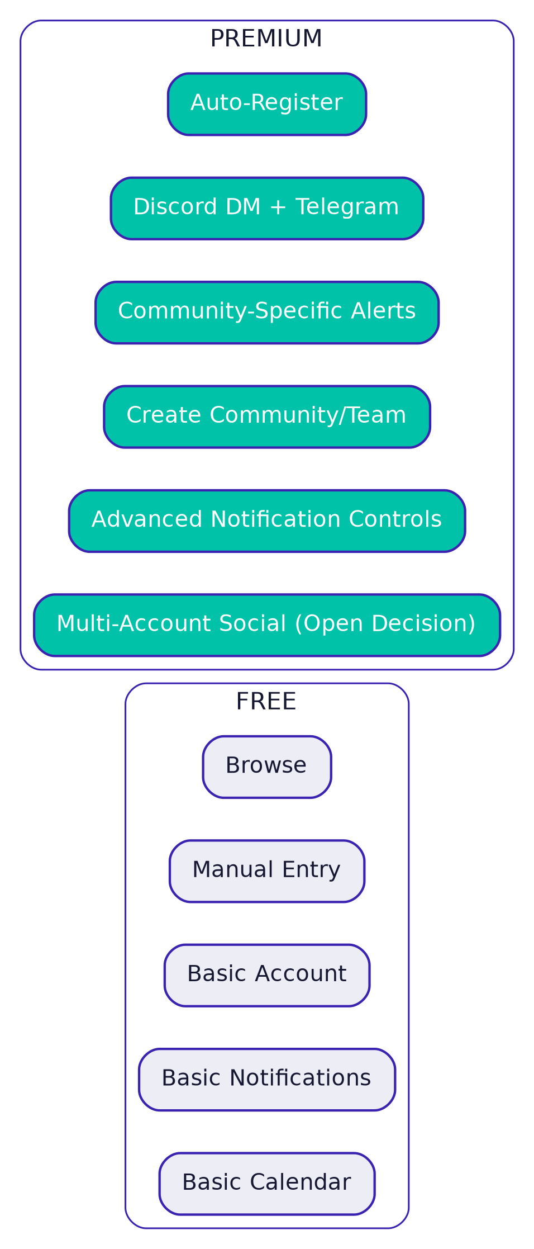
Figure 10 — Free vs Premium

12.1 Free
- Browse
- Manual Raffle Entry
- Basic Account
- Basic Email/Push Notifications
- Basic Calendar

12.2 Premium
- Advanced Discord notifications
- Telegram notifications
- Community-specific notifications
- Auto-Register
- Community / Team creation
- Advanced notification controls
- Multi-account X support (Confirmed) — multiple X accounts per user, with provider limits and anti-abuse policies.
Non-negotiable principle: Premium does not provide any advantage within the draw algorithm itself (it does not increase winning probability) — see P2 in Section 2.

13 Auto-Register (Premium)
A Premium feature that allows the user to configure preferences so participation is registered automatically in matching Raffles:
- Select Communities
- Select Projects
- Select Raffle Types
- Enable / Disable
- Activity Log: Successful / Failed / Pending
- Preferences
Confirmed — Auto-Register is a core Premium product feature. It registers the user in the Raffle and completes the required tasks according to the permissions granted by the user to integration providers. Successful / Failed / Pending is recorded for every operation.
Auto-Register only performs actions that fall within the permissions granted to each Provider, and Scopes must be isolated per provider with no unnecessary permissions requested.
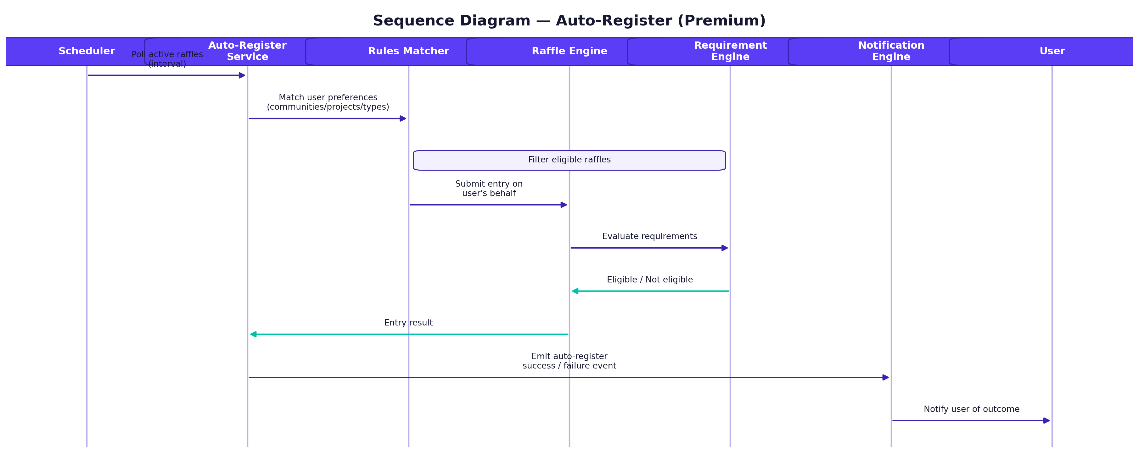
Figure 11 — Sequence Diagram: Auto-Register Flow

14 Community / Team — Management and Roles
The approved term in this document is Community, and it contains Projects, Raffles, Events, Team, Templates, Integrations, Notifications, and Settings.

14.1 Community Page Structure
Overview / Projects / Raffles / Rules / Templates / Members / Hiring / Integrations / Notifications / Settings.

14.2 Community Creation
The Create Community button is visible to everyone, but creation requires Premium.
Confirmed

14.3 Roles and Permissions
Role | Typical Permissions
founder | Giving permission to others/editing comm settings
Comm manager
Head of collab
Collab manager
mod

Roles and permissions are managed as capability scopes within the Community and enforced server-side. They include Owner/Founder, Manager, Moderator, Collab roles, and independent Hiring permissions. The system supports explicit and audited Ownership Transfer, Recovery through verification/support, and invitations that expire and can be cancelled and resent. All material team, permission, Raffle, and Integration actions are recorded in the Audit Log.

15 Community Rules and Templates

15.1 Community Rules
Each Community selects from Available Platform Rules managed by the Super Admin through a centralized Rule Catalog.
Recommended design: the Raffle takes a Snapshot of the rule configuration when it is created, because future rule changes must not unintentionally modify the history of an old Raffle.
Confirmed Baseline — Centralized Rule Catalog + Raffle Snapshot + reusable Templates.

15.2 Templates
Core productivity feature: Create Raffle → Save as Template → Reuse later by changing variables only → Publish.
The Template may contain: Requirements, Raffle Type, Winner count, Duration defaults, Visibility, Notification defaults, Description template, Project relation.
Community Template and Project Template must remain distinct.
Proposed Architecture
Figure 12 — Complete Community creation and Raffle publishing flow. After creating a Template, the user defines only core variables such as Winner Count and Duration, while the remaining settings are populated from the Template and saved rules.

16 Raffle Management and Winner Selection

16.1 Raffle Management Dashboard
Sections: Overview / Entries / Requirements / Winners / Notifications / Settings.
Actions: Edit / Duplicate / Finalize / Reroll / Export Winners / Post to Discord / Post to Telegram / Cancel, while preserving the draw history and results without deleting winner history.

16.2 Winner Selection System (Provably Fair)
Sequence: Valid Entries → Freeze → Entries Hash → Public Entropy → Reveal Server Seed → Draw Seed → Deterministic Draw → Winners. The result must be externally verifiable from the same published evidence.
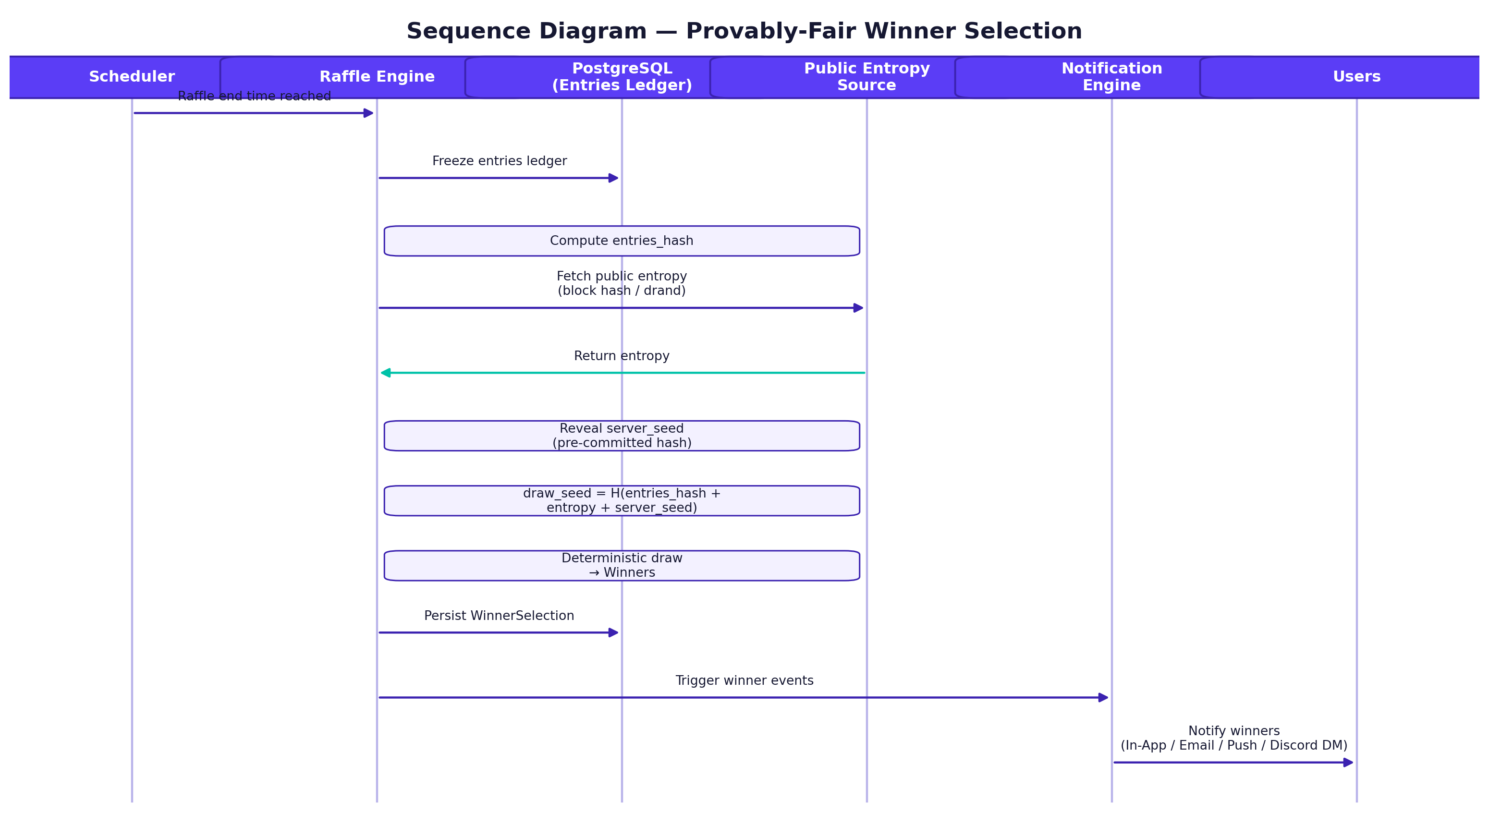
Figure 13 — Sequence Diagram: Verifiable Winner Selection (Provably Fair)

16.3 Reroll
Winner → Reroll → New Selection → History Preserved (old history is not deleted) → New Notification.

17 Reputation System
Reputation is a formal independent Domain that aggregates signals from multiple sources:
- X Followers
- X Activity
- Money Score
- ASOS Score
- Community Experience
- Roles
- Participation
- Wins
- Other verified signals
These are aggregated into one Reputation Score displayed to the user, example: 91 / 100.
Formula = Open Decision, while the Domain itself is Confirmed and included in the product structure. Any connection between Reputation Score and winning probabilities requires a separate explicit decision; the default assumption is that Reputation does not change Odds within the Raffle.
Important decision to lock: Reputation Score must not be linked to winning odds inside any Raffle without a separate explicit decision by the client — preserving P5 (Provably Fair).

18 Professional Profile / CV

18.1 Profile Sections
About / Reputation / Wallets / X / Discord / Collections / Current Roles / Community History / Professional Experience / Hiring Status.
Each Experience item contains: Community, Role, Start Date, End Date, Current?, Verified?.

18.2 Open for Opportunities
An ON/OFF toggle inside the profile, with the desired roles specified: Community Manager, Collab Manager, Recruiter, Other.

19 Hiring — Phase 2

19.1 Job Opening
A Community can create a Job Opening containing Role, Description, Requirements, Status, and Hiring Manager. It appears to users as a job opportunity within the Community/Talent Context.

19.2 Job Application
The candidate clicks Apply, then the status progresses: Applied → Shortlisted → Accepted or Rejected. The Hiring Manager sees: Candidate, Reputation, Experience, Roles, Communities, Socials, Collections, Availability.
There is no standalone Job platform or app; Hiring and Applications are part of the Web App and Community/Talent Context and are delivered in Phase 2.
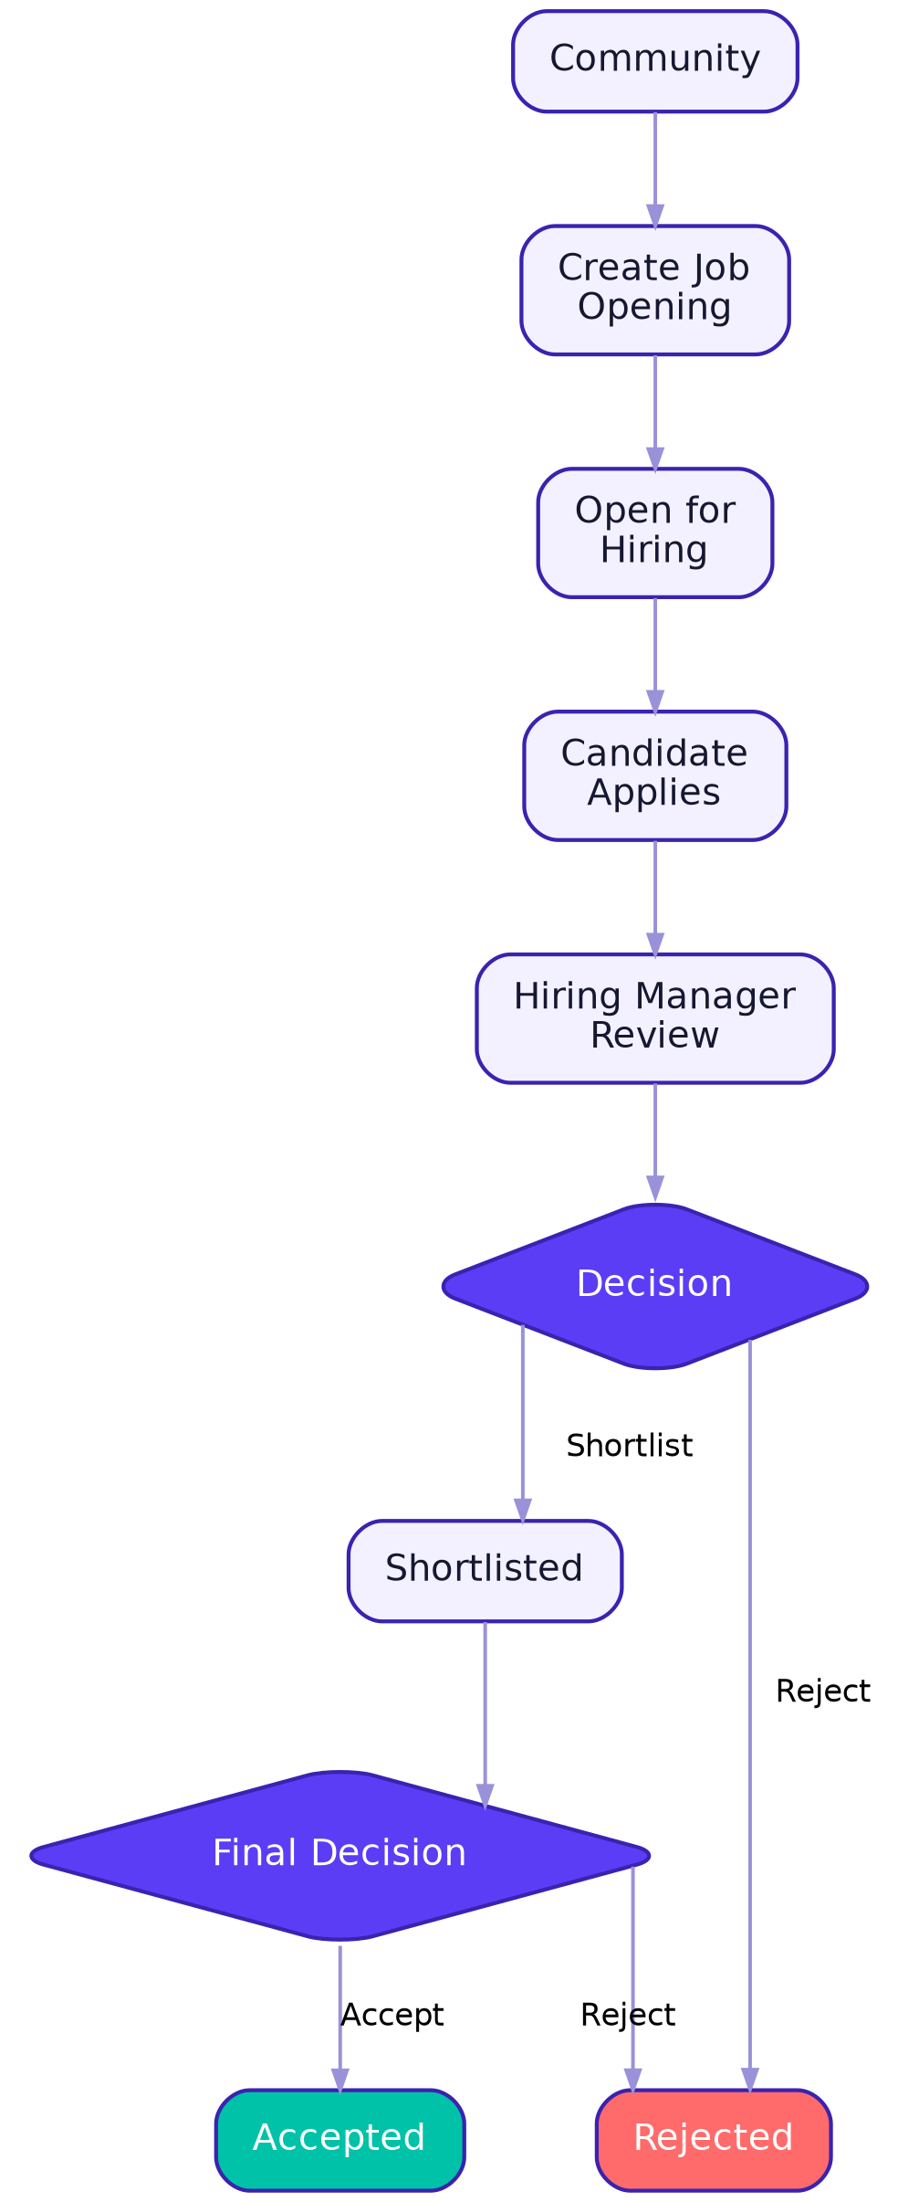
Figure 14 — Hiring flow from job opening to acceptance

19.3 Community Invitation — Phase 2
A completely separate flow from Apply: Community → Invite User → User decides Accept or Reject.
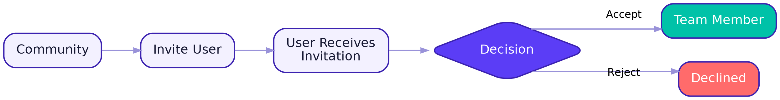
Figure 15 — Community invitation flow: the invitation/link has an expiry and can be cancelled and resent.

20 Support & Internal Messaging
Sections: Help Center / Search / Popular Articles / Start Conversation / My Conversations.
Support includes an internal messaging system between the user and Support Agent for tickets and requests, while keeping these conversations separate from any public Social Chat.
An AI-powered Chatbot may be added later for initial responses to common requests before escalation to a human Support Agent.

21 Super Admin Dashboard
The Platform Admin in the current SRS operates across all tenants (Cross-Tenant) and includes Vetting, Fraud & Support, Feature Flags, Subscription Overrides, Emergency Takedown, and Premium management.

21.1 Full Modules
Module | Function
Overview | Real-time platform health KPIs
Users | User management, suspension/ban, identity review
Communities | Community approval/suspension, request review
Projects | Management of projects associated with each Community
Raffles | Monitor all platform Raffles, emergency intervention
Rules | Centralized Rule Catalog used by all Communities
Templates | Platform-approved templates
Subscriptions | Premium plans, billing, manual overrides
Fraud | Suspicious behavior detection, Sybil Detection, automatic/manual banning
Hiring | Platform-wide job and application monitoring
Notifications | Notification template management and platform-wide broadcasts
Support | Support tickets, Popular Articles, Multilingual Config
Integrations | API keys for Discord/X/Telegram/Blockchain providers
System Health | Performance, error, and response-time monitoring
Audit Logs | Complete log of every sensitive administrative action
Settings | Global platform settings, Feature Flags

21.2 Admin Dashboard Security
- Mandatory two-factor authentication (2FA) for all admin accounts.
- Granular RBAC permissions for each module.
- Every sensitive action (ban, raffle modification, subscription override, or support action) is recorded in a non-deletable Audit Log.

22 Mobile App Specification (Flutter) — Final Phase
A single mobile app (unified Flutter Codebase) is released on iOS and Android in the final phase, using the same business logic as the web with mobile-specific experience adaptations:

22.1 Mobile-Specific Features
- Push Notifications via Firebase Cloud Messaging (Android) and APNs (iOS).
- Deep Linking to open a Raffle or Community page directly from a notification or external link (such as a Discord link).
- Wallet Connect via WalletConnect v2 to support mobile wallets (MetaMask Mobile, Trust Wallet, Rainbow...).
- Biometric Login (Face ID / Fingerprint) as an additional security layer on top of the session after the initial login.
- Offline-first for some screens (My Raffles, My Wins, Calendar) with automatic synchronization when connectivity returns.
- Bottom Navigation Bar instead of the web Sidebar.
- Direct sharing (Native Share Sheet) for sharing a Raffle link or win result.

22.2 Web Synchronization
When the mobile phase is implemented, the core functions available on the Web must be available on Mobile using the same business logic. Mobile is not part of the MVP acceptance criteria.

22.3 Store Publishing Requirements
- Compliance with Apple App Store and Google Play policies for Web3/Crypto applications (disclosure of wallet use, no real-money-funded gambling).
- Privacy Policy and Terms of Service pages published and accessible from within the app.
- Account Deletion functionality available inside the app as a mandatory store approval requirement.

23 Web App Specification (React)
A web application built with React + TypeScript, serving as the primary MVP surface and responsible for the full Public Platform, User Platform, and Community Platform experience, except for Super Admin, which is built as a separate application.

23.1 Technical Considerations
- Server-Side Rendering or Static Generation for public Discovery/Project/Raffle pages to improve SEO and initial load speed.
- Wallet Connect through the browser (MetaMask Extension, WalletConnect QR for other wallets).
- Fully responsive design that works on mobile web as a fallback even before the Flutter app is launched.
- Real-time updates (WebSocket / Server-Sent Events) for participant counters and the Countdown on the Raffle page.

23.2 Web vs Mobile Differences
Aspect | Web | Mobile
Primary Navigation | Sidebar / Top Menu | Bottom Navigation
Notifications | In-App + Email | Push + In-App + Email
Wallet Linking | Extension / WalletConnect QR | WalletConnect Deep Link
Login | Credentials + OAuth | Credentials + OAuth + Biometric
First Screen | Home | Home with brief Onboarding

24 Admin Dashboard Specification (React)
A fully independent web application from the user applications, built with React + TypeScript, with separate authentication (Separate Auth Realm) and granular RBAC permissions, covering all modules described in Section 21.
- Access to this dashboard through the user mobile app is not allowed — only through a web browser with separate admin authentication.
- All tables (Users, Raffles, Communities...) support advanced search, filters, and CSV/Excel export.
- Main Dashboard with real-time indicators: active users, ongoing Raffles, detected fraud rate, Premium revenue.

25 Backend Platform and API Architecture

25.1 API Pattern
- Unified REST API for Web and Admin Dashboard and Mobile when launched (same endpoints, different permissions by token).
- A single BFF (Backend For Frontend) / API Gateway layer handling authentication, Rate Limiting, and routing to internal services.
- A separate WebSocket Gateway for real-time updates (participant counters, draw status).

25.2 Core Services (Microservices / Modular Monolith)
Service | Responsibility
Auth Service | Login, OAuth/Provider Linking, sessions, and identity management. No general Wallet Auth.
Core API | Users, projects, communities, profiles
Raffle Engine | Complete Raffle lifecycle, from creation through Finalization
Requirement Engine | Requirement Tree evaluation (AND/OR)
Verification Workers | Asynchronous verification for Discord/X/NFT/Token/Wallet/CAPTCHA, including NFT Holder Main Wallet Verification.
Notification Engine | Notification delivery across all channels
Reputation Engine | Reputation Score calculation from multiple signals
Hiring Engine | Jobs, applications, candidate statuses
Admin API | All Super Admin Dashboard operations

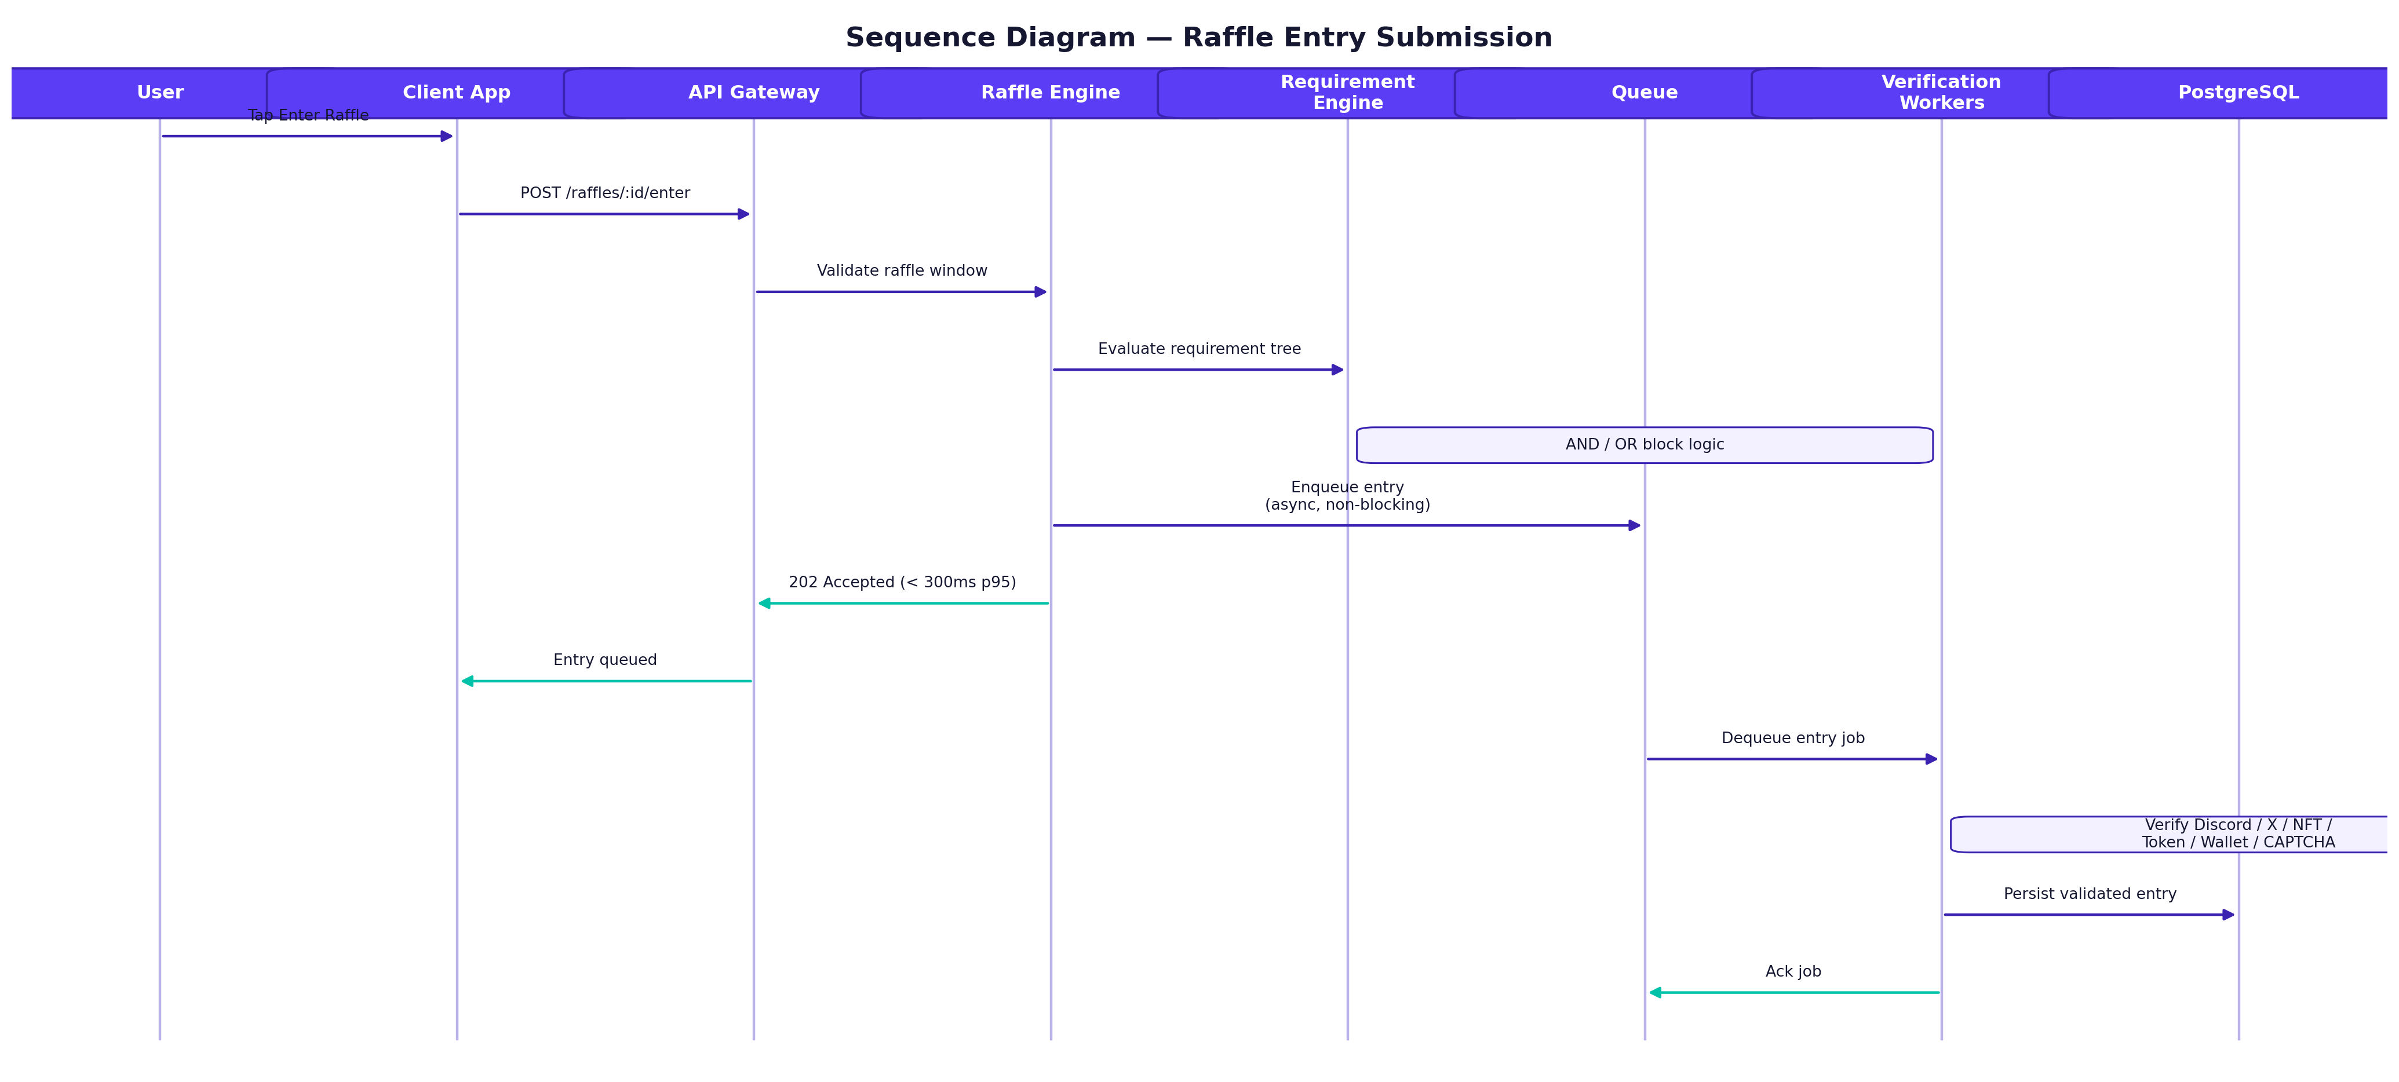
Figure 16 — Sequence Diagram: Raffle Entry Flow from the App to the Database

26 System Architecture
The current SRS follows the core architecture: NestJS/Node.js, PostgreSQL, Redis, Workers, external providers, Discord service, Object Storage, with replaceable Provider Adapters.
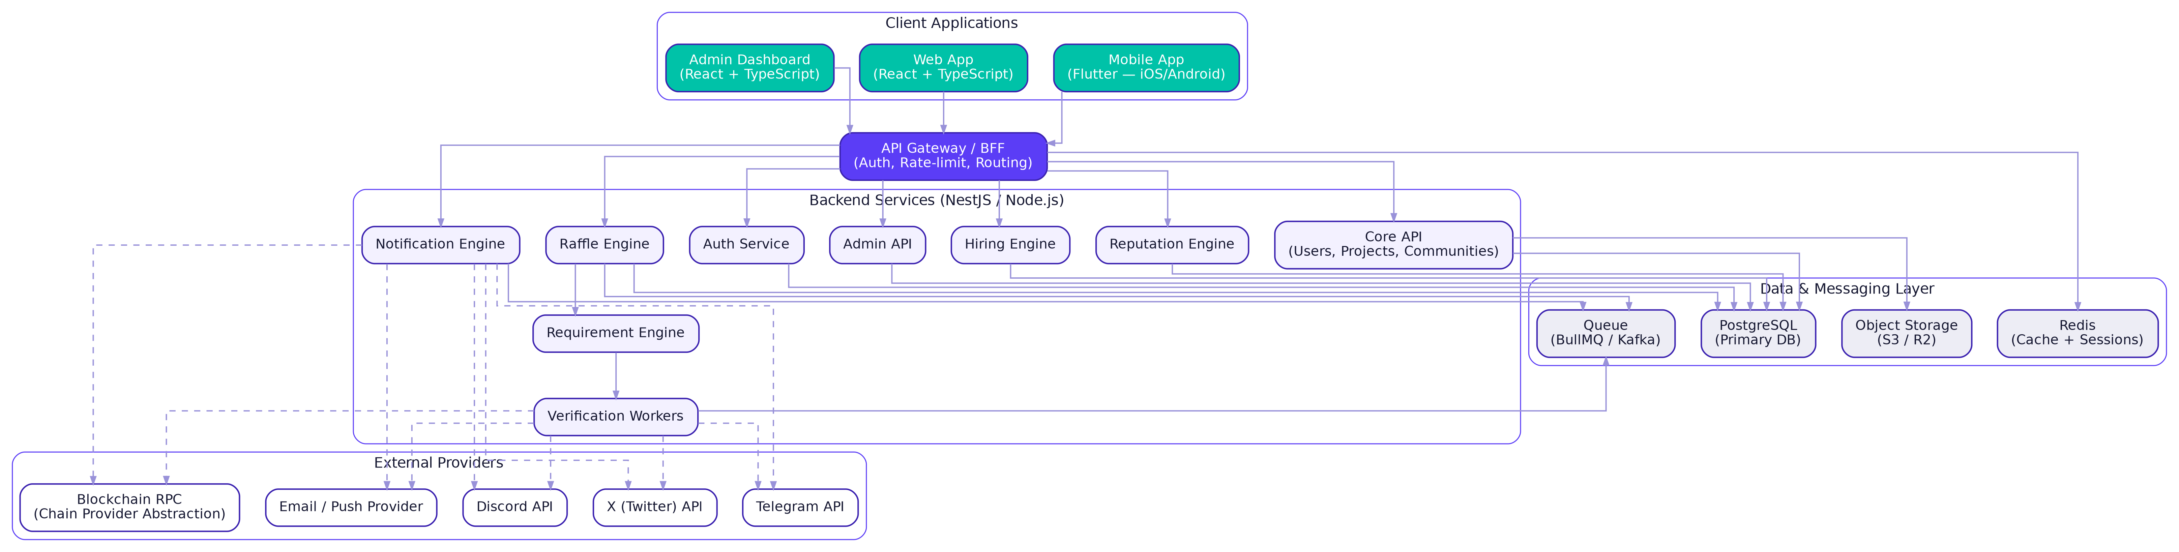
Figure 17 — Overall Architecture: Mobile, Web, and Admin over a unified Backend platform

26.1 Database (ERD)
The core data model includes User / Wallet / SocialAccount / Community / Team Membership / Project / Raffle / Requirement / Entry / Winner / Calendar / Notification / Reputation / Hiring / SupportConversation / SupportMessage / AuditLog, with Main Wallet NFT Verification separated from Add Wallet.
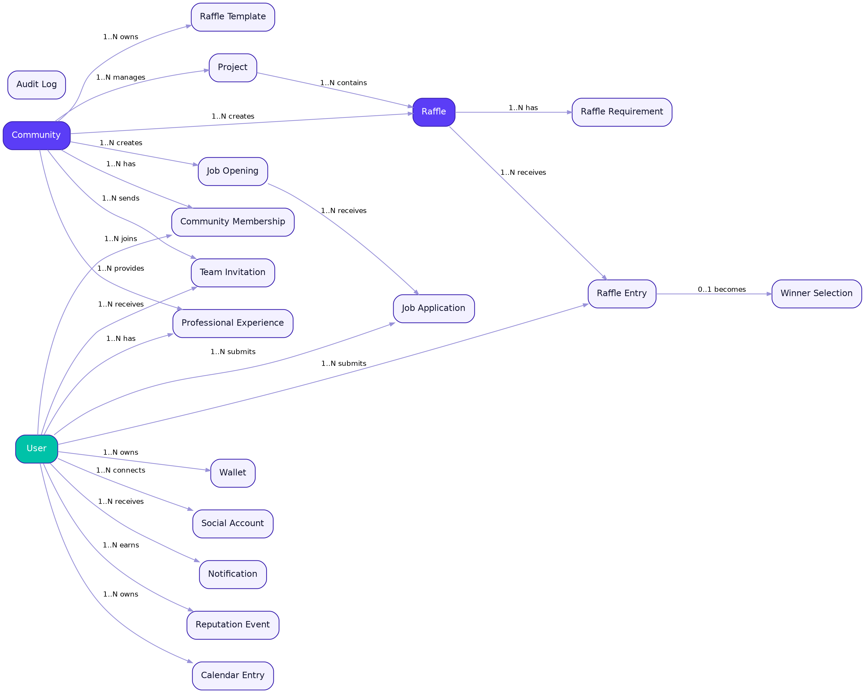
Figure 18 — Entity Relationship Diagram (ERD)

27 Security Architecture

27.1 Fixed Principles from the Start
- Wallet Signature: used only when required to verify ownership of the Main Wallet associated with NFT holdings. There is no general Wallet-based Login and no storage of private keys.
- OAuth Tokens: stored encrypted via Secret Manager / KMS.
- Raffle Entry: CAPTCHA → Rate Limit → Identity Dedup → Verification, then create the Entry Idempotently, using the user's linked X accounts to execute X requirements.

27.2 Additional Layers
- Audit Logs are immutable for every sensitive action.
- 2FA is mandatory for admin accounts.
- All tokens are encrypted (Token Encryption) and sessions are rotated (Session Rotation).
- Rate Limiting at both user and IP level.
- Anti-Sybil layers to prevent multiple fake accounts.
- Circuit Breakers to protect external services (Discord/X/Blockchain RPC) from cascading failure.
- Backup / Point-in-Time Recovery (PITR) for the database.
Approved security architecture: encrypted OAuth Tokens, Identity Binding, Anti-Sybil, and Provider Scope protection, with complete separation between X Feed fetching and X Eligibility actions.

28 Infrastructure & Tech Stack
Layer | Technology
Mobile App | Flutter (iOS + Android from one Codebase)
Web App | Next.js / React / TypeScript
Admin Dashboard | React / TypeScript
Backend | NestJS / Node.js
Database | PostgreSQL
Cache | Redis
Queue | BullMQ / Redis Streams
Scale-up Queue | Kafka
Storage | S3 / Cloudflare R2
Blockchain | Chain Provider Abstraction (multi-network)
Discord | discord.js
Telegram | grammY
Push Notifications | Firebase Cloud Messaging + APNs
Monitoring | Prometheus / Grafana
Error Tracking | Sentry
Tracing | OpenTelemetry
CI/CD | GitHub Actions
Containers | Docker
Orchestration | Kubernetes or equivalent managed services
The current SRS recommends approximately the same technology stack for the same reasons: library maturity, hiring ease, and horizontal scalability.

29 Development Roadmap

Phase 0 — Foundation
Repo, CI/CD, Dev/Staging/Production, PostgreSQL, Redis, Secrets, Observability, Base Schema, Auth Foundation, Design System. Estimated duration: approximately two weeks.

Phase 1 — Core Web MVP
Authentication, Unified User Profile, Multiple X Accounts, Add Wallets, NFT Holder Main Wallet Verification, core Discovery, Projects, Raffles, Raffle Modes, Requirement Engine, Discord, Premium, Auto-Register, Reputation, Calendar, My Raffles, My Wins, Communities, Templates, Provably Fair, Basic Admin, Support & Internal Messaging.

Phase 2 — Ecosystem Expansion
VEXUS Feed and Public X Project Updates, Advanced Notifications, Telegram, Hiring, Job Applications, Community Invitations for Hiring, Community/Talent enhancements, Advanced Analytics, and expanded social/integration features.

Phase 3 — Final Platform Expansion
Flutter Mobile App, Mobile-specific capabilities, Advanced Hiring, Advanced Reputation, White-label, deeper analytics, additional network support, and advanced Fraud/Risk systems.

30 Acceptance Criteria
Before accepting each Phase as complete, the following minimum criteria must be satisfied:
- Initial Raffle Entry response time below 300ms at p95, with capacity for at least 5,000 submissions/minute per Raffle.
- Every winner draw result must be independently verifiable (Verify Fairness) without blind trust in the server.
- Mobile/Web parity is not required for the MVP; when Mobile launches in Phase 3, core functions must remain consistent with Web from the same source of truth.
- No code path may store a Private Key or Seed Phrase on the server, and Wallet Signature must not be used as general login.
- Every sensitive admin action must be recorded in a non-deletable Audit Log.
- Pass a Load Test simulating a Raffle scenario with at least hundreds of thousands of concurrent participants for one large project.

31 Remaining Open Decisions Before Freeze
The following items must be resolved before their final details are locked, and none is an additional MVP requirement unless explicitly stated in the Roadmap.

Authentication
- Finalize the list of additional Login providers and any final Provider restrictions. Multiple X accounts are confirmed and required, with Abuse controls and Rate Limits.
- Detailed Username/Password/OTP/2FA policy and re-authentication stages.
- Password Security Policy (Username/Password Security Policy). (At baseline, it must be required on the website and be strong + OTP + 2FA)

NFT
- Final NFT Holder benefit details, what Premium Benefits are unlocked, and the sources/networks used to verify the Collection.
- Whether NFT ownership affects Community permissions remains a Product decision independent from ownership proof itself.
- Discounts or additional Benefits for holders of specific Collections are managed from the Dashboard when approved.

Premium
- Final Premium limits and pricing/billing/package design.
- Policies for Multi-Account X usage within Premium, if any, without affecting Odds.
- Auto-Register itself is Confirmed; only Provider Scopes, execution constraints, and provider-specific policies remain.
- Create Community = Premium Confirmed.
- Hiring = Phase 2, with final Premium entitlement to be determined before Hiring launches.

Reputation
- Final formula for the Reputation Score.
- Final Range / normalization.
- Source of the Money Score and its verification mechanism.
- Source/interface for the ASOS API and any additional external signals.
- Public and private presentation format for Reputation Details.
- Future effects of Reputation on the product, assuming by default that it does not change Odds.

Hiring
- Final Job Opening/Application workflow details for Phase 2.
- There is no standalone Job Chat; Support Messaging remains separate from Hiring communication.
- Whether advanced Interview/Offer workflows exist within Phase 2.
- Job Proposal/Offer details if approved.

Raffle
- Exact Weighted Draw weights and rules for interpreting/applying the weights.
- Exact eligibility rules for each Provider/Requirement Type.

Infrastructure
- Expected traffic target (Traffic Target).
- Monthly infrastructure budget.
- Preferred Cloud Provider.
- Final Launch Deadline.

32 Appendix — Terminology and Current Readiness

32.1 What Is Ready Now as the Execution Baseline
# | Item
1 | Product Scope
2 | Site Map
3 | Page Map
4 | User Flows
5 | Community Flows
6 | Hiring Flows
7 | Raffle State Machine
8 | Winner Selection Flow
9 | Database Domain Model
10 | High-Level Architecture
11 | Authentication Architecture
12 | Notification Architecture
13 | Premium Model
14 | Reputation Model
15 | Hiring Model
16 | Admin Model
17 | Security Model
18 | Infrastructure Baseline
19 | Development Phases
20 | Open Decisions
21 | Mobile App Specification — Final Phase
22 | Web App Specification — MVP Primary Surface
23 | Admin Dashboard Specification — Core
24 | Sequence Diagrams (Auth / Entry / Winner Selection / Auto-Register)
25 | Full ERD

32.2 Priority Principle
No part of the previous SRS is final by itself; this version is the Master Baseline after the client's current decisions. Alphabot details remain Reference Behavior only and are not the final authority for the Vexus product.

32.3 Next Step
After approval, this document becomes the Single Source of Truth for implementation. The Vexus team starts with Phase 0, then Phase 1 Web MVP, while Feed/Hiring/Advanced Notifications are deferred to Phase 2 and Mobile to Phase 3.

