Pedestrian Detection Using YOLOv8 on the LLVIP Dataset

# 1. Dataset Description

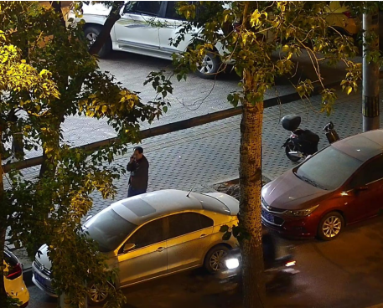The LLVIP dataset includes over 12,000 images in the visible spectrum. Each image has a corresponding XML file that contains annotated bounding boxes for detected objects. This project focuses exclusively on the 'person' class.

# 2. Data Preprocessing

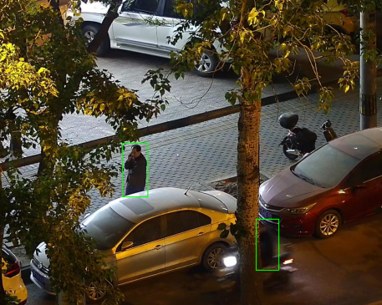The preprocessing stage includes reading XML annotations, converting bounding boxes to YOLO format, and splitting the dataset into training and validation sets using an 80:20 ratio. Only images with pedestrian annotations were kept.

# 3. Model Training

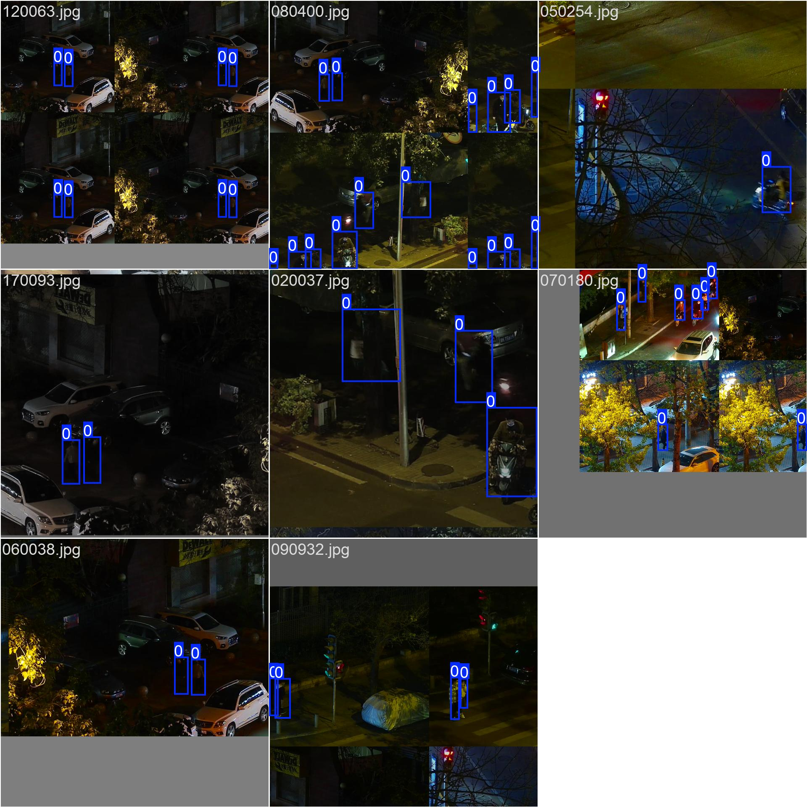YOLOv8 was used as the detection model. Initially, the large version (yolov8l) was loaded and trained on the dataset for 5 epochs.

# 6. Results

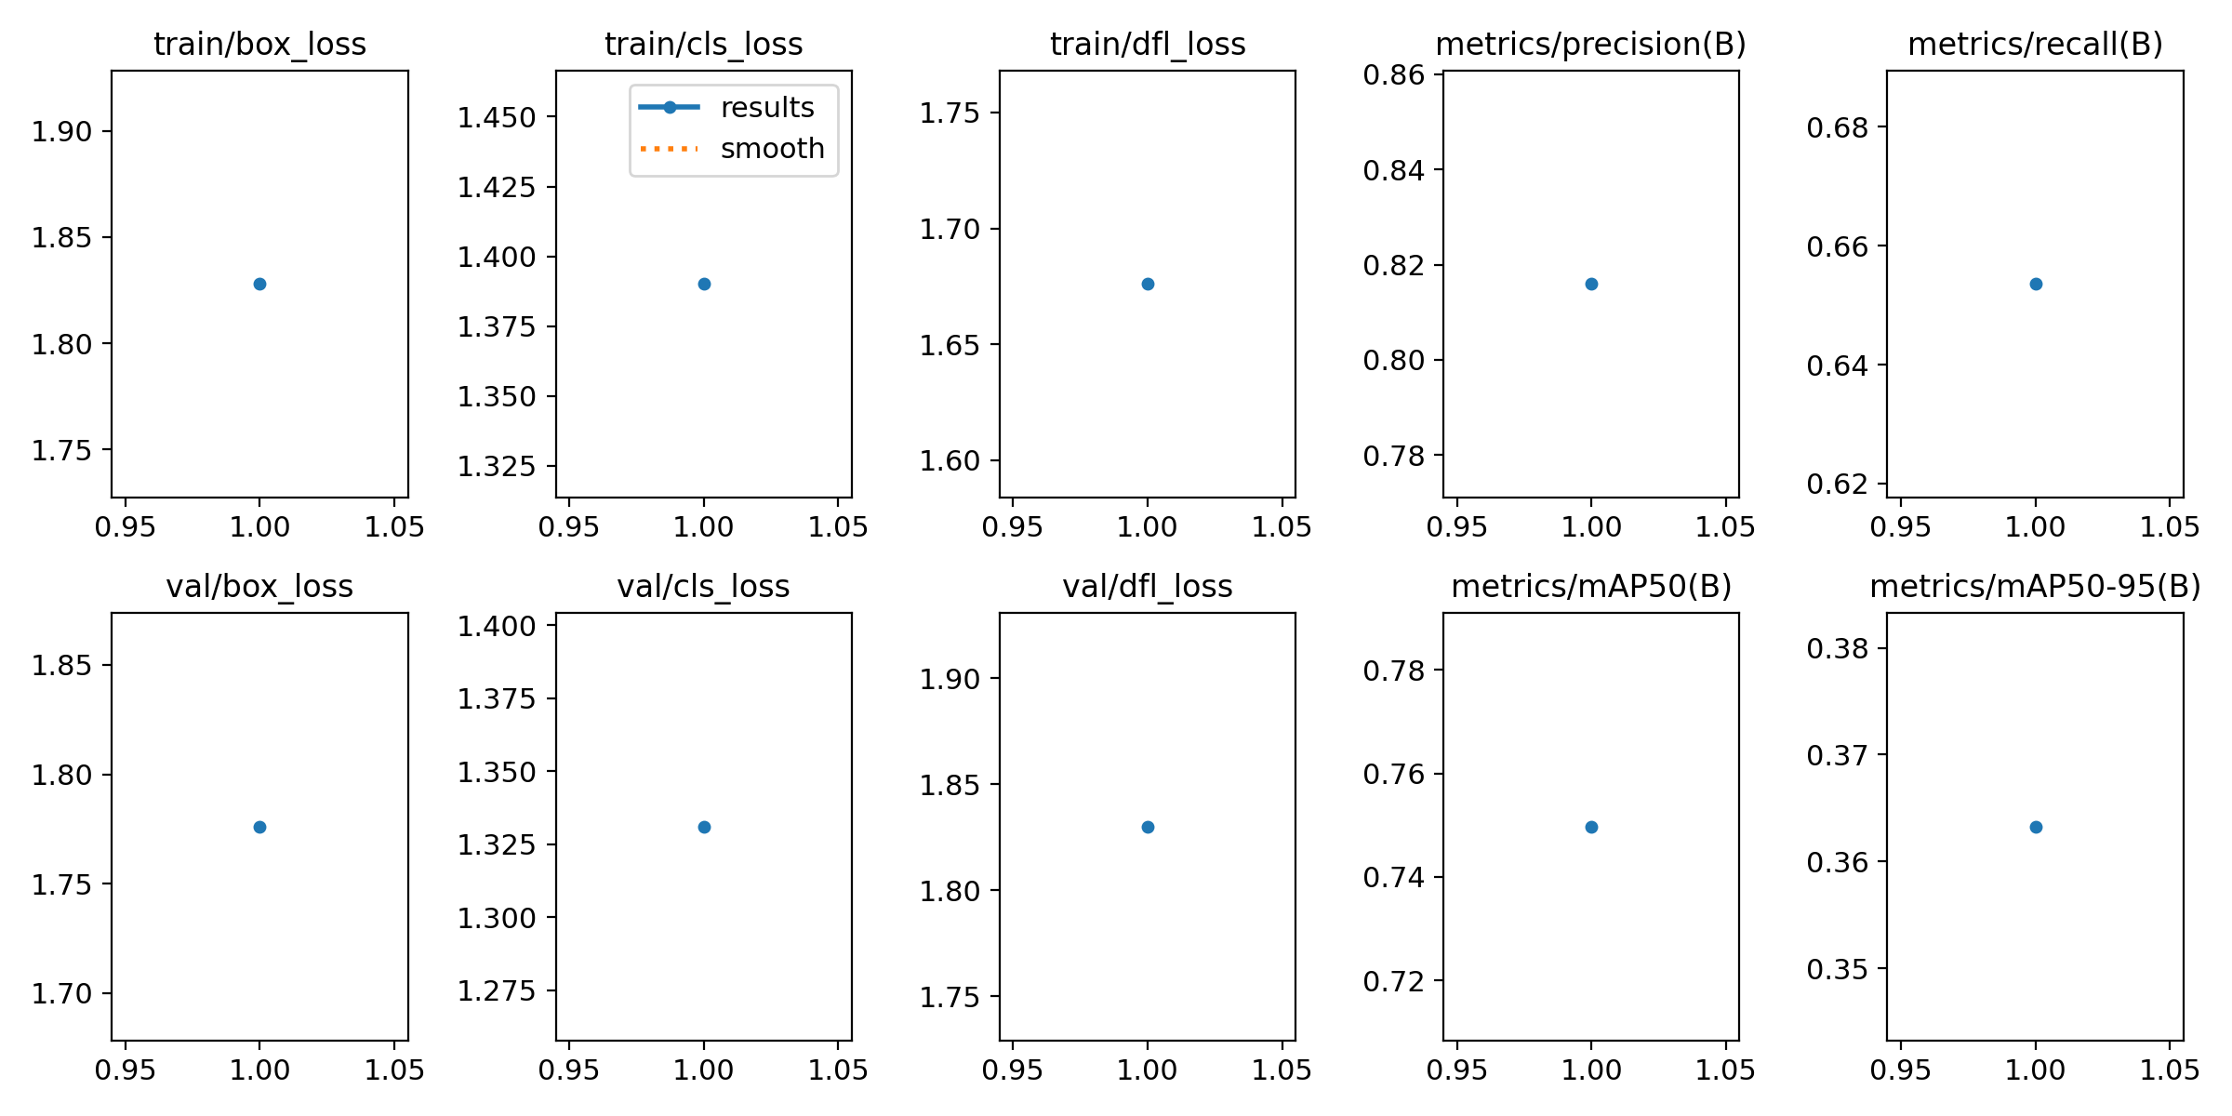The results show that YOLOv8 can effectively detect pedestrians in the LLVIP dataset

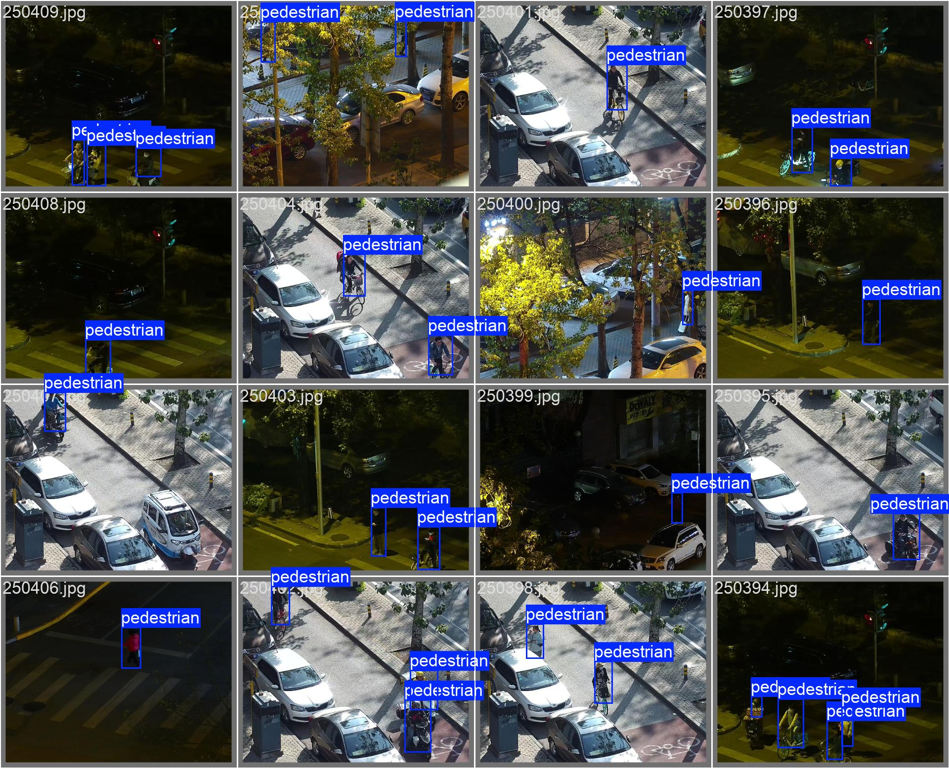

# 7. pre-trained yolo model Results

