Title of Your Presentation

Author(s) ,
Department of physics, Faculty of sciences, University of Boumerdes

ABSTRACT
These instructions give you guidelines for preparing abstract of your work. Use this document as a template with Microsoft Word 6.0 or later. Define all symbols used in the abstract. Do not cite references in the abstract. The abstract body copy should be in Times or Times New Roman, 10 pt.
Index Terms — Instructions, guidelines, abstract, copy.

1 INTRODUCTION
This document is a template for Microsoft Word versions 6.0 or later. If you are reading a paper or PDF version of this document, please download the electronic template from to prepare your manuscript.
The objective of this document is to provide a template for the preparation of a paper for publication in the JSPP. The use of this template will ensure the professional appearance of your paper as well as providing a uniform digital source from which to satisfy the electronic publication requirements.
When you open this document, select “Page Layout” or “Print Layout” from the “View” menu in the menu bar, which allows you to see the footnotes. Then type over sections of this document or cut from another document and paste and then use markup styles. The pull-down style menu is at the left of the Formatting Toolbar at the top of your Word window (for example, the style at this point in the document is “Text”). Highlight a section that you want to designate with a certain style, then select the appropriate name on the style menu. The style will adjust your fonts and line spacing. Do not change the font sizes or line spacing to squeeze more text into a limited number of pages.
Use italics for emphasis; do not underline. Turn off “smart quotes” (Tools | AutoCorrect | AutoFormat tabs). Turn off automatic hyphenation (Tools | Language | Hyphenation).
To insert images in Word, position the cursor at the insertion point and either use Insert | Picture | From File or copy the image to the Windows clipboard and then Edit | Paste
Manuscript received on X Month 2005, in final form XX Month 2005.
Special | Picture (with “Float over text” unchecked).

2 Methods / Metodologie
This section covers the details regarding preparation of your manuscript for submission, the submission procedure, review process and copyright information.

Preparation of Manuscript
Since the final printed pages are based on the submitted copy, we urge that utmost care be taken in the preparation utilizing this electronic template. For your information, page size is 8.5x11 inches and column width is 3.5 inches (8.9 mm) and column length 9.2 inches (23.4 cm). All figures and tables should have adequate titles or captions, and must be integrally placed at their proper location(s) in the text. For the benefit of the readers, the figures, tables, graphs and photos should be placed near the corresponding text; that is, not accumulated at the end of the text or at the end of the manuscript. Further information on Figures and Tables can be found in Section 6.1.
Due care should be exercised to avoid the use of abbreviations and phrases which may not be familiar to all readers
The length of technical papers, in general, is preferred to be not more than 2 pages (including all figures and biographies). Review type papers may be longer. This requirement is unfortunately dictated by financial constraints.

Somme result and discussion
The Transactions Editor will need to receive an electronic version of your manuscript. The only acceptable electronic format is Word 6.0 or later (.doc).
Papers must be submitted electronically to the following web site: jspp.contact@gmail.com. The web site will require you to enter information about the paper as well as contact information. Upon successful submission of the paper an email confirmation will be sent to the corresponding author acknowledging the receipt of the paper and other information.
If there are questions, the corresponding author may wish to contact.

3 MATH
When using Word, use either the Microsoft Equation Editor or the MathType add-on (http://www.mathtype.com) for equations in your paper (Insert | Object | Create New | Microsoft Equation or MathType Equation). “Float over text” should not be selected.

4 UNITS
Use only SI units. In cases where none SI units are desired these must be placed in parenthesis next to the SI units.

5 HELPFUL HINTS
Large figures and tables may span both columns. Place figure captions below the figures; place table titles above the tables. If your figure has two parts, for example, include the labels “(a)” and “(b)” as part of the artwork. In the text use Figure 4a and not Fig. 4 (a). Figures 5a and 5b and not Figs. 5 (a) and (b). Please verify that figures and tables that you mention in the text actually exist. Use ‘Figure’ even in the middle of sentence. Do not use the abbreviation “Fig.”. Do not abbreviate “Table.”
Figure axis labels are often a source of confusion. Use words rather than symbols. As an example, write the quantity “Rate,” or “Rate, R,” not just “R.” Put units in parentheses. Do not label axes only with units. As in Figure 1, for example, write “Rate (kb/s).”
Multipliers can be especially confusing. Write “Rate (kb/s)” or “Rate (10³ b/s),” not “Rate (b/s) × 1000.” Figure labels should be legible, approximately 8 to 12 point type.
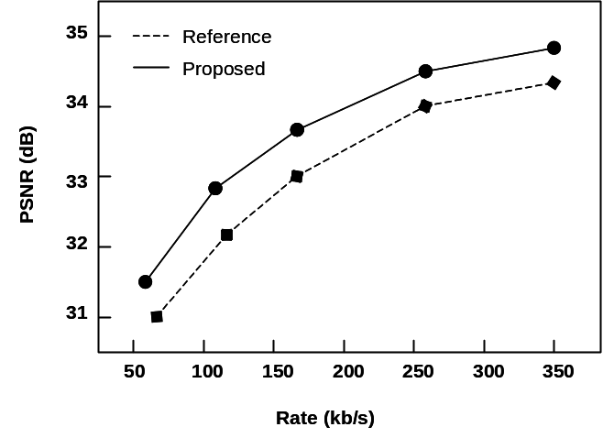
Figure 1. Rate-Distortion curves comparing Reference and Proposed algorithms. There is a period after the figure number, followed by two spaces. It is good practice to explain the significance of the figure.

6. EQUATIONS
Number equations consecutively with equation numbers in parentheses flush with the right margin, as in (1). First use the equation editor to create the equation. Then select the “Equation” markup style. Press the tab key and write the equation number in parentheses. To make your equations more compact, you may use the solidus ( / ), the exp function, or appropriate exponents. Use parentheses to avoid ambiguities in denominators. Punctuate equations when they are part of a sentence, as in

Be sure that the symbols in your equation have been defined before the equation appears or immediately following. Symbols should be as used in the equations either in Roman or italics. Refer to “equation (1)” not “Eq. (1)” or “(1),” except at the beginning of a sentence: “Equation (1) is ... .”

7 Conclusions
Table 1. Units and Corresponding Symbols
Unit | Unit Symbol
megabytes per second | MB/s
kilohertz | kHz
nanosecond | ns

Conclusions must be supported by data or literature references so that the reader may judge the paper’s validity independently. The author is expected to differentiate between conclusions based on association and those that can be attributed to specific causes. The manuscript should be precise, concise, and candid. All pertinent literature, including antithetical references, should be cited. Mere summaries of the literature, progress reports having no permanent value, and papers containing commercial overtones are not acceptable. A conclusion section is very useful. Although a conclusion may review the main points of the paper, do not replicate the abstract as the conclusion. A conclusion might elaborate on the importance of the work or suggest applications and extensions.
Failure either to disclose the generic name of a material, or to characterize it technically, and the improper use of a trademark will result in a request for revision as a condition of acceptance.
Acknowledgment
Avoid expressions such as “One of us (S.B.A.) would like to thank ... .” Instead, write “S.B.A. thanks ... .” Put sponsor acknowledgments in the Acknowledgment section.
This template is based in part on that used by IEEE Transactions on Consumer Electronics and thanks are extended to the creators of that template.

8 ReFERENCES
Number citations/references consecutively in square brackets [1]. The sentence punctuation follows the brackets [2]. Multiple references [2, 4-6] are numbered between same brackets. When citing a section in a book, please give the relevant page numbers [8]. In sentences, refer simply to the reference number, as in [3]. Do not use “Ref. [3]” or “reference [3]” except at the beginning of a sentence: “Reference [3] shows ....”
Example:
- A. Vetro, H. Sun, P. DaGraca, and T. Poon, “Minimum drift architectures for three-layer scalable DTV decoding”, IEEE Trans. Dielectr. Electr. Insul, Vol. 44, pp. 527-536, 1998.

