CHAPTER ONE: INTRODUCTION

General Introduction:
The introduction of the library management system marks the dawn of a digital era in managing library resources efficiently. In traditional library setups, manual processes often lead to inefficiencies and errors. However, with the advent of technology, the transition to digital platforms has become imperative for libraries to streamline their operations.

Aim and Objectives:
The aim of this project is to develop a robust library management system that automates various tasks involved in managing library resources. The objectives of the project include:

1. Efficient Resource Management:
Develop a system to efficiently manage books, clients, and user data.
2. Streamlined Operations:
Automate day-to-day library operations such as book lending, returns, and client management.
3. Enhanced User Experience:
Design an intuitive user interface that makes it easy for library staff to perform tasks and for patrons to access library resources.
4. Data Integrity and Security:
Implement measures to ensure data integrity and security, protecting sensitive information such as user credentials and transaction history.
5. Reporting and Analysis:
Provide tools for generating reports and analyzing library usage patterns to make informed decisions.
6. Scalability and Adaptability:
Build a system that can scale with the growth of the library and adapt to future technological advancements.

Problem Statement:
Traditional library management systems often rely on manual processes, leading to inefficiencies, errors, and delays. Some common problems faced by libraries include:

1. Manual Book Tracking:
Keeping track of books, their availability, and lending status manually is time-consuming and prone to errors.
2. nefficient Client Management:
Managing client records, memberships, and transactions manually can lead to data inconsistencies and delays in serving clients.
3. Limited Accessibility:
Physical access to library resources restricts users' ability to browse and borrow books remotely, especially in today's digital age.
4. Data Security Risks:
Storing sensitive user data in traditional paper-based systems or unsecured digital databases poses risks to data security and privacy.
5. Lack of Reporting Tools
The absence of robust reporting and analysis tools makes it challenging for library administrators to gather insights into library usage patterns and make informed decisions

In Chapter Two of your literature review, you're diving into the landscape of software development methodologies, specifically focusing on comparing different methodologies and justifying the selection of Scrum for your project. Additionally, you're exploring related concepts and literature pertinent to your project. Here's how you might structure this chapter:

CHAPTER TWO: LITERATURE REVIEW

Software Development Methodologies:

In the realm of software development, methodologies play a crucial role in the successful completion of projects. As I reflect on the completed project, it is essential to understand the systematic approaches that guided our journey. Let's explore the software development methodologies we employed:

1. Waterfall Model:
During the project, we embraced the widely recognized Waterfall Model. This approach allowed us to divide the development process into distinct phases, namely requirements, design, implementation, testing, and maintenance. By following a sequential path, we ensured that each phase was completed before seamlessly transitioning to the next.

2. Agile Methodologies:
Our project also leveraged the power of Agile methodologies, including Scrum, Kanban, and Extreme Programming (XP). These methodologies fostered an environment of iterative development, collaboration, and continuous customer feedback. The flexibility and adaptability they offered were integral to our success.

3. Scrum:
Within the Agile umbrella, we specifically adopted the Scrum framework. This framework empowered us to conduct short iterations called sprints, facilitating efficient development. By promoting self-organizing teams, frequent communication, and continuous improvement, Scrum played a vital role in our project's triumph.

Comparison between different Software Development Methodologies:

Throughout the project, we assessed various software development methodologies to determine the most suitable approach. Let's briefly compare the Waterfall, Agile, and Scrum methodologies:

- Waterfall: This methodology proved suitable for projects with well-defined requirements and minimal customer involvement. Its linear and sequential nature made it less adaptable to changes during development.

- Agile: Our project demanded an approach that accommodated evolving requirements and extensive customer collaboration. Agile methodologies, with their emphasis on flexibility, adaptability, and rapid delivery, aligned perfectly with our goals.

- Scrum: Among the Agile methodologies, Scrum emerged as the ideal choice. Its focus on delivering value through iterative development, along with its clear roles, ceremonies, and artifacts, provided a solid foundation for effective project management.

Reason for the choice of Scrum Methodology:

The decision to implement the Scrum methodology stemmed from various factors that influenced our project's success:

- Flexibility: Scrum's iterative approach allowed us to be flexible and adaptable, enabling us to accommodate changing requirements or priorities seamlessly.

- Customer Collaboration: Embracing Scrum ensured active involvement of stakeholders, including our valued customers, throughout the entire development process. Their input and feedback were invaluable in shaping the final product.

- Continuous Improvement: Scrum's commitment to regular reflection and adaptation fostered a culture of continuous improvement. This led to enhancements in both the product itself and the overall development process.

- Team Empowerment: Scrum empowered our self-organizing teams, granting them autonomy to make decisions and take ownership of their work. This resulted in heightened motivation and productivity, driving our project forward.

General review of related concepts with respect to our chosen project:

Considering the library management system that we have successfully implemented, several related concepts played a pivotal role:

- Database Management: Our system efficiently and securely handled various data related to books, clients, users, and transactions. The robust database management ensured smooth operations.

- User Interface Design: A key consideration was designing an intuitive and user-friendly interface that enabled seamless interaction between library staff and patrons. The focus on user experience enhanced the usability of the system.

- Security: Strong security measures were implemented to safeguard sensitive information and prevent unauthorized access, ensuring the confidentiality and integrity of data within the system.

- Integration: Our library management system seamlessly integrated with other systems and services, such as online catalogs or external databases. This integration enhanced the overall functionality and accessibility of the system.

Review of related literature with respect to your chosen project:

As we embarked on our library management system project, exploring relevant literature proved invaluable. Some of the literature we delved into included:

i. Best practices in library automation and digitization: We studied the principles and methodologies that have yielded successful library automation and digitization projects. These insights guided our decision-making process.

ii. Case studies of successful library management system implementations: Analyzing real-life examples of successful library management system implementations provided us with valuable lessons and inspiration.

iii. Emerging technologies and trends in library services and operations: Staying updated with the latest technologies and trends in the library landscape enabled us to incorporate innovative solutions into our project.

iv. User experience (UX) design principles for library interfaces: Understanding the principles of user experience design for library interfaces allowed us to create a system that was intuitive and enjoyable for users.

v. Challenges and solutions in data management and information retrieval for libraries: We explored the challenges faced by libraries in managing and retrieving data effectively, seeking out solutions to overcome these obstacles.

By immersing ourselves in the relevant literature, we gained a comprehensive understanding of the library management domain, enabling us to create a robust and successful system.

CHAPTER THREE: METHODOLOGY AND MATERIALS

Research Methodology:

For the development of the library management system, the following research methodology is proposed:

1. Research Design: This project will utilize a mixed-methods research design. It will involve both qualitative and quantitative approaches to gather comprehensive insights into the requirements and preferences of users, as well as to evaluate the effectiveness of the system.

2. Data Collection Methods:
- Surveys: A survey was be conducted among library staff and patrons to gather feedback on their needs, expectations, and preferences regarding the library management system.
- Interviews: In-depth interviews will be conducted with librarians, administrators, and IT personnel to gain a deeper understanding of specific requirements and technical considerations.
- Observations: Observations of library operations and user interactions will be conducted to identify workflow patterns and areas for improvement.

3. Sampling Strategy: Convenience sampling will be used to select participants for surveys and interviews. The sample will include a diverse range of library stakeholders, including librarians, staff, administrators, and patrons.

4. Data Analysis: Survey responses will be analyzed using statistical techniques to identify common trends, preferences, and priorities. Interview transcripts and observational data will be thematically coded to identify recurring themes and insights.

5. Ethical Considerations: Ethical principles will be upheld throughout the research process. Informed consent will be obtained from all participants, and their privacy and confidentiality will be protected.

6. Limitations and Delimitations: Limitations may include constraints on time, resources, and access to certain stakeholders. The study's findings may be limited in generalizability to other libraries with different contexts or demographics.

System Requirements (Functional and Non-Functional):

Functional Requirements:

1. User Management:
- Ability to create, edit, and delete user accounts with different roles (e.g., librarian, administrator, patron).
- User authentication and authorization mechanisms to control access to system features.

2. Book Management:
- Functions for adding, editing, and deleting books from the library catalog.
- Search, sort, and filter capabilities for books by title, author, category, etc.
- Support for barcode scanning and RFID technology for book identification.

3. Client Management:
- Tools for managing library patrons, including registration, profile management, and borrowing privileges.
- Notification system for overdue books, reservation statuses, etc.

4. Transaction Management:
- Facilities for handling book checkouts, returns, renewals, reservations, and fines/fees.
- Integration with payment gateways for online fine payment and fee collection.
5. Reporting and Analytics:
- Capabilities for generating reports on library activities, such as circulation statistics, inventory status, overdue books, etc.
- ata visualization tools for analyzing trends and patterns in library usage.

Non-Functional Requirements:

1. Performance:
- The system should respond promptly to user actions, with minimal latency.
- Support for concurrent access by multiple users without performance degradation.
2. Reliability:
- The system should be available whenever needed, with minimal downtime or service interruptions.
- Data backup and recovery mechanisms to ensure data integrity and continuity of service.

3. Security:
- Robust measures to protect sensitive data, including encryption, access controls, and threat detection.
- Regular security audits and updates to mitigate security risks and vulnerabilities.

4. Usability:
- Intuitive and user-friendly interface design, with features optimized for ease of navigation and accessibility.
- Support for multiple languages and customization options to accommodate diverse user preferences.

5. Scalability:
- The system should be scalable to accommodate future growth in the number of users, books, and transactions.
- Flexible architecture and modular design to facilitate seamless expansion and integration with other systems.

System Design
Architecture of your system (HLD)

1. Client Interface:
- Login Interface: Allows users to log in using their credentials.
- Main Interface: Provides access to various features like managing books, clients, users, and settings.

2. Backend:
- Database: Utilizes MySQL to store and manage data related to books, clients, users, and operations.
- Python Backend: Contains the logic to interact with the database and process user requests.

3. Functionality:
- User Authentication: Validates user credentials during login.
- Book Management: Allows adding, editing, searching, and deleting book records.
- Client Management: Provides functionality for managing client records.
- User Management: Manages user accounts, including adding, editing, and logging in.
- settings: Allows adding categories, authors, and publishers.
- Day-to-Day Operations: Handles lending books to clients and tracking operation details.
- Data Export: Enables exporting data related to day operations, books, and clients to Excel files.

4. UI Themes:
- Supports different UI themes to customize the appearance of the application.

5. Security Considerations:
- Authentication and authorization mechanisms ensure that only authorized users can access sensitive functionalities.
- Data validation mechanisms prevent injection attacks and ensure data integrity.

6. Scalability and Performance:
- Designed to handle a growing database of books, clients, and users efficiently.
- Optimization techniques may be implemented to improve query performance and overall system responsiveness.

7. Error Handling:
- Comprehensive error handling mechanisms to handle exceptions gracefully and provide informative error messages to users.

8. Integration:
- May support integration with external systems for features like online book purchases, book recommendations, etc.

9. Deployment:
- Can be deployed on local servers or cloud platforms depending on the scale and requirements of the library.

10. Maintenance and Updates:
- Modular design allows for easy maintenance and updates to individual components.
- Version control systems can be used to track changes and collaborate on development.

11. Testing:
- Comprehensive testing procedures to ensure the correctness and reliability of the system.
- Unit tests, integration tests, and system tests can be performed to validate different aspects of the application.

USECASE DIAGRAM

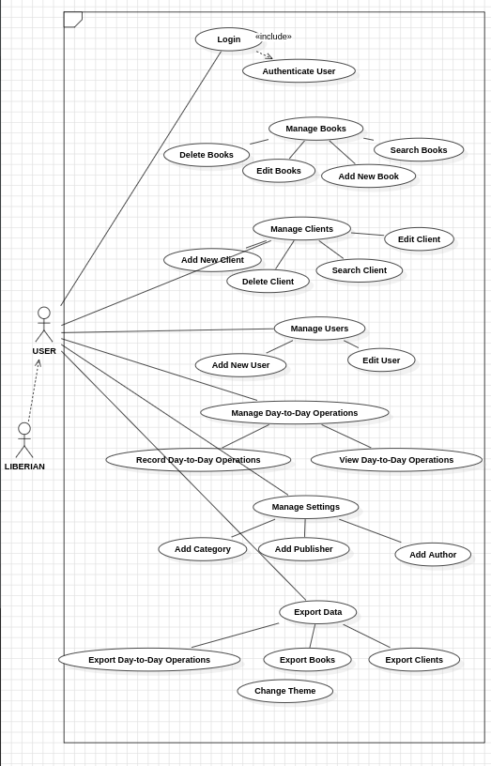

CLASS DIAGRAM
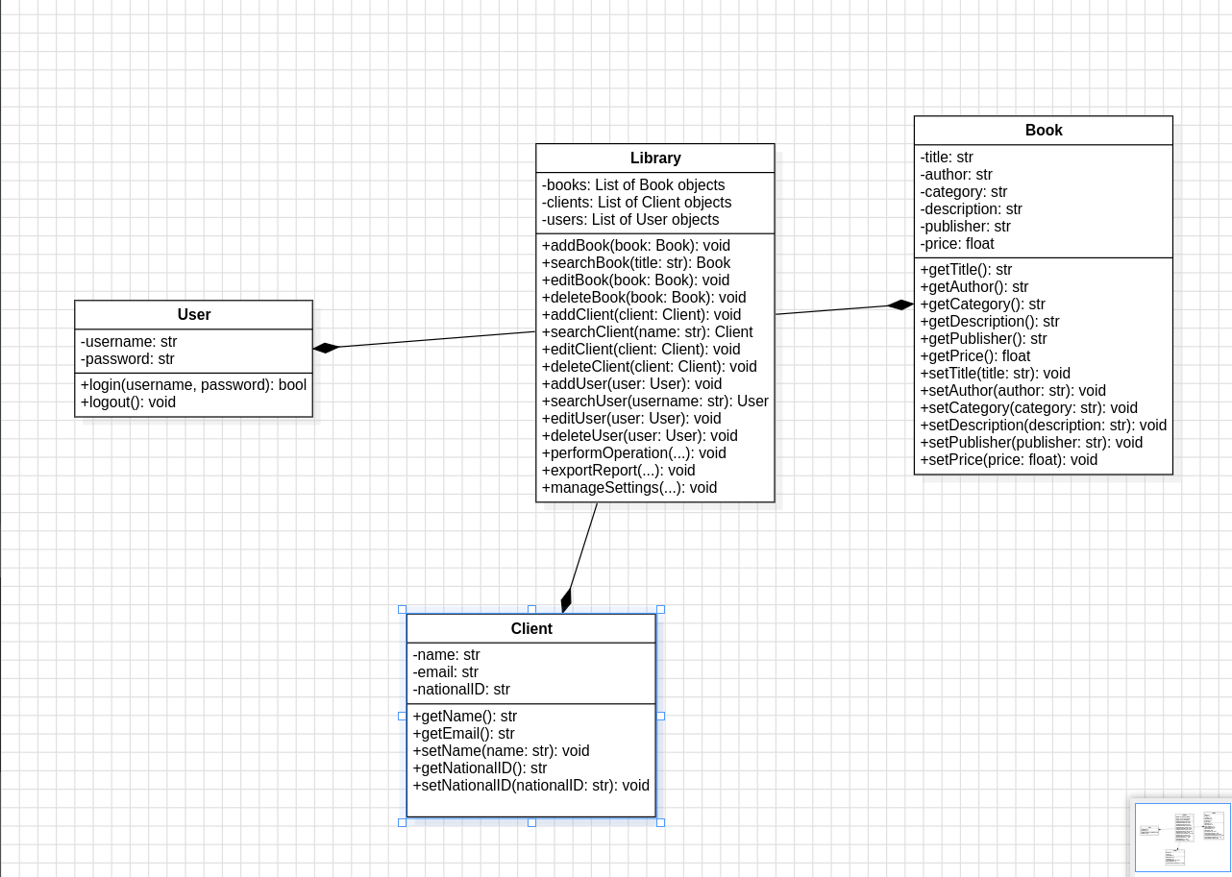

SEQUENCE DIAGRAM

Borrow Book

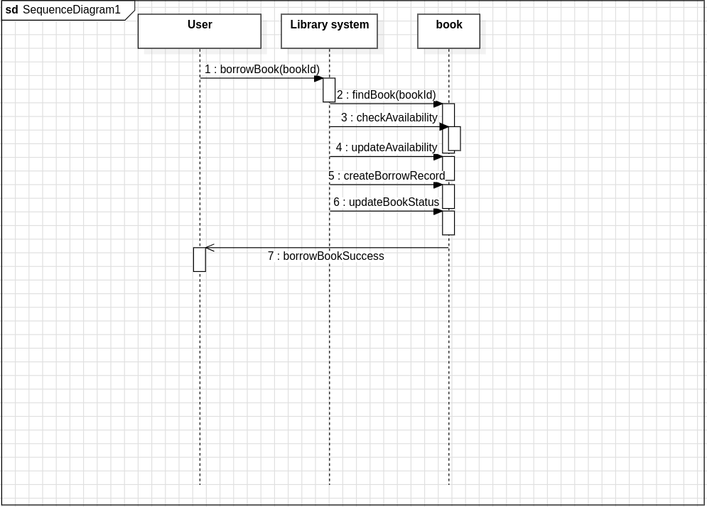
Returm Book

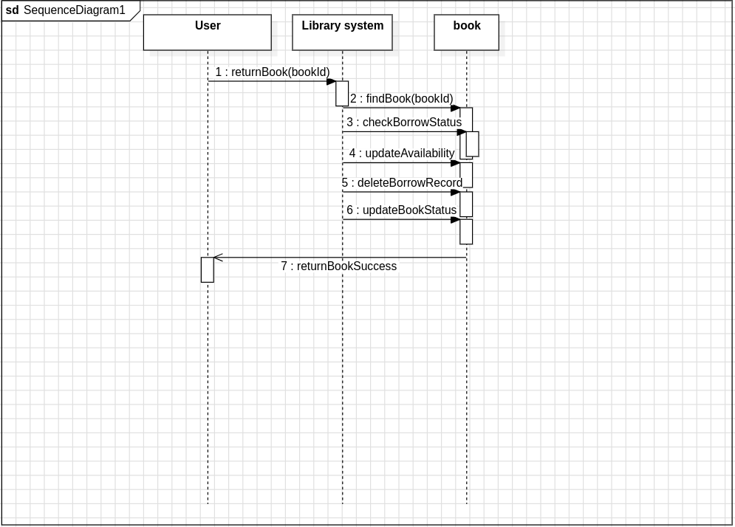

Add book

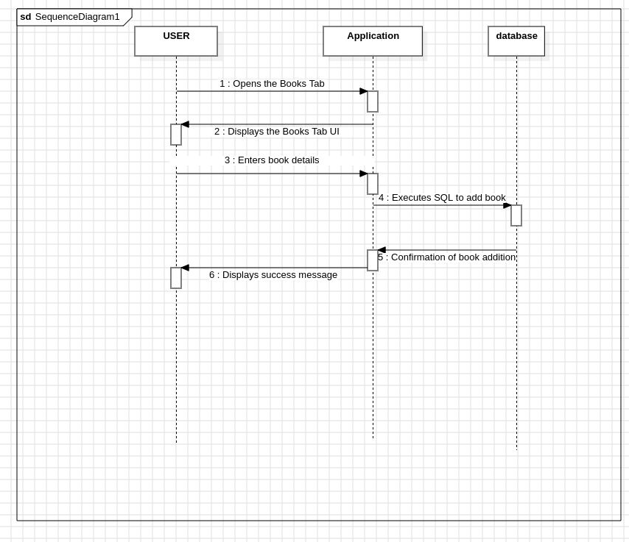

Delete book

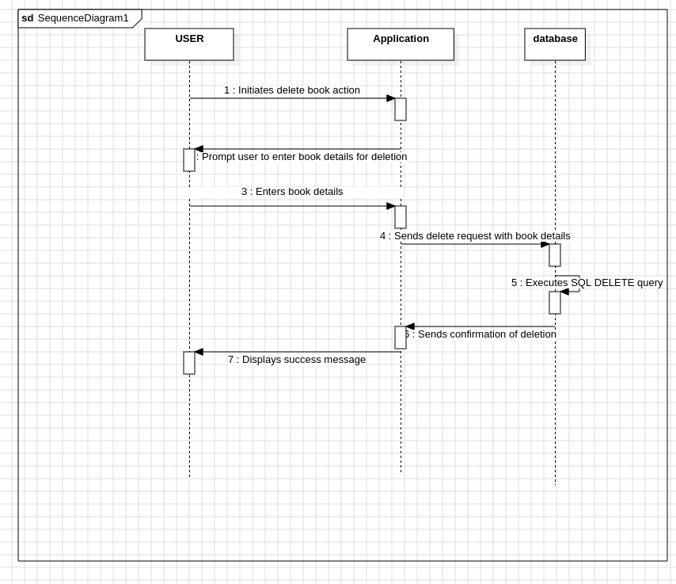
login

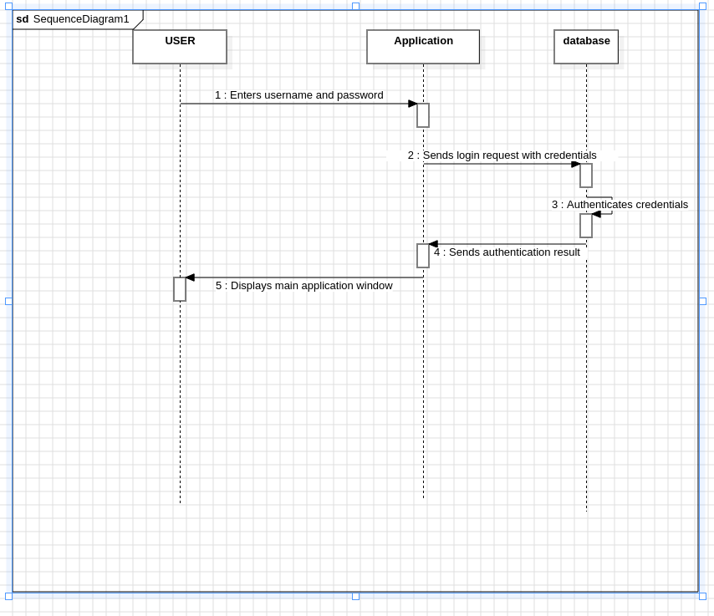

APPLICATION OF SCRUM

Team Organization:
  - You divided the work among team members, ensuring each member had individual tasks to work on. This promotes collaboration and accountability within the team.
- Workflow Management:
  - Daily group meetings via WhatsApp group calls allowed for quick updates on progress, impediments, and alignment of goals. These meetings are akin to daily stand-ups in Scrum, enabling transparency and keeping everyone on the same page.
  - Sprint meetings at the end of each week provided an opportunity to review the work done, discuss any issues or challenges encountered, and plan for the next sprint. This aligns with the Scrum practice of sprint reviews and sprint retrospectives.
- Conflict Resolution:
  - By implementing sanctions for members who did not attend meetings and taking attendance at the end of each meeting, you addressed the issue of non-participation. This proactive approach helps ensure that team members understand the importance of their participation and commitment to the project.
- Challenges Encountered and Overcoming Them:
  - Some team members were unfamiliar with GitHub. You addressed this challenge by directing them to group members who had expertise in using GitHub. This is a practical approach to knowledge sharing within the team and leveraging the skills of each team member.
  - By holding daily and sprint meetings, you created regular opportunities for team members to seek help, share knowledge, and collaborate effectively, ultimately overcoming challenges through teamwork and communication.

PRUDOCT BACKLOG:

User Story ID | User Story | Acceptance Criteria | Priority | Initial Time Estimate | Adjustment Time | Final Estimate
US001 | As a user, I want to be able to log in | User should be able to enter username and password | High | 4 hours | 2 hours | 6 hours
US002 | As a user, I should be able to view books | User should be able to see a list of available books | High | 6 hours | 1 hour | 7 hours
US003 | As a user, I want to add a new book | User should be able to enter book details (title, description, category, author, publisher, price) | High | 8 hours | 3 hours | 11 hours
US004 | As a user, I want to search a book | User should be able to search for a book by its title | High | 6 hours | 2 hours | 8 hours
US005 | As a user, I want to delete a book | User should be able to delete a book from the system | High | 4 hours | 1 hour | 5 hour
US006 | As a user, I want to add a new client | User should be able to enter client details (name, email, national ID) | High | 6 hours | 2 hours | 8 hours
US007 | As a user, I want to edit a client | User should be able to search for a client by national ID | High | 4 hours | 1 hour | 5hour
US008 | As a user, I want to delete a client | User should be able to delete a client from the system | high | 2 hours | 1 hours | 4 hours
US009 | As a user, I want to add a new user | User should be able to enter user details (username, email, password) | High
US010 | As a user, I want to edit a user | User should be able to search for a user by username | High | 3.5 | 1 hour | 4.5 hours
US011 | As a user, I want to export day-to-day operations | User should be able to export day-to-day operations data to an Excel file | Medium | 6 hrs | 0.5 hours | 6.5 hours
US012 | As a user, I want to switch UI themes | User should be able to change the UI theme | Low | 4 hours | 1 hours | 5 hour
US013 | As a user, I want to add a new author | User should be able to enter a new author name | low | 3 hours | 1 hours | 4 hours
US014 | As a user, I want to export clients | User should be able to export clients data to an Excel file | Meduim | 5 hour | 1 hour | 6 hour
US015 | As a user, I want to add a new category | User should be able to enter a new category name | Low | 3 hour | 1 hours | 4hours
US016 | As a user, I want to export books | User should be able to export books data to an Excel file | meduim | 6 hour | 1 hour | 7hour
US017 | As a user, I want to add a new publisher | User should be able to enter a new publisher name | Low | 3 hours | 1 hour | 4 hours

