Abdoulfatah Abdillahi ID: 921623492
Github: Abdoul1996 CSC415 Operating System

Assignment 4 – Word Blast

Description: This program is to read a file and count the words that are 6 or more characters long. The main goal of the assignment is to familiarize with threads. Threads will take a chunk of data from WarAndPeace.txt file and process it and it returning the 10 words that are 6 or more characters long.

Approach/ What I did:

Before I start solving the problem, I read several times to understand the assignment, and then I break down into steps to code the project.

I had a hard time to understand how to defined the size of the file because a few times I had segmentation fault when I run the program. It took me time to understand what’s the segmentation even you mentioned in the class.

Issues and Resolution:

The issues I faced was segmentation fault, I think I was accessing area that I was not allowed. It took me for s quiet while to understand.

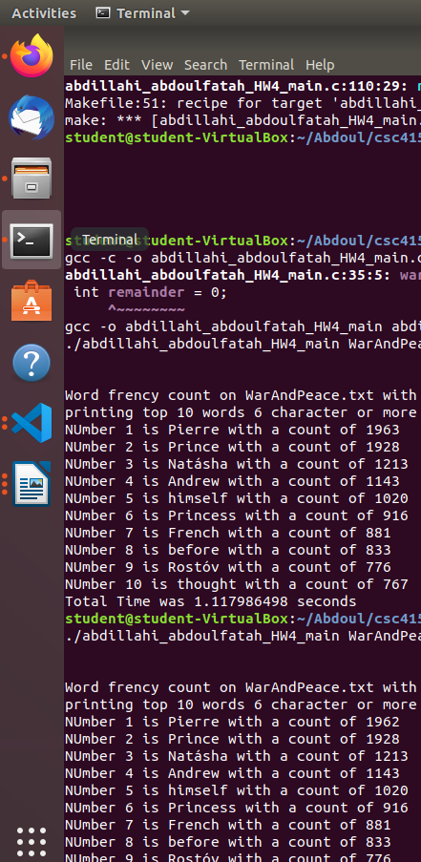

The OUTPUT:
