Who did best for Canada in Olympics?

We have tried to find out the time period, gender, sports and athlete which performed/represented comparatively well and consistent in Olympics for Canada.

So first we have selected the data for Canada and filtered out rest of the countries and tried to find the answer to question stated above.

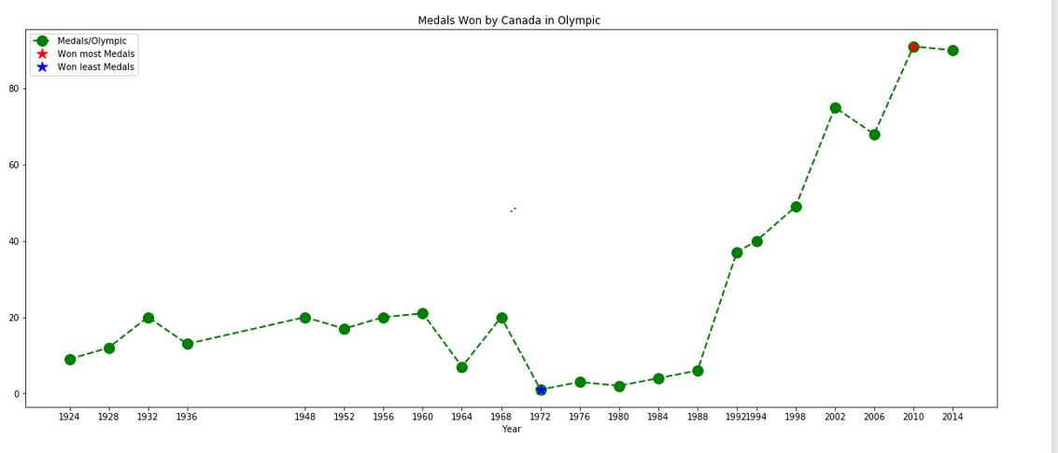We first checked how Canada has performed through the Olympics and found a rapid increase in winning overall medals. We observed a rapid growth in winning medals after 1994. 2010 was recorded as the highest while 1972 with the lowest where Canada managed to win just one Silver medal.

We checked the gender wise distribution of winning medals and found at the start only men were able to win medals and their performance wasn’t consistence. From year 1976 to year 1988 men wining overall medals was below 10 and observed almost zigzag from year 1992 onwards from men gender.

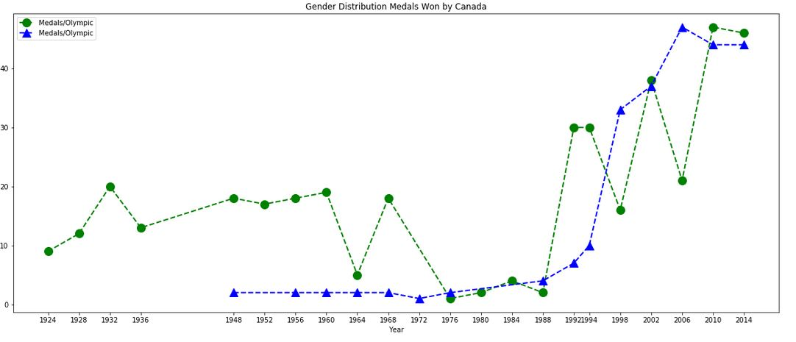But on the hand, women have shown significantly better and improving performance from 1994 and even in some Olympics events they managed to win more than men. From year 1994 to 2014 Canadian women have dominated the Olympics event as compare to Canadian men.

As our analysis is focused on finding the best and consistent performance and we have observed in above figure that women have performed well from 1994 to 2014 so we have limited our analysis to women gender and to these years only and viewed the medal distribution in these years.

As mentioned above that Canada won most medals in year 2010 but women performance was remarkable in year 2014 in terms of winning the overall medal. This year was also recorded best for women to win gold medal for their country.

Then we checked which sport is major contributor for women for winning medals in year 1994 to 2014 and Ice Hockey was top of the list. Canadian women have shown a great interest in Ice Hockey and a lot of improvement is observed in this sport in last decade. As most of Canada is goes throw cold weather so it seems like that weather is providing the environment to athletes to prepare them according. Due to cold weather Canada is paying more attention to ice game which is favoring and benefiting athletes to prepare. 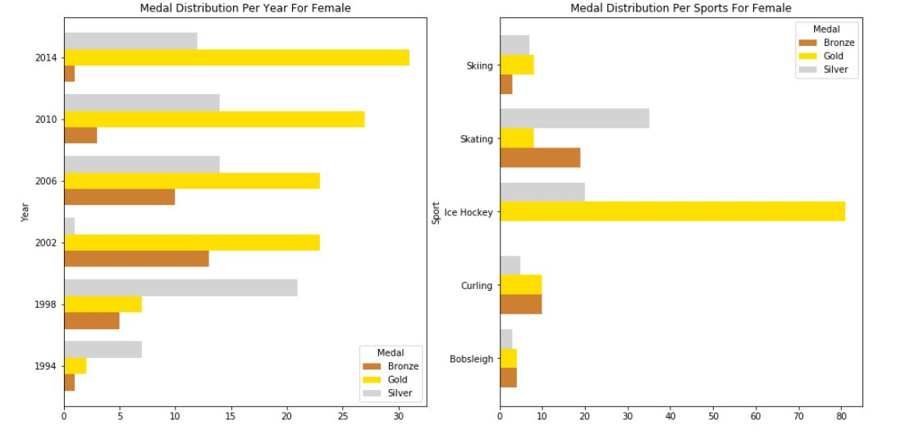

Now we know that women are performing consistently and in year 2014 they won and Ice hockey is the sport which is providing the platform but which specific female athlete has won most of medals and was she just won consecutively. So we have plotted medal count of top 20 women athletes and we find out that HEFFORD Jayna and WICKENHEISER, Hayley won 1 Silver and 4 Gold medal each for their country in Ice hockey Sports in consecutive Olympics from year 1994 t0 2014.

