COE 4DK4 Lab 4: Simulation of ARQ Protocols
Nov 11, 2026 · @Abdu
Group members: Abdurahman Butt (student number), [name, student number], [name, student number]

1. Simulation design
Our simulator is a single discrete-event program in C that implements the general Selective-Repeat (SR) protocol with send window Ws and receive window Wr. It uses the simlib event-list library from the earlier labs. Setting Wr = 1 gives Go-Back-N (GBN) and Ws = Wr = 1 gives Stop-and-Wait (S&W), so the three protocols share one code path and differ only in their parameters. All times in the simulator are in milliseconds.

1.1 Events
There are four event types. Each handler updates the state and schedules whatever events follow from it.
Event | Scheduled | What the handler does
End of data packet transmission | 1 ms after a transmission starts | Frees the transmitter, starts the packet's retransmission timer (unless the packet was ACKed or marked for resending while it was on the line), schedules the packet's arrival 5 ms later, then starts the next transmission if one is allowed
Data packet arrival | 5 ms after the end of transmission | Draws the data-packet error. An errored packet is discarded and nothing else happens. Otherwise the packet is classed as a duplicate, inside the receive window, or beyond it; in-order packets are delivered; an ACK is generated, its error is drawn, and if it survives its arrival is scheduled 5 ms later
ACK arrival | 5 ms after the ACK is sent | Marks the acknowledged packets, cancels their timers, slides the send window, records the completion time if a finite transfer is done, and starts the next transmission
Timeout | Tout after the end of a packet's transmission | Marks the packet for retransmission, applies the window rule in 1.3, and starts the next transmission if the transmitter is free

1.2 State variables
The sender keeps send_base (oldest unacknowledged packet), next_seq (next new packet), a transmitter_busy flag, and an array of Ws slots. Each slot holds the packet's sequence number, an acked flag, a retransmit flag (timed out and waiting for the transmitter) and the event id of its running timer. The receiver keeps rcv_base (next packet expected in order) and an array of Wr flags marking which packets in its window have arrived. Packet seq lives in slot seq mod Ws at the sender and seq mod Wr at the receiver.
The statistics are the number of data transmissions, the number of packets delivered in order at the receiver, and the transfer completion time. Sequence numbers are unbounded integers, so the sequence-number space never limits the window sizes.

1.3 Protocols, timers and errors
Every ACK carries two fields: RN, the next packet the receiver expects in order (a cumulative ACK for everything below RN), and seq, the packet it has just accepted (a selective ACK, set to −1 when the packet was beyond the receive window and discarded). With Wr = 1 the two fields always agree, which is the GBN cumulative ACK. With Wr > 1 the selective field lets the sender mark a packet received even when an earlier one is still missing. Because every ACK carries both fields, the same receiver code works for all three protocols, and any difference between them comes only from the window settings. The receiver ACKs every error-free arrival, including duplicates, so a packet whose ACK was lost is acknowledged again when its retransmission arrives.
Each outstanding packet has its own timer, held as a timeout event in the event list. The timer starts when the packet's last bit leaves the sender and is descheduled when the packet is acknowledged. An error-free packet's ACK therefore comes back 10 ms after its timer starts, and the default 15 ms timeout leaves a 5 ms margin. Each packet gets its own timer because SR has to detect every loss separately. A single timer on the oldest packet would work for GBN, but in SR it would hold up the retransmission of any later packet that was lost. We start the timer at the end of transmission so the timeout can be compared directly with the 10 ms the ACK needs after the packet has left. This also puts the premature-timeout boundary in Part 5 at exactly 10 ms.
The sender has one transmitter. When it becomes free, packets marked for retransmission go first, lowest sequence number first. Otherwise a new packet is sent if next_seq < send_base + Ws and the source still has packets. Retransmissions come first because the window cannot slide until its oldest missing packet is acknowledged; sending the lowest sequence number first clears the window base as early as possible.
When Wr < Ws, resending only the expired packet is not enough. While packet i is missing, the receiver discards anything at or beyond i + Wr because it lies outside the receive window. The timeout handler therefore also resends every outstanding, unacknowledged packet from i + Wr upward:
on timeout of packet i:
mark i for retransmission
for k = i + Wr to next_seq - 1:
if k not acked and not already marked:
mark k for retransmission and cancel its timer
transmit next packet if transmitter is free
With Wr = 1 this resends i and everything after it, which is go-back-N. With Wr = Ws the loop is empty and only i is resent, which is pure SR. Values in between give SR with a limited receiver buffer.
Data-packet errors are drawn when a packet reaches the receiver: it is in error if a uniform(0,1) sample is below pd. ACK errors are drawn with a second, separate sample against pa, and only for packets that arrived without error. Every draw is a fresh sample, so data and ACK errors are independent of each other and of earlier errors.
The performance measures are computed at the end of each run:
η = (packets delivered in order × Tx) / (elapsed time)
Attempts per packet = (data transmissions) / (packets delivered in order)
For a finite transfer the completion time is the time from the start of the first transmission (t = 0) to the ACK arrival that acknowledges the last outstanding packet.

1.4 Assumptions
- Packet length 1000 bits at 1 Mbps (Tx = 1 ms), 5 ms propagation each way, default timeout 15 ms. ACK transmission and all processing times are zero.
- The timer starts at the end of a packet's transmission, not the start, so the timeout is measured from the moment the packet has fully left the sender.
- The ACK fields are as described in 1.3. A packet beyond the receive window still produces an ACK carrying RN. This gives the sender up-to-date cumulative information and can never mislead it.
- When Wr is larger than Ws (for example Wr = 8 with Ws = 4), the extra receive slots can never be used, so the protocol behaves exactly like Wr = Ws.
- The backlogged source always has a new packet ready. In the finite case all N packets are present at t = 0 and none arrive later.
- Every run starts with an empty link. No warm-up period is removed, since 100,000 delivered packets make the start-up transient negligible.
- Efficiency counts only packets delivered in order at the receiver. Duplicates and discarded copies count as attempts but not as delivered packets.

2. Experimental setup
Unless an experiment varies them, the link parameters are Tx = 1 ms, round-trip propagation 10 ms and Tout = 15 ms. Every data point is run for S&W (Ws = Wr = 1), GBN (Wr = 1) and SR with three receive windows: Wr = 2, Wr = 8 and Wr = Ws.
Part | Varied | Held fixed | Run length
1. Verification traces | pd = pa = 0, then pd = pa = 0.5 | N = 6 packets; S&W; GBN with Ws = 4; SR with Ws = Wr = 4; seed 400435085 | One transfer each
2. Backlogged, no errors | Ws = 1 to 20 | pd = pa = 0 | 100,000 delivered packets per seed
3(a). Backlogged, data errors | pd = 0, 0.01, 0.02, 0.05, 0.1, 0.15, 0.2, 0.25, 0.3, 0.4, 0.5 | Ws = 32, pa = 0 | 100,000 delivered packets per seed
3(b). Backlogged, data errors | Ws = 1 to 40 | pd = 0.1, pa = 0 | 100,000 delivered packets per seed
4. Backlogged, data and ACK errors | pa = 0 to 0.5 in steps of 0.05 | pd = 0.1, Ws = 32 | 100,000 delivered packets per seed
5. Timeout | Tout = 2, 4, 6, 8, 9, 11, 12, 13, 15, 20, 25, 30, 40, 50, 75, 100 ms | pd = pa = 0.1, Ws = 32 | 100,000 delivered packets per seed
6. Finite transfer | Ws = 1 to 40; three error cases: (pd, pa) = (0, 0), (0.05, 0), (0.05, 0.05) | N = 100 | 200 transfers per seed
7. Transfer size | Ws = 1 to 40; N = 10 and N = 1000; cases (0, 0) and (0.05, 0.05) | Same as Part 6 | 200 transfers per seed
The fixed send window Ws = 32 used in Parts 3(a), 4 and 5 is well above the 11 packets needed to fill the error-free link. It also covers the 27 ms from the start of a lost packet to the ACK of its retransmission (1 ms transmission + 15 ms timeout + 1 ms retransmission + 10 ms round trip), so a single loss does not stall the SR send window. For Part 3(b) we picked pd = 0.1, which separates GBN and SR clearly while the link still carries a reasonable amount of traffic.
Four random-number generator seeds are used for every experiment with errors: 400435085 (a group member's student number), 333333, 222222 and 44444. The same seeds are used for every protocol and window size, so all curves in a figure see the same error sequences from the same starting points. A backlogged run ends after 100,000 packets have been delivered. A finite-transfer data point averages 200 transfers per seed, or 800 transfers in total. Each plotted marker is the mean over the four seeds and its error bar is the standard deviation over the seeds. Only markers are plotted for simulation results; dashed lines, where shown, are analytical results. When Ws is on the x-axis, S&W has only one value per experiment, so we draw it as a labelled horizontal reference line. Each figure's axes are labelled with units, and its title lists the parameters held fixed.
We set the run lengths by looking at the spread between seeds. With 100,000 delivered packets per seed, the standard deviation of efficiency across the four seeds stays below 0.007, well under the gaps between curves. Individual finite transfers with errors vary a lot, so we averaged 200 transfers per seed, which keeps the spread of the mean completion time under 1%. Window sizes run up to 40 so that every curve reaches its flat region, and the pd, pa and Tout points are packed more closely where the curves change fastest.

3. Results and analysis
The Part 1 traces are discussed with the verification in Section 4.

3.1 Part 2: backlogged source without errors
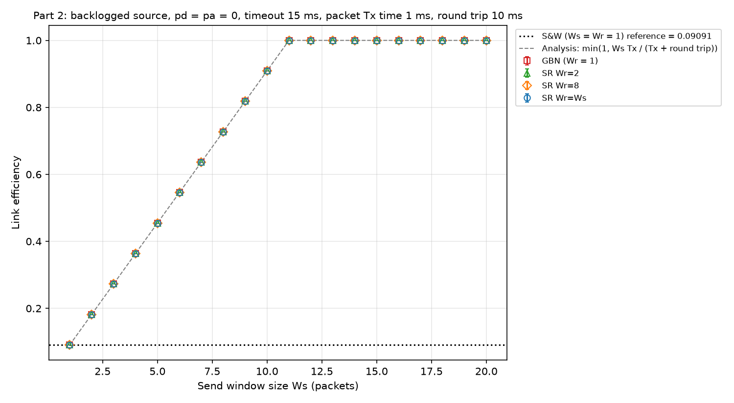
Figure 1. Link efficiency versus send window size Ws for GBN and SR (Wr = 2, 8 and Ws), pd = pa = 0, Tout = 15 ms. The dotted line is S&W and the dashed line is the analysis from lectures.
The lecture analysis for GBN and SR on an error-free link, with processing time and ACK transmission time set to zero, is:
η = min{ Ws·Tx / (Tx + 2·Tprop), 1 } = min{ Ws / 11, 1 }
Our results match this formula at every window size. Efficiency starts at 0.0909 for Ws = 1 (the S&W value, 1/11), rises by 1/11 per extra packet of window, and reaches 1.000 at Ws = 11. For Ws ≥ 11 it stays at 1. There are no errors, so the runs are deterministic and the four seeds give identical results.
Below Ws = 11 the sender sends Ws packets and then has to wait, because the first ACK returns 11 ms after the first packet started (1 ms transmission plus 10 ms round trip). The link is idle for 11 − Ws ms of every 11 ms cycle. Once Ws ≥ 11, the ACK for the oldest packet comes back just as the window would close, and the sender never has to stop.
GBN and all three SR curves lie on top of each other. With no errors every packet arrives in order and is delivered immediately, so the receive window never holds more than one packet and no retransmission ever happens. SR's extra receive buffer and selective ACKs bring no gain here; what matters is how Ws compares with the 11-packet round trip.

3.2 Part 3(a): efficiency versus pd
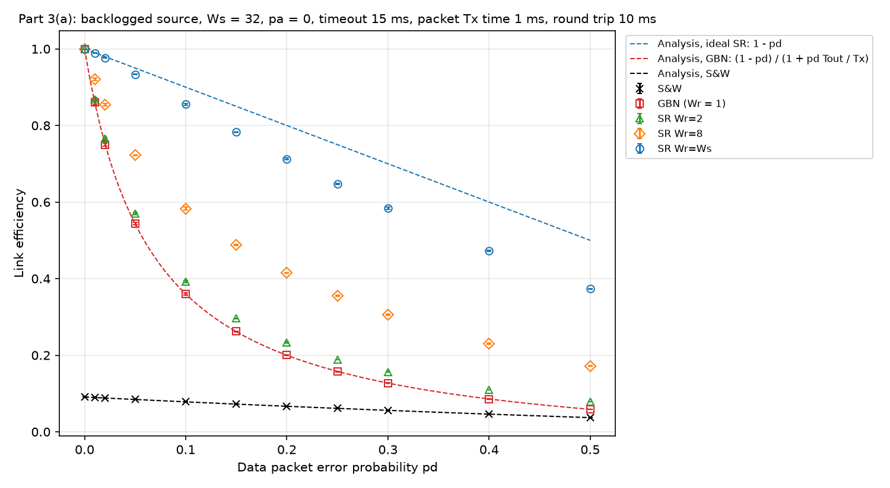
Figure 2. Link efficiency versus data-packet error probability pd, Ws = 32, pa = 0, Tout = 15 ms. Dashed lines are the analytical results below.
The lecture formulas need some adjustment, since our timeout is fixed at 15 ms. The S&W formula from lectures, η0(1 − Pf), assumes the timeout equals the 11 ms cycle. Here a failed attempt costs Tx + Tout = 16 ms and a successful one costs 11 ms, which gives the first formula below. The lecture GBN formula, (1 − Pf)/(1 + (Ws − 1)Pf), assumes the timeout is Ws·Tf. With a fixed timeout and Ws = 32, each loss instead wastes Tx + Tout = 16 packet times, so Ws − 1 is replaced by Tout/Tx = 15. For SR the lecture result is 1 − Pf, provided the window never closes.
η(S&W) = (1 − pd)·Tx / [ (1 − pd)(Tx + 2·Tprop) + pd·(Tx + Tout) ]
η(GBN) = (1 − pd) / (1 + pd·Tout / Tx)
η(SR) = 1 − pd
pd | GBN sim | GBN analysis | SR (Wr = Ws) sim | SR analysis | S&W sim | S&W analysis
0.01 | 0.860 | 0.861 | 0.989 | 0.990 | 0.0896 | 0.0896
0.05 | 0.544 | 0.543 | 0.934 | 0.950 | 0.0844 | 0.0844
0.1 | 0.360 | 0.360 | 0.856 | 0.900 | 0.0783 | 0.0783
0.2 | 0.200 | 0.200 | 0.713 | 0.800 | 0.0666 | 0.0667
0.5 | 0.059 | 0.059 | 0.374 | 0.500 | 0.0370 | 0.0370
S&W and GBN agree with the analysis to within 0.2% over the whole range. SR with Wr = Ws follows 1 − pd closely at small pd but drops below it as pd grows, to 0.856 against 0.9 at pd = 0.1 and 0.374 against 0.5 at pd = 0.5. The 1 − pd result assumes the send window never closes. Ws = 32 covers one recovery (27 ms), but a packet that is lost twice needs 1 + 15 + 1 + 15 + 1 + 10 = 43 ms before its ACK returns, and the window stalls at its base until then. That happens with probability pd², which is small at pd = 0.01 but large at pd = 0.5. The SR attempts per packet are exactly 1/(1 − pd) (1.111 at pd = 0.1, 2.003 at pd = 0.5), which confirms that SR never resends a packet that got through. The shortfall from 1 − pd is time spent waiting with a full window.
The two SR curves with limited receive windows sit between GBN and pure SR. With Wr = 2 the receiver keeps only one packet beyond the gap, so the sender has to go back for almost everything sent after a loss, and the efficiency (0.393 at pd = 0.1) is only slightly above GBN (0.360). Wr = 8 recovers more (0.583 at pd = 0.1).
GBN loses efficiency far faster than the other two. An error rate of only pd = 0.01 already costs it 14% of the link, because every loss throws away the 15 packets sent behind it. S&W starts low (0.0909) because its link is idle most of the time, and errors only lengthen the idle periods. Its efficiency falls by a factor of 2.5 from pd = 0 to pd = 0.5, while GBN falls by a factor of 17 and ends only 1.6 times above S&W.

3.3 Part 3(b): efficiency and attempts versus Ws with pd = 0.1
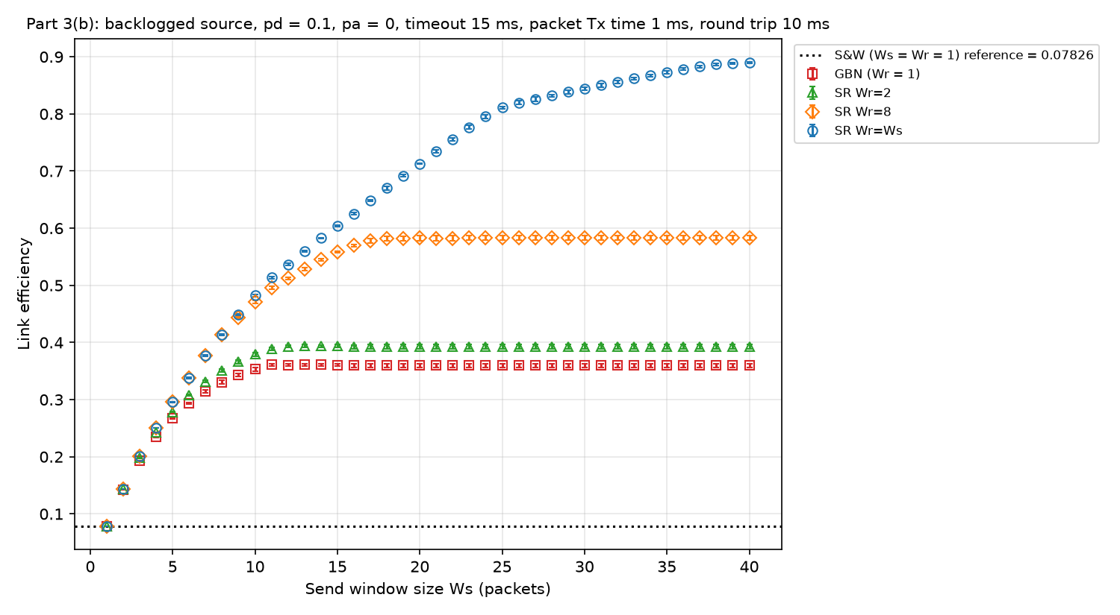
Figure 3. Link efficiency versus Ws, pd = 0.1, pa = 0, Tout = 15 ms.
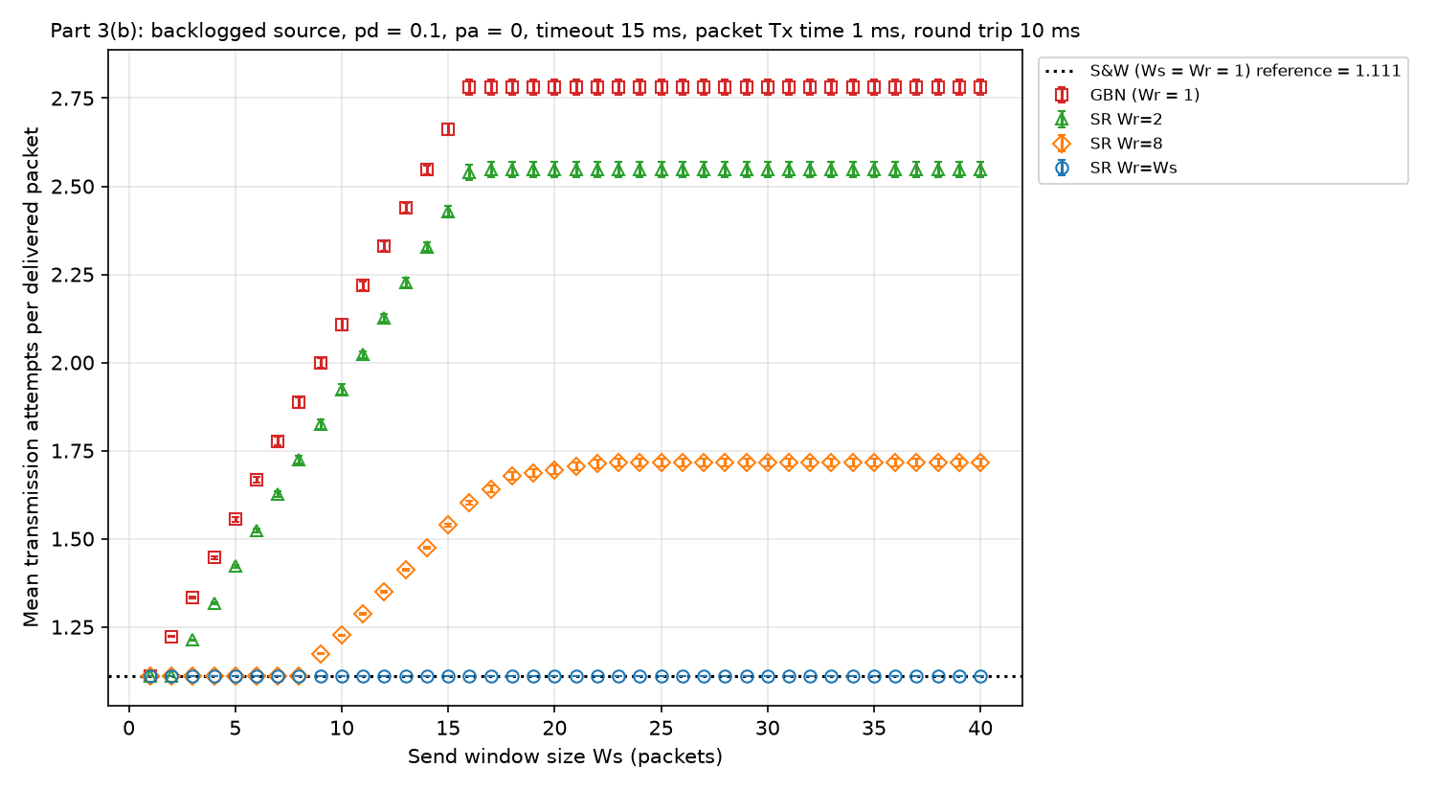
Figure 4. Mean data-packet transmission attempts per delivered packet versus Ws, pd = 0.1, pa = 0, Tout = 15 ms.
GBN efficiency rises with Ws up to about 0.36 at Ws = 11 and stays there; making the window larger than 16 changes nothing. Its attempts per packet rise in a straight line from 1.111 at Ws = 1 to 2.78 at Ws = 16, then stay flat. After a loss, the GBN sender keeps sending until either its window fills or the timeout expires 16 packet times after the lost packet started, and every packet sent after the lost one is discarded and sent again. For Ws < 16 the window fills first, so each loss costs Ws transmissions and the attempts are about 1 + pd·Ws/(1 − pd). This gives 1.889 at Ws = 8 against 1.887 simulated. For Ws ≥ 16 the timeout comes first, the cost stops at 16 transmissions, and the attempts settle at 1 + 0.1 × 16/0.9 = 2.78. A larger window lets GBN fill the link with more packets that will be thrown away, which is why its efficiency stops improving past the error-free optimum of 11.
Pure SR (Wr = Ws) shows the opposite pattern. Its attempts stay at 1.111 = 1/(1 − pd) for every window size, and its efficiency keeps rising over the whole range: 0.513 at Ws = 11, 0.856 at Ws = 32 and 0.890 at Ws = 40, approaching 1 − pd = 0.9. With errors, SR needs a window that covers the recovery time of a lost packet (27 packet times for one loss, more for repeated losses) instead of the 11-packet round trip. Below that, the efficiency loss is time spent with a full window waiting for a retransmission to be acknowledged.
The limited receive windows fall in between. Wr = 8 matches pure SR for Ws ≤ 8, where the receive window covers the whole send window. Above that its efficiency levels off at 0.583 and its attempts rise to 1.716, because packets more than 8 beyond a gap are discarded and resent. Wr = 2 levels off at 0.393 with 2.55 attempts per packet, close to GBN.
With errors present, GBN is held back by the cost of each recovery, which appears as extra transmissions. SR is held back by its send window, which appears as idle time. SR's advantage over GBN grows with Ws, from nothing at Ws = 1 to a factor of 2.5 at Ws = 40.

3.4 Part 4: data-packet and ACK errors
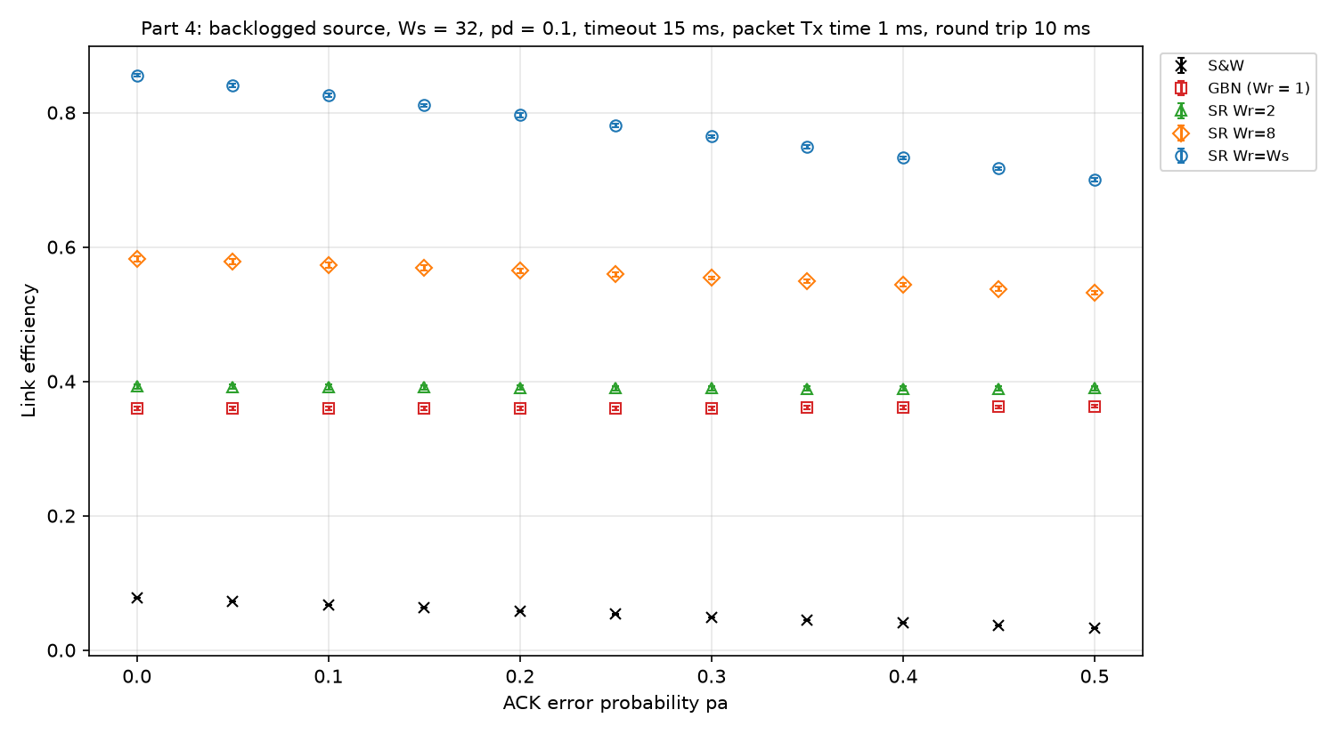
Figure 5. Link efficiency versus ACK error probability pa, pd = 0.1, Ws = 32, Tout = 15 ms.
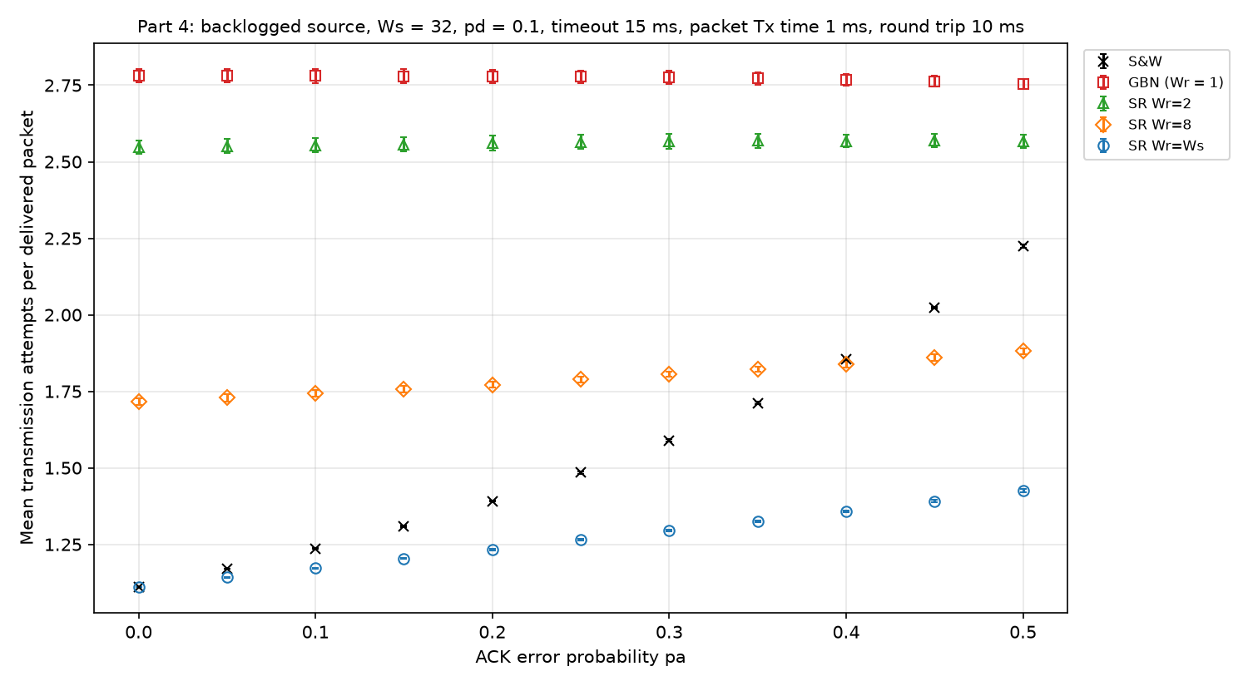
Figure 6. Mean data-packet transmission attempts per delivered packet versus pa, pd = 0.1, Ws = 32, Tout = 15 ms.
We kept Ws = 32 from Part 3(a) and used the three receive windows to show how the window sizes change the effect of ACK errors.
For S&W a lost ACK costs exactly the same as a lost data packet: the sender times out and resends. The probability that an attempt succeeds becomes (1 − pd)(1 − pa), and replacing 1 − pd with this product in the S&W formula of Section 3.2 predicts the simulation closely. At pa = 0.5 the analysis gives 0.0327 and the simulation gives 0.0327. The attempts follow 1/((1 − pd)(1 − pa)): 2.222 predicted and 2.224 simulated. S&W efficiency falls by 58% between pa = 0 and pa = 0.5.
ACK errors have almost no effect on GBN. Its efficiency stays between 0.360 and 0.363 and its attempts between 2.76 and 2.78 over the whole range, changes that are about the size of the spread between seeds. Two features protect it. First, the ACK is cumulative: if the ACK for packet k is lost, the ACK for k + 1 arrives 1 ms later with a larger RN and acknowledges k as well. The timer has a 5 ms margin, so a timeout needs a run of about five lost ACKs in a row. Second, with pd = 0.1 a data error occurs roughly every 10 packets, and the packets after it are discarded and resent no matter what happens to their ACKs. When a run of lost ACKs does cause an early go-back, most of the packets it resends would have been resent anyway. Part of this comes from the high data error rate. With a much smaller pd, far fewer packets would be resent because of data errors, so the extra go-backs caused by runs of lost ACKs would show up and GBN would become more sensitive to pa.
Of the windowed protocols, pure SR suffers most. Its efficiency falls from 0.856 to 0.700 and its attempts rise from 1.111 to 1.425. When the ACK for packet k is lost, the next ACK's RN covers k only if no packet below k is missing. With pd = 0.1 and up to 32 packets in flight there is usually a gap below k, so k times out and is resent even though the receiver already has it. The send window cannot slide past k until then, which adds idle time. The cumulative field still prevents most of the damage: if every lost ACK forced a resend, the attempts at pa = 0.5 would be 2.22 (the S&W value) instead of 1.425. SR with Wr = 8 falls less (0.583 to 0.532) and SR with Wr = 2 hardly changes, since with a small receive window it behaves mostly like GBN.
How much ACK errors matter depends on how many later ACKs can cover a lost one before its timer runs out. S&W has only one packet outstanding, so nothing can cover a lost ACK. GBN accepts packets only in order, so RN always covers every earlier packet. SR with a large Wr accepts many packets out of order, and their ACKs can only be covered once the gap below them is filled. Data errors hurt GBN far more than SR (each costs GBN up to 16 transmissions and SR one), while ACK errors hurt SR more than GBN. Pure SR is nevertheless still the most efficient protocol at pa = 0.5 (0.700 against 0.363 for GBN and 0.033 for S&W). For SR an ACK error is also cheaper than a data error: raising pd from 0 to 0.1 adds 0.111 attempts per packet, while raising pa from 0 to 0.1 adds 0.062.

3.5 Part 5: effect of the retransmission timeout
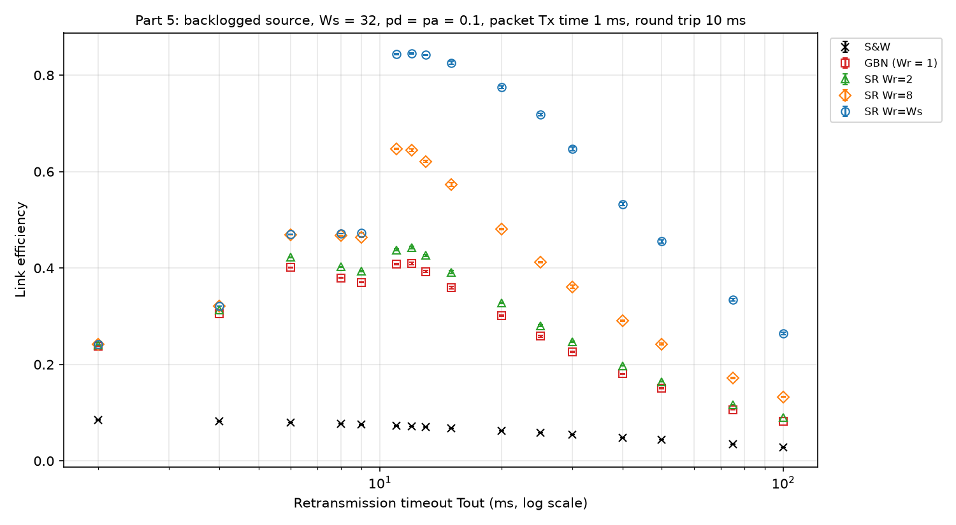
Figure 7. Link efficiency versus retransmission timeout Tout, pd = pa = 0.1, Ws = 32.
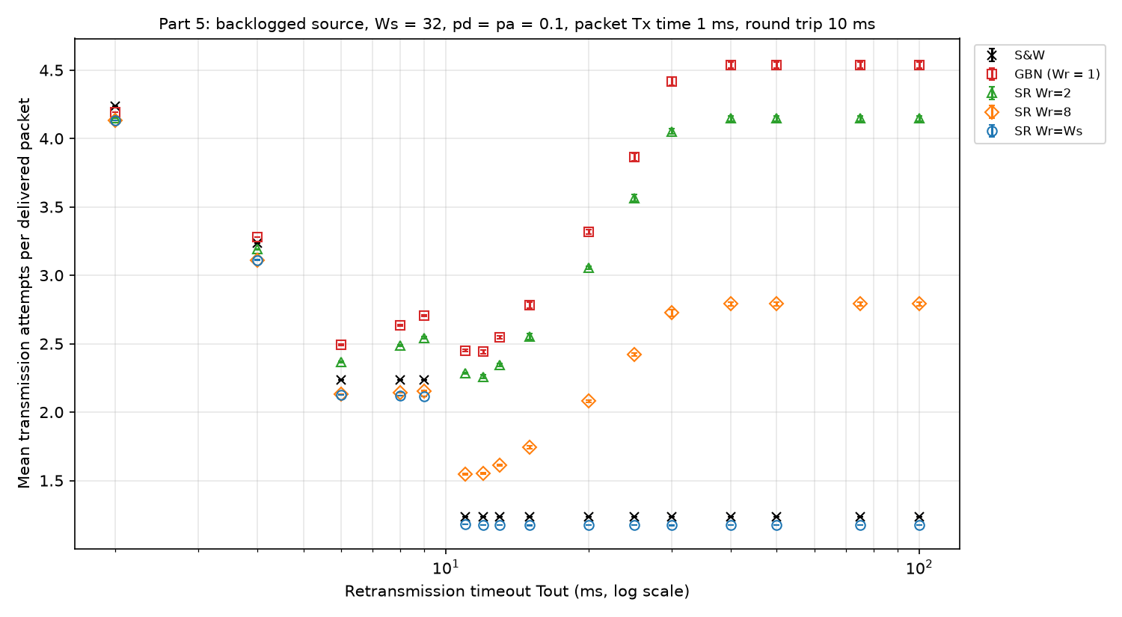
Figure 8. Mean data-packet transmission attempts per delivered packet versus Tout, pd = pa = 0.1, Ws = 32.
The timer starts when a packet finishes transmitting, and an error-free ACK returns 10 ms later. A timeout below 10 ms is therefore premature: every packet times out before its ACK can arrive and is sent at least twice, even when nothing is lost. The attempt counts make this obvious. For S&W they are 2.235 for Tout = 6 to 9 ms (two copies per packet plus the error retries) and 4.235 at Tout = 2 ms, and for all protocols they are above 2 at Tout ≤ 9 ms. As soon as Tout passes 10 ms the S&W attempts drop to 1.237, which is 1/((1 − pd)(1 − pa)) = 1.235, and stay there for every longer timeout.
A timeout much shorter than necessary wastes link capacity on duplicates. For GBN and SR the duplicates take transmission slots away from new packets, so efficiency collapses: pure SR goes from 0.846 at Tout = 12 ms to 0.473 at 9 ms and 0.242 at 2 ms. The SR curves for different Wr come together at short timeouts because nearly every packet is resent by its own timer and the receive window hardly matters. In this region the GBN and SR curves are not monotonic (GBN is higher at 6 ms than at 8 or 9 ms), since the result depends on how the premature timeouts line up with the returning ACKs.
A timeout much longer than necessary wastes time instead. Every real loss, data or ACK, is detected late, and the link sits idle or carries packets that will be discarded until the timer expires. Efficiency falls steadily as Tout grows. At Tout = 100 ms pure SR is down to 0.264, GBN to 0.082 and S&W to 0.029. The best timeout for every windowed protocol is just above the round trip, at 11 to 12 ms, where pure SR reaches 0.846 and GBN 0.410.
The timeout affects the three protocols in different ways.
- S&W only loses time. Its link is idle while it waits, so premature copies cost no extra time and even help: a copy already on its way makes up for a lost packet sooner. S&W efficiency is highest at the shortest timeout (0.085 at 2 ms against 0.068 at 15 ms), but at the price of 4.2 transmissions per packet.
- GBN loses both ways. A short timeout causes repeated go-backs, and a long one lets the sender fill its window with packets behind each loss that will be discarded. Its attempts grow with Tout up to 4.54 at Tout = 40 ms and then stop growing, because from that point the 32-packet window fills before the timer expires and the sender just waits. Beyond 40 ms a longer timeout only adds idle time.
- Pure SR loses only time once Tout is above the round trip. Its attempts stay at 1.17 to 1.18 for every Tout ≥ 11 ms, so it never resends a packet unnecessarily, but the send window stalls while a lost packet waits for its timer. With Ws = 32 the window covers one recovery only if Tout + 12 ≤ 32 packet times, which is why its efficiency starts dropping quickly beyond Tout = 20 ms.
- SR with Wr = 2 and Wr = 8 falls between GBN and pure SR at every timeout. Like GBN, their attempts level off at long timeouts (4.15 and 2.79) once the send window fills before the timer expires.

3.6 Part 6: finite transfer of N = 100 packets
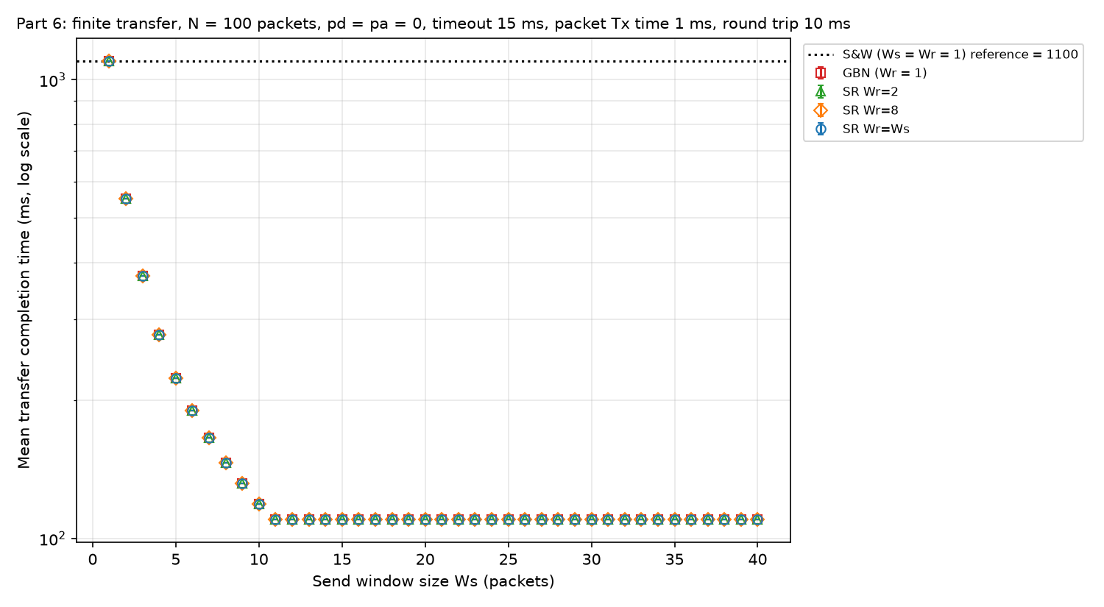
Figure 9. Mean transfer completion time versus Ws, N = 100, pd = pa = 0. The dotted line is S&W.
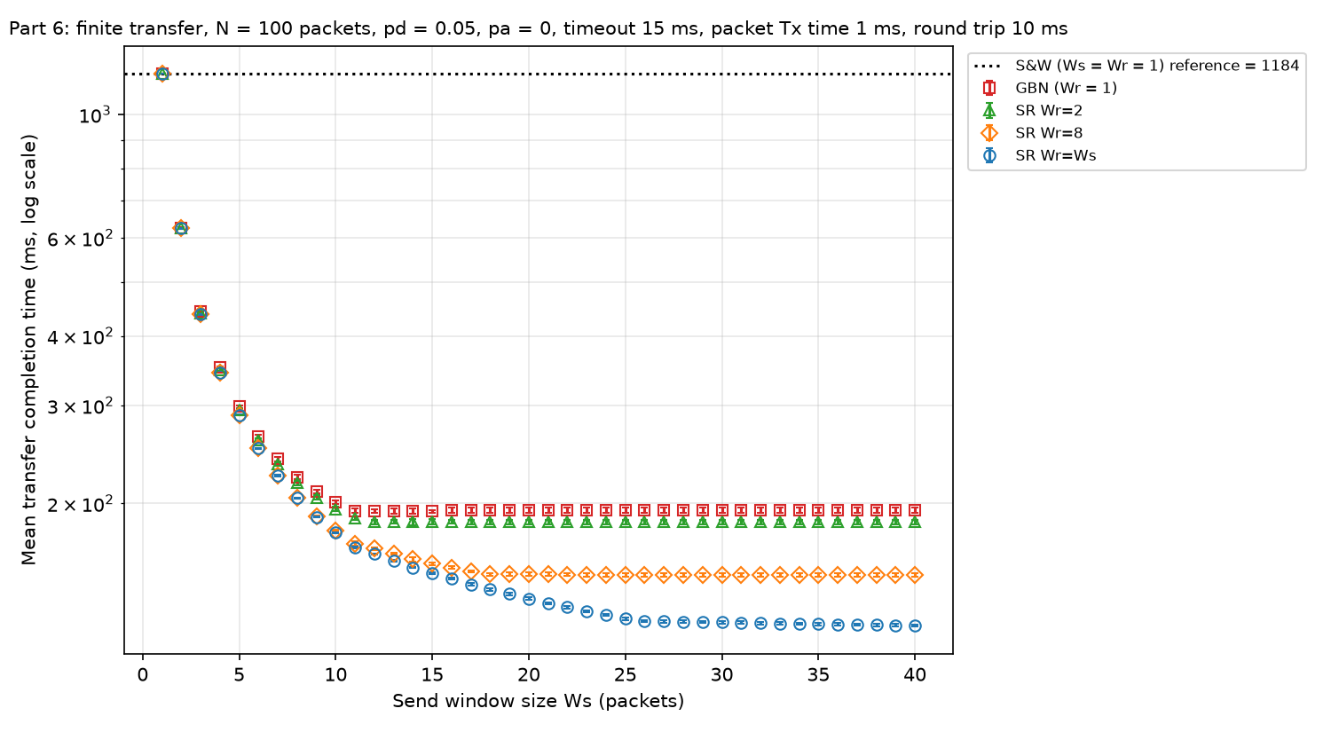
Figure 10. Mean transfer completion time versus Ws, N = 100, pd = 0.05, pa = 0.
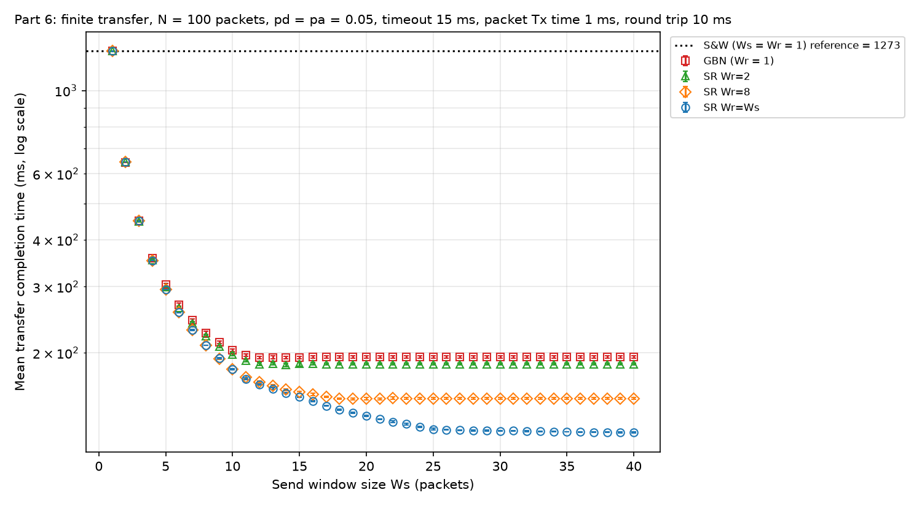
Figure 11. Mean transfer completion time versus Ws, N = 100, pd = pa = 0.05.
The completion times are plotted on a log scale because S&W takes about ten times longer than the windowed protocols.
Without errors (Figure 9) the completion time is fixed by the window. S&W takes 1100 ms, 11 ms per packet. For Ws < 11 the sender sends a burst of Ws packets every 11 ms. With k = ⌈N/Ws⌉ bursts, the last burst holds N − (k − 1)·Ws packets, so the transfer takes 11(k − 1) + N − (k − 1)·Ws + 10 ms. This gives 551 ms at Ws = 2, 224 ms at Ws = 5 and 119 ms at Ws = 10, exactly the simulated values. From Ws = 11 the link never idles and the transfer takes N·Tx + round trip = 100 + 10 = 110 ms, the minimum possible. A window larger than 11 changes nothing, and GBN and all SR curves are identical, as in Part 2.
Data errors (Figure 10, pd = 0.05) change both the level and the shape of the curves. S&W rises to 1184 ms, which matches the expected 11 + 16·pd/(1 − pd) = 11.84 ms per packet. GBN reaches about 193 ms at Ws = 12 to 15, then gets slightly worse (194.5 ms for Ws ≥ 20), since a larger window puts more packets behind each loss that have to be resent. SR with Wr = Ws keeps improving well past the error-free optimum: 166.9 ms at Ws = 11, 134.9 ms at Ws = 20 and 120.8 ms at Ws = 40. SR with Wr = 8 levels off at 149 ms and Wr = 2 at 185 ms. Errors therefore push the useful window size upward. For GBN there is nothing to gain beyond about 12, while SR needs a window that covers the recovery time of a loss, as in Part 3(b).
Unlike the backlogged case, a finite transfer has a tail. Even pure SR with a large window cannot reach 110 ms, because a loss among the last packets is only detected when its timer expires, and no new packets are left to keep the link busy meanwhile. Each such loss adds about 16 ms to the transfer. With 100 packets the tail is a noticeable part of the 121 ms total.
Adding ACK errors (Figure 11, pd = pa = 0.05) has a small effect on the windowed protocols and a large one on S&W. S&W goes from 1184 to 1273 ms, matching 11 + 16·(1 − q)/q with q = (1 − pd)(1 − pa) = 0.9025, or 12.73 ms per packet. GBN barely moves (194.5 to 194.8 ms at Ws = 40) because of the cumulative ACK. Pure SR goes from 120.8 to 122.8 ms. Part of that increase comes from the last packets: the final ACKs have no later ACK to cover them, so if the last ACK is lost the sender has to time out and resend a packet the receiver already has before the transfer can finish. The ordering of the protocols and the best window sizes are the same as in Figure 10.

3.7 Part 7: effect of transfer size
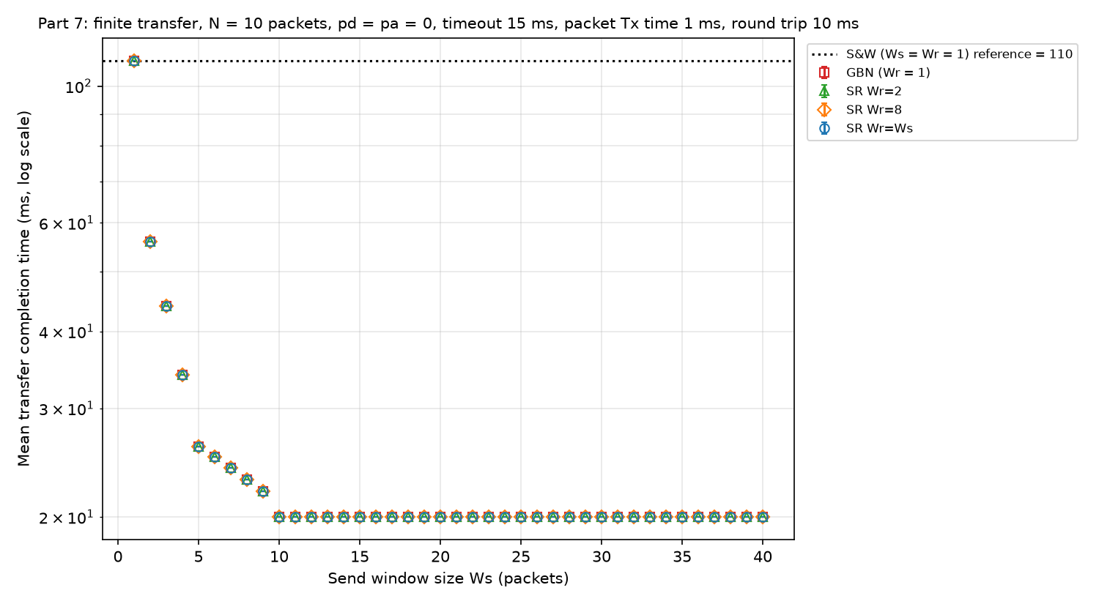
Figure 12. Mean transfer completion time versus Ws, N = 10, pd = pa = 0.
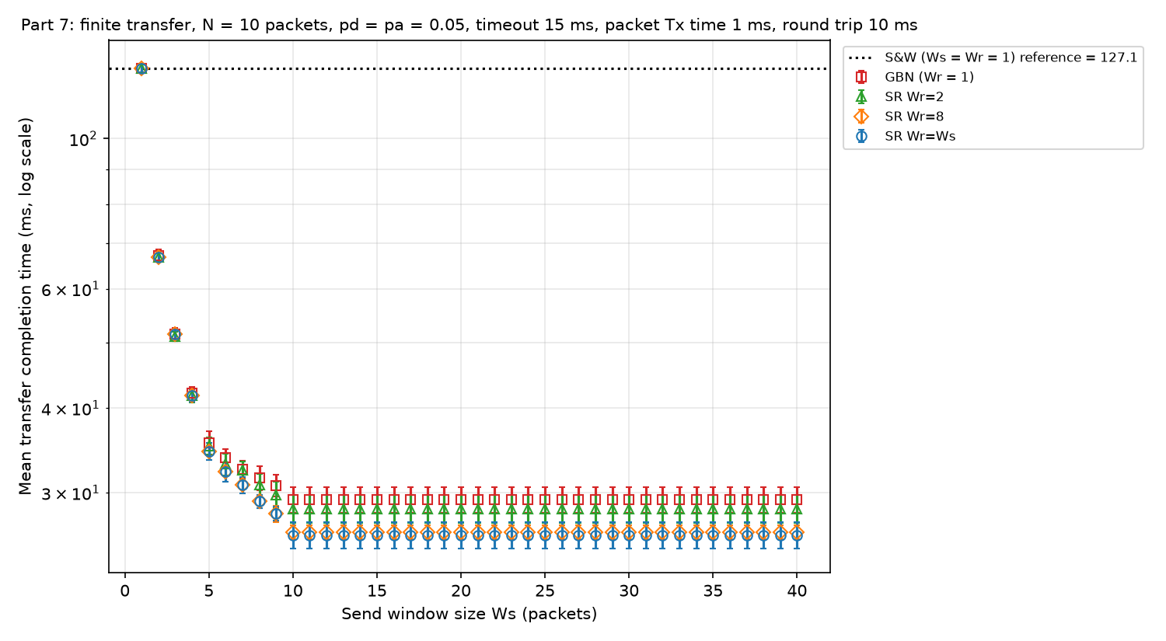
Figure 13. Mean transfer completion time versus Ws, N = 10, pd = pa = 0.05.
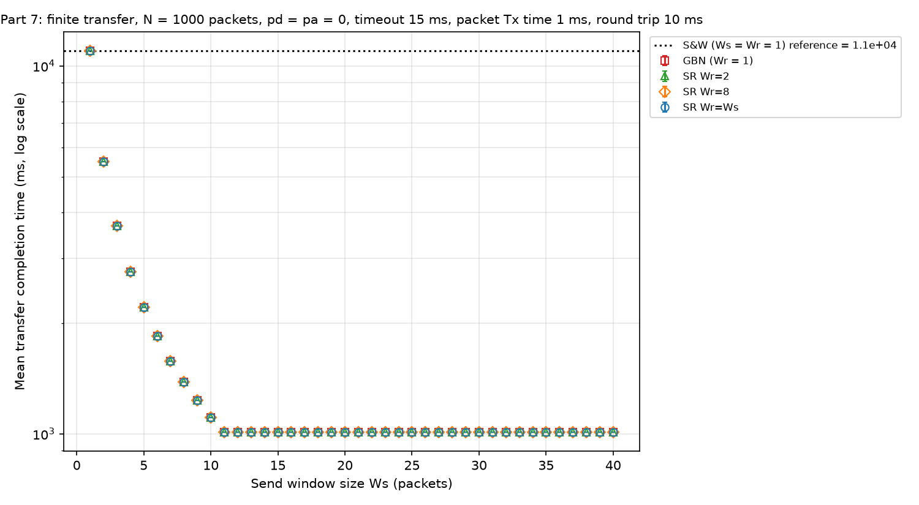
Figure 14. Mean transfer completion time versus Ws, N = 1000, pd = pa = 0.
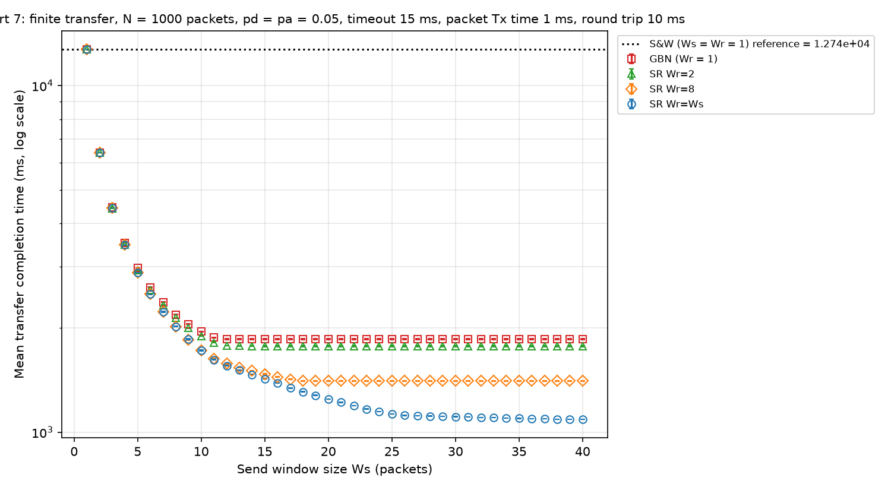
Figure 15. Mean transfer completion time versus Ws, N = 1000, pd = pa = 0.05.
For Part 7 we reran the error-free case and the case with both error types at N = 10 and N = 1000.
For a small transfer (N = 10) the window cannot be used beyond N. Without errors the minimum of N + 10 = 20 ms is reached at Ws = 10, one packet below the 11 needed in the backlogged case, because the whole file fits in one window and the sender only has to wait for one round trip. With errors, every curve is flat from Ws = 10: GBN at 29.3 ms, SR with Wr = 2, 8 and Ws at 28.4, 26.2 and 26.0 ms. The round trip and the timeout of the occasional lost packet dominate the transfer, so the protocol choice matters little: GBN takes only 13% longer than pure SR.
For a large transfer (N = 1000) the curves look like the backlogged results. Without errors the minimum is 1010 ms from Ws = 11 on. With errors, GBN levels off at 1853 ms from about Ws = 12, while pure SR keeps improving up to Ws = 40 (1089 ms) and SR with Wr = 8 levels off at 1406 ms. The effective efficiency 1000/1853 = 0.54 for GBN is close to the backlogged GBN efficiency of 0.544 at pd = 0.05 in Part 3(a), and pure SR gives 1000/1089 = 0.92, close to its 0.934. The start-up and the tail are spread over many more packets, so the steady-state behaviour decides the completion time. GBN takes 70% longer than pure SR here, against 59% at N = 100 and 13% at N = 10.
Overall, the transfer size decides how much the window size matters. A transfer smaller than the window cannot use the extra window, and a small transfer is dominated by fixed delays, so GBN and SR give similar times. As N grows, the completion time approaches N divided by the backlogged efficiency, and the larger windows and selective retransmission of SR pay off in proportion.

4. Simulation verification and reliability
We checked the simulator in two ways. First, we read short event traces line by line (Part 1). Second, we compared the long-run results with closed-form values wherever one was available. The complete traces are in results/part1_trace.txt, submitted with the code. All traces use N = 6 packets, Tout = 15 ms and seed 400435085.

4.1 Part 1 traces without errors (pd = pa = 0)
For S&W each packet takes one 11 ms cycle: packet 0 is sent at 0 ms, arrives at 6 ms (1 ms transmission plus 5 ms propagation), and its ACK reaches the sender at 11 ms, when packet 1 starts. The transfer completes at 66 ms = 6 × 11 ms with 1.000 attempts per packet.
For GBN (Ws = 4, Wr = 1) and SR (Ws = Wr = 4) the traces are identical. Packets 0 to 3 go out at 0, 1, 2 and 3 ms and the window closes. The ACK for packet 0 arrives at 11 ms and opens the window for packet 4, and the ACK for packet 1 at 12 ms lets packet 5 go. The last ACK arrives at 12 + 11 = 23 ms, which is the recorded completion time, again with no retransmissions.

4.2 Part 1 traces with errors (pd = pa = 0.5)
The S&W trace shows both kinds of error and the duplicate handling:
0.000 ms SENDER transmits new packet 0 (send window 0 to 0)
6.000 ms RECEIVER packet 0 is in ERROR, discarded, no ACK
16.000 ms SENDER timeout of packet 0 (0 outstanding packets beyond the receive window will also be resent)
16.000 ms SENDER retransmits packet 0
...
38.000 ms RECEIVER packet 0 accepted (receive window 0 to 0)
38.000 ms RECEIVER sends ACK (RN=1, seq=0), ACK is LOST
48.000 ms SENDER timeout of packet 0 (0 outstanding packets beyond the receive window will also be resent)
48.000 ms SENDER retransmits packet 0
54.000 ms RECEIVER packet 0 is a duplicate, discarded
54.000 ms RECEIVER sends ACK (RN=1, seq=0)
59.000 ms SENDER receives ACK (RN=1, seq=0), send window now 1 to 1
The errored packet produces no ACK, and the timer fires at 16 ms, 15 ms after the end of transmission. When the ACK is lost at 38 ms the sender times out again at 48 ms; the receiver recognises the retransmission as a duplicate, does not deliver it twice, and ACKs it again. The sender only moves on when that ACK arrives at 59 ms. The S&W transfer finishes at 242 ms with 2.83 attempts per packet.
The GBN trace shows the go-back behaviour:
6.000 ms RECEIVER packet 0 is in ERROR, discarded, no ACK
7.000 ms RECEIVER packet 1 is in ERROR, discarded, no ACK
8.000 ms RECEIVER packet 2 is outside the receive window 0 to 0, discarded
8.000 ms RECEIVER sends ACK (RN=0, seq=-1), ACK is LOST
9.000 ms RECEIVER packet 3 is outside the receive window 0 to 0, discarded
9.000 ms RECEIVER sends ACK (RN=0, seq=-1)
14.000 ms SENDER receives ACK (RN=0, seq=-1), send window now 0 to 3
16.000 ms SENDER timeout of packet 0 (3 outstanding packets beyond the receive window will also be resent)
16.000 ms SENDER retransmits packet 0
17.000 ms SENDER retransmits packet 1
18.000 ms SENDER retransmits packet 2
19.000 ms SENDER retransmits packet 3
With Wr = 1 the receiver discards packets 2 and 3, which arrived correctly, because packet 0 is missing. Its ACKs carry RN = 0 and do not move the send window. When packet 0 times out the sender resends 0 and all three packets after it, back to back. The GBN transfer finishes at 223 ms with 8.67 attempts per packet.
The SR trace (Ws = Wr = 4) shows buffering, selective retransmission and the cumulative field covering lost ACKs:
8.000 ms RECEIVER packet 2 accepted (receive window 0 to 3)
8.000 ms RECEIVER sends ACK (RN=0, seq=2), ACK is LOST
9.000 ms RECEIVER packet 3 accepted (receive window 0 to 3)
9.000 ms RECEIVER sends ACK (RN=0, seq=3)
14.000 ms SENDER receives ACK (RN=0, seq=3), send window now 0 to 3
16.000 ms SENDER timeout of packet 0 (0 outstanding packets beyond the receive window will also be resent)
17.000 ms SENDER timeout of packet 1 (0 outstanding packets beyond the receive window will also be resent)
18.000 ms SENDER timeout of packet 2 (0 outstanding packets beyond the receive window will also be resent)
24.000 ms RECEIVER packet 2 is a duplicate, discarded
...
54.000 ms RECEIVER sends ACK (RN=1, seq=0), ACK is LOST
55.000 ms RECEIVER packet 1 accepted (receive window 1 to 4)
55.000 ms RECEIVER packet 1 delivered
55.000 ms RECEIVER packet 2 delivered
55.000 ms RECEIVER packet 3 delivered
55.000 ms RECEIVER sends ACK (RN=4, seq=1)
60.000 ms SENDER receives ACK (RN=4, seq=1), send window now 4 to 7
Packets 2 and 3 are buffered while 0 and 1 are missing. Packet 3's selective ACK arrives, so packet 3 never times out. Packet 2's ACK was lost, so packet 2 times out at 18 ms and its retransmission is discarded as a duplicate and ACKed again. When packet 1 finally arrives at 55 ms, packets 1, 2 and 3 are delivered together and RN jumps to 4. The ACK for packet 0 was lost at 54 ms, but RN = 4 acknowledges it at 60 ms without a retransmission. Later in the trace the ACK for packet 4 is also lost and is covered in the same way by the ACK for packet 5. The SR transfer finishes at 72 ms with 2.17 attempts per packet, against 223 ms and 8.67 for GBN on the same seed.

4.3 Checks against analysis
The long runs agree with every closed-form result we could derive for this model:
- Part 2: efficiency equals min(1, Ws/11) exactly for all three protocols.
- Part 3(a): S&W and GBN efficiency are within 0.2% of the formulas in Section 3.2 for every pd. SR attempts equal 1/(1 − pd) to three decimals.
- Part 3(b): GBN attempts follow 1 + pd·min(Ws, 16)/(1 − pd).
- Parts 4 and 5: S&W efficiency and attempts match the success probability (1 − pd)(1 − pa), for example 1.237 attempts simulated against 1.235 predicted at pd = pa = 0.1.
- Parts 6 and 7: the error-free completion times match the burst formula of Section 3.6 exactly for every Ws and N, and the S&W completion times with errors match 11.84 and 12.73 ms per packet.

4.4 Reliability
Each backlogged data point is the mean of four runs of 100,000 delivered packets, one per seed, and each finite-transfer point is the mean of 800 transfers. The standard deviation over the four seeds is at most 0.007 for efficiency and 0.07 for attempts per packet. For completion time it is at most 3.6 ms at N = 100 and 8.5 ms at N = 1000, under 1% of the mean. In most figures the error bars are smaller than the markers, so the differences between curves that we discuss are much larger than the run-to-run variation. Error-free runs are deterministic and all seeds give identical results.
These results have several limitations. Four seeds give only a rough estimate of the spread. The model has zero ACK transmission time and zero processing time, so the absolute efficiencies are upper bounds for a real link with the same parameters. Sequence numbers are unbounded, so the constraint that the sequence-number space places on Ws and Wr in a real protocol does not appear. Finally, the timer starts at the end of each transmission; a timer started at the beginning would shift the Part 5 curves by 1 ms.

5. Code
The complete simulation program is submitted separately. make builds arq_sim, ./arq_sim runs all seven experiments (or ./arq_sim 3 for one part) and writes the traces and CSV files to results/, and python3 plot_results.py draws the figures. The pseudocode for the timeout rule is in Section 1.3.
File | Contents
simparameters.h | Link parameters, run lengths, seeds and every experiment's parameter values
main.c, main.h | Data structures and one simulation run (arq_simulation_run)
sender.c, sender.h | Send window, end-of-transmission, timeout and ACK arrival events
receiver.c, receiver.h | Data packet arrival event: errors, receive window, delivery and ACK generation
experiments.c, experiments.h | Parameter sweeps for Parts 1 to 7
output.c, output.h | Event trace and CSV output
cleanup.c, cleanup.h | Frees the memory of a run
simlib.c, simlib.h, trace.h | Event-list library from the earlier labs, unchanged
plot_results.py | Plots with seed means as markers, seed standard deviations as error bars, and analytical curves

