WPS Office®

{{name}}to WPS Office - {{date}}

{{surname}}Office is a lightweight, feature-rich, and comprehensive office suite with high compatibility.

As a handy and professional office software, WPS Office allows you to edit files in Docs,

Sheets, Slides and PDF to improve your work efficiency.

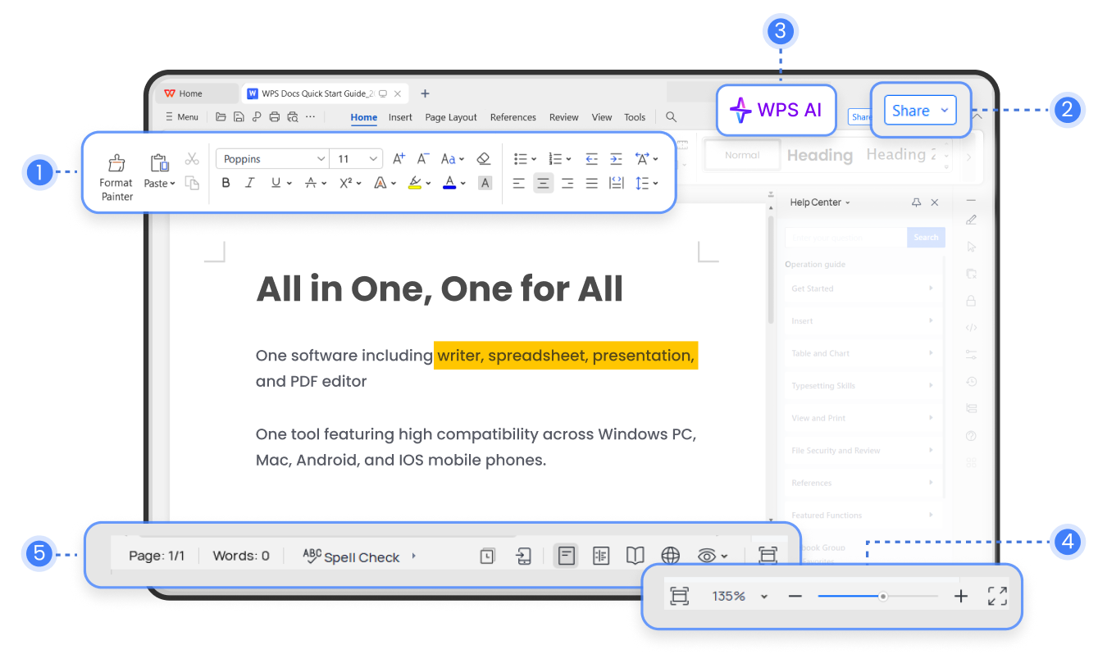

1. {{name}}.
2. {{surname}}.
3. {{date}} Switch between single-page and multi-page views by adjusting the window size.
4. Count the number of words and pages in your document in real time.

WPS AI+Docs

WPS Docs integrates advanced AI technology to help you quickly draft articles and improve existing content. When reading documents in other languages, it also provides side-by-side translations for easy comparison.

WPS AI-Docs Smart Create

Simply input commands to quickly draft articles and effortlessly generate summaries, event plans, social media posts, sales emails, and content for up to 15 different scenarios.

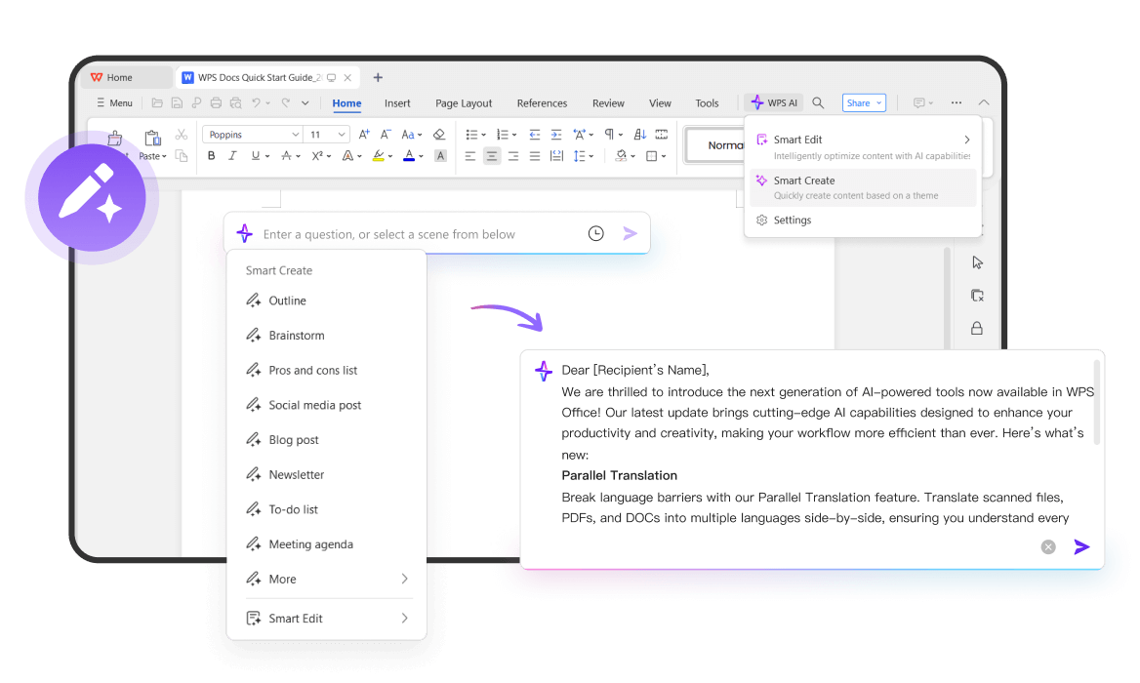

WPS AI-Docs Smart Edit

Continuation, rewriting, expansion, optimization - WPS AI handles it all to enhance your creativity and help you write better. Simply select the paragraph you want to revise and click the floating quick menu.

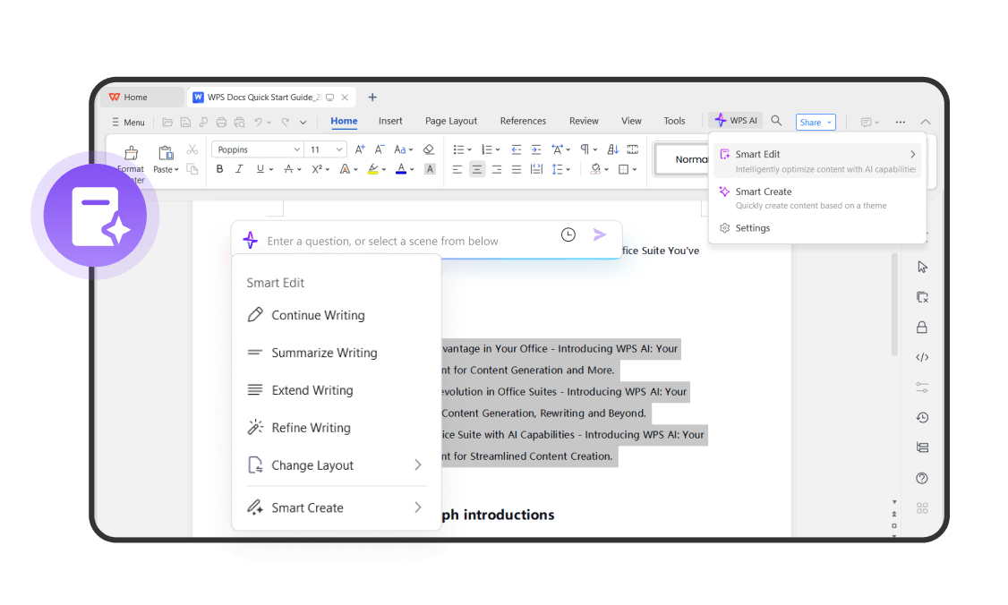

Parallel Translate

Simply click on Review > Parallel Translate to generate side-by-side translations for your multi-language documents. While reading, the original text and translated text will be highlighted simultaneously, ensuring easy comparison and understanding.

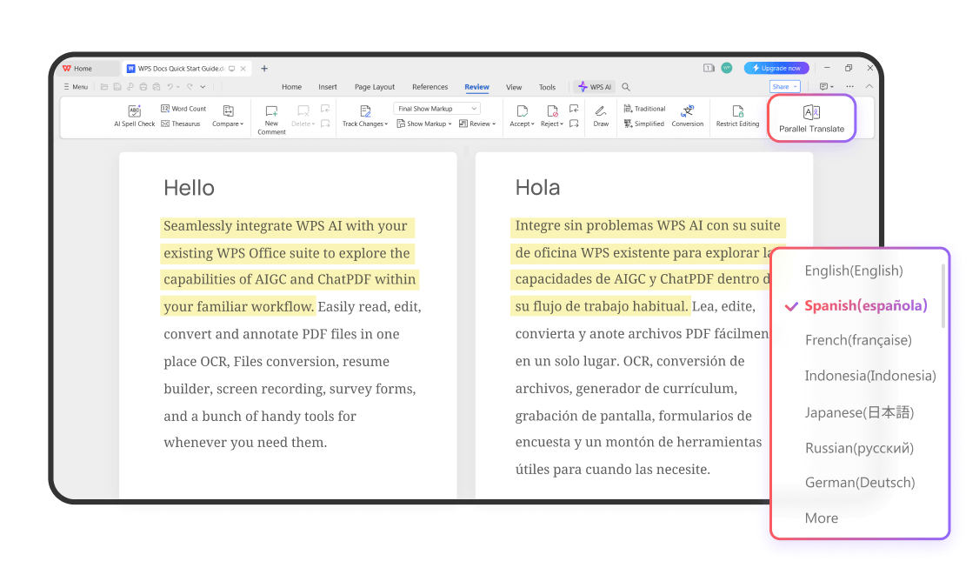

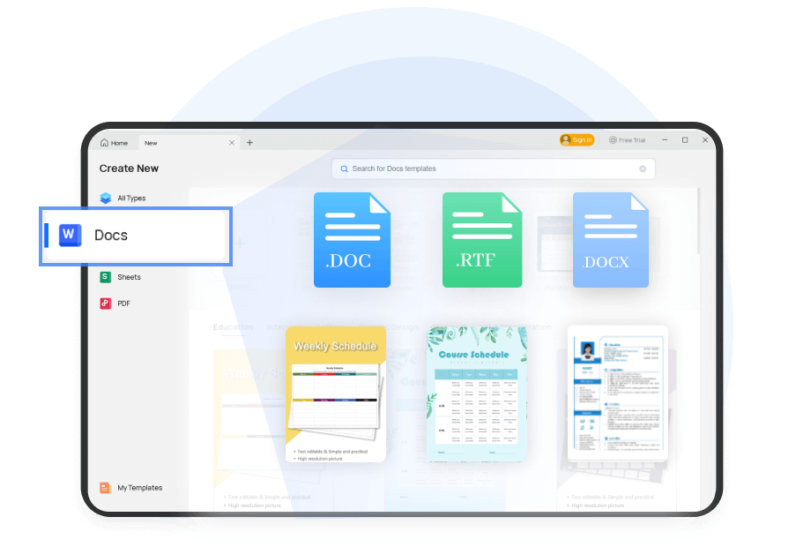For all your document process needs

Create Document

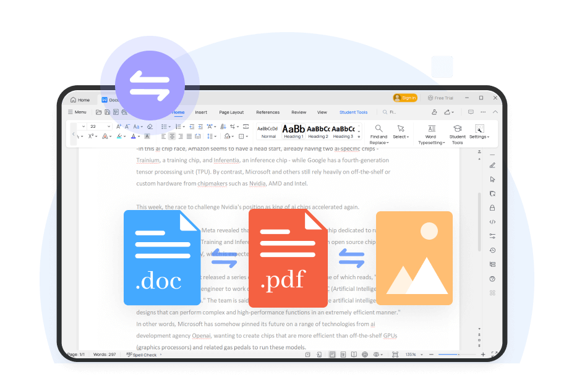Start with a blank document and begin working right away. Alternatively, choose a template that suits your needs and save yourself a lot of time. Click on File > New, and select or search for the desired template.

Format Conversion

Easily convert Word to PDF, PDF to Word, PNG, JPG, TXT, and more.

Effortlessly batch convert multiple files.

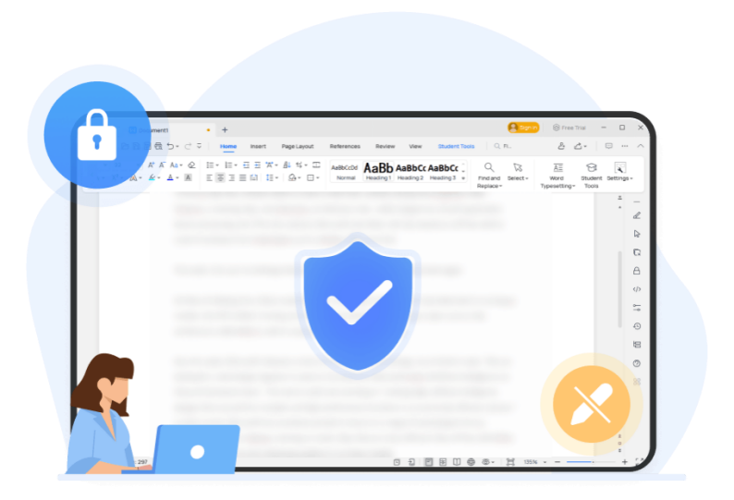

Restrict Editing

Sometimes, you may need to send documents to colleagues while wanting to prevent unauthorized changes by others. To enhance document security, click on Review > Restrict Editing to set permissions for editing, reading, commenting, and other actions.

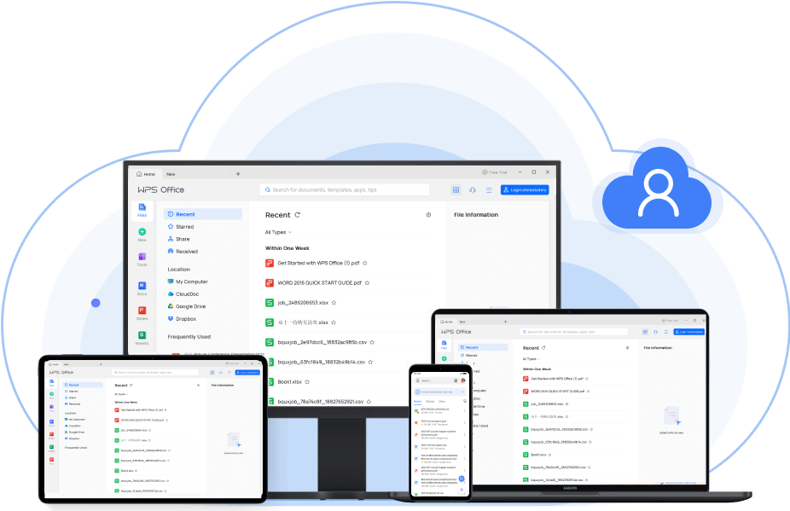

Co-Edit With Others

Share your work with others through links, QR codes, emails, and more.

Everyone can simultaneously edit the same document, enabling seamless collaboration.

Editing and typesetting

Find and Replace

Utilize the Find and Replace function to swiftly modify text in your documents, boosting productivity. You can also search for specific formats to meet complex requirements. Click on Home > Find and Replace, with the short-cut key being Ctrl+F.

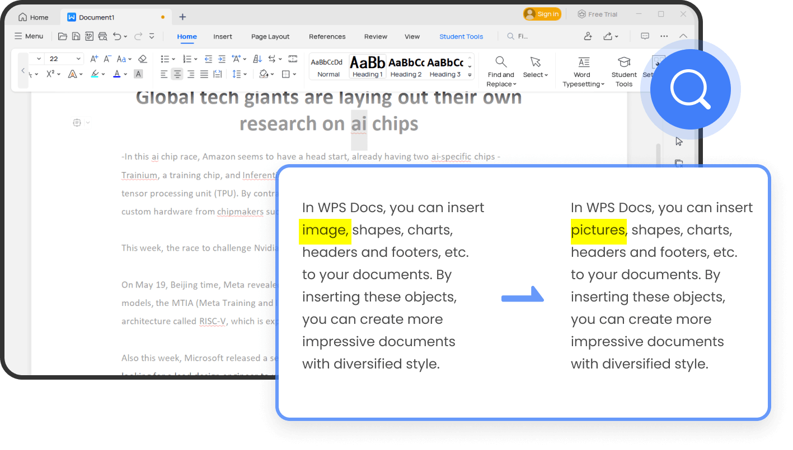

Efficient Word Typesetting

Save time on document layout and boost creativity with WPS. Click Home > Word Typesetting to quickly adjust formats and bulk delete content, including blank pages, separators, text formatting, and objects.

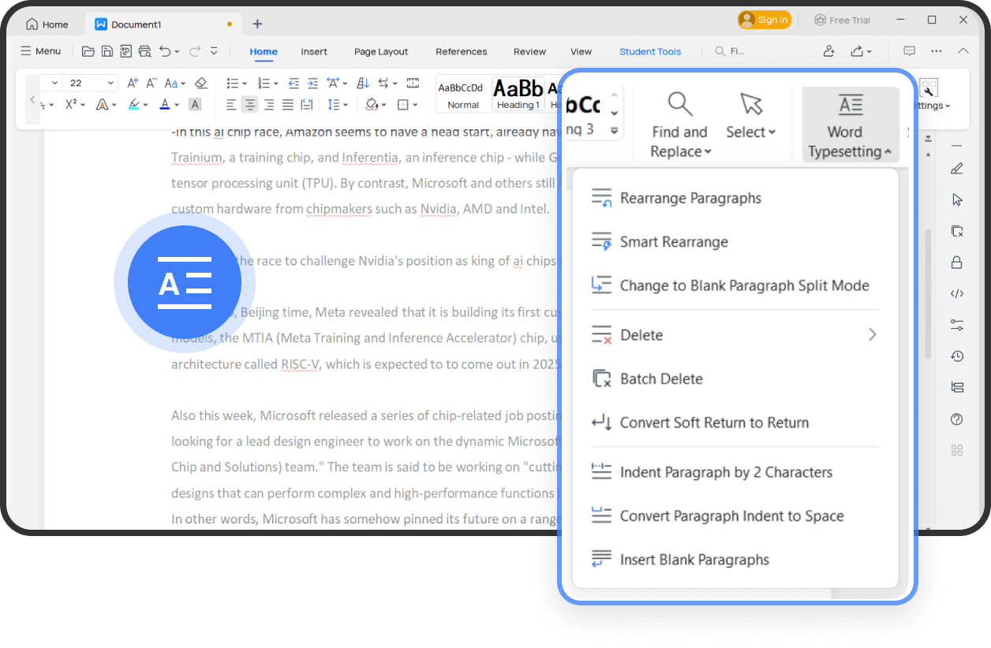

Spell Check

Finish and submit documents faster while ensuring they are free of spelling mistakes. Click on Review > Spell Check to receive suggestions for corrections. This feature supports multiple languages.

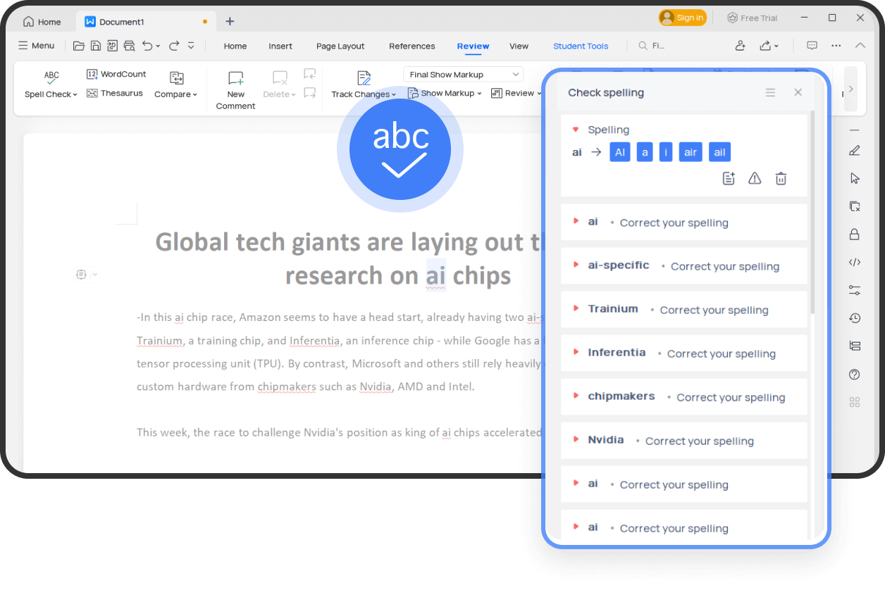

Track Changes

Click on Review > Track Changes to assist the original author in identifying changes made during document editing.

Filter changes by date or reviser and switch between per-revision and post-revision states effortlessly, enabling focused viewing and easy comparison of changes.

### WRITER (14)

### More Popular features

### C:\Users\kingsoft\Downloads\2222222.png2222222Table of Contents

The Table of Contents can automatically identify the article chapters and title levels, generating the table of contents in just one second.

### Mail Merge

It enables you to batch generate and edit multiple documents, such as emails, invitations, greeting cards, pay slips, and more. Say goodbye to repetitive document editing.

### Table Tools

You can create tables directly in Writer without the need to create a new document. We provide a comprehensive table toolbox for beautification, formulas, sorting, and more.

### File Collection

With WPS File Collection, you can efficiently manage file sharing among team members. Collected files are automatically aggregated into a shared folder, allowing you to view, edit, and delete them at any time.

### Merge & Split

WPS Writer supports splitting or merging files, and you can customize the number of file splits. It provides an easier way to manage your documents.

### Eye Protection Mode

By adjusting the screen's color temperature and brightness, you can reduce blue light radiation, minimize eye fatigue, and ensure optimal vision during work and study.

Free ALL-IN-ONE Office Suite

Install free WPS Office to enjoy the same benefits on Android & ios!