ABDUL AKRAM A

720721115002

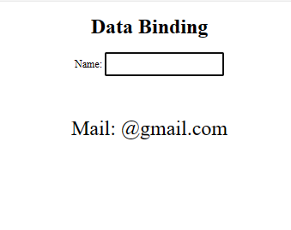 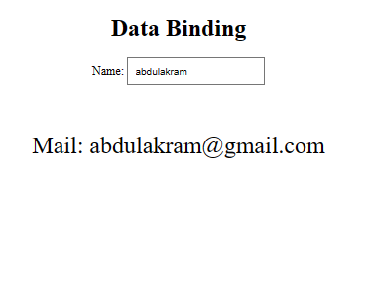

**CODE**

<!DOCTYPE html>

<html ng-app="myApp">

<head>

  <title>AngularJSDataBinding</title>

  <script src="https://ajax.googleapis.com/ajax/libs/angularjs/1.6.9/angular.min.js"></script>

</head>

<body ng-controller="MyController as ctrl">

    <CENTER>

    <h1>Data Binding</h1>

    <p>Name: <input  type="text" ng-model="ctrl.message" id="a" style="padding: 10PX;"></p>

    <BR><BR>

    <p style="scale: 200%;">Mail:             {{ctrl.message}}@gmail.com</p></CENTER>

    <script>

        var app=angular.module("myApp",[])

        app.controller("MyController",function(){

            this.message='';

            this.clearMessage=function(){

                this.message='';

            }

        });

    </script>

</body>

</html>