**E-Commerce Website**

Abdul Akram A

720721115002

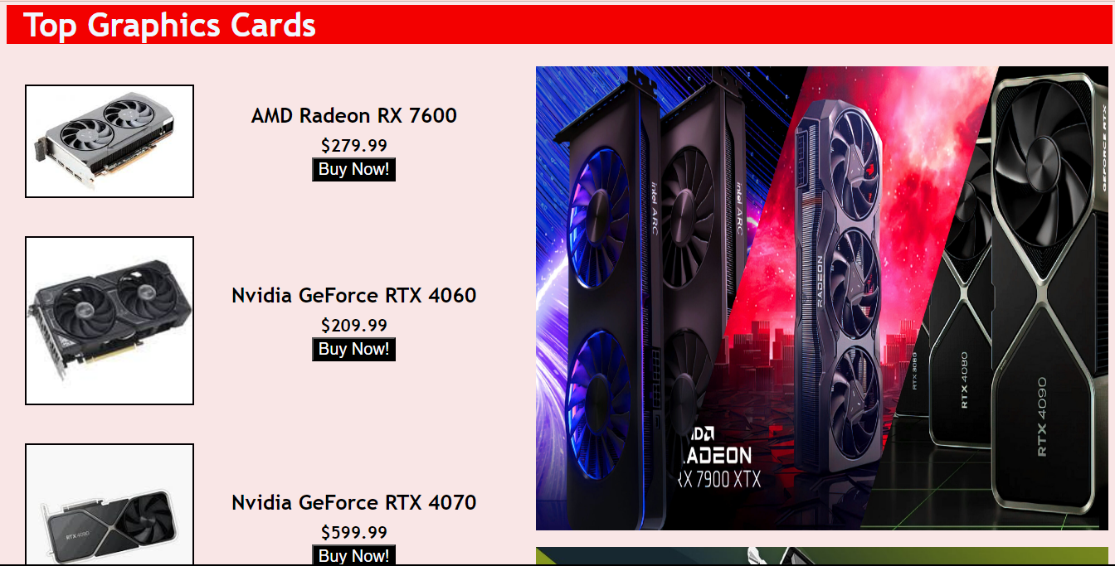

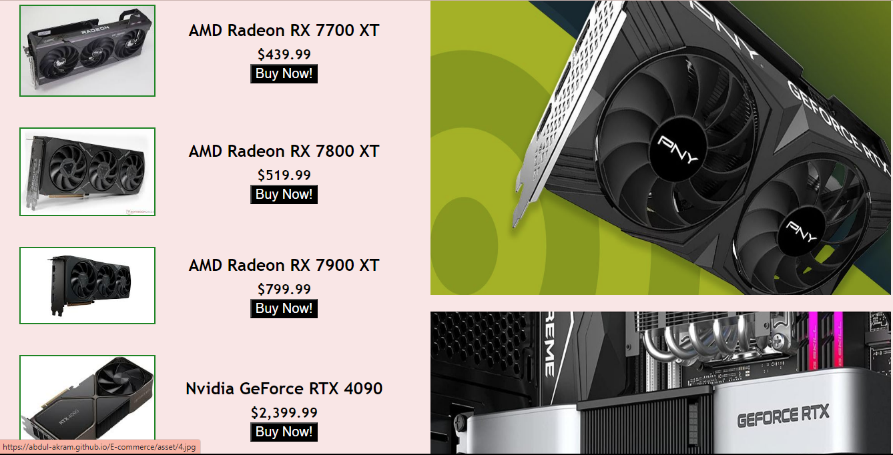

**HTML CODE**

<!DOCTYPE html>

<html lang="en">

<head>

<meta charset="UTF-8">

<meta name="viewport" content="width=device-width, initial-scale=1.0">

<link rel="stylesheet" href="style.css">

<title>GPU's</title>

</head>

<body>

<div class="main">

<div class="title">

<h1 style="font-size: 40px;">Top Graphics Cards</h1>

</div>

<div class="content">

<table align="left" style="max-width: 45%;">

<tr>

<td><a href="asset/1.jpg"><img class="i" src="asset/1.jpg" width="200px"></a></td>

<th>AMD Radeon RX 7600<br><sub>$279.99</sub><br><button type="button"><a href="https://www.amazon.com/ASUS-RadeonTM-Graphics-DisplayPort-Axial-tech/dp/B0C42D32FN?tag=p00935-20&ascsubtag=06dSV7XrWP90LHvwItrRX5r" target="_blank">Buy Now!</a></button></th>

</tr>

<tr>

<td><a href="asset/2.jpg"><img class="i" src="asset/2.jpg" width="200px"></a></td>

<th>Nvidia GeForce RTX 4060<br><sub>$209.99</sub><br><button type="button"><a href="https://www.amazon.com/ASUS-DisplayPort-2-5-Slot-Axial-tech-Technology/dp/B0C7YPGFFW?tag=p00935-20&ascsubtag=01Sh8V1N8vI9MkvqMDC2Rd4&th=1" target="_blank">Buy Now!</a></button></th>

</tr>

<tr>

<td><a href="asset/3.jpg"><img class="i" src="asset/3.jpg" width="200px"></a></td>

<th>Nvidia GeForce RTX 4070<br><sub>$599.99</sub><br><button type="button"><a href="https://www.bestbuy.com/site/-/6539358.p?cmp=RMX&nrtv_cid=c39a40ef1f00cba8fa9338e5824f4c93e47e484492ccac4b8185e89422a514a3&utm_source=narrativ&ar=1830211465609904466&irclickid=yKm3zGWZkxyPWZ8XoIxWLWZwUkHx7L3x5QsdWc0&irgwc=1&ref=198&loc=Howl%20Technologies%2C%20Inc.&acampID=0&mpid=376373" target="_blank">Buy Now!</a></button></th>

</tr>

<tr>

<td><a href="asset/4.jpg"><img class="i" src="asset/4.jpg" width="200px"></a></td>

<th>AMD Radeon RX 7700 XT<br><sub>$439.99</sub><br><button type="button"><a href="https://www.amazon.com/XFX-Speedster-QICK319-Graphics-RX-77TQICKB9/dp/B0CGMBYMY6?tag=p00935-20&ascsubtag=068Kkznq7gHW64edEnhJkRV" target="_blank">Buy Now!</a></button></th>

</tr>

<tr>

<td><a href="asset/5.jpg"><img class="i" src="asset/5.jpg" width="200px"></a></td>

<th>AMD Radeon RX 7800 XT<br><sub>$519.99</sub><br><button type="button"><a href="https://www.amazon.com/Sapphire-11330-02-20G-Radeon-Gaming-Graphics/dp/B0CFWM1LNH?tag=p00935-20&ascsubtag=007IavHCOCwPIXFtJYlrOlb" target="_blank">Buy Now!</a></button></th>

</tr>

<tr>

<td><a href="asset/6.jpg"><img class="i" src="asset/6.jpg" width="200px"></a></td>

<th>AMD Radeon RX 7900 XT<br><sub>$799.99</sub><br><button type="button"><a href="https://www.amazon.com/Sapphire-11323-02-20G-Radeon-Gaming-Graphics/dp/B0BR6L7TKR?tag=p00935-20&ascsubtag=02g5hdESh0XV8iIi0O4RMzX" target="_blank">Buy Now!</a></button></th>

</tr>

<tr>

<td><a href="asset/7.jpg"><img class="i" src="asset/7.jpg" width="200px"></a></td>

<th>Nvidia GeForce RTX 4090<br><sub>$2,399.99</sub><br><button type="button"><a href="https://www.amazon.com/ZOTAC-Graphics-IceStorm-Advanced-ZT-D40900Q-10P/dp/B0CCSSRLWY?tag=p00935-20&ascsubtag=06pVomDu1yBOCe1APQbrv9y" target="_blank">Buy Now!</a></button></th>

</tr>

<tr>

<td><a href="asset/8.jpg"><img class="i" src="asset/8.jpg" width="200px"></a></td>

<th>AMD Radeon RX 7900 XTX<br><sub>$969.99</sub><br><button type="button"><a href="https://www.amazon.com/XFX-Speedster-MERC310-Graphics-RX-79XMERCB9/dp/B0BNLSW23M?tag=p00935-20&ascsubtag=02nKHRqFlBbCcnPK8k8PyRJ&th=1" target="_blank">Buy Now!</a></button></th>

</tr>

<tr>

<td><a href="asset/9.jpg"><img class="i" src="asset/9.jpg" width="200px"></a></td>

<th>Intel Arc A580<br><sub>$169.99</sub><br><button type="button"><a href="https://www.amazon.com/ASRock-Challenger-Intel-ARC-A580/dp/B0CJGSP9R7?tag=p00935-20&ascsubtag=00T1f7BD5Nu6VkPHrirhINo" target="_blank">Buy Now!</a></button></th>

</tr>

</table>

</div>

<div class="banner" align="right">

<img src="asset/m1.jpg" alt="Banner" width="690px" height="560px" style="position: absolute;">

<img src="asset/m2.jpg" alt="Banner" width="690px" height="560px" style="position: absolute; margin-top: 580px;">

<img src="asset/m3.jpg" alt="Banner" width="690px" height="530px" style="position: absolute; margin-top: 1165px;">

</div>

</div>

</body>

</html>

**CSS CODE**

body{

background-color: rgba(236, 171, 171, 0.288);

}

.title{

text-align: left;

}

th,td{

padding: 20px;

}

th,h1{

font-size: 25px;

font-family: 'Trebuchet MS', 'Lucida Sans Unicode', 'Lucida Grande', 'Lucida Sans', Arial, sans-serif;

}

button{

background-color: black;

font-size: 20px;

}

a:link {

color: rgb(255, 255, 255);

background-color: transparent;

text-decoration: none;

}

a:visited {

color: rgb(254, 255, 255);

background-color: transparent;

text-decoration: none;

}

a:active {

color: rgb(218, 53, 53);

background-color: transparent;

}

h1{

margin-left: 20px;

color: aliceblue;

}

.title{

background-color: rgb(245, 4, 4);

}

.i{

animation: example 4s infinite;

}

@keyframes example {

0% {

border: 2px solid rgb(17, 0, 255);

}

25% {

border: 2px solid rgb(248, 0, 0);

}

50% {

border: 2px solid rgb(190, 18, 119);

}

75% {

border: 2px solid rgb(0, 0, 0);

}

100% {

border: 2px solid rgb(21, 136, 21);

}

}

button:hover{

scale: 110%;

}

.banner{

margin-right: 695px;

}

@media screen and (max-width:650px) {

    th,h1{

    font-size: 15px;

    font-family: 'Trebuchet MS', 'Lucida Sans Unicode', 'Lucida Grande', 'Lucida Sans', Arial, sans-serif;

    }

    th,td{

        padding: 10px;

    }

    .title{

        min-width: 650px;

        width: fit-content;

        background-color: rgb(245, 4, 4);

    }

    #b1,#b2,#b3{

        width: 345px;

        height: 440px;

    }

    #b1{

        margin-top:20px;

    }

    #b2{

        margin-top:565px;

    }

    #b3{

        margin-top:1100px;

    }

}